Food and Beverage Operations
BMIH4002
Lecturer Name: Antoinette Milne

Student Name: Catalina Ianos
Student Id: 2232322

Table of Contents
Part 1: Restaurant Concept 3
Part 2: Menu Design 3
Reference List and bibliography 9

Part 1: Restaurant Concept
The main concept on which Hotel Trinity and its menu are based is veganism. Vegan food is solely based on plants and excludes every animal-derived food product including dairy and eggs. The concept of the restaurant is to serve its guests with delightful vegan dishes unparalleled in taste. Furthermore, the restaurant is also going to offer vegan food in exchange for comparatively cheaper prices. According to Sexton et al. (2022), some vegan food items, due to their lower shelf lives, tend to be costlier compared to their non-vegan counterparts. Nevertheless, it is a well-established fact that vegan food is a healthier food choice compared to other types of food. Furthermore, environmental sustainability is quite frequently associated with the consumption of vegan food. According to Gray (2020), a vegan diet is widely considered to generate a smaller environmental footprint. Therefore, the choice of a vegan menu is justified from the perspective of healthier food choices and environmental sustainability.
The market will be segmented based on the lifestyle and dietary choices of the customers. The three main segments of the market will be the non-vegetarians, the vegetarians, and the vegans. Among these, the prime target of Hotel Trinity would be vegan individuals. The number of vegan populations in the UK is increasing gradually. As of 2023, nearly 4% of the population aged between 18 and 64 years were found to be following veganism (Statista, 2023). People belonging to the younger age group are especially prone to adopt veganism. Therefore, the selection of the target market is quite justified from this perspective.
The interior and aesthetics of the restaurant would match the main theme of the restaurant. The internal ambience will be specially optimized to meet customers’ experience. The menu will display a variety of food items from across the UK. Dishes with seasonal fruits, vegetables, and crops will be included in the menu, thereby allowing for a broad range of choices for the guests. Service quality will be prioritized over the cost of services. The restaurant will offer a special menu on different occasions like Christmas, Halloween, Valentine’s Day and so on.

Part 2: Menu Design
TITLE: Crafting a Memorable Dining Experience Menu for a Special Occasion
The restaurant will mainly serve multinational cuisine, however French and oriental cuisine will be made available on demand. Guests will be provided with table service, in other words, they will be served by the restaurant staff. On special demand, Buffet services might be made available for customers. In addition to delicious food and a calm ambience, the restaurant would have live music where artists will play soothing music to enhance the ambience.
Menu Items

Appetizers | Price | Main Course | Price | Side Dishes | Price | Desserts | Price | Beverages | Price
Beetroot Hummus  . | £9.0 | Vegan black bean burgers | £12.0 | Creamy corn salad | £8.0 | Apple cookies | £15.0 | Dairy-free Dalgona Coffee | £12
Chickpea Bruschetta | £10.0 | Tofu Stir-Fry | £15.0 | Cauliflower steaks | £9.0 | Vegan waffles | £15.0 | Peach Raspberry Vegan Smoothie | £14
 |  | Vegetarian Sushi | £11.0 | Quinoa Salad | £9.0
Table 1: Tentative menu and pricing
(Source: Created by the learner)

Pricing Strategy
The pricing of the food items has been mentioned in table 1. The prices have been fixed using a cost-plus pricing strategy. In the cost-plus pricing strategy, the prices of each item are determined by adding a certain percentage to the cost to produce that item. The cost-plus pricing strategy has been used here to make sure that the price of each food item is affordable to customers and profitable to the company at the same time.
Menu Design
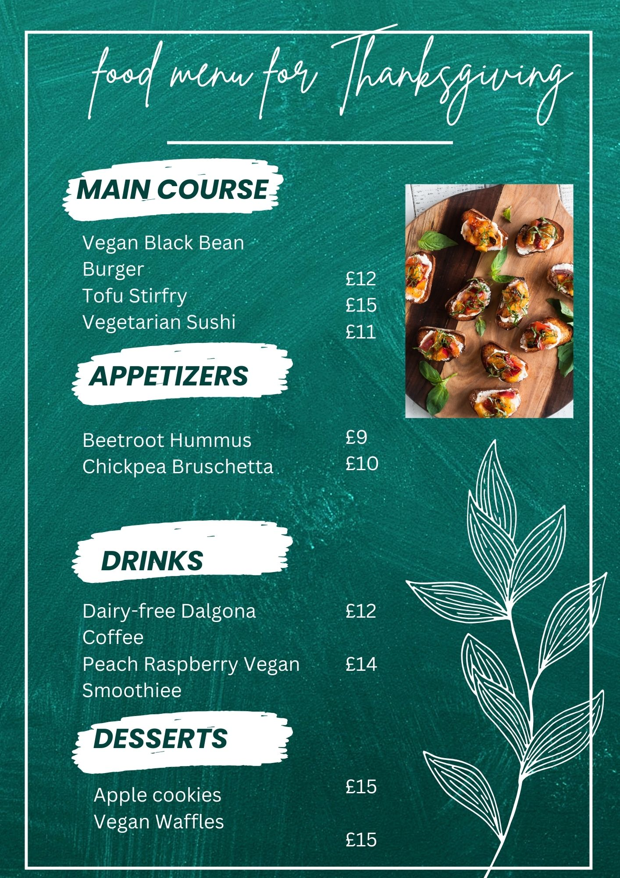
Sustainability and Seasonality
As mentioned earlier, the restaurant will only serve vegan food options. Various seasonal ingredients will be used in the menu. Furthermore, as the menu features only vegan food items, the environmental footprint is estimated to be far lower than non-vegetarian food options.

Reference List and bibliography
Brown, D.R., 2013. The restaurant manager's handbook: How to set up, operate, and manage a financially successful food service operation (Vol. 1). Atlantic Publishing Company.
Cousins, J. 2020. Food and beverage service. 9th ed. London: Hodder Education Group.
Davis, B., Lockwood, A., Pantelidis, I. and Alcott, P., 2013. Food and beverage management. Routledge.
Foskett, D., Paskins, P., Pennington, A. and Rippington, N., 2021. The theory of hospitality and catering. Hachette UK.
Gray, R. 2020. Why the vegan diet is not always green. [online]./ Available at:<https://www.bbc.com/future/article/20200211-why-the-vegan-diet-is-not-always-green> [Accessed on: 7th October 2023].
Johnston, R. 2012. Service operations management : improving service delivery. 4th ed. Harlow, England: Pearson
Sexton, A.E., Garnett, T. and Lorimer, J., 2022. Vegan food geographies and the rise of Big Veganism. Progress in Human Geography, 46(2), pp.605-628.
Statista, 2023. Vegans: share of population in the United Kingdom 2021-2022. [online]. Available at:<https://www.statista.com/forecasts/1062126/vegans-share-of-population-in-great-britain#:~:text=Aggregating%20four%20surveys%20carried%20out,of%202022%20by%20one%20percent.> [Accessed on: 7th October 2023].
Walker, J. 2017. Introduction to Hospitality. Harlow: Pearson Education Limited
Wood, R. 2013. Key Concepts in Hospitality Management. London: Sage

