

Student name: Jenny Hermoso
Student ID: 2436151
Module name: Introduction to Health and Social care
Module code: [LCHS4003_LON]
Lecturer name: Mohammed Aliyu

Contents
TASK 2 4
PAST HISTORY 4
MODERN HISTORY 4
Reference list: 6


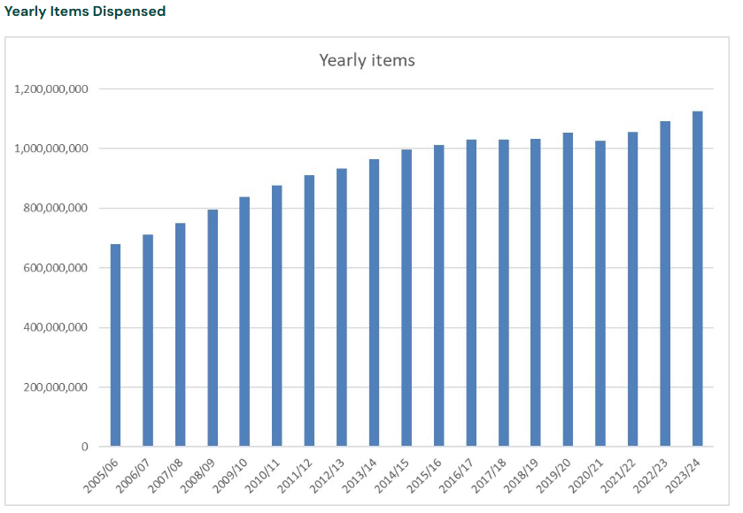
History:
The trade in medicines in the UK was regulated initially by the Guild of Pepperers. The Worshipful Society of Apothecaries was founded after, marking the beginning of formal pharmacy practice in England.
Since 1948, pharmacy within the NHS has been transformed from a dispensing-focused role into a pivotal component of clinical care and public health. Pharmacists are now regarded as essential contributors to patient-centred services, therapeutic management, and health promotion.
The Linstead Report (1953) expanded their roles and involvement in medical education, with the Medicines Act (1968) establishing a licensing process for pharmacists.
What can a pharmacist do for you? What should you do in a pharmacy?
Pharmacists also give free medical and medication advice for certain conditions, can also remind people to pick up their medication, and occasionally deliver medication.
When in a Pharmacy, as a civilian, you can ask questions regarding your prescriptions. Details such as side effects and additional information about the medication.
You can also ask for advice on a range of illnesses, medicines, and treatments from them.
Prescribed medicine and other medicines you may need is available to collect over the counter.

Challenges:
Digital Transformation: The healthcare sector is undergoing significant digital changes, impacting how pharmacists manage patient data and interact with healthcare systems. Adapting to electronic health records, telepharmacy, and digital prescription services requires pharmacists to continuously learn and adjust their workflows.
Increased Workload and Pressure: Pharmacists are experiencing higher workloads due to increased demand for services, staffing shortages, and expanded responsibilities, such as administering vaccinations and providing patient counselling. This is an addition to the reduction in budget pharmacy in 2017.

Current Functioning:
According to Community Pharmacy England (2025), there has been a relatively steady increase in the dispensary of pharmaceutical items throughout the years. It is even evident from the statistics shown for the years Apr 2022-Mar 2024 that the increase has been steady

Introduction:
What is a Pharmacy and How does it operate?
A Pharmacy is a either a shop or hospital depository of medicinal drugs.
You can buy many of the more basic medications from the Pharmacy, however some medication requires a prescription from your GP or doctor.

e
Pharmacy Services

TASK 2

The History or the Origin of NHS
The National Health Service (NHS) was officially inaugurated on 5 July 1948, representing a pivotal shift in British social policy. Its establishment was influenced by the Beveridge Report (1942), in which a welfare state was proposed to address the "five giants" of Want, Disease, Ignorance, Squalor, and Idleness. The widespread devastation caused by World War II was recognised as a catalyst for the urgent implementation of a universal healthcare system, designed to serve the population irrespective of financial means.
In contemporary England, the National Health Service (NHS) is no longer regarded as a singular entity, but rather as a multifaceted system composed of numerous organisations functioning at national, regional, and local tiers. It has been recognised as the largest employer in Europe, with a workforce exceeding 1.7 million individuals across the United Kingdom. The current framework is characterised by several core components. NHS England is entrusted with the oversight of financial resources, strategic development, and service commissioning. Integrated Care Systems (ICSs) have been established as regional collaborations responsible for coordinating health and social care services. Primary care is mainly provided through general practitioner clinics, dental offices, optometry practices, and community drugstores. NHS Trusts provide secondary and tertiary care, which includes hospitals and specialized healthcare facilities. Regulatory functions and public health initiatives are overseen by statutory organizations, such as the Care Quality Commission.
Britain’s first majority Labour government, led by Clement Attlee, formulated plans for a comprehensive Welfare State. An NHS, free at point-of-delivery, was the cornerstone of these plans. As part of that, the National Health Service Act was passed in 1946. When the NHS officially launched in 1948, it symbolized a profound social commitment to equity and collective responsibility. The model influenced healthcare systems around the world and remains one of Britain’s most defining institutions.
The introduction of hospital services as part of the NHS helped the UK move from a system reliant on private consultation and referrals to a collaborative effort within a trust, allowing a more streamlined process for the delivery of medical treatment and medications for the majority of the population, allowing others to be able to experience the same level of medical treatment in a timely manner.
In the year 1962, Britain was experiencing economic growth, allowing the provision of a framework known as Enoch Powell’s Hospital Plan (1962) in order to help shine light on people who were particularly vulnerable and required protection, those with chronic illnesses, and those who were mentally impaired. This movement helped shine a light on previous medical malpractices, which resulted in more public knowledge and protest.
Around the year 1988, there was a push to decentralise the NHS, allowing trusts to alter the way they work based on the specific needs, specialisation, and general activities performed by the specific trust. This allowed the hospitals to be more dynamic and adaptable to the environment around them, which facilitated higher quality care overall. Between the years of 2007-2017, an international monetary crisis resulted in stagnation of NHS growth and restraint of staff pay.
The Pharmaceutical Society of Great Britain was replaced by the Royal Pharmaceutical Society and the General Pharmaceutical Council in September 2010. This change aimed to clearly separate professional representation from regulatory functions, ensuring greater transparency and accountability. Then, the Health and Social Care Act 2012 introduced major structural changes, promoting competition and the involvement of private providers in the NHS. This sparked considerable debate about the future of the NHS and its funding. Some argued that these reforms could increase efficiency, while others feared they would undermine the founding principles of universal, free healthcare. Despite ongoing challenges, the NHS and its regulatory bodies continue to evolve and adapt to new technologies, changing population needs, and modern-day economic pressures while striving to uphold the standards established over centuries of medical development.

Reference list:
Clement, M. (2023). The founding of the NHS: 75 years on - History of government. [online] history.blog.gov.uk. Available at: https://history.blog.gov.uk/2023/07/13/the-founding-of-the-nhs-75-years-on/.
General Medical Council (2024) History of medical regulation. Available at: https://www.gmc-uk.org/about/who-we-are/our-history
Health Service Navigator. (2025). A short history of the NHS - Health Service Navigator. [online] Available at: https://www.myhsn.co.uk/top-tip/a-short-history-of-the-nhs/.
Rivett, G. (2019). The history of the NHS. [online] The Nuffield Trust. Available at: https://www.nuffieldtrust.org.uk/health-and-social-care-explained/the-history-of-the-nhs.
Sloan, R. (2018). NHS England» 100 years of General Practice. [online] www.england.nhs.uk. Available at: https://www.england.nhs.uk/blog/100-years-of-general-practice/.
Wikipedia Contributors (2025). Worshipful Company of Grocers. [online] Wikipedia. Available at: https://en.wikipedia.org/wiki/Worshipful_Company_of_Grocers.

