Component 2
Module Name: Computer Architecture and Operating Systems
Module Code: ACCA4022
Student Name: Jordan-Lee O’Regan
Student ID: 2520324
Lecturer Name: Md Shantanu Islam

Submission date: 20/07/2026

Contents
Introduction 4
Key functions of general Operating Systems 4
Task Management: 4
Application/Program Management: 5
File/Directory Management: 6
Device Management: 6
Security Management: 7
Use of Windows OS CLI commands 8
Example 1: 8
Example 2: 8
Example 3: 9
Example 4: 9
Example 5: 10
Example 6: 10
Example 7: 10
Example 8: 11
Example 9: 11
Example 10: 12
Use of Linux OS CLI commands 12
Example 1: 13
Example 2: 13
Example 3: 13
Example 4: 14
Example 5: 15
Example 6: 15
Example 7: 15
Example 8: 16
Example 9: 16
Example 10: 17
Use of Windows OS scripts 17
Example 1: 18
Example 2: 19
Use of Linux OS scripts 20
Example 1: 20
Example 2: 21
Conclusion 21
References 22
Appendices 23

Introduction
An operating system (OS) is one of the most important pieces of software on a computer because it allows the user to interact with the hardware and run applications. Before studying this module, I did not fully understand how much an operating system does behind the scenes. It manages resources such as memory, files, storage and connected devices while making sure programs can run properly. In this report, I will explain the main functions of a general operating system before demonstrating the use of Windows Command Line Interface (CLI) and Linux Bash commands. I will also look at simple Batch and Bash scripting to show how command-line automation can make everyday tasks easier and more efficient [1], [2].

Key functions of general Operating Systems
Microsoft Windows is one of the operating systems I am most familiar with, so it makes a good example when explaining the main functions of an operating system. As I have worked through this module, I have learned that Windows is responsible for much more than simply displaying the desktop. It manages hardware resources, runs applications and helps keep the whole system working efficiently [1], [3].

Task Management:
Task management is one of the main functions of an operating system because it controls how different processes run at the same time. Windows uses the processor to schedule tasks, making sure each application receives enough processing time to run efficiently without slowing the whole system down. If a program stops responding, the Task Manager allows the user to end the process without needing to restart the computer. This helps improve performance and keeps the system running smoothly, even when several applications are open at once. Understanding task management has shown me how the operating system balances system resources to maintain stability and efficiency [1], [3].
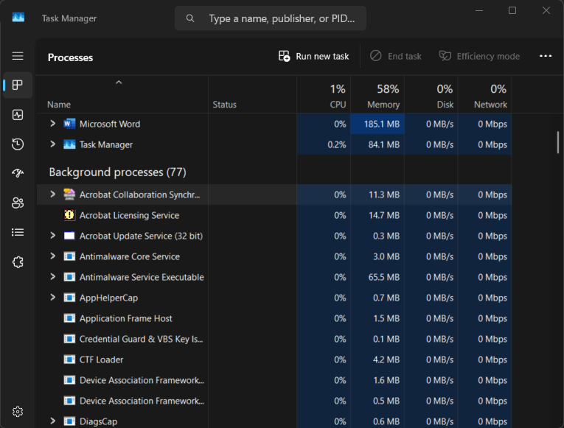
Figure 1: Windows Task Manager showing running processes and system performance.

Application/Program Management:
Application management is another important function of an operating system because it controls how software is installed, run, updated and removed. Windows makes sure that applications have access to the processor, memory and other system resources they need to work correctly. It also helps prevent programs from affecting one another by managing these resources efficiently. If an application stops responding or requires an update, Windows provides built-in tools that allow the user to manage it safely. Learning about application management has helped me understand how the operating system keeps the computer stable, organised and running smoothly for everyday tasks [1], [3].
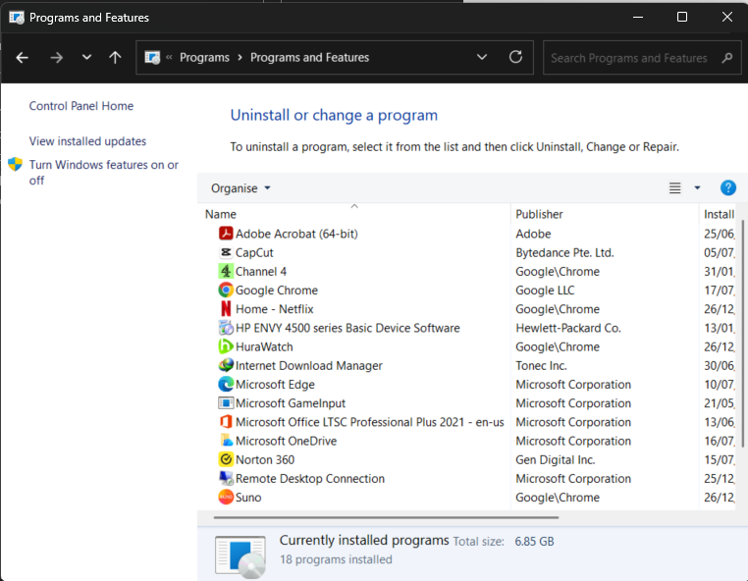
Figure 2: Windows Settings showing Control Panel – Programs and Features.

File/Directory Management:
File and directory management is one of the main functions of an operating system because it helps organise and store information in a structured way. Windows uses a file system to keep files and folders organised so they can be found and accessed quickly. Through File Explorer, users can create folders, move files, rename documents and remove items they no longer need. The operating system also controls file permissions to help protect important information from unauthorised access. Learning about this function has helped me understand how good file management improves organisation, makes files easier to locate and helps the computer run more efficiently [1], [2].

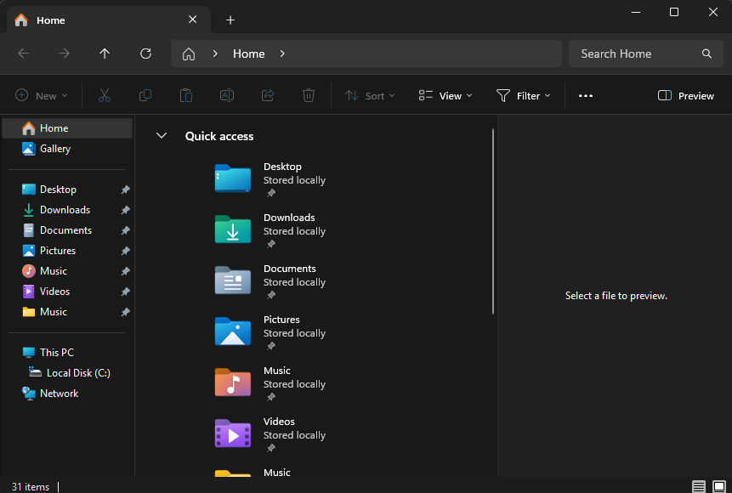
Figure 3: Windows File Explorer showing folders and files.

Device Management:
Device management is another important function of an operating system because it controls how hardware devices communicate with the computer. Windows automatically detects devices such as keyboards, printers, monitors and USB storage devices by installing the correct drivers. Device Manager allows users to view connected hardware, check whether devices are working correctly and troubleshoot any problems that occur. If a driver becomes outdated or stops working, Windows provides tools to update or reinstall it. Learning about device management has helped me understand how the operating system ensures hardware and software work together reliably, allowing the computer to perform efficiently [1], [3].
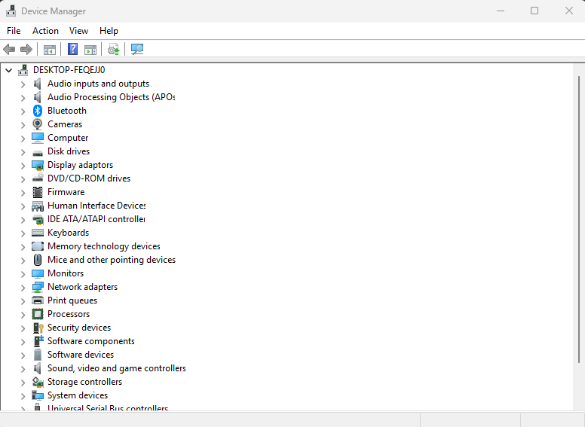
Figure 4: Windows Device Manager showing installed hardware devices.

Security Management:
Security management is an important function of an operating system because it helps protect the computer, its users and stored information from unauthorised access. Windows includes security features such as user accounts, passwords, Windows Defender and the built-in firewall to help prevent malware and cyber threats. It also controls user permissions, allowing administrators to decide who can access files, install software or change system settings. Learning about security management has helped me understand how operating systems protect personal data while keeping the computer safe and reliable for everyday use [1], [2].
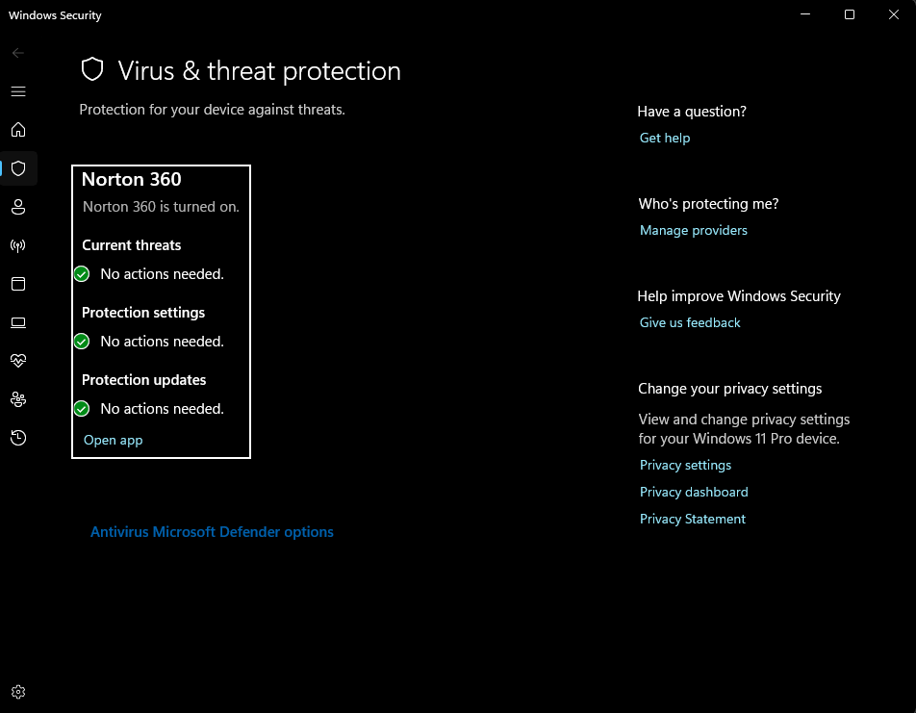
Figure 5: Windows security showing Virus & threat protection settings.

Use of Windows OS CLI commands
The Windows Command Line Interface (CLI) allows users to interact with the operating system by typing commands instead of using the graphical interface. It is commonly used for file management, troubleshooting and system administration, making many tasks quicker and more efficient than using menus alone [3], [4].

Example 1:
The dir command displays the contents of the current directory, including files and folders. The output shows file names, sizes and the date and time they were last modified, making it useful for viewing the contents of a directory [3].
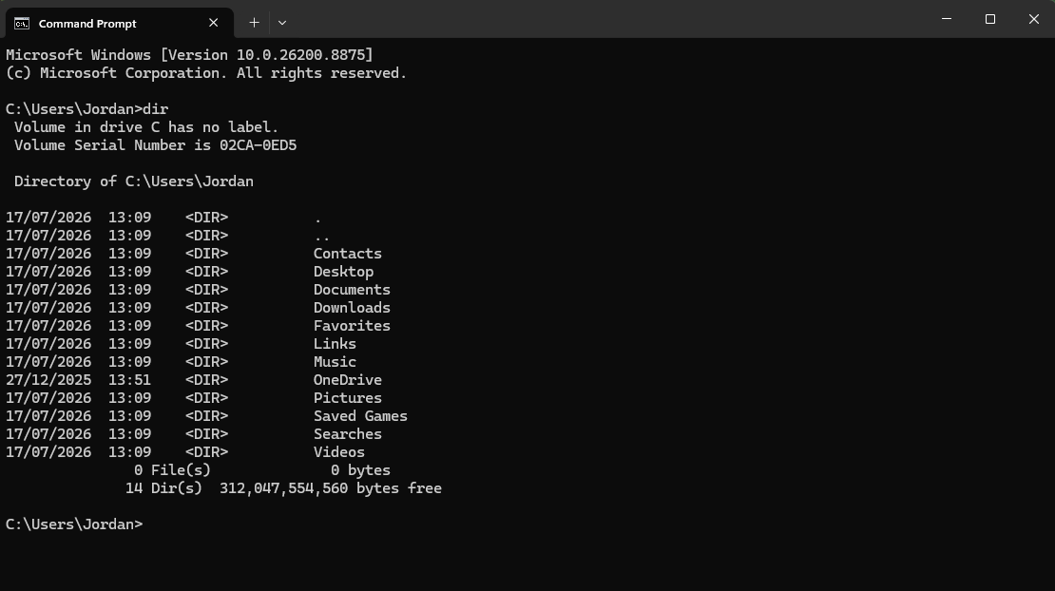
Figure 6: dir command displaying the contents of the current directory.

Example 2:
The cd command changes the current working directory. After entering the command, the prompt changes to show the new folder location, confirming that the user has successfully navigated to a different directory [3].
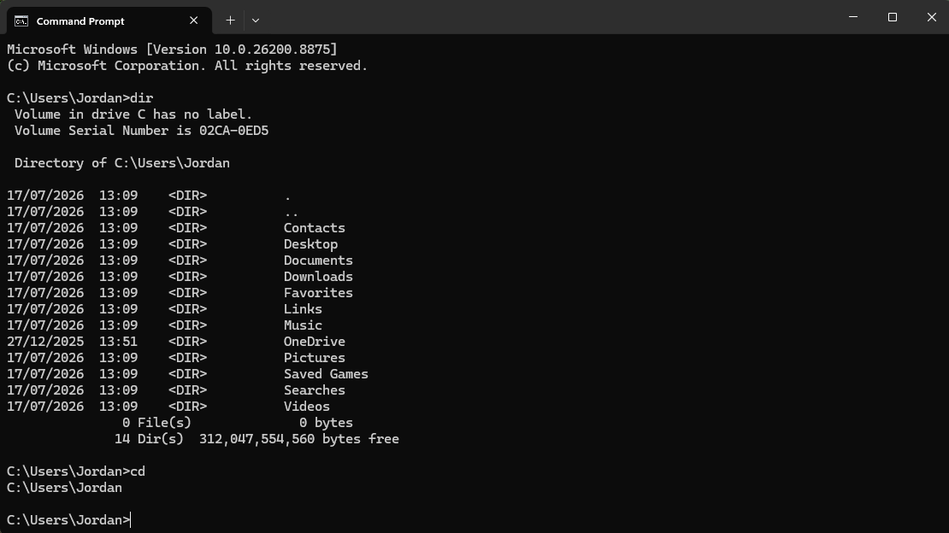
Figure 7: Using the cd command to change directories.

Example 3:
The mkdir command creates a new folder in the current directory. Once the command has been run, the new folder appears when the directory contents are displayed using the dir command [3].
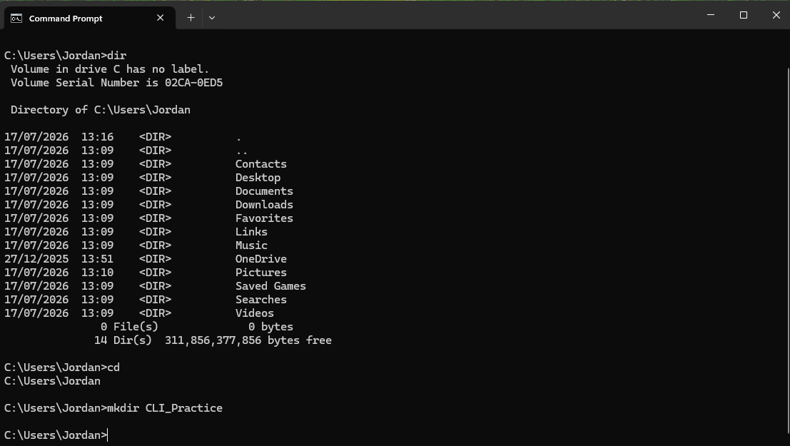
Figure 8: Creating a new folder using the mkdir command.

Example 4:
The ipconfig command displays the computer's network configuration. The output showed information such as the IPv4 address, subnet mask and default gateway, which can be used to check network settings and troubleshoot connection problems [3], [4].
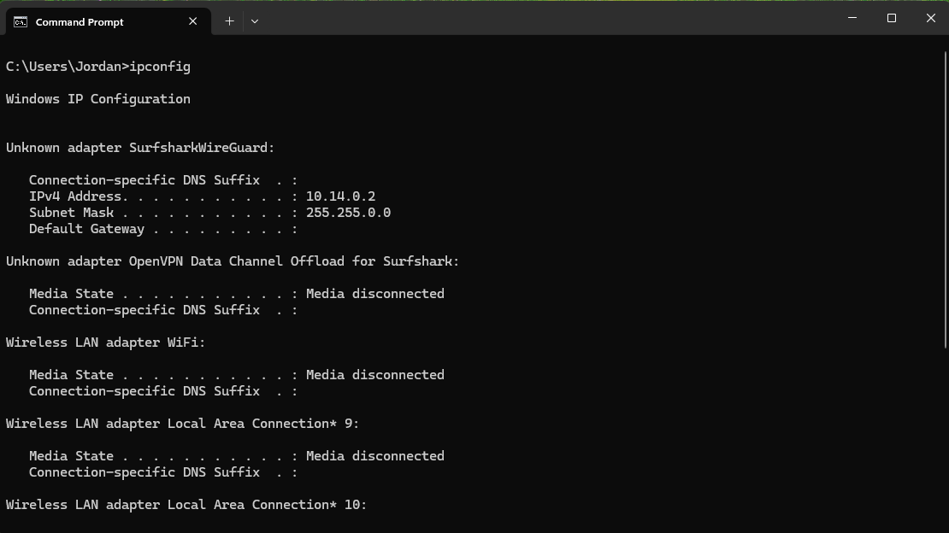
Figure 9: Displaying network configuration using the ipconfig command.

Example 5:
The tasklist command displays all processes currently running on the computer. The output showed the process name, process ID (PID) and memory usage, making it useful for monitoring active applications and system processes [3].
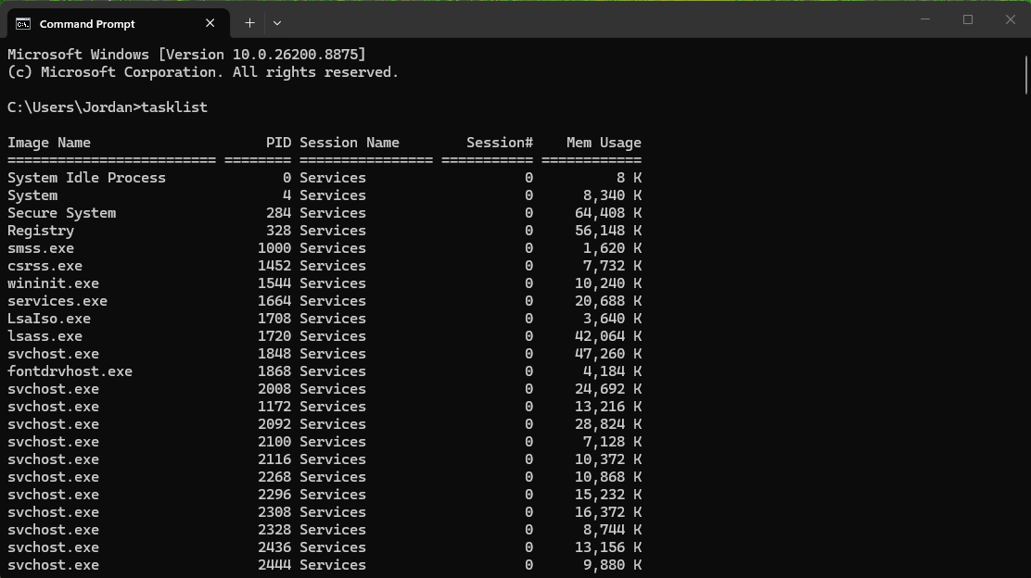
Figure 10: Displaying running processes using the tasklist command.

Example 6:
The copy command creates a duplicate of an existing file. The output confirmed that one file had been copied successfully and the copied file appeared in the directory listing [3].
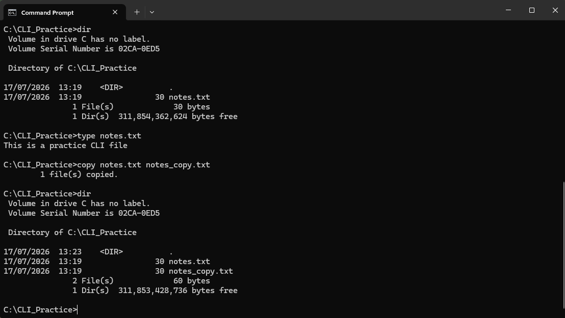
Figure 11: Copying a file using the copy command.

Example 7:
The whoami command displays the name of the user currently logged into Windows. The output showed my user account, confirming which account was running the Command Prompt session [3].
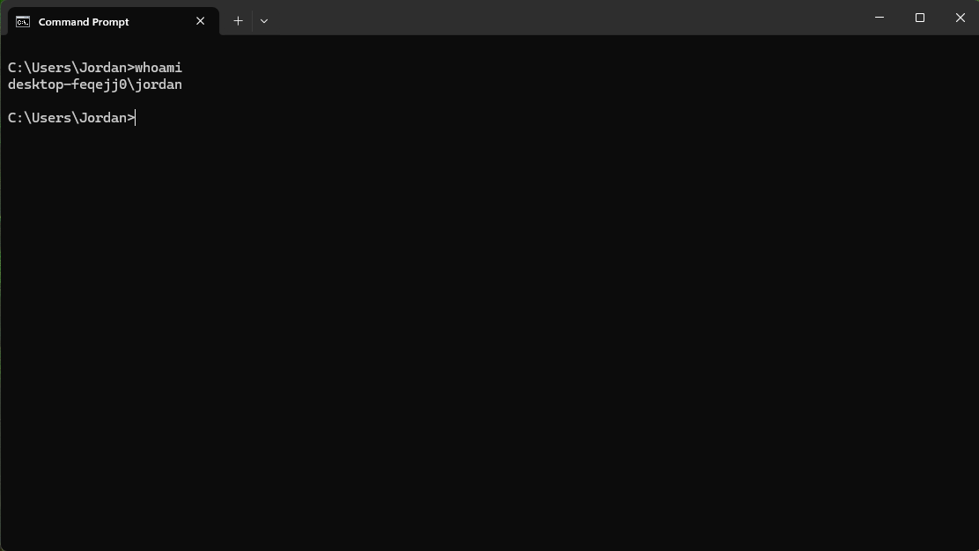
Figure 12: Displaying the current logged-in user using the whoami command.

Example 8:
The del command deletes one or more files from the current directory. After the command completed, the deleted file no longer appeared in the directory listing [3].
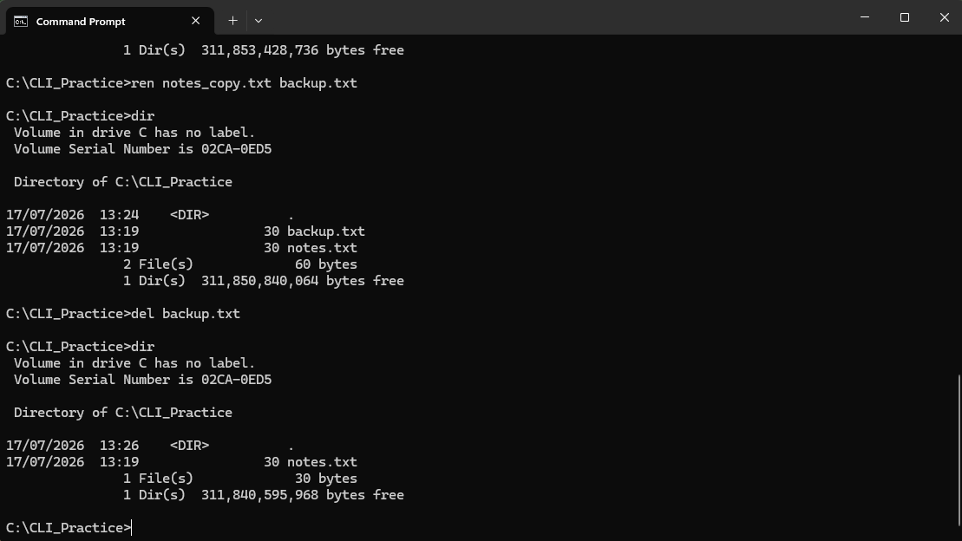
Figure 13: Deleting a file using the del command.

Example 9:
The schtasks command displays the scheduled tasks configured on the computer. The output showed a list of tasks along with information such as their status and next run time, helping users monitor scheduled activities [3].
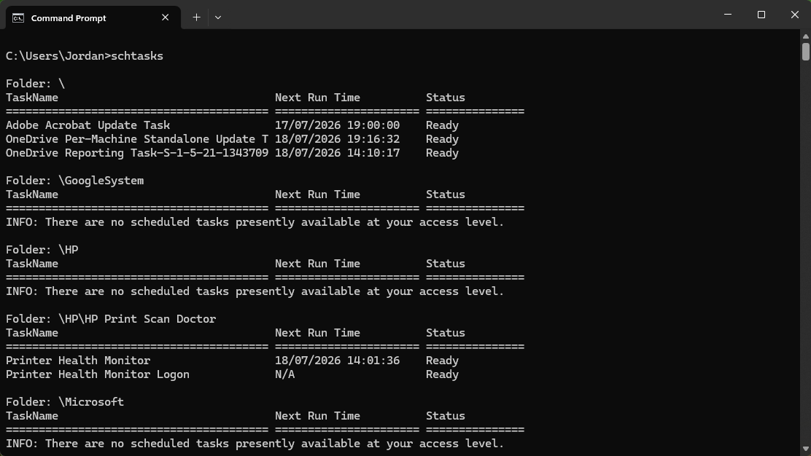
Figure 14: Displaying scheduled tasks using the schtasks command.

Example 10:
The help command displays a list of available Command Prompt commands with a brief description of each one. The output can be used to learn new commands and understand their purpose [3].
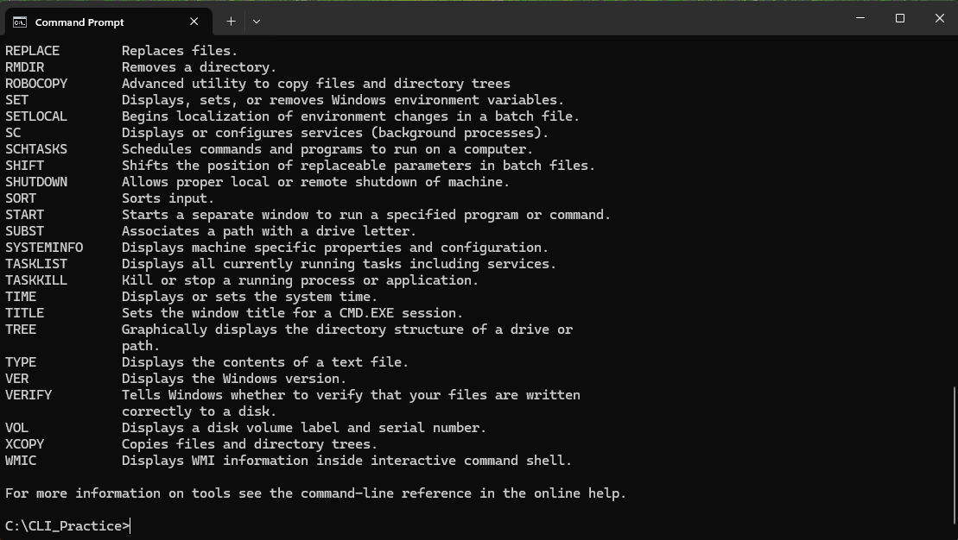
Figure 15: Displaying available commands using the help command.

Use of Linux OS CLI commands
The Linux Command Line Interface (CLI) allows users to interact with the operating system by entering text-based commands rather than using a graphical interface. It is commonly used for navigating directories, managing files, monitoring the system and carrying out administrative tasks. In this section, I will demonstrate a range of Linux Bash commands and explain how they can be used to manage and troubleshoot the operating system effectively [5], [6].

Example 1:
The pwd command displays the current working directory in Linux. The output showed the full path to my home directory, confirming my current location within the Linux file system and helping with directory navigation [5].
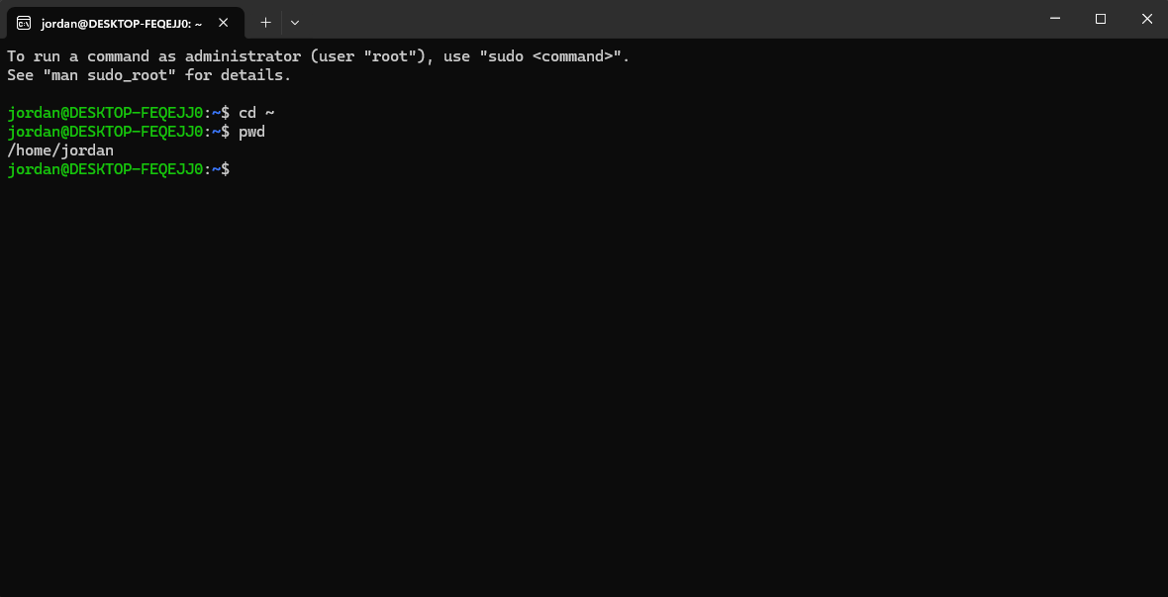
Figure 16: Displaying the current working directory using the pwd command.

Example 2:
The mkdir command was used to create a new directory called CLI_Practice within my home directory. Creating directories helps organise files and keep related data stored in a structured location [5].
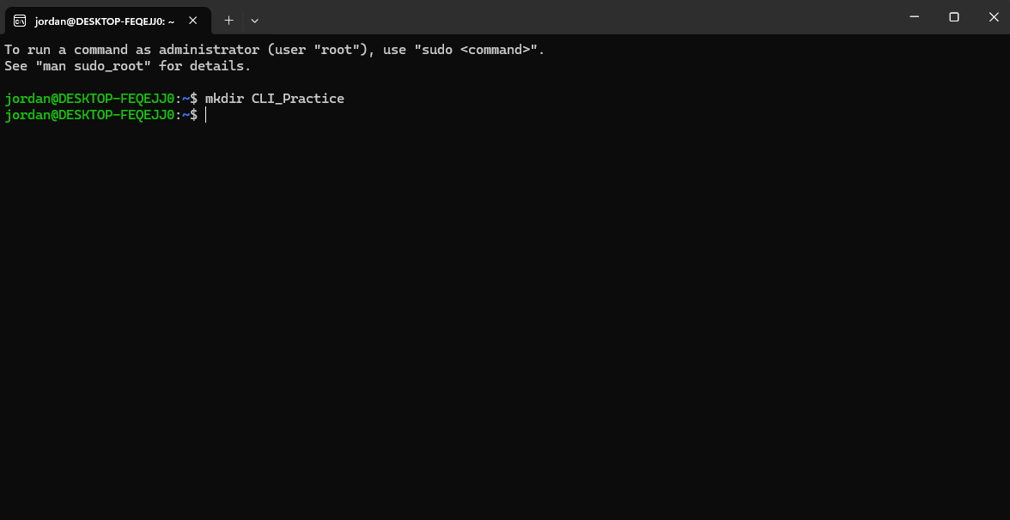
Figure 17: Listing the contents of the current directory using the ls -l command.

Example 3:
The ls -l command lists the contents of the current directory in a detailed format. The output displayed the CLI_Practice directory together with its permissions, owner, size and modification date, making it useful for viewing file and directory information [5].
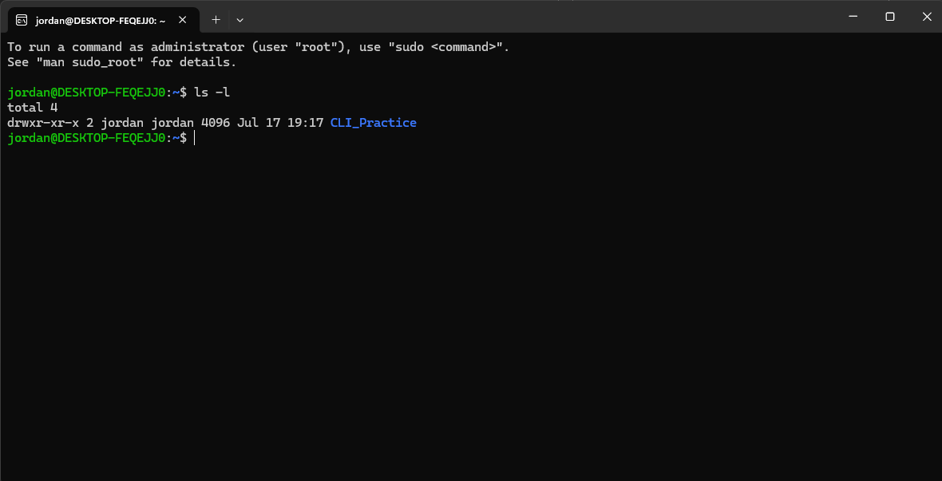
Figure 18: Listing the contents of the current directory using the LS -L command.

Example 4:
The cp command was used to create a copy of the notes.txt file called backup.txt Copying files is useful for creating backups or duplicate versions while keeping the original file unchanged [5].
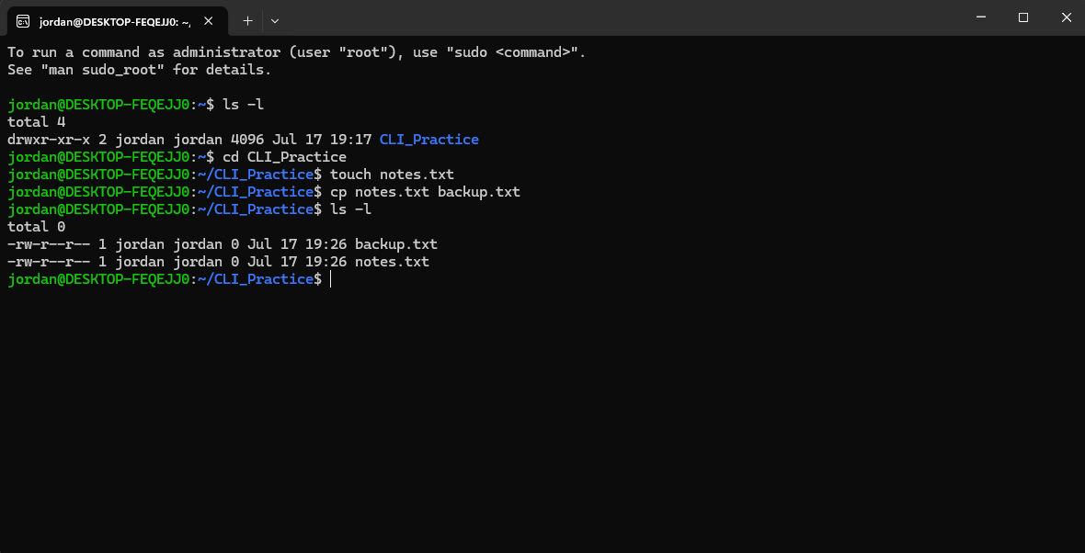
Figure 19: Copying a file using the cp command.

Example 5:
The rm command was used to permanently remove the backup.txt file from the current directory. Deleting unnecessary files helps keep the file system organised and ensures only required files are retained [5].
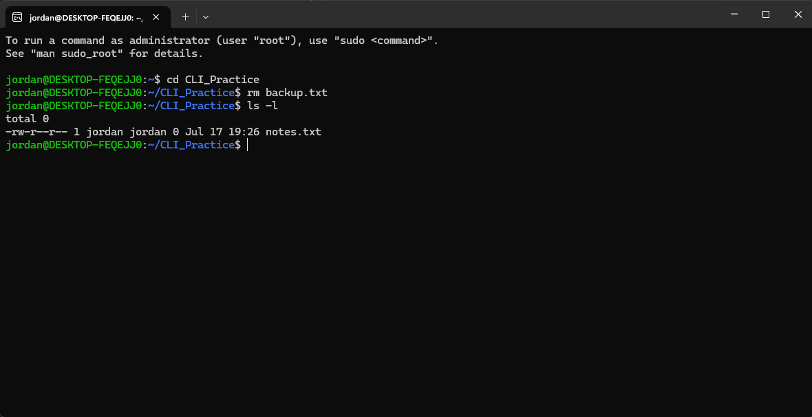
Figure 20: Deleting a file using the rm command.

Example 6:
The ps -ef command displays a detailed list of all running processes on the Linux system. It provides information such as the user, process ID (PID), parent process ID (PPID) and the command currently being executed [5].
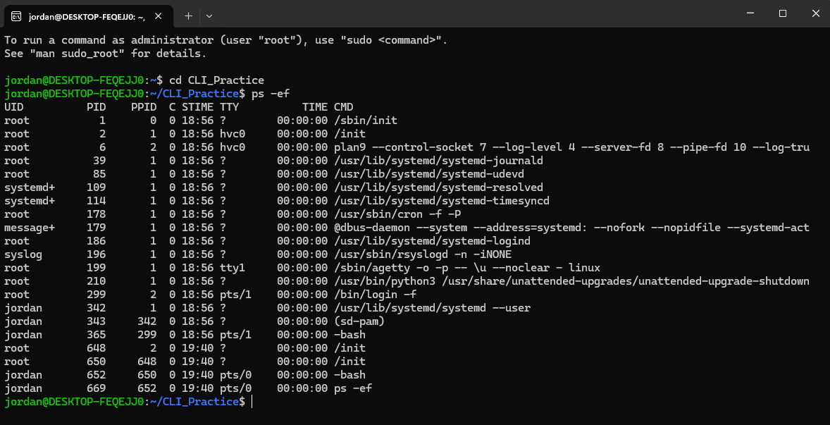
Figure 21: Displaying running processes using the ps -ef command.

Example 7:
The ip addr show command displays information about the network interfaces configured on the Linux system, including IP addresses and interface status. This information is useful when checking network connectivity and troubleshooting network issues [5].
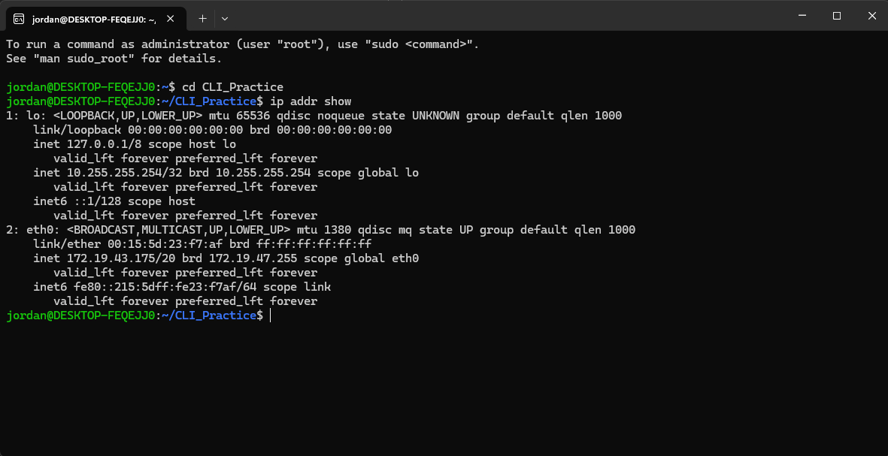
Figure 22: Displaying network interface information using the ip addr show command.

Example 8:
The whoami command displays the username of the currently logged-in user. It is useful for confirming which user account is active, particularly when managing permissions or performing administrative tasks [5].
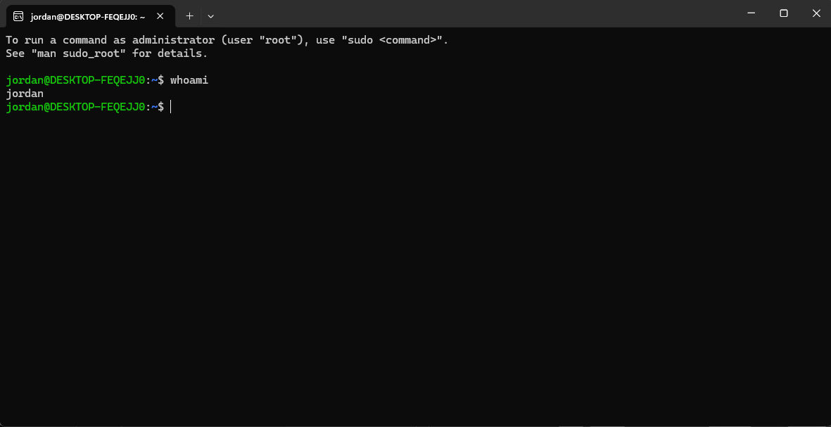
Figure 23: Displaying the current logged-in user using the whoami command.

Example 9:
The crontab -l command displays the scheduled tasks for the current user. In my case, no scheduled tasks were configured, but the command confirmed that the system checked for an existing crontab [5].
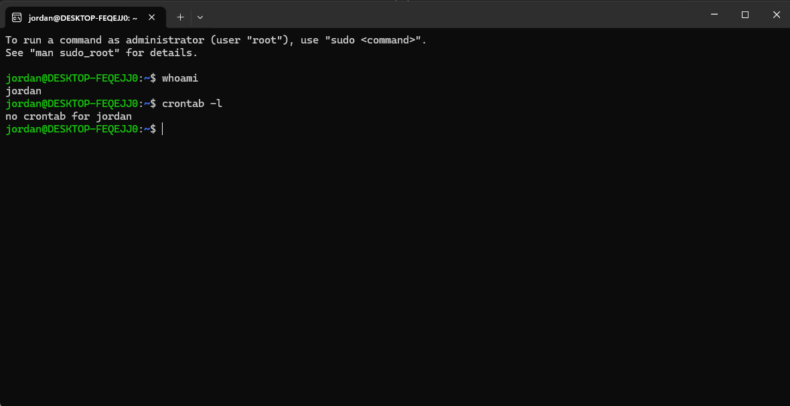
Figure 24: Displaying scheduled tasks using the crontab -l command.

Example 10:
The man ls command opens the Linux manual page for the ls command. It provides information about the command, including its purpose, syntax and available options, making it a useful source of help and documentation [5].
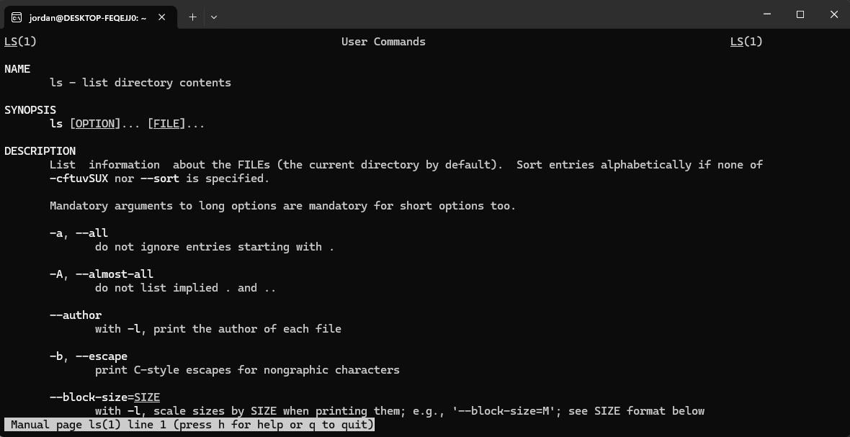
Figure 25: Viewing the Linux manual page for the ls command.

Use of Windows OS scripts
Batch scripting is used to automate tasks within the Windows operating system by executing a series of Command Prompt commands stored in a .bat file. Batch scripts can be used to manage files, perform system administration, automate repetitive tasks and improve efficiency by reducing manual input [7], [8].

Example 1:
This Batch script demonstrates how Windows can automatically display useful system information. The @echo off command hides the commands while allowing the results to be shown clearly. The whoami command identifies the current logged-in user, while the hostname command displays the name assigned to the computer. The ipconfig command provides information about the network configuration, including the IP address and network adapter details. Blank lines are created using echo. to improve the readability of the output. The script finishes with the pause command, which keeps the Command Prompt window open until a key is pressed. Running these commands together in a Batch file allows users to quickly collect important system and network information without entering each command separately. This type of automation is commonly used by system administrators when checking computer settings or troubleshooting network connectivity problems [7], [8].

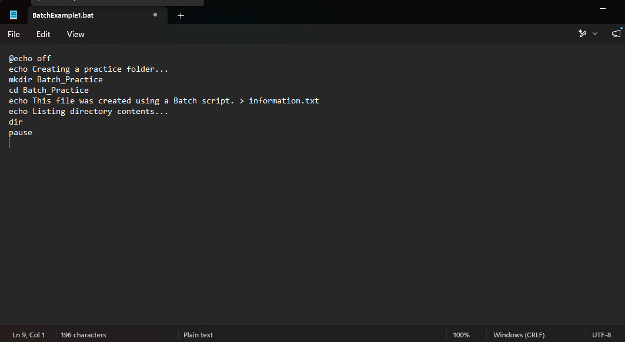
Figure 26: Batch script used to create a practice folder and text file.
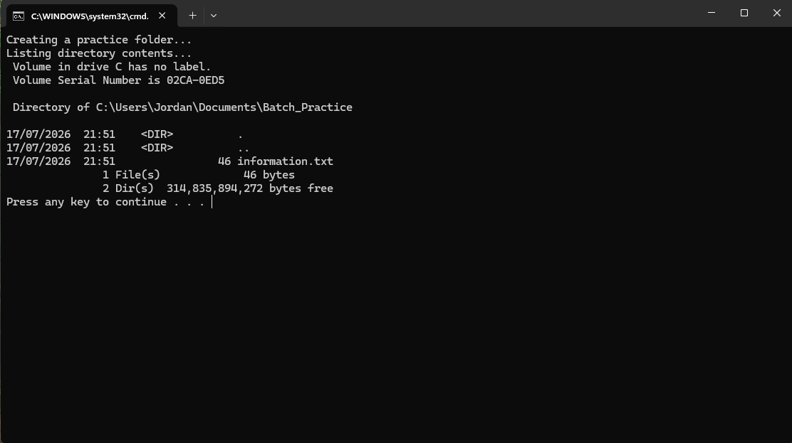
Figure 27: Output of the Batch script showing the successful creation of the Batch_Practice folder and information.txt file.

Example 2:
This Batch script demonstrates how several Windows commands can be combined to automatically display useful system information. The @echo off command prevents the commands themselves from being displayed, making the output easier to read. The echo commands provide headings that clearly identify each section of information. The whoami command displays the username of the currently logged-in user, while the hostname command shows the computer's name. The ipconfig command displays the current network configuration, including details such as the IPv4 address and network adapter settings. The script finishes with the pause command, which keeps the Command Prompt window open until a key is pressed so that the information can be viewed. This example demonstrates how Batch scripting can automate system administration tasks by collecting important information using a single script instead of entering multiple commands individually [7], [8].

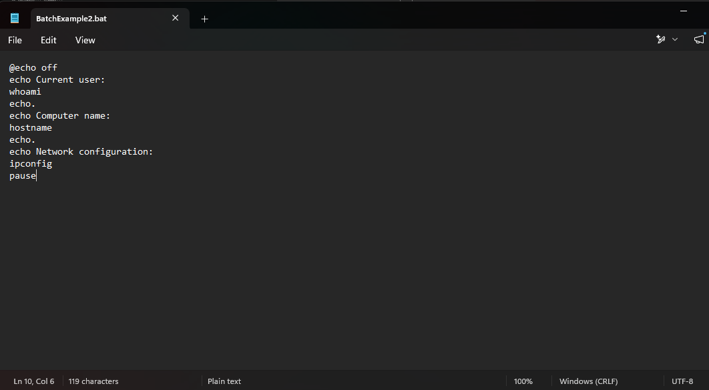
Figure 28: Batch script used to display system and network information.
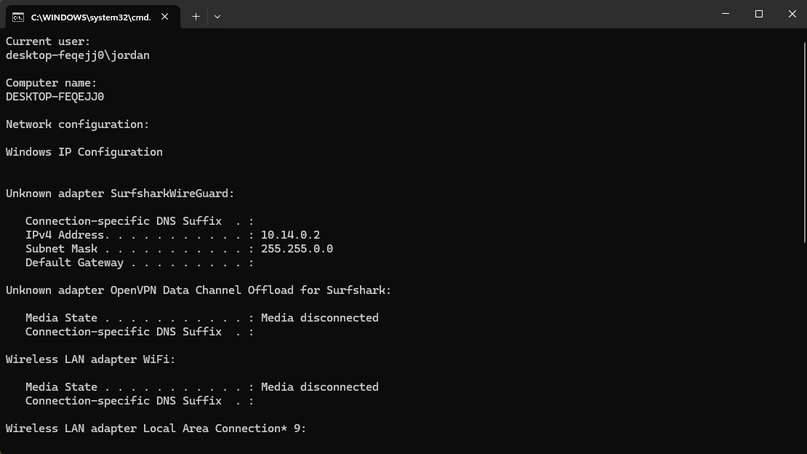
Figure 29: Output of the Batch script displaying the current user, computer name and network configuration.

Use of Linux OS scripts
Bash scripting allows Linux users to automate tasks by combining commands into a single script file with a .sh extension. Bash scripts are commonly used for file management, system administration, software installation and repetitive tasks, helping to improve efficiency while reducing manual input [5], [6].

Example 1:
This Bash script demonstrates how several Linux commands can be combined into a single executable script to automate file management tasks. The first line (#!/bin/bash) identifies the script as a Bash script and tells the operating system which interpreter to use. The mkdir -p command creates a directory called Bash_Practice, while the echo command writes a short message into a text file named notes.txt. The cp command then creates a copy of this file called backup.txt, demonstrating how files can be duplicated automatically. Finally, the ls -l command displays the contents of the directory in a detailed format, allowing the user to confirm that both files were created successfully. Automating these tasks with a Bash script saves time, reduces the need to enter commands individually and helps minimise user error when performing routine file management tasks [5], [6].
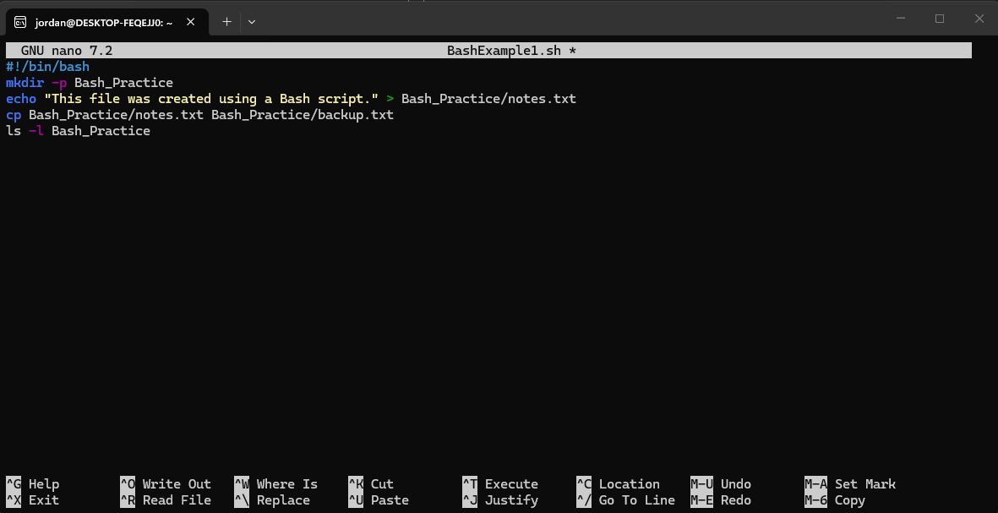
Figure 30: Bash script used to create a directory, create a text file, copy the file and display the directory contents.
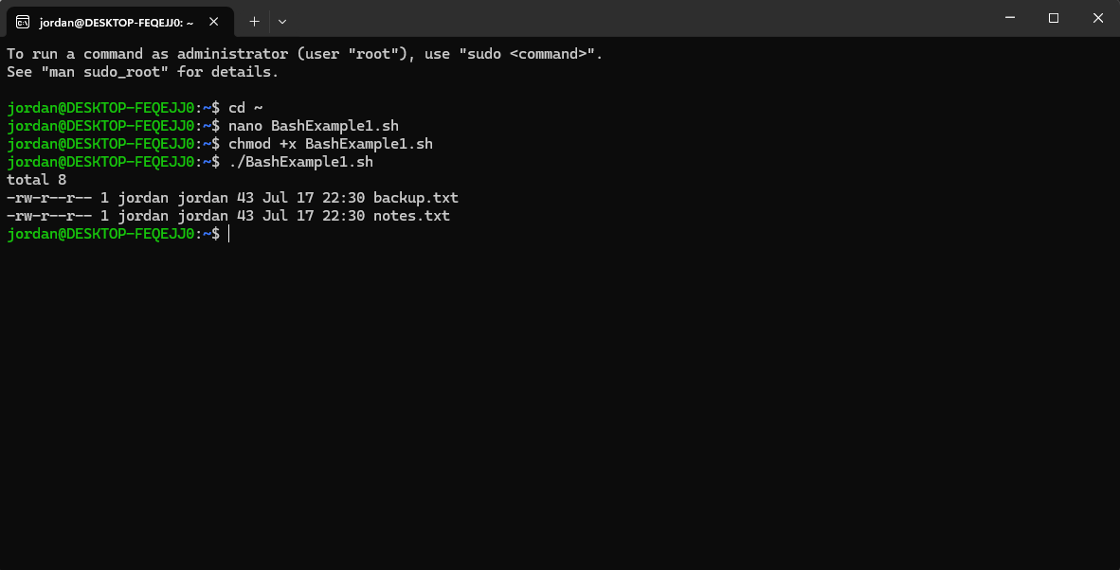
Figure 31: Output of the Bash script showing the successful creation and copying of files.

Example 2:
This Bash script demonstrates how Linux can automate the collection of system information using a single executable script. The #!/bin/bash line identifies the script as a Bash script and specifies the interpreter used to execute the commands. The echo commands provide headings to make the output easier to read. The whoami command displays the username of the currently logged-in user, while the date command shows the current system date and time. The uname -a command displays detailed information about the operating system, including the Linux kernel version, machine architecture and host name. By combining these commands into a single script, users can quickly retrieve important system information without entering each command individually. This demonstrates how Bash scripting can improve efficiency, reduce repetitive manual tasks and support system administration activities [5], [6].
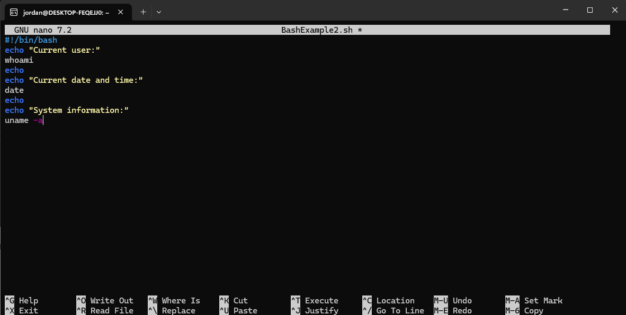
Figure 32: Bash script used to display the current user, date, time and system information.
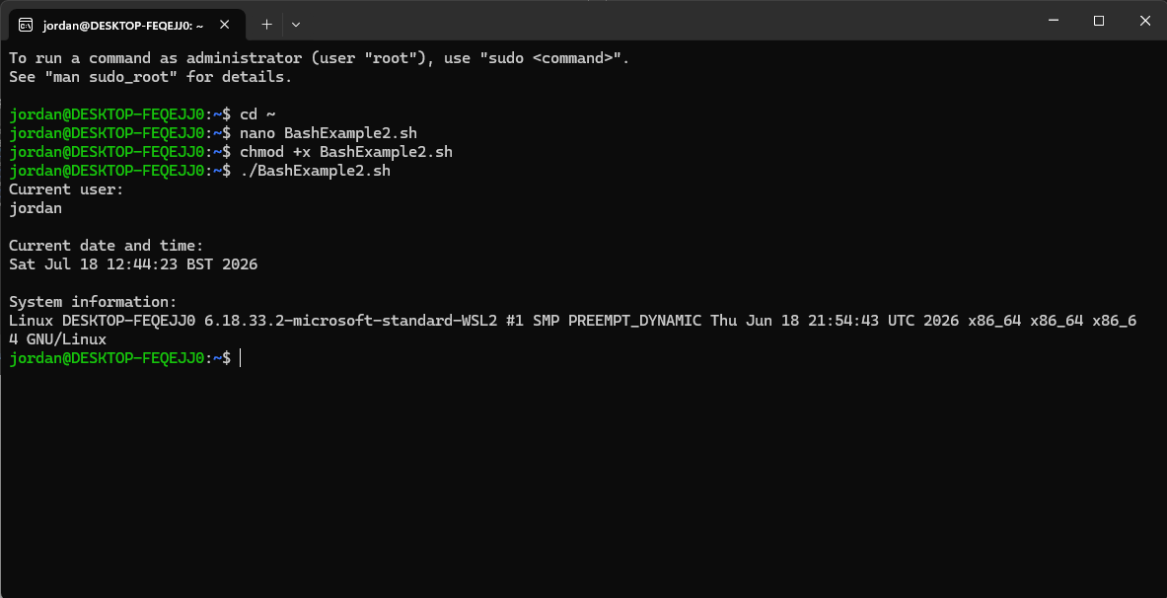
Figure 33: Output of the Bash script displaying the current user, date, time and system information.

Conclusion
This report has improved my understanding of Windows and Linux operating systems, including their management functions, command-line tools and scripting capabilities. Completing the practical tasks demonstrated how operating systems automate processes, manage resources and support system administration, helping me develop both theoretical knowledge and practical computing skills [1], [5].

References
[1] Microsoft, Windows Documentation. Available: https://learn.microsoft.com/windows/. [Accessed: 10-Jul-2026].
[2] Microsoft, Windows Command Reference. Available: https://learn.microsoft.com/windows-server/administration/windows-commands/. [Accessed: 10-Jul-2026].
[3] Silberschatz, A., Galvin, P. B. and Gagne, G., Operating System Concepts, 10th ed. Hoboken, NJ: John Wiley & Sons, 2018.
[4] Stallings, W., Operating Systems: Internals and Design Principles, 9th ed. Harlow: Pearson, 2018.
[5] Ubuntu, Ubuntu Documentation. Available: https://help.ubuntu.com/. [Accessed: 11-Jul-2026].
[6] The Linux Documentation Project, The Linux Documentation Project. Available: https://tldp.org/. [Accessed: 11-Jul-2026].
[7] Microsoft, Batch Files. Available: https://learn.microsoft.com/windows-server/administration/windows-commands/. [Accessed: 15-Jul-2026].
[8] GNU Project, Bash Reference Manual. Available: https://www.gnu.org/software/bash/manual/. [Accessed: 15-Jul-2026].

Appendices
Online Course name: Cisco Networking Academy
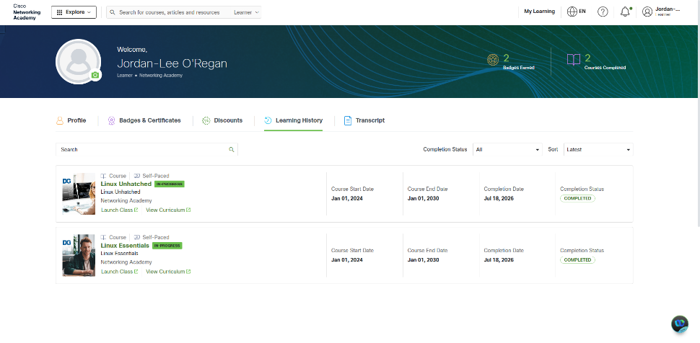
Figure 34: Cisco Networking Academy learning history
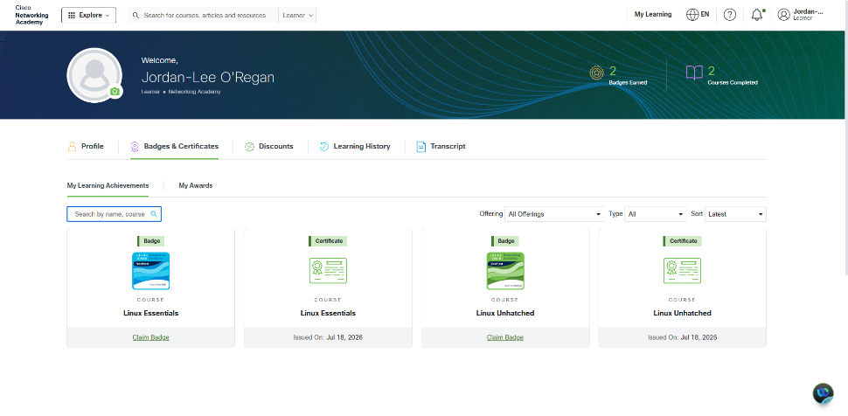
Figure 35: Cisco Networking Academy badges and certificates

Figure 36: Cisco Networking Academy Linux Essentials Certificate of Completion.
Week 1
Activity 1 – What do you think the module is about?
I think this module will focus on how computers operate by exploring the relationship between hardware and software. I expect to learn about computer architecture, processors, memory, storage devices and operating systems, as well as how these components work together. I also believe the module will introduce practical skills such as using command line interfaces, managing files and understanding how operating systems support users and applications.
Activity 2 - Types of Computers?
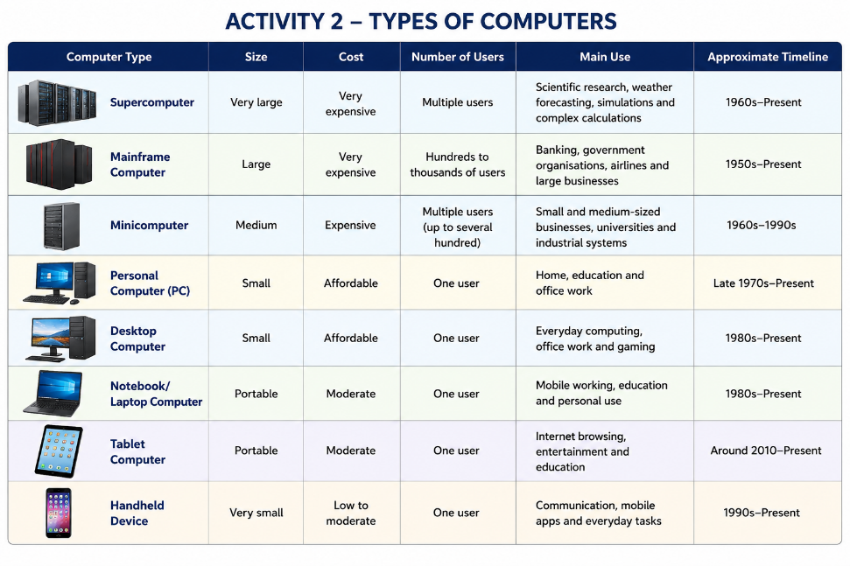
Figure 1. Types of computers comparison.
Activity 3 - Key components of a computer
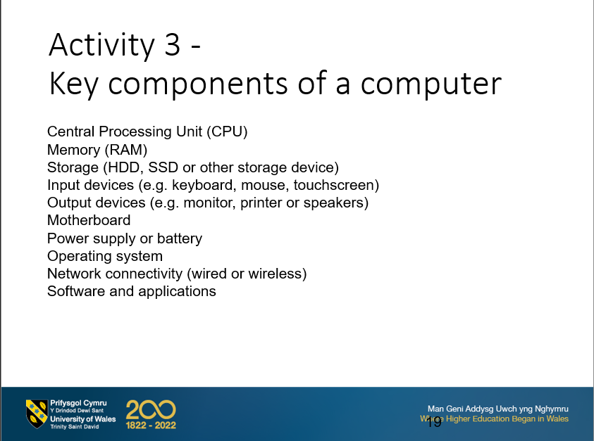
Figure 2. Common components found in different types of computers.
Activity 4 - Key components of a computer
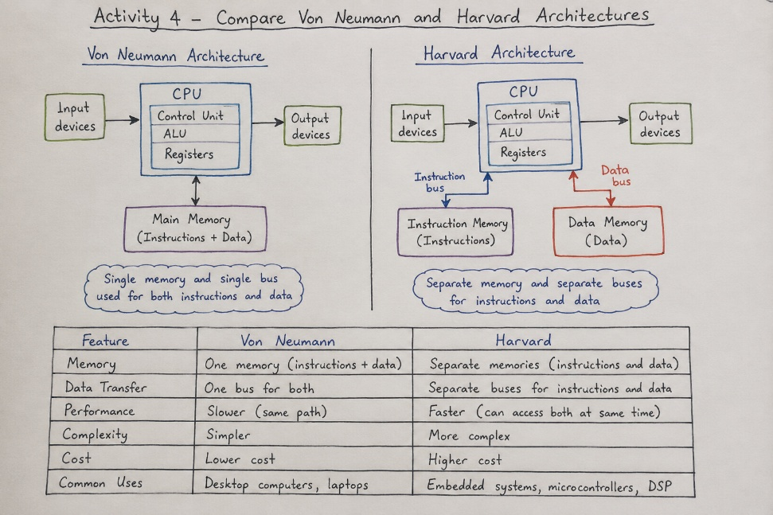
Figure 3. Comparison of the Von Neumann and Harvard architectures.
Week 2
Summary activity –
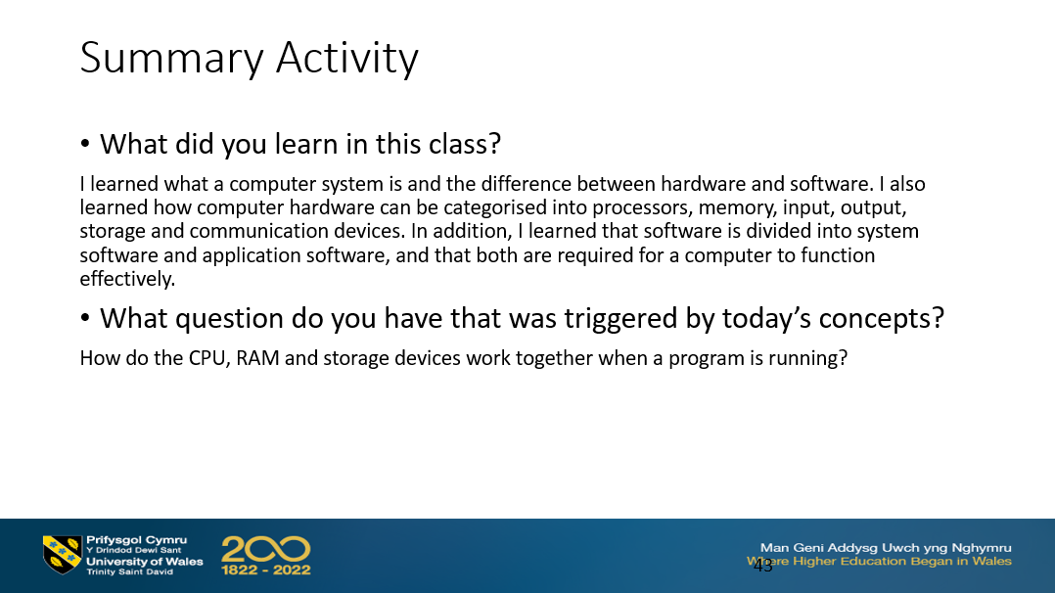
Figure 4. Week 2 summary activity.

Week 5
Logic Gates Exercise 1 -
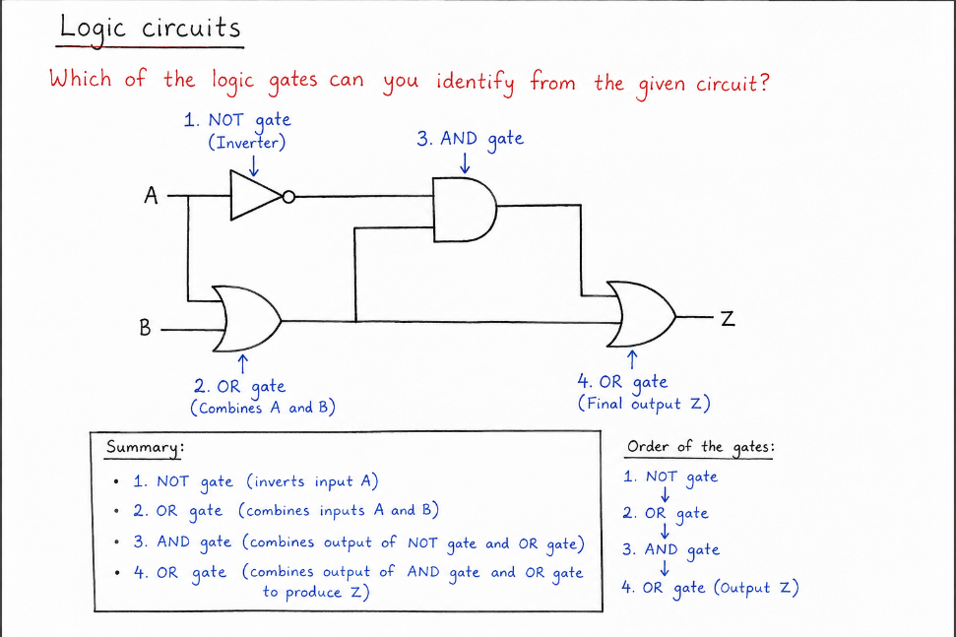
Figure 5. Identification of logic gates within a logic circuit.
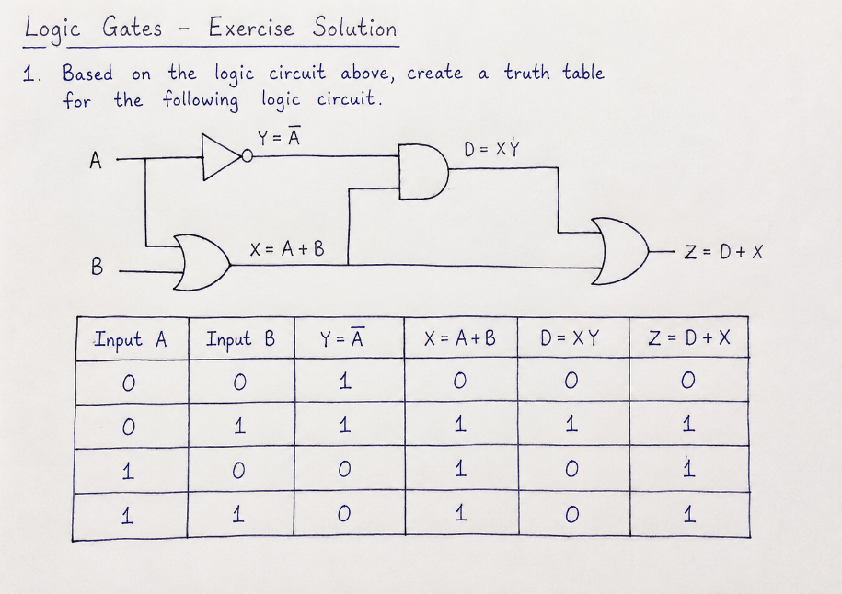
Figure 6. Logic Gates Exercise 1 – logic circuit and completed truth table.

Logic Gates Exercise 2 -
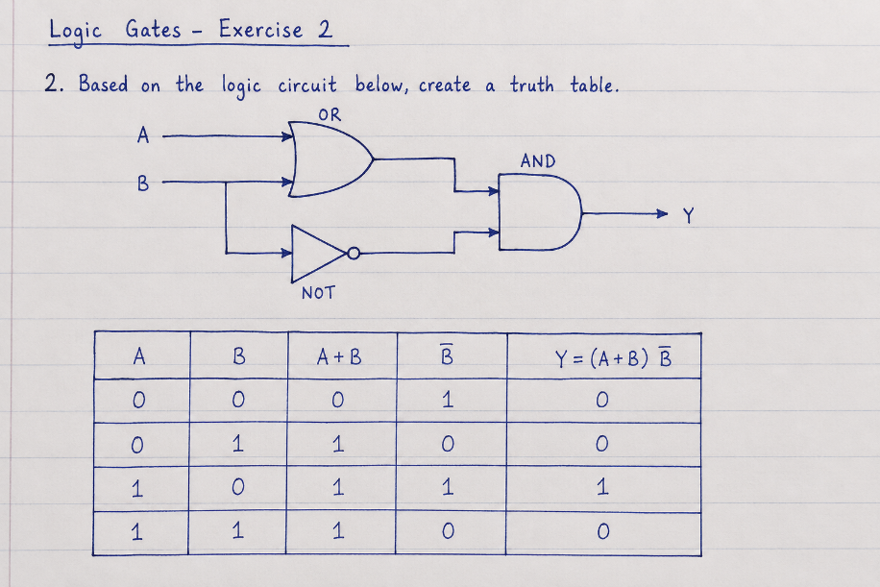
Figure 7. Logic Gates Exercise 2 – logic circuit and completed truth table.

Week 7
Class activity –
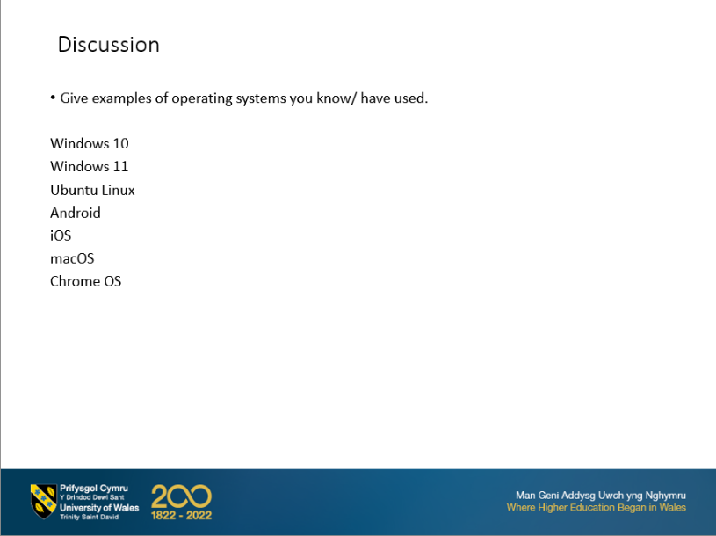
Figure 8. Examples of commonly used operating systems.
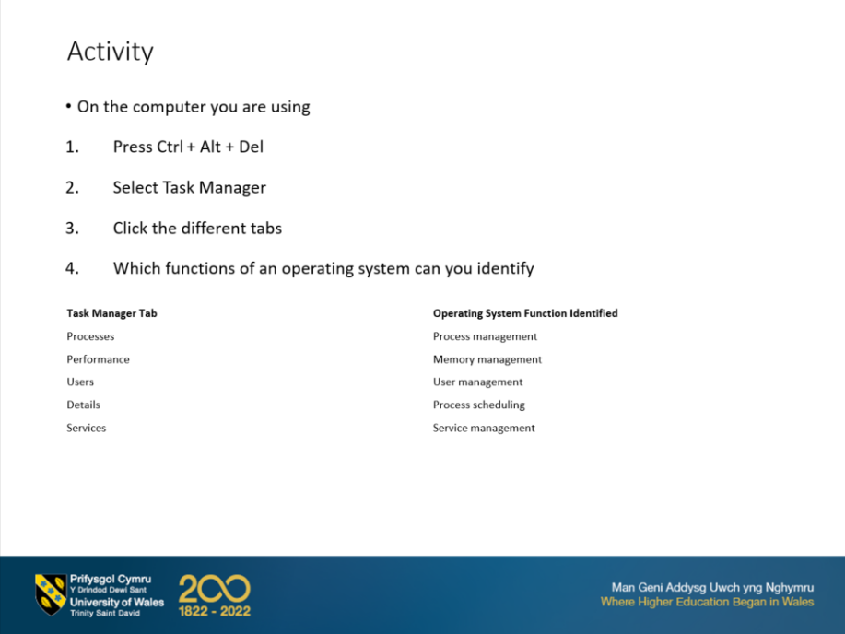
Figure 9. Windows Task Manager showing key operating system functions.
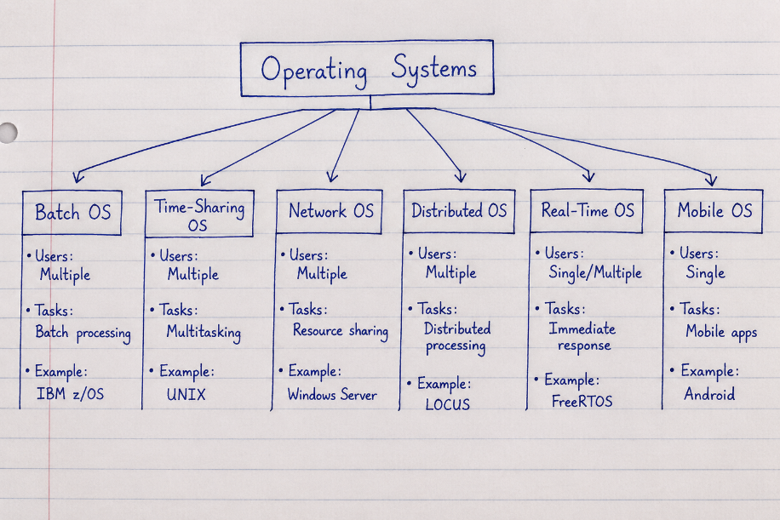
Figure 10. Comparison of different operating system types.

