GLOBAL BUSINESS ENVIRONMENT
Assessment 2

Tutor: Syed Jaffery
Student Name: Ilie Topliceanu
Student Number: 1916174

Table of Contents

1. Introduction…[3]

2. Findings and Analysis…[3]
● Porter’s value chain for Tesla…[3]
● Primary activities…[3]
● Secondary activities…[6]

3. PESTEL analysis…[6]
● Porter’s five forces framework on Tesla…[7]
● Benefits and challenges in producing Electric Vehicles for Tesla…[8]
● How natural resources are extracted for the electric car and how it is disposed of…[9]
● Critical analysis and recommendations…[9]

4. Conclusion…[10]
Reference List…[11]

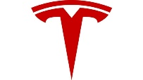
1. Introduction
From its first appearance in Europe, towards the end of the 19th century, the car was a symbol of engineering inventiveness and social prestige. In the last century, the automobile evolved rapidly from the status of an expensive toy for the rich to the most common and widespread means of personal transportation in most developed countries. People have fallen in love and become more dependent on the car because it connects them (relatively quickly) with work, school, malls, or recreation areas. In many families, after buying a home, the car is the second significant expense. For some of our contemporaries, the possession of a newer, "branded" car, or with more horsepower, is also a personal aspiration and a mark of the status of the star of the street, neighbourhood, or town where they live. At the end of 2014, more than 1.2 billion cars were on the world's roads, numbering an estimated 2 billion in the next 20 years. In 2014, oil contributed 32% to the total primary energy used worldwide, generating 35% of the world's total CO2 emissions. Of these, 22% were due to transportation. For example, in the United States, the transportation sector was even more affluent, producing 27.3% of total fossil fuel emissions. The reality of these figures and current efforts to mitigate the effects of climate change has brought to the fore the electric car's use as the motor vehicle of the future (Voelcker, 2014).
2. Findings and Analysis
This study is going to focus on Tesla Motors Inc., the superior electric vehicle producer from the US, who’s estimated net worth is $34.3 billion. The essay is expecting to analysed different aspects of Tesla in international trading through the academic framework. It will also acknowledge different phases of the electric car production of Tesla and relate it with automotive industry trends. The study will comprehend the value chain analysis of Tesla as this is a practical analytical framework to acknowledge the business activities of the company for developing concentric value and competitive edge in the market.
● Porter's value chain for Tesla
The value chain is linked to the name of Michael Porter, the first to suggest its application in strategic analysis. In this context, Porter proposes the analysis of each component of the company's added value, respectively, of the contribution it brings to the competitive advantage enjoyed by the entire organization. In a company with several spheres of activity, the analysis must be performed at the product groups’ level, (Porter, 1985).
● Primary activities
Inbound logistics
The most effective approach for Tesla is inbound logistics. While this mostly entails in-house manufacturing, other parts are manufactured and delivered from various distributors in a timely way. This approach reduces the period of waiting while improving efficiency.
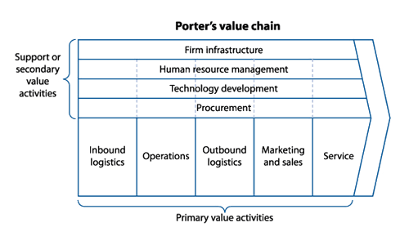
[Fig. 1, Source: Internet]

The company has a warehouse of 1.3 million square meters in the Oaks Logistics Centre, California. In addition to raw materials needed for electric cars, solar panels, and energy shields, Tesla also obtains other rare materials such as steel, nickel, copper, and aluminium (Gianesello et al., 2017). Currently, the company is focusing on the "custom build" process, which has short or medium-term effects; for this reason, building a long-lasting relationship with suppliers should become important.

Operations
Tesla divides its operations into two sections. "Automotive” which deals with the design, production, and sales of "electric cars”. The company manufactured in 2017 almost two thousand vehicles from models 3 and 101,420 from models x, and its second category, "Energy generation and storage." deals with the design, production, and installation of energy storage items and solar panels. Tesla installed 523 MW solar panels in 2017. The vital point is the use of robots in the manufacturing process. The company's engineers say, "up to eight robots work on a single S model in a choreographed routine."

Outbound Logistics
Tesla's outbound logistics includes the storage and distribution of electric cars, solar panels, and energy storage systems. The cars are sold through their stores in the USA and 29 other countries (Kalaitzi et al. 2019). A good part of the clients prefers to buy a personalized car with the help of online reservations. The company maintains a limited number of cars in its stores. Tesla's outbound logistics is an extremely well-developed one, creating direct advantages for customers because it delivers the machine to the customers directly without intermediaries, thus reducing delivery time and cost.
Marketing and Sales
Tesla, compared to the other competitors in the field, invests relatively little in marketing. The automotive industry being extremely ferocious from this point of view, most companies use traditional means to promote their products—other digital channels for marketing and promotion. Ellon Musk, director and product architect of Tesla, uses online social networks for Tesla worldwide.
Services
The company has recently received several complaints about its services. Many of these complaints accuse the company directors of not taking an interest in repairing car faults promptly. Many customers are waiting for weeks to repair their electric cars Models X (Kim, 2020). To solve this problem, Tesla allows direct contact of directors in case of malfunctions. In addition to this measure, they also offer "after-sales services" at local service centres. They have 250 service centres and 350 service cars on-demand in the USA.
● Secondary activities
Infrastructure | Effective leadership, potential managing team, clear and horizontal infrastructure
Technology | Massive investment in R&D, cost leadership and superiority in technology
Procurement | Short agreements with suppliers, partnerships
HRM | The effective relationship among the employees, outsourced recruitment

3. PESTEL Analysis
The political factors play a significant role for Tesla. To achieve success on the international market, Tesla needs to consider the political stability, the level of corruption, the legal framework, the pricing regulations, the trade regulations and tariffs related to Consumer Goods, etc. The governments are open to low-emissions initiatives, providing loans and benefits towards environmentally friendly technology – Tesla received federally backed funding’s for U.S. government. From the economical point of view, it is known that we have an increasing demand for more-efficient cars and sustainable energy. Here, Tesla needs to be aware on the type of economic system the countries in which it operates have, the efficiency of the financial markets, labour costs, economic growth, inflation rate, interest rates and so much more. The social beliefs can also influence an organisation, as the society’s attitude play a great role in the marketing process. The reception for electric car is related to the increased environmental concerns, the social factors being favourable. Being the leader of the electric car industry, Tesla’s technological innovation and continuous advancement in battery packs, charge infrastructure and computerization allows it to gain competitive advantage and worldwide fame. From the environmental perspective we can say that the increasing awareness of climate change and the need for low-emissions vehicles allowed Tesla to thrive. The legal factors are related to the continuously changing trading regulations in all the countries that Tesla sells its electric car.

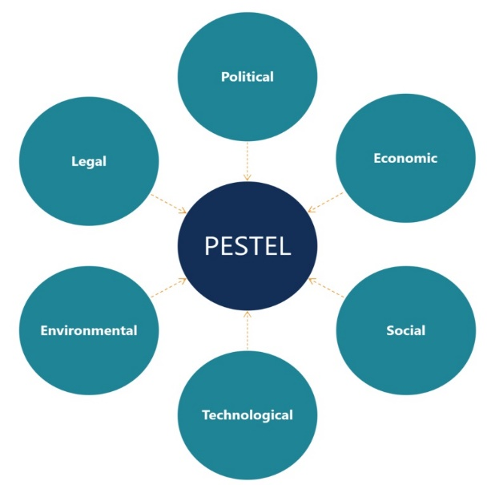
[Fig. 2, Source: Internet]

● Porter’s five forces framework on Tesla
Porter’s five forces is an analytical framework used to analyse the competition of a business. The threat of new entrants into the electric vehicle manufacturing industry is a weak force. Tesla provides fully electric, high performance models that offer speed and long mileage and is the leading manufacturer in the industry. Bargaining power of suppliers in the electric car industry is a moderate force, as Tesla has a wide supplier base. The bargaining power of buyers is moderate but can become significant. Price sensitivity can affect the buyer, as Tesla products are expensive, but now the customer do not have many quality alternatives. The threat of substitution is also a moderate force as Tesla is one of the leading manufacturers of electric cars worldwide. It is important to mention that other automobile manufacturers are creating excellent electric vehicles. Competitors like General Motors, Toyota or Volkswagen are creating as well high-quality electric models or hybrid cars and for this reason the degree of rivalry is a strong force affecting this company.

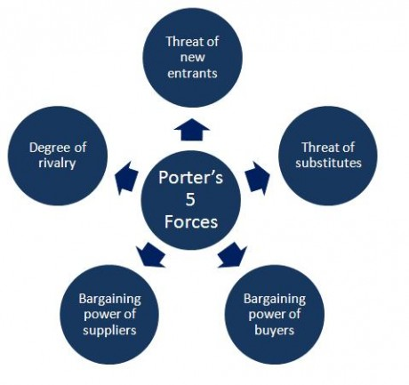
[Fig. 3, Source: Internet]

● Benefits and challenges in producing Electric Vehicles for Tesla
There are a great number of benefits in producing electric vehicles. Electric cars are cheaper to run, as the electricity needed to charge an EV costs less than the petrol use for conventional vehicles. Tesla models are cheaper to maintain, having fewer moving parts than a petrol/diesel car and needs relatively little servicing. For a battery electric vehicle, you need to maintain brakes, tyres and suspension and forget about the exhaust system, fuel injection system, radiator and many other parts. Another important benefit of Tesla and the EVs is that they are better for the environment. Tesla vehicles help reduce harmful air pollution (having zero exhaust emissions) and reduce the greenhouse emissions by using renewable energy to recharge. Because of the reduced harmful exhaust emissions, better air quality leads to less health problems. These are a significant source of air pollution (with pulmonary, cardiovascular, and respiratory consequences) and greenhouse gas emissions. One of the biggest challenges that Tesla faces is related to the price. EVs are more expensive than petrol or diesel-fuelled cars. The price for the battery is high and because of this the demand for electric vehicles remains low. The electric car’s range remains the biggest concern of users, even if the Tesla Model S promised 375 miles in one charge. The recharge time is also an issue as EVs take hours to fully charge in comparison to the petrol tank which can be filled in a few minutes. However, Tesla is working on technologies that can allow its vehicles to charge while on the move. The charging infrastructure is another major issue that Tesla needs to overcome (Thompson, 2015, p. 261-263).
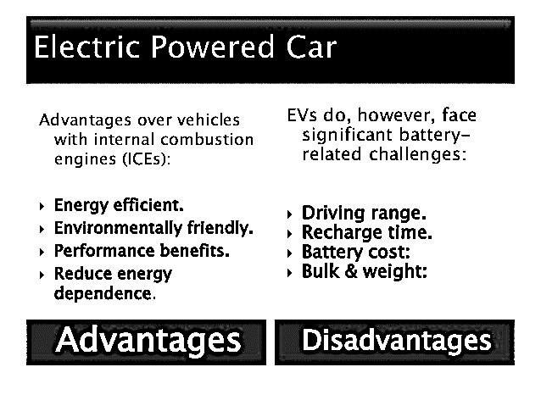
[Fig. 4, Source: Internet]

● How natural resources are extracted for the electric car and how it is disposed of
Lithium-ion batteries play a key role in Tesla’s products, as they power the electric cars. Tesla built a massive manufacturing facility called the Gigafactory which increases the number of lithium-ion batteries produced on the market, but lithium needs to be extracted using coal. Furthermore, when a battery reaches the end of its life it needs to be recycled and now only 5% of the lithium-ion batteries are properly discarded and this contributes to a negative impact causing significant environmental harm (Westervelt, 2015). To combat all these environmental issues Tesla needs to develop more recycling facilities to reduce transportation costs and to provide renewable energy at the lithium extracting mines (Tesla Gigafactory, 2019).

● Critical analysis and recommendations
Tesla has the strength to remain successful, as it is the leading manufacturer in the field. There are unfortunately various issues that the company needs to resolve to maintain its competitive advantage. Tesla must expand its multinational presence by opening new facilities and sales operations in high developing countries. Now, the company has a limited network, most of its international trading is being done online. Another important recommendation is that the company needs to continue to increase its investments in research and development so that it will produce more advanced competitive products. Tesla has the potential to grow despite the aggressive competition, but it is recommended to further develop their brand value through new services for growth and development (Tesla, 2020). So, by expanding operations in foreign markets, increasing investments for product innovation and diversifying the supply chain, Tesla can overcome the business competitiveness remaining at the top of the electric car industry.

4. Conclusion
Tesla Motors is a company that deals with the sale of high-performance cars and whose primary purpose is to transform the way electricity is produced and used, especially in the field of transport. Tesla Motors has a well-developed business strategy, maintaining itself as a world leader in the electric car industry by continually adapting to market requirements and the evolution of production. In the above, with the help of several academic frameworks and tools such as Porter's value chain analysis, PESTLE analysis, and Porter's five forces analysis, the study highlighted various aspects of Tesla and its current status in the industry.

References:

[1] Voelcker, J, – 1.2 Billion Vehicles on World’s Roads Now, 2 Billion By 2035: Report, Green Car Reports – The ultimate guide to cleaner, greener driving, 2014.
http://www.greencarreports.com/news/1093560_1-2-billion-vehicles-on-worlds-roads-now-2-billion-by-2035-report

[2]Thompson, A. A. (2015). Tesla Motors’ Strategy to Revolutionize the Global Automotive Strategy. In A. A. Thompson, M. Peteraf, J. E. Gamble, A. J. Strickland, & 20th (Ed.), Crafting & Executing Strategy: The Quest for Competitive Advantage: Concepts and Cases (pp. C245-C273). New York: McGraw-Hill/Irwin.

[3] Tesla Gigafactory, 2019, from Tesla:
https://www.tesla.com/gigafactory

[4] Westervelt, Amy - “Tesla’s new batteries may be harder on the environment than you think,” The Guardian, 2015.
https://www.theguardian.com/vital-signs/2015/jun/10/tesla-batteries-environment-lithium-elon-musk-powerwall

[5] Tesla, Inc., “The Mission of Tesla,” 2020.
https://www.tesla.com/en_GB/blog/mission-tesla?redirect=no

[6] Kalaitzi, D., Matopoulos, A. and Clegg, B., - Managing resource dependencies in electric vehicle supply chains: a multi-tier case study. Supply Chain Management: An International Journal, 2019.

[7] Kim, H., 2020. Analysis of how Tesla Creating Core Innovation Capability. International Journal of Business and Management, 15(6). [Accessed on: 05:08:2020] Available at:
https://www.researchgate.net/profile/Hyeonjoo_Kim2/publication/341323098_Analysis_of_how_Tesla_Creating_Core_Innovation_Capability/links/5ebb5c13299bf1c09ab933e5/Analysis-of-how-Tesla-Creating-Core-Innovation-Capability.pdf
[8] Michael E. Porter - Competitive Advantage of Nations: Creating and Sustaining Superior Performance, Kindle Edition, 1985.

[9] Tesla, 2019.
https://www.tesla.com/about

