Choice 3 images of ONE group at risk of exclusion and critically reflect upon these representations and how they might be interpreted by society
This portfolio will focus and discuss the variations of middle social class families, how they are defined and what stigma and stereotypes they carry. The guardian (2016) suggests that the typical middle-class family is now seen as the poorest individuals of the past in the current financial climate.
The Institute for Fiscal Studies cited in the guardian (2016) conducted a study which suggests that two thirds of children are defined as being below the poverty line and had at least one parent working which suggests that the annual income for middle class families is low and not incorporated into the living wage. Middle class families are becoming more and more dependent on benefits and the welfare system just to get by as their wages and income even if two incomes are being brought in is not enough to sustain a healthy lifestyle above the poverty line (The Institute for Fiscal Studies cited in the guardian, 2016).
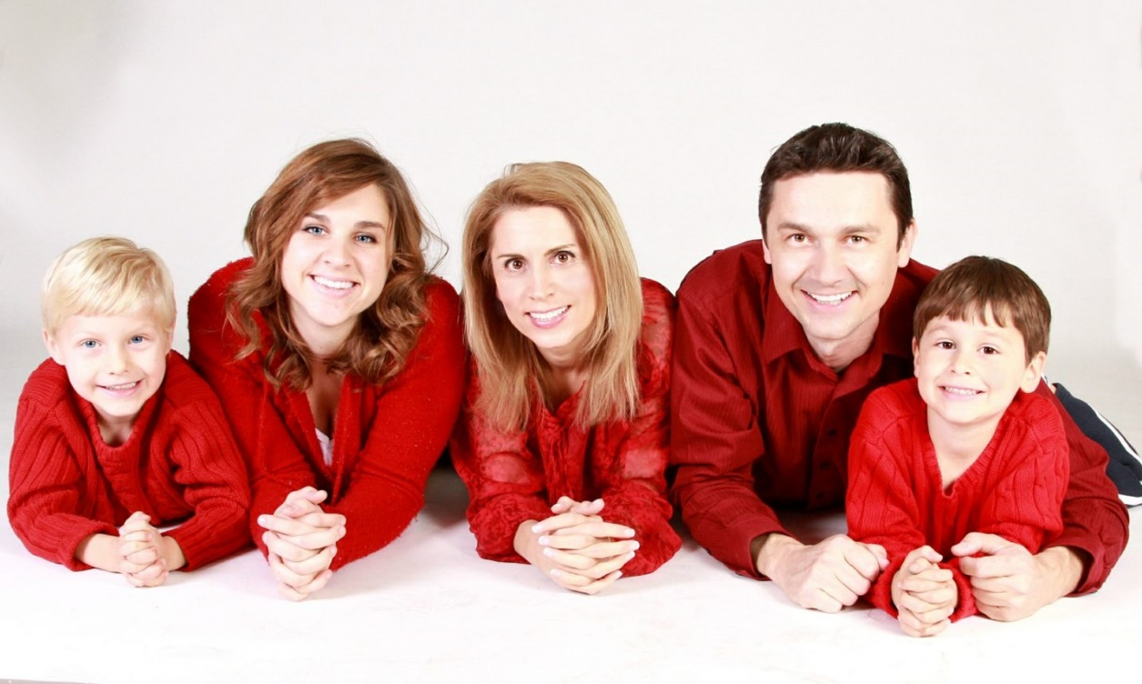

(Jewish journal, 2017)
Moore et al (2000) proposes that there are various versions of a middle-class family. However, the one most shown is the ‘Nuclear family’. It is suggested that middle-class families majorly have characteristics of a nuclear family and there is less interaction between each other. Nevertheless, in each social class the family dynamics and forms can differ and adapt with societal norms. Within this picture of a middle-class family, is not the societal norms of a ‘Nuclear family’ as there are more than two children with a mother and a father. However, structures of families can be caused by geographical locations of career advancements, nevertheless this picture could be taken in various interpretation but the interpretation which is used in this portfolio is a middle-class family with three children (Moore et al, 2000). Another interpretation this picture could be taken is a lesbian couple with their sperm donor and their kids, which is again another unorthodox interpretation of a middle social class family as suggested by Moore et al (2000).
However, Larsen (2013) proposes that from around the 1970’s middle class families were becoming more diverse and changing than the orthodox and traditional ‘Nuclear family’. Diversity and unemployment rates changed and challenged the construction of middle social class families and in turn the construction of a middle class nuclear family was at risk. As* ++
post-modern family structures begin to form, middle social class families become more diverse such as a mother and father and three children or a lesbian couple, children and a sperm donor, for example. However, Larsen (2013) proposes that within the 1970’s was a period of major changes for example women employment increased, the women movement was developed, less people were marrying, and more people were getting divorced which shifting the entire family structure across all the social classes. It is proposed that family structures have been overturned by society within middle social classes. Also, the period of industrialisation suggests that middle social class families such as the one in this picture could expect inequality with finances. Larsen (2013) suggests that the impact of this and deindustrialisation was diverse and had a major effect on economic inequality. By looking at this first picture, it is suggested that there is various interpretation that this picture can give such as a mother, father and three children. This proposes that the traditional ‘Nuclear family’ is not just part of the middle social class as middle social classes are diverse and adaptable as well as society. As society varies, changes and adapts according to its demographic, families do not just consist of the typical ‘Nuclear family’ but same sex couple, cohabitation, families big and small from different ethnicities and cultures, single parent household, people living alone, for example (Larsen, 2013). Larsen (2013) also proposes that within traditional middle social class families were challenged by various variables such as immigrants with developed and low-level skills as they could have the chance to become middle social classed but could be a product of industrialisation. The first picture in this portfolio suggests that although the stereotypical middle social class is the ‘Nuclear family’ however, this picture is not your typical middle social class family, this picture suggests that this family in this picture could be interpreted in several ways as society is diverse and there are several social norms. This suggests that the image entangles within society and the fabrics of society. However there are various degrees of social erosion within social norms of families and their social classes.
Following this, looking at this second picture and comparing with the first. I will look at stereotypical ‘nuclear family’.


(I stock by Getty images, 2018)

This picture is the traditional ‘nuclear family. This suggests that even though this family is from a different culture and has a different ethnicity, the ‘Nuclear family’ is dominant throughout all society and social classes. This suggests and shows that the ‘Nuclear family’ was a major party of society as it was so dominant in the 1950- 1960’s. The ‘Nuclear family’ was viewed as a social norm within the UK. Most of western society in the 20th century believed that the ‘Nuclear family’ is societal norm. The ‘Nuclear family’ is defined by Moore et al (2000) as a ‘heterosexual couple and their dependent children’. However, with society being so diverse and adaptable to change, this proves to not always be a clear representation of a middle social class family within the UK as they could have no dependent children and have no children at all. Nevertheless, throughout the 20th century into 21st the amount of ‘Nuclear families’ started to decline as society became more diverse. Although like this picture there are still nuclear families but the culture and ethnicities of them are varied and less stereotypical as it once was throughout society (Moore et al, 2000). Individuals part of nuclear family should be a white heterosexual couple with dependent children as this picture show that this now is not the case. Nevertheless, politicians feel that the ‘Nuclear family’ is what they refer to as ideal, they suggest that this model of families are what helps inspires social policies throughout society by focusing on this group of families (Moore et al, 2000). However, this suggests within a current climate of how diverse society is, this is not ideal and there should be various models of families that they look to cover and help everybody within society. According to Moore et al (2000) when politicians and important figureheads talk about ‘the family’ and how to support ‘the family’, they are usually talking and referencing the typical and traditional ‘Nuclear family’.
According to Hunt (2016) when looking social classes like middle social classes which this portfolio is looking at, there tends to be a lot of generalisation about middle social class families and nuclear families. Individuals tend to generalise various cultures and ethnicities. The Erickson Model cited in Hunt (2016) is ideal for Nuclear families and middle social class. This model focuses on the idea of ethnocentricity and monogamy like the ‘Nuclear family’ which reflects the social norms of a western society that is deemed appropriate instead of looing at universal social norms. The model also looks at ‘the cycle of life’ and how this can be taken advantage of and overlooked and imitates the social norms of western society. Therefore, such models look to become more valid to developments of ‘the cycle of life’ as the diversity of society increases, and developments can be established, changed and adapted in correlation of the diversity of society (Hunt, 2016). Overall this second image although is the ideology of a ‘Nuclear family’ shows and suggests that the traditional ‘Nuclear family’ is still in society but varies with different cultures and ethnicities as this second pictures shows. It also shows that the second picture doesn’t just look at the ideology and the ideal ideas of a ‘Nuclear family’ within society today full of varied cultures and ethnicities.


(DailyMail, 2011)

Following this, looking at the last image is the ideal of ‘Nuclear family’ in a middle social class family. Shorter (1985) cited in Hunt (2016) suggests that the traditional ‘Nuclear family’ has changing family relationships within society. They suggest that the ‘Nuclear family’ is the ideology of idealistic love between spouses, their dependent children and the mother and father family roles and their links between the actual family community family links. However, this develops increasingly as the diversity of society does. This picture shows that this family is the typical traditional family and idealistic although it also suggests this was an older photo as the domination of the ‘Nuclear family’ become less and decreased substantially in the 1950’S – 1960’S which also shows the growth of the diversity of society throughout current times within society. Following this as British families grew or decreased, child welfare became a crucial issue by the late 19th century. Child welfare became looking at the child holistically such as when looking at this picture the image itself give the ideology of a perfect ‘Nuclear family’ however they could have all sorts of problems as suggested by Hunt (2016). Another interpretation of this picture could be a blended family such as partners with children from previous relationships and cohabitating for example. Although this picture may interpret and suggest that this family is happy and idealistic, the reality may be not such as the children could have behaviour problems, or the father could be abusive towards the mother and children causing dysfunction and rifts for example. Another interpretation of this family in this last picture could be that parents could be strict, and they could restrict their children’s extra-curricular activities.
A theory that could fall into this is Becker (1960) labelling theory, he suggests that an individual can play up to their label and stereotype if they truly believe that label or stereotype is all they can or will be and anything else such as they could be labelled perfect but leading into later life, this could cause issues such as anorexia and self-harm in order to live up to their label however that is extreme. This idea follows in every picture, although they could be labelled the idealistic nuclear family, the nuclear family in a different ethnicity and culture and an unorthodox middle-class family. Each family could be suffering from a hidden issue but for the sake of a picture to seem happy for sentimental value, they hide it such as bereavement, bullying, self-harm and eating disorders, abusive of all kinds and divorce. Families in middle social class can be labelled well off and at an advantage however, parents could be working fulltime and be able to generate enough income to buy necessities such as food after paying bills and the cost of living. Families in middle social classes in these pictures above may find that they ay be spilt up as there aren’t enough opportunities where they are living, or they simply can not afford to care for the children as well on their income. They may also find a children self-harming or have a mental health issue, addiction or an eating disorder and may feel a rehabilitation centre is the best option for them and that is the picture they take before they go. These families in these three picture all show and representation however a representation is only a depiction of something. These interpretation and labels and following the labelling theory in these pictures suggests that by being labelled, it could cause problems in later life and cause the individual to play up to their stereotype and what they are labelled as.
Ultimately Hunt (2016) proposes that the idealistic nuclear family as moral aspects based on dependency as seen in society. Society could also see and interpret middle social class families as mediocre and idealistic but by giving them these labels and stereotypes within society this could lead to problems such as stress and addiction. The fabric of society may interpret and suggest that middle social class families present society with a perfect ideology which is hard to maintain and proves to be harmful for those within society. This could suggest that within society, this could cause individuals to have behavioural issues, stress related issues such as drug and alcohol addiction. Society could also interpret middle social class families as better off which could help target middle class families in media and society. Hunt (2016) also proposes that the ideology within a middle-class family could proposes to be harmful as it focuses on the ideology of care such as a mother should take of the home and the children and the male should be the main breadwinner for example. With society ideologizing care, this could suggest that the investment of financial and cultural capitals promise and harm the ‘perfect’ childhood as suggested and perceived by social media within society. Social media can have a serious effect on social classes and families. Social media can give individual harmful perceptions and opinions to society about middle social class families. This could suggest that middle class family relationships could change because of these social media perceptions. Within postmodernism, mass education and consumption has affected middle social class families such as children could find it hard to form a sense of self and identity as perceptions from social media and society could affect middle social class families and their children. These interpretations of middle social class families within society could suggest that families have dynamics of poverty throughout society such as they could not afford for necessities with their annual income such as having to use food banks and may also have to rely on benefits which could associated with social media perceptions which could suggest that social media could perceive negatives things throughout social media. Social media can give negative perceptions to people in society about middle social class which could give negative social norms to individuals within society which could then be passed to others which could cause the whole world negative perceptions on middle social classes. This could propose that social media will give society negative social norms and value which could increase crimes, hate crimes and propaganda which could prove to give negative views to all individuals in society.
In all these pictures there could be underlying issues such as broken and blended families, abusive relationships, strict relationships and behaviour issues for example. Hunt (2016) suggests that things on the outside could be completely different to what’s happening on the inside.

Reference list

- Picture 1 : https://www.theguardian.com/business/2016/jul/19/middle-income-families-poverty-ifs-report
- Picture 2: http://jewishjournal.com/culture/lifestyle/family/228135/middle-class-risk-4-challenges-facing-middle-class-families/
- Picture 3: www.dailymail.co.uk/debate/article-2070583/Decline-nuclear-family-Who-cares-proper-family-Just-thankful-ties-bind.html
- Mark Walsh, Paul Stephens, Stephen Moore (2000) Social Policy and Welfare.
- Hunt (2016) The Life Course: A Sociological Introduction.
- Larsen (2013) The Rise and Fall of Social Cohesion: The Construction and De-construction of Social Trust in the US, UK, Sweden and Denmark.
- Guardian (2016) Middle-income families in UK resemble the poor of years past, says IFS. Available at: https://www.theguardian.com/business/2016/jul/19/middle-income-families-poverty-ifs-report.

