CHLOÉ CHIGNELL 1702365
^{LEVEL FIVE BUSINESS MANAGEMENT}
UNIVERSITY OF WALES TRINITY SAINT DAVID
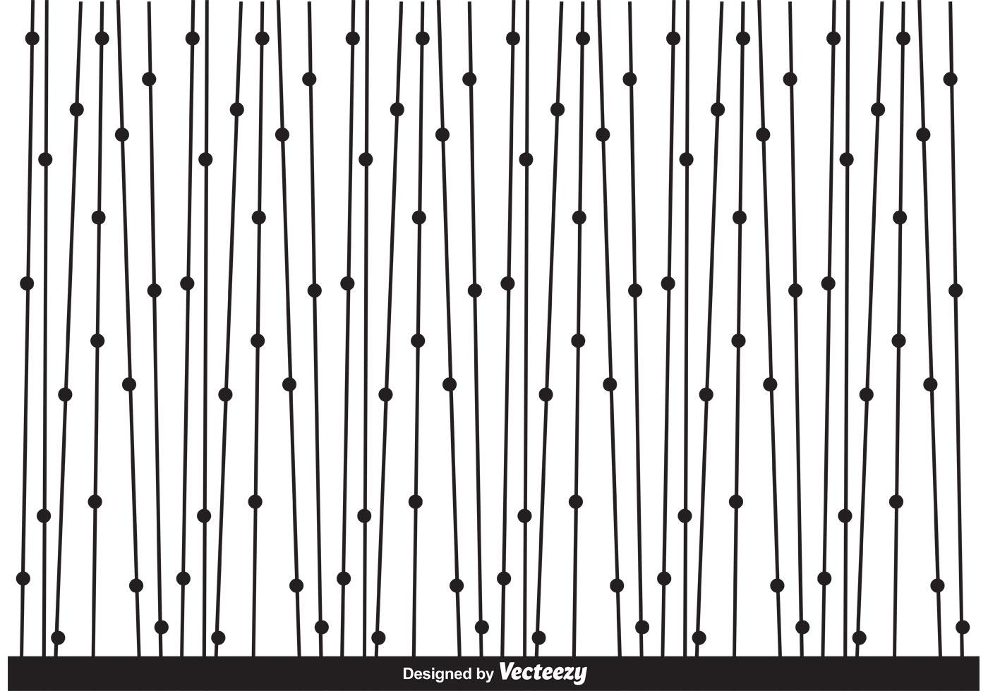
Corporate Social Responsibility of Samsung Electronics
Management Ethics - M5X00803

Table of Contents
Introduction 3
Corporate Social Responsibility Theories 4
Ethical Decision-Making Process 6
Conclusion 6
References 8
Appendices 9

Introduction
This report investigates Samsung Electronics (Samsung) and their corporate social responsibility (CSR). This follows a poster created to inform the public of the unethical treatment of their employees, focusing on their non-union policy for their electronics manufactures. When approached, Mr Lee Kun-hee, the head of Samsung has said “(...What) Samsung does not recognise is not the trade union itself, but the need to have a trade union. In other words, Samsung has a principle of management that does not need trade unions.” (International Trade Union Confederaton, 2016).
This report aims to evaluate Samsung’s ethics through CSR models of theory. It also aims to derive logical solutions to avoid the unethical issue from happening in the future.
There are four categories of CSR; Instrumental, Political, Integrative and Ethical (Crane & Matten, 2015). Instrumental CSR looks at theories such as Friedman’s Stockholder theory whereas ethical CSR looks at ideas such as Kantian Ethics.

Corporate Social Responsibility Theories
Milton Friedman (1970) argues that corporations cannot hold social responsibility in his classic article “The Social Responsibility of Business is to Increase Profits”. Friedman discusses how business cannot be purely concentrated o making money, but also on their ‘social conscious’ (Friedman, 1970).
Firstly, because only humans can be responsible for their own actions, business’ cant be held accountable. Only the individuals involved can be. Friedman also argued that a manager’s sole responsibility is to act in the interest of the shareholders. The executive who enforces CSR into the business would end up not working with the best financial interests causing cost to rise. This would make the executive lose trust and therefore power.
Edward Freeman (1984) opposed Friedman’s Stockholder Theory with his Stakeholder Theory. Stakeholder theory suggests that a business has a moral responsibility to any stakeholder of said business. See Appendix A for Samsung’ stakeholder map. Freeman’s theory works alongside Archie Carroll’s (1991) model of CSR, see figure 1.

Total Corporate Social Responsibility
Figure 1 - Pyramid of Corporate Social Responsibility (Carroll, 1991)
This model added that being profitable is just the basics which needed to be mastered first. Next you need to obey the law, then be ethical and then to reach full corporate social responsibility, you need to be a ‘good citizen’ by contributing to the community. See Figure 1.

Samsung fulfils their economic responsibility, which is required by society, in being profitable making an operating profit of 50 billion US Dollars in 2017 which is nearly double what was made in previous years. By fulfilling this level, Samsung have met Friedman’s Stakeholder Theory of the sole purpose a business being to make a profit.
Samsung do not always meet their legal responsibilities, as what happened in September of 2016 when several Samsung Galaxy Note Tablet devices had to be recalled due to them exploding (Samsung Electronics, 2016). The devices had been rushed through production and were being sold with faulty batteries. When Samsung were called out on the issue, they immediately recalled the devices and replaced them with new ones.
Samsung does not meet the ethical responsibilities. As discussed in the poster and the report by CWUnion National (2017), Samsung Electronics have been mistreating their employees overseas. They don’t do what is right to avoid harm and encounter harm to their employees. Many have fallen ill due to exposure to toxic chemicals (CWUnion National, 2017). Not allowing them to unionise to have their rights met and firing those who do unionise is unethical treatment. Samsung discusses how to ‘detect workers who are most likely to attempt to organise, how to monitor them and how to isolate and eventually thwart workers who exercise their rights to form a union’ (International Trade Union Confederaton, 2016, p. 45). As this responsibility is only expected by society and not required, Samsung don’t feel the need to do anything about it. Without meeting this responsibility, they are unable to move up to meet their philanthropic responsibilities.
Although the philanthropic responsibilities are only ‘desired’ by society, they are still important, and business do still need to meet them. As Samsung hasn’t met the ethical responsibilities, they cant meet the philanthropic one in being a good citizen and positively contributing to the community.

Ethical Decision-Making Process
The ethical; decision making process is a simple way to present a complex process. Firstly, the moral issue needs to be recognised, next is to make a moral judgement, next is to establish moral intent and finally moral behaviour needs to be engaged. See figure 2.

Figure 2 - Ethical Decision-Making Process
Applying this model to Samsung’s Ethical Issue being discussed falls down after the second stage. The moral issue is recognised by Samsung. They have publicly discussed their non-union policy. The next stage is to make a moral judgment, which is where Samsung fail. As Samsung have open admitted that they see no need for a union and will ‘thwart’ any person(s) who engage in union activities, they are clearly consciously ignoring the moral judgement. As Samsung have not met this step, they are unable to establish a moral intent to fix the issue and therefore won’t be able to engage in any moral behaviours o fix it either.
The limitations of this model are that it isn’t always as simple as it is made out to be, there are far more details which need to be investigated. Another limitation is that various stages rely on one another and this isn’t obvious in the model.

Conclusion
In conclusion, Samsung have recognised their moral issue but were un willing to change. Although they are still a successful business in Friedman’s model, as they are making a profit, they are a poor company in relation to corporate social responsibility.

References
Carroll, A. B., 1991. The pyramid of corporate social responsibility: Toward the moral management of organizational stakeholders. Business Horizons, 34(4), pp. 39-48.
CWUnion National, 2017. Behind the Samsung Galexy: union busting and worker exploitation. 17 April.
Friedman, M., 1970. The Social Responsibility of Buisness is to Increase its Profits. The New York Times Magazine , 13 September.
International Trade Union Confederaton, 2016. Samsung - Modern Tech, Medieval Condictions, s.l.: International Trade Union Confederaton.
Jung-a, S., 2018. Finacial Times. [Online]
Available at: https://www.ft.com/content/896fba54-8a5b-11e8-bf9e-8771d5404543
[Accessed 23 October 2018].
Mundy, S., 2013. Samsung's Code of Ethics put to the test: The Financial Times. [Online]
Available at: https://www.ft.com/content/2b6d8012-83e0-11e2-b700-00144feabdc0
[Accessed 9 November 2018].
Samsung Electronics, 2018. Vision 2020: About Samsung: Samsung. [Online]
Available at: https://www.samsung.com/uk/aboutsamsung/vision/vision2020/
[Accessed 11 November 2018].

Appendices

Appendix A – Samsung’s Vision and Mission Statements (Samsung Electronics, 2018)
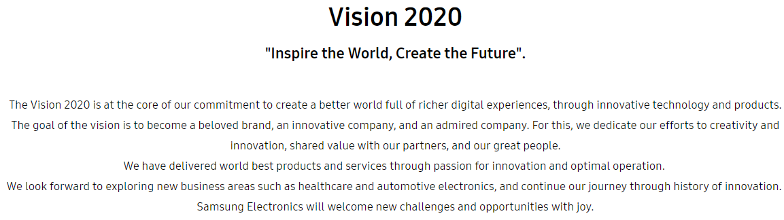
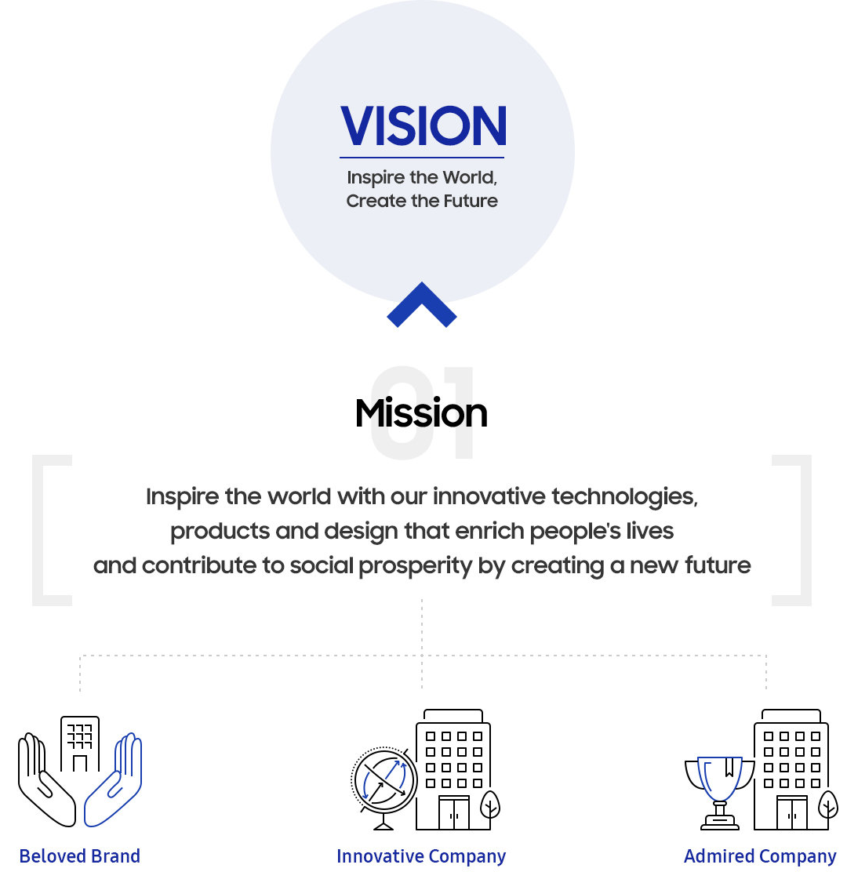
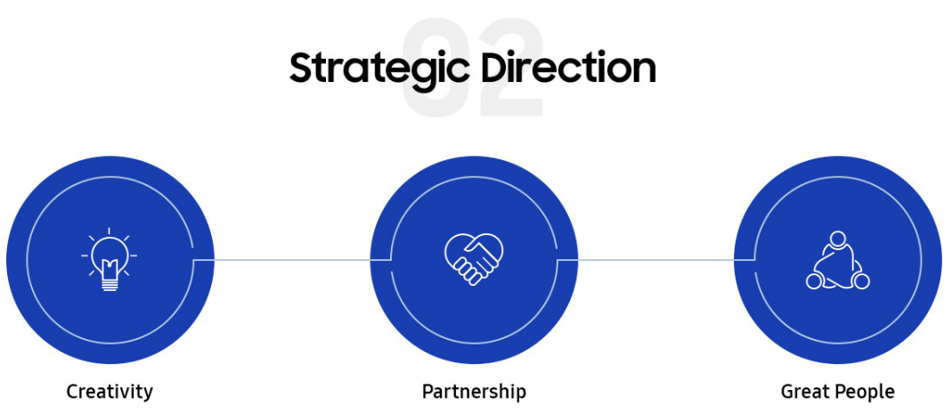

Appendix B – Samsung’s Code of Ethics (Samsung Electronics, 2018)
- Basic Principles
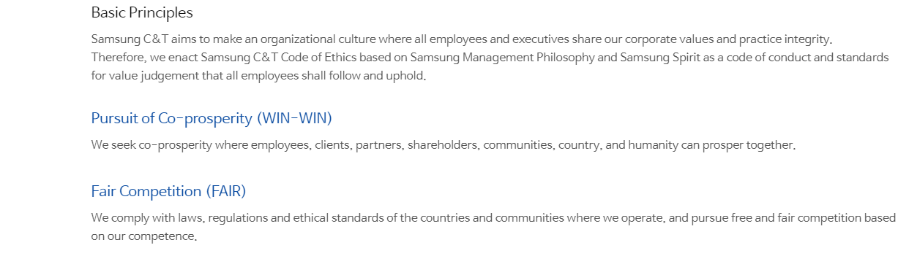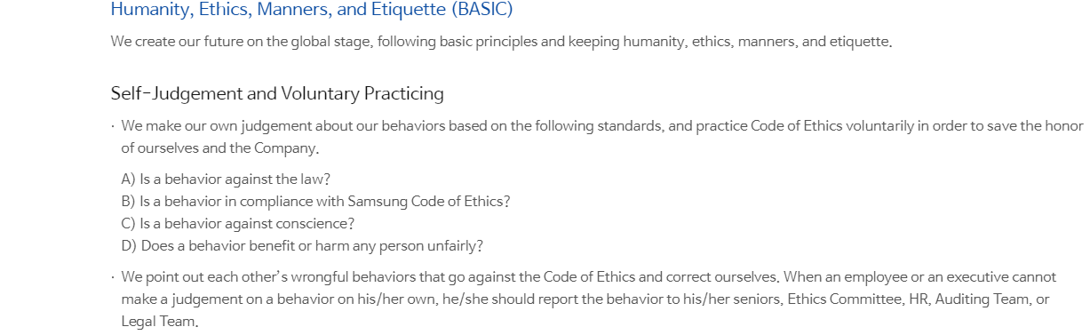
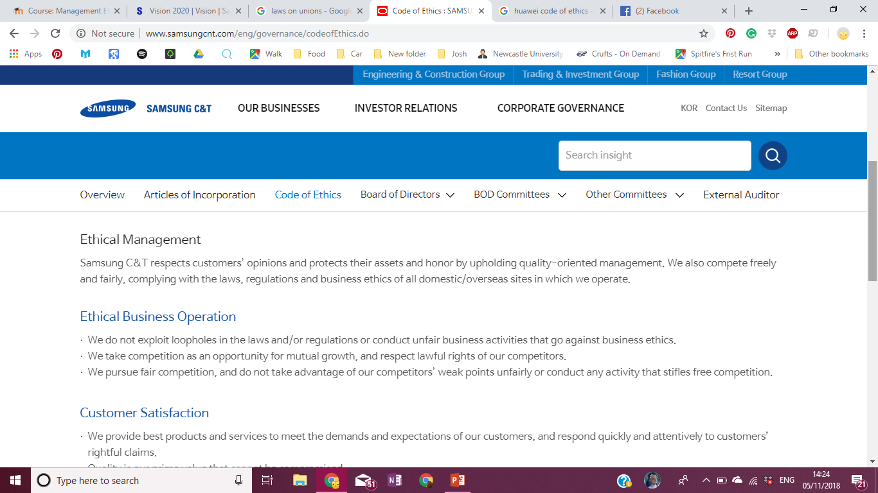
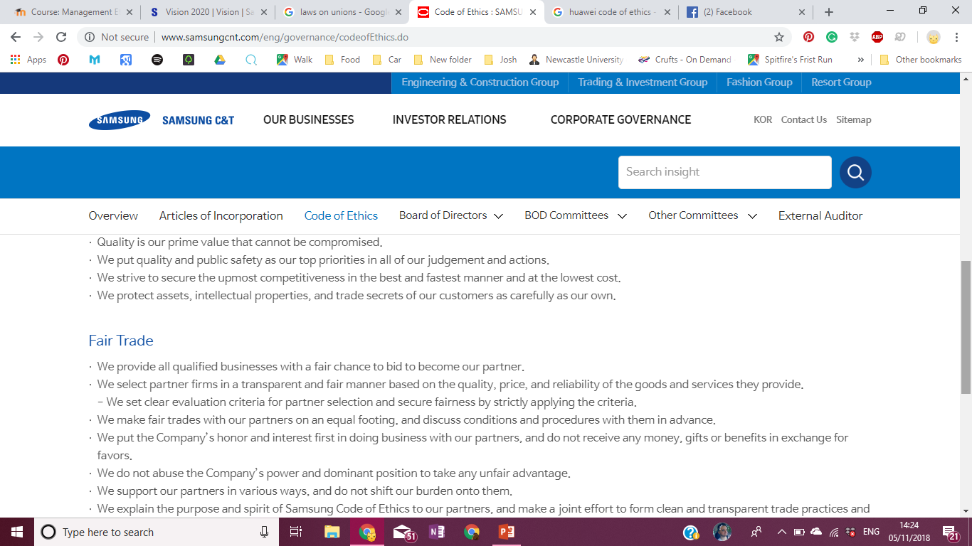
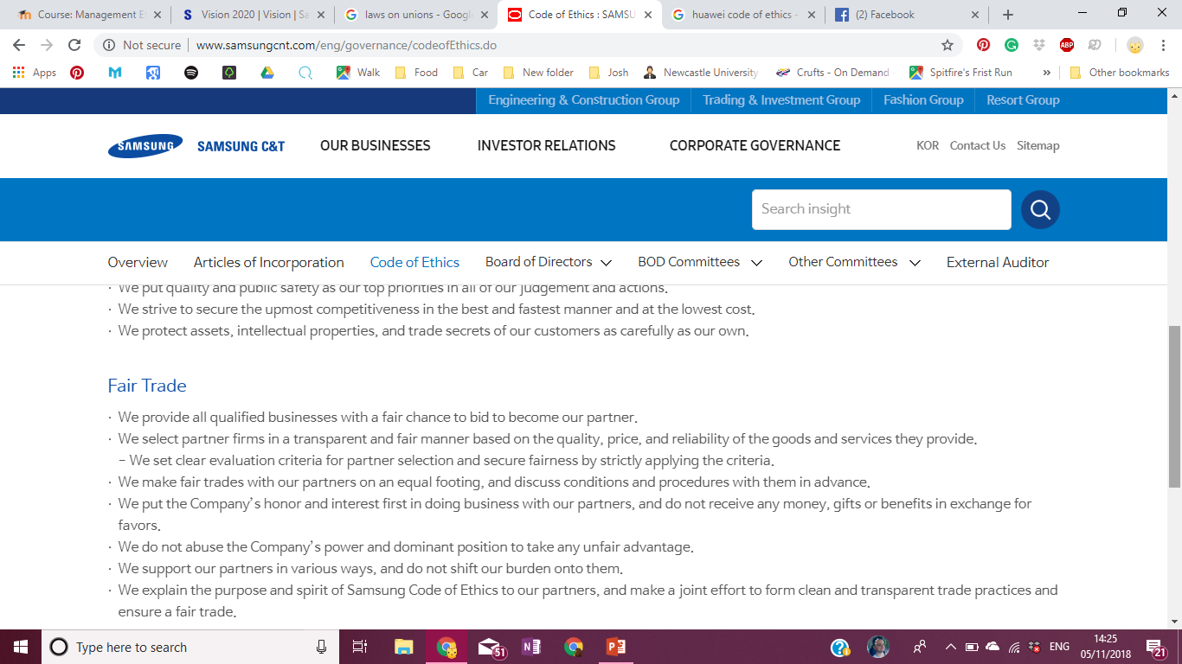
- Ethical Management

- Basic Ethics of Employees
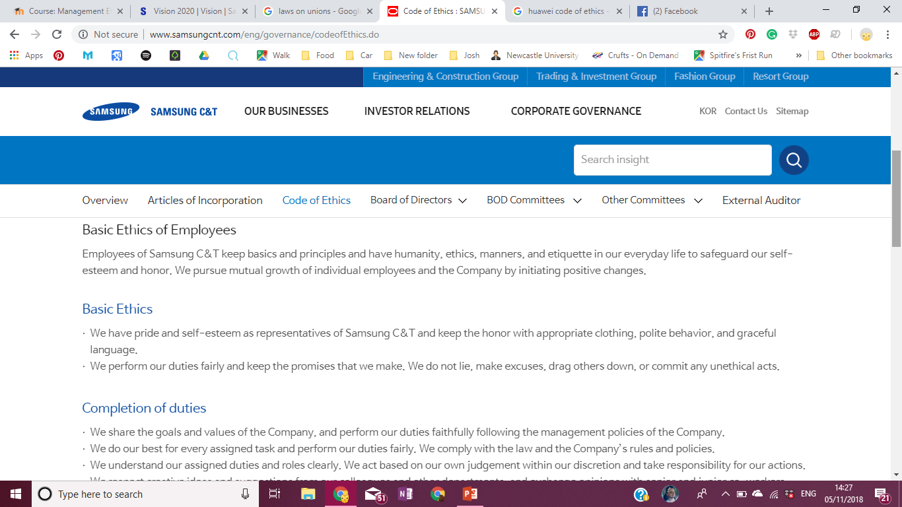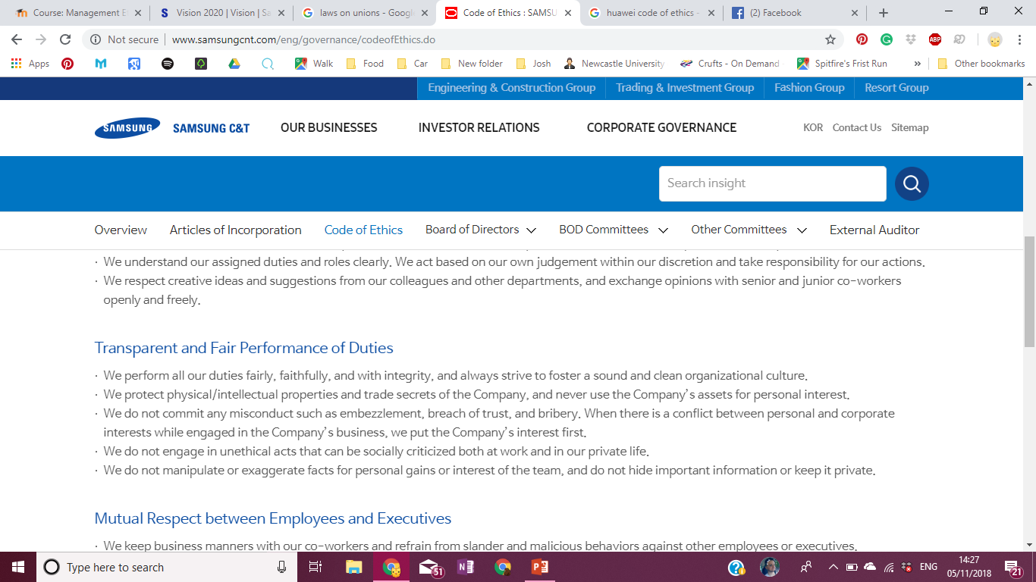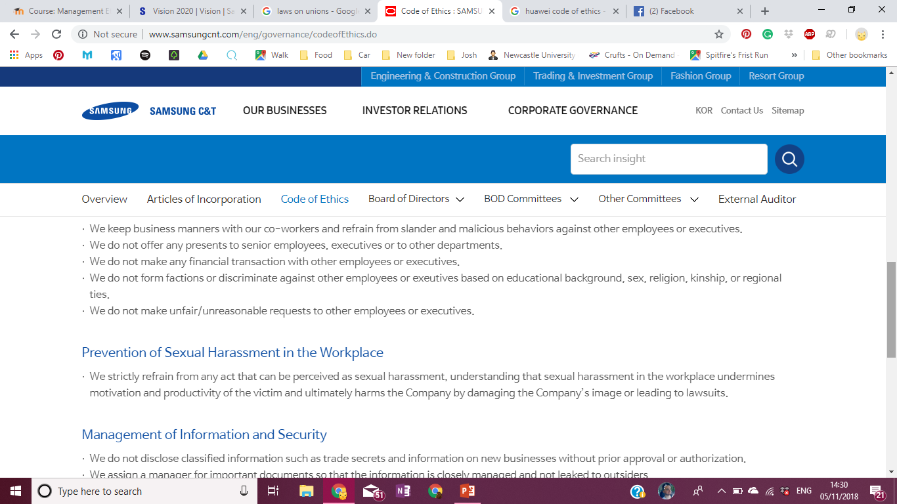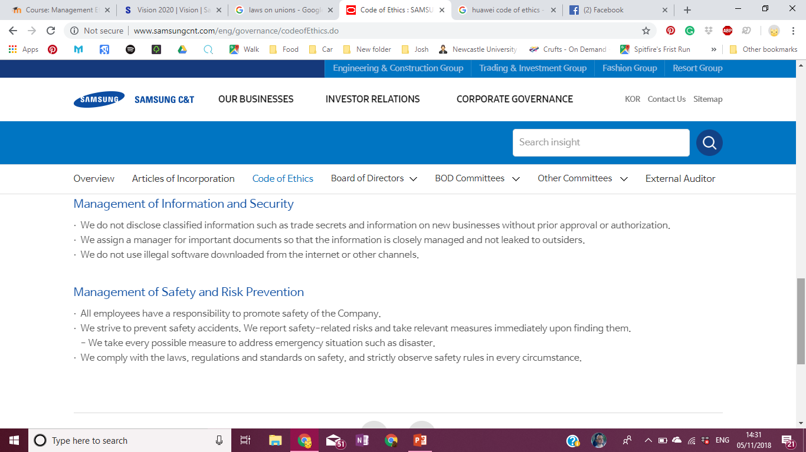

- Responsibility to Employees and executives
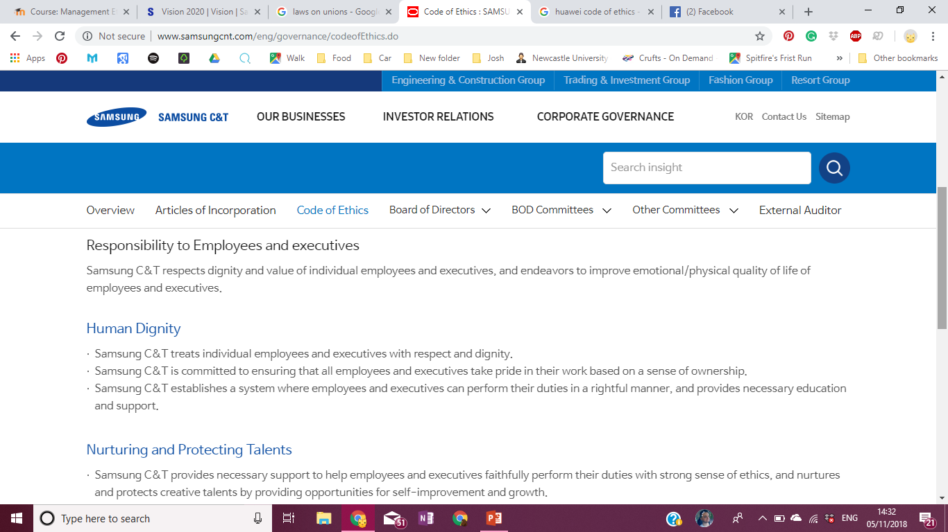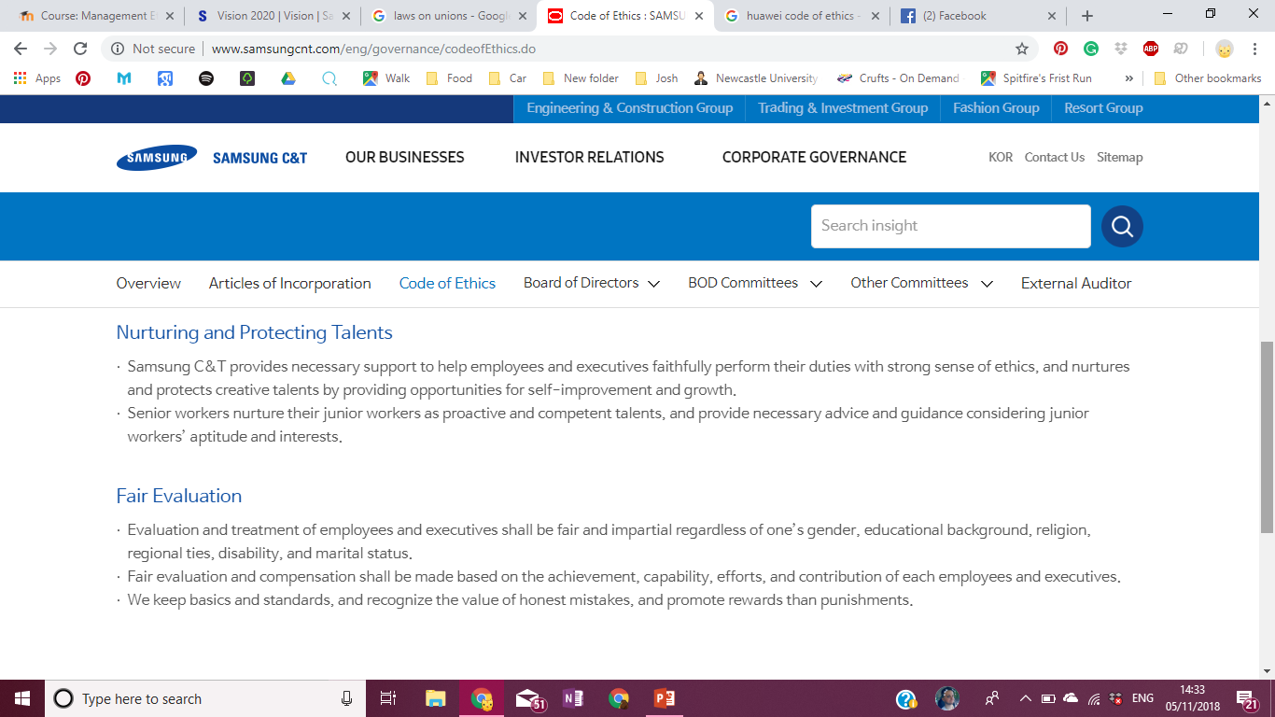
- Responsibility to our country and Society
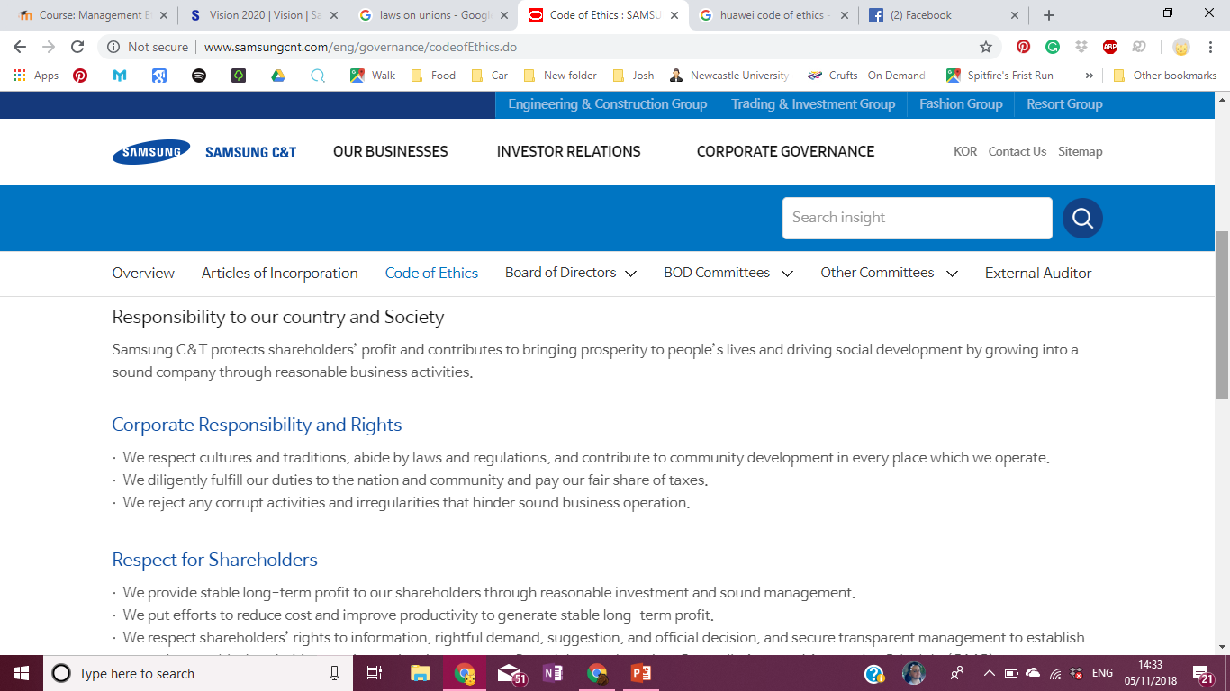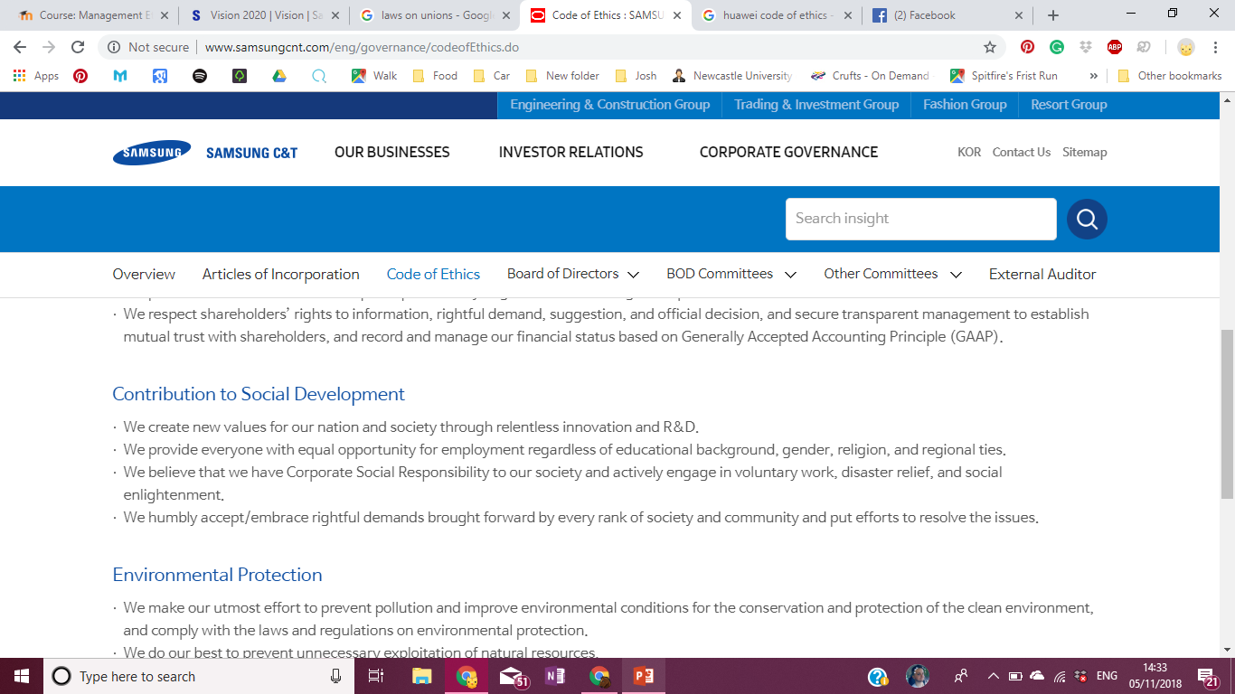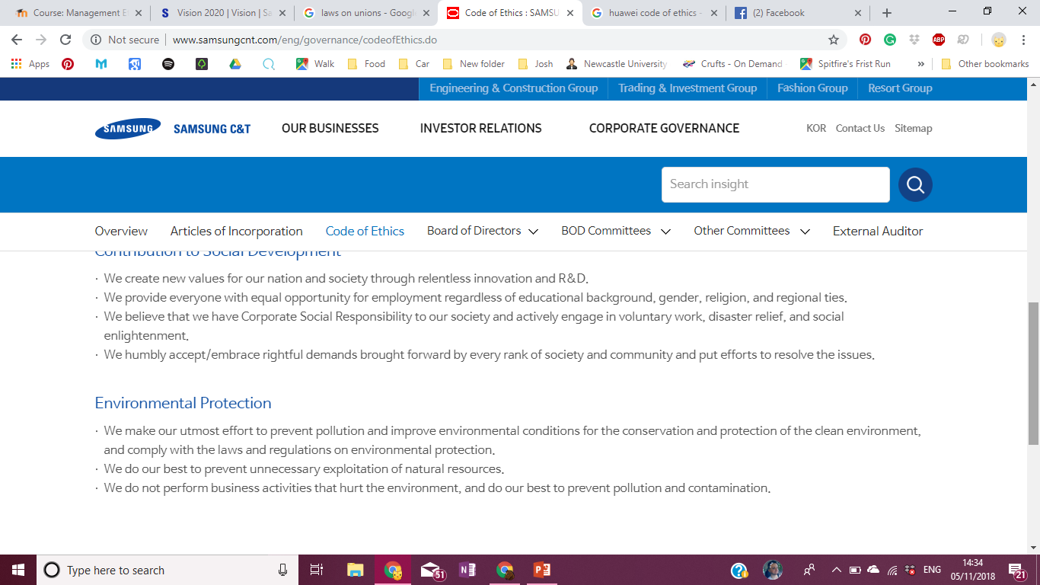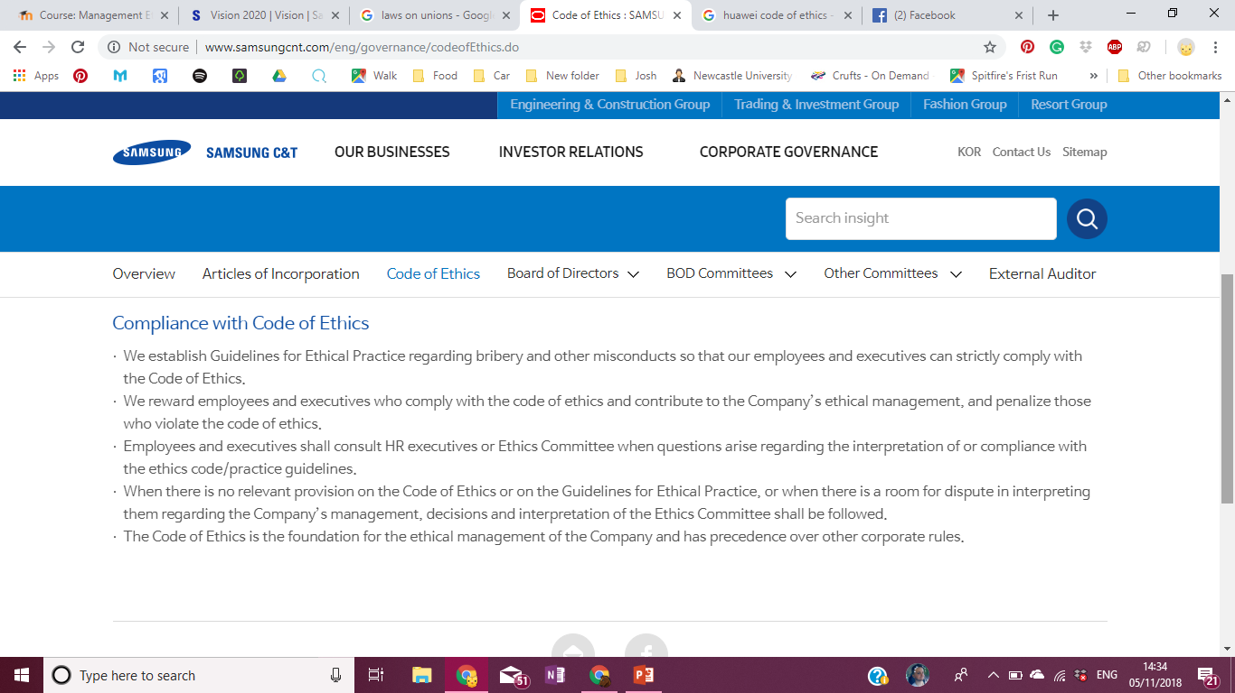

Appendix D – ‘Samsung Code of Conduct put to the test’ (Mundy, 2013)
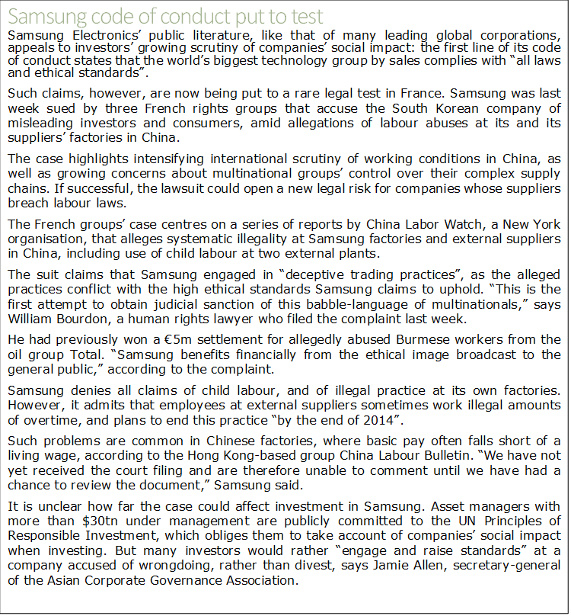
Article by the Financial time

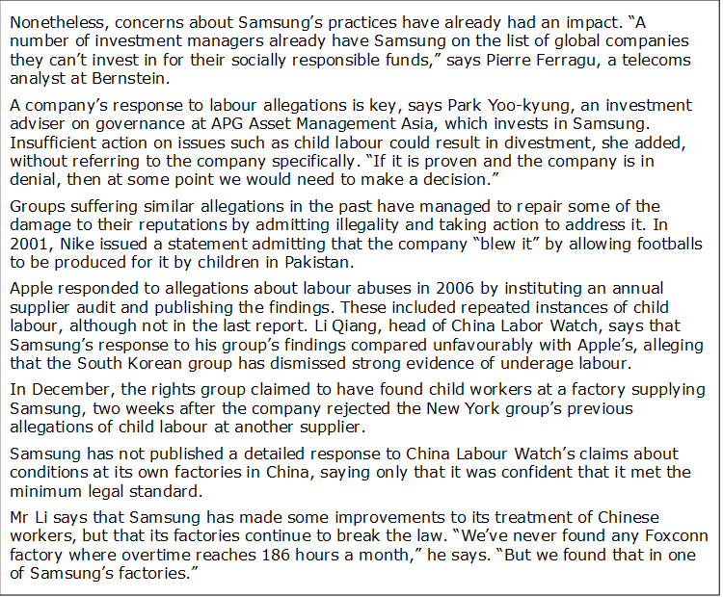

Appendix E – (CWUnion National, 2017)


