University of Wales Trinity Saint David
Wales Institute of Science and Art


Assignment Name: Vehicle Electronics

Module name and code: vehicle Electronics

Student Name Finn O’Connor
Student Number 2406000
Date 04/2026
Contents
1 Task 3 1
1.1 Scope Time Division Calculations (6) 1
1.2 Function Generator output square wave (6) 1
1.3 Capacitor charge and discharge wave marked at correct points. (6) 1
1.4 Basic Capacitor Calculations (6) 2
1.5 Capacitor discharge table (5) 3
1.6 Plot log(V) Gradient (5) 3
1.7 Gradient Calculations and Compare(8) 4
1.7.1 Gradient Calculations 4
1.7.2 Comparison table 4
1.8 Capacitor Uses (5) 5
1.9 Inaccuracies Question (4) 5
1.10 Risk Question (10) 6
2 References 7

Figures

Figure 1 - Square wave output from function generator (500 us/div) 1
Figure 2 - Discharge scope trace 2
Figure 3 - Plot of ln(v) against time of best fit 3

Task 3

1.1 Scope Time Division Calculations (6)
The oscilloscope time base was set so that the capacitor charging and discharging waveform could be observed clearly across the screen. The time constant for the circuit was found to be T=2.37 X 10^-4s. A full transient response is typically observed over approximately 4T, therefore
4T = 4 x 2.37 x 10^-4 = 9.49 x 10^4s
This is approximately 0.95ms. The oscilloscope was set to 500 µs/div, giving us a total screen width of approximately 5 ms across 10 divisions. This was sufficient to display the full waveform clearly for measurement and analysis.

1.2 Function Generator output square wave (6)

Figure 1 - Square wave output from function generator (500 us/div)
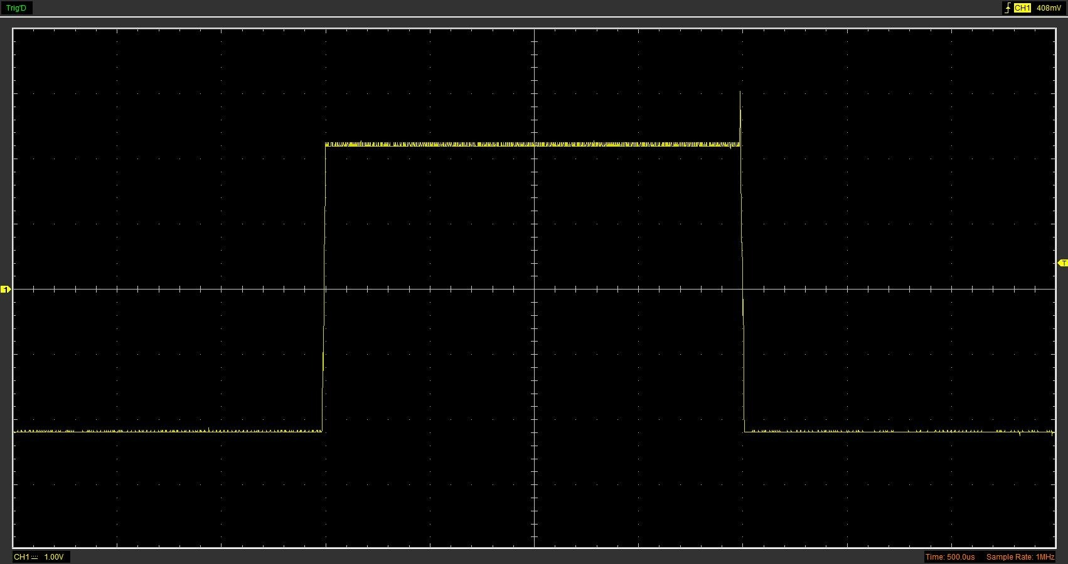
The function generator was used to produce a Square wave signal, as shown in Figure 1. The square wave alternates between the high and low voltage levels, providing a periodic input to the RC circuit. When the input voltage rises, the capacitor begins to charge, and when the voltage falls, the capacitor discharges. This allows the transient response of the capacitor to be overserved and analysed. The oscilloscope was set to 500 us/div, allowing the waveform to be clearly displayed and measured.

1.3 Capacitor charge and discharge wave marked at correct points. (6)

Figure 2 - Discharge scope trace
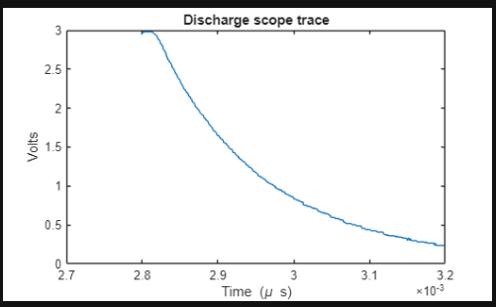

Figure 2 shows the voltage across the capacitor during discharge. The waveform follows an exponential decay, which is characteristic of an RC circuit. When the input voltage is removed, the capacitor releases its stored energy through the resistor, causing the voltage to decrease over time.
The data was also processed using MATLAB to generate a clear discharge curve, allowing the exponential behaviour to be visualised more accurately.
During charging, the capacitor voltage increases exponentially towards the supply voltage, while during discharging, it decreases exponentially towards zero. The rate of change is governed by the time constant (t), which determines how quickly the capacitor responds.

1.4 Basic Capacitor Calculations (6)

The capacitance of the circuit was determined using the time constant relationship
Τ=RC
Rearranging gave this
C= τ​/R
The time constant was calculated from the discharge data 2.37 x 10^-4 s. Using a resistor value of 1000 ohms, the capacitance was calculated as:

C = 2.37 X 10^-4 / 1000 = 2.37 x 10^-7 F
This is equivalent to 0.237 µF. This value is compared with other methods in later sections to evaluate accuracy.

1.5 Capacitor discharge table (5)
Time (s) | Voltage (V) | ln (V) | dy = y2 – y1  dy = ln(V)2-ln(V)1 | dx = x2- x1  dx = Time2 – Time1 | dy/dx
0 | 0 | 0 | x | x | x
0.000039 | 0.6902 | -0.370774 | 0.5595744 | 0.000039 | 14348.061
0.000078 | 1.2078 | 0.1888005 | 0.261383 | 0.000039 | 6702.1277
0.000117 | 1.5686 | 0.4501835 | 0.1739351 | 0.000039 | 4459.8742
0.000156 | 1.8666 | 0.6241186 | 0.1112256 | 0.000039 | 2851.9394
0.000195 | 2.0862 | 0.7353442 | 0.086416 | 0.000039 | 2215.7954
0.000234 | 2.2745 | 0.8217602 | 0.0537085 | 0.000039 | 1377.1408
0.000273 | 2.4 | 0.8754687 | 0.0321445 | 0.000039 | 824.21675
0.000312 | 2.4784 | 0.9076132 | 0.037265 | 0.000039 | 955.51277
0.000351 | 2.5725 | 0.9448782

1.6 Plot log(V) Gradient (5)

Figure 3 - Plot of ln(v) against time of best fit

Figure 3 shows a plot of ln(V) against time for the capacitor discharge. The graph produces an approximately linear relationship, which confirms the exponential nature of the capacitor discharge.
A line of best fit was added to the data, allowing the gradient to be estimated. This gradient is related to the time constant of the circuit.
The graph was used to verify the expected linear relationship for exponential decay. The slight deviation from a perfect straight line can be attributed to experimental error and measurement noise.
The gradient was then calculated more accurately using the dy/dx method from the data table, which was used to determine the time constant in the following section.

1.7 Gradient Calculations and Compare(8)

1.7.1 Gradient Calculations

The gradient of the discharge curve was calculated using the dy/dx method, where dy = ln(v2) – ln(v1) and dx = time2 – time 1. This method calculates the gradient between each pair of adjacent data points.
The Dy/Dx values were calculated for each interval, and the mean gradient was found to be 4216.83
The time constant was calculated using the relationship:

τ = 1/ mean gradient (4216.83)
τ = 1/4216.83 = 2.37 x 10^-4 s

Using the relationship C = τ / R and a resistor value of 1000 ohms, which was defined in the MATLAB analysis, the capacitance was calculated as:

C= 2.37 x 10^-4 / 1000 = 2.37 x 10^-7 F

This is equivalent to 0.237 µF. This value is compared with results obtained from other methods in the following section

1.7.2 Comparison table
 | Capacitance | Delta | Percentage difference
Actual | 1 µF | x | X
Marker Calculation | 0.276 µF | 0.724 µF | 72.4%
Gradient Calculation | 0.237 µF | 0.763 µF | 76.3%
MATLAB method | 0.150 µF | 0.850 µF | 85.0%

The capacitance values obtained from the different methods show noticeable variations from the rated value of 1 µF. The marker method gave a value of 0.276 µF, the gradient method gave 0.237 µF, and the MATLAB method gave 0.150 µF.
The differences between the measured and actual values can be attributed to several factors. These include experimental error when measuring the time values from the oscilloscope, noise in the signal, and limitations in data processing. Additionally, capacitors may have manufacturing tolerances, meaning the actual capacitance may differ from the stated value.
The MATLAB method, while providing a smoother curve fit, may introduce further deviation due to data manipulation and fitting techniques. Despite the differences in calculated values, all methods correctly demonstrate the expected exponential behaviour of an RC discharge circuit

1.8 Capacitor Uses (5)

Capacitors are widely used in electrical and automotive systems due to their ability to store and release electrical energy (Electronics tutorials n.d). Some common applications include:

- Power supply smoothing – capacitors reduce voltage fluctuations and provide a stable DC output in power supplies
- Timing circuits – Capacitors control timing in circuits by charging and discharging at predictable rates
- Signal filtering – Capacitors used to filter out unwanted noise or frequencies in electrical circuits
- Energy storage – Capacitors store electrical energy temporarily and release it when required
- Automotive ECU systems – Capacitors help stabilise voltage and protect sensitive electronic control units
- Ignition systems – Capacitors are used in ignition circuits to assist in generating the spark required to start engines
- Audio systems – Capacitors smooth power delivery and improve sound quality in audio equipment
- Sensor circuits – Capacitors are used in sensors to detect changes in voltage, pressure, or position
- Backup power systems – Capacitors can provide short term power to maintain system operation during brief interruptions
- Coupling and decoupling circuits – Capacitors block DC signals while allowing AC signals to pass, protecting and isolating parts of a circuit.

1.9 Inaccuracies Question (4)

The calculated capacitance values differ from the rated value of 1 µF due to several sources of error. One major source of error is component tolerance, as capacitors and resistors do not have exact values and may vary from their stated ratings.
Measurement inaccuracies when using the oscilloscope can also affect the results, particularly when determining time values for small intervals. Electrical noise and signal fluctuations may further distort the voltage readings.
Additionally, the process of adjusting voltage values and applying the natural logarithm introduces further approximation errors. The use of graphing and averaging methods, such as dy/dx, can also contribute to variation in the final result.
Despite these inaccuracies, the overall trend of the data follows the expected exponential behaviour of a capacitor discharge, indicating that the method used was valid.

1.10 Risk Question (10)

Modern vehicles depend heavily on electronic communication networks like the Controller Area Network (CAN bus) to enable different electronic control units (ECUs) to interact. These networks manage vital functions such as braking, steering, and engine control. As vehicles become more connected, the threat of cyber attacks has grown considerably. One major danger is unauthorized access to the vehicle's network. If a hacker breaches the CAN bus, they could send harmful commands to ECUs, potentially causing dangerous scenarios like disabling brakes, changing engine performance, or disrupting steering. Attackers might also access sensitive information like location data or driver behavior. Additionally, older vehicle networks often lack built-in security, making them more vulnerable. Many CAN systems were initially designed without encryption or authentication, increasing their susceptibility. With the advent of connected vehicles and wireless options like Bluetooth and Wi-Fi, these weaknesses are more exposed. To mitigate these risks, standards such as ISO/SAE 21434 have been introduced to enhance automotive cybersecurity (ISO, 2021). These guidelines recommend security measures like encryption, authentication protocols, and secure software updates. Intrusion detection systems can also help monitor network activity for unusual behaviour. In summary, while electronic communication systems are vital for modern vehicles, they pose notable cybersecurity threats. Still, by employing proper security strategies and adhering to established standards, these dangers can be effectively managed, ensuring vehicle safety and dependability.

References

- Electronics Tutorials (n.d.) RC Circuits. Available at: https://www.electronics-tutorials.ws/rc/rc_1.html (Accessed: 17 April 2026).

- International Organization for Standardization (ISO) (2021) ISO/SAE 21434: Road vehicles — Cybersecurity engineering. Available at: https://www.iso.org/standard/70918.html (Accessed: 17 April 2026).

