Assessment 2
Module: LCBB5004 Managing People
Lecturer: Piymika Gamage
Student: Danica Kanchevska
Student ID: 2124692

Cover page
- Introduction…………………………………………………………………1
- Causes and effects of employee attrition within the nursing industry in
The UK………………………………………………………………………1
- Monetary and non-monetary existing retention schemes used by
National Health Sector…………………………………………………….3
- Conclusion…………………………………………………………………..5
- Recommendation…………………………………………………………...6
- References…………………………………………………………………..7

Introduction
After I was appointed as a Human Resources Consultant, I was given the task to provide a report to the Head of Human Resources-National Health Service UK, addressing the causes of nurse attrition, analyze the retention schemes, and give recommendations for reducing the attrition. This report summarises my analysis of the causes and effects of employee attrition within the nursing industry in the UK, an evaluation of the existing retention schemes used by the National Health Sector, as well as my recommendations for improving nurse retention to lower the nurse attrition rate in the UK.

Causes and Effects of employee attrition within the Nursing Industry in the United Kingdom
During my research, I found out that The National Health Sector Vacancy Statistics, April 2015 - June 2022 shows a data of vacancy rate of nearly 12% within the Registered Nursing Staff groups that is nearly 47,000 available vacancies which shows an increasing number compared to the same time range of last year with the 10% vacancy rate and 39,000 vacancies available. (www.digital.nhs.uk)
The gap between for and supply of nurses is not going any better.
According to Palmer, B. and Rolewicz, L. (2022) the UK Health Sector suffers from high levels of nurse shortages. Although the government commitment to increase by 50,000 more nurses by March 2024 has made progress, the level is not increasing as required. Among the factors that influence joining and leaving the NMRC nursing register, the COVID-19 Pandemic is included, and subsequently changes in working conditions and opportunities in nurses’ country of training. They highlighted that the leaver rate is nearly 12% with more than 40,000 nurses in England that left the professional register. This rate increased significantly in the last year (over 27,000 in the year to March 2022).
Speaking of the COVID-19 pandemic, the demand for qualified nurses has even gone up from the previous levels as well as the recovery followed by it. (www.kingsfund.org.uk)
The study shows that the most common reason for leaving is retirement followed by work-life balance, leaving because of health reasons (health and wellbeing), lack of rewards, low levels of staffing followed by pressure and stress, lack of further training and education, feeling undervalued and exhausted (burn-out), presence of negative workplace culture, discrimination at work, unfair treatment (bullying or harassment from fellow colleagues).

1
Although the international requirement is crucial in covering nursing vacancies, uncertainty about Brexit, changes to the immigration policy, and the changes to the language requirements additionally have influenced the international requirement and decreased the inflow of nurses from the European Union countries.

As we can see, nursing retention is a significant issue and need a serious and robust approach.
Not addressing retention is an extremely high cost. The report data from the National Health Service (Farah, M. 2022) shows that:
-The cost of replacing a fully-trained nurse is equivalent to £12,000 and yearly spending by each Trust is estimated to be £3,6 million;
-The cost to NHS for not addressing retention is £21,7 billion;
-Overseas recruited nurse cost is £6,371.41;
-£100,000 is the cost of an agency nurse each year in terms of retention;
-The turnover rate of Nurses is 10-12% with 25,219 nurses that left the register in the year to March 2022.
-Due to absence, NHS lost £1,4 million in April 2019. These figures are nearly the same as pre-pandemic levels and Covid is the reason for 14% of leavers
The data stated above give us clear evidence of staff leaving the NHS is high and the priority is improving NHS staff retention and the need to reduce the high staff turnover rate is urgent.
The National Health Service Long Term Plan (Buchan, J. et al., 2019) published in January 2019 is a new workforce implementation plan and is addressing service delivery expansion and change. This plan has been delivered because the too small effort was given to retaining the existing nursing workforce and because of decreased funding for professional development. Quick improvement can be made by retention (compared with the new staff training). This will decrease vacancies and will improve staff stability. The stability index is the percentage of staff at the beginning of the year remaining in the role at the end of the year.

2
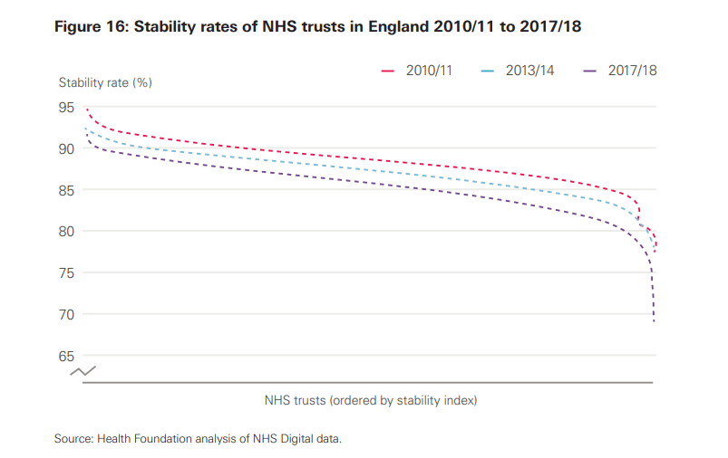
The focus of this plan is based on a critical `pressure point` - the retention and attrition of student nurses and National Health Sector nurses. Their improvement is a main area for policy attention and offers quicker and less costly methods for lowering nursing shortages rather than training and recruiting new staff.
This Long Term Plan highlights the opportunities for resolving the issues in the right direction and sets out the actions and reforms for reducing workload pressure and offering flexibility as well as professional development. The plan presents the aim for increased funding, expanding international recruitment, and implementing new incentives. (www.longtermplan.nhs.uk)

Monetary and non-monetary existing retention schemes used by the National Health Sector

Monetary and non-monetary incentives have a direct influence over the recruitment and retention of employees and their performance (Pilbeam, S. 2010).
In terms of retaining the nursing workforce, the National Health Service Trustees are using plenty of incentives. When evaluating these incentives I realized that all of them are good with some minor disadvantages and one of the main ones is that they are expensive. However, they are still not as expensive as training new nurses. The most important is that they have to be always used accordingly. In this report, I will highlight and list the most valuable incentives. (www.publications.parlament.uk)
3
-Flexible working means reducing hours, compressing hours, and flexible start and finish time due to valuing home life and life outside highly, just to look after mental health and personal wellbeing. This method is highly valuable but not always available and it depends on the organisational structure. Flexible working improves retention in the workforce and makes the workplace more attractive and accessible. However, flexible working ensures equality, diversity, and inclusion among staff. The method is crucial for retaining older workers. It makes National Health Sector a more attractive employer too. And most of all, if it is managed well, flexible working is a long-term plan for predicting the number of nurses trained by the National Health Service in each specialty in years’ time.
-Pay is a very important incentive for NHS nurses and felt to be an issue as well.
It is not right for nurses to not be able to pay rent, to afford petrol, unable to get mortgages or to rely on food banks. All the nurses should get a pay award adequate for the cost–of–living crisis. That way their highly valuable work to keep the National Health Service running will be reflected and rewarded.
Offering competitive wages is increasing the retention rate. When we think about the cost of the loss of an experienced worker and the cost of training the new one for replacement it is more than obvious that offering fair pay will be more cost efficient. Fair pay will boost the extra effort for achieving employers’ goals as well.
-Pensions and flexible retirement – because of concerns over pensions, senior nurses are either reducing their hours or retiring earlier than normal – and all because of the changes to pension taxation rules. Because of this, the Government must act to reform the National Health Sector pension scheme in order to be able to keep senior staff for longer and not to lose staff who are willing and able to work (mounting waiting list and ever–increasing demand).
-Improve internal communication and boost engagement – can be done by a platform such as an employee up that allows two-way communication and engagement with the workforce and sharing feedback. Employee engagement can be measured through the app which allows learning and development (showing interaction and responding to messages).
-Give employees flexible scheduling – adopting a flexible working schedule correlates with higher retention. The employee app can be used to cover last–minute replacements and provide shift coverage. Enabling work–life balance will provide work with minimal stress.
-Recognized and reward the employees’ effort – because a one-size-fits-all approach doesn’t work, the recognition programs are different and it is crucial to adapt them according to nurses’ preferences. Recognition can be monetary or non-monetary reward usually through the platforms, direct appreciation, or as perks: gift cards, benefits of flexible working hours, or development opportunities.

4
-Listen and act on employee feedback – it is important to be present and proactively ask for feedback. It is very important to follow up on promises by gathering feedback and ideas, listening to staff views, and acting accordingly on their say helps in improving retention.
-Supporting new starters and those moving roles – is essential for reducing the turnover of new employees. They should experience the real picture of their role and alongside that experience, they will gain a positive first impression of the organization and will reduce leaving in the first few months. Additionally, keeping in touch with them over the period between the offer and the start date will engage them with the organization which will help to feel part of it. This can be done by good induction and giving them all the information for effective work. Providing mentoring and support will help with increased attrition during the first few years.
-Shaping organizational culture – treating the staff the way they want to be treated will ensure high-quality and effective patient care. By creating a positive environment the nursing staff will feel valuable, share decision-making, and deliver high-quality care for their patients. Staff engagement and an inclusive working environment will help in creating a culture where the nurses will like to stay and be part of the National Health Service (www.nhsemployers.org).
-Understand the career advancement needs – one of the top reasons for resigning (Karolina, 2022). The higher job title is prioritized by employers more than job growth and learning opportunities. Overcoming the barriers is important for retaining top talent. Investing in employees’ carrier and welfare simply means prioritizing learning and training opportunities as well as reducing the intensity of their work alongside keeping up with the changing technology.
-Special discounts for NHS workers such as Blue Light Card which gives them a lot of different stores discounts (food and drink discounts, clothing and shoes, health and wellbeing discounts, days out deals, mobile phone contracts, etc) and help with mortgage schemes.

Conclusion
The gap between the demand for and supply of NHS staff is not getting any better.
The present incentives and rewards are often not used as intended because of the high complexity level, too difficult target, or too time-consuming for negotiation and mainly because of a lack of consistency in a designing way. The analysis of the incentives and rewards is difficult to outline a conclusion in terms of the effect of the national incentives over the years and what should be the risk level, how to balance properly national and local incentives and finally, what will be the impact of adding or removing of the incentives. (www.england.nhs.uk)

5
While focusing on retention it is crucial for NHS to keep an eye on the inflows in terms of newly qualified and overseas recruits and the outflows like retiring or leaving the roles outside NHS. The outcome of these actions will be improved well-being at work and to be fit for the patients from the retention of experienced at knowledgeable staff. This is the main target that every leader has to understand and act on the reasons for leaving or such an intention.
Because of this, it is crucial that a completely funded workforce is essential to ensure that boosting retention will be improved for resolving the workforce crisis.

Recommendation
From all the data presented in this report, my recommendation will be addressing the following:
- More generous establishment of funds to attract prospective students;
- Allocating placement with the health care providers for all students and the necessity for them to be paid in an efficient and timely way;
- More support for second–year students should be provided;
- Flexible actions to be taken based on evaluating the impact of recognizing and rewarding current nursing staff which will increase retention rate.

6
References:
A critical moment: NHS staffing trends, retention and attrition
The Health Foundation,
James Buchan, Anita Charlesworth, Ben Gershlick and Ian Seccombe, February 2019
NHS Staff Retention Review: Costs and Impacts
Available at: https://www.nurses.co.uk
(Accessed: 09/03/2023)
NHS Vacancy Statistics England April 2015-June 2022 Experimental Statistics
Available at: https://wwwdigital.nhs.uk
(Accessed: 09/03/2023)
Improving staff retention
Available at: https://wwwnhsemployers.org
( Accessed: 09/03/2023)
Online version of the NHS Long Term Plan: Overview and summary
Available at: https://www.longtermplan.nhs.uk
( Accessed: 27/04/2023)
Peak leaving? A Spotlight on nurse leaver rates in the UK
Available at: https://www.nuffieldtrust.org.uk
( Accessed: 09/03/2023)
People resourcing and talent planning: HRM in practice
Stephen Pilbeam & Marjorie Corbridge, Pearson Hall,4th ed.
Review of incentives, rewards, and sanctions: Discussion paper for stakeholders
Available at: https://www.england.nhs.uk
( Accessed: 27/04/2023)
6 effective employee retention strategies in healthcare
Available at: https://www.joinblink.com
( Accessed: 09/03/2023)
Workforce: recruitment, training and retention in health and social care
Available at: https://www.publications.parlament.uk
( Accessed: 09/03/2023)

