University of Wales Trinity Saint David


Wales institute of Science and Arts

Designing and Improving Robot Gripper for Additive Manufacturing

Independent Project ACMA 6013

Bachelor of Engineering Programme
Mechanical Engineering

Jamie Woodberry

April/2024

Abstract

The following report covers the design and optimisation of a mechanical gripper using additive manufacturing techniques. Whilst applying Design for Additive Manufacturing techniques and Finite Element Analysis studies to improve the grippers efficiency. The gripper design was to have a multipurpose use, with aim to handle different object geometries. The research in the project was to go into more depth of the topic, covering the background of grippers, finding gripper designs that would provide guidance into designing a multipurpose gripper by additive manufacturing.

The DfAM technique that were applied was the Lucas method, this method was used to optimise the gripper and improve the design efficiency with aim of simplifying the process for additive manufacturing. Finite element analysis studies were undertaken to analyse the behaviour on the key component of the gripper under different loading conditions, to find the maximum loading conditions the design can withstand. From this study it would be possible to find the areas of the design that can be redesigned and improved to be more appropriate for the application.

This research contributes to the improvement of the gripper by Additive Manufacturing, DfAM, and FEA techniques to design an efficient gripper design. The findings provided important perceptions for the design and optimisation of mechanical grippers for multipurpose use.

Declaration of Authenticity

This thesis is the result of the author’s original research. It has been composed by the author and has not been previously submitted for examination which has led to the award of a degree.

Signed: J.T.Woodberry Date: 29/04/2024

Acknowledgements

I would like to express my deepest gratitude to my dissertation supervisor Jordan Jenkins, for his invaluable guidance and support throughout my project.

My family and friends for the continued support and reassurance through the time of my studies at university. Their support has been detrimental through my studies at University of Trinity Saint Davids.

My deepest gratitude for my lectures throughout my studies at university, that gave me knowledge that I could interpret into this project and learning experience throughout my time studying.

I would also like to thank University of Trinity Saint Davids for providing the resources and facilities necessary to complete this project.

Finally, I would like to thank everyone that took their time and insights to complete my studies, without these my studies would not have been possible.

Contents
1 Timing Plan 8
2 Introduction 9
2.1 Aims 9
2.2 Objectives 10
3 Literature Review 11
3.1 Preface 11
3.2 Evolution of mechanical Grippers 11
3.2.1 UNIMATE 11
3.2.2 Stanford Arm 12
3.2.3 Salisbury Multi finger hand gripper 13
3.2.4 Soft Grippers 14
3.2.5 Collaborative Robots 15
3.3 Benefits and limitation of mechanical grippers in industrial use 16
3.4 End of arm tooling (EOAT) 17
3.5 Current designs of a mechanical gripper 18
3.6 Importance of additive manufacturing 20
3.7 Material selection for Additive Manufacturing 21
3.8 Regulations for Robots 21
3.9 Finite Element Analysis 22
3.10 Design for Manufacture and Assembly 23
3.11 Selective Laser Sintering 23
3.12 Component Consolidation with Additive Manufacturing 24
4 Methodology 25
4.1 Identifying limitation of designs 25
4.2 DfMA/ Design efficiency 26
4.3 Designing a Multipurpose Gripper 27
4.4 Initial design improvement 27
4.5 Implementing FEA onto the design 28
5 Initial Design 29
6 Evaluation and Analysis for Initial Design 34
6.1 DfMA 34
6.1.1 Boothroyd & Dewhurst (Design Efficiency) 34
6.1.2 Lucas Fitting Analysis 37
6.1.3 Lucas Handling Analysis 39
6.2 Costing For initial design 41
6.3 FEA on Gripper Components 43
6.3.1 Meshing strategy 43
6.3.2 Tool Flange 44
6.3.3 Drive Mechanism 47
7 Iterative Design Techniques 57
7.1 Redesign 1 57
7.1.1 Incorporating Tool Flange and Body 58
7.1.2 Component Consolidation 60
7.2 Final Design 63
8 Evaluation and Analysis on Final Design 67
8.1 DfMA on Final Design 67
8.1.1 Boothroyd & Dewhurst (Design Efficiency) 67
8.1.2 Lucas Handling Analysis 68
8.1.3 Lucas Fitting Analysis 69
8.2 Costing of Final Design 71
8.3 FEA on tool flange 72
8.4 FEA on Drive Mechanism 73
9 Conclusion 79
10 Further Work 81
11 Bibliography 82

Table of Figures

Figure 1- UNIMATE Gripper (George Devol) 12
Figure 2- Standford Arm Gripper (Victor Scheinman) 13
Figure 3- Salisbury Gripper 14
Figure 4 - Development of Soft Grippers 15
Figure 5- Collaborative Robots 16
Figure 6- a) Vacuum gripper b) mechanical c) pneumatic gripper 17
Figure 7 - Robotiq 2F-140 18
Figure 8- Robotiq 2F-85 19
Figure 9- Technical Drawing of Robotiq 2F-140 19
Figure 10 - SWOT Analysis for Additive Manufacturing 20
Figure 11- A.) Encompassing grip B.) Parallel Grip 27
Figure 12 -Figure A.) Front view B.) side view C.) Spehrical D.) cylidrical object 32
Figure 13- A.) Contact point of finger B.) encompassing grip from equilibrium line 33
Figure 14- Diagram of functional analysis for Lucas DFA 34
Figure 15- Fitting Analysis 37
Figure 16- Handling Analysis 39
Figure 17- Preform printing. 42
Figure 18- Meshing on key components 44
Figure 19- Fixed support Boundary condition. 44
Figure 20- Distributed Mass Boundary condition. 45
Figure 21- A.) STRESS B.) STRAIN C.) DEF 46
Figure 22- Altered to yield strength of nylon 12 46
Figure 23- Fixed support on Drive Elbow 47
Figure 24- Revolute joints applied on gripper 48
Figure 25- Force applied on gripper 48
Figure 26- A.) Stress on full component B.) Max stress points 49
Figure 27-Altering the maximum value to yield of material 50
Figure 28 – A.) Max strain points B.) Strain on full gripper at 30N 51
Figure 29- Deformation 52
Figure 30- A.) Stress on full component B.) Max stress points at 98.1N 53
Figure 31- Stress Altering to maximum yield 54
Figure 32- A.) Strain on full component B.) Max strain points at 98.1N 54
Figure 33- Deformation 55
Figure 34- A.) Stress on full component B.) Max stress points at failure 56
Figure 35- a.) fasteners interference b.) maximum stroke c.) improved maximum stroke d.) new fastener 57
Figure 36 A.) Max stroke because fixing restriction B.) New tool flange design 58
Figure 37 A.) Stress B.) Strain C.) Deformation 59
Figure 38 A.) New drive block design B.) Component consolidation. 60
Figure 39- A.) Full gripper B.) Max stroke of new design 61
Figure 40- A.) Full Gripper B.) Dimension of Gripper C.) Encompassing grip D.) Parallel Grip 64
Figure 41 A.) New tool flange B.) Bearing housing redesign 65
Figure 42- A.) Drive mechanism B.) New choice of fasteners 66
Figure 43- A.) Redesign of Upper Elbow B.) New Finger Design 66
Figure 44- Preform printing Details 72
Figure 45- A.) Stress B.) Strain C.) Deformation 72
Figure 46- A.) Stress on full component B.) Max stress points at 30N 73
Figure 47- A.) Strain on full component B.) Max strain points at 30N 74
Figure 48- Deformation at 30N 75
Figure 49- A.) Stress on full component B.) Max stress points at 98.1N 76
Figure 50- A.) Strain on full component B.) Max strain points at 98.1N 77
Figure 51- A.) Stress on full component B.) Max stress points at Failure 78
Table of Tables

Table 1- Timing of Major Project 8
Table 2 - Dimension of First Design 29
Table 3 - Components in the Design 30
Table 4- Application of key components 31
Table 5- Design efficiency of initial design 36
Table 6- Fitting Index 38
Table 7- Handling Index 40
Table 8 – Costing for Fasteners 41
Table 9- Component costs 42
Table 10- Material Properties for Nylon 12 43
Table 11- maximum and minimum loads 46
Table 12 – Maximum and Minimum loads of Gripper 52
Table 13- Maximum and minimum loads at 98.1N 55
Table 14- Maximum and minimum load of 2nd tool flange design 59
Table 15- Number of components on design 60
Table 16-Design efficiency 2nd design 62
Table 17- New dimensions of gripper 63
Table 18- Final gripper components 63
Table 19- Design Efficiency of final design 68
Table 20- Handling index of Final Design 69
Table 21- Fitting Index of Final design 70
Table 22- Final costings of gripper 71
Table 23- Maximum and Minimum loads on final tool flange design at 10kg 72
Table 24- Maximum and Minimum loads at 30N 75
Table 25- Maximum and minimum loads at 98.1N 77
Table 26- Maximum and Minimum loads at failure 78

Table of Equations

Equation 1- Design efficiency 36
Equation 2- Fitting ration 38
Equation 3- Handling ration 40
Equation 4- Percentage improvement 67
Equation 5- Design Efficiency for final design 68
Equation 6- Handling ration for final design 69
Equation 7- Fitting ration for final design 70

Abbreviations

AM = Additive Manufacturing
PUWER = Provision and Use of Work Equipment Regulations
ISO = International Organization for Standardization
CAD = Computer Aided Design
ANSYS = Analysis System
CAGR = Capital Annual Growth Rate
EOAT = End of Arm Tooling
FEA = Finite Element Analysis
DFMA = Design for Manufacture Assembly
DFA = Design for Assembly
DFM = Design for Manufacture
UR= Universal Robots

Timing Plan
Table 1- Timing of Major Project
Tasks​ | Time Period​ | Deadline​
Familiarisation and Research​ | Full Project | 27/04/2024​  ​
Literature Review | 4 weeks | 30/03/2024
Initial Design ​ | 3 weeks ​ | ​20/01/2024
Design Review ​and Analysis | 1 Day​ | 04/04/2024
FEA on Key Components | 2 weeks ​ | 15/04/2024
Final Redesign | 2 Days | 20/04/2024
Analysis on Final Design | 3 Days | 23/04/2024
Analysis on all findings​ | 2 Day | 25/04/20204
Write up Complete​ | Full Project​ | ​27/04/20204
Proofread and Editing | 1 days | 28/04/2024
Final Review and Submission​ | 1 day​ | 29/042024
Poster and Presentation​ | 1 week​ | ​09/04/2024

Introduction

In an era governed by technology and the enhancement of automation appliances such as robotics, the development of a versatile and efficient gripper plays a critical role in various industries to improve the production time and costs. The project topic is significant, for the development in industries, where many companies have begun to incorporate robots into the production of products to improve efficiency.

The aim of this dissertation was to explore the potential of integrating Design for Additive Manufacturing methods and Finite Element Analysis techniques to improve the design efficiency and durability of a mechanical gripper. By exploring the capabilities of additive manufacturing processes, by doing so improving the life of the gripper and optimising the design from the Lucas method.

The first study focused on the applying DfAM principles to optimise an initial design for additive manufacturing processes. The aim for carrying out this study, was to improve the design efficiency of the initial gripper and from the technique it was possible to improve the design by referring to the methods used. As would be designed by additive manufacturing, it was necessary to take into consideration the limitations of 3D printing, whilst using the benefits that the process has optimising the gripper.

Furthermore, this dissertation covered Finite Element Analysis to analyse the structural integrity and performance of key components on the gripper. By studying the key components in ANSYS, allowed it possible to understand how a range of different loading condition will affect the gripper. From the analysis that was calculated it would be possible to study the components, to find the limitations on them and evaluate these components to find areas on the design to improve the longevity of the gripper.

Aims

Design a versatile, safe, and cost-effective mechanical gripper for consistent and reliable multipurpose use.

Utilise additive manufacturing for efficient production processes and design efficiency.

Objectives

Gripping Force: Determine the required gripping force to lift and hold different types of objects and specify the gripper's maximum force output accordingly.

Material Compatibility: Select an material compatible for additive manufacturing, whilst also providing good mechanical properties.

Ease of Use: Designing a gripper that is easy to use, limiting unnecessary components, whilst operating easily for a multipurpose use.

Regulatory Compliance: Ensure the gripper complies with relevant safety and industry standards and regulations.

Compatibility with End-Effector: Ensure the gripper design is compatible with the UR10 robot.

Maintenance and Repairability: Design the gripper with easy maintenance and repair in mind to minimize downtime.

Review Design for Additive manufacturing principles: with a view to deploying these to optimise gripper design.

FEA: methods to analyse key components within the gripper assembly with a view to optimising mechanical properties.

Literature Review

Preface
The topic area that will be being covered will be mechanical grippers. A gripper is a device that allows robots pick and place objects. When grippers are combined with collaborative industrial robots, the robots can work in the same workplace as humans (Li Liu, 2024).

The choice of designing a mechanical gripper is the evolution in industry, introducing many robots into the workspace. The growth of robotics is increasing each year, which is where the relevance of this project falls into with the with the number of robotics and grippers being implemented into the workspace. Two sources that support this statement is one by Fortune Business Insights, that claims current global market size of industrial robots was valued at $16.78 billion in 2022. The market is expected to grow to $41.02 billion by 2030, which is a 12.3% Capital Annual Growth Rate (Martignago, 2024). The second source is Markets and Markets which has valued the current industrial robotics market at $17 billion globally in 2023, by 2028 it is projected to be valued at $32.5 billion with CAGR of 13.8% from 2023 to 2028 (Markets, 2023). To increase each year from 2023 to 2028 averages at around 5 billion each year, which by projecting the values to 2030 the industrial robot market would be values at around $42 billion globally. Therefore, from the two sources supplied suggests robotics are developing and becoming a lot more common in industry.

The aim of the literature review was to gain a deeper understanding of grippers, how using additive manufacturing can benefit the components being made by this process.

Evolution of mechanical Grippers
Mechanical grippers have developed a lot over the years, with the first grippers being manually operated by humans. Evolution has changed this which now grippers are connected to robots in automated systems with minimal human interaction. This section will show the invention of grippers and how they have changed from the basic human operated systems.

UNIMATE
The development of grippers and automated processes was inevitable; it was only a matter of time before somebody invented this concept in industry. George Devol was the first person to invent an automated robotic gripper, which was in the mid-1950s called the Unimate (Paul-Ajuwape, 2022). With the development of the Unimate industrial robot, it launched the development of automated processes in industry. The idea of Unimate came from Devol’s patent specification ‘Programmed Article Transfer’, which introduced the concept of universal automation (Azim, 2019), (Banerjee, 2017).

Devol’s invention of the Unimate gripper, was a huge development for the industrial world which has led to many different inventions and improvement of the Unimate Gripper. The Unimate was operated by using pneumatic actuators, which is compressed air withing tubes this allowed the gripper to grasp and manipulate objects (Marsh, 2022). Figure 1 shows the UNIMATE Gripper, as shown the gripper was very large being 1.6 metres tall, 1.2 meters wide and 1.5 meters deep and weighed 1360kg which would not be practical today (Marsh, 2022) (Bouchard, 2011).
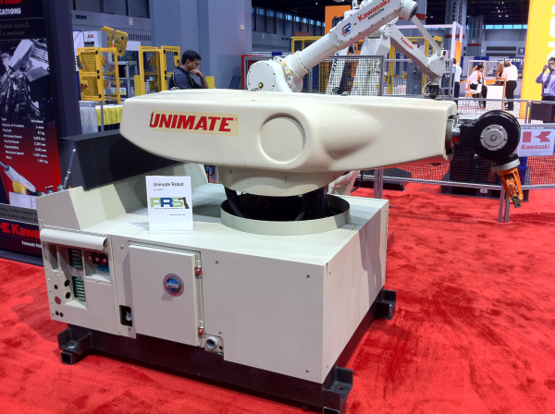
Figure 1- UNIMATE Gripper (George Devol)

Stanford Arm
With Devol being the first to invent a robotic gripper, different versions and improvements of grippers then began to arise. In the 1970s Victor Scheinman, developed a new gripper arm that would be able to move in six axes. This robot was the first electrically powered gripper, which was a change was from the UNIMATE which as pneumatic robot (Scheinman, 2016) (Bélanger-Barrette, 2015). The invention of Scheinman was more commonly known as the Stanford arm, this design meant that robotics and grippers within industry became much more versatile and could move in more axis creating more options to moving in a more complex directions as a human would be able to do (Moran, 2007). Figure 2 shows the Stanford arm developed by Victor Scheinman (Scalera, 2019).

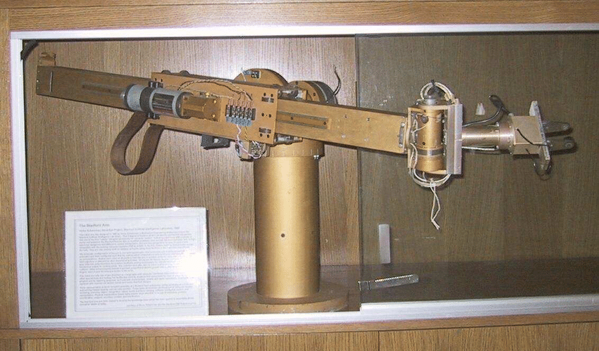
Figure 2- Standford Arm Gripper (Victor Scheinman)

Salisbury Multi finger hand gripper
In the 1980s Salisbury, designed a gripper that implemented the use of hand picking and placing objects. This was great development seeing finger joints, that were able to grasp irregular shaped objects as a hand would be able too (Lionel Birglen, 2018). The design of the gripper was a non-anthropomorphic hand which possess a human hand like structure but lacks the typical features a hand would have (Morgan Quigley, 2014). Figure 3 shows the Salisbury gripper, where more of a human hand end effector was designed to have a better grasp on objects (Grupen, 2005).

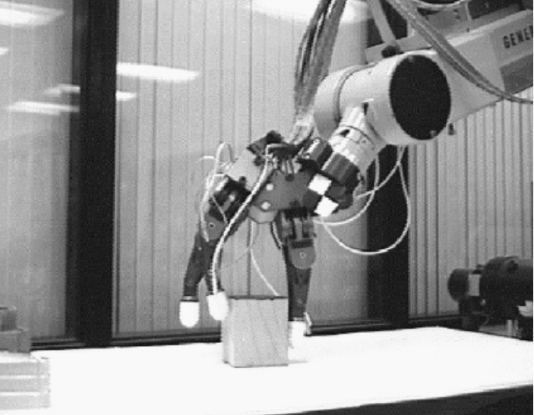
Figure 3- Salisbury Gripper

Soft Grippers
Soft grippers began to get introduced in 1978, although they really started to emerge in the early 2000s. The purpose of these soft grippers is to handle objects delicately without damaging the objects (Josie Hughes, 2016). To also prevent these grippers from damaging the surface of the object, sensors were implemented into the design which allowed the gripper to calculate the force that would be needed pick and place the objects (Jun Shintake, 2018). These soft grippers are particularly useful in environments where the typical rigid grippers may struggle to handle object with complex geometries and fragile materials. The fingers of these soft grippers would typically be made from a material that is elastomeric, which is like a rubber texture. This provides a smooth surface and soft body when applying a force to pick and place an object, minimising the risk of damaging the object (Charbel Tawk, 2019). Figure 4 can show the changes of soft grippers from 1978 to 2016 (Jun Shintake, 2018).

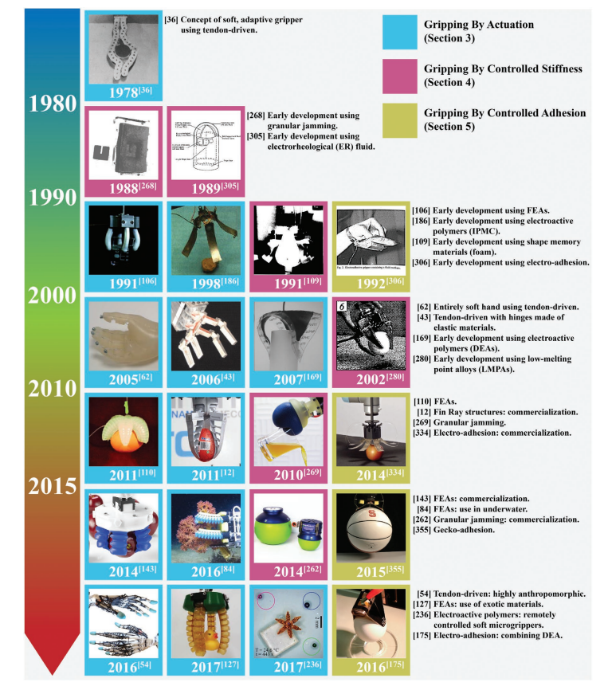
Figure 4 - Development of Soft Grippers

Collaborative Robots
Collaborative robots are the most recent development for robots and grippers, with a lot of industries going automated it was inevitable that a robot was going to be designed where it could work in an environment with humans and to a point making it a safe environment to work in (Bogue, 2016). The development of these robots is still ongoing, while engineers are gathering more information on this development to understands the lengths on how collaborative robots can be within a workspace and how safe it can be to work around humans (Danica Kragic, 2018). Figure 5 is a collaborative robot, and the same robot that the student will be designing the gripper for (RoboDK, 2024).

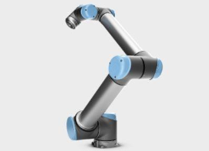
Figure 5- Collaborative Robots

Benefits and limitation of mechanical grippers in industrial use

Mechanical grippers are becoming common tools in industrial automation, offering numerous benefits alongside limitations. One significant advantage would be the simplicity and reliability. Mechanical grippers, offer a robust solution for gripping and handling objects in various industrial environments (Baohua Zhang, 2020). Their mechanical design facilitates easy integration into existing manufacturing processes, contributing to increased productivity and efficiency (Mohammed Salman Azim, 2019).

Benefits that robots have brought into industry include increased accuracy if programmed correctly. The limitation with this would be if the workpiece that was being moved was not in the correct orientation. This could lead to gripper not grasping the object correctly and dropping and damaging the workpiece or injuring a human working in that area (Lionel Birglen, 2018).

Grippers and the robots are expensive to begin which can pose a problem for smaller companies that are wanting to start using robotics as the start-up cost is expensive. Although, once installed robotics use far less energy than humans and can work constant unless the robot is down for maintenance (D. Mourtzis, 2017). As robot grippers need to be programmed, the correct force exerted onto the object must be incorporated into the programming. This can cause complications from handling objects that require a lot of force to pick and place to change to fragile objects, which will cause damages to the new objects. This makes the practically of robots difficult when programming various objects that require different forces to pick and place (Jaime Hernandez, 2023).

End of arm tooling (EOAT)

End of arm tooling is an important part of robotics, the EOAT will refer to the part of the robot that interacts with parts and components. If the robot did not have EOAT the robot would not be useful, therefore by having a EOAT is important in automation. Whether the EOAT is a welding, fastening, or measuring tool. (Team, 2019). However, the most common EOAT that can be seen on a robot would be gripper for pick and placing parts and components (Lappalainen, 2020) (PFA, 2022). Grippers are the focus in this project, therefore their different types of EOAT grippers the three main grippers are the vacuum, mechanical and pneumatic grippers which can be seen in figure 6 (Robots, 2024), (Anon., 2024)
.

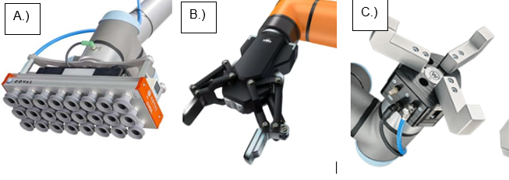
Figure 6- a) Vacuum gripper b) mechanical c) pneumatic gripper

Optimising the EOAT is important with increasing the efficiency of the robot, this could be down too limiting the number of moving parts in the design. By limiting the number of components will improve the ease of control with kinematics, reducing the chances of failure in the EOAT (Ceccarelli, 2009). A poorly designed EOAT can cause negative effects such as cell productivity, which could be the dexterity robot, increased turning radius and extra movements to avoid kinematic constraints (Lappalainen, 2020).

Current designs of a mechanical gripper

Grippers can have many ways to operate to handle different shaped bodies, this section will review different designs of grippers getting inspiration for the development of the initial design. Figure 7 shows Robotiq 2F-140 which the ideal design on how the student will design the desired gripper. The Robotiq 2F-140 can handle different shaped objects without changing the end effectors to suit the task. The design is simplistic engineering and effective, this design of gripper can pick and place objects that will need a parallel grip and a encompass grip around an object. The Robotiq has a maximum stroke of 140mm which gives flexibility on small and large objects, with the maximum payload 2.5kg. The Robotiq also only weighs 1kg and the UR10 Robot weighs 28.9 kilograms, which is a great advancement from the UNIMATE robot that weighed over a 1000 kilograms (Chromos, 2024) (robotics, 2024).

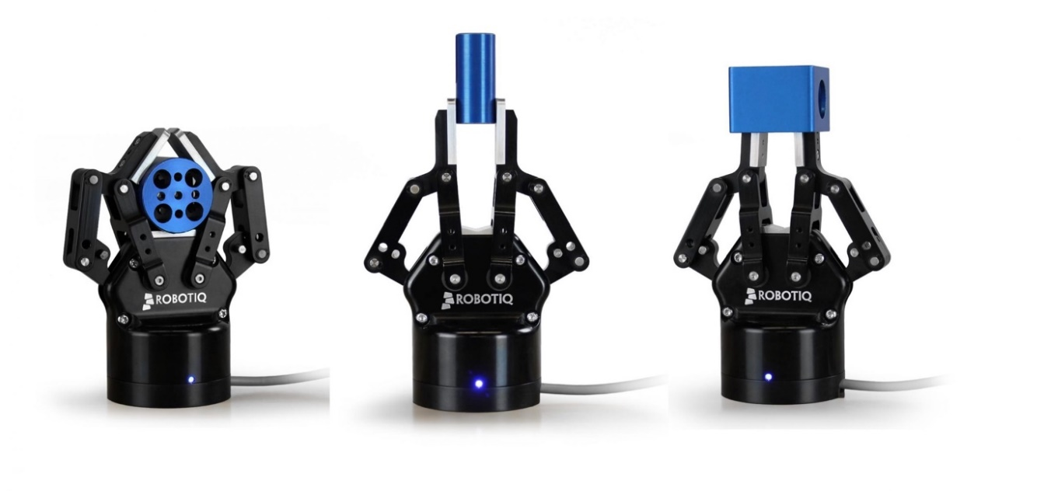
Figure 7 - Robotiq 2F-140

Figure 8 is the Robotic 2F-85 which has the same mechanism as the Robotiq 2F-85, the difference between both grippers is the payload and maximum stroke of the grippers (Maltais, 2020). The 2F-85 model has a maximum payload of 5kg which is double the payload of the 2F-140 model, although the payload is more than this model has lower maximum stroke of 85mm. Both the models have their own benefits, where the smaller model can grasp smaller objects and have a higher payload and the larger model can grasp larger objects but has a lower payload (Jobin, 2019).
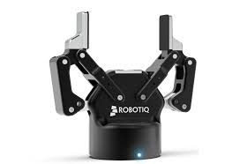
Figure 8- Robotiq 2F-85

Figure 9 shows the object picking of the 2F-140 model, the way that this gripper work is that it has a parallel grip region and encompassing grip region. The gripper has been designed to have an equilibrium line, where the fingers of the gripper can pick up objects based on their geometry. If the object was cylindrical, the fingers will revolve around the object creating an encompassing grip which provides a much better grasp of the object, reducing the chances of the dropping the object. If the object being picked up was a spherical geometry, the gripper will pick the item up with a parallel grip (Robots, 2024). This 2-finger gripper creates a lot of versatility in industry with being able to pick and place items with different geometries, with not having the inconvenience of having two different end effector that need an encompassing grip and parallel grip. Figure 9 can show how the encompassing grip and parallel grip works with different geometries (Bolee, 2022).

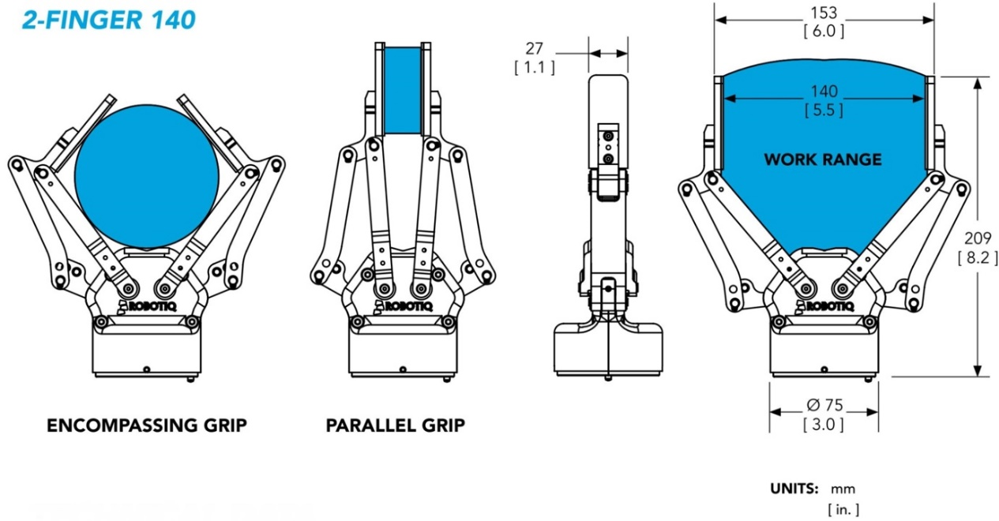
Figure 9- Technical Drawing of Robotiq 2F-140

Importance of additive manufacturing

Additive manufacturing has become an important process in industry today (Mahmoud, 2016). The task of deigning a gripper will be manufactured by additive manufacturing, as the some of the components in the gripper design will be very complex to machine. It would be possible manufacture the gripper by a block of material, although it would be difficult and will waste a lot of the benefits that are supplied by additive manufacturing. By using additive manufacturing, it will benefit the student with reducing the weight, as machining parts to reduce the weight can be difficult with removing material in the correct locations. Therefore, by using additive manufacturing for this application was the most suitable.

AM provides many benefits in industry and these benefits can be used for this project, specific benefits that were important for the project was complex geometries, reduce material waste and weight optimisation (Rohan Prabhu, 2018). By applying a SWOT analysis on additive manufacturing, it will be able to show a better understanding of the Strengths, Weaknesses, Opportunities and Threats of the process. Figure 10 shows a SWOT analysis provided from a conference ‘The importance of Additive Manufacturing Processes in Industrial Applications’ (Mahmoud, 2016).

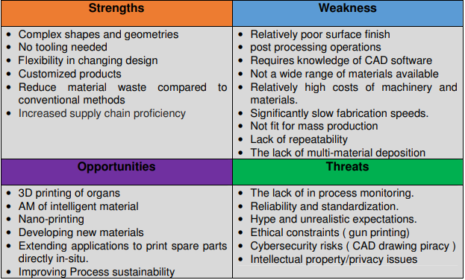
Figure 10 - SWOT Analysis for Additive Manufacturing

Material selection for Additive Manufacturing

Material selection was an important aspect for the gripper, in an ideal situation to choose a material with the best strength to weight ratio. Although that is not practical or cost worthy in this situation, nylon 12 was the material being used for this. Nylon 12 provides good material properties, for this application where moving parts will be involved will increase the rate of wear on components. Nylon 12 provides a lot better characteristics than other nylons, as it has a higher young’s modulus and strength and is used in gears in automotive (Isabel Clavería, 2020). A technical data sheet by Smiths also claims that nylon 12 provides good sliding properties and can be seen in bearings and gear applications (Smiths, 2023). With having the properties of low wear, using nylon 12 can reduce the number of washers in the design, which will reduce the number fasteners and increase the design efficiency of the gripper.

Regulations for Robots
The standard regulations are important to take into consideration when manufacturing a gripper. ISO:10218-2:2011 which states “Safety requirements for industrial robots — Part 2: Robot systems and integration” (ISO, 2011). This provides requirements for when incorporating robotics into the workspace that it follows the safety regulations. This international standard provides the guidance for the safety for the integration and installation of the robot. For the safety standard for a EOAT can be seen in ISO10218-1-2011 which suggest “Robots and robotic devices — Safety requirements for industrial robots — Part 1: Robots” (ISO, 2011). The consideration that needs to be take into consideration with this international standard, where the requirement of the robot would need to have safety barriers which would be on the EOAT to avoid accidents when handling, emergency stop systems which is already included on the UR10 robot.

As the UR10 robot is a collaborative robot, international standards would need to be followed and met when humans and robots are working within the same workspace. ISO/TS 15066:2016 is the standard that needs to be met when collaborative robots are used. This standard can be met when the robot has met the regulations of ISO 10216-1 and ISO 10218-2. The safety of the workspace space is important, to acknowledge that there is space between the robot and human workspace when operating, the space of the workpiece also needs to be taken into consideration (ISO, 2016).

As the gripper will be operating as a tool it will come under the Provision and Use of Work Equipment Regulations, therefore the risk hazards associated with the gripper will need to be addressed (HSE, 2024). Potential hazards that can happen with grippers are crushing when the fingers close, this can be minimised by incorporating sensors to shut off the robot. Another hazard will be impact to a human or machinery, this can be minimised by following the ISO standards. Although as the robot is working in a collaborative workspace there will also be the hazard interaction with humans. PUWER requires that equipment is safe for use, in this instance it will be the gripper, it would require that the gripper is suitable for intended use, safe for use, only people who are trained and have sufficient information and training, accompanied by health and safety measures and used in accordance with specific requirements (HSE, 2024).

Finite Element Analysis
Fine Element Analysis is a technique that in commonly used to predict the behaviour of components, where it can calculate the deformation, von mises stress, strain and more effects that can happen in the material when under a load (Giraldo, 2024). The use of element analysis will be detrimental to find the behaviour on the key elements on the gripper. By carrying out FEA on these components it was possible to find the safety and reliability, without carrying studying the behaviour on the key components it would be inefficient on how safe the design is.

FEA is an important technique in manufacturing, this section will show the important properties that can be used from this method in manufacturing. Firstly, the use of FEA has been crucial in design optimisation, by understanding the stresses that component withstand (Wei Zeng a, 2020). As FEA is calculated by a computer, it reduces the costs of the design and manufacturing process by reducing the number of prototypes. As the test carried out on the design can be done computationally rather than physical test. ANSYS as a software can supply material selection, therefore in industry there is the opportunity to test and evaluate the different behaviour of material and find the most suitable material for that application. FEA is versatile in this instance as by creating many prototypes from a range of materials will increase the cost dramatically. By carrying out FEA studies it also allows the manufacturer to optimise the design to reduce weight, if necessary, because FEA calculates the high and low points of deformation, stress and strain it is then possible to optimise the design by removing material in the area that are not under any loads (Fazilat H Dar, 2002). And the same by improving the design in parts of the design where there is too much deformation to improve the life of the component. Thus, shows like FEA plays a crucial role in manufacturing to optimes the design, saving money and to get a better understanding of the behaviour of the design when under a load.

Design for Manufacture and Assembly

Design for Manufacture and assembly plays a crucial role in manufacturing products, by applying this method can improve the design by reducing fasteners, reducing the number of components in the final design (Comp, 2023). Design for Assembly (DFA) was introduced with the aim the improve the time and cost of the product being designed, making it easier to assemble such as reducing the number of fasteners in the design (Durakovic, 2018). Design for Manufacture is used to reduce the complexity of parts in the design and reducing the numbers of components that would need to be manufactured (Durakovic, 2018). By approaching this method can reduce the cost of the final design by reducing manufacturing time of component and the number of parts that would need to be bought or manufactured (Nilesh Kailas More, 2015). By introducing this method in the early process of designing a product is the most practical, due to by applying this method in the first design can will reduce the time of the design stage. Introducing DfMA in the first design will also guide the designer of the product to make necessary changes to the product to improve the design efficiency (K. Annamalai, 2013). By applying this method on the gripper will guide the designer to the final product whilst improving the efficiency of the gripper, this method will be crucial for the improvement of the initial design to the final product and is used a lot in industry, thus shows that this is credible approach to improve design efficiency.

Selective Laser Sintering

Selective Laser Sintering is additive manufacturing technique for 3D printing components, this technique is commonly used for Rapid Manufacturing (RM), which is a process where a 3D CAD drawing can be directly 3D printed into the SLS machine without the need of tooling (H. Zarringhalam, 2006). By having the option of rapid manufacturing has significantly helped developing the manufacturing time, which improves the production in industry. SLS works by the consolidation of consecutive powders being applied over each other to create layers, this process eventually creates the product that was supplied by CAD (Anketa Jandyal, 2022). SLS provides many advantages, with an important one being able to print complex geometries, that would not be manufactured by many other processes. SLS also provides high accuracy and precision and is also suitable for mass production, with zero external inference needed when a CAD drawing has been applied (Anketa Jandyal, 2022).

Component Consolidation with Additive Manufacturing

Component consolidation is a design method where it is possible to redesign component in CAD into one singular component to reduce the number of components that will need to be assembled. This improves the design efficiency due to fewer components. As 3D printing is produced by layers of powders on top of each other, it allows the process to create nearly any shape, such as internal channels and lattice filled walls (Carolyn Schwaar, 2022). By creating these types of geometries allows the process to create component consolidation which is essentially moving component in one singular assembly without the need of fixings (Zhenguo Nie, 2020). Although this poses benefits by having fewer components in the design, the correct choices are needed on the component that will be 3D printed. If the component failed the whole section will need to be designed and 3D printed again, as there will be no joints to disassemble the design (Moon, 2020).

Methodology

The method that the student approached the design and improvement of the gripper, was influenced by the literature review research. By gaining a deeper understanding of the topic it allowed the student to incorporate the research found into a design. The research that was found in the literature influenced and help the student on designing and improving a functional gripper design. The methodology for this application will include Design for Manufacture and Assembly, the limitations of the gripper and how implementing FEA onto the gripper can help improve the gripper and gain understanding the deviation in the components.

Identifying limitation of designs

Designing a gripper can cause many issues, therefore when the student began the initial design of the gripper considerations were needed for the limitations of the gripper. The gripper design was to be designed to handle different geometries, therefore the limitation of object diversity had to be taken into consideration. The aim of the gripper was to have a multipurpose use, which was to handle spherical and cylindrical objects. The limitations on handling more complex geometries would be that the design of the fingers would not be able to grasp these objects safely. Also, complications can arise when designing grippers with the weight of the component that it will be handling, especially with the UR10 as the UR10 robot only has a maximum payload of 10 kilograms. Therefore, optimising the design to handle different geometries and weight and cause many limitations in the design stage of a EOAT project. Thus, means that when designing the gripper, it will need to be able to adapt to different variations whether it would be weight, size, or shape of the objects. To overcome this limitation was to design an adaptable gripper which will be able to handle different weight, sizes and geometries, this design was influenced by research carried out in the literature review, which helped gain an understanding on how grippers in industry function such as robotiq grippers which can handle different geometries and sizes.

Grip strength was a limitation that the student had to take into consideration, as the gripper would need to be able to apply enough force to be able to grasp the object firmly without it falling out or the grasp being too strong and damaging the object and the gripper. Therefore, applying a sensor was the method to control the amount of force being applied onto the substrate. By applying a sensor into the system, it would be able to calculate the amount of force being applied onto the substrate. As the gripper would be driven by a lead screw connected to a starter motor, this would continue to apply pressure onto the object with not knowing when the right amount of force would be needed. The limitation of this would lead to reduced life on the components on the gripper due to excessive wear and force being applied to them and could lead to damages on the objects that the gripper would be handling.

The gripper needed to be designed to have ease of use, this would decrease the cost if used in industry. As grippers that would have complex drive mechanism would increase design time, manufacturing time and ease of control would be difficult. This would increase the total cost of designing and time manufacturing. Therefore, by balancing this will decrease the cost and improve the ease of use and assembly. As creating of a gripper too complex will pose limitations and difficulties when needing to assemble the gripper, the more parts and fixings will increase the assembly time, it will have a higher chance of being assembled incorrectly and most importantly have a poor design efficiency.

DfMA/ Design efficiency

In the design stage of the gripper the student used design for manufacture and assembly, to the important components in the gripper. The method played a crucial role in the development of the gripper, by improving the ease of assembly of the gripper and unnecessary components. And most importantly by improving the design efficiency of the gripper, influencing important changes that will improve the design. The student used the Lucas process for calculating the design efficiency on the gripper, this method was carried out by deciding if components were essential or non-essential. From carrying out this method on the components and fixings the design efficiency could be produced, the initial design had an extremely low design efficiency which was expected.

The Lucas method shown and helped to guide the improvements needed for a new design, using an iterative technique to make improvements from the initial design to the final design. From this it was possibly to see how much of an effect design for manufacturing and assembly does for designing component. If the gripper did get put through into manufacturing, it would improve the assembly time and the design efficiency of the gripper. The Lucas method can also be used for improving the assembly time.

The Lucas method is a credible method for design efficiency as it is used a lot in industry to guide and improve designs. Thus, shown that by the student using this method is an accurate representation on how to improve a design to industrial standards.

Designing a Multipurpose Gripper

Designing a multipurpose gripper was influenced by following similar steps on how current grippers are designed to handle different geometries. The main design that influenced the student to design a gripper for multipurpose use, was the Robotiq grippers as both these grippers were designed for this use. Figure 11 is from the patent of the Robotiq 2F-85 and it can be seen how the gripper is able to handle different geometries, the figure shows the gripper handling an spherical object and cylindrical object (JOBIN, 2012). The way this gripper is able to handle different geometries is by the design having an equilibrium line on the fingers, if a flat surface was to be picked up by the gripper, it would create a parallel grasp. Whereas, if a spherical object was to be picked up the fingers will create an encompassing grip around the object. This can be seen in figure 11a where the fingers recognise the geometry of the object creating a better grasp to hold the object, this type of gripper provides variety of options increasing the productivity by having a range of gripping techniques.

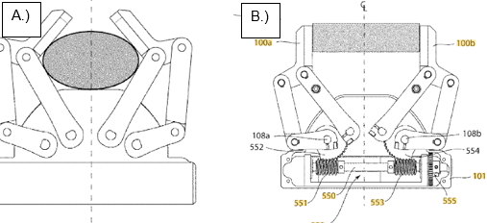
Figure 11- A.) Encompassing grip B.) Parallel Grip

Initial design improvement

The initial design improvement on this gripper, involved taking into consideration of the finding from the design efficiency from the Lucas Method. By analysing the results from this method, it was possible to redesign the components that had a poor design efficiency. This was accomplished by using component consolidation to remove components. The Lucas method provided the design efficiency of the initial design, which was expected to have a poor design efficiency. Although, it allowed it possible to revisit this evaluation on areas that could have been improved. This method does not only improve design efficiency it will also have a cost reduction, such as having fewer fixings and parts to be manufactured which is a significant design improvement and how it would be expected to be conducted in industry.

From the initial design it was possible to apply an iterative design technique, this method allowed the student to refer to the initial design and decide suitable improvements that would benefit the gripper and design stage. These changes were guided by research that had been carried out previously in the report, by imbedding similar design specifications that current gripper designs have. The aim for the design improvements for the original design, was to keep the kinematics of the gripper as it operated correctly with the ability to handle cylindrical and spherical objects. The developments of the gripper that was needed was to reduce the components and fixings, as it had a lot of unnecessary components that could be improved.

Implementing FEA onto the design

Finite Element analysis was an important role of this project, to understand the force that the gripper undergoes when operating. By carrying out an FEA study it allowed the student to acknowledge the limitations of the gripper, such as the maximum forces that can be exerted on the gripper before failure. By carrying out this study the student was able to compare the maximum forces that current design of grippers operating, from this it was possible to obtain results on how heavy component the gripper can handle. From acknowledging the material properties of nylon 12, it was possible to find the maximum force to be applied on the gripper. The results from ANSYS allowed the student to student to compare the results, when the stress on the gripper exceeded the yield strength of the material, it shown that material may fail. From analysing where the maximum stress points occur on the components, it shown areas of the gripper that could be improved.

Initial Design

The initial design of the gripper that the student designed, involved a lot of work and understanding into the arms and drive mechanism of the gripper. As these components were an important section for the design to have multipurpose use. The initial design had a poor design efficiency, as the student did not optimise the design by limiting the number of fasteners and using the advantages of additive manufacturing. By 3D printing multiple components that could be assembled as a singular assembly. The key parameters of the gripper are shown in table 2, where the length of the gripper is 283.63mm, the length of the gripper is justifiable as the largest version of the robotiq gripper has a length of 233.3mm. The robotiq gripper was electronically powered, therefore the gripper does not have a lead screw to drive the gripper, this component increased the length of the student’s gripper with need of a Acoplamento and stepping motor for the gripper to operate accordingly, which increased the length of the design. The width of the gripper without fixings stayed the same throughout the redesigns, due to widest section of the gripper from the support arms, as the student did not redesign the grippers drive mechanism.

Table 2 - Dimension of First Design
Length (mm) | Width (without fixings mm) | Width (With fixings mm)
283.63 | 70 | 80

Table 3 shows all the components in the design of the gripper, the initial design having over 90 components, it was inevitable before completing the design efficiency analysis that this design would have a low design efficiency. The Lucas method for the fitting analysis will also be high due the amount fasteners, this would cause a lot of complications when assembling the gripper, also increasing the overall costing of the gripper having the purchase that many fasteners. The components in this design that are key and would not be removed would be the tool flange, stepping motor, Acoplamento, Drive block, Drive connectors, Drive Elbow, Drive Arm, Upper Elbow, Support Arm and fingers, as without these components the gripper would not be able to operator from the UR10 robot.

Table 3 - Components in the Design
Components | Number of Components
Tool Flange | 1
Stepping Motor | 1
Acoplamento Flexible | 1
T8 Lead Screw | 1
Lead Nut | 1
Drive Block | 1
Drive Connectors | 2
Drive Elbow | 2
Bearing Support | 1
Bearing Housing | 1
Bearing | 1
Drive Arm | 2
Support Arm | 2
Upper Elbow | 2
Sensor | 2
Finger | 2
Finger Pad | 2
Fasteners | 70
Total Components | 96

Table 4- Application of key components
Component | Use
Stepper Motor, Lead Screw, Lead Nut and Drive Block | The stepper motor will be the key component to operate the gripper. It will drive the lead screw which threaded into the lead nut, this will move the drive block in the Y-axis uniformally opening and closing the grippers arms.
Acoplamento | This selection of using this component is to protect the lead screw from torsional vibrations and overloads when the lead screw is being operated by the stepper motor. The acoplamento will be connected to the lead screw and stepper motor (Power Master, n.d.).
Drive Elbow, Drive Arm, Support Arm, Upper Elbow and Finger | These components are crucial on how the gripper will open and shut, from the stepper motor. Designing these components critcally allowed the gripper to have a larger stroke.
Sensor | A sensor was implemented into the design specification in the need of calculating the force exeterted onto the fingers and object. This be crucial for not applying too much force onto the object leading to failure of the gripper.

Figure 12 A and B shows the full assembly of the gripper with all fixings and components. From analysing the figure A and B alone, it is clear to see that the outside of the gripper alone has many fasteners which would cause a lot of complications when assmebling the gripper. Figure 12 C and D, shows the gripper for a multipurpose use, picking up an cylindrical object and spherical. The complexity comes when the gripper handles an cylindrical object, where the fingers create a encompaasing grip around the object.

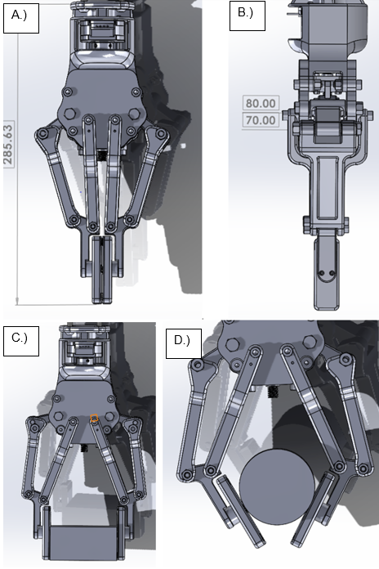
Figure 12 -Figure A.) Front view B.) side view C.) Spehrical D.) cylidrical object
Figure 13 is from a aritcle called “Design and Implementation of a Multi-Function Gripper for Grasping General Objects”, this article supplied an interesting diagram on how a multi-functional gripper operates. This shows a good representation of how the gripper being designed will be able to perform an encompassing grip around the object. Figure13a shows the first contact point of the gripper and how it can perform an encompassing grip (Long Kang, 2019).

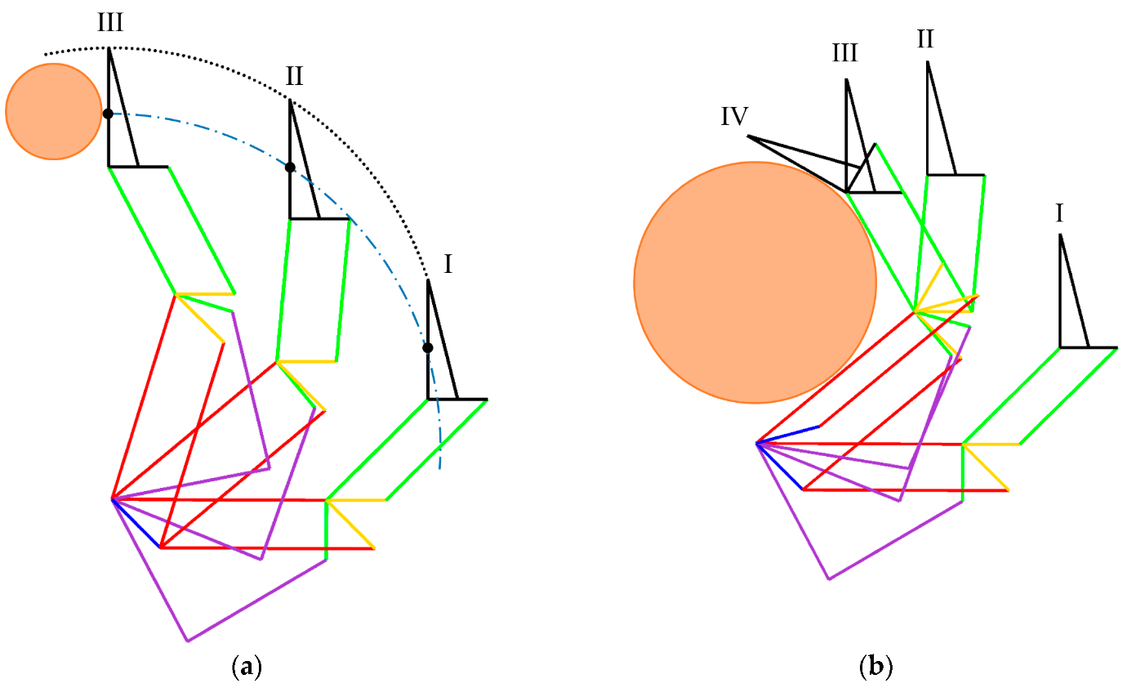
Figure 13- A.) Contact point of finger B.) encompassing grip from equilibrium line

Evaluation and Analysis for Initial Design
This section will cover FEA on the key components of the gripper and using DfAM methods to conclude the design efficiency of the gripper, also including the costing of the gripper if manufactured. This section was crucial on finding the critical results on how the gripper will operate under loads, and the final design efficiency of the gripper which will then instigate the important changes for the further designs of this project.

DfMA

The following analysis is the design efficiency of the gripper by using the Lucas DFA method, this method will show how efficient the gripper design was. From following these steps it will improve the design by reducing times, eliminate errors and reduce the cost of the final design (Jozef Matusze, 2020). This will be achieved by reducing the need of unnecessary fixings and parts in the design or incorporating parts that can be assembled as an individual component. It has been stated in an article by Marek Sikola, that any fastener or component in the design that does not stop the design from functioning are classed as non-essential components, this are usually fasteners as there are always ways around of removing or the of separate fastener (Sikola, 2023).

Boothroyd & Dewhurst (Design Efficiency)
Figure 14 shows the functional analysis that is performed on components and fasteners in the design. The method involves going through this diagram to make decisions based on each question to decide whether each component is an essential or non- essential part which has been stated previously on the functional analysis by Marek Sikola (Farr, n.d.).
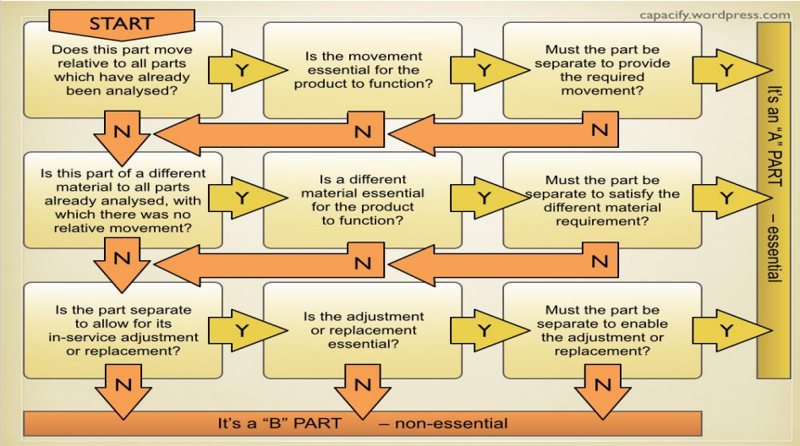
Figure 14- Diagram of functional analysis for Lucas DFA
Table 5 shows the design efficiency of the gripper, the design efficiency of a design should be greater than 60%, if this value is not reached it is suggested for a redesign (Iñigo Ezpeletaa, 2019), (Sikola, 2023). The initial gripper was exceedingly below the recommended design efficiency, this would be for the unnecessarily number of fasteners that have been incorporated into the design. In the initial design there are components that can be designed better, by doing so will reduce the part to one whilst also removing the need of fasteners on this component. The initial design has a design efficiency of 29.76%, this value has a 77.4% difference to the ideal design efficiency of 60%.

From carrying out this study it was evident that many improvements to the gripper were needed for the gripper to achieve the recommended design efficiency. The design efficiency has shown that the current design of the gripper would not be suitable for manufacturing with the low design efficiency, as the current design has 70 fasteners in the design which has not only decreased the design efficiency significantly it will also increase the overall mass of the gripper. Therefore, by reducing the number of fasteners in the design will benefit the gripper in many ways by ease of assembly, reducing weight and the overall cost of the gripper. The components that were improved from this design were improved in this design was by incorporating the tool flange and body, component consolidation on the drive component of the gripper, these improvements are in iterative design technique, which has been implemented by the design efficiency of the Lucas DFA method. From implementing these changes onto the new design has allowed improvement to design by applying the Lucas method.

Table 5- Design efficiency of initial design
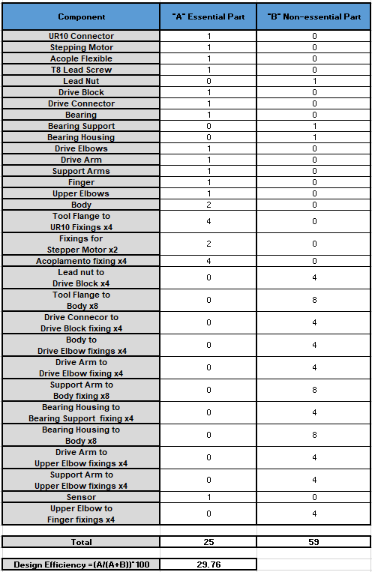
$$design efficiency= \frac{A}{(A+B)}.100$$
Equation 1- Design efficiency

Lucas Fitting Analysis

The Lucas fitting index does not supply much information for improvements on the design. The important factor that can be taken from this method, was if the fitting index was high with respect to the number of fixings and components. This would suggest that the fasteners and components in the design would cause complications when assembling the gripper. Ideally the design would need to have the lowest fitting index possible by following the steps in figure 15, it was possible to calculate the fitting index for the gripper. From the figure it is clear to see that when the assembly of the gripper is complex the fitting index will be higher due the higher scores that will need to be applied on components. The fitting index should not exceed 2.5, if the fitting index did exceed this vaue a redesign should be carried out to improve the design (Iñigo Ezpeletaa, 2019). The fitting index for this design was 4.85, thus shown that the design had to be improved.

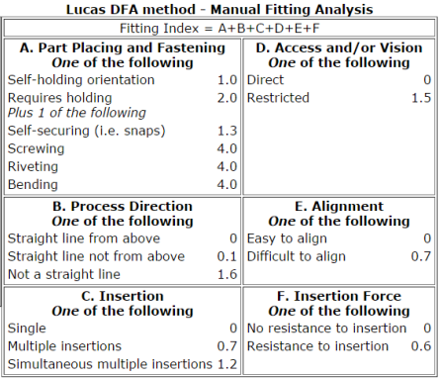
Figure 15- Fitting Analysis

Table 6- Fitting Index
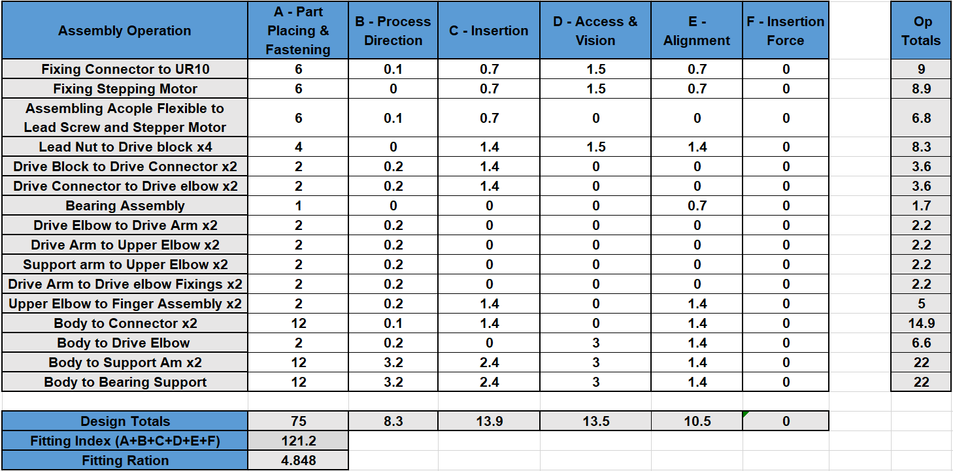

$fitting ration= \frac{fitting index}{A}$
Equation 2- Fitting ration

Lucas Handling Analysis

The Lucas handling index also follows the same rule as fitting index, if the design ration exceeds 2.5, there should be redesign of the design (Iñigo Ezpeletaa, 2019). This process also follows the same process, the greater the overall handling index of the design would suggest that the design would not be as efficient, which can be seen in figure 16 with the scores that would need to be applied to each component. The ration for the initial gripper was 5.07, therefore the gripper exceeded the recommended ration for the handling index. The reason for this design exceeding the value, was because of the number of fasteners in the design.
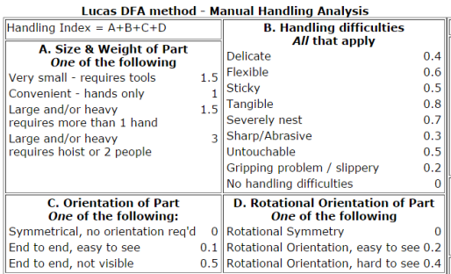
Figure 16- Handling Analysis

Table 7- Handling Index
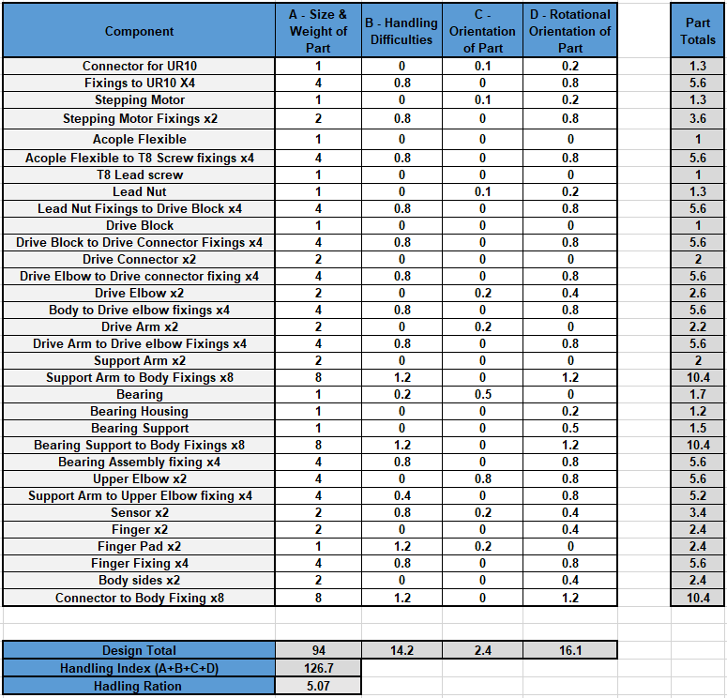

$$handling ration= \frac{handling index}{A}$$
Equation 3- Handling ration

Costing For initial design

Table 8 is the costing of all the fasteners that were needed for the initial, these costing were not the final costing. The costings are shown to show the difference for the final design with aim of reducing as many fasteners as possible. All the fasteners were taken from the same website called Orbital Fasteners (Orbital Fasteners , 2024). As shown in the table the total cost of the fasteners was unnecessary high, which was due to the poor design of the first gripper.
Table 8 – Costing for Fasteners
Part | Quantity | Price Per Unit | Total
M6X16 Button  Head Screw | 4 | £0.06 | £0.24
M3X12 Button Head Screw | 2 | £0.03 | £0.06
M5X20 Socket Cap Screw | 10 | £0.60 | £6.00
M6X55 Hexagon  Head set Screw | 4 | £0.70 | £2.80
M2.5 X 16 Socket  Cap Screw | 6 | £0.70 | £4.20
M4X20 Socket  Cap Screw | 4 | £0.40 | £1.60
M4X35 Socket  Cap Screw | 4 | £0.60 | £2.40
M5X16 Counter-  Sunk Screw | 4 | £0.40 | £1.60
M6 Nut | 4 | £0.10 | £0.40
M5 Nut | 14 | £0.10 | £1.40
M4 Nut | 8 | £0.10 | £0.80
M2.5 Nut | 6 | £0.10 | £0.60
 | Total Cost for Fasteners and Fixings |  | £22.10

Table 9 shows the parts in the design, this costing table was very unlikely to change due to all these components needed for the gripper to operate. The only change that would possible would be the costing of printing, although as the component that would be improved would not change the gripper weight that much (Components, 2024), (Formlabs, 2024).

Table 9- Component costs
Components | Quantity | Price Per Unit | Total
Stepping Motor | 1 | £59.82 | £71.78
Acoplemento | 1 | £54.06 | £64.87
3D Printed  Gripper | 1 | £102 per/kg | £51.24
T8 Lead Screw | 1 | £11.05 | £13.26
Bearing | 1 | £12.73 | £15.28
Load Cell | 1 | £56.00 | £59.00
 | Total Cost for Component and Gripper |  | £275.43

Figure 17 shows the manufacturing process when the CAD file was exported into preform, which was the software that the university uses to 3D print. The total time to print the initial design was 17 and ½ hours, which is a realistic time as additive manufacturing is not a fast process. As seen in the figure the design would need to print 2658 layers. The total powder being applied into the SLS printer was 4.45kg, although this is not the weight gripper, the gripper weighed 0.42kg, therefore the was 4.03kg of unfused powder which means that this was the unused powder in the printing procedure.

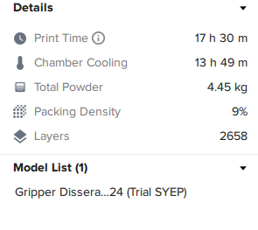

Figure 17- Preform printing.

FEA on Gripper Components

This section undergoes an FEA study on the major component of the gripper design, from carrying out this study on ANSYS it was possible to discover the maximum forces that the gripper can undergo whilst in operation before chances of failure. This will be carried out by applying range of forces ono the fingers of the gripper until the von mises stress exceeds the yield strength of the material.

Table 10 shows the properties of Nylon 12 rigid, which would be the material being used for 3D printing on the gripper by selective laser sintering. The properties that were provided for the properties are from (Granta Edu Pack, 2022).

Table 10- Material Properties for Nylon 12
Properties | Values
Youngs Modulus | 1.21 Gpa
Specific Stiffness | 1.34 MN.m/kg
Tensile Strength | 49.75 Mpa
Yield Strength (elastic limit) | 38.86 Mpa
Compressive Modulus | 1.35 Gpa
Compressive Strength | 63 Mpa
Density | 1.01e3 kg/m3
Poisson’s Ratio | 0.414

Meshing strategy

Figure 16 shows the meshing on the components, which will capture the material properties at each node of the mesh. Creating a larger mesh would not capture the correct results in the body. Creating a mesh too fine can lead to round off error and inaccuracy of the results.
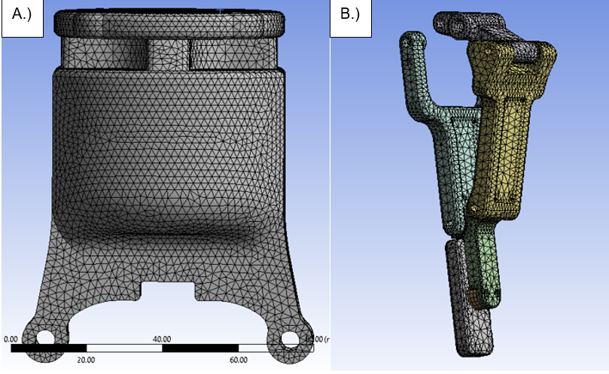
Figure 18- Meshing on key components

Tool Flange

Figure 19 shows the boundary conditions that were applied to the tool flange of the gripper. The student applied fixed supports, which are the sections highlighted in blue in the figure. The fixed supports would replicate tool flange being fastened to the UR10 robot.

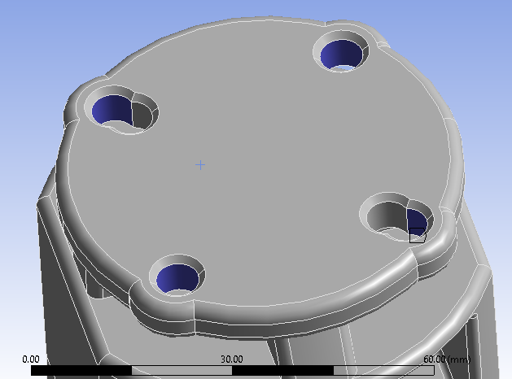
Figure 19- Fixed support Boundary condition.
Figure 20 shows the second condition that was applied onto the tool flange, the student applied a distributed mass along the bottom holes of the tool flange where the gripper will be connected too. This would replicate mass would replicate the mass of the gripper and the object it would be handling; the student entered a distributed mass of 10KG as that is that maximum pay load of the UR10.

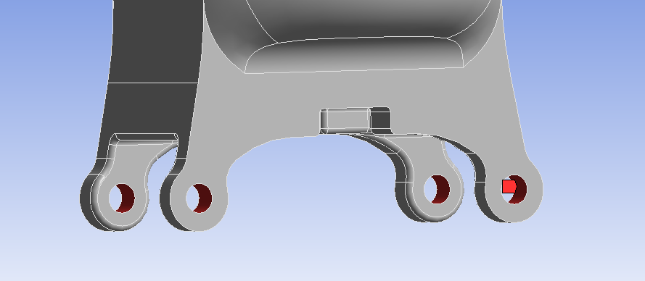
Figure 20- Distributed Mass Boundary condition.
The FEA study that was carried out on the gripper, was finding the deformation, stress and strain on this component with a 10kg mass being applied onto it. Figure 21 shows the results that were calculated through an ANSYS static structural study. As this component is a large solid body the tool flange did not deform under these loads. These results have suggested that the tool flange will be able to withstand the maximum payload of 10KG without deforming or failing under these conditions. Figure 21a shows the stress of the component, these areas with the highest stress points, are in the sections where it would be expected, where the gripper would be fixed onto the UR10 robot. The stress has a value of 6Mpa, when investigating the stress in this area it would not be concerning for failure. The yield strength of Nylon 12 is 38Mpa, therefore the stress on the gripper is far from this value, meaning that the material would not fail under this this. Figure 21b was the strain simulated on the tool flange, the strain for a mass of 10kg was extremely low, therefore this would not affect the performance of the gripper. Figure 21c shows the deformation of the gripper, the areas that are deforming the most are where it would be expected, the top face of the gripper where it will be secured. Also, where the stepper motor will be placed has created a weakness on two fixing slots for gripper. Although the results that have been calculated seem to look extreme, the deformation is not concerning as the value is very small and would not noticeable and affect the operation of the gripper.
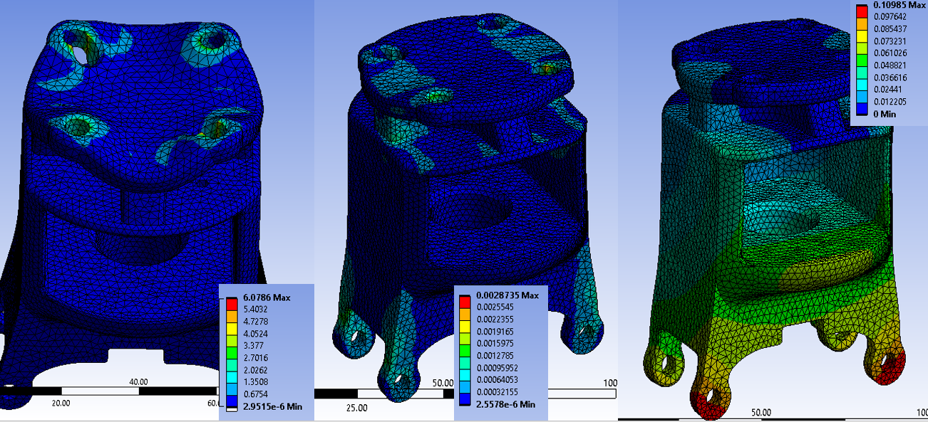
C.)
B.)
A.)
Figure 21- A.) STRESS B.) STRAIN C.) DEF
Table 11- maximum and minimum loads
Max Stress | 6.079  (Mpa) | Max Strain | 0.0028735  (mm/mm) | Max Deformation | 0.10985(mm)
Minimum Stress | 2.951e-6  (pa) | Minimum Strain | 2.5e6  (mm/mm) | Minimum Deformation | 0

Figure 22 shows that by altering the scale of the stress to the yield strength of the material, gave a better representation on how the stress is affecting the tool flange. As shown in the figure it is evident that the stress on the component is from failure, therefore the total weight that the UR10 can withstand will not affect the tool flange.
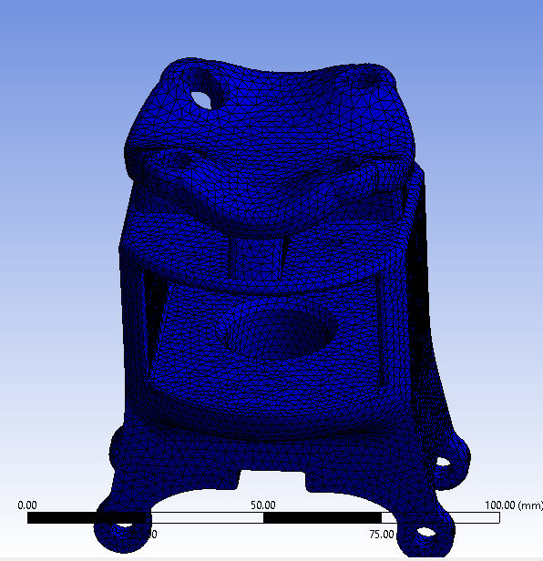
Figure 22- Altered to yield strength of nylon 12

Drive Mechanism

The study the drive mechanisms of the gripper, involved the fingers, upper elbow, drive arm, support arm and sensor, to find out the load these key components will be under when operating. The study was only carried out on these components to reduce solving time of the model, otherwise selecting the correct boundary conditions on the full gripper will increase the chance of inaccuracy due inaccurate supports on components. Also, by solving the full model will cause computational resource problems increasing the chances of inaccurate results on the key components.

The conditions that were applied are as follows:

Figure 23 Shows applying a fixed support on the drive elbow, this will replicate where the elbow would be connected the body.
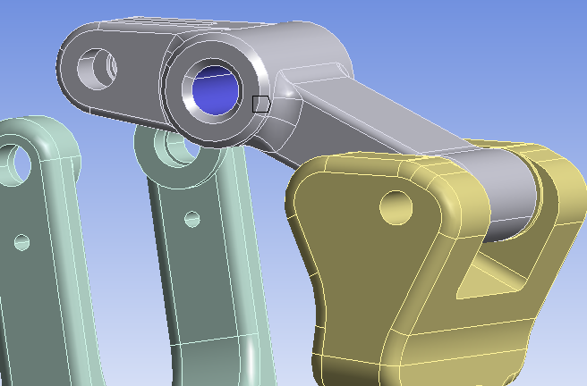
Figure 23- Fixed support on Drive Elbow
Figure 24 shows the joints that were applied onto model, revolute joints were applied onto the highlighted sections. By applying a revolute joint, it allowed these components to move in that axis, acting as the gripper would if a force was applied onto the components. From this it was possible to apply a force onto the finger, as the gripper was picking up an object to find the properties that the drive mechanism go through when operating. From this it would be possible to find the maximum force that the gripper would be able to apply to an object when picking up.
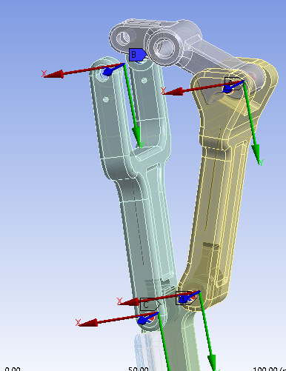
Figure 24- Revolute joints applied on gripper

Figure 25 shows the area where the student applied the force onto the finger, this force was acting as if the finger was meeting an object, therefore by changing the force at each step made it possible to find the maximum force that the gripper can withstand whilst grasping an object.

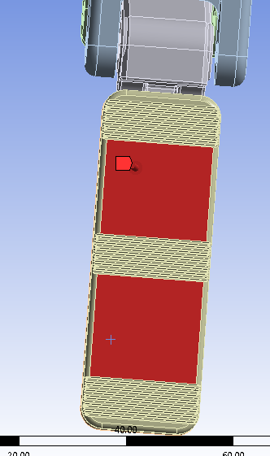
Figure 25- Force applied on gripper

The following results carried out on this component, consisted of applying 3 different forces onto the finger, first by applying a force lower force of 30N to retrieve the loads being applied onto the gripper. A force of 98.1N which is the equivalent of 10kg of force being applied. The final force will be to find the maximum force the gripper design will be able to withstand.

30N

The initial load that was applied to the gripper was 30N, this load condition was chosen to find the structural integrity of the gripper when a low load had been applied. As this was the initial design, by carrying out this study would make it possible to find areas in the gripper that could be improved. Figure 26a suggest that there are highest residuals of stress on the upper elbow of the gripper. This will be from the amount of force being projected thought the fingers of the gripper onto the upper elbow. As the upper elbow is a small component and high forces will have been transferred through the component, it has caused a high circulation of stress towards the top of the component where it will be connected to the support and drive arm.

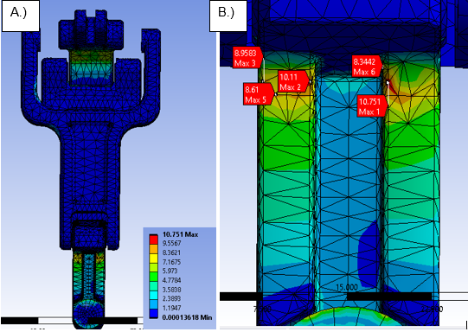
Figure 26- A.) Stress on full component B.) Max stress points
To have a better representation on how the stress points at the lower forces, the student altered the max stress on the gripper to the yield strength of Nylon 12. By doing so changed the full gripper to 38.86Mpa, figure 27 shows that the stress on the gripper is very low compared to the yield strength of the material.

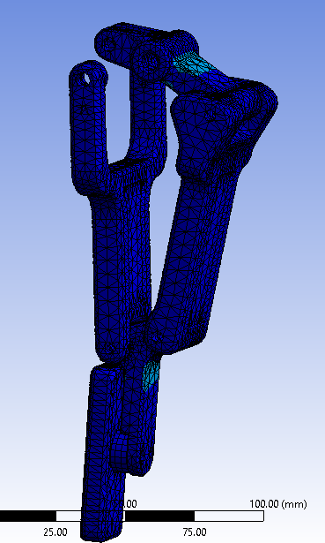
Figure 27-Altering the maximum value to yield of material
Figure 27 shows the strain on the gripper, this high concentration points are in the same area where the stress was localised. Stress and strain are similarly related, this would suggest that where the highest localisation points of stress, there will be high strain in this area. This study has shown that the gripper will be able withstand the maximum induced stresses and strain.
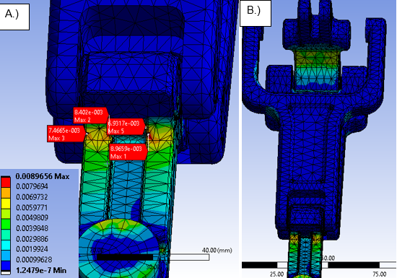
Figure 28 – A.) Max strain points B.) Strain on full gripper at 30N
The maximum deformation in this study does not show too much, as the study was setup with revolute joints, the fingers would be able to move. Therefore, that is why the highest displacement occurs in this area. The results provide justification that the module was carried out correctly as this would be the area that would have the highest displacement on the design. The residuals do suggest on the upper elbow, support arm and drive arm, does not incur a lot of displacement, this has shown that the gripper can withstand the applied force of 30N.

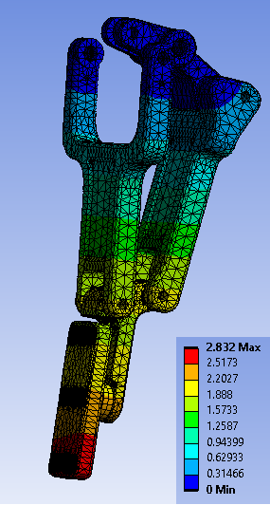
Figure 29- Deformation
Table 12 – Maximum and Minimum loads of Gripper
Max Stress | 10.751  (Mpa) | Max Strain | 0.0089  (mm/mm) | Max Deformation | 2.832  (mm)
Minimum Stress | 0.000136  (Mpa) | Minimum Strain | 1.24e-7  (mm/mm) | Minimum Deformation | 0

98.1N equivalent of 10kg

By applying a load equivalent of 10kg has caused a lot more stress on the gripper, this was down to poor design of the upper elbow, as there was too much material removed from this section as the upper elbow is only a small component. The stress residuals are localised, all in the same area which will eventually cause the failure under these loads. Although, the residuals have not exceeded the yield strength continuous use at these loads will eventually cause the material to fail due to fatigue on the component. The highest stress point is 35.157Mpa, this is only 3.703Mpa of the total yield strength of the material.
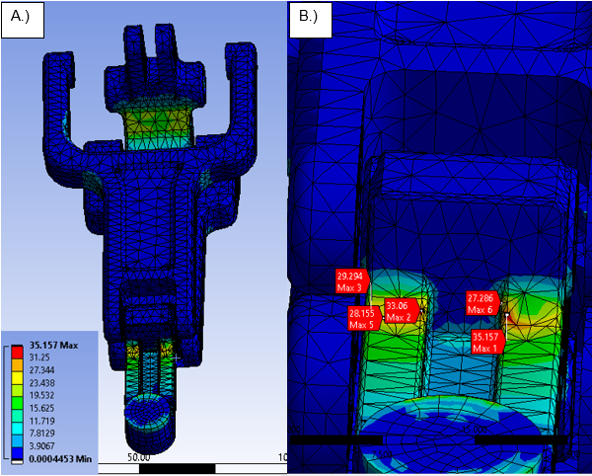
Figure 30- A.) Stress on full component B.) Max stress points at 98.1N
The same method as figure 22 was applied to figure 31 by altering the gauge to the yield strength of nylon 12. Figure 31 suggest that the stress has increased significantly where it is to see in the animation that there are high stresses on the components. This would unveil that the gripper is close to failure.
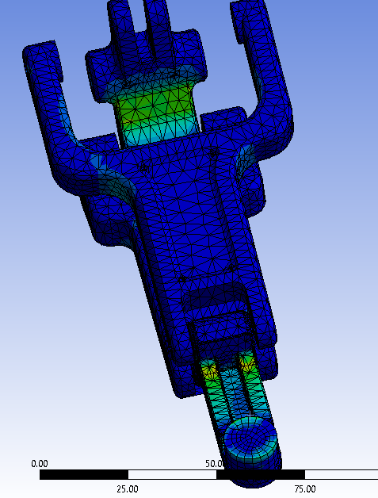
Figure 31- Stress Altering to maximum yield
As mentioned previously the strain will occur in the same places as the stress, therefore the higher stress on the component the more the strain will increase deforming the material even more. Figure 32a shows where the strain is a occurring in the material and figure 32b shows the max probes at where the maximum points of strain in the material. The behaviour of the material under 98.1N, is close enough to failure. Therefore, it would be recommended that this is the maximum force to operate the gripper.
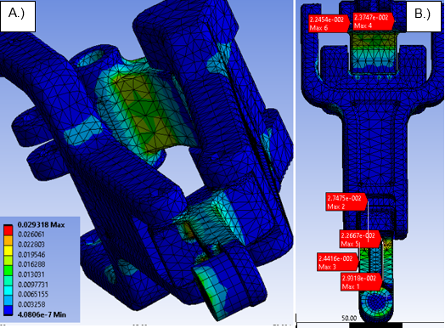
Figure 32- A.) Strain on full component B.) Max strain points at 98.1N
Figure 33 has shown that when the force is increased the displacement on the gripper components also increase, this would be the expected component to occur the highest displacement.

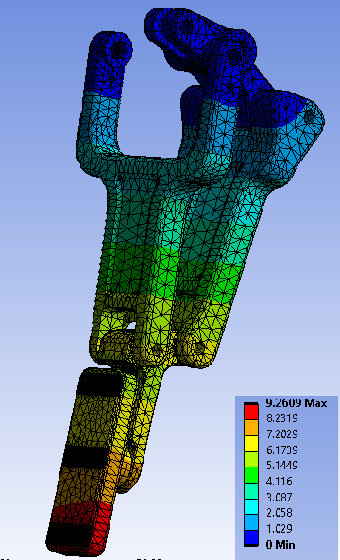
Figure 33- Deformation
Table 13- Maximum and minimum loads at 98.1N
Max Stress | 35.157  (Mpa) | Max Strain | 0.0293  (mm/mm) | Max Deformation | 9.26  (mm)
Minimum Stress | 0.00044  (Mpa) | Minimum Strain | 4.08e-7  (mm/mm) | Minimum Deformation | 0

Maximum force for Gripper (108.44N)

By trial and error, the student applied a variety of different forces onto the finger of the gripper to find the maximum load of the gripper when the stress of component exceeds the yield strength of the material. The maximum force that was found to be applied on the gripper was 108.44N, at this load the stress on the gripper had exceeded the yield strength of nylon 12. Figure 34 shows the maximum points of stress, therefore by the student redesigning the upper elbow to reduce the localization of stress in this area will improve the efficiency and there will be able to handle higher forces. It will be inevitable that this component will have the highest stress due to the amount of force that would be transferred through it. Although the drive elbow has a high stress applied to it, the value is not near the yield point therefore a redesign would not be needed on this component.

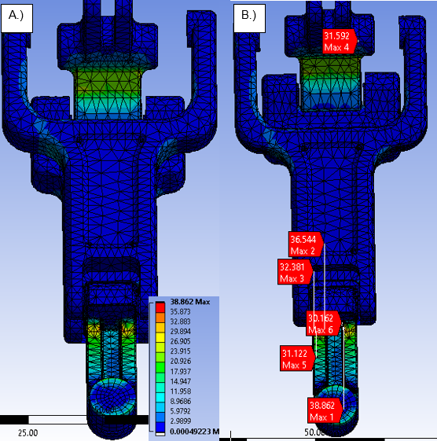
Figure 34- A.) Stress on full component B.) Max stress points at failure

Iterative Design Techniques

Redesign 1
From analysing the design, the fixing for body and support arm fastener was too long which limited the stroke of the gripper to 109.35mm which can be seen in figure 35a and 35b. This caused limitations for when the gripper arms opened, the support arm fixing would encounter the drive elbow fixings restricting the maximum stroke of the gripper. Figure 35c and 35d show the improvement design by using a shorter bolt and thin nut to allowed clearance for the drive mechanism.

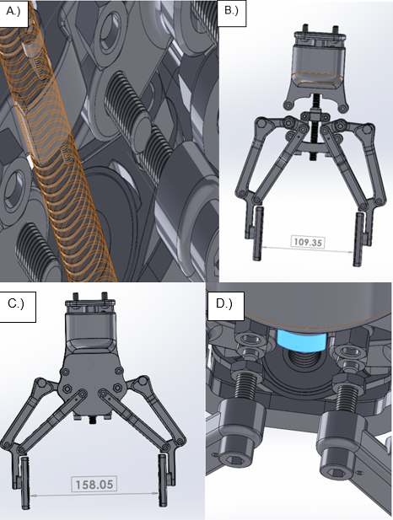
Figure 35- a.) fasteners interference b.) maximum stroke c.) improved maximum stroke d.) new fastener

Incorporating Tool Flange and Body
From critically evaluating the results Lucas DFA method and referring to the CAD design of the gripper, the student was able to analyse the components and parts of the gripper that could be removed or consolidated with each other. A component that stood out was the tool flange and body, this was improved by incorporating the body from the initial design onto the tool flange. This design specification allowed the design to remove 8 fasteners on this component, whilst doing so it would also decrease the printing time as there would only need to be one solid body to be printed rather than 3. As the body for the gripper were two separate components.

Figure 36 shows the redesign of the tool flange and body, the design was limited by the bearing support fixings which came into contact with support arms. This problem was resolved by creating a counter sunk hole, this meant it was possible to use a counter sunk fastener that would sit flush to the body removing the restriction of the support arms opening.
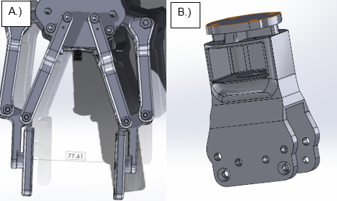
Figure 36 A.) Max stroke because fixing restriction B.) New tool flange design

The same conditions were appplied to the new desing of tool flange, the results caluclated was lower than the initial design which was an improvement. This new design has removed the amount of fasteners and also improved materail beaviour under a 10kg load.

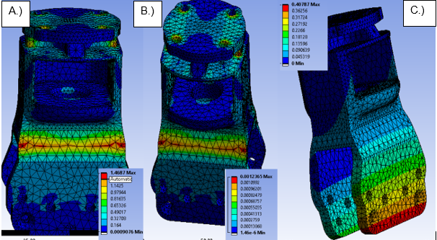
Figure 37 A.) Stress B.) Strain C.) Deformation

Table 14- Maximum and minimum load of 2nd tool flange design
Max Stress | 1.47  (Mpa) | Max Strain | 0.00123  (mm/mm) | Max Deformation | 0.041(mm)
Minimum Stress | 0.0009  (Mpa) | Minimum Strain | 1.46e-6  (mm/mm) | Minimum Deformation | 0

Component Consolidation
By using the benefits of additive manufacturing, it allowed improvements on the design by using component consolidation. This involved creating 5 separate components into one assembly and losing a part as it was not essential part from the design efficiency analysis. As the lead nut that has been removed from the original design, was the component the lead screw to be threaded into to move the drive block translational. Therefore, a redesign was carried out on the drive block by creating a thread on this component which removed the need of the lead nut. By using the benefits of additive manufacturing it was possible to redesign the drive elbow, drive connector and drive block into one singular component, which can be seen in figure 38b. This design improvements meant that design lost 10 fasteners and one part.

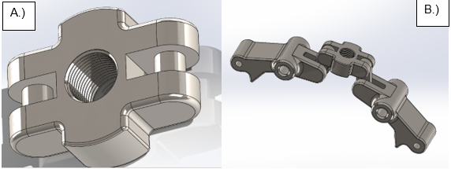
Figure 38 A.) New drive block design B.) Component consolidation.
Table 15- Number of components on design
Components | Number of Components
Tool Flange | 1
Stepping Motor | 1
Acoplamento Flexible | 1
T8 Lead Screw | 1
Component Consolidation for Drive block | 1
Component Consolidation for Upper Elbow and Fingers | 1
Finger Pad | 2
Bearing Support | 1
Bearing Housing | 1
Bearing | 1
Drive Arm | 2
Support Arm | 2
Fasteners | 46

Total Components | 61

The redesign of this gripper removed 36 components; this was possible by the student refereeing back to the analysis on the initial design to make reasonable adjustments to the design to improve the efficiency. This redesign also improves the stroke as the drive block had no more fasteners allowing more clearance when fully extended.

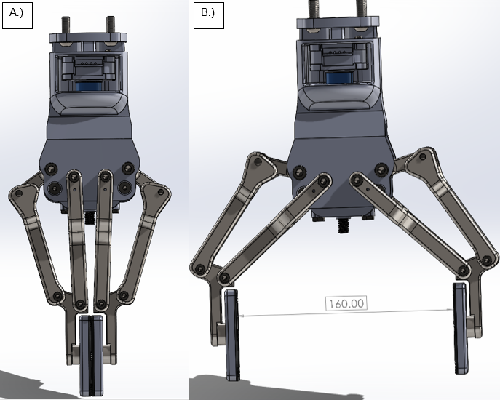
Figure 39- A.) Full gripper B.) Max stroke of new design

The new design of the gripper was in the recommended design efficiency; therefore, the student applied the same method again to further improve the design.

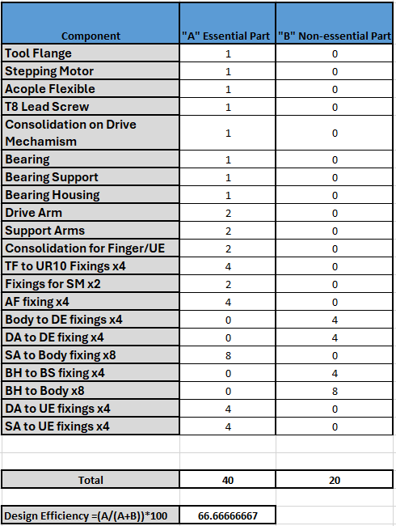
Table 16-Design efficiency 2nd design

Final Design

The final design was a massive improvement from the first design, this design had 70 less components in the design. This was achieved by using the benefits of additive manufacturing and removal of non-essential parts in the design. The final design was 2mm larger in length, this was due to the fact redesign of the upper elbows, which received the most stress in the previous studies.
Table 17- New dimensions of gripper
Length (mm) | Width (without fixings mm) | Width (With fixings mm)
285.61 | 70 | 80

Table 18- Final gripper components
Components | Number of Components
Tool Flange | 1
Stepping Motor | 1
Acoplamento | 1
T8 Lead Screw | 1
Component Consolidation for Drive block | 1
Component Consolidation for Upper Elbow and Fingers | 1
Finger Pad | 2
Drive Arm | 2
Support Arm | 2
Fasteners | 23

Figure 40 Shows the full assembly of the final design. For the final design the student used pins on the arms of the gripper, this removed the need of having nuts and bolts connected to the component. By using pins on these components, it reduced the fasteners to six rather twelve. Figure 40c and 40d show the final design of the gripper being able to handle two different geometries.
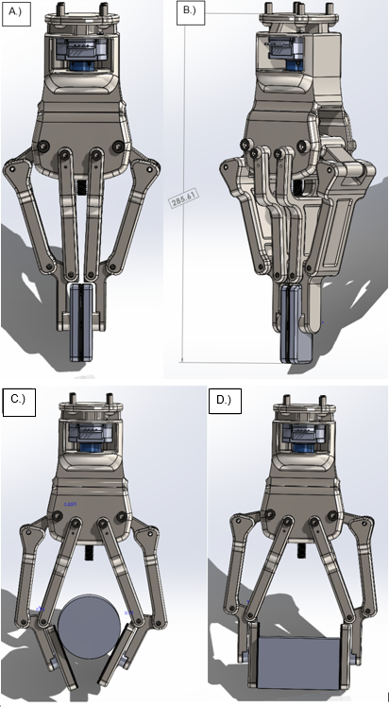
Figure 40- A.) Full Gripper B.) Dimension of Gripper C.) Encompassing grip D.) Parallel Grip

For the final design of the tool flange, the student removed the need of the bearing support and bearing housing, by incorporating these components into the tool flange design, which can be printed as one full component. Figure 41b shows the redesign for the bearing housing.

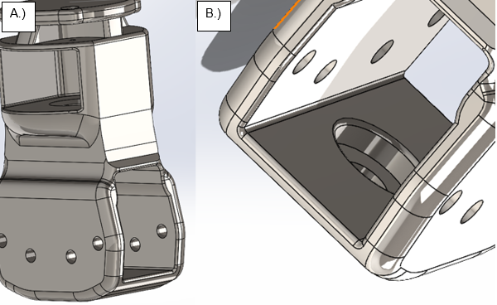
Figure 41 A.) New tool flange B.) Bearing housing redesign

The following figure 42a shows a skeleton view of the gripper, the view from this figure can show that a lot of fasteners have been removed whilst also have the same operation as the initial gripper that had 70 more fasteners. This has shown by applying design for manufacture and assembly techniques plays a crucial role in design optimisation.

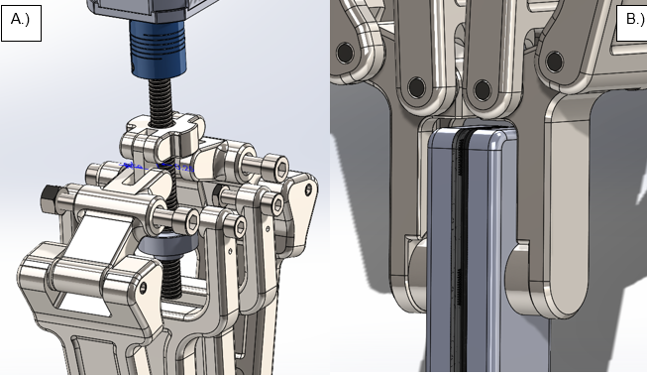
Figure 42- A.) Drive mechanism B.) New choice of fasteners
From the findings in the previous FEA results it was evident that the upper elbow needed redesigning to allow the gripper to handle a wider range of forces. Figure 43a shows the redesign of the component, the student applied more material onto the component where it would be able to handle more forces being transferred through. Figure 43b shows a redesign of the fingers, the student created grooves in the design of the fingers for when handling cylindrical objects, the gripper will be able have a better grasp on the component reducing the chances of the object falling out of the gripper.
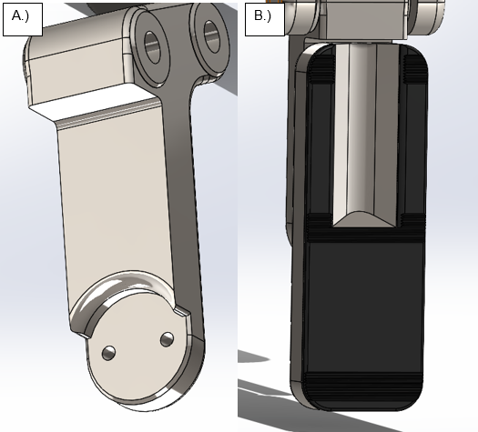

Figure 43- A.) Redesign of Upper Elbow B.) New Finger Design

Evaluation and Analysis on Final Design

DfMA on Final Design

By following the same procedure for the initial design, the student was able to find the design efficiency, fitting index, and handling index of the final design.

Boothroyd & Dewhurst (Design Efficiency)

The design of the final gripper improved significantly from the initial design. This shown that the methods being applied to optimise the gripper has worked and has demonstrated that by applying the Lucas method improves the design by removing unnecessary components. This final design had an 165.3% improvement from the initial gripper; therefore, the aim had been met for the design efficiency by improving the design.
$Percentage Improvement= \left(\frac{Final-Initial}{Initial}\right)×100$
Equation 4- Percentage improvement

Table 19- Design Efficiency of final design
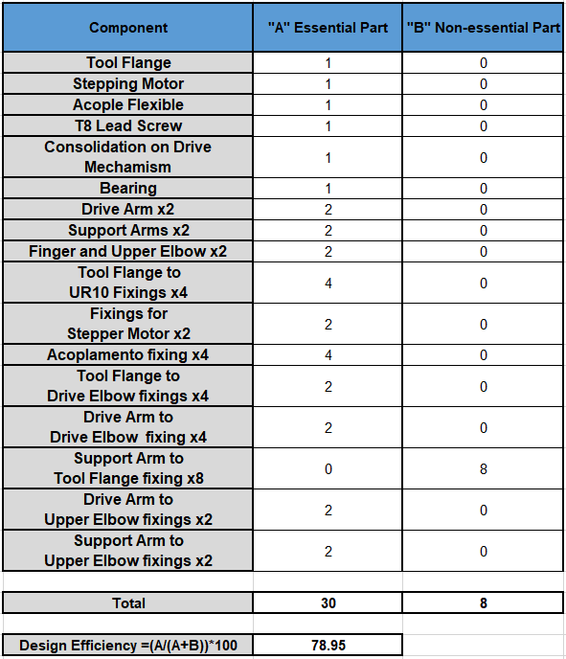

$$design efficency= \frac{A}{(A+B)} . 100$$
Equation 5- Design Efficiency for final design

Lucas Handling Analysis

From removing a lot of components and fasteners the final design has improved for the handling index. The value is below 2.65, therefore the final design is within the criterion and does not need to be redesigned.

Table 20- Handling index of Final Design
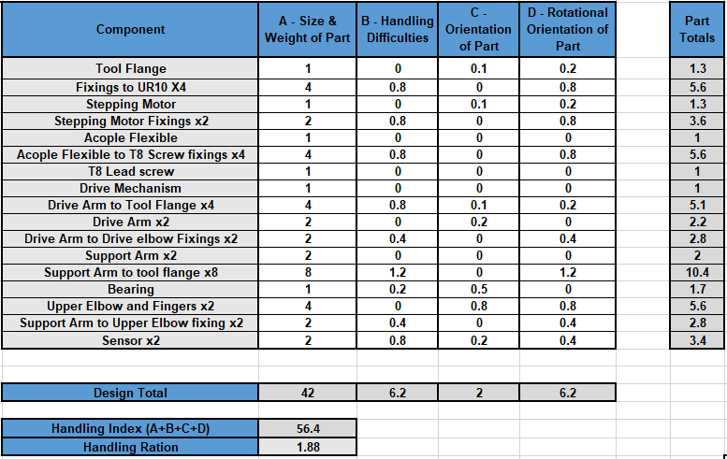
$$handling ration= \frac{Handling index}{A}$$
Equation 6- Handling ration for final design

Lucas Fitting Analysis

This is the same for the fitting index, the student expected the fitting index to be reduced significantly due to the number of fasteners that were removed from the final design. The fitting ration also below the recommended values and would therefore not need to be redesigned.

Table 21- Fitting Index of Final design
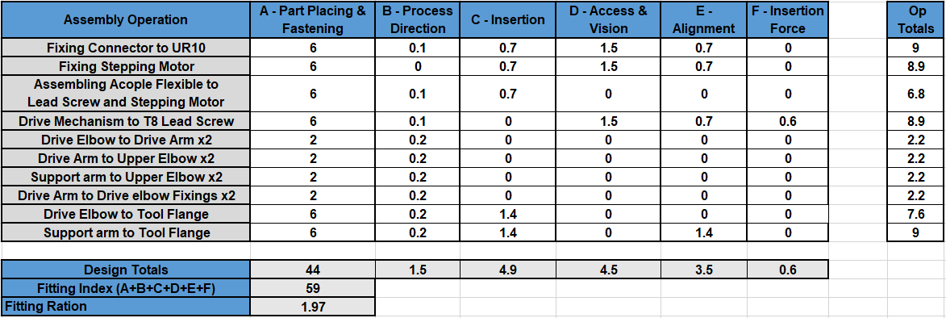

$$fitting ration= \frac{fitting index}{A}$$
Equation 7- Fitting ration for final design

Costing of Final Design

Table 22- Final costings of gripper
Components | Quantity | Price Per Unit | Total
Stepping Motor | 1 | £59.82 | £71.78
Acoplemento | 1 | £54.06 | £64.87
3D Printed  Gripper | 1 | £102 per/kg | £51.24
T8 Lead Screw | 1 | £11.05 | £13.26
Load Cell | 1 | £56.00 | £59.00
M6X16 Button  Head Screw | 4 | £0.06 | £0.24
M3X12 Button Head Screw | 2 | £0.03 | £0.06
M5X20 Socket Cap Screw | 4 | £0.60 | £2.40
M4X20 Socket  Cap Screw | 4 | £0.40 | £1.60
M6 Nut | 2 | £0.10 | £0.20
M5 Nut | 4 | £0.10 | £0.40
55mm Pin | 2 | £0.10 | £0.40
30mm pin | 4 | £0.10 | £0.40
 | Total Cost for Component and Gripper |  | £265.85

The final design took 3 minutes less to print, this was not a significant change onto the design. This would be because of the size of the gripper. Therefore, to reduce the time of additive manufacturing is difficult as it is not a fast process. Figure 44 Shows that the fused powder has increased by 0.01kg, although preform calculated the gripper to weigh 0.42kg without fasteners. This would be because the gripper has not changed size significantly which was the reason the weight not reducing.
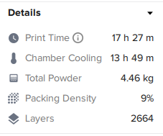
Figure 44- Preform printing Details

FEA on tool flange
Figure 45 shows the studies of FEA carried out on the final tool flange for the gripper, the values obtained from ANSYS have suggested that the new tool flange perform better under 10kg load. The residuals for the gripper are not concerning for failure with them being far from the yield strength of nylon 12. The deformation of the gripper is a lot lower; this would be where the bearing support is, this has strengthened the tool and removed the need of having bearing support and bearing housing.
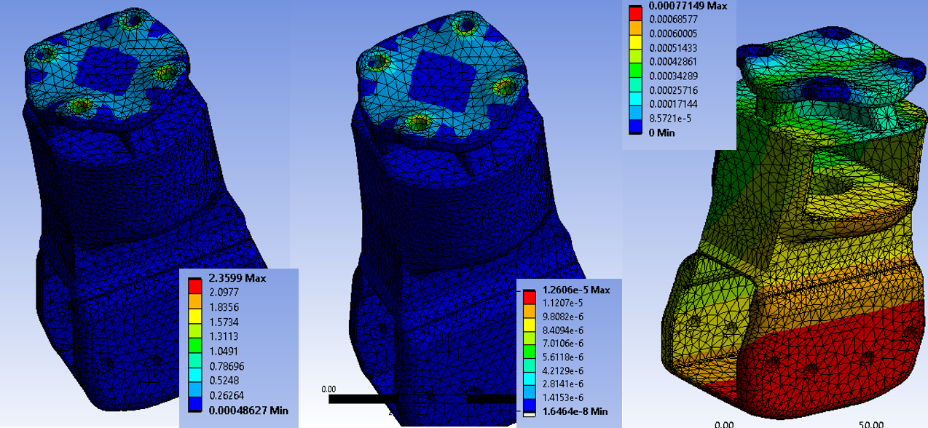
Figure 45- A.) Stress B.) Strain C.) Deformation
Table 23- Maximum and Minimum loads on final tool flange design at 10kg
Max Stress | 2.36  (Mpa) | Max Strain | 1.26e-5  (mm/mm) | Max Deformation | 0.00077  (mm)
Minimum Stress | 0.0005  (Mpa) | Minimum Strain | 1.646e-8  (mm/mm) | Minimum Deformation | 0  (mm)

FEA on Drive Mechanism
The final design followed the process as the initial design by applying the same loading until it is evident that the material may fail. The following results will show how the design has improved by redesigning the upper elbow component, to improve the forces that it can obtain.
30N

Figure 46 shows the force of 30N being applied onto the new design. The stress residuals are lower than the initial drive mechanism by 2Mpa, therefore by making the upper elbow thicker has reduced the force being transferred through improving the behaviour of the material. By having less stress in this component will lower the stresses throughout the drive mechanism, improving the performance of the gripper.
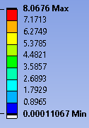
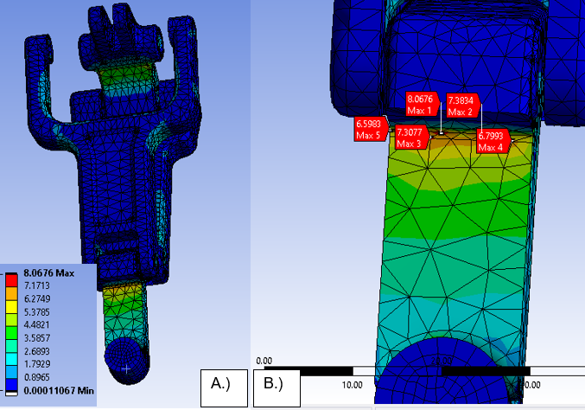
Figure 46- A.) Stress on full component B.) Max stress points at 30N

As previously stated in the report the strain concentrations will be localised where there are high stress points are in the material. Therefore, as the stress has been decreased at this load the strain on the component would have also decreased from the initial design.
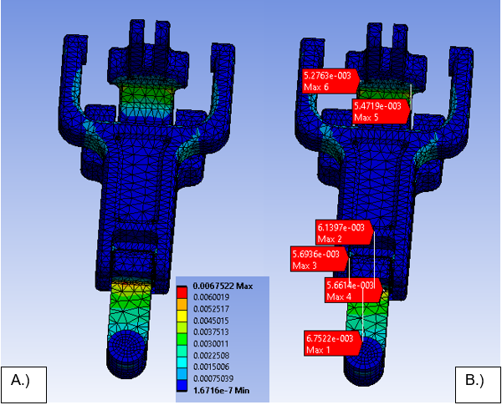
Figure 47- A.) Strain on full component B.) Max strain points at 30N
The deflection of the drive mechanism will not deviate too much on the drive mechanism due to the revolute joints, therefore as stated previously there is not much to take from this result. Figure 48 shows the deflection is on this component, this will be from less deformation on the finger and arms of the gripper. This has proven that the redesign of the upper elbow has reduce the deflection is these areas, which the aim of redesigning this component.
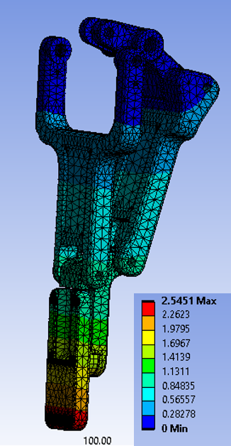
Figure 48- Deformation at 30N

Table 24- Maximum and Minimum loads at 30N
Max Stress | 8.06  (Mpa) | Max Strain | 0.0067  (mm/mm) | Max Deformation | 2.545(mm)
Minimum Stress | 0.00011  (Mpa) | Minimum Strain | 1.67e-7  (mm/mm) | Minimum Deformation | 0

98.1N

The final design can withstand the equivalent of 10kg of force a lot better than the initial design, where the initial design was close to yield strength of the material. The final design has a lot lower residuals at this load, this would suggest the forces are being distributed better through the new design of the upper elbow. Thus, has shown that final design would be able to operate more frequently at this load, without the need of changing the component as frequently due to fatigue.
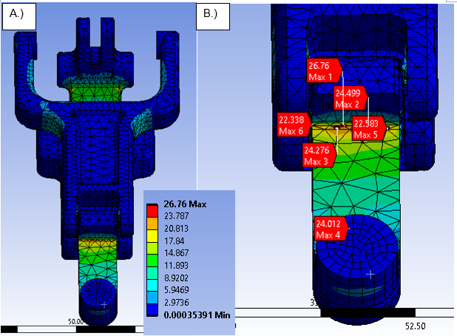
Figure 49- A.) Stress on full component B.) Max stress points at 98.1N

Figure 50 shows the strain being applied onto the gripper at 98.1N, these residuals are also lower than the initial design. The FEA study has justified that the gripper has been improved in all aspect by redesign out the upper elbow being able withstand this force without being close to failure on this component.

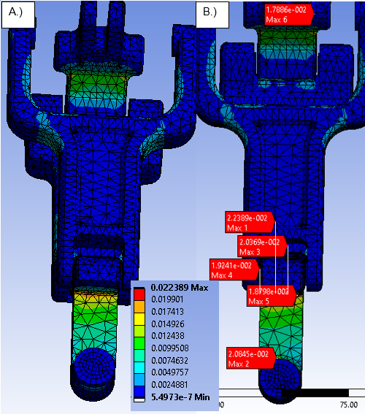
Figure 50- A.) Strain on full component B.) Max strain points at 98.1N

Table 25- Maximum and minimum loads at 98.1N
Max Stress | 26.76  (Mpa) | Max Strain | 0.022  (mm/mm) | Max Deformation | 12.65
Minimum Stress | 0.0003  (Mpa) | Minimum Strain | 5.49e-7  (mm/mm) | Minimum Deformation | 0

Max for 141.25N

The results that were found on the final gripper design, was the maximum force that would be able to apply onto the fingers before the material may fail. The max force that was calculated onto the fingers was 141.25N which was 32.81N of force than the initial design, although at this force the gripper would be in the realms of failing due to the maximum stress applied on the component exceeding the yield strength of the material. This upper elbow was the component that still experience the highest stress and would be the most likely to fail first.
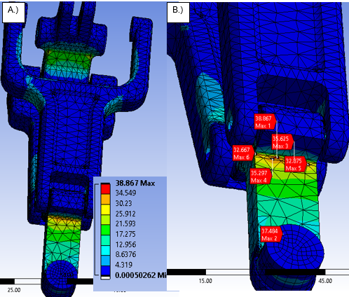
Figure 51- A.) Stress on full component B.) Max stress points at Failure
Table 26- Maximum and Minimum loads at failure
Max Stress | 38.867  (Mpa) | Max Strain | 0.0376  (mm/mm) | Max Deformation | 14.85(mm)
Minimum Stress | 0.0188  (Mpa) | Minimum Strain | 2.88e-5  (mm/mm) | Minimum Deformation | 0

Conclusion

The student aim was to design a multipurpose gripper by additive manufacturing, this was achieved and guided from the literature review. By carrying out research in the early stages of the report of previous gripper design and how a multipurpose gripper would operate, gave the student inspiration for the initial gripper design. The initial design was able to handle different geometries, this was achieved by the recognition on the fingers, when the side of the object are revolved the gripper will create an encompassing grip around the object. Without carrying out research this would not have been possible, as the kinematics of this design are not too complex, the difficult was to have arms of the gripper working symmetrically together.

The report found important finding when applying different manufacturing techniques to improve the design of the gripper. The most important result that were found in this report was the improvement of the design efficiency, the student carried out a DfAM technique called Lucas method. This design technique allowed the student to improve the design by referring to the indexes that are provided in the Lucas method. The initial design had a poor design efficiency of 29%, which was down to fact of the amount of non-essential components in the design, by the student carrying out the design efficiency of the gripper made it possible to make reasonable changes the gripper removing the non-essential component improving the design efficiency and the ease of use. The method posed to play a beneficial role on this application as the final design efficiency was 78%, this was a massive improvement from the initial design without changing too many components in the design. Therefore, this had shown the poor choices that the student applied ono the initial design first design impacted the gripper significantly for the design. The initial design also would cause many complications in assembling as there were too many fixings that the user needs to assembly making the ease of use difficult. This shown that DfAM was credible technique for the student to use in this application, by removing components, lowering costs of the gripper and simplifying using the gripper.

The FEA studies that the student carried out shown the loading conditions that the gripper will undergo when operating. The tool flange, which was the part connected to the UR10 study, needed to be a well designed component where the residuals on the component were not high and would not be near to failure. As the maximum payload of the UR10 robot was 10kg, the student based the loading condition off that weight, to find how the tool flange would react under this load. All three designs of the tool flange did not come close to failure, which justified that the component was a well-designed component and would not be risk of failing when the gripper is operating. The final tool flange was the best for application with the lowest residuals, this was from redesign and incorporating the body and bearing support into the design creating extra support for the design. The aim for the FEA studies for the drive mechanism was to improve the maximum force that these components can withstand whilst operating. From the study it was clear to see from the results that the component causing the limitation on the force was the upper elbow. The student redesigned this component showed considerably amounts of improvement by being able to handle 32.5N more than the original upper elbow design.

To conclude, the techniques and methods the student underwent in this report shown beneficial improvements to the design of the gripper. The literature research posed important information and guidance to design a fully functional gripper, whilst including the important factors that are needed to design a gripper. The guidance of the literature research shown important standards that need to be met when designing a gripper, and from what was found the design of the gripper met them. Thus, has shown that from knowledge that was found and studies carried out in the project, the gripper has met the aims and objectives that had been set from the start.

Further Work

- Fatigue Analysis: Perform fatigue analysis on the gripper to assess its long-term durability and resistance to different loadings. This is particularly important for applications where the gripper will be exposed to repeated use.

- Spring Study: Carry out a spring study on the gripper, where the springs will be used to close the gripper at the maximum stroke.

- Material Choices: This design failure section was the Upper Elbows; a further study could have been carried out to change the material on this component to reduce the stress in this area and improve the longevity of the gripper.

- Life Cycle Assessment: Perform a life cycle assessment on the gripper, to estimate the environmental impact across all stages of its life. This can be from raw material extraction to end-of-life disposal. By doing can identify the opportunities for reducing environment footprint and optimising resource usage.

- Comparison of Design efficiency of Gripper Designs: Reviewing current gripper design and carrying out the Lucas Method on this design, to compare the design efficiency of gripper to industrial grippers.

Bibliography
Anketa Jandyal, I. C. I. W. A. R. M. I. U. H., 2022. 3D printing – A review of processes, materials and applications in industry 4.0. Sustainable Operations and Computers, Volume 3, pp. 33-42.
Anon., 2024. Robot27. [Online]
Available at: https://www.robot27.com/2019/03/12/how-to-pick-the-right-gripper-for-your-cobot/
[Accessed 10 April 2024].
Azim, M. S., 2019. DESIGNING A UNIVERSAL GRIPPING SOLUTION FOR HANDLING PART VARIATIONS IN A ROBOT APPLICATION, Tampere: Tampere University.
Banerjee, A., 2017. Robotics in Indian Industry. International Journal of Engineering Research & Technology , 6(1), pp. 374-379.
Baohua Zhang, Y. X. J. Z. K. W. Z. Z., 2020. State-of-the-art robotic grippers, grasping and control strategies, as well as their applications in agricultural robots. Computers and Electronic in Agriculture, Volume 177.
Bélanger-Barrette, M., 2015. ROBOTIQ. [Online]
Available at: https://blog.robotiq.com/robotics-history-from-gm-workfloor-to-collaborative-robots
[Accessed 03 April 2024].
Bogue, R., 2016. Europe continues to lead the way in the collaborative robot business. The Industrial Robot, 43(1), pp. 6-11.
Bolee, 2022. Bolee Machine Tool Ltd. [Online]
Available at: https://www.bolee.com.hk/en/robotiq-2-finger-85-robot-gripper/
[Accessed 08 04 2024].
Bouchard, S., 2011. ROBOTIQ. [Online]
Available at: https://blog.robotiq.com/bid/29054/Automate-2011-Robot-Roundup
[Accessed 03 April 2024].
Carolyn Schwaar, E. N., 2022. All3DP. [Online]
Available at: https://all3dp.com/1/3d-printing-for-part-consolidation-the-ultimate-guide/#:~:text=Consolidation%20of%20parts%20in%20manufacturing,unit%20with%20no%20assembly%20required.
[Accessed 19 April 2024].
Ceccarelli, C. L. a. M., 2009. An Optimization Problem Algorithm for Kinematic Design of Mechanisms for Two-Finger Grippers. The Open Mechanical Engineering Journal, Volume 3, pp. 49-62.
Charbel Tawk, A. G. M. i. h. P. G. M. G. A., 2019. A 3D-Printed Omni-Purpose Soft Gripper. IEEE Transactions on Robotics, 35(5), pp. 1268-1275.
Chromos, 2024. Chromos Industrial. [Online]
Available at: https://www.cobots.ch/en/product/robotiq-2f-140/#
[Accessed 2 April 2024].
Comp, B., 2023. CAD Crowd. [Online]
Available at: https://www.cadcrowd.com/blog/design-for-manufacturing-and-assembly-tips-dfma-cut-your-product-design-companys-production-costs/#:~:text=DFMA%20commonly%20seeks%20to%20eliminate,snap%2Dfit%20functionality%20where%20possible.
[Accessed 19 April 2024].
Components, R., 2024. RS Components. [Online]
Available at: https://uk.rs-online.com/web/p/stepper-motors/8293547?gb=s
[Accessed 25 April 2024].
Components, R., 2024. RS Components. [Online]
Available at: https://uk.rs-online.com/web/
[Accessed 25 April 2024].
D. Mourtzis, V. Z. E. V., 2017. Augmented reality application to support remote maintenance as a service in the Robotics industry. Procedia CIRP , Volume 63, pp. 46-51.
Danica Kragic, J. G. H. K. P. J. a. R. K., 2018. Interactive, Collaborative Robots: Challenges and Opportunities. Proceedings of the Twenty-Seventh International Joint Conference on Artificial Intelligence, pp. 18-25.
Durakovic, B., 2018. Design for Additive Manufacturing: Benefits, Trends and Challenges. Periodicals of Engineering and Natural Sciences, 10 December, pp. 179-191.
Farr, R., n.d. Capacify. [Online]
Available at: https://capacify.wordpress.com/2015/02/13/design-for-assembly-and-harmony/
[Accessed 25 April 2024].
Fazilat H Dar, J. R. M. a. R. M. A., 2002. Statistical methods in finite element analysis. Journal of Biomechanics, 35(9), pp. 1155-1161.
Formlabs, 2024. [Online]
Available at: https://formlabs.com/uk/store/materials/nylon-12-powder/
[Accessed 2024 April 2024].
Giraldo, G., 2024. Simscale. [Online]
Available at: https://www.simscale.com/blog/fea-for-beginners/#:~:text=FEA%20is%20the%20acronym%20for,heat%20conduction%2C%20and%20fluid%20flow.
[Accessed 10 April 2024].
Granta Edu Pack, 2022. Granta Edua Pack. [Online]
[Accessed 19 April 2024].
Grupen, R. A., 2005. Research Gate. [Online]
Available at: https://www.researchgate.net/figure/The-Stanford-JPL-hand-used-to-learn-robust-adaptive-grasping-policies-using-interaction_fig1_228862101
[Accessed 3 April 2024].
H. Zarringhalam, N. H. N. K. J. d. V., 2006. Effects of processing on microstructure and properties of SLS Nylon 12. Materials and Science and Engineering , Volume 435-436, pp. 172-180.
HSE, 2024. Provision and Use of Work Equipment Regulations 1998 (PUWER). [Online]
Available at: https://www.hse.gov.uk/work-equipment-machinery/puwer.htm
[Accessed 10 April 2024].
Iñigo Ezpeletaa, D. J. U. B. a. J. Z., 2019. DFA-SPDP, a new DFA method to improve the assembly during all the product development phases. CIRP Design, Volume 84, pp. 673-679.
Isabel Clavería, S. G. I. M. G. M. A. L. Á. F. P. C. a. D. E., 2020. Tribological Performance of Nylon Composites with Nanoadditives for Self-Lubrication Purposes. Polymers, 30 September, pp. 1-22.
ISO, 2011. Robots and robotic devices — Safety requirements for industrial robots — Part 2: Robot systems and integration. [Online]
Available at: https://www.iso.org/obp/ui/en/#iso:std:iso:10218:-2:ed-1:v1:en
[Accessed 10 April 2024].
ISO, 2016. ISO/TS 15066:2016 Robots and robotic devices — Collaborative robots. [Online]
Available at: https://www.iso.org/obp/ui/en/#iso:std:iso:ts:15066:ed-1:v1:en
[Accessed 10 April 2024].
Jaime Hernandez, M. S. H. S. J. S. I. R. M. I. I. Z. S. I. A. H. U. A. M. H. R., 2023. Current Designs of Robotic Arm Grippers: A Comprehensive Systematic Review. Robtics, 12(1), pp. 1-33.
Jobin, J.-P., 2019. Robotiq. [Online]
Available at: https://assets.robotiq.com/website-assets/support_documents/document/2F-85_2F-140_Instruction_Manual_CB-Series_PDF_20190329.pdf
[Accessed 08 04 2024].
JOBIN, L.-A. A. D. L.-P., 2012. A gripper having a two degree of freedom underactuated mechanical finger for encompassing and pinch grasping. France, Patent No. 2013075245.
Josie Hughes, U. C. F. G. F. G. A. R. F. I., 2016. Soft Manipulators and Grippers. Frontiers of Soft Robotics, Volume 3, pp. 1-12.
Jozef Matusze, T. S. L. D. a. E. B., 2020. Manufacturbility Assessment of the Product Assembly Processes Design inthe Automotive Indutry. Communications, pp. 112-120.
Jun Shintake, V. C. D. F. a. H. S., 2018. Soft Robotic Grippers, Lausanne: WILEY-VCH Verlag GmbH & Co. KGaA.
K. Annamalai, C. D. S. K. a. M. M. P., 2013. Early Cost Estimate of Product During Design Stage Using Design for Manufacturing and Assembly (DFMA) Principles. Advanced Material Research, Volume 622-626, pp. 540-544.
Lappalainen, N., 2020. Additive Manufacturing and Simulation in Design and Manufacturing of a Robotic Gripper, s.l.: Etteplan .
Li Liu, F. G. Z. Z. a. V. G. D., 2024. Application, Development and Future Opportunities of Collaborative Robots (Cobots) in Manufacturing: A Literature Review. International Journal of Human–Computer Interaction, 40(4), pp. 915-932.
Lionel Birglen, T. S., 2018. A statistical review of industrial robotic grippers. Robotics and Computer-Integrated Manufacturing, 49(1), pp. 88-97.
Lionel Birglen, T. S., 2018. A statistical review of industrial robotic grippers. Robotics and Computer Integrated Manufacturing, Volume 49, pp. 88-97.
Long Kang, J.-T. S. S.-H. K. W.-J. K. a. B.-J. Y., 2019. Design and Implementation of a Multi-Function Gripper for Grasping General Objects. Robot Grasping Manipulation, 4 December , pp. 52-66.
Mahmoud, M. A.-M. a. D., 2016. THE IMPORTANCE OF ADDITIVE MANUFACTURING PROCESSES IN INDUSTRIAL APPLICATIONS. Cairo, AMME.
Maltais, D., 2020. Robotiq. [Online]
Available at: https://blog.robotiq.com/robotiq-improves-the-worlds-best-selling-grippers-for-collaborative-robots#:~:text=The%202F%2D85%20remains%20the,tasks%20and%20harsh%20industrial%20environments.
[Accessed 08 04 2024].
Markets, M. a., 2023. Markets and Markets. [Online]
Available at: https://www.marketsandmarkets.com/Market-Reports/Industrial-Robotics-Market-643.html?gad_source=1&gclid=EAIaIQobChMIvNqvgd6yhQMVZJFQBh09nQhcEAAYAiAAEgKcR_D_BwE
[Accessed 08 04 2024].
Marsh, A., 2022. In 1961, the First Robot Arm Punched In The era of industrial robots began with Unimate, at a GM plant in Trenton. IEEE Spectrum, 30 August.
Martignago, F., 2024. Fortune Business Insights. [Online]
Available at: https://www.fortunebusinessinsights.com/industry-reports/industrial-robots-market-100360
[Accessed 08 04 2024].
Mohammed Salman Azima*, A. L. a. A. P., 2019. Methodology for implementing universal gripping solution for robot application. Proceedings of the Estonian Academy of Sciences, 68(8), pp. 413-420.
Mohammed Salman Azim, A. L. a. A. P., 2019. Methodology for implementing universal gripping solution for robot application. Proceedings of the Estonian Academy of Sciences, 68(4), pp. 413-420.
Moon, S. K. a. S. K., 2020. A Part Consolidation Design Method for Additive Manufacturing based on Product Disassembly Complexity. Applied Sciences, 10(3), pp. 1-15.
Moran, M. E., 2007. Evolution of robotic arms. Robotic Surgery, 1(1), pp. 103-111.
Morgan Quigley, C. S. A. Y. J. S., 2014. Mechatronic design of an integrated robotic hand. The International Journal of Robotics Research, 33(5), pp. 706-720.
Nilesh Kailas More, R. B. B. S. M. A. S. S., 2015. DESIGN FOR MANUFACTURE AND ASSEMBLY (DFMA) ANALYSIS OF BURRING TOOL ASSEMBLY. International Research Journal of Engineering and Technology (IRJET), 2(6), p. 2015.
Orbital Fasteners , 2024. Orbital Fasteners. [Online]
Available at: https://www.orbitalfasteners.co.uk/products/m6x18-butn-skt-screw-1-09-bzp-box-200-bs-4168
[Accessed 26 April 2024].
Paul-Ajuwape, K. A., 2022. Design and Manufacturing of a Lead Screw Robotic Gripper, Massachusetts: Massachusetts Institute of Technology.
PFA, 2022. PFA incorparated. [Online]
Available at: https://www.pfa-inc.com/what-is-an-end-effector-eoat/#:~:text=EOATs%20are%20mechanical%20or%20electromechanical,useless%20without%20the%20end%20effector.
[Accessed 10 April 2024].
Power Master, n.d. Power Master. [Online]
Available at: https://powermaster.com.br/en/produtos/acoplamento-hidraulico-oleo/#:~:text=It%20is%20recommended%20for%20soft,in%20the%20appropriate%20power%20ranges.
[Accessed 26 April 2024].
RoboDK, 2024. RoboDK. [Online]
Available at: https://robodk.com/robot/Universal-Robots/UR10
[Accessed 3 April 2024].
robotics, C., 2024. Clearpath Robotics. [Online]
Available at: https://store.clearpathrobotics.com/products/universal-robots-ur10
[Accessed 2 April 2024].
Robots, A., 2024. Active8 Robots. [Online]
Available at: https://active8robots.com/robotiq-2f85/
[Accessed 08 04 2024].
Robots, U., 2024. Universal Robts. [Online]
Available at: https://www.universal-robots.com/fi/plus/products/coval/suction-cups-vacuum-gripper-cvgl335xa50c1/
[Accessed 10 April 2024].
Rohan Prabhu, D. T. W. S. D. S. R. M. D. N. A. M., 2018. THE EARLIER THE BETTER? INVESTIGATING THE IMPORTANCE OF TIMING ON EFFECTIVENESS OF DESIGN FOR ADDITIVE MANUFACTURING EDUCATION. Quebec City, ASME.
Scalera, L., 2019. Research Gate. [Online]
Available at: https://www.researchgate.net/figure/Stanford-Arm-from-16_fig2_329590080
[Accessed 03 April 2024].
Scheinman, V. M. J. S. J., 2016. Mechanism and Actuation. In: Springer Handbook of Robotics. s.l.:Springer, Cham, pp. 67-90.
Sikola, P. L. a. M., 2023. Design of Hydraulic Quick Coupling Using DFA. Atlantis Highlights of Engineering, 30 May, pp. 50-54.
Smiths, 2023. Smith Metal. [Online]
Available at: https://www.smithmetal.com/pdf/plastics/nylon-12.pdf
[Accessed 09 April 2024].
Team, A. M., 2019. Automate. [Online]
Available at: https://www.automate.org/robotics/blogs/eoat-in-robots-a-basic-overview#:~:text=End%20of%20arm%20tooling%20(EOAT)%20is%20a%20crucial%20aspect%20of,on%20a%20robotic%20welding%20system.
[Accessed 10 April 2024].
Wei Zeng a, Y. L. b. X. H. c., 2020. Biomechanical evaluation of internal fixation implants for femoral neck fractures: A comparative finite element analysis. Computer Mehtods and Programs in Biomedicine , Volume 196.
Zhenguo Nie, S. J. L. B. K. K. S. W., 2020. Optimization of Part Consolidation for Minimum Production Costs and Time Using Additive Manufacturing. Mechanical design, 142(7).

