
Master of Business Administration Programme
LCMB7035 - Dissertation
Dissertation Proposal Structure
Topic-“The Role of Green Marketing Strategies in Shaping Consumer Buying Behaviour: A Case Study of The Body Shop UK”

Table of Contents
Proposal 3
1. Introduction 3
2. Literature review 5
3. Methodology 10
4. Expected findings 11
5. Limitations 11
6. Timeframe 12
7. Conclusion 13
References 14

Proposal
1. Introduction
Background of research
Green marketing strategy refers to the process of product and service promotion considering environmental sustainability measures. Responsible approach of product development helps in gaining understanding about the principles of competitive edge. Green marketing shapes consumer approach by using eco-labels and certifications to develop trust, promote strategy of sustainable innovation (Aldaihani et al. 2024). Core axioms of consumers’ preference are completeness, transitivity and non-satisfaction. Attitude-behaviour gap creates situational barriers in competitive positioning and understanding the connectivity between buying decisions, psychological preference becomes difficult. Green marketing affects consumers’ buying decisions by promoting environmental consciousness, eco-friendly product attributes. For example, Body Shop UK adopts the application of natural ingredients such as recycled material for sustainable packaging, community-focused social activism and commitment towards sustainable practice. Green products of Body Shop include natural and organic ingredients, 100% recycled PET Plastic use, and avoidance of toxic raw materials. Based on the objectives of the research it can be stated that Body Shop focuses on creating awareness regarding eco-friendly consumption. In the earlier research the strategy to drive consumers’ loyalty with eco-friendly product attributes is missing and skepticism towards the claim of greenwashing creates questions for the company's reputation.
Significance (Purpose and direction of study)
The purpose of the research is to analyse the role of green marketing strategy in shaping consumer overview in The Body Shop UK. Cultural, social, psychological, economic factors determine buying behaviour of customers and it directly shapes their brand preferences (Sumarsono et al. 2025). Thus, the direction of the study is to generate awareness of environmentally-focused products, eco-friendly promotion creating sustainable outcomes by The Body Shop.
Issue identification
Community Fair Trade Programme aims at production of ingredients that provides extensive benefits to the communities worldwide (The Bodyshop, 2025). Challenges faced in implementation of Green Marketing strategy include issues of green washing, evolving shift in consumers’ expectation, high competition from new brands, unsubstantiated sustainability claims. This issue will be addressed in the study with focus on understanding customers’ psychology and making them aware regarding eco-friendly consumption.
Research aims and objectives
The research aims to evaluate the role of green marketing strategy in determination of consumer approach in The Body Shop, UK.
- To analyse the importance of green marketing in shaping consumer overview in The Body Shop.
- To evaluate the strategy to use green marketing in determination of consumer behaviour in The Body Shop, UK.
- To understand challenges observed by The Body Shop in application of green marketing strategy for determining consumer perspectives.
- To recommend strategies to deal with the challenges observed in implementation of green marketing strategy by The Body Shop.
Research question
What is the importance of green marketing in shaping consumer behaviour in The Body Shop UK?
What strategies are helpful to determine consumer behaviour with focus upon green marketing strategy?
What are the challenges faced by The Body Shop in making adequate application of green marketing for shaping consumer behaviour?
How does The Body Shop address the challenges of green marketing in consumer decision-making?
Rationale
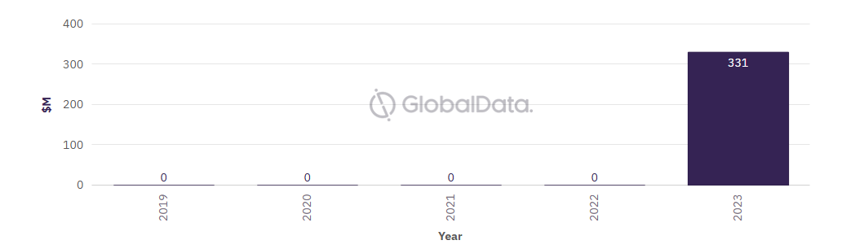
Figure 1: Value of deals
(Source: Globaldata, 2025)
The above figure highlights the trend of change observed in deal value to determine progress index. Perceived gap between the existing ethical image and existing business practice is the most notable issue for The Body Shop for green marketing. Average deal value has reached from $M200 in 2020 to $M331 in 2023 indicating intense transition in the business practice (Globaldata, 2025). Increase in production cost of Body Shop due to the use of sustainable material and lack of standardised green certification are notable challenges. Lack of consumers’ awareness is the issue identified and this research will help to develop strategy to apply green marketing in addressing the gap. Thus, in future it can create challenges for The Body Shop in a continuously evolving consumer market.
2. Literature review
Importance of green marketing in determining consumer behaviour
Literature is the strategy of comprehensive analysis of previously published journal articles in order to develop insights on the topic. Inclusion of different scholars' opinions helps to add value to the topic and gain insights on the core context. Green marketing helps in shaping consumers’ buying behaviour and gaining progress in competitive advantage can be helpful.
Green marketing helps in increasing awareness among consumers and access success in eco-label sustainable branding by The Body Shop. According to the opinion of Alzghoul et al. (2024), fostering brand loyalty and higher cost of green production create barriers in determining consumer behaviour. For example, The Body Shop pioneers green marketing strategy with focus on refillable and recycled strategy of packaging. Ethical materials of sourcing used by the company are FSC-certified words, RSPO-certified palm oil (The Bodyshop, 2025). Green advertisement helps in determination of consumers’ preferences and gaining competitive advantage can be easier. In the context of sustainable packaging Braik et al. (2024), stated that inclusive environmental considerations can be achieved with a sustainable distribution network. The figure below evaluates the connectivity between green buying decisions and environmental awareness. Thus, it is necessary to address the challenges observed due to the lack of awareness among consumers of The Body Shop.
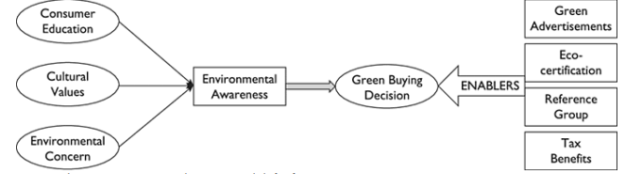
Figure 2: Stages of Green Buying Decision
(Source: Öztürk, 2025)
Strategy implementation for achieving success for green marketing
Green marketing strategy helps in developing consumers’ awareness regarding environmental sustainability issues with interactive social media campaigns. According to the view of Deshmukh and Tare (2024), Eco-label and certification helps in developing transparency, trust for interactive engagement. For instance, The Body Shop pioneer transparent campaigns with ethical storytelling to drive positive change in business dynamics. In the context of interactive engagement Braik et al. (2024), agreed and stated that being rooted in sustainability, ethical sourcing and strategy of consumers’ engagement are crucial. Furthermore, sustainable product design with energy efficient and eco-friendly strategy can assist the goal of reaching eco-conscious consumers. Transparent green branding creates space to manage supply chain sustainability and creation of reliable output can be helpful. Gap in value alignment is responsible for the trust and credibility challenges encountered by The Body Shop. Therefore, the requirement is to address the social and ecological challenges observed in implementation of green marketing.
Evaluating challenges in implementing green marketing for shaping consumer behaviour
Price sensitivity is the most crucial area of challenge observed by organisations in shaping consumers behaviour. According to the view of Busemeyer et al. (2025), successful implementation of green strategy appears to be challenging due to the issue in organisational culture. For instance, The Body Shop finds green marketing challenging due to the emergence of new entrants, managing premium price for green products. Additionally, the phenomenon of consumers switching brands has contributed to the business challenge by the company. On the context of high production cost Sumarsono et al. (2025), opined that consumers’ scepticism due to the green washing makes it difficult for brands to gain success in value creation. The figure below identifies the role of organisational culture in determining green strategy and improving financial performance. Inconsistency in regulations is responsible for perceived compromise to the brand performance and gaining genuine benefits becomes difficult.
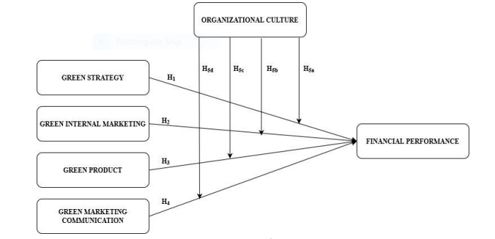
Figure 3: Challenges in green marketing
(Source: Akuma et al. 2025)
Recommendation of strategies to implement with the obstacles observed in green marketing
Development of community awareness with authenticity and transparency in approach are two notable strategies to address challenges of green marketing. It is recommended to develop an eco-friendly process of designing with value-driven informative marketing campaigns. As per the view of Shao et al. (2025), green supply chain management provides an opportunity to reduce harmful footprint and conveying the green promotional message can be helpful. Utilisation of recyclable and biodegradable options can optimise the scope for ethical logistic management principles. In the context of ethical sourcing Akuma et al. (2025), agreed and opined that building brand credibility is essential to convey the message. Furthermore, it is suggested to design a value-driven approach for localised informative campaigns and creation of awareness can be beneficial. Therefore, addressing challenges observed in green marketing for shaping consumers’ behaviour can turn out to be helpful.
Theoretical framework
Social Practice Theory of Marketing
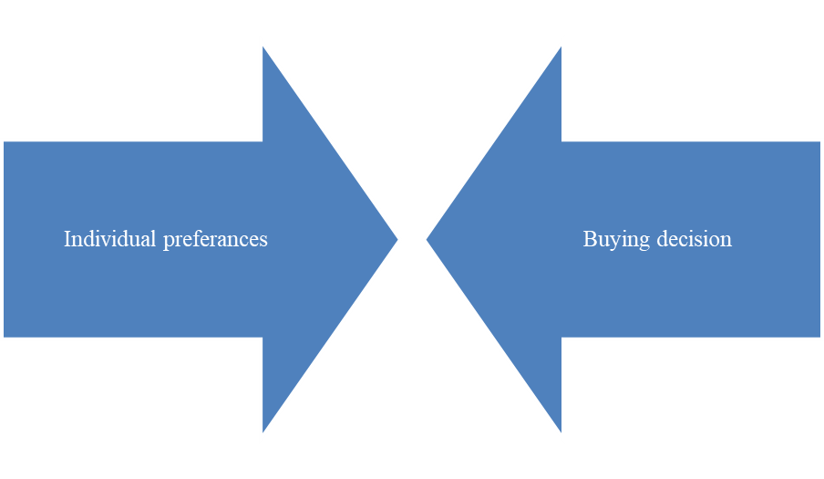
Figure 4: Social Practice Theory
(Source: Self-developed)
Social Practice Theory in Marketing focuses on individual preferences of consumers and gains insights regarding buying decisions. Evaluation of consumers’ psychology is the most notable factor to be considered to accomplish success in competitive growth opportunity (Salo et al. 2024). In terms of implementation of green marketing strategy, it helps to enhance environmental awareness, develop positive brand perception and generate purchase intent for sustainable products. Social practice theory helps in understanding the shift in customers’ preferences and its implication on buying decisions. Applying the theory provides an opportunity to formulate awareness and reach the desired objectives of green marketing for future progress. In case of application of the theory, gaining insights regarding the individual preference of customers and making them aware regarding the benefits of sustainable buying behaviour can be helpful.
Revealed Preference Theory of Consumers’ Behaviour
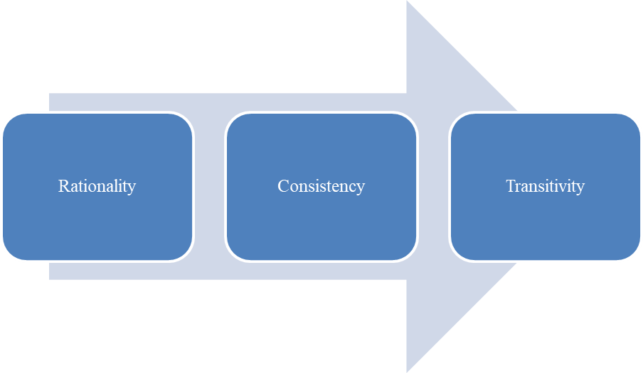
Figure 5: Revealed Preference Theory of Consumers’ Behaviour
(Source: Self-developed)
Identification of purchasing patterns of customers is the most vital part to accomplish success in competitive edge. Analysis of consumers’ psychology is the primary stage to be considered to develop a stable market (Fujiwara et al. 2025). Rationality, consistency and transitivity are three pillars to develop a stable framework in evaluating consumers’ behaviour. Observation towards the purchasing choice of customers to infer their preferences is the purpose of the theory. Observation-based revelation of preference helps in managing consistency in brand positioning in targeted markets. Application of the theory helps in increasing awareness regarding sustainable purchasing decisions, driving willingness to consume premium eco-friendly goods. Additionally, influencing brand choice is directly linked with demonstration of commitment towards sustainability and management of ethical values can be helpful.
Literature gap
The literature review section has shed ample amount of light on the importance of green marketing strategy in determining consumers’ buying behaviour. However, less focus is given towards evaluation of consumers’ psychology and its impact on developing awareness of sustainable consumption. Cost management is one of the crucial challenges in gaining success for green marketing implementation (Rawat and Pande, 2024). Evaluation of both the consumers’ psychology and buying potential are necessary to gain success in competitive positioning. Moreover, this section lacks clarity regarding the process of managing cost effective strategy of production along with green supply chain implementation. Therefore, the requirement is to manage balance between green marketing and its effect on consumer behaviour.
It can be summarised from the above literature review that creation of awareness is the most notable area of consideration to get the opportunity of competitive positioning. Understanding consumers’ psychological preferences is the primary area to be considered and implication of it is observed on success of green marketing.
3. Methodology
Research approach
Inductive research approach will help in focusing upon the specific observation and demonstrates insights on the topic. Green marketing helps in shaping consumers’ preferences towards environmentally responsible approaches to consumption (de Oliveira Lima et al. 2024). Inductive research approach will help to understand the strategy to develop environmental awareness and formulate responsible consumption habits. It provides an opportunity to address the objective of the research with focus upon transparency, responsible strategy of business promotion. Additionally, research philosophy of interpretivism will help to analysing the existing source of information and understanding the subjective meaning of the topic will be easier. Thus, addressing the objectives of research and understanding the role of green marketing in shaping consumer behaviour will be helpful.
Data collection method
Secondary qualitative data will provide an opportunity to gain insight on the topic of research in a cost-effective manner. Easily accessible information sources can provide opportunities to understand the topic and evaluate it from diverse perspectives (Aljerian et al. 2024). Collection of secondary data in the form of scholar’s opinion will help in understanding the process of developing long-term loyalty and raise awareness regarding affordable green consumption. Therefore, addressing the objectives of research and achieving progress in research context can be helpful.
Sampling strategy
Purposive sampling strategy will be followed in order to make application of secondary sources of information and develop in-depth insights on a particular phenomenon. Identification of relevant data sources help in evidence-based experimental outcome (Heidari et al. 2024). Green marketing can provide positive results to the brand only by shaping consumers’ buying behaviour in progressive manner. 16 journal articles will be included in this research in order to address 4 objectives considered here. Henceforth, addressing the purpose of research and increasing insights on the topic will become helpful.
Analysis techniques
In order to conduct an in-depth examination of the subject secondary data analysis techniques will be followed and development of insightful solutions will be possible. Green marketing helps in dealing with the obstacles observed in creating awareness regarding sustainable habits of consumption (Putra et al. 2024). Descriptive research design will assist in gathering and analysing existing sources of information to get a valuable outlook. This data analysis technique will assist in understanding the role of social, cultural, psychological factors in determining purchasing decisions.
4. Expected findings
Influencing purchase intent towards eco-friendly products helps in development of brand loyalty and managing standards of ethical consumption can be helpful. Inclusion of Suppliers Code of Conduct helps The Body Shop in improving the scope of collaboration in business networks (The Body Shop, 2022). This research will help to gain insights regarding the energy-efficiency production process with eco-label and use of natural ingredients. Additionally, awareness gap is responsible for the business integration challenges with green marketing faced by The Body Shop. Spreading awareness is the pillar to drive positive changes in the business dynamics and adding value in operation management can be helpful (Javed et al. 2024). This research will help to understand the strategy to develop insights regarding consumers’ psychology to predict their buying preferences. Thus, achieving scope in successful implementation of green marketing for shaping consumer behaviour will become helpful.
5. Limitations
This research will be based upon secondary data collection with inclusion of 16 journal articles to get a realistic overview of green marketing. Creation of consumers’ awareness is one of the most notable factors to be considered in order to increase the popularity of sustainable products. Diversification of information sources is necessary to evaluate a topic from different perspectives (Fàbregues et al. 2025). Exclusion of thematic analysis of secondary qualitative data has not provided an opportunity to interpret the topic in light of scholars’ opinion. Absence of primary quantitative (survey) and qualitative (interview) sources of information have made the research limited and real-life responses with practical experiences will not be included. Lack of inclusion of individual opinion will create challenges in understanding real-life perspectives in reference to their experience. Thematic analysis of secondary data will provide opportunity to in-depth contextual understanding but limitation will be observed due to research bias, subjectivity challenge. Thus, limitations of data collection methods will create challenges in managing relevance and credibility.
6. Timeframe
Activities | “Week 1” | “Week 2” | “Week 3” | “Week 4” | “Week 5” | “Week 6”
“Selection of the topic”
“Reviewing the existing literature”
“Determination of methodology”
“Reviewing scholars’ opinion”
“Analysis of data”
“Recommendation for improvement”
Table 1: Timeframe
(Source: Self-developed)
The above table (timeline) highlights important stages to ensure completion of the research to interpret the role of green marketing in shaping consumers’ behaviour. Division of different activities of research among 6 weeks will help to ensure completion of developing insights on the topic.
7. Conclusion
It can be stated from the above evaluation that understanding the customers’ psychology is the most notable area to be considered. The Body Shop UK is a well-established brand that focuses upon increasing credibility of business action with responsible manufacturing, marketing. It has been observed that the cost estimation challenge in sustainable supply chain management practice is the crucial area to be considered. Sustainable supply chain management helps in responsible product manufacturing and consequences are observed in reducing harmful environmental emission. This study will focus on innovative strategies of decision-making to resolve real-world challenges associated with green marketing. Potential contribution of the research will help to generate insights regarding the strategy of responsible process of manufacturing network management. This research will be worth undertaking as it will anticipate the future challenges and implement strategic measures to deal with them.

References
Akuma, J.K., Akude, D.N., Kwaning, E.A. and Asiama, K.A., (2025). ‘Green marketing practices and financial performance of manufacturing firms: The moderating role of organizational culture’. Multidisciplinary Reviews, 8(1), pp.2025017-2025017.
Aldaihani, F.M.F., Islam, M.A., Saatchi, S.G. and Haque, M.A., (2024). ‘Harnessing green purchase intention of generation Z consumers through green marketing strategies’. Business Strategy & Development, 7(3), p.e419.
Aljerian, N.A., Alharbi, A.A., Alghamdi, H.A., Binhotan, M.S., AlOmar, R.S., Alsultan, A.K., Arafat, M.S., Aldhabib, A. and Alabdulaali, M.K., (2024). ‘External vs internal e-referrals: results from a nationwide epidemiological study utilizing secondary collected data’. Risk Management and Healthcare Policy, pp.739-751.
Alzghoul, A., Aboalganam, K.M. and Al-Kasasbeh, O., (2024). ‘Nexus among green marketing practice, leadership commitment, environmental consciousness, and environmental performance in Jordanian pharmaceutical sector’. Cogent Business & Management, 11(1), p.2292308.
Braik, A., Saleh, Y. and Jaaron, A.A., (2024). ‘Green marketing practices and organizational sustainable performance in developing countries context: an empirical study’. Journal of Foodservice Business Research, 27(6), pp.769-809.
Busemeyer, M.R., Stutzmann, S. and Tober, T., (2025). ‘Digitalization and the green transition: Different challenges, same policy responses’?. Regulation & Governance, 19(2), pp.422-447.
de Oliveira Lima, L.A., da Silva, J.M.S., de Oliveira Santos, A., Marques, F.R.V., da Silva Leāo, A.P., Carvalho, M.D.C.L., Estevam, S.M. and Ferreira, A.B.S., (2024). ‘The influence of green marketing on consumer purchase intention: a systematic review’. Revista de Gestão Social e Ambiental, 18(3), pp.1-11.
Deshmukh, P. and Tare, H., (2024). ‘Green marketing and corporate social responsibility: A review of business practices’. Multidisciplinary Reviews, 7(3), pp.2024059-2024059.
Fàbregues, S., Younas, A., Inayat, S., Escalante‐Barrios, E.L. and Durante, A., (2025). ‘Mixed methods studies using secondary analysis in nursing and midwifery: A methodological review’. Journal of advanced nursing, 81(5), pp.2316-2332.
Fujiwara, K., Varghese, V., Chikaraishi, M., Maruyama, T. and Fujiwara, A., (2025). ‘Does response lag affect travelers’ stated preference? Evidence from a real-time stated adaptation survey’. Transportation, 52(2), pp.693-713.
Globaldata (2025) The Body Shop. Available at:https://www.globaldata.com/company-profile/the-body-shop-international-ltd/ (Accessed on: 31 October 2025)
Heidari, A., Shishehlou, H., Darbandi, M., Navimipour, N.J. and Yalcin, S., (2024). ‘A reliable method for data aggregation on the industrial internet of things using a hybrid optimization algorithm and density correlation degree’. Cluster Computing, 27(6), pp.7521-7539.
Javed, T., Mahmoud, A.B., Yang, J. and Zhao, X., (2024). ‘Green branding in fast fashion: examining the impact of social sustainability claims on Chinese consumer behaviour and brand perception’. Corporate Communications: An International Journal, 29(6), pp.915-934.
Öztürk, A., (2025). ‘The Green Consumer Profile And Transformation In Marketing Strategies’. International Journal of Environmental Sciences, 11(22s), p.2025.
Putra, A.H.P.K., Mariam, S., Tafsir, M. and Rosanti, N., (2024). ‘Deciphering the green marketing puzzle: understanding the interplay of green marketing strategic orientation, attitude towards green marketing, brand integrity, and purchase intention’. International Review of Management and Marketing, 14(4), p.210.
Rawat, G. and Pande, M., (2024). Adoption of green marketing strategies and challenges in sustainable business practices: Insights from Indian companies. Journal of Corporate Governance, Insurance, and Risk Management, 11(2), pp.98-112.
Salo, P., Francisco, S. and Olin Almqvist, A., (2024). ‘Understanding professional learning in and for practice’. Professional development in education, 50(3), pp.444-459.
Shao, X., Jeong, E., Zhang, X. and Jang, S., (2025). ‘Green marketing versus demarketing: The impact of individual characteristics on consumers’ evaluations of green messages’. Journal of Hospitality & Tourism Research, 49(1), pp.29-44.
Sumarsono, H., Narmaditya, B.S., Rahmawati, F., Prayitno, P.H. and Sahid, S., (2025). ‘Green marketing for sustainability business: A bibliometric analysis’. Multidisciplinary Reviews, 8(3), pp.2025078-2025078.
The Body Shop (2022) Sustainability Report 2022 Available at:https://www.thebodyshop.gr/media/files/The_Body_Shop_Sustainability_Report_2022.pdf (Accessed on: 31 October 2025)
The Bodyshop (2025) Brand Values Available at:https://www.thebodyshop.in/our-values?srsltid=AfmBOoqkeqHwof5qoF_CMhnVNeSc8ohmzo51_pKPwhKCPBR8RzBEUw_I (Accessed on: 31 October 2025)

