STRATEGIC MANAGEMENT AND SUSTAINABILITY
MODULE CODE: LCBB 6015
COMPONENT 2: COURSEWORK:

STUDENT NAME: IONUT HRISCA
STUDENT ID: 2243953

Executive Summary
In this report, the strategic position of Volvo in the fast-evolving global automotive sector, which is electrified, digitalised, and with growing expectations of sustainability, is analysed. The research analyses internal competencies and external environment of Volvo based on strategic frameworks, including PESTEL, SWOT and the VRIO frameworks, in order to determine the important opportunities and challenges. The good brand reputation in terms of safety, premium positioning, and sustainability practices gives Volvo a solid base to build on its competitive advantage. Nevertheless, the company has some problems that it deals with due to the high cost of production, supply-chain interruptions and intense rivalry both with established vehicle makers and the latter artisan car maker of electric vehicles. Through the analysis, the authors emphasise the need to introduce electric vehicles at Volvo much faster, build a stronger digital ecosystem, and add a more robust supply chain. Future expansion and strategic alliances into high-growth markets are also found to be the key to their future success. In general, the report can conclude that Volvo has a great chance of long-term growth provided it keeps adjusting to industry trends and plays to its strong points in the area of safety and innovation.

Table of Contents
Executive Summary 2
1. Introduction 4
2. Overview 5
3. Strategic Intent 5
4. Current Performance 6
5. Strategy Analysis 7
5.1 External Environment 7
5.2 Internal Environment 8
6. Strategy Formulation 10
7. Conclusion & Recommendations 11
References 13

1. Introduction
Strategic management could be defined as the examination of both the external environment and the internal environment of an organisation, the formulation of strategic plans and the execution of strategic plans in an effort to attain long-term objectives. It is necessary in the dynamic industries, such as automotive, where there is a need for constant changes owing to the high rate of technological change and changes in regulations. Strategy is significant because it allows firms to achieve a competitive edge, resource allocation efficiency, and adaptation to environmental unpredictability (Fainshmidt et al., 2019). Among the benefits are better decision-making, innovation, and sustainable growth. The purpose of this report is to prepare a strategic plan for Volvo through an analysis of its present situation and recommendations on its future strategies. The report will be divided into the sections of company background, strategic intent, performance analysis, environmental analysis (external and internal), strategy formulation, and final recommendations.
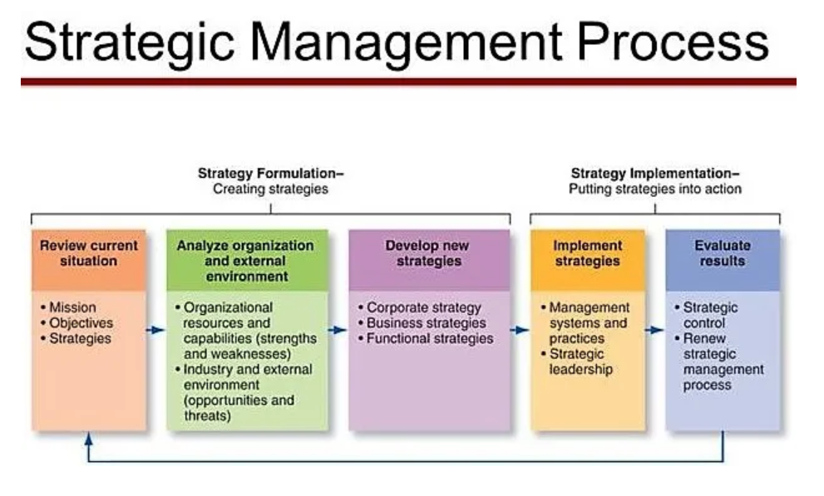
Figure 1: Strategic Management Process
Source: (Intactone, 2025)

2. Overview
Volvo is a Swedish manufacturer of vehicles with its headquarters located in Gothenburg, Sweden. It has operations spanning the whole world, and it is associated with the production of luxury cars, such as SUV models, sedans and electric cars. Geely Holding Group owns the company that operates mostly in the premium car division (Volvo, 2025). Internal combustion engine cars, hybrids, and fully electric cars like the EX30 and XC40 Recharge belong to the product molecules of Volvo. The company has developed a good reputation for safety, innovation, and being environmentally friendly. Volvo is a competitor emerging in the world automotive industry that is very competitive, as it deals with competitors like BMW, Tesla and Toyota. It has also changed its strategy to electrification and sustainability to become a fully electric car company by 2030 (Volvo Cars, 2024).
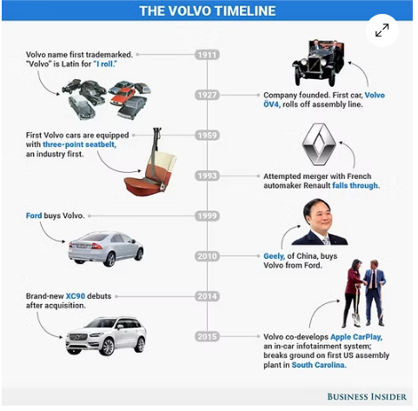
Figure 2: Volvo Timeline
Source: (Solanki, 2023)

3. Strategic Intent
Vision:
To be a fully electric premium automobile brand and climate neutral.
Mission:
To offer safe, sustainable and innovative mobility solutions that transform customer experience.
Objectives:
- Formulate the sale of 100 per cent of electric vehicles by the year 2030.
- Reach net-zero emissions by 2030.
- Enhance digitised and connected car services.
- Grow in the global markets, particularly in EV markets.
The strategic intent of Volvo indicates great consistency with the trends in the global arena of sustainability, electrification, and digitalisation.

4. Current Performance
Volvo has been able to achieve consistent growth over the last several years, much of which has been contributed to by the incredibly rapid growth rate of its electrified vehicles department. The company has also invested heavily in electric vehicle (EV) technology, battery innovation, and digital innovation, and has been producing a growing proportion of its total sales via hybrid and fully electric vehicles (Rani, 2025). This change is in line with the global trends in the industry of electrification and sustainability, which is reinforcing the competitive positioning of Volvo. The transition year of 2025 is also proving to be challenging for Volvo Cars, which is confronting an unwelcoming electric vehicle (EV) shipment and heightened rivalry, following the groundbreaking 2024 (PRnewswire, 2025). Although the Volvo has reported a decline in Q1 2025 revenues and operating income because of the lower volume of wholesale and inventory losses, the car maker has implemented a SEK 18 billion cost management action scheme to cushion the profitability (Volvo Cars, 2025). Geographically, Volvo is further increasing its global growth with good performances in Europe and growing its market presence in China and the United States. It has been able to share the platform, new cost efficiencies, and faster technological development through strategic collaboration with its parent company, Geely. Also with strengths, Volvo has been experiencing increasing challenges due to high competition levels, increasing cost of production, and increasingly rigorous environmental laws, all of which demand that Volvo must adjust its strategy continuously.

5. Strategy Analysis

5.1 External Environment
PESTEL Analysis
Political:
Volvo is subjected to a very regulated environment with both the EU and the US implementing strict emission regulations that put the company on the path of electrification (Bergquist and Näsman, 2021). Electric vehicles (EVs) incentives given by the government are also supportive of the transition strategy of Volvo.
Economic:
Increased inflation raises the expenses of production and raw materials, and derailments in global supply chains, particularly in semiconductors, have impacts on manufacturing performance and profitability (Bergquist and Näsman, 2021).
Social:
Sustainable mobility is gaining more and more attention, as the environmental problem is becoming more conscious (Gallo and Marinelli, 2020). Trends are moving towards EVs, which fit the brand's sustainability-oriented approach.
Technological:
New competitors receive new opportunities due to innovations involving artificial intelligence and new vegetable development and battery improvements, thus fuelling competition in the field of vehicles and AI-driven autopilots (Abro et al., 2023).
Environmental:
The effects of environmental pressure due to climate change and global carbon neutrality requirements require Volvo to minimise emissions and invest in sustainable manufacturing and EVs.
Legal:
The Volvo operations are influenced by strict safety and emissions regulations, but the company has a high safety reputation, which is an edge over its competitors.
Porter’s Five Forces Analysis
Force | Level | Analysis
Competitive Rivalry | High | The automotive sector is also a very fierce market, with reputable companies like BMW, Tesla and Toyota battling it out in terms of innovation, price, as well as brand positioning (Have ignition, 2025). Volvo is under severe pressure to differentiate with a focus on sustainability and safety to remain in line with the fast changes in EVs.
Threat of New Entrants | Moderate | Barriers to entry can be seen through high capital requirements, economies of scale and well-developed brands. Nevertheless, the emergence of EV startups and technology companies poses a threat to the industry and escalates competition, especially in the electric and autonomous vehicle industry (Thomas and Maine, 2019).
Supplier Power | High | The suppliers, particularly the battery suppliers and semiconductor suppliers, have great power as their availability is limited, and demand is high. The reliance of Volvo on them makes it costlier and more susceptible to supply issues.
Buyer Power | High | The automotive market offers a wide variety of options to consumers, thus raising their bargaining power. Volvo has price sensitivity and an innovation demand that drives the company to add value and customer experience every time.
Threat of Substitutes | Moderate | Other alternatives like ridesharing, mobility-as-a-service, and public transport decrease car ownership (Lucken and Shaheen, 2021). The automotive market is, however, still supported by the need for personal mobility.
Table 1: P5F analysis
Source: (Learner)

5.2 Internal Environment
SWOT Analysis
Strengths | Weaknesses
- Volvo has a very good reputation for being safe in the world, and this distinguishes it among other competitors and fosters confidence in its customers.  - The company has also been credited with leadership in terms of sustainability, following the increased concern about environmental issues.  - Also, its high-end market segmentation enables Volvo to have sustained high profit margins and brand loyalty. | - Volvo has produced goods at a high cost alongside operational costs, especially following investment in electrification and modern technologies.  - Economies of scale are less than those of bigger competitors and thus can decrease cost competitiveness as well as reach the global market.
Opportunities | Threats
- The electric vehicle (EV) market is going through a boom phase, which offers a great expansion opportunity (Faizal et al., 2019).  - Connected car functions and subscription schemes can also help Volvo create new sources of revenue and customer experience, and can be used as an advantage during the process of boosting its profits. | - The free market of vehicles is very competitive since there are such powerful competitors like Tesla and BMW who are adding pressure (Have ignition, 2025).  - Also, continuous delay of the supply chain and reliance on important materials such as semiconductors threaten the stability of production and its profitability.
Table 2: SWOT analysis
Source: (Learner)
VRIO Analysis
Resource/Capability | Valuable (V) | Rare (R) | Inimitable (I) | Organised (O) | Competitive Implication
Safety technology | Yes | Yes | Yes | Yes | Sustained competitive advantage
Brand reputation | Yes | Yes | Yes | Yes | Sustained competitive advantage
EV innovation | Yes | No | No | Yes | No Competitive advantage
Table 3: VRIO analysis
Source: (Learner)
Sustained competitive advantages are offered by the Volvo safety technology and good brand reputation, since they are not common and hard to copy. Its EV innovation, however, is not an uncommon one in the existing market, which means that it provides it with a temporary competitive edge.

6. Strategy Formulation
1. Accelerate EV Transition
Volvo needs to increase its switch to electric vehicles by investing more in battery technology, capacity, and partnering with charging infrastructure. This works to its 2030 target of becoming an entirely electric brand and addresses the regulatory pressures and increased consumer demand (Volvo Cars, 2024). Production of EVs on a large scale will also help in the cost efficiency and enhance the competitive capabilities of Volvo over its competitors, including Tesla and BMW.
2. Strengthen Digital Ecosystem
The company is required to come up with software-defined vehicles with advanced digital platforms. Recurring revenue streams can be generated by improving in-car connectivity, over-the-air updates, and subscription-based services (e.g. infotainment, maintenance, and insurance). The move to service-based value propositions as compared to the product-based ones will enhance the customers' experience and brand loyalty in the long term.
3. Strategic Partnerships
Volvo ought to facilitate partnerships with technology companies and battery pack companies in order to deal with the expensive and intricate nature of innovation. The collaborative efforts in the fields of artificial intelligence, autonomous driving, and battery would be able to promote a faster pace of innovation, lower their costs of R&D and shorten their time-to-market of innovative technologies.
4. Supply Chain Resilience
To prevent risks of semiconductor shortages, geopolitical upsets and other risks, Volvo ought to resort to vertical integration initiatives and diversify the suppliers. The move towards localisation of the production process and the acquisition of supplementary raw resources (e.g., lithium ion batteries) will not only improve the stability of production by reducing the reliance on the external supply chain but also align with the trends in the industry (Adegboye, Olateju and Okolo, 2024).
5. Market Expansion
Volvo must aim at expanding its EV markets, especially in Asia and North America, where the electric car markets are growing exponentially. This will be achieved through expanding distribution networks and adapting the products to the local tastes and preferences, which will support global market share and revenue increase, hence long-term sustainability.

7. Conclusion & Recommendations
Volvo has a chance of emerging successfully in the ever-changing automotive industry due to its powerful global brand, safety leadership, and proper focus on sustainability and electrification. The strategic direction of the company can be closely associated with the key trends in the industry, like a transition to electric vehicles, digitalisation, and production which is environmentally friendly. Nevertheless, Volvo still experiences major problems, such as high competition with the established automakers and new EV competitors, technological disruption at a high pace and persistent economic pressures, including price increases and supply chain unpredictability. Volvo has to switch to electric vehicles faster to be competitive and grow in the long term by increasing production and making more investments in battery technology. Meanwhile, increasing its digital ecosystem with the help of software-defined vehicles and paid subscription services will play an important role in designing new sources of revenue and making the customer experience more convenient. There is also a need to mitigate risks by strengthening supply chain resilience through developing diversity and vertical integration. More so, an exploration of high-growth markets and strategic alliances will enhance innovation and international competitiveness. In the end, Volvo can be successful in the future only if it manages to embrace the changes in the industry as quickly as they happen, preserving its top attributes: safety, quality, and sustainability.

References
Abro, G.E.M., Zulkifli, S.A.B., Kumar, K., El Ouanjli, N., Asirvadam, V.S. and Mossa, M.A., (2023). Comprehensive review of recent advancements in battery technology, propulsion, power interfaces, and vehicle network systems for intelligent autonomous and connected electric vehicles. Energies, 16(6), p.2925.
Adegboye, O., Olateju, A.P. and Okolo, I.P. (2024). Localised battery material processing hubs: assessing industrial policy for green growth and supply chain sovereignty in the Global South. International Journal of Computer Applications Technology and Research, 13(12), pp.38-53.
Bergquist, A.-K. and Näsman, M., (2021). Safe before Green! The Greening of Volvo Cars in the 1970s–1990s. Enterprise & Society, [online] 24(1), pp.59–89. https://doi.org/10.1017/eso.2021.23.
Fainshmidt, S., Wenger, L., Pezeshkan, A. and Mallon, M.R. (2019). When do dynamic capabilities lead to competitive advantage? The importance of strategic fit. Journal of Management Studies, 56(4), pp.758-787.
Faizal, M., Feng, S.Y., Zureel, M.F., Sinidol, B.E., Wong, D. and Jian, G.K. (2019). A review of challenges and opportunities of electric vehicles (EVs). Journal of Mechanical Engineering Research and Developments, 42(4), pp.130-137.
Gallo, M. and Marinelli, M. (2020). Sustainable mobility: A review of possible actions and policies. Sustainability, 12(18), p.7499.
Have Ignition (2025). Go-to-Market Strategy for Automotive. [online] Have Ignition. Available at: <https://www.haveignition.com/industry-guides/go-to-market-strategy-for-automotive> [Accessed 18 March 2026].
Intactone (2025). Process of strategic management and the levels at which strategy operates. [online] Intact One. Available at: <https://theintactone.com/2018/12/23/sm-u1-topic-5-process-of-strategic-management-and-levels-at-which-strategy-operates/> [Accessed 18 March 2026].
Lucken, E. and Shaheen, S. (2021). Incorporating Mobility-on-Demand (MOD) and Mobility-as-a-Service (MaaS) automotive services into public transportation. Handbook of public transport research, pp.410-433.
PRnewswire (2025). Volvo Cars reports Q2 2025 results. The turnaround plan is fully on track. PRnewswire. [online] 17 Jul. Available at: <https://www.prnewswire.com/apac/news-releases/volvo-cars-reports-q2-2025-results-turnaround-plan-is-fully-on-track-302507700.html> [Accessed 18 March 2026].
Rani, A. (2025). Volvo Cars reports strong 2024 performance but warns of challenges in 2025. [online] Just Auto. Available at: <https://www.just-auto.com/news/volvo-cars-2024-performance/> [Accessed 18 March 2026].
Solanki, G., (2023). Marketing Strategy of Volvo | A brand built on safety, strength & style | Detailed analysis. Marketing Weekly. Available at: <https://www.marketingweekly.com/post/marketing-strategy-of-volvo-a-brand-built-on-safety-strength-style-detailed-analysis> [Accessed 18 March 2026].
Thomas, V.J. and Maine, E. (2019). Market entry strategies for electric vehicle start-ups in the automotive industry–Lessons from Tesla Motors. Journal of Cleaner Production, 235, pp.653-663.
Volvo Cars (2024). Volvo Cars adjusts electrification ambitions; Remains committed to fully electric future | Volvo Cars Media Intl. [online] Volvo Cars. Available at: <https://www.volvocars.com/intl/media/press-releases/AD2DD41C49DDDC40/> [Accessed 18 March 2026].
Volvo Cars (2025). Volvo Cars reports Q1 2025 results, Launches SEK 18 billion cost and cash Action Plan | Volvo Cars Media Intl. [online] Volvo Cars. Available at: <https://www.volvocars.com/intl/media/press-releases/63BF9CDA493AF797/> [Accessed 18 March 2026].
Volvo (2025). About us. [online] AB Volvo. Available at: <https://www.volvogroup.com/en/about-us.html> [Accessed 18 March 2026].

