UNIVERSITY OF WALES TRINITY SAINT DAVID
LONDON CAMPUS
Assignment 2
Learning in the Digital Era
Video Link: https://youtu.be/8B6dF5WLoxE

Module Name: Learning in the Digital Era
Module Code: ACCA 4025

Student Name: Shafi Ahmad
Student ID: 2532392
Group: 1

Lecturer’s Name: Koushik Madok

Table of Contents
Introduction 2
Main Body 2
Conclusion 9
References 9

Introduction
This presentation dives into personal growth, starting with self-evaluation and reflection to sharpen learning skills. I’ll walk you through what I found about my own strengths and weaknesses while reflecting on my experiences and show how these discoveries shape my path forward. We’ll look at Gibbs’ reflective model and see how it helps break down experiences so you can learn from them, not just live through them. The report also pulls in ideas from “Learning to Learn,” like agile learning, mindset, feedback, and how forming good habits really matters. In the end, this is all about why it’s so important to keep improving yourself, stay adaptable, and use reflection if you want to do well in school and get ready for your career.

Main Body
Video Link: https://youtu.be/8B6dF5WLoxE

Slide 1 COVER PAGE

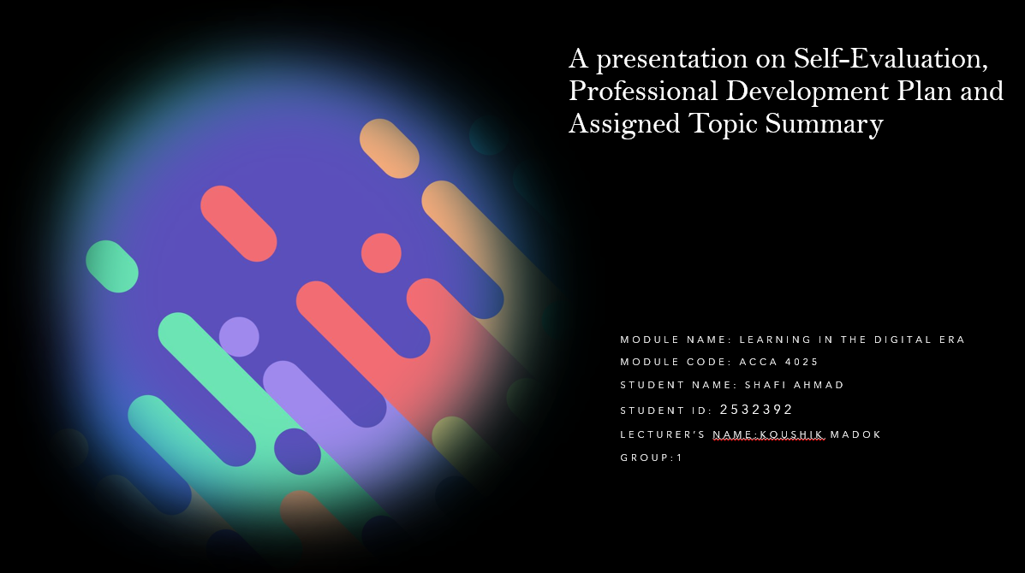

Slide 2 CONTENTS

Slide 3 INTRODUCTION
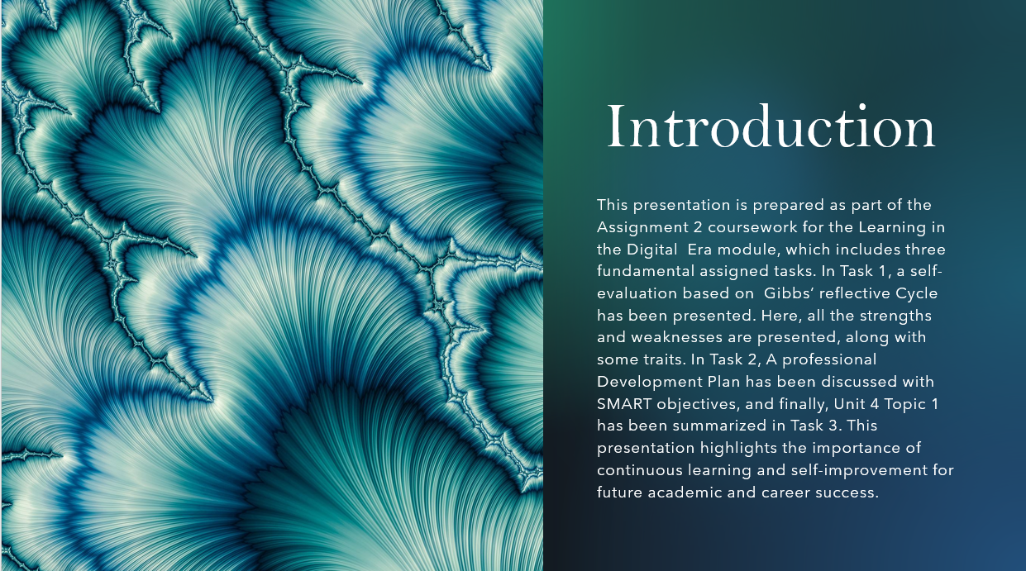

Slide 4 MAIN BODY

Slide 5 GIBB’s REFLECTIVE MODEL
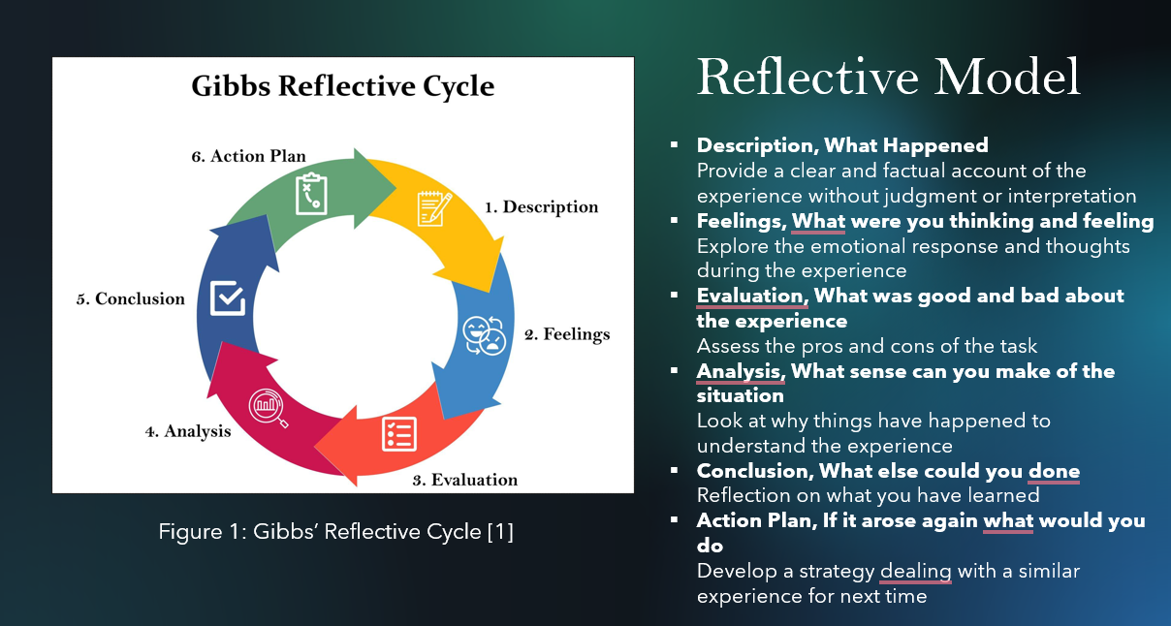

Brief explanation: Gibbs’ Reflective Cycle gives you a clear way to learn from your experiences. It breaks things down into six steps: you describe what happened, dig into your feelings, evaluate the situation, analyse it, draw conclusions, and come up with an action plan. The whole point is to get you thinking about what went well, what didn’t, and how you can do better next time. For Assignment 2, I’m going to use this model to look back at my learning journey and see where I’ve grown and where I still need work. I’ll start by laying out the moments that stood out during my studies. Then I’ll get honest about how I felt, what I did well, and what tripped me up. By evaluating and analysing these experiences, I can pinpoint what’s working and what’s not. Once I know all that, I’ll put together a plan to work on my communication and boost my confidence. Taking time for this kind of reflection isn’t just about grades; it sets me up for real professional growth down the line.

Slide 6 TASK 1: SELF EVALUATION
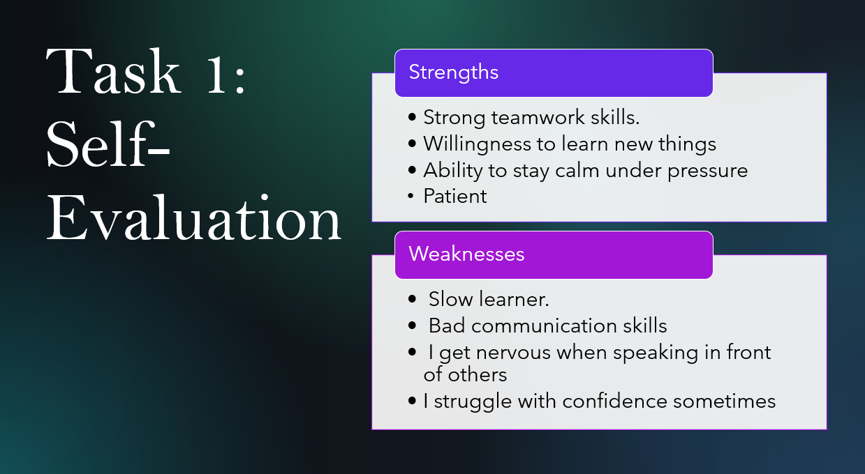
Brief explanation: One of my key strengths is my strong teamwork skills. I am able to collaborate effectively with others, listen to different perspectives, and contribute positively to group tasks. This strength helps me perform well in group assignments and develop good interpersonal relationships [1].I have a willingness to learn new things and the ability to stay calm under pressure, which supports my academic progress and problem-solving abilities. However, one of my main weaknesses is my lack of confidence, particularly when speaking in front of others [2]. I often feel nervous during presentations, which affects my communication skills. I also recognise that I can be a slow learner at times, which means I need extra time to fully understand new concepts. To improve, I plan to practice public speaking, seek feedback, and develop better communication strategies to build my confidence over time [3].

Slide 7 TRAITS GAINED FROM THE SELF EVALUATION
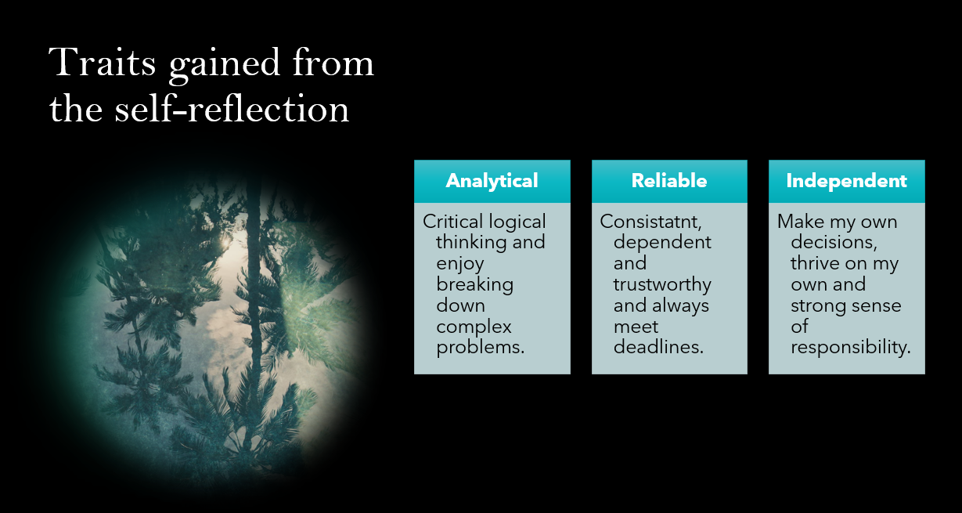

Brief explanation: The traits developed through self-reflection highlight important aspects of personal and academic growth. Being team-oriented shows the ability to collaborate effectively with others, share ideas, and contribute positively in group settings, which is essential for success in both education and the workplace. Resilience under pressure reflects the capacity to stay calm in challenging situations, make better decisions, and remain focused on tasks. This trait is valuable when dealing with deadlines, exams, or stressful environments. Developing confidence is another key trait, as it involves improving communication skills and becoming more comfortable when speaking in front of others. Although confidence is still growing, self-reflection helps identify areas for improvement and encourages continuous progress. Overall, these traits demonstrate a positive learning attitude and a commitment to personal development through reflection and experience [1][2].

Slide 8 PROFESSIONAL DEVELOPMENT PLAN
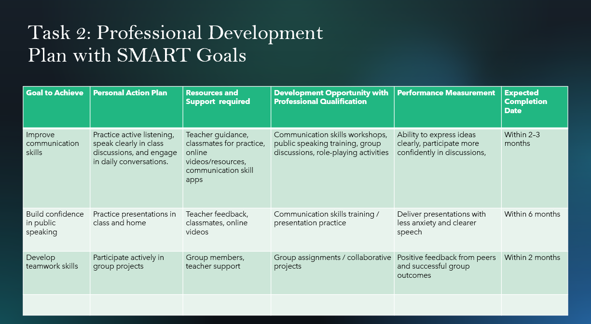

Brief explanation: A Professional Development Plan (PDP) with SMART goals really gets you organized and focused about building both personal and academic skills. In this plan, the focus falls on three main areas: better time management, gaining confidence in public speaking, and strengthening teamwork. The approach isn’t vague, these goals are specific, measurable, and have deadlines, so you know exactly what you’re working towards. For instance, setting up a weekly study schedule helps tackle time management. Practicing presentations, even in front of a mirror or with friends, slowly builds confidence on stage. Group projects are perfect places to sharpen teamwork and communication, you learn to listen, share ideas, and adapt. The plan also leans into resources around you: teachers, honest feedback from classmates, and a bunch of learning tools online. Progress isn’t just guesswork. You keep tabs on how well you’re meeting deadlines, whether your presentations get clearer, and what kind of feedback you’re hearing. Sticking to realistic timelines helps you actually see if you’re moving forward or stuck in place. All this isn’t just about ticking boxes, it’s about taking charge of your own growth, staying accountable, and developing skills that make a real difference, both at school and later when you dive into your career [3].

Slide 9 UNIT 4 TOPIC SUMMARY
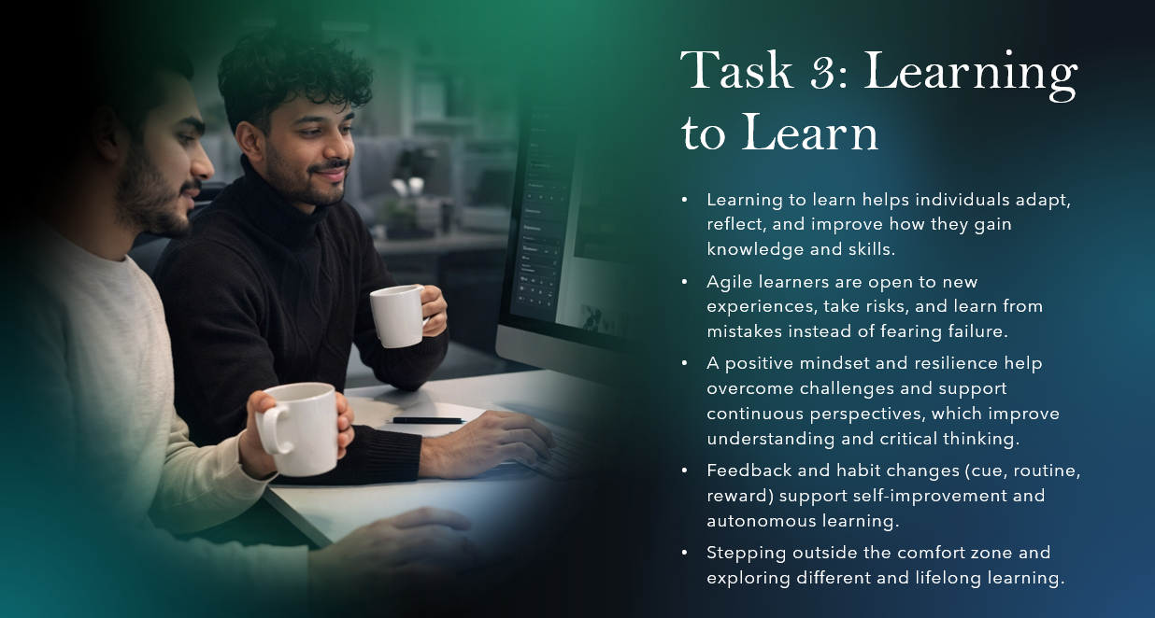

Brief explanation: Learning to learn is really about figuring out how you take in new information and how you can do it better. The goal? To be more independent and flexible, and to actually trust yourself as a learner. One big idea is being an agile learner that means welcoming new experiences and ways of doing things, plus seeing mistakes as chances to grow. Don’t treat failure like a dead end; think of it as a lesson that can make you more confident and help you keep moving forward. Staying positive matters a lot, especially when things get tough or weird. It keeps you motivated [1]. You also have to challenge yourself. Real learning happens when you step outside your comfort zone, even if it feels awkward or hard at first. These situations often lead to new skills and fresh perspectives. And honestly, you have to watch out for echo chambers, places where you only hear opinions that match your own. If you seek out different viewpoints, your critical thinking gets sharper, and you understand things more deeply. Feedback’s also huge. It tells you what you’re good at and where you can do better [2]. Habits shape how you learn. Think of the habit loop: cue, routine, reward. Something triggers a behaviour, you follow your routine, then get a reward (even if it’s just feeling good about finishing something). Procrastination, for example, can become a habit, but you can break it by creating new routines and rewarding yourself for sticking to them. In the end, learning to learn is about growing, staying open to change, and never stopping. That’s the stuff that prepares you for school, honestly, whatever career or life throws your way [3].

Slide 10 CONCLUSION

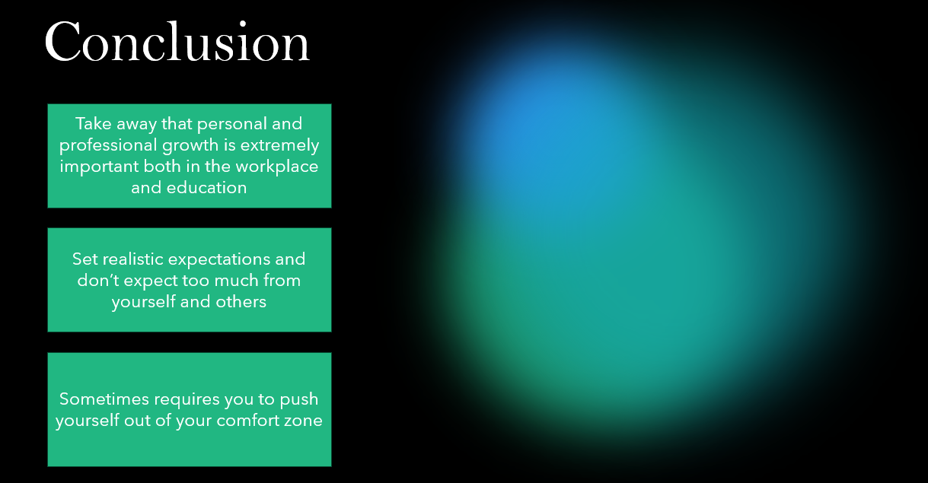

Brief explanation: Personal and professional growth really matters, both in school and at work. It isn’t always a smooth ride. Pushing yourself usually means getting out of your comfort zone and tackling things that feel a little scary. It’s not always fun, but you gain confidence and pick up new skills along the way. You also learn to be honest about what you can handle instead of chasing perfection, you focus on what’s realistic for yourself and others. The real takeaway is about balance. Challenge yourself and aim higher, but don’t forget to show some patience and kindness for the process. That’s how you get better without burning out or losing heart.

Conclusion: This presentation boosted my confidence in front of the camera, and I learned how to create presentations using MS PowerPoint. It really helped me face my weaknesses and notice my strengths. I even made a table to plan out how I can turn my weaknesses into strengths, and I believe if I keep working on it, I'll get there soon.

References

Task 1:
[1] A. Gürel and M. Tat, “SWOT Analysis: A Theoretical Review,” Journal of International Social Research, vol. 10, no. 51, pp. 994–1006, 2017.
[2] K. J. Barrett and D. H. Moore, Learning Styles and Strategies. London, UK: Routledge, 2011.
[3] C. Dweck, Mindset: The New Psychology of Success. New York, NY, USA: Random House, 2006.
Task 2:
[1] G. T. Doran, “There’s a S.M.A.R.T. Way to Write Management’s Goals and Objectives,” Management Review, vol. 70, no. 11, pp. 35–36, 1981.
[2] A. Locke and G. Latham, A Theory of Goal Setting and Task Performance. Englewood Cliffs, NJ, USA: Prentice Hall, 1990.
Task 3:
[1] C. Dweck, Mindset: The New Psychology of Success. New York, NY, USA: Random House, 2006.
[2] C. Duhigg, The Power of Habit: Why We Do What We Do in Life and Business. New York, NY, USA: Random House, 2012.
[3] P. Honey and A. Mumford, The Manual of Learning Styles, 3rd ed. Maidenhead, UK: Peter Honey Publications, 1992.

