Essay
Reflection
Finbar Jenkins 2013803

How can I take my work to the next level?

During the essay, I will be reflecting on the process of creating my short drama series. I will look at how materials have influenced my ideas and helped better my work. These would include books, articles online as well as professionals in the industry. I’m using this essay as guidance and a chance for me to put my work into perspective and see the areas that I can improve as I go forward making more films. The goal of this is to take my work to the next level, using this as a building step to progress from student films to something I can share and express myself at the industry level. Using the experience and knowledge that I have after spending time working on high-end TV productions to help me understand what it takes to get to this level.

Over the last few weeks, I have been developing a short drama series based on a cold case in Swansea. I first came across it when collaborating with students as we were challenged to come up with ideas for films based on a certain subject. One subject that came up was ‘exploring the unknown’ or how I interpreted it as a chance to explore a mystery. Me and Callum, a fellow classmate and some whom I am collaborating with on this project, began brainstorming some areas we can look at. Many ideas were thrown about including aliens, conspiracy theories as well as unsolved murders. I really enjoyed brainstorming with other people as I found they offered ideas that I would have never really thought of. If it wasn’t for the process I would never come across this unsolved murder in Swansea, in fact, it was Callum who originally found the case before I began my research on it.

The case itself is about a young girl named Muriel Drinkwater, aged 12, who was raped and killed in Penllergaer woods in 1946. The case remained unsolved, but over 50 years later in 2009 to everyone’s surprise, a child’s book was bought in a charity shop in Carmarthen with the girl’s name on it, which they believe she had with her when she was killed. The last person to see Muriel alive was her mother from her kitchen window about 400 yards away as she was walking back from school. Within a brief moment the mother loses sight of her behind some trees, the young girl was sadly taken and killed nearby. All this information was found when doing research online and I was instantly engaged with it from the start. Researching is an area of film production that I have always enjoyed doing, as I see it as investigation where you find little clues in different areas that help construct the story. This is the process I used to help me construct my story.

Here a link to the research pack that I have created: https://express.adobe.com/page/TyLsEAUlPwgDv/

Script development

To develop my script, I used my research on the case, picking little areas that inspired me for scenes and storylines. I started off looking at the theme of the series and I wanted it to be a dark drama, very much like ‘The End of the F**king World’. The way she was killed, as a 12-year-old raped and left to die, would affect any audience hearing that, but as I began to see the story develop, I wanted to leave out the fact she was raped as I didn’t feel comfortable for family and people involved to show this, and I turned into a murder mystery. I started reading a book called ‘How to write a movie in 21 days’ by Viki King given to me by my father. This book is about using the method called ‘the inner movie’ to help you develop your idea. It sets out tasks and challenges to help you get clarity and get past them writing blocks. I found this book a massive help when I didn’t know how to start my script. This first challenge was to write down what we know about the story so far using as few words as we can and only in 8 minutes. This was the outcome I had:
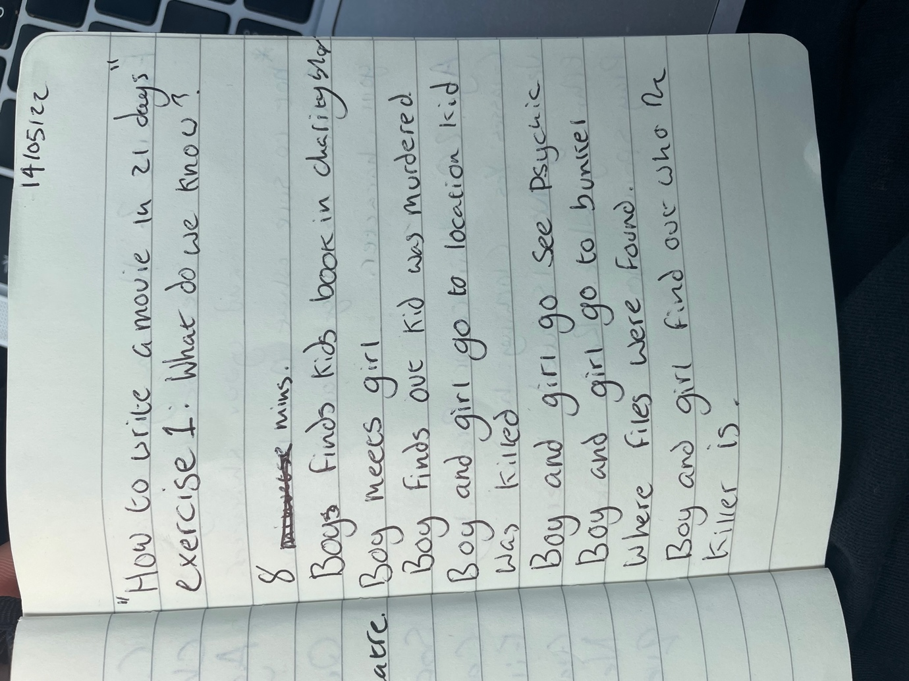
This exercise was brilliant because it made you realise how much you already know without overthinking it and before you know it you have your structure for the script. During a lecture with Chris, he showed several short films from ‘Shorts of the Week’ for us to use as inspiration for the level we should aim for. He spoke about how to keep it all contained in both location and story. This showed me that it’s important to keep it simple and contained to get the best we can out of it, without having to worry about a million different factors if we kept changing location or having 2 pages of dialogue. This is where I got my inspiration to split my story into 4 episodes. I decided to create my script in steps, concentrating on one episode at a time and getting it produced and made before thinking about the next episode. This allowed me to fully focus and get the best I can out of each episode as I didn’t want to lose myself trying to write the whole series. This is my first time writing a script, and with past projects I’ve worked on, I tend to find myself losing touch with the original idea of the story as I let my mind wander and begin to add 100 more ideas until it looks nothing like I started with. During one lecture with Chris, we broke down a scene from ‘The Unbelievable Truth’ about how conversations between two characters about how one thing can mean something completely different. For the example Chris showed us it was two people talking about a book, but they were playing a game and trying to figure out if they liked each other. I put this in practice when creating my first draft of the script where the girl character was talking about some old coins, but she was really talking about desires and what she wants from life.

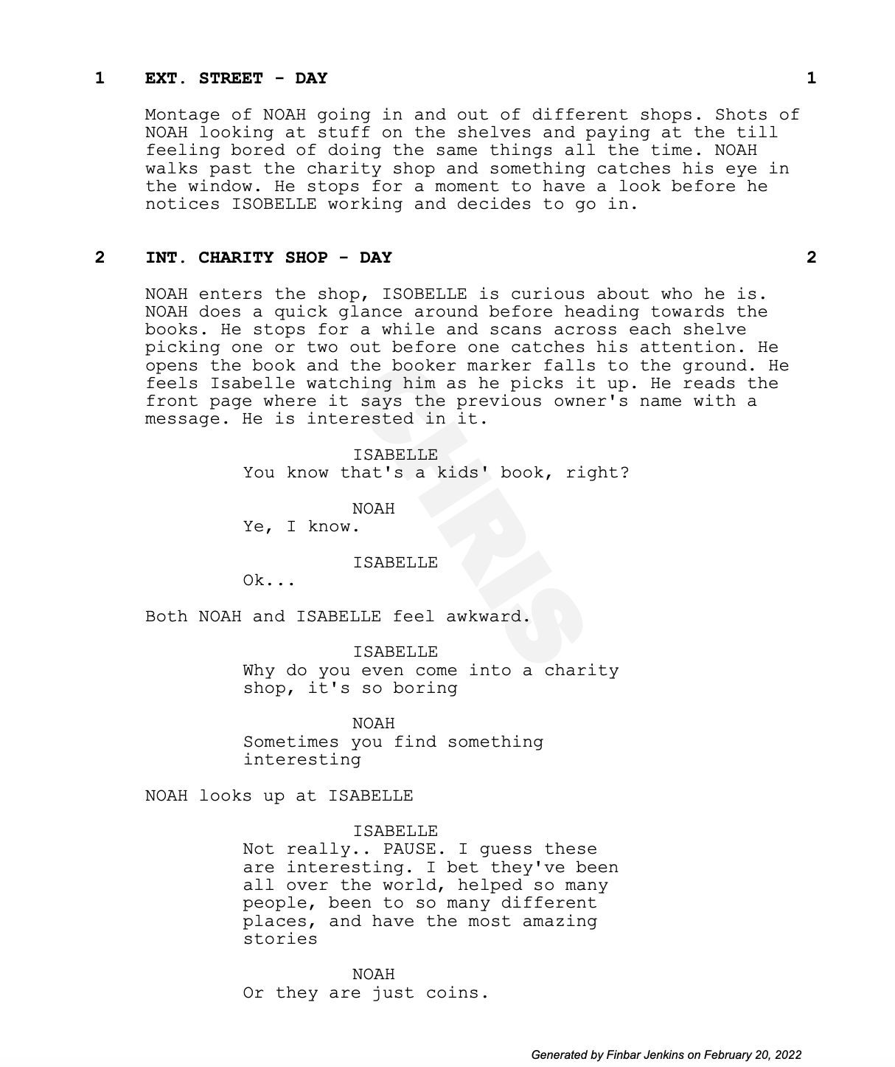

First Noah says “sometimes you find something interesting” he is not on about clothes or books, but he is on about her. I would use the action ‘Noah looks up at Isabelle’ for me to direct the actor on the feeling of the line and how I want it to be seen. The second part is where Isabelle is talking about some old coins, but she is really talking about herself. I really liked this exchange between the two characters, but I wondered if it was irrelevant to the story and if it was really needed in the scene. Questioning this I decided to send the script to my father who a director in the industry.
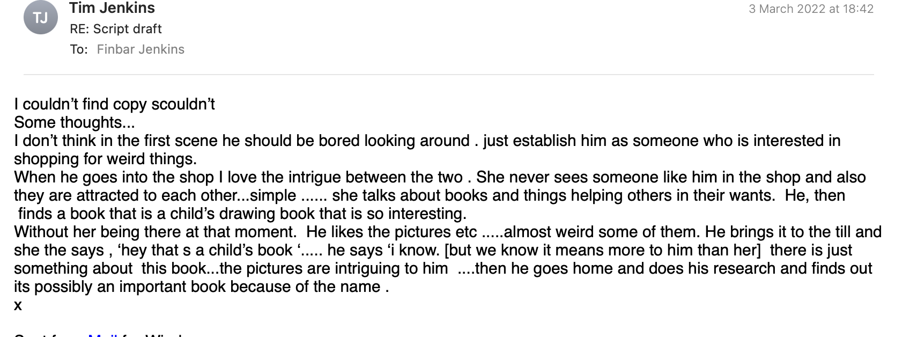

I thought this was great feedback to have because helped me decide what the film is about, is it the two characters or the unsolved case. With that in mind, I went back to create my second draft concentrating on the case as the basis of the story on the first episode. As the series develops, I will show the story behind the two characters more so the audience can relate to them.

Character development

I instantly knew when I started developing the story that I was going to have two main characters, one boy and one girl and they go on this journey solving it together.
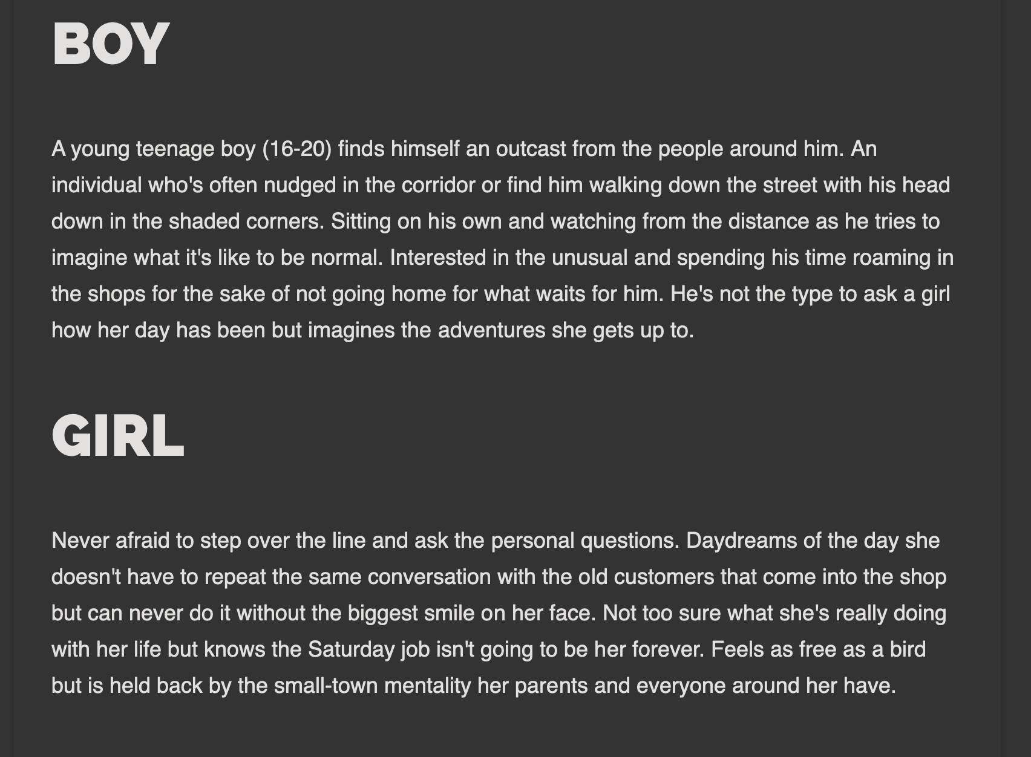

I never really understood why I was adamant about these two characters and how I could be so specific on what I wanted until I started reading ‘How to make a movie in 21 days.’ There is the chapter where it says, ‘How your age reveals what’s on your mind’ and it says people in their early 20s theme behind their writing is “I’m okay and the world is terrible” and you’ll find “your hero will be idealistic… and against all odds, triumphs”. This seems to be the case in my story. This isolated boy who feels rejected by the rest of the world ends up solving this 70-year-old cold case. The book explains how without even knowing it that the main character that I am writing about is me. When I read this, I sat back for a moment and looked back on the character description and looked at what he wants, and it is deep down what I want. It was strange to put it in that perspective and it made me realise I’m writing about myself. What I really look for in life is to meet a girl in unexpected circumstances and go on an adventure through life together. It’s something I’ve always played over in my head and this story reflects that. One quote I found helpful moving forward is “If the character seems to be you- then jump in and make him you… The idea is to find and show real feelings because they will tell you what is true”. I found it helpful because it’s important to relate these people to ourselves and our feelings because that is what the audience connect with and relate to.

Dramatizing true crime stories

There were several options of how I was going to bring this idea to life with one idea to create a documentary where I explore the case and interview people involved to get a better understanding. I originally liked this idea, but I felt restricted to the story I could tell. There is a BBC production called ‘Dark Land: Hunting the Killers’ which is a documentary about the case. I thought it was made well and they were the people who found the book in the charity shop and were able to give a voice to family members of the girl who died to say how it affected their lives. I began looking at how other productions dramatized true stories. I was listening to an interview with the producer of Mindhunters, David Fincher, which is a series based on true crimes looking into the minds of serial killers. One quote that stood out was by the writer of the series, Joe Penhall when he said “I don’t want to do deal with real people, I want to be free to dramatize it as it should be for the uninitiated”. To me, this quote means it gives us writers the opportunity to explain the story to the people who don’t know and help them understand it. The case that my story is based on is complicated and it is full of events that seem too unrealistic to be true. Dramatizing the story and creating it into a series for the audience will help them understand what really happened over 70 years ago.

Casting for the series

I began looking at casting for my series and this is an area that I’ve never done before so I did some research into creating casting calls and looking at tips when auditioning. There were different ways to create a casting call, some more specific than others and it was important for me to find out what worked for what I was looking for. I did some research on Facebook groups looking at examples from students to see how they did theirs. I was influenced by one as they had a picture of a character from Love Actually next to the character they were casting for. I thought this was a really good idea because it gives the actors something to research and gain inspiration for their performances. There was a quote that I found helpful what creating the character description and coming up with characteristics. It was "Don’t box yourself into an idea. Let talent show you how they’re interpreting your opportunity and be open to new ideas." This meant to me that I didn’t want to be too specific and even though I had a clear image in my head but to be open to new opportunities. It was through this process that I ended up casting a Polish girl when originally, I would never of picture this and now, I am incredibly happy with this decision as I feel it will add a new twist to the story and will keep this quote in mind in the future. I set up interviews for two actors, one for the girl and one for the boy. I had never done anything like this before and I didn’t want to put any pressure on the actors as they are students and I believe when you are comfortable is when we get the best out of ourselves. It was mainly a chance for them to get a better idea of what I was looking for and the story behind the project. For me, it was a chance to see what they would bring to the role and see what kind of personalities they have and if I was able to picture them in the scene.

The first interview with Charlie, who was auditioning for the role of Noah, went well and I really liked the look of him with long brown hair he could hide behind and big bold glasses like someone who would enjoy reading. I was surprised for him to be so quiet, and he didn't really ask many questions whether that was down to the nerves or just the person he is. But I instantly thought that this is perfect, a quiet boy with a soft voice almost afraid to ask any questions is exactly what I was looking for. He hasn't got much experience and has been in a few scenes on student short films but is keen to practice. The second interview was with Nikolina auditioning for the role of Isabelle, the other main character. The interview itself was almost completely opposite to that with Charlie as she was much more confident, relaxed and even at one point picked up her dog for the camera. This showed that she has a strong outgoing personality, and we spent some time talking about her travelling and the stories that she got up to. This is exactly the type of person I was looking for to help bring the character Noah out of his shell and they would both bounce off each other well. After the interviews, I wanted to look at some tips for directors when casting for the future as there are areas that I wanted to improve, whether that was to ask more questions to find out more about them. I looked at one interview on YouTube with a casting director called Anne Chapman who mainly works with student filmmakers to see if she had any advice. One tip I thought I did well in when I was interviewing was “there is no room for ego and whatever is best for the project is what the tone of the room should be. Whether that’s you stepping back and them taking the lead or helping them.” I thought I did this well as I was dealing with two different personalities. With Charlie being quiet and I had to explain what I was looking for and ask him questions, so I had to take the lead in the conversation to get the information I need. But with Nikolina she was very much in control of the situation and was very calm, confident and clear on what she could bring with the role, so I was able to take a step back and assess her.

Reflecting has been a massive part of this journey as I have been putting together this production and it helps me keep in control of it all. Taking a step back looking at the information I’ve gathered when I needed to make a decision has massively helped better my work. Not only at times giving myself constructive feedback but using techniques that are used in the industry is going to help me take my work to the next level, which is what this project is all about for me. I look forward to reflecting on the production once it has finished seeing areas I can improve on to keep progressing my work.

Reference:
Advice for directors on the casting process - arvold ASK. 2017. [video] Directed by A. Chapman. USA: Arvold. URL: https://www.youtube.com/watch?v=qIcPzCHdBWA

Staff, B., 2022. How to Write a Casting Notice + Breakdown. [online] Backstage.com. Available at: <https://www.backstage.com/magazine/article/how-to-write-a-casting-notice-breakdown-71183/> [Accessed 16 March 2022].

Behind the Curtain, 2019. Mindhunter- Dramatizing True Stories. [image] Available at: <https://www.youtube.com/watch?v=RCjU4F1RdJg> [Accessed 16 March 2022].

Behind the Curtain, 2019. Mindhunter- Dramatizing True Stories. [image] Available at: <https://www.youtube.com/watch?v=RCjU4F1RdJg> [Accessed 16 March 2022].

King, V., 2020. How To Write A Movie In 21 Days. Hollywood: Harper Paperbacks, pp.15-40.

