Bogdan Halinga (1715162)

Abstract:
In this report I will present the advantages of a DMBS. I will start by introducing the company in the computer base database, I will present the design of my database. Then I will present them how is distributed with proves of screenshots. And finally will be my conclusion.
ACCC5001 Database Management Systems
Assessment

Table of Contents

- Introduction………………………………………………………………………………………...1
- Design of Database…………………………………………………………………………………2
  - Conceptual Model……………………………………………………………………………..2
  - Logical Model…………………………………………………………………………………3
  - Physical Model………………………………………………………………………………..4
- Proposal…………………………………………………………………………………………….5
- Conclusion………………………………………………………………………………………….9
Appendices………………………………………………………………………………………..10
References ………………………………………………………………………………………..11

Task 2
- Introduction
The company is using ordinary filing system for the moment. That means that their system is very old and has many disadvantages. One of this disadvantages is the accessibility. Being on paper file base is very difficult to move the information from one branch to others one. Like the case study said, the company has three different branches. In this case is possible that one client register a sale property in a branch with exactly the proprieties that another buying client is looking for in other branch, but, because of paper base, they didn’t know each other. Using a modern database is very easy to communicate between the branches, one of the branches can upload a property and others two branches can see that property in their list.
Another disadvantages is time spending in organize and find documents and information. With a proper database, with a simple query they can find all information they need in seconds.
- Design of database

Before to start any database, you should design it. “Data Modelling is the process of creating a data model for the data to be store in a database. This model is a conceptual representation of: data objects, the associations between different data objects and the rules.” (https://www.guru99.com/data-modelling-conceptual-logical.html). There are two types of Data Model Techniques: Unified Modelling Language (UML) and Entity Relationship Diagram (ERD). For my design I chose ERD because is easiest to design and understand.

  - Conceptual Model
According with the study case I found 5 entities: BRANCH, STAFF, PROPERTY, SALE and MAINTENANCE. In the BRANCH table the attributes are: branch_ID, branch_ADDRESS, branch_PHONE and branch_EMAIL. These attributes help me to know the ID, the address of the branch and the contact details (phone number and email).
The next table is STAFF. There I found seven attributes: ID, name, DOB (date of birth), address, phone, email and insurance number. These attributes help me to find the id of the employee, the name, date of birth, his address, phone number and email and the insurance number.
On PROPERTY table are as well seven attributes: ID, address, type, bedrooms, value, phone and email. It helps me to find the id of property, the address where is the property, how many bedrooms it has, the value of it, and the contact details of the owner.
SALE table is more complex than others ones. It has 8 attributes, but here you can find attributes providing from other tables. This attributes are: sale_ID, Property_ID, staff_ID, branch ID, STATUS, PRICE, LIST_DATE SOLD_DATE.
MAINTENANCE is the last table. Here you can find six attributes: ID, Property_ID, DATA_START, DATE_END, DESCRIPTION and COST. You can see all this information in Fig.1.

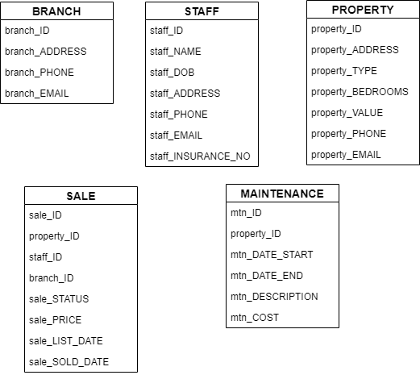
Fig.1 – Conceptual Model

  - Logical Model
On the logical concept we must to setup the relationship between the existing entities.
There are the type of relationship: One-to-One, One-to-Many and Manu-to-Many. In my database the most seen relationship is One-to-Many, but you can see One-to-One as well (see Fig. 2).
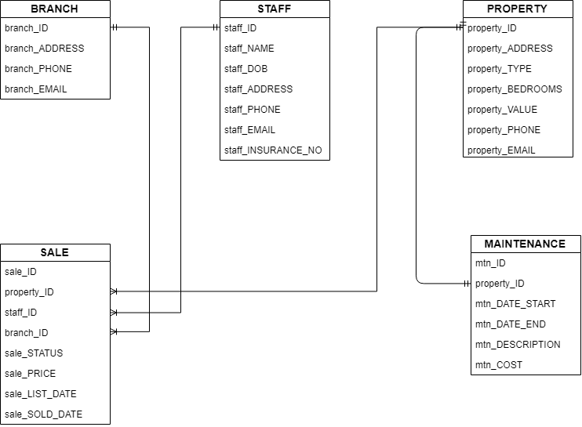
Fig.2 – Logical Model

  - Physical Model

The Physical Model help us to define different rules of the database. Some of this rules are to declare the Primary and Foreign Keys and declare the data type of each attribute. I stetted all ID as a Primary Key and as integers (see Fig.3).

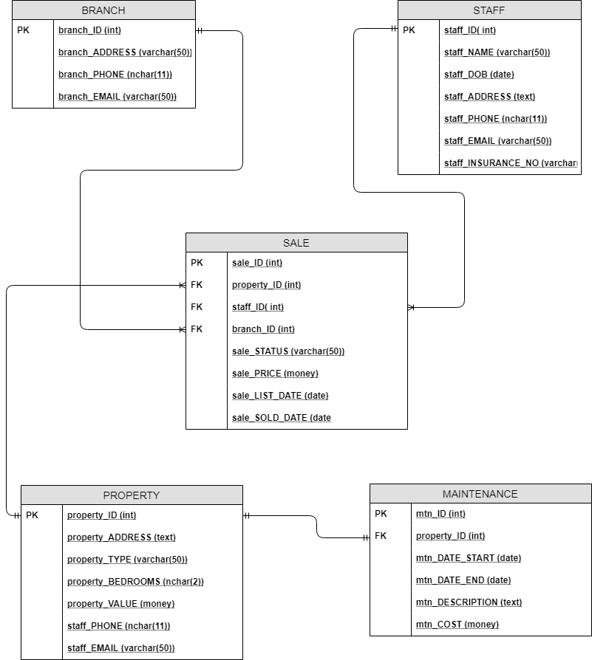
Fig.3 – Physical Model

- Proposal

Like I said on 1.1 Conceptual Model, I found 5 tables: BRANCH, STAFF, PROPERTY, SALE and MAINTENANCE. Those tables will help to manage all the information needed. On BRANCH and STAFF table, the owners or manager can verify how many employees they have and where he is working. On PROPERTY table they can find all information needed about the properties on sale or sold, like the full address, contact details of the owner and the value. The most complex table is SALE which has a relationship with almost all other tables (except MAINTENANCE). In SALE table you can find where (branch) and who (staff) listed the property, the status (if is on sale, maintenance or sold), the price (actual price or sold price), date of list and date of sold (if necessary). MAINTENANCE table help the owners or employees to know witch property suffered maintenance, the duration and the cost of it.
BRANCH, STAFF, PROPERTY tables have One-to-Many relationship with SALE and PROPERTY has One-to-One relationship with the MAINTENANCE.
Using those tables is very easy to manage all the information in seconds from all branches in same time without duplicates (see Fig.4 and Fig. 5).

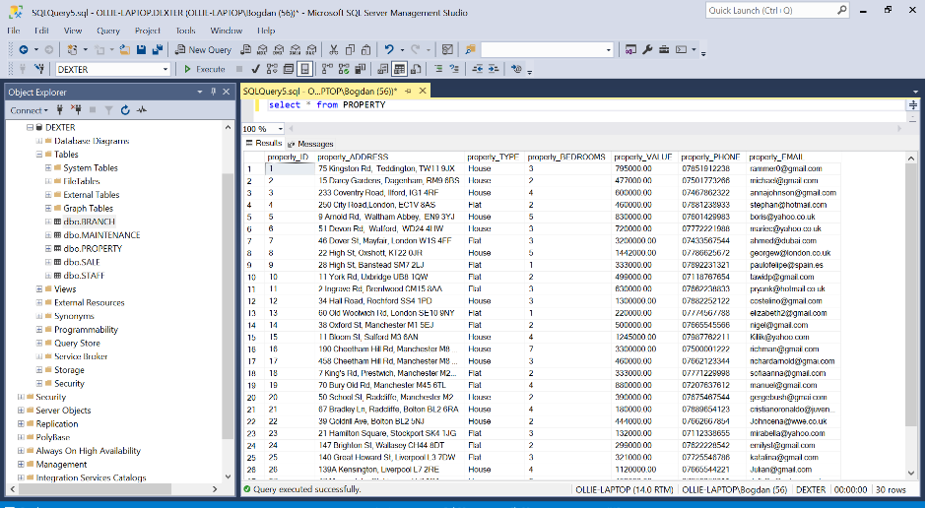
Fig.4 – Property table
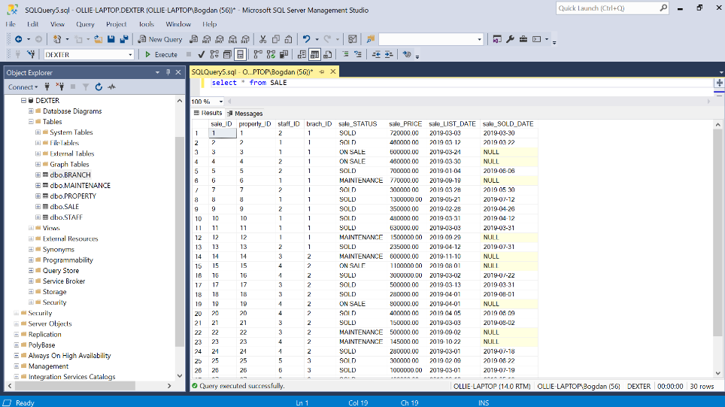
Fig.5 – Sale Table

With this database is not easy only to access the information, is very easy and quick to filter the information. Using queries you can put parts of many table one next to other one and make your job easier. In the below image (Fig.6) you can see that I choose the property address (as property name) from property table and amount of transaction, in all cases where the property was sold.

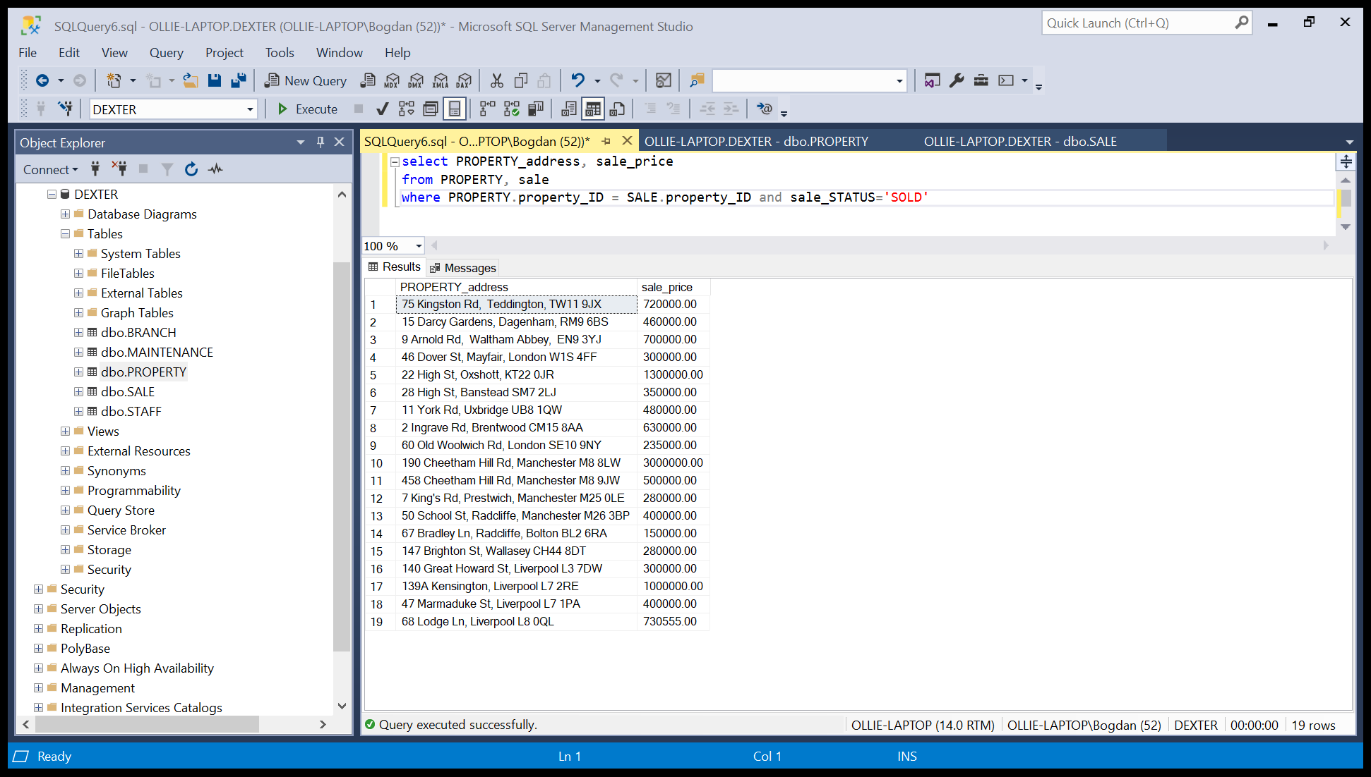
Fig.6 – Query of property name and sold price

As well, in Fig.7, you can see that we put together information from three different tables. I choose the name of the employee which managed the transaction, the property address (as a name) and the amount of transaction, all of this ordered alphabetically. This information help you to find which one of your employees are selling more properties.

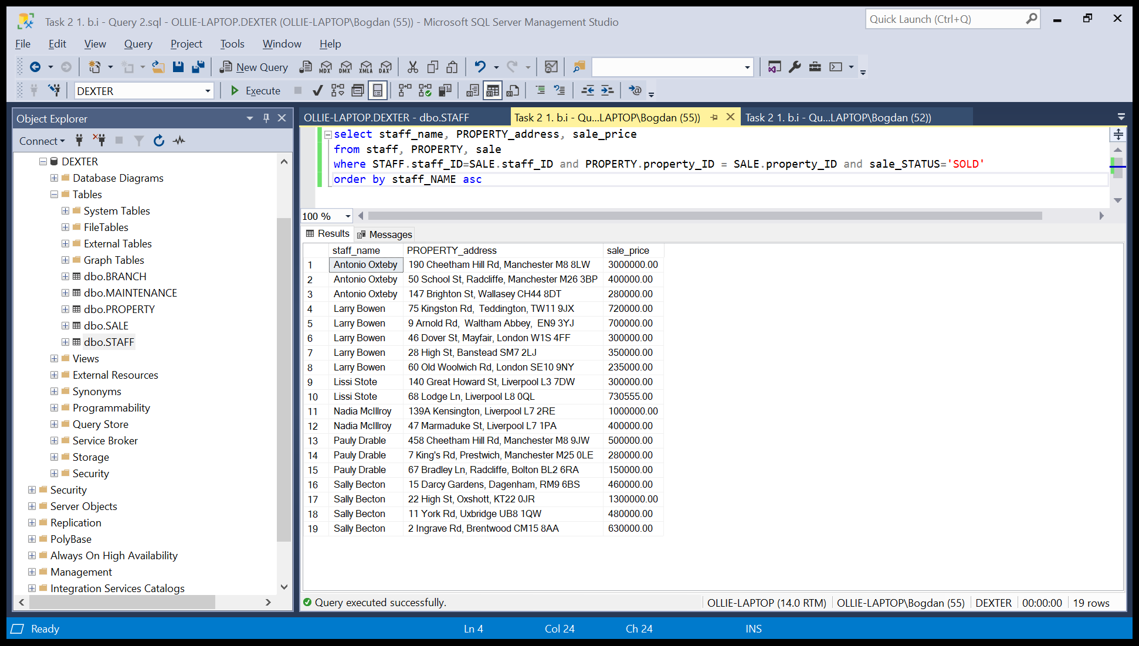
Fig.7 –Query of employee and property name and sold price

You apply date filter for any query. As I presented on the above figure, we can filter the information for finding how sold more properties, but this time within a specific period (Fig.8).

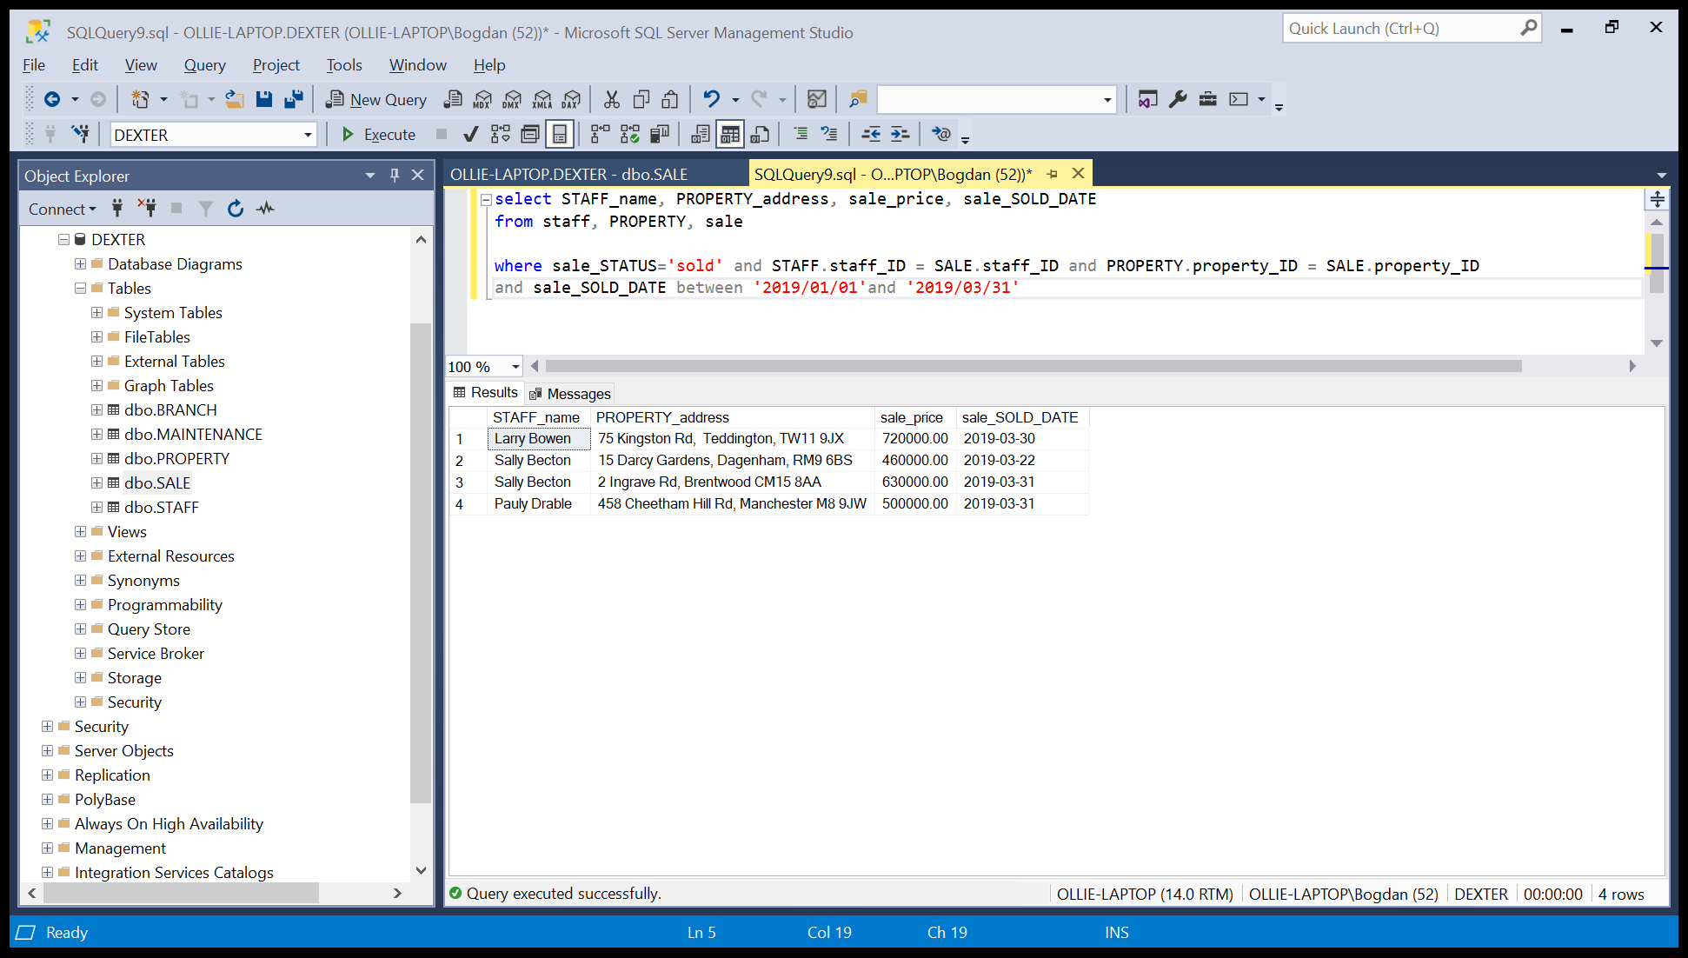
Fig.8 – Query showing how sold more properties during a specific period of time

Another advantage of using a computer base database is the connectivity. You can use different software to generate tables or chars. That helps to understand better the data. All the employees will be able to manage the data directly from the database software, but for the owner or a costumer or any other person, will be difficult to understand. For that we can connect our database with MS Excel for example and produce there tables and charts nice and easy to understand for everyone. In Fig. 9, we have a MS Excel table, with two columns from two different table from our database.

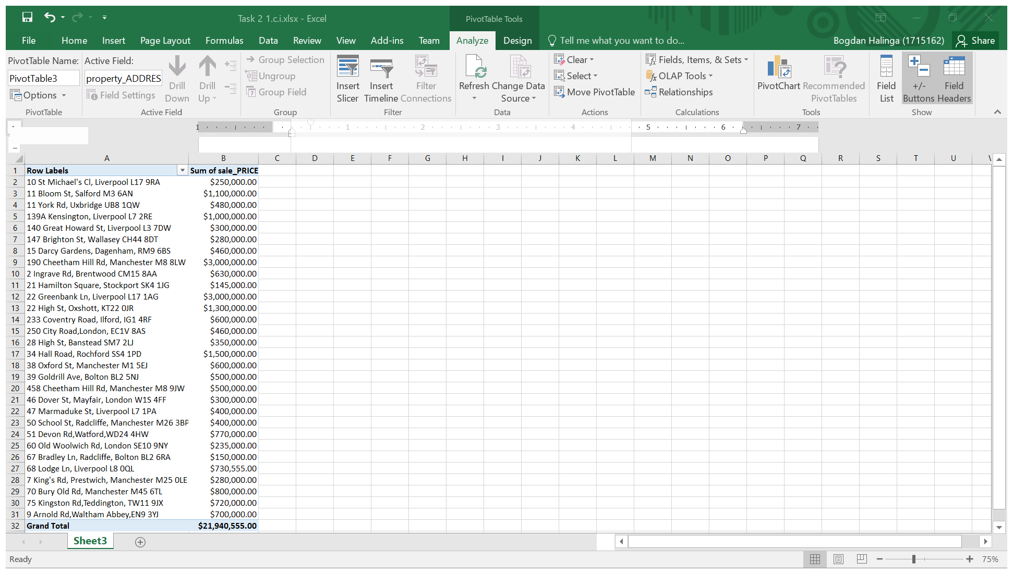
Fig.9 – Pivot Table in MS Excel –Sold properties

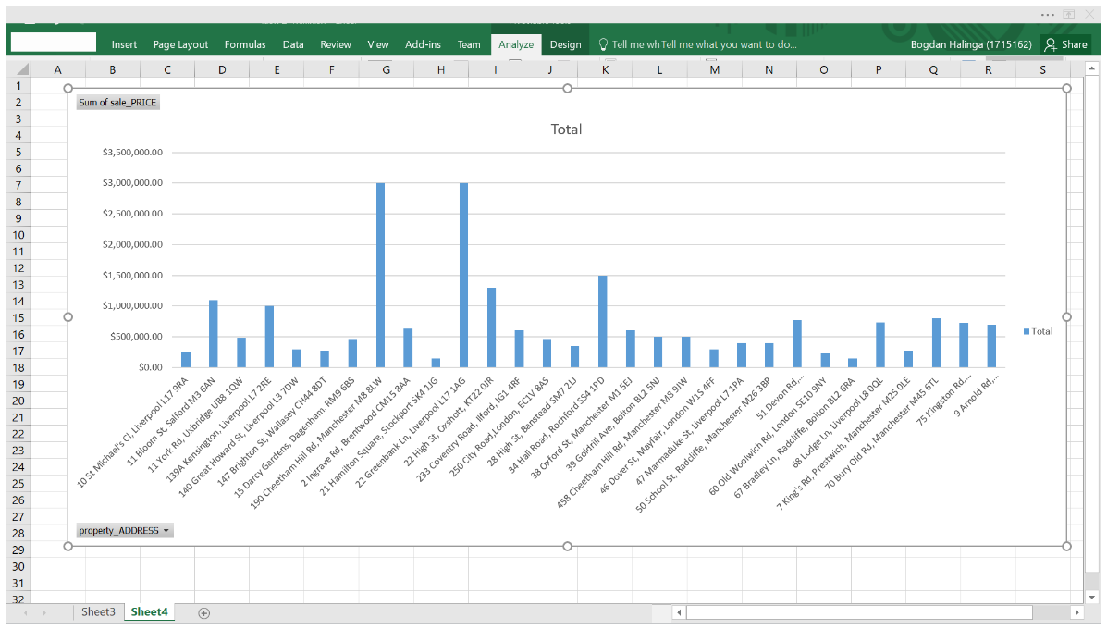
Fig.10 – Pivot chart in MS Excel – Sold properties

In Fig.10 we have same thing like in Fig.9, but now it is show in a chart. As you can see, is very easy to understand that chart, on the bottom part is displayed the address of the property (as a name) and in the left side are the prices.

After I presented all of this, you can see that having a DBMS (Database Management Software) allow to do the tasks faster and is very easy to manipulate. For example, in a paper base system, the employer must to write by hand all the information of the property, then add the property in a list. If they want to display the property in others two branches they should sent it by post and wait couple of days until the branches receive it. If each branch has a client interested in same property, they must to communicate by phone or fax all the time to don’t be a confusion on the selling time. If one of the branches sold the property, they must to notice others branches to avoiding sell the property again and wasting time.
With a DBMS all this long story became very simple. When somebody came to offer a property, one of the employers should time the property details in the DBMS list. Immediately after he/she finish this task, others branches will be noticed that a new property is in the system. If the property will be sold, again the employer will change the status in the list and in just few seconds others two branches will know that the property was sold and they don’t need to waste the time.
Every company in the world has a finance/accountant department. One of his roles is to analyse the data and generate reports to know the profit or losses during a specific period of time. In a paper base system, he must to collect all the information needed for a specific period of time (a year/ half year/ a semester), read all the information and generate reports. In a big company hundreds of thousands of file. This can generate trouble even in moving from one room to other one, can you imagine how long will take to read all that information? With a DBMS the computer will do all this thing for you in few seconds. You just need to create the filters and the computer will generate you the answers.

- Conclusion
In my opinion the estate agency should update their system immediately. Now a day the costumers want very fast and secure services. The company spent a lot of time for easy task, if they will upgrade to DBMS, the tasks will be done much faster and they can dedicate more time for others take to improve the company, like finding costumers interested in buying or people which are looking for sale, they can reduce the staff for saving money or they can open new branches and move the employees to that branch.
For these company DMBS means saving time and money, means progress and evolution.

Appendices
Appendix A
Task 2. 1. B (i) – SQL code to generate the required query
“select PROPERTY_address, sale_price
from PROPERTY, sale
where PROPERTY.property_ID = SALE.property_ID and sale_STATUS='SOLD'”

Appendix B
Task 2. 1. B (ii) – SQL code to generate the required query
“select staff_name, PROPERTY_address, sale_price
from staff, PROPERTY, sale
where STAFF.staff_ID=SALE.staff_ID and PROPERTY.property_ID = SALE.property_ID and sale_STATUS='SOLD'
order by staff_NAME asc”

Appendix C
Task 2. 1. B (iii) – SQL code to generate the required query
“select STAFF_name, PROPERTY_address, sale_price, sale_SOLD_DATE
from staff, PROPERTY, sale
where sale_STATUS='sold' and STAFF.staff_ID = SALE.staff_ID and PROPERTY.property_ID = SALE.property_ID
and sale_SOLD_DATE between '2019/01/01'and '2019/03/31'”

References

- https://www.guru99.com/data-modelling-conceptual-logical.html (accessed 24/082019)
- https://searchdatamanagement.techtarget.com/definition/entity-relationship-diagram-ERD (accessed 25/082019)
- ELMASRI, Ramez. Fundamentals of database systems. Pearson Education India, 2008.
- RAMAKRISHNAN, Raghu; GEHRKE, Johannes. Database management systems. McGraw Hill, 2000.
- CORONEL, Carlos; MORRIS, Steven. Database systems: design, implementation, & management. Cengage Learning, 2016.
- DATE, Christopher John. SQL and relational theory: how to write accurate SQL code. “O’Reilly Media, Inc.", 2011.
- HENDERSON, Ken. The guru's guide to Transact-SQL. Addison-Wesley Longman Publishing Co., Inc., 2000.
- WHITNEY, Arthur; SHASHA, Dennis; APTER, Stevan. High volume transaction processing without concurrency control, two phase commit, SQL or C++. 1997.
- HADZILACOS, Thanasis; TRYFONA, Nectaria. Logical data modelling for geographical applications. International Journal of Geographical Information Science, 1996, 10.2: 179-203.

