

Jack and entertainment contracts

Samantha Hopkins - 1903145

Assignment 1

—

Contract Law

—

BMLW5006


INSTRUCTIONS

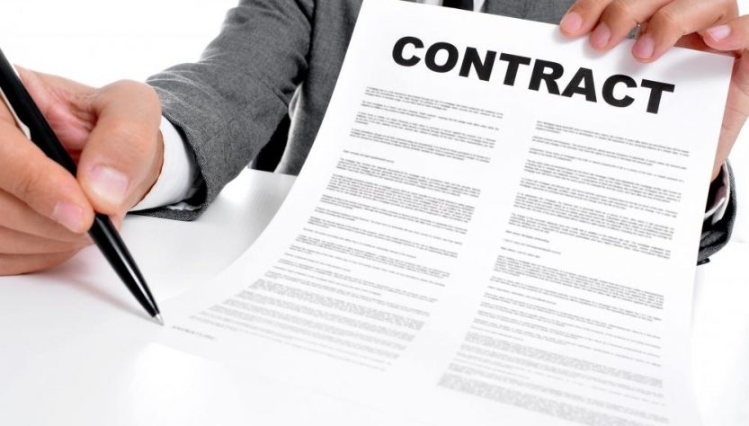
Referring to the task description, Jack is organising entertainment for the student union. A letter was sent out as following: ‘Want to attract new fans and get paid at the same time? Come and play at Oakwood Student Union. We are looking to hire performers to play on Friday or Saturday nights in May. Pay: £500 per gig, willing to negotiate.’ This letter then attracted Kate and Logan. This assignment will look at which valid contracts were formed or entitled to payment addressing the following questions:

- Advise Jack as whether a valid contract has been formed with Kate?
- Advise Logan as to whether a valid contract was formed with Jack and if so whether Logan can claim for the £500 he would have earned selling merchandise?
- Advise Jack whether he is legally obliged to pay DJ Mason anything for his performance?
- Advise Nell whether her agreement with Jack was intended to create legal relations?
- Advise Nell whether there was a valid consideration for Jack’s promise to pay £250.00?

Advise Jack as whether a valid contract has been formed with Katie?

Looking at whether Jack has a valid contract with Katie, the court case Carlill v Carbolic (1) made an offer to treat to which carbolic accepted by purchasing the smoke ball. Comparing this with the contract with Jack and Katie, Jack made an offer to treat and Katie then in writing offered to play the gig accepting the offered amount of five hundred pound. With Corbolic, they argued that Carlill using the ball would not benefit them, this is then projected into Katie and Jack, after Jack read bad reviews and did not want Katie to perform. He simply did not reply to her which means Jack did not accept her offer to play. An invitation to treat is what the advertisement Jack made is. Jack was requesting people to apply and make offers to which then he could accept or refuse or even counter offer. Katie accepted the invitation to treat without making an offer so no agreement for her to perform or Jack to allow her to perform for the money was agreed upon. No valid contract was formed with Katie.

An invitation to treat through the advertisement (2) is where Jack made the invitation and Katie then made her offer of accepting his invitation, as Jack did not accept Katie’s offer no contract was made between them resulting in no need for Jack to pay Katie when she showed up to perform.

Notes: 500 words total needed, 1 more references/case studies. rejected but not rejected in writing? Mirror image rule = valid acceptance? Postal acceptance, look into the fact that Jack sent a letter himself to local musicians, does this mean he should of researched first before sending as the could be a direct personal element to this? Adams V Lindsell… offer becomes contracts performs the condition… an advert is NOT a contract it is an offer.

I think I am looking too much into this, I have no idea what is right and what is wrong because a lot of information contradicts other information. Should I put it all in?

Advise Logan as to whether a valid contract was formed with Jack and if so whether Logan can claim for the £500 he would have earned selling merchandise?

Looking at Byrne v Van Tienhoven [1880] (3), Jack accepted Logan’s offer by replying by post on the first of May. Therefore, with an offer made and being accepted and agreement was in place between Logan and Jack to which Jack broke contract when he did not allow Logan to perform. Paying him for what Logan would have been paid would be the correct way to deal with the breach of contract but the sale of merchandise was never mentioned within the contract.

Notes: 500 words needed total, 2 more case studies/references. Bulk it out more, cannot find anything about sales of merchandise???

Advise Jack whether he is legally obliged to pay DJ Mason anything for his performance?

Advise Nell whether her agreement with Jack was intended to create legal relations?

Currie V Misa [1875] (4) refers to consideration and promises made. Between Nell and Jack, Nell would be the detriment when performing for Jack, the benefitee. Although before performing Jack was asking Nell to preform with Nell then becomes the giver and provides goods which is her performing in exchange for, well nothing in return so there is no valid contract between them. In the eyes of the court Nell should have negotiated a price prior to the agreement and performance taking place.

Advise Nell whether there was a valid consideration for Jack’s promise to pay £250.00?

Roscorla V Thomas [1842] (5) talks about a sale of a horse where after the sale had been made, the horse then showed signs of bad behavior. This was then taken to court and the courts ruled that as it had not been discussed prior to the sale and the sale had indeed already taken place that it was now known as past consideration meaning no valid contract was in place for this to hold any claims in the court. Looking at Nell and Jack, Nell had already performed and Jack stating he would pay her two hundred and fifty pound for gratitude is past consideration. This means there is no legal requirement that Jack has to pay Nell.
Looking at Lampleigh v Braithwait [1615] (6), Lampleigh was asked to do a task that he usually does with no prior fee agreed upon before he performed his action. The courts deemed that as it was his regular job that Braithwaite should indeed pay what he had promised to pay Lampleigh even if it was past consideration. In the text, it is mentioned that Nell does a regular comedy routine for Jack but there is no mention of if she gets paid for this or how much. With that being the case, it could be argued also that if Nell preforms which is what she is normally paid for, it will enforce a later promise to pay where the money is indeed payable by Jack to Nell.

