
Skills for the Workplace
Module Assignment Submission
Student Name: | Rebecca Leismeier
Student Number: | 1910915
Module No: | BMSK4003
Module Title: | Digital Skills and Research Methods

Statement of Confirmation of Authenticity
By the act of making this submission, the student declares that this is the work of the student named above. The work has not, in whole or in part, been knowingly presented elsewhere for assessment, or where assessment has been built on a previous assessment, this has been identified. Where materials have been used from other sources it has been properly acknowledged. If this statement is untrue, the student acknowledges that an assessment offence has been committed.
Attention is drawn to the plagiarism and unfair practice policies of both the University and of ILM.
Permission for ILM to use this script
ILM uses learners’ submissions – on an anonymous basis – for assessment standardisation. By submitting, both the centre and the learner agree that ILM may use this script on condition that identifying information is removed. However, if you are unwilling to allow ILM use this script, please refuse by ticking the box: □

Table of Contents
Introduction 3
Introduction 3
What has been the impact of 21st Century Technologies on the modern workplace? 3
Part 1 3
An Overview of the 21st Century Workplace 3
An in-depth look at technologies used in own workplace 6
Part 2 6
An exploration of the use of social media in the workplace generally 6
An in-depth look at the use of social media in own workplace 9
The use of social media to enhance networking and career prospects 10
LinkedIn Profile 10
Conclusion 13
References 13
Appendix 1 14
Appendix 2 15

Introduction
Technology has reshaped the modern workplace and now plays a significant role in business. During this assignment, research was conducted in order to establish what the impacts of technology have had on businesses in the 21st century and if they have been positive or negative. Digital skills such as the use of social media to enhance career prospects were also implemented and credible sources were also C.R.A.A.P tested. C.R.A.A.P being an acronym for Currency, Relevance, Authority, Accuracy and Purpose.

What has been the impact of 21st Century Technologies on the modern workplace?

Technology in the modern workplace has evolved significantly. In the 20th century, the reliance on physical workers was heavy and constricted within offices and buildings. Today, technology has enabled people to work from any location and within working hours that are most suited to them. With the use of the internet, the modern workplace can collaborate and explore new means of communication. As well as bringing many advantages technology also has some bad points such as the replacement of physical work with machines and ultimately resulting in the loss of jobs. A report by the consultancy firm PwC found that 30% of jobs in Britain are potentially at risk due to an increase in artificial intelligence.
I believe this not to be true. I think that technology in modern society has created more jobs especially now that the modern workplace is more flexible. Having the ability to work from anywhere and without set times means that more people can have the opportunity to work. With technology being continuously updated, I think this creates a surge in the number of IT technicians, and therefore creating more jobs.

Part 1

An Overview of the 21st Century Workplace

The expansion of modern technology has reshaped the workplace and changed the way we work. Technology in the 21st Century is critical for businesses to succeed. Having the use of computers, tablets and smart phones, facilitates businesses to run complex tasks efficiently and enables them to perform well. However, these devices alone are constrained, the following technologies can be utilised to take full advantage of the devices:
Software
Computer software designed to perform a specific task, such as navigation, project management, process control, word processing, graphic design, communication, etc. (TheFreeDictionary.com, 2020). The use of an office suite such as Microsoft Office 365 is beneficial to all businesses and can enhance productivity within the workplace and provide IT control and efficiency. Here are some examples of Office 365 applications and their purposes:
- Excel – An electronic spreadsheet that is used for tracking information, creating lists and reports as well as storing, collecting and organizing data.
- Word – For the use of writing and producing documents such as letters, resumes, proposals and to create leaflets, posters and newsletters
- PowerPoint – Used to create professional presentations to create visual impact and the sharing of content.
- Tasks & Planner – Allows users to plan events, schedule meetings and set reminders. Ability to set due dates and priority levels.
Downloadable software is also available for smart phones, and small businesses can benefit greatly with the use of Applications such as, online booking systems, accounting software, apps for data access and storage, organisation apps and also the use of social media to promote products, services and advertisement.

Wireless Communication
One of the biggest advantages of wireless networks is its ability to fuel increased mobility in businesses. With a workplace equipped with wireless LAN connectivity, employees can move around the office space without any restrictions arising from cables. A wireless network allows access to all applications and documents on your network from anywhere inside the building within the range of the wireless network signal (Small Business Trends, 2020)
Cloud Computing
Cloud computing isn’t software but can provide software as a service or SaaS for short. An example is Gmail or LinkedIn. These are both software/applications but are running in the cloud and not on the user’s machine. Therefore, the software is provided as a service. The cloud enables businesses and employees to store and access system resources online, making it easily accessible from various devices. This promotes flexible work for employees and the ability to share documents and information via the internet. Cloud storage provides live backups of files reducing the risk of data loss due to computer malfunctions or human error.
When used together, these three technologies equip businesses and employees with advanced tools to help them flourish and improve workflow. Online research suggests that most modern workplaces rely heavily on these technologies. A 2015 survey based on 535 adult internet users, who are employed full-time or part-time indicates that employees rated Email and the internet as a “very important tool” to their job, and social media was rated as the least important. The results are shown below.
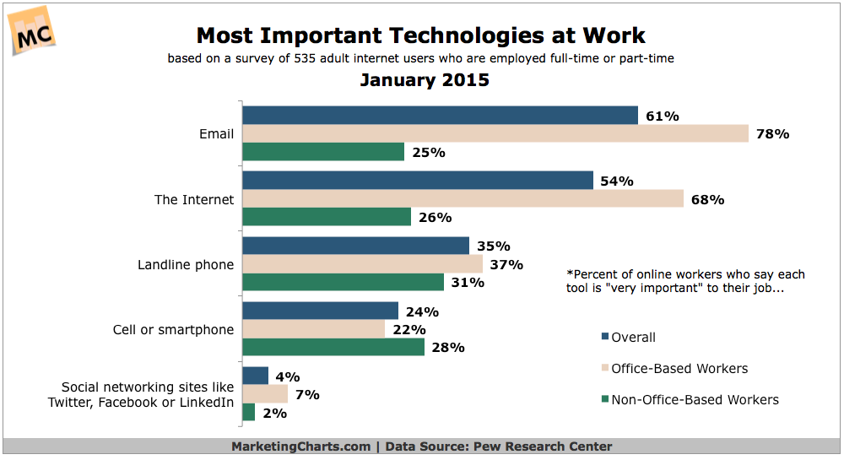(Marketing Charts, 2020)
These technologies are effectively reshaping the modern workplace. The arrival of smartphones, social media and email have changed the way businesses and people communicate with each other. Wireless communication and software as services have enhanced productivity and ultimately changed work ethics. This can be seen with the increase in employees working remotely. Employee efficiency can also be improved, such as time management. With the help of modern technological tools, the time and effort spent on daily activities are reduced which allows employees to more time on developing new ideas and becoming more creative. Teleconferencing via applications such as skype gives businesses the ability to hold conferences and meetings at convenience, saving money and diminishing the time spent on travelling. Email provides effective and reliable communication and is delivered straight away in comparison to traditional post. Dress codes are becoming more informal and work ethics
In addition, technology within the workplace also has its disadvantages, such as loss of interpersonal communication skills. With phones, e-mail, texting and social media replacing face to face communications, it can decrease vital personal interaction and ultimately lead to an unhealthy work-life balance. A study into the future workforce by Dell EMC found that 2 out of 3 UK employees prefer to speak face to face with their colleagues and that 84% believe that in person communication is important for productivity. upgrades and maintenance costs are also another disadvantage.
With technology constantly being improved, regular upgrades can be expensive and require employee training. There is also a risk of security issues such as hacking, and the internal threat of information theft for businesses, employees and clients. Boasting both good and bad aspects, the impact of modern technology has changed the way business is conducted and is constantly reshaping the workplace.

An in-depth look at technologies used in own workplace

In the hair salon, modern technology is highly relied on. A recent discussion with the salon owner revealed that the business uses a salon management software system called Salon Tracker. This provides a variety of useful and important features such as cloud storage, online bookings, stock management, recording client details and history, and business sales reports. Additionally, authorised security is provided for staff and clients, keeping information private and confidential. The salon also has a point of sales system (pos) used to perform transactions such as the sale of services or products. The pos system operates in conjunction with specific software that is installed onto computers, laptops and smartphones within the salon. Hardware components such as receipt printers, card terminals and cash drawers are also other technologies that are used within the business.
Upon further discussion with the salon owner, it also revealed that Internet connection and mobile apps are heavily relied on. The business uses messaging apps such as WhatsApp as well as intelligent marketing apps that distribute copious pre-filtered SMS messages to clients, engaging with them and encouraging a return visit. Social media such as Facebook and Instagram are also used to advertise special offers and promote the salon.
An additional app used on the manager’s smartphone is for the use of security cameras within the salon. These cameras alongside the app serve a great purpose such as protecting against theft of products, cash and client and staff personal belongings. The cameras also provide a level of safeguarding for the business against violent crimes and assault.

Part 2

An exploration of the use of social media in the workplace generally

The arrival of social media in the modern workplace brings the potential to increase brand awareness and the ability to connect with an intended audience. Another use is to promote products or services and attract new customers as well as build stronger connections with existing customers. Social media has become essential for businesses, and when appropriately used, it can be a useful tool for the following:

Marketing
Social media marketing (SMM) can deliver a variety of benefits for a business, one being advertising. Advertising on social media is one of the most effective methods known to the modern world. With the ability to target a select audience, businesses can share their content and generate traffic to their websites, ultimately leading to an increase in sales and profit. SMM is also very cost-effective and is one of the cheapest means of digital marketing.

Customer Service
The use of social media can allow businesses to provide a high level of customer service. With most social networking platforms having direct messaging, offering support and advising customers with purchases and questions is made simpler. Costs are also decreased by diminishing the need for call centres and replacing with online messaging to handle customer complaints and queries. Creating a faster response and promoting customer satisfaction builds trust with customers and leads to increased sales.

Information gathering
Social media provides businesses with a valuable opportunity to gather relevant data and information, that can help build marketing strategies. The collection of data such as audience interaction, age range, location and gender provide businesses with an opportunity to mark trends and measure engagement.

Communication
Social media is one of the most important channels of communication for a business. It provides companies with the opportunity to stay as close to customers as possible. In addition to advertising, there are also four other ways social media can promote communication to reach customers. They are as follows:
- Connections – Connecting with an intended audience such as customers, rather than pushing the sales of a product promotes trustworthy engagement.
- Campaigns – Using social media to broadcast a marketing campaign is a highly effective advertising strategy. Within minutes of the campaign going live, customers can interact and engage with the content allowing businesses to respond quickly and promote effective communication.
- Image – Promoting brand and product visualization allows customers to make faster decisions such as making a purchase.
- Availability - Social media provides businesses with easily accessible communication that is always available. Having this enables faster responses at convenient times, ultimately leading to customer satisfaction.
When effectively used, businesses can highly benefit from the use of social media within the workplace. In 2017 a company called clutch “A platform of in-depth client reviews, data-driven content, and vetted market leaders” (Clutch.co, 2020) surveyed 344 social media marketers from around the world to determine the most valuable social media platforms for businesses. The results of the findings are presented below.

The data revealed that Facebook is the most valuable social media platform. More than 50 million businesses use Facebook, and in 2015 the platform influenced 52% of consumers online and offline purchases – an increase from 36% in 2014 (Clutch.co, 2020). Facebook appeals to a wide range of consumers and is, therefore appealing to companies. Another valuable platform is LinkedIn. LinkedIn is a social networking site designed specifically for the business community. The goal of the site is to allow registered members to establish and document networks of people they know and trust professionally. (WhatIs.com, 2020) With other platforms such as YouTube, Twitter, Instagram and Google+ also being most valuable, businesses can tailor through to find the correct platform most accommodating to them.

There are also legal considerations to require when using social media within the workplace. Some UK laws are:
The Data Protection Act 1988 covers how information about employees and job applicants can be collected, handled and used.
The Human Rights Act 1998 Article 8 gives a 'right to respect for private and family life, home and correspondence'. Case law suggests that employees have a reasonable expectation of privacy in the workplace.
The Regulation of Investigatory Powers Act 2000 covers the extent to which organisations can use covert surveillance (Archive.acas.org.uk, 2020).

An in-depth look at the use of social media in own workplace

The hair salon highly relies on the use of social media platforms and a discussion with the manager revealed that the business mostly uses Facebook and Instagram. When questioned about the choice of social media platforms, the manager explained how they felt that those platforms had a wider audience and were most suited to the type of content that the salon would be sharing. Facebook delivers effective communication, and with the use of messenger, the salon can provide many business aspects online such as customer service. With Facebook offering a wider audience than other social media platforms, the salon can engage with people of all ages and in any location. The benefit of this is the advantage of trying to target potential clients.
With the hair salon being a creative environment, Instagram is another important platform for the business. Photos are uploaded daily to showcase employees work, achievements and overall promote the salon and increase clientele. The platform is also used to create a following, by using hashtags with the salon name and location, customers can showcase photos of the services they have received and share their experiences.
Furthermore, a survey was created and distributed to all staff working at the salon. The objective was to find out which social media platforms are most valuable within the workplace. The findings of the results are as follows:

The results show that Facebook is the most used social media platform within the hair salon. Every employee has a Facebook account, and all of them use it for work purposes as well as for personal use. Most felt that Facebook was more accessible due to already having a profile with connections and that the platform produces a much easier way to share content in comparison to the others.
LinkedIn is one of the least used social media platforms within the workplace, with only the managers and salon owner, using this platform. When questioned about the results, both managers revealed that use of LinkedIn is primarily for business connections and sometimes used for new recruitments.

The use of social media to enhance networking and career prospects

As a professional individual seeking the potential to one day start a small business, social media is vital. An active online presence is a great way to gain clients and maintain customers, not only for the workplace but also for self-employment opportunities. Social media platforms provide ways to self-advertise and promote one's work, leading to future career prospects, both as an employee or as a potential small business owner. Instagram is an ideal platform for hairdressing and beauty, as photos can showcase abilities as a hairstylist, colourist and make-up artist and essentially become an online portfolio. The use of this when applying for a new job provides potential employers with the need to know information, such as skills, abilities and the possibility to gain additional clients. Furthermore, leading to a higher chance of being recruited than those who do not have a social media profile.

The sharing of photos also brings the potential to attract businesses of other trades. For example, companies that sell salon products and equipment are likely to be interested in collaborating with an individual that has many connections. The outcome of this can result in benefits such as paid sponsorships and more followers.

LinkedIn Profile

With LinkedIn being a business network, an individual’s profile must look professional. LinkedIn’s photo guidelines suggest that users should upload a headshot, with the face taking up 60% of the frame. The photo should also be recent and unedited to avoid misleading potential employers when meeting face to face. The summary on the profile should include skills and abilities as well as a reflection of personality, as this is one of the first things people will see. Recent and previous job history and employers should be listed, with job titles and positions also stated. Furthermore, connections should be made to extend networking and career prospects.

My personal LinkedIn profile was created to gain connections, promote personal skills and potentially develop new career prospects. My profile photo was taken at my current workplace by another employee. I chose to upload this photo to my LinkedIn account as I am wearing my work uniform and I believe it makes my profile look very professional. The header is a photo of hairstyling tools. It is bright and colourful and showcases my profession well. The photo was sourced from a website called Pexels and they produce stock free images, so that there is no risk of copyright. A sample of my Photo and Header is shown below.

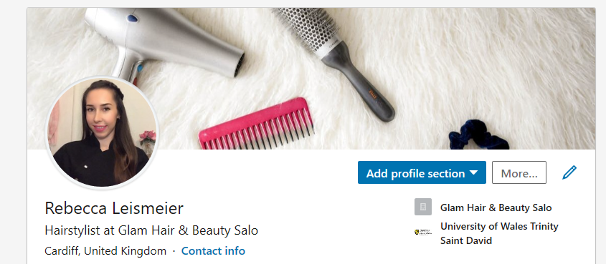

The next part of the profile is the summary, experience, education and certificates. Here I have listed my current workplace, and just below that is a summary of my personality traits and abilities. For education, I have added the university as a place of study and listed the previous colleges and schools I attended. This provides potential employers with some background information and leads to an insight into the qualifications I have achieved. These are shown below.
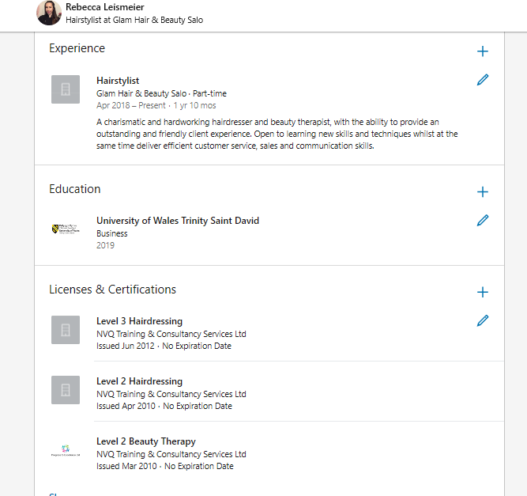

The benefits of having a LinkedIn profile are that it helps professional individuals promote themselves and get noticed by potential recruiters. It provides the ability to branch out and make connections, as well as establish a professional presence.

After researching a range of other social media platforms that are available to me, I think that LinkedIn is not very useful for the enhancement of my career. In comparison to alternative social media platforms, I believe that Facebook and Instagram are the most relevant and that they will deliver better career prospects. My current job requires me to show creativity, and I feel that LinkedIn hinders this whereas Facebook and especially Instagram are all for advertising and promoting a self-brand.

Conclusion
Technology has been extremely beneficial in the workplace and is continuing to reshape the way in which business is conducted. Social media platforms have been identified as well as their uses for enhancing career prospects, for both employees and potential business owners. Technology has helped the definition of the workplace change and has aided many people in adopting different lifestyle choices. When used appropriately, businesses can achieve a huge amount within the next few years with workplace technology.

References

Application software - TheFreeDictionary.com. (2020). Application software. [online] Available at: https://medical-dictionary.thefreedictionary.com/Application+software [Accessed 13 Jan. 2020].
Cloud Computing - wiseGEEK. (2020). What are the Different Types of Cloud Computing Software?. [online] Available at: https://www.wisegeek.com/what-are-the-different-types-of-cloud-computing-software.htm [Accessed 14 Jan. 2020].
Impact of wireless technology in the workplace - Small Business Trends. (2020). Impact of Wireless Technology in the Workplace - Small Business Trends. [online] Available at: https://smallbiztrends.com/2016/11/wireless-technology-in-the-workplace.html [Accessed 14 Jan. 2020].
Most Important Technologies Chart - Marketing Charts. (2020). Most Important Technologies at Work - Marketing Charts. [online] Available at: https://www.marketingcharts.com/digital-49729 [Accessed 20 Jan. 2020].
Meet Clutch - Clutch.co. (2020). Meet Clutch | Clutch.co. [online] Available at: https://clutch.co/about-us [Accessed 23 Jan. 2020].
Social Media In The Workplace Advice and Guidance - Archive.acas.org.uk. (2020). Social Media in the Workplace Advice & Guidance | Acas. [online] Available at: https://archive.acas.org.uk/index.aspx?articleid=3375 [Accessed 24 Jan. 2020].

Appendix 1

Appendix 2

