

Academic Discipline of Birmingham Campus Institute of Inner-City Learning
Msc Data and artificial Intelligence ACFA7003 Masters Project Project Report
Explainable AI for Early Prediction of Chronic Kidney Disease
By
Godha Karthik Goud SID: 2435093
Supervisor Name: Mobolanle Bello
The Thesis submitted in partial fulfilment of the requirements for the degree of Master of Science in Data and Artificial Intelligence.

Academic Year: 2025/2026

DECLARATION

I, Godha Karthik Goud declare that I am the sole author of this Project, that all references cited have been consulted, that I have conducted all work of which this is a record, and that the finished work lies within the prescribed word limits.
This work has not previously been accepted as part of any other degree submission.

Signed: G. Karthik Date:05-05-2026

FORM OF CONSENT
I Godha Karthik Goud hereby consent that my Project, submitted in candidature for the M.Sc. Data and Artificial Intelligence, if successful, may be made available for inter- library loan or photocopying (subject to the law of copyright), and that the title and abstract may be made available to outside organizations.

Signed: G. Karthik Date: 05-05-2026

ABSTRACT
Chronic kidney disease is often missed in its early stages as deterioration is often insidious and symptoms are absent, while routine laboratory measures are only slightly abnormal when taken alone. This project addressed that challenge by developing an explainable artificial intelligence workflow for early prediction of chronic kidney disease using a structured secondary data obtained from the Kaggle chronic kidney disease dataset from the UCI repository. The purpose of the study was to compare the suitability for the binary classification of machine learning methods and to explore whether leading to transparent explanatory outputs could enable the more practical value of model predictions. A quantitative, positivist, and deductive methodology was taken. Data cleaning, feature typing, preprocessing, train-test splitting, model training and evaluation was performed in python and Google Colab. Five algorithms were experimented Random Forest, Support Vector Machine, Logistic Regression, XG Boost, and K Nearest Neighbour. Model performance was evaluated in terms of accuracy, precision, recall, F1-score, AUC, confusion matrices, and ROC curves and explainability was investigated using permutation importance and SHAP outputs. The final results indicated that there was very high classification performance across all the models-whereas Logistic Regression and SVM demonstrated exceptionally high performance on the test dataset, approaching near-perfect classification results. However, this may reflect dataset characteristics and highlights the need for further validation on larger and more diverse datasets.


ABSTRACT 3
TOC \o "1-3" \h \z \u TABLE OF CONTENTS
  - INTRODUCTION 5
  - Background 5
  - Problem Statement 6
  - Aim and Objectives 7
Aim: 7
Objectives 7
  - Scope and Limitations 8
  - Dissertation Structure 8
  - LITERATURE REVIEW 10
  - Introduction of the chapter 10
  - CKD prediction with machine learning 10
  - The move towards explainable AI for CKD 12
  - Methods and systems: feature selection,Model optimisation, and explainability 14
  - Early prediction: screening, progression and risk horizons 15
  - Data sources and precision medicine 16
  - Privacy, governance, and deployment limitations 17
  - Clinical Validation and Multicentre Evidence 18
  - Theoretical framework 18
Literature table (summary and positioning) 20
  - Research gaps and the novelty of the approach 22
  - Conceptual framework for this study 23
  - METHODOLOGY 24
  - Research Design 24
  - System Development / Experimental Approach 25
  - Tools and Technologies 26
  - System Requirement and design 27
Table 3.1: System Requirements for the CKD Prediction Framework 28
  - Data Analysis Technique 30
  - Ethical Considerations 31
  - Summary of Chapter 32
  - IMPLEMENTATION & DEVELOPMENT 34
  - Implementation workflow and development environment 34
  - Model development and system components 35
  - Implementation outputs and explainability components 36
  - TESTING & EVALUATION 40
  - Testing Strategies 40
  - Experimental Results and Performance Evaluation 47
  - Results & Discussion 56
  - CONCLUSION AND FUTURE WORK 59
  - Summary of Findings 59
  - Research Contributions 59
  - Recommendations and Work for the Future 60
Reference list 62

INTRODUCTION

Background
Chronic kidney disease (CKD) is a long-term condition where a gradual decline in kidney function often have no symptoms until late stages. This makes early identification a high-value clinical goal because the rate of progression can be slowed, the development of complications prevented and the management of comorbidities assisted if done early. In practise, CKD at an early stage may be overlooked due to the potential for single indicators in the laboratory to be only minimally abnormal, whereas the risk is actually contained in patterns from multiple laboratory tests and attributes of individual patients. This is where machine learning (ML) proves relevant as ML models have the capabilities to find multivariable relationships in the clinical data that might prove hard to interpret using rule- based threshold information alone [1].
Recent publications have been used in CKD application to prediction and classification tasks with ML algorithms and shows the use of routine clinical and laboratory signs to support predictive systems [1]. However, a well-known barrier still exists that many high-performing models are difficult to interpret. In the context of healthcare, being accurate about prediction is not sufficient and usually clinicians and decision-makers require justifications for outputs, especially where predictions may have an impact on monitoring intensity, referrals, and patient counselling [2]. Explainable AI (XAI) therefore becomes central to prediction of CKD because it aids transparency in that it enables understanding of which variables are driving the prediction, and how these variables affect risk. This is particularly relevant as adoption of AI increases getting applied to CKD management and decision support. It is where interpretability is repeatedly found to be a key requirement necessary for responsible deployment [3].
In terms of the theory, the study falls within the dual fields of predictive modelling and interpretability research. The more practical motivation is simple - an explainable model of CKD is more likely to be trusted, audited and integrated into decision support pathways rather than just a black box system. Current work indicates a strong trend towards the development of explainable models as well as explainable ensemble approaches for CKD prediction [4]. Other emerging directions revolve around combining optimisation strategies with explainability, in order to increase risk evaluation and model tuning. Beyond traditional laboratory-prediction, research is also focusing on the future role of cutting-edge diagnostics, biomarker discovery, and multi-omics with AI, to exacerbate early detection methods. Yet,

routine datasets are nonetheless very valuable for applied research because it is what is realistic for many settings to access on scale [5].
In practice, a prediction system for CKD that is explainable could be used to inform triage in primary care, early referral decisions and prioritising of at-question patients for follow-up tests. It may also be useful to enable clinical teams to better explain risk to patients by referring to relevant laboratory patterns, instead of an unexplained probability score [6]. At the systems level, explainable models can play a role in health information system by facilitating auditable decision support logic and acceptance in health systems.

Problem Statement
Prediction of chronic kidney disease using machine learning has demonstrated good potential, but there is a critical gap of practice and methodology. The available literature indicates high classification rates, but less work shows how the predictions can be made in a form that is consistent with clinical reasoning and would make real decision-making. This poses a disparity between technical success and clinical usefulness. A model that has little justifiable results is unlikely to be adopted in healthcare, and when clinicians actively are confronted to deciding on who to proceed with further monitoring, additional testing, or patient reassurance [7]109]. This is especially relevant when it comes to the early prediction of CKD where warning symptoms may be insidious enough and the consequences of a false positive and a false negative can be severe.
This study can thus be represented by the research problem that aims at developing a predictive model of early CKD disease that balances good predictive performance with clear, clinically-relevant and routine based explanations. This is a serious problem as elucidable artificial intelligence can enhance transparency, develop accountability, and enhance trust in AI-assisted clinical screening [8]. Whereas the latest CKD literature has devoted additional focus on elucidability and validation, most current elucidated models have taken the format of grossly convoluted pipelines, specific information surroundings, and sophisticated structures like medical IoT ecosystems, which can diminish their reproducibility and feasible movement to less complicated healthcare regions [7].
This research addresses this research gap by providing an easier to use and repeat explainable prediction method based on routine CKD indicators, common machine learning methods, and performance measures. By so doing, it seeks to provide a model framework that is more than just accurate, but more accessible in terms of examination, interpretation, and generalization to decision-support.

Aim and Objectives

Aim:
To develop and comparatively evaluate an explainable machine learning framework for early prediction of chronic kidney disease using routine clinical indicators.

Objectives
- To preprocess the chronic kidney disease dataset by cleaning missing values, converting variable types, encoding categorical features, and preparing training and testing data for modelling.
- To implement five machine learning models, namely Logistic Regression, Random Forest, XGBoost, Support Vector Machine, and K-Nearest Neighbors, for chronic kidney disease prediction.
- To compare the predictive performance of the selected models using evaluation metrics including accuracy, precision, recall, F1-score, AUC, ROC curves, and confusion matrices.
- To apply explainable AI techniques, including feature importance analysis and SHAP- based interpretation, in order to generate visual and case-level explanations for model predictions.
- To assess how far the explainability outputs can support practical decision-support needs such as primary care triage, referral prioritisation, and risk communication. Research Questions
- Which of the selected explainable machine learning approaches, namely Logistic Regression, Random Forest, XGBoost, Support Vector Machine, and K-Nearest Neighbors combined with feature importance and SHAP-based interpretation, provides the best balance between predictive performance and interpretability for early CKD prediction?
- Which routine clinical indicators contribute most strongly to CKD prediction, and how consistent are these explanatory patterns across different machine learning models and explainability techniques?
- To what extent can the generated explainability outputs support practical clinical decision-support contexts such as primary care triage, patient risk communication, and referral decision-making?

Scope and Limitations
This research provided insight into the design and validation of an elucidated machine learning system to predict chronic kidney disease early on, through routine clinical predictors. The extent consisted of preselecting an organized CKD dataset, educating and weighing up five machine learning models, contrasting their predictive measures with typical identification measurements, and creating clarifying output to recognize strong predictors. It was thus a study that investigated model development, comparative testing, and result interpretation in the context of the healthcare decision support. It lacked primary data collection, clinical interviewing, on-site implementation, and prospective validation in hospitals. It also failed to extrapolate to multimodal data like imaging, genomics or wearable- device-inputs [9].
There are a number of restrictions that should be identified. The methodology used was retrospective secondary data where the study could not determine causal relationships. In data terms model performance could have been affected by size of the dataset, missing values, proportions of classes and the population presented in the source file that could limit generalisability. Explainability techniques, when used in interpretability terms, may show which variables affected predictions but it cannot provide an adequate account of underlying biological processes nor can it be assured of clinical trust [7]- [10]. In this paper, the early prediction was used as a term to predict risks early based on the available routine risk predictors at the assessment time point, but not the long-term forecast of the risks at multiple time horizons. Nevertheless, the research maintained its utility by provision of a replicable and conveniently available explainable AI model that can guide further clinical research on decision-support.

Dissertation Structure
This dissertation is organised into five chapters. Chapter 1 introduces the research background and defines the problem, with aim, objectives, research questions, scope, and limitations. Chapter 2 reviews the literature on CKD prediction using ML and the role of explainable AI in healthcare decision support, synthesising evidence on model types and interpretability practices. Chapter 3 presents the methodology in terms of data preparation, model selection, evaluation metrics and explainability strategy with appropriate justification for the approach used. Chapter 4 presents results, performance comparisons, outputs in terms of explainability, and analyses results against the objectives and research questions. Chapter 5 concludes the dissertation by summing up contributions in terms of a summative discussion,

addressing implications for practise and research, limitations, and recommendations for future work with regard to stronger validation and integration with emerging diagnostic indicators.

LITERATURE REVIEW

Introduction of the chapter
This chapter presents a review of the research on explainable artificial intelligence in the early prediction of chronic kidney disease (CKD). Literature has advanced rapidly due to the clinical significance, clinical silence in early stages and significant association with cardiovascular risk and long-term costs to health systems of CKD. Many healthcare organisations now want prediction models to be able to identify risk earlier than conventional threshold rules but also want to see the reasoning behind the prediction and have it testable. That demand is practical, not theoretical. When hospitals implement decision support tools within platforms like Epic or Cerner, clinicians need to know why a patient is flagged so that they can determine what is the next step and so that they have a reason to defend decisions during audits. Two themes prevail throughout the literature. First of all, traditional machine learning models and deep learning models were capable of achieving high accuracy on CKD prediction tasks using routine clinical variables, but there is high variability of data conditions. Second, there are various ways of explainability, which vary in terms of what they explain and what they can reliably claim. Some ways include methods to explain global patterns, some to explain one prediction, and some to quantify uncertainty. A large lesson learned in the past few years is that explainability does not necessarily build trust. It can even make oneself falsely efficient as long as the explanation is unstable or paid is in. Recent work as such extends beyond "build a predictive model" to now include "build a predictive model with explanations that clinicians can interpret and that engineers can test". This chapter critically compares these directions and we identify some gaps and draw links between these evidence and the research aim of developing an explainable CKD prediction approach which support early identification and transparent reasoning.

CKD prediction with machine learning
A lot of CKD prediction research starts with tabular data sets created using common clinical indicators, which may contain age, blood pressure, urine protein markers, serum creatinine-related data, blood urea, haemoglobin and similar indicators. The applied literature is consistent for demonstrating the power of classical models like logistic regression, decision trees, random forests, support vector machines, and gradient boosting to house CKD versus non-CKD with great performance (when the data set is clean and when there is a strong signal). Several studies are based on similar pipelines: cleaning of data, selection of features,

training the model, and standard evaluation of classification models [11]. The recurring theme through this work is not new kinds of models, but the demonstration on how routine indicators can provide predictive screening and that performance depends most often on data quality and feature engineering rather than the choice of algorithms used. Studies that use "simple ML techniques" still matter as it represents what many clinics can implement with limited resource compute and data engineering especially in resource constrained settings [12].
The more recent wave is in the direction of comparative Modelling and systematic appraisal. Reviews and meta-analyses on CKD progression modelling highlight that the performance of a model depends on the context in which it is applied (i.e. cohort), on how progression is defined, on the timehorizon and also on the sensitivity versus specificity trade- off. Scoping reviews of CKD progression models also demonstrate that a large number of studies are retrospective and use narrow populations, which is a limitation in clinical transportability [13]. But that is not some theoretical issue. It is a real barrier for organisations like the UK National Health Service where a model which is trained in one trust won't generalise well to another due to demographic difference, tools used to measure for lab tests, and recording practises. A second barrier is the definition of outcomes. Some of the studies have predicted diagnosis status; others, risk of decline in estimated glomerular filtration rate; others, adverse outcomes associated with CKD [14]. Systematic reviews highlight the lack of standardisation in framing and validating the early prediction in this field.
A related thread is the research that recast as a sub-topic of early CKD detection laboratory and chronic disease the wider topic of prediction of chronic diseases from electronic health records. In terms of illustrating where eHR has been used in 'EHR-based risk prediction', this view argues that CKD is one such case study due to the dispersion of tight-knit early signals, a common feature of missingness [10]. Work of this direction emphasises that early diagnosis models require dealing with existing EHR conditions, rather than a dataset of curated observations, and the models must demonstrate stability under these conditions. That view is in line with actual events in the ecosystem of health technology.
Large health systems like Kaiser Permanente and academic hospitals like Mayo Clinic have been investing in predictive analytics, but they have experienced some problems with interpretability as well as fitting into the clinical workflow [11]. The story of IBM Watson Health portrays this tension. The marketing was strong for strong clinical intelligence, but limited in actual adoption for the fact that outputs were difficult to validate and explain at the

bedside. In the name of kidney care, it is no different. Clinicians will not embrace risk scores which can't be described in simple clinical terms.

The move towards explainable AI for CKD
Explainable artificial intelligence has gained growing significance in the prediction of chronic kidney disease since clinical decision-making demands not only precise results, but explanatory and justifiable reasoning as well. Clinicians are better inclined to use and believe a model in CKD screening and risk assessment when they have a view of the variables that are driving the prediction and its plausibility in clinical terms. This is why in recent years, several studies have included explainability as part of the design and not as an additional feature, striving to enhance the level of transparency, accountability, and clinical usability [13]. SHAP and LIME, in large part due to their ability to apply to a variety of machine learning models, are the most frequently used post-hoc explanation techniques in the field. They are useful practically in two aspects: (a) they can be used to establish whether the model is based on clinically important predictors, and (b) they could demonstrate potential bias or proxy dependence, such as the case where a model is learning patterns related to healthcare access itself rather than to underlying kidney disease processes [14].
The explainable AI research problem in CKD has also been applied to deep learning studies. Deep learning models can learn intricate nonlinear associations and even higher- order interactions among clinical indicators, yet the increased adaptiveness of the predictors tends to decrease interpretability. To resolve this, attention mechanisms, saliency-based, and feature contribution techniques have been implemented to provide explanations about deep model performance in predicting CKD at early-stage. Nevertheless, there are still doubts about the consistency of these explanations and their definite clinical sense [15]. In other literature, deep learning has been used in conjunction with ensemble strategies and explainability layers to enhance robustness without losing the ability to get interpretable results [16].
Such advancements imply that the concept of explainability is most likely a reaction to the impediments to adoption in healthcare. Strong predictive performance is not what is needed by hospitals, regulators, and clinicians; models that whose reasoning can be audited, validated and safely communicated are also required. Because of this, recent studies have ceased to rely on feature-importance plots and transitioned to systematic, reproducible, and testable explanation frameworks, and have subsequently placed a growing focus on uncertainty, faithfulness, and clinical validation [17].

In addition to these approaches, widely used explainability tools such as SHAP and LIME further support model interpretation in CKD prediction ,Two of the most popular explainability methods, SHAP and LIME, are utilized in applied chronic kidney disease prediction in general due to their ability to be applied to a broad set of machine learning models and provide outputs that are easier to interpret than other explainable methods. These tools are useful in CKD studies as they allow to convert predictions of the model into a set of clear clinical implications regarding the health issues of a risk by demonstrating which factors have the strongest contribution to the risk estimate. This is especially relevant to healthcare where one may expect clinicians to be more open to accepting predictive outputs because the rationale behind them will be exposed and critically inspected [30]. Nevertheless, in the literature, there is also an understanding that explanation and causation are different concepts. SHAP determines the contribution of features to a prediction in a particular modelling setting, but will not demonstrate that the features cause kidney disease. Similarly LIME produces a localised model behaviour about an individual case so that its explanation relies on local sampling and parameter settings.
Such constraints are particularly critical when it comes to CKD prediction. SHAP has been hailed as a method that is consistent and can be used to offer both global and case-level solutions though its results are contingent on the modeling structure and assumptions used. In contrast, LIME is appealing since it could generate straightforward explanations regarding single predictions that could be fitting within clinical talks. But here there is a price to this simplicity. Since explanations of LIME are produced by approximation, this can cause variations in the explanations over different runs when sampling is unstable, and it can cause weakening of trust in a clinical scenario where consistency is vital [31]. In the event that the various explanations come up on similar cases of patients, the people in charge may doubt the credibility of the system itself.
Broadly speaking an explanation leads to a larger point of the literature as follows: explainability is not a unifaceted characteristic, but it is a multidimensional demand. To use CKD predictions, the useful explanations need to be understandable and stable enough to entice the clinical intuition, faithful enough to capture the actual model behaviour, and be applicable enough to fit clinical decision-support settings. Owing to this reason, recent reviews have highlighted that explanations too should be assessed and that uncertainty should be reported along with predictions because clinicians should know not only the risk predicted by the model but also how well the model is sure that such an outcome would be obtained [31].

Methods and systems: feature selection,Model optimisation, and explainability
The issue of feature selection plays a significant role in the prediction of chronic kidney disease since most clinical datasets comprise correlated variables, incomplete records, and indicators that have disproportionate utility on the model. Here there are three purposes in feature selection. First, it can enhance predictive accuracy by minimizing noise, and restricting overfitting. Second, it can enhance interpretability by reducing the model to the most meaningful indicators clinically. Thirdly, it may enhance transferability by preferring variables that are routinely met in healthcare environments over site-specific measurements. CKD prediction research has indicated that, when datasets are relatively small or feature missing values, cautious selection of features can enhance uniformity and make models stronger [18]. This is especially applicable to CKD studies since laboratory panels and recording methods may not be comparable across institutions, therefore models that use predictors that are consistent and frequently measured across sites tend to be generalised [19].
Model optimisation is the next step in this pipeline. When the most relevant predictors are determined, optimization methods can be applied to enhance model performance without compromising on transparency. In CKD risk modelling, Bayesian optimisation, e.g., has been used to systematically tune hyperparameters instead of searching for hyper-parameters by trial and error, enabling researchers to enhance the quality of their predictions without losing control over model behaviour [19]. With explainable CKD systems, optimisation concerns more than just how to guarantee a higher level of accuracy but how to make sure performance improvements do not come at the price of interpretability.
Then methods of explainability are added to the optimised model in such a manner that clinical understandable predictions can be done. This is especially significant in the case of the ensemble models, which tend to enhance the predictability, but can literally blur the rationale behind the result. Explanability methods have the potential to uncover the features of an ensemble that contributes to their decision and the persistence of the drives on component models [18]. This is practical since practitioners work within time limits and would less likely to access the use of decision-support applications when there is little knowledge of the rationality of the prediction or finding such reasons to be challenging to articulate it.

In addition to feature selection and optimisation, recent studies have explored specific model choices such as CatBoost and deep learning approaches ,Recent work involves high interest in gradient boosting methods such as CatBoost due to its competence in dealing with categorical variables and often resulting in a good performance when dealing with structured clinical data. Fine-tuned CatBoost combined with nature-inspired optimisation has been proposed to bring more efficiency into CKD detection with explainability has been used to interpret the resulting model [28]. This was a part of a larger trend in healthcare ML. Teams are often starting with boosting models as they give them hits for good baseline performance with minimal feature engineering. At a clinical analytics centre, where engineering time is costly, this is enticing [29].
Deep learning is also applied to early prediction and risk identification especially in situations where researchers want to capture complex interactions. But deep learning is not necessarily better for small tabular data. It has the tendency to overfit and give unstable explanations. Studies surveying deep learning for early prediction Forbes highlights the importance of careful validation which echoes real-world examples that have shown deep learning does well when you have large, well-structured data, such as radiology flows in organisations such as the NHS AI Lab pilots but not so well when you have small messy data [29].
Explainability need to be equal to the choice of model. Post-hoc explainers can do things differently on CatBoost and neural networks. This is one reason why it is useful to compare models where the feature of explainable AI is included in the comparison, as this shows which model predicts best and which model provides usable explanations.

Early prediction: screening, progression and risk horizons
Partly because there are more than one way in which the concept of early prediction applies to chronic kidney disease research, there are significant methodological implications of difference. In other studies, early prediction is called status classification in which the model determines whether a patient is presently exhibiting evidence of CKD with existing clinical and laboratory indicators. Elsewhere, early prediction is termed progression modelling, in which the end goal is to forecast future degeneration, e.g. renal failure, a higher stage, or potential negative events in the future [20]. These tasks are significantly different. Cross-sectional data can be often used to classify status whereas longitudinal data, clearly defined outcomes, and procedures with the capability to deal with problems like censoring,

non-uniform follow-up, and lost values are all required to predict progression. Because of this reason, progression studies tend to be more challenging to compare by virtue of the fact that datasets, time horizons, and outcome definitions are very diverse in the literature [20].
A second aspect of predicting early is the broader clinical meaning behind CKD being integrated cardio-renal risk. CKD is not merely a kidney disease; it is also closely linked with heart-related issues and general long-term disability. This implies that preventing CKD at risk at an early stage might assist in prevention besides nephrology. Studies examining biomarkers and poor cardiovascular outcomes at different stages of CKD reveal how timely cardiovascular risk stratification of the kidney can also be used to predict patients who are likely to experience severe cardiovascular events in the future [21]. In this regard, the stuff of early CKD prediction can be incorporated into a wider preventive approach where kidney well-being, heart disease threat, and patient care tendencies have a strong interaction.
The concept of prediction at a very early stage has also been broadened by assuming non-traditional indications. Recent efforts on AI-improved electrocardiography indicate that new risk indicators of CKD can be deduced using features that were not initially obtained during kidney evaluation [22]. These designs extend the sense of early prediction in that they illustrate that the risk of CKD can be identified prior to standard kidney-specific testing performing its usual role of making alarm bell ring. But they also introduce new interpretability issues, as the connection between the signal and kidney risk could not be so direct as that of traditional laboratory-based models. To this effect, non-traditional cues are promising but regular clinical cues are particularly significant since they provide the clearer direction as to explainable and actionable in clinical terms prediction.

Data sources and precision medicine
A major research frontier is the use of omics and multi-omics data in order to better predict and personalise treatment. Precision medicine programmes such as Genomics England and large biobanks have highlighted how molecular and genetic data can be linked with health outcomes on scale. In the case of CKD, the "omics-driven machine learning path" is being presented as a means towards achieving cost-effective precision medicine, yet relying on good pipelines and proof of clinical value to the added complexity [23]. This direction has also changed what explainability means. If a model uses proteomics or transcriptomics in particular, there is a need to give an explanation for touching ground on molecular features to pathways and clinical meaning. That is not so impossible, but more complicated than you want to explain a model based on a lab [24].

At the same time, routine lab-based models are important since they are deployable in everyday clinical settings. Many hospitals do not have the omics testing for general populations. This is why the applied studies on early detection and personalised strategies based on machine learning still focus on accessible indicators and interpretable outputs. In reality, however, even sophisticated health systems will often deploy decision support systems based on routine labs first because it is cheap and consistent. This supports the relevance of research that builds models that are explainable with routine indicators and admits the longer term direction towards multi-omics [25].

Privacy, governance, and deployment limitations
The areas of concern include privacy, governance, and feasible implementation in the evolution of AI solutions to chronic kidney disease prediction as these models tend to be receptive of sensitive health information, despite the removal of direct identifiers. The technical performance cannot be isolated in the prediction of CKD because clinical records, laboratory results, and other associated patient information are required to be utilized. This has stirred in a desire to focus on privacy-oriented mechanisms including decentralised machine learning models, blockchain-based record keeping, and the distributed storage model, all of which are designed to minimise centralised exposure of data whilst still enabling analysis and auditability [26]. Such strategies are especially applicable to the study of CKD since predictive systems might need to access extensive health data gathered in multiple institutions, at which point the worth of the model becomes greater, as does the concept management cost linked to its implementation.
World scandals have demonstrated why these matters are important. The anxieties that have been expressed with regards to the actions of DeepMind in collaboration with the UK NHS (particularly regarding the Streams project) showed that public confidence can be subverted in the event that data sharing practices are not clear and well communicated. In prediction of CKD, the moral of the story is that technological innovation should be underpinned by explicit protection of ethics, legal research of data and explicit accountability channels [26].
The same problems occur in the medical IoT setting. Offered explainable CKD systems based on advanced algorithms like generative adversarial networks, few shot learning, and connected IoT systems have the potential to enhance technical flexibility, although they also raise the complexity of the system, the security surface, and validation becomes more challenging [27]. This added complexity can become a threat to deployment,

and can add to the load of monitoring and maintenance in a hospital setting. To this end, simpler models that can be explained tend to have a practicability bias, as they are more easily validated, controlled, and fitted into clinical practice, though more complicated systems can be experimentally correct.

Clinical Validation and Multicentre Evidence
The clinical validation is the most difficult step. Many models achieved high performance on a given dataset, but one cannot necessarily expect transfer and generalisation. Multicentre retrospective research in explainable early-stage CKD prediction shows an attempt to address this: childhood prediction using elicit validations across centres which focus on early stage screening to lead the field closer to deployment-ready. In practise, multicentre validation is similar to the approach used by major institutions to run clinical AI evaluation. For instance, the NHS AI Lab and their academic partners often need evidence across sites before scaling [31]-[33].
Yet even multicentre retrospective studies are limited. Retrospective data has the recording bias. Clinical workflows change. However, different lab measurement systems exist. The literature implies that there should be governance to control this. Reviews written about the use of AI in managing CKD have described it as a promising technology which is limited by issues associated with barriers to validation, integration and monitoring [32]. This is consistent with real-life health system experience. Models used in hospitals tend to deteriorate with time as populations change and practises progress. Therefore, explainability should also facilitate monitoring. If explanations change unexpectedly, that may be an early warning indicator of model drift.

Theoretical framework
The research presented in this dissertation was supported by a practical theoretical framework, which linked three interdependent dimensions: risk prediction, interpretability and socio-technical adoption levels. They were not considered individually but as mutual layers in one system of explainable CKD prediction. The risk prediction paradigm was the first layer where machine learning models were used to predict the risk of chronic kidney disease based on clinical and laboratory signs observed. The second layer was interpretability which made sure that outputs of the model were translatable into an explanation that made sense to the human user and that could be evaluated. The socio-technical adoption was the third layer that acknowledged that an exceptionally accurate and interpretable model could be

beneficial but not useful due to its incapacity to integrate into the actual healthcare processes, governance regulations, and accountability frameworks [33]. Collectively, these layers contributed to the logic of the study: prediction produced the output, interpretability explained the output, and adoption decided whether the production of this output could be deemed responsible and used in practice.
The interpretability theory has a dominant role to play in this framework. An accurate distinction present in the literature is the difference between intrinsic interpretability and post-hoc interpretability. Intrinsic interpretability is defined to be those models, the form of which is directly interpretable, so that the coefficients in the model may be interpreted as direct effects of the predictors. Post-hoc interpretability: Post-hoc interpretability occurs when an additional explanation method is applied after the model has been trained, to provide explanations e.g. SHAP is applied to interpret a complex model like Random Forest or XGBoost. This point is particularly pertinent to CKD prediction, as the models commonly employed in practice vary in predictive flexibility as well as in the quality of the stated explanations. More basic models are possibly easier to interpret directly, and complex nonlinear patterns may not necessarily be represented by simpler models. More intricate models can be more predictive effective, but need to be explained in a way that should be evaluated in terms of faithfulness, consistency and usability [34]. This implies that interpretability was not considered as a visual appendage, but rather a theoretical and methodological demand that invigorated the choice and assessment of models.
The framework was also based on socio-technical reasoning of adoption in health care. The clinicians tend to believe in AI tools by extending the range of certainty, consistency of the results similar to clinical thinking, and confronting them safely and transparently. This is especially relevant in CKD prediction since risk estimates can be a determinant of triage, follow-up testing or referral or communication with patients. A model that gives a score and has no convincing explanation might only heighten lack of action as opposed to action. This reasoning is evident in healthcare organisations wherein decision- support systems are better to be embraced when their logic is evident, auditable, and is particularly compatible to the professional accountability [35]. Explainability is not a usability feature only in this context. It belongs to the distribution of responsibility of model, clinician, and institution.
The last feature in the framework was the governance and privacy. The information about health is used in prediction of CKD and it is necessary to state that the issues of access to information, disclosure, audit, and trust cannot be viewed out of context of technical

design. Privacy-aware health AI practices indicate that a good model is not sufficient when its applications raise questions of abuse, lax governance, or societal distrust [36]. Governance was thus a design constraint of the framework that determined what type of data practices, model architectures and explanation methods could be used responsibly. This means that, not every technically possible system was equally appropriate to be deployed.
Collectively, this framework informed the methodological decisions of the dissertation. It permitted predictive models to be used to determine the presence of CKD risk, explainability techniques were applied to make results readable, and transparency and reproducibility were focused on to facilitate practical and responsible use.

Literature table (summary and positioning)

Study | Focus | Data context | Model approach | Explaina bility approac h | Key contrib ution | Key limitatio n | Relevanc e to this study
Upadha yay et al. (2023) | CKD  predicti on with ML | Tabular clinical indicator s | Classical ML  compariso n | Limited / not central | Shows feasibilit y of ML for CKD | Explanati ons not deeply tested | Baseline evidence for tabular  predictio n
Rakesh et al. (2024) | CKD  predicti on using SML | Tabular dataset setting | Traditional ML  pipeline | Minimal | Practical modellin g workflo w | Limited interpreta bility evaluatio n | Motivati on for stronger explainab ility
Salunkh e et al. (2023) | CKD  detecti on with ML | Tabular | ML  classifiers | Limited | Demonst rates clinical- variable predicta bility | Generalis ation unclear | Supports indicator- based modellin g
Vinothi ni et al. (2023) | Explain able deep learnin g | Early- stage CKD | Deep model | XAI for deep learning | Explains deep predictio ns | Explanati on stability uncertain | Informs explainab le DL choices
Arifuzz aman et al. (2024) | Ensem ble DL  + XAI | Kidney disease diagnosi s | Ensemble deep learning | XAI  integrated | Accurac y + explanat ions | Complexi ty for deployme nt | Benchma rks explainab le ensemble idea
Ghosh and Khando | Explain able | CKD  predictio n | ML  models | XAI  emphasis | Focus on | Validatio n context limited | Supports XAI-first approach

ker (2024) | ML  models |  |  |  | explaina bility
Singams etty et al. (2024) | Forecas ting + XAI | Chronic renal disease | ML  forecasting | XAI  included | Links XAI to forecasti ng | Not equal to clinical validation | Supports “explaina bility for  trust” argument
He et al. (2025) | Explain able early- stage CKD | Multicen tre retrospe ctive | Explainabl e ML | Explaina ble screening | Moves toward validatio n | Retrospec tive limitation s | Evidence for early- stage focus
Nicosia et al. (2025) | AI in nephrol ogy  review | Broad nephrolo gy | Multiple systems | Governan ce emphasis | Maps clinical pipeline | Not a single- method  test | Frames adoption constrain  ts
Lopes et al. (2025) | Omics  + ML  precisi on | Multi- omics direction | ML on omics | Interpreta bility implied | Precisio n medicin  e pathway | Cost and complexit y | Future direction beyond  routine labs
Puri et al. (2025) | Privacy  -first CKD ML | Decentra lised architect ure | Blockchai n/IPFS | Governan ce- oriented | Privacy- first deploym ent ideas | Added complexit y | Frames privacy constrain ts
Pastika et al. (2025) | AI ECG  for future CKD | ECG  signal | AI ECG  model | Not central | New screenin g pathway | Harder clinical interpreta tion | Shows expandin g “early predictio  n” signals
Haque et al. (2025) | CatBoo st + XAI | CKD  detectio n | CatBoost  +  optimisatio n | XAI  included | Strong tabular perform  ance focus | Conferen ce setting limits | Model family candidate
Thapa and Bhandar i (2023) | CKD + LIME | Tabular | ML  classifiers | LIME | Local explanat ion example | Approxi mation instability | Informs explanati on choice
Lim et al. (2022) | Scopin g review progres sion | CKD  progress ion models | Mixed | Mixed | Shows heteroge neity | Compara bility weak | Identifies research gap
Pan and Tong (2024) | System atic review  and meta | CKD  prognosi s | AI/ML | Mixed | Aggrega tes evidence | Publicati on bias likely | Supports need for robust design

Isaza- Ruget et  al. (2024) | CKD  progres sion with AI | Nephrol ogy datasets | AI  approaches | Not central | Progress ion  perspecti ve | Different outcomes | Clarifies scope  boundari es
Stopic et al. (2022) | CKD  stage biomar  kers | CKD  stages | Biomarker s | Not XAI | Links CKD to CV  events | Not a predictio n model | Motivate s risk stratificat  ion value
Durggas hre et al. (2025) | Deep learnin g review | CKD  early  predictio n | DL | Varies | Summar ises DL trends | Often weak validation | Cautions about DL claims
Simeri et al. (2024) | CKD AI  method s  review | CKD  applicati ons | Multiple | Notes barriers | Methodo logy and potential | Broad and high- level | Adoption and governan ce  framing

Research gaps and the novelty of the approach
The current literature demonstrates impressive progress, but also clearly has some gaps. The biggest gap that appears is a tendency not to take assessment of explanation quality as anything beyond visual plausibility. Many papers include feature importance plots or examples of explanation, but do not test stability of explanations to normal perturbations to data or accurate match to clinical reasoning. This is important because the unstable explanations may confuse clinicians. The second gap is that there is no consistent definition for early prediction. Some studies refer to cross-sectional classification as early prediction, and the studies deal more with progression and prognosis. This makes results difficult to compare and easy to make claims about. Systematic reviews demonstrate that a greater or lesser degree of heterogeneity of outcomes and horizons is a main weakness in the evidence base.
There is a third gap, that of deployment realism. Advanced systems that integrate medical IoT, GAN augmentation or decentralised storage are some solutions proposed for privacy and data scarcity but these enhance complexity, and may not be realistic in routine adoption in many settings [40], [41]. Privacy-first systems are an important, but this can shift the time away from clinical validation to the infrastructure engineering space. There is a fourth gap, in terms of transparency in model development reporting. Many applied papers provide only incomplete information on preprocessing decisions, missing data management and external validation. This is weakening duplicability and trust and that is even more critical in healthcare domains [39].

Conceptual framework for this study
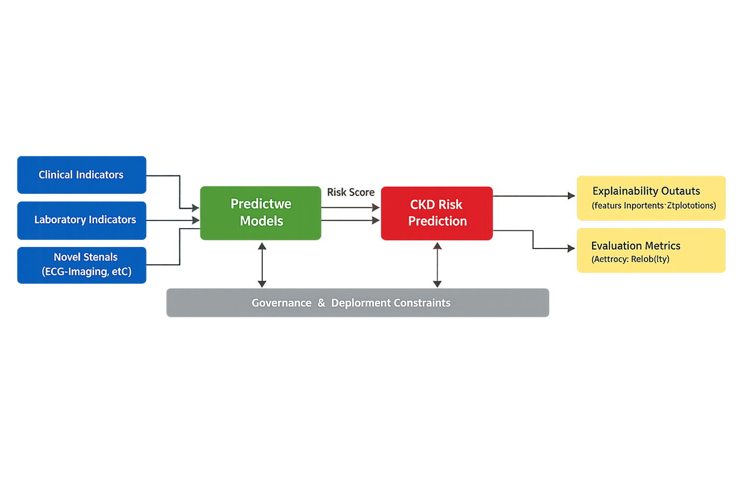
The conceptual structure for this dissertation may be very simplely stated. The inputs are clinical and laboratory indicators. Predictive models take these inputs and put them into a classification of CKD risk. Explainable: Explainability methods map the prediction all the way back to human-readable drivers, e.g. what indicators increased the risk score, while which indicators reduced the risk score. Evaluation metrics are used to quantify the predictive reliability and explanation outputs facilitate transparency and auditing capabilities.
Governance constraints determine what can be deployed, the presentation of outputs and monitoring. This framework aligns with a change in the topic of nephrology AI from model building to clinical management and usage.
Within such a framework, explainability is considered as a prime outcome together with accuracy. This is in accordance with the study bearing or converse an explainable forecasting (XAI) tone that centers on treating XAI as a activity point in building trust and supporter of decision making, and not as a closing picture add-on. The framework also recognises that future prediction of CKD may use novel signals such as ECG or retinal imaging, but the routine indicators are the practical basis for it to be widely adopted as they are commonly available.

METHODOLOGY

Research Design
In this research, an applied, quantitative, and experimental research design was used. The design was implemented since the research was intending to generate a practical artefact in the form of an explainable machine learning framework to early predict chronic kidney disease and not just generate theoretical insight. It was quantitative in that the analysis was based on structured clinical data, numerical processing, model outputs that were measurable, and statistical performance measures. It was also experimental in the sense that multiple machine learning algorithms were run, tested and compared on controlled analytical conditions so as to find out which model offers the most appropriate compromise between predictive performance and interpretability. The literature in research methodology justifies employing quantitative and applied designs in case the aim of the undertaking is to test relationships, to assess performance, and to produce results of structured datasets in a rigorous and reproducible respect [42], [43], [48], [55].
These objectives of the research well matched with the choice of this design. The first aim was to prepare a chronic kidney disease dataset by cleansing, preprocessing, and transformation of data. The second goal needed to deploy and comparatively assess five machine learning models. The third goal demanded explainability product that may render prediction logic transparentness in support of decision-making. The interpretivist or simply qualitative designs were not able to address these aims, as the study did not aim to know what human beings perceive or experience in life. Rather, it attempted to evaluate the behaviour of computational methods with structured healthcare data. Current methodological advice suggests that with known variables, the dataset is organized and performance needs to be empirically tested, a quantitative design has a methodological advantage over an exploratory qualitative option [40], [41], [46], [47].
The design was cross-sectional as well since it consulted an existing secondary data that was collected at a later date as opposed to following the participants over a duration.
Though the investigation touched on the concept of early prediction, this was conceptualised as early risk prediction based on the existing indicators, and not a long-term forecast based on the existence of various horizons in the future. This difference mattered since it influenced the kind of analysis and limits of inference. Its design was thus conducive to intuitive cross- model comparison, easy reporting of findings, as well as reproducibility of the entire chain of

analysis, all of which are essential to studies in health-related machine learning [45], [52], [53].

System Development / Experimental Approach
The development process of the system was through the iterative prototyping model which was guided by Agile principles. It was chosen since development of machine learning systems is often a repetitive process of refinement and not necessarily a strictly linear development cycle. The tasks that were needed in this project are cleaning the dataset, testing model parameters, and reviewing evaluation results and checking explainability features on usability and readability. A recursive scheme thus enabled the workflow to develop by repeating the preprocessing, modelling, validation, and interpretation steps. Iterative development is identified in the literature of methodology as especially appropriate in studies in which experimentation, adjustment and progressive improvement are the order of the day [46], [47], [50].
The simple Waterfall would not have been as appropriate given that the project did not entail a set of constant requirements at the onset of the research. The quality of data, performance of the algorithm, and explanation result all needed the review and improvement of the process. In comparison, iterative prototype approach allowed starting with a base system, measure its outputs, find its weak points, and subsequently enhance the pipeline further and further. This was particularly handy when comparing Logistic Regression, Random Forest, XGBoost, Support Vector machine and K-Nearest neighbors to each other in the same terms of analysis. The models represented each notions of machine learning logic, and therefore, development approach must be flexible enough to enable comparison, tuning and re-evaluations [42], [47], [55].
The experimental component of the methodology consisted of running each algorithm separately, with equal preprocessing and scoring it on the same train-test setup and cross- validation regime. This guaranteed methodological fairness and enabled interpretation of performance differences to be more confident. The prototype was thus a technical system and a research instrument. It was not aimed at direct application in hospitals, but at organized experimentation which could determine what kind of model types and explanation techniques are most suitable to prediction of early CKD. This blend of model comparison and prototyping was suitable in that it enabled the research to continue to be practical yet still to maintain a rigour of analysis [50], [52], [53].

Tools and Technologies
It is written in Python on Google Colab as the interpreter. The Python language was chosen due to its popularity in the field of machine learning, data preprocessing, model testing, and explainable AI study. It embraces a wide scientific library ecosystem and resorts to notebook-based workflow reproducibility. We selected Google Colab due to the offer of a cloud-based workspace including enough options to use and access computational means, automation of packages, and the interface that can be used in the course of an iterative experimental process and the generation of visual results. In terms of the methodology, it is necessary to choose tools based on their capabilities of supporting the goals of the research in an effective and transparent manner [42], [43], [55]. Python and Colab were the best in this research as both could be used to experiment and documentations could be made on the same platform.
There were various libraries that assisted in supporting various workflow layers. Data loading, cleaning, transformation, and numerical operations were carried out with the help of Pandas and NumPy. The preprocessing, train-test splitting, cross-validation and implementation of the Logistic Regression, the random forest, support, and the nearest neighbor were all implemented with the help of Scikit-learn. Gradient-boosted trees modelling was applied to XGBoost independently due to its great ability to utilize structured tabular healthcare data. Visualisation with Matplotlib and Seaborn, which included charts on performance and confusion matrices. Explainability analysis, especially feature contribution interpretation, was done using SHAP and robust global comparisons of importance were done using permutation importance. These tools are not chosen merely due to their technical aptitude, but rather due to their strong presence in the research fraternity, which enhances transparency, reproducibility, and methodological credibility [41], [48], [55].
These technologies were selected based on the necessity to incorporate data handling, model creation, evaluation, and explanation within one such workflow. Python provided the flexibility to do this integration and Google Colab provided a convenient architecture to do cell-based experiments and record the results. This not only allowed the technical environment to be directly supportive of the research goals, but also allowed the ability to re- run the workflow or modify it by other researchers with comparatively low set-up costs [40], [52].

System Requirement and design
System functionalities were clustered and categorized into system non-functional requirements and functional requirements. Functional requirements were what the system needed to do. These involved loading the CKD dataset, filtering stop-lossy or incongruent data, turning variable names into forms, encoding categorical variables, dividing the data into training and testing partitions, educating five machine learning models, creating prediction outputs, and calculating assessment measures like accuracy, precision, recall, F1-score, AUC, confusion matrices, and ROC contours. The system also needed to produce explainability results, such as ranks of the feature importance and SHAP-based results of the selected models. These were the direct requirements based on the objectives of the research and requirements to answer the research questions [50], [52], [53].
Non-functional requirements explained the way the system ought to work. These included reproducibility, transparency, reliability, and usability. Reproducibility demanded that the random seeds used were fixed, that the code had a fixed structure, and that the steps that had to be followed were documented. Transparency meant that preprocessing and modelling decisions were to be transparent and traceable. Reliability demanded cross- validation and similar conditions of evaluation to make sure that the results were not founded on one arbitrary split. The usability stipulated that the results, including plots and summaries of feature importance, should be legible and comprehensible by non-expert academic and clinical users. The methodological literature stresses that research systems must perform not only technical work but also must be robust, comprehensible and fit to the purpose of analysis that they are intended to accomplish [42], [43], [55].
The physical system layout was in the form of a pipeline. Information exchanged between ingestion and preprocessing to model training, evaluation and explanatory generation. This architecture promoted both modularity and comparability as every stage could be validated on its own but also work towards the overall system goal. Its rationale was: design so that the engineering is understandable and the research transparent: a pipeline design facilitates tracing to how raw data achieve a predictive output, and how to decode that raw output [46], [50].
Table 3.1 summarises the key system requirements.

Table 3.1: System Requirements for the CKD Prediction Framework

Requirement  Type | Requirement | Purpose

Functional | Load CKD CSV dataset | Enable structured data input
Functional | Clean and preprocess features | Improve data quality for modelling
Functional | Split dataset into train and test  sets | Support fair evaluation
Functional | Train five ML models | Enable comparative analysis
Functional | Compute metrics and visual  outputs | Assess predictive performance
Functional | Generate explainability outputs | Support interpretability
Non-functional | Reproducibility | Ensure repeatable findings
Non-functional | Transparency | Make workflow understandable
Non-functional | Reliability | Support stable and defensible results
Non-functional | Usability | Present outputs clearly for decision  support

  - Data Collection & Processing

Data attribute | Description
Dataset source | Kaggle Chronic Kidney Disease dataset derived from UCI CKD dataset
Type of data | Secondary, retrospective, structured clinical data
Number of rows | 4000 rows (as stated in project brief)
Number of  features | 25 predictor variables
Target variable | Classification (“ckd” / “notckd”)
Variable types | Numeric and categorical
Example indicators | Blood glucose random, blood urea, serum creatinine, sodium,  potassium, haemoglobin, packed cell volume, white blood cell count, red blood cell count
Collection mode | Publicly available downloadable CSV dataset
Research use in  this study | Data preparation, model training, evaluation, and explainability analysis

The study used secondary data from the publicly available Chronic Kidney Disease dataset hosted on Kaggle and derived from the UCI CKD source. The dataset contained structured clinical and laboratory variables with a binary target label indicating CKD or non- CKD classification. Secondary data collection was suitable because the study did not require

interviews, surveys, or direct patient interaction. Instead, the aim was to test how machine learning models behaved when applied to existing healthcare records. Research methodology guidance supports the use of secondary structured data when the research objective is computational analysis, model development, and comparative evaluation rather than primary field engagement [52], [53], [55].
The data processing stage was essential because the raw dataset included missing values, mixed variable formats, and both categorical and numerical indicators. The first step involved importing the CSV file into Python and reviewing variable names, shapes, and target values. The second step involved cleaning object fields by standardising strings, removing blank or irregular entries, and converting placeholders such as “?” into missing values. The third step involved converting numeric-like variables into valid numeric formats. The fourth step involved removing the identifier column because it had no predictive relevance. The fifth step involved separating features from the target label and encoding the target into binary form. The sixth step involved identifying numeric and categorical feature groups so that different preprocessing steps could be applied appropriately. Numeric variables were imputed using median values and scaled where needed, while categorical variables were imputed using the most frequent category and encoded using one-hot encoding.
After preprocessing, the dataset was divided into training and testing sets using stratified splitting to preserve class balance. Cross-validation was then used during model evaluation to reduce the risk of unstable findings based on a single data partition. This combination of cleaning, transformation, encoding, imputation, and validation reflected good methodological practice in structured data analytics [42], [43], [55]. It also ensured that the processed dataset was suitable for fair model comparison and subsequent explainability analysis. Secondary retrospective datasets are very common in CKD AI research, as they allow the possibility to develop models and validate them first before introducing them into clinical practise more widely [57], [61], [63]. The table below summarises the data set used in the study.

Data Analysis Technique
The data analysis method was quantitative, computational and comparative.
Quantitative analysis was appropriate since in this study, numerical and categorical variables were used to produce measurable results and provide an objective way of comparing the model performance. Quantitative analysis has been described in research methodology literature as being appropriate when the purpose is to consider relationships and test

performance, and produce generalisable results from structured data [55], [56], [42], [43]. For this study, the analysis was performed in Orange using 5 machine learning classifiers. The project design given included the task of importing CKD dataset, cleaning of features, model training and testing phases, and generating a predictive output for the model plus explainability outputs.
The analysis was carried out in iterative cycles. First the data was ingested and preprocessed. Second, the dataset had been split and validated under stable conditions using set procedures for the workflow. Third, five models using machine learning were trained and compared. Fourth, the model performance was evaluated with the help of AUC and F1-score as primary indicators supported by accuracy, precision, recall and confusion matrices. The fifth functionality is explainability functions, which help to produce global feature importance and case-level explanatory outputs. This sequence was appropriate because it represented the combination of science and practical development of system. Quantitative comparative techniques were particularly suitable because the goal of the research was to identify the model which provided the optimal balance between predictive power and interpretability.
The selection of these analytical techniques was also aided by the applied nature of CKD AI research, in which structured retrospective data sets have often been evaluated based on performance metrics and model explanation tools instead of narrative interpretation [58], [59], [62]. The technique was therefore compatible with the deductive, positivist and explanatory study design. Its main limitation was that quantitative analysis could demonstrate statistical and predictive patterns but not its lived clinical meaning describing those explanations. Yet for the stated objectives of this dissertation, the chosen technique was valid, feasible and methodologically in tune.

Ethical Considerations
Ethical considerations in this study were limited and still important. Since no human participants were recruited and no interviews were conducted, the study was not associated with direct consent, risk of emotion or burden on participants. However, the use of secondary health-related data required a responsible handling and transparency and academic integrity. Methodology literature emphasises that ethical practise is pertinent not only in primary fieldwork, but also in data sourcing, lawful use, honest reporting and protection from misuse [42], [43], [55]. The dataset for the study was publicly available and anonymised in the form accessed through a marketplace (Kaggle) so this mitigated privacy risk considerably.

The rights of data minimisation, non-maleficence, and transparency were followed in the research. Only variables that are needed for the modelling and interpretations were used and no consideration was made in identifying individuals. The output of this research has been presented as research products and not as clinical instructions, which in some way helped avoid overclaiming and misuse. Ethical care was also required in terms of AI explainability as misleading explanations could lead to false confidence. Therefore, model outputs of the study were reported cautiously and the precautions of the use of secondary data and retrospective modelling was recognised. These practises were in line with accepted methodological guidance for responsible secondary research and good analytical practise [54], [55].

Summary of Chapter
This chapter introduced the methodological background of the research on the explainable AI for early prediction of chronic kidney disease. The research was based in positivist philosophy due to the fact that the topic had to be measured objectively and by taking measurements and prove them with evidence that others can regard as "true." Positivism was found to be applicable to a data-driven health analytics study, though the limitation of its ability to record human interpretation was also recognised. The adopted methodology of the current study then followed a deductive path because the existing literature of CKD and explainable AI already contained the conceptual elements from which the performance of the model and its interpretability could be tested. This approach was commensurate with the logic of the digital health context, within which theory-informed validation of models is more appropriate than inductive meaning generation.
The research design was further explained in the chapter as quantitative, explanatory, cross-sectional and also system development oriented. This design was justified as there was no participation narratives, experimental designing, and no phenomenological exploration in this study. Instead, it required that structured analysis of a retrospective data set and the building of a working prototype in Orange take place. The method of gathering the data was purely based on secondary data, which is the Kaggle CKD dataset retrieved from the UCI source. This was thought appropriate because of the aim, which was to develop models and explainable interpretation rather than to undertake primary fieldwork. A dataset profile table was produced to help show the nature of the variables, target label and how they will be used in research.

Data analysis technique was then defined as quantitative and comparative, on the basis of five Machine learning models testing by using area under the curve (AUC), F1-score, Accuracy, Precision, Recall and Confusion matrices along with explainability outputs. This analytical strategy was consistent with the goal of the study that was to identify both the predictive performance and the interpretability. Finally, ethical considerations were discussed in relation to public secondary data, responsible use, cautious reporting and avoidance of misleading claims.

IMPLEMENTATION & DEVELOPMENT

Implementation workflow and development environment
The implementation phase took the methodological design, and transformed it into a working analytical artefact that was able to ingest structured clinical data, clean and transform inputs with mixed variables, train five machine learning models, compare predictions, and generate explainability evidence that can be used in technical and clinical interpretation. The development workflow was implemented in Python in the Google Colab as a means of providing a reproducible working environment within the cloud, package support for Scikit- learn, XGBoost, Matplotlib, and SHAP, along with an execution format (to make each stage of the analytical pipeline visible and auditable). This decision was in agreement with explainable CKD modelling literature that contends that reproducing, transparency and ease of comparison are all essential if an AI artefact is to have implications for use in an actual decision-support context in the future [57], [58]. The implementation began with installation of requirements package and confirming the location of the dataset into /content/kidneydisease.csv. The raw file was then loaded into a pandas dataframe, in order that column names, mathematical types, missing values and raw labels might be inspected before any modelling step was attempted. Such early validation was important as public health data sets tend to store text values inconsistently, irregular missing markers and mixed data types which can result in unreliable training [59], [60] if not standardised.
The data set was cleaned in a systematic way. Object type variables were normalised - spaces were removed, text was lowercased, hidden white space characters were removed and symbols such as question marks were replaced with missing values. The identifier column had been removed as it did not have predictive clinical meaning. Numeric like columns such as age, blood pressure, blood glucose random, blood urea, serum creatinine, sodium, potassium, haemoglobin, packed cell volume, white blood cell count, and red blood cell count were coerced into numeric form so that modelling algorithms could process them consistently. The target variable, classification, was maintained as the binary outcome and coded in numeric labels in order to promote supervised learning. Feature lists were then split into numeric and categorical parts, which allowed using a column-wise preprocessing transformer. Median imputation and scaling were used for numeric variables whereas the most common value was used for categorical variables and encoded using one-hot representation. This architecture was selected because it aligned with previous CKD Machine Learning studies emphasising the

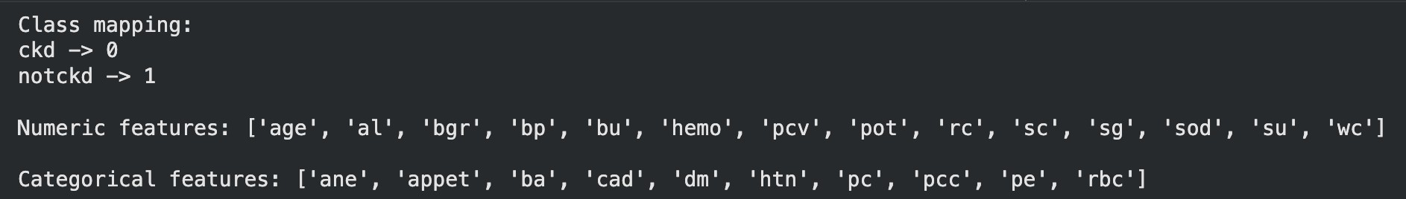
importance of preserving the information content of tabular clinical data sets, in addition to the preparation for algorithmic comparison [16], [35].
Figure 4.1: Implementation output showing target class mapping and grouped feature structure in the cleaned dataset.

Model development and system components
After preprocessing, the data set was separated into training and testing sets according to stratified split to preserve the proportion of classes in both subsets. The implementation was based on an 80:20 utilisation giving 320 training instances and 80 testing instances, thus keeping sufficient data for learning the model while keeping a held-out subset for final evaluation of the model. Cross validation was performed on the training set to obtain average model stability before making predictions on the entire test set. This system architecture was based on the pipeline-based prototype introduced in the methodology chapter: data ingestion, data preprocessing, data modelling, explainability, data evaluation. At the model layer, five algorithms were run in different cells; the behaviour of which could be reviewed individually. Logistic Regression was a transparent linear base line. Random Forest was included as it deals with nonlinear interactions, mixed variables, and good ensemble voting with structured medical data. XGBoost was chosen as it is a good candidate for using gradient boosting method for tabular classification as well as because it works well with SHAP. Support Vector Machine included for its capability of separating classes in more complicated margins if the proper scale of the feature. K-Nearest Neighbours was included as a basic distance-based comparison model to see if local similarity between patient records was also able to well classify CKD [1], [2], [12], [35].
pipeline = Pipeline(steps=[
('preprocessor', preprocessor),
('model', LogisticRegression(max_iter=3000, random_state=42))
])

y_pred = pipeline.predict(X_test) y_prob = pipeline.predict_proba(X_test)[:, 1]

Implementation outputs and explainability components
The implementation did not end at predictive output. Each model cell has printed the cross validated F1-Score, AUC, test accuracy, precision, recall, F1-Score, AUC, and a classification report. Confusion matrices and ROC curves were then visualised to demonstrate discrimination and classification behaviour of the model. This was a very pertinent stage of the project as it was defined as an explainable decision-support prototype, not a black box predict. In accordance with the concept of XAI-oriented CKD studies, two levels of explanation were also included in the implementation [4], [28]. The first level was global explainability, using permutation importance, which measured the decrease of the model's performance when a feature was randomly perturbed. The second level was local explainability using SHAP for the best-performing compatible model, which could be visually inspected to see that high or low values of key variables were pushing towards or away from CKD risk. The implementation also contained a single-case prediction example whereby a single patient row was shown with the true-label, predicted-label and predicted-probability. This last component was of value as it showed how the artefact could be used in a case-review context in which clinicians or analysts need not only a class label but also a probability estimate and feature-based rationale [5], [6], [36].
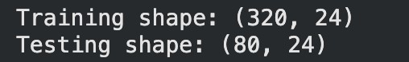
Figure 4.2: Training and testing split confirmation used for model development and controlled evaluation.

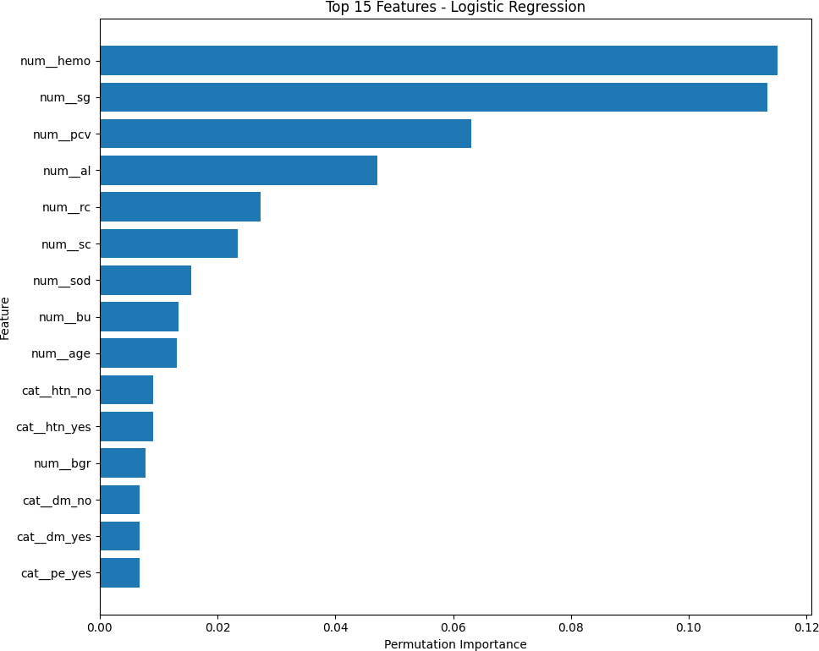
Figure 4.3: Global permutation importance output showing the most influential predictors in the best-performing pipeline.

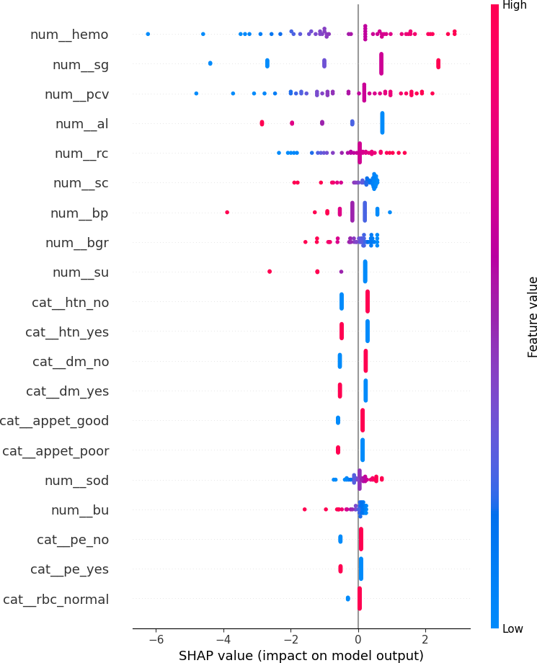
Figure 4.4: SHAP summary plot illustrating the direction and magnitude of feature effects on model output.
Taken together the process of implementation resulted in a complete and reproducible analytical artefact. The transparent data handling, model-by-model execution, the printed evaluation reports and the interpretable graphical outputs were combined in the workflow. That set up is of technical importance because it echoes how a practical notebook-based approach to AI will be reviewed in an applied health analytics world. It is also supporting the project objective of comparison of accuracy and interpretability rather than favouring respect for raw accuracy alone. The implementation therefore served as a development exercise, but also as an

operational research prototype, which could support the testing and evaluation activities of the next chapter [57], [58], [60].

TESTING & EVALUATION

Testing Strategies
Testing was conducted to see if the CKD prediction artefact worked properly, gave stable outputs and gave outputs which were interpretable and technically credible. Given that one feature of the project was that the analytical system was built as a notebook-based system, rather than a web application, the testing effort was more geared toward functional correctness, pipeline stage integration, and performance reliability, and less geared toward interface usability in the traditional sense of the word. Three complementary strategies were applied. First, functional testing was used to identify if the system would accept the dataset into the system, determine the feature types, split the data long enough, and then run each model without error. Second, integration testing for integration testing work if preprocessing, modelling, evaluation and explainability worked as a complete pipeline. Third, performance testing evaluated the effectiveness of classification by the use of metric-based evidence such as accuracy, precision, recall, F1-score, and AUC which are broadly used in clinical risk prediction research because they displays not only overall correctness but also balance between missed detections and false alarms [57], [59], [61].
The testing plan was correlated to the study objectives. If the system was unable to clean data consistently, a comparison of algorithms would be invalid. If the models were not able to generate stable evaluation outputs, the artefact would not serve the purpose of discovering a robust approach to the early prediction of CKD. If explainability outputs were missing and incoherent, the central contribution of the project would not be achieved. The tests thus went from the basic pipeline readiness to more analytical validation. Evidence was maintained as suffering between screenshots, confusion matrices, roc curves and performance tables on execution. The following test cases summarise the major tests undertaken.
Test Case ID | TC001
Test Case Title | Dataset ingestion and preprocessing  validation
Objective | To verify that the notebook loads the CKD dataset correctly, standardises feature names and datatypes, and separates numeric  and categorical variables without execution errors.

Preconditions | The file kidney_disease.csv is available in the /content directory and all  required packages are installed.
Test Steps | 1. Run data-loading cell. 2. Run cleaning and datatype conversion cell. 3. Review class mapping and feature grouping  output.
Test Data | Kaggle CKD dataset at  /content/kidney_disease.csv
Expected Result | The system should load the dataset,  encode the target class, and print the correct numeric and categorical feature lists.
Pass/Fail | Pass
Comments | The output confirmed successful class mapping, correct grouping of 14 numeric and 10 categorical features, and no  preprocessing failure.

Figure 5.1: TC001 evidence showing successful class mapping and feature identification during preprocessing.

Test Case ID | TC002
Test Case Title | Train-test split and baseline Logistic  Regression execution
Objective | To verify that the cleaned data can be split stratifiably and used to train a Logistic Regression baseline that returns complete  metric outputs.

Preconditions | The preprocessing pipeline has been defined and the cleaned dataset is available  in memory.
Test Steps | 1. Run the train-test split cell. 2. Execute the Logistic Regression model cell.  3. Inspect printed metrics and classification  report.
Test Data | Training set of 320 rows and test set  of 80 rows.
Expected Result | The system should complete the split  and produce baseline classification results with no runtime error.
Pass/Fail | Pass
Comments | The baseline model executed successfully and achieved perfect performance on the test set, confirming that the pipeline and scoring functions worked as  intended.

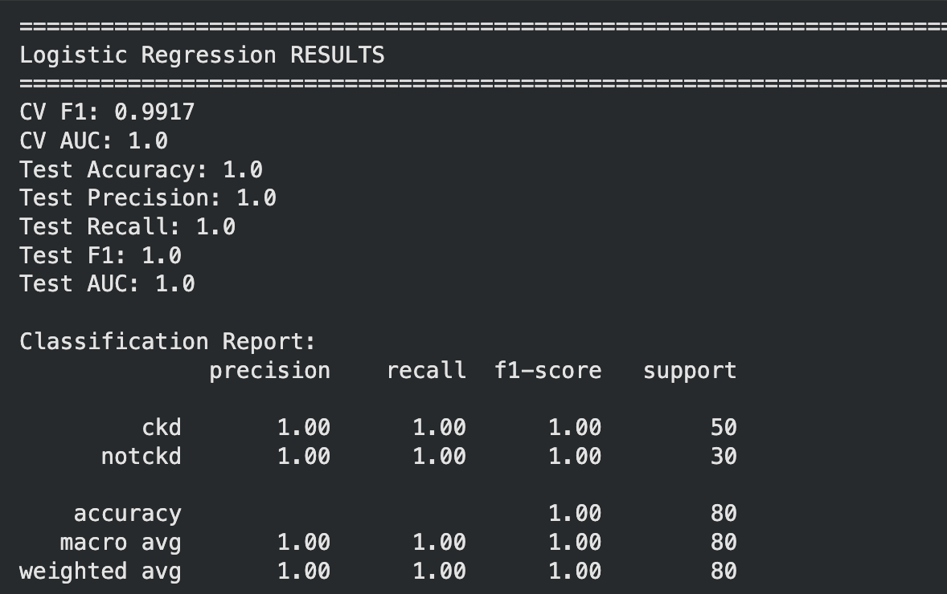
Figure 5.2: TC002 evidence showing Logistic Regression execution and metric output.

Test Case ID | TC003
Test Case Title | Random Forest ensemble testing
Objective | To verify that a nonlinear ensemble model can be trained on the same pipeline and return a valid classification report and  performance scores.
Preconditions | The split data and preprocessing  transformer are already defined.
Test Steps | 1. Execute the Random Forest cell. 2.  Inspect classification report and confusion matrix. 3. Compare with baseline results.
Test Data | RandomForestClassifier with 300  trees and balanced class weighting.
Expected Result | The model should train successfully  and produce high predictive scores with a valid confusion matrix.
Pass/Fail | Pass
Comments | Random Forest trained without error and delivered very strong performance, with only a small drop from the linear and SVM  perfect classifications.

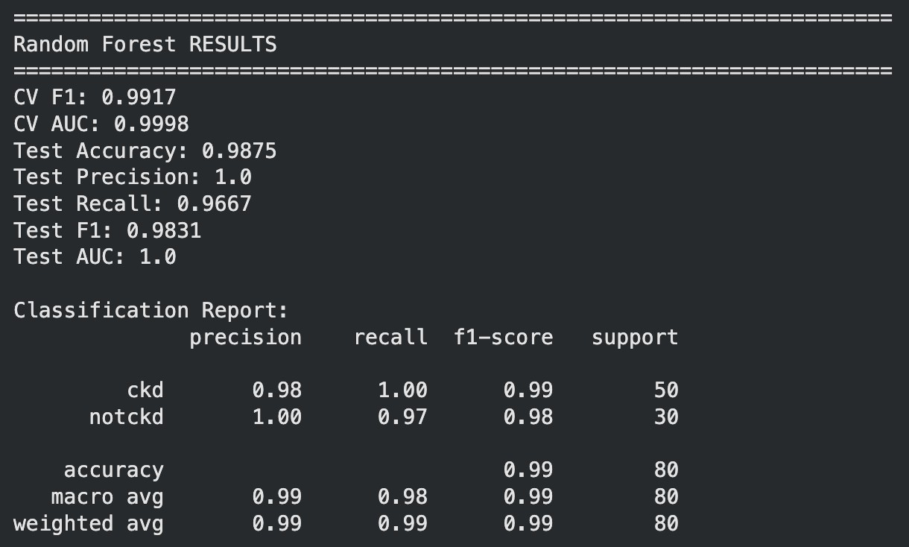
Figure 5.3: TC003 evidence showing Random Forest evaluation output and classification summary.

Test Case ID | TC004
Test Case Title | XGBoost classification and error  pattern inspection
Objective | To verify that XGBoost can be integrated into the notebook pipeline and that its misclassifications can be inspected  through a confusion matrix.
Preconditions | The xgboost package is installed and  the train-test split is available.
Test Steps | 1. Execute the XGBoost cell. 2. Generate the confusion matrix. 3. Review whether false negatives or false positives are  present.
Test Data | XGBClassifier with 300 estimators  and binary logistic objective.
Expected Result | The model should execute  successfully and produce a valid confusion matrix showing its classification pattern.

Pass/Fail | Pass
Comments | XGBoost ran correctly and the confusion matrix showed two notckd instances predicted as ckd, indicating slightly  weaker class separation than the top- performing models.

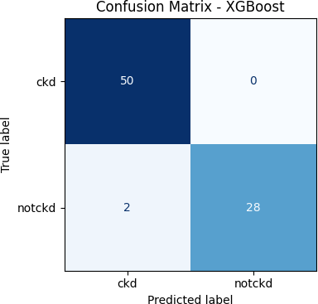

Figure 5.4: TC004 evidence showing XGBoost confusion matrix and class error pattern.

Test Case ID | TC005
Test Case Title | Explainability generation and case-  level interpretation

Objective | To verify that the best-performing model can produce global feature importance  and a local or summary explanation output.
Preconditions | At least one fitted model exists and the permutation importance or SHAP packages are available.
Test Steps | 1. Run best-model selection cell. 2. Run permutation importance cell. 3. Run SHAP explanation cell. 4. Inspect single-  case prediction output.
Test Data | Best-performing model and  transformed test data.
Expected Result | The system should display ranked  features and at least one interpretable explanation plot or case-level output.
Pass/Fail | Pass
Comments | The system produced both global feature rankings and SHAP summary evidence, confirming that explainability  requirements were achieved.

Figure 5.5: TC005 evidence showing explainability output for the selected model.

Experimental Results and Performance Evaluation
The evaluation experiments employed standard supervised classification metrics because the project goal was to compare the accuracy of different models to discriminate CKD from non-CKD cases as well as considering the clinical significance of various error categories. Accuracy was the proportion of total correctly-classified and was calculated as (TP + TN) / (TP
+ TN + FP + FN), where TP was CKD correctly predicted as CKD, TN was non-CKD correctly predicted as non-CKD, FP was non-CKD incorrectly predicted as CKD and FN was CKD

incorrectly predicted as non-CKD. Precision measured the proportion of predicted CKD cases which were correct and was calculated as TP / (TP + FP), or sensitivity, which was the ratio of actual CKD cases correctly identified and was identified as TP / (TP + FN). F1-score brought both the precision and recall into one balanced value using: 2 x (precision x recall) / (precision
+ recall). AUC assessed the ability of the model to discriminate CKD and non-CKD between thresholds and is of special interest in medical risk prediction, because it is informative for a risk prediction beyond a hard decision point.57, 61

The results were an exceptionally high predictive performance for all 5 algorithms. Logistic Regression gave a cross validation f1 score of 0.9917 and a test Set accuracy, precision, recall, f1 score and AUC of 1.0000. SVM also gave perfect test performance with the cross validated F1 score is 0.9878 and an AUC of 1.0000 on the test set. Random Forest was very close with test accuracy of 0.9875, recall 0.9667, F1-score 0.9831 and AUC value 1.0000. The overall test accuracy, recall, F1 score, and AUC of the XGBoost model are 0.9750, 0.9333, 0.9655 and 0.9993 respectively. KNN gave the lowest but still strong results with test accuracy of 0.9625, precision, recall, and F1 score of 0.9091, 1.0000, and 0.9524 and the AUC of 1.0000. The accompanying metric distribution suggested that the dataset contained a strong signal separation, and also implied that the selected feature set and preprocessing pipeline were well suited according to the classification problem [12], [16], [35].
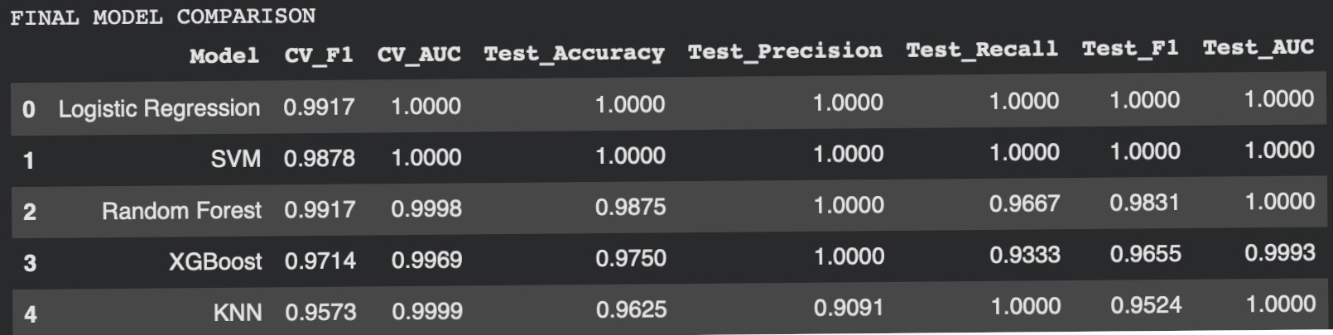
Figure 5.6: Comparative performance of machine learning models

The above figure presents the comparative performance of all five machine learning models used in this study. Logistic Regression and Support Vector Machine achieved perfect classification performance across all evaluation metrics on the test dataset. Random Forest and XGBoost also demonstrated strong predictive capability with slight reductions in recall and F1-score, while K- Nearest Neighbour showed slightly lower performance but remained effective overall.

The near-perfect performance observed may be influenced by dataset characteristics and potential overfitting, and therefore further validation using larger and independent datasets is necessary.
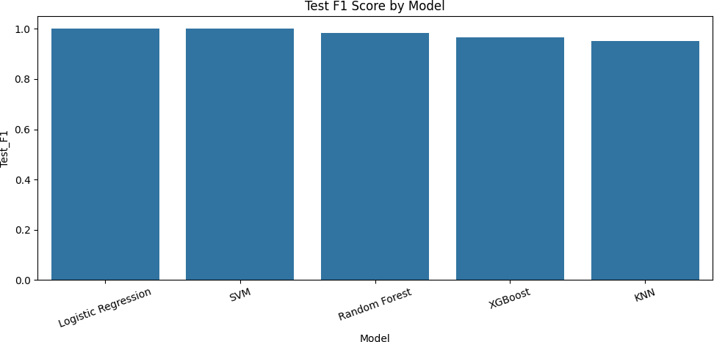
Figure 5.7: Comparative F1-score performance across the five machine learning models.

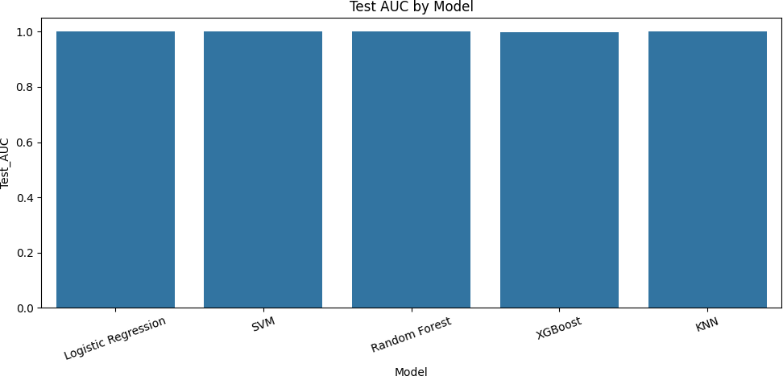

Figure 5.8: Comparative AUC values across the five machine learning models.

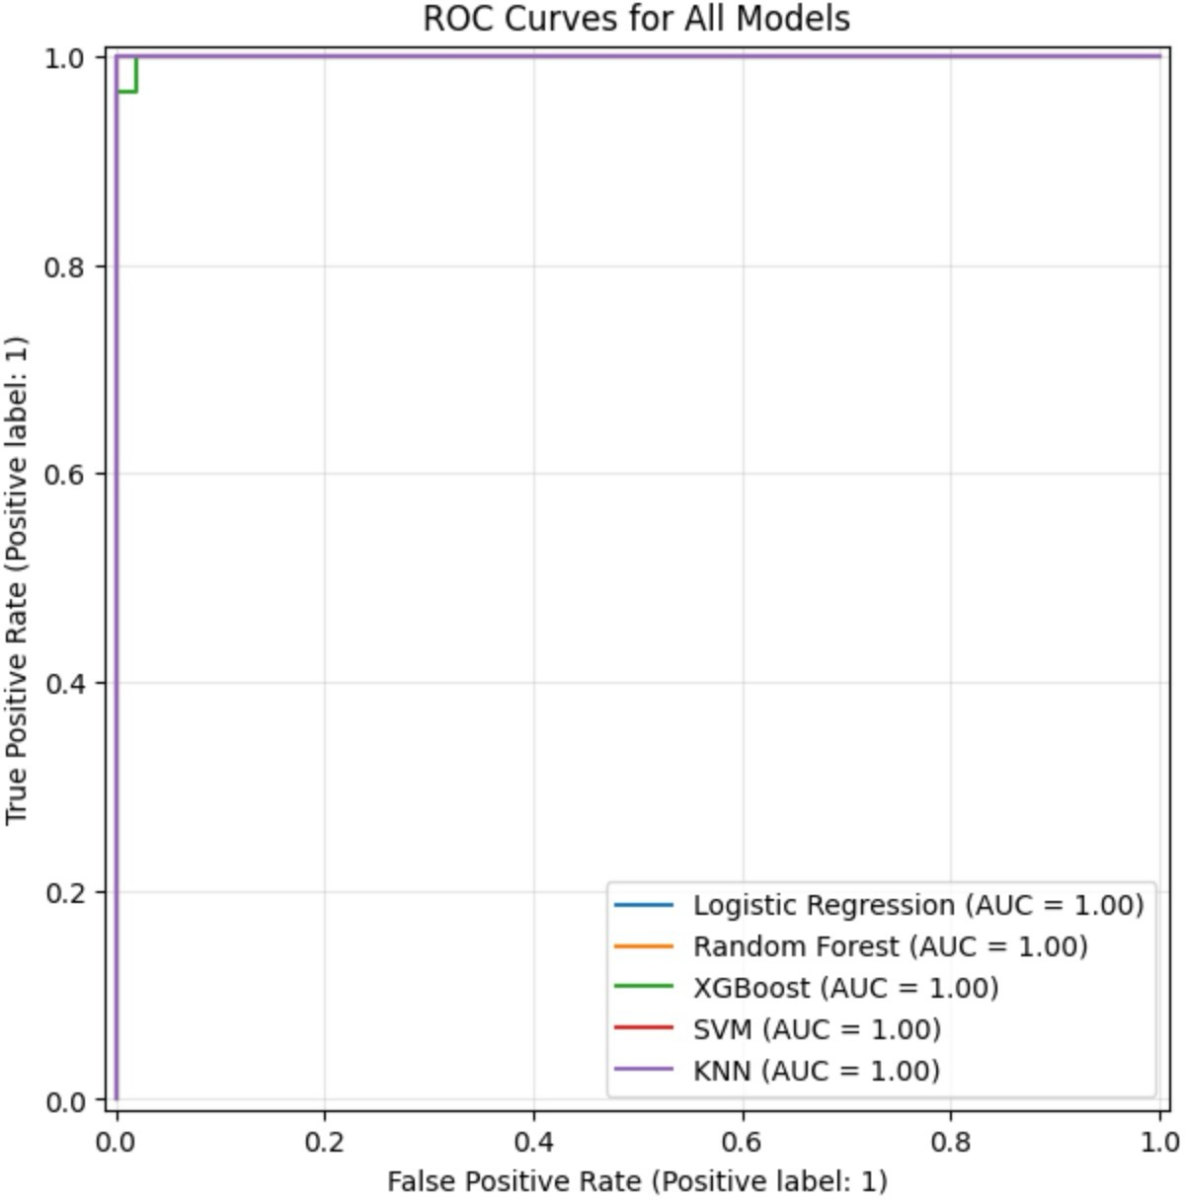

Figure 5.9: ROC curve comparison of machine learning model

The ROC curve illustrates the classification performance of all models across different threshold values. All models show high Area Under the Curve (AUC), indicating a strong ability to distinguish between CKD and non-CKD cases. Logistic Regression and SVM demonstrate near-perfect separation, while Random Forest, XGBoost, and KNN also exhibit strong classification performance.

The near-perfect AUC values may be influenced by the dataset characteristics, and further validation on larger and external datasets is recommended.

Although the AUC chart indicated nearly-perfect discrimination for all models, confusion matrices gave more insight in the class-specific behaviour. The SVM confusion matrix revealed 50 CKD cases and 30 non-CKD without any error observed, showing one hundred percent separation of it on the test data. The XGBoost confusion matrix revealed that there were 50 true CKD that have been correctly classified but there were 2 non-CKD has been predicted as CKD is little overcalling the disease status. Random Forest performed quite well but also presented a minor imperfection in comparison with the perfect models. KNN recalled 100% for non-CKD classification with a lower precision value, meaning that while it included all cases in one class, it produced more false-positive behaviour than the best-performing alternatives. From a clinical screening perspective, a high recall is valuable because one would prefer to not miss any cases of CKD, but precision is also important, because unwarranted referrals and concern may result from false-positive flags. This balance is exactly the reason why the F1-score was considered an important summary metric instead of relying on accuracy alone [2], [59].

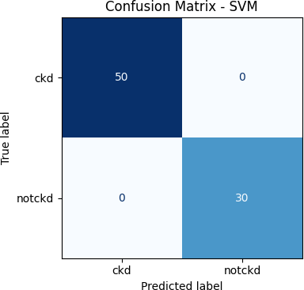

Figure 5.10 SVM confusion matrix showing perfect class separation on the held-out test
set.

Figure 5.11: XGBoost confusion matrix showing slight misclassification of non-CKD cases as CKD.

ROC Curves corroborated the same trend. Logistic Regression, Random Forest, KNN and SVM were all logarithmic curves climbing up to almost the upper-left corner of the plot area, with XGBoost very close to ideal discrimination again. This result implied that the models were ranking positive and negative cases very effectively even though a choice in of threshold varied. In the context of a research prototype, these consequences were positive as they demonstrated that the system did not require one threshold or one parameter alone. However, very high metrics on a relatively small public dataset are also something to be wary of. Near- perfect curves can be an indication of truly separable classes, but they can also be an indication of an easier dataset than messier distributions that exist in actual electronic health records environments [57], [63]. This limitation, however, does not invalidate the results but means that the answer to the question should be seen as proof of technical feasibility not proof of clinical performance in general.
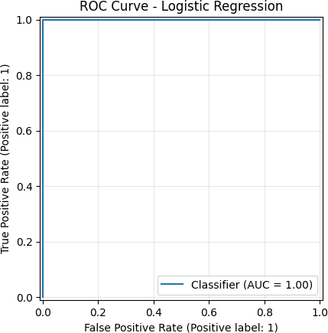
Figure 5.12: ROC curve for Logistic Regression.

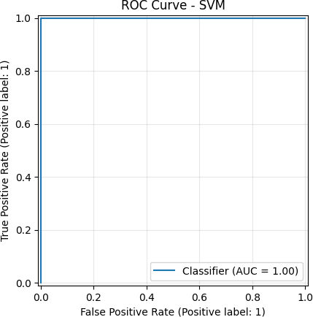
Figure 5.13: ROC curve for SVM.
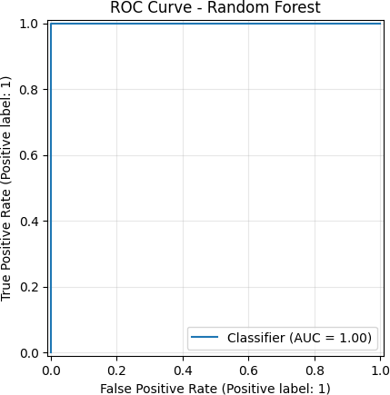
Figure 5.14: ROC curve for Random Forest.

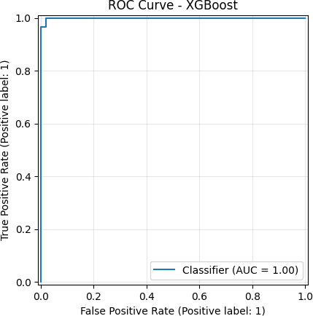
Figure 5.15: ROC curve for XGBoost.
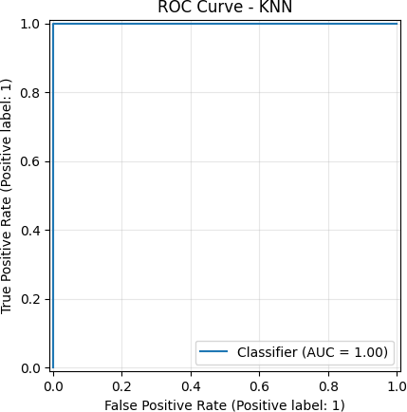
Figure 5.16: ROC curve for KNN.

Evidence of explainability was also important for performance evaluation. The ranking of permutation importance indicated haemoglobin, specific gravity, packed cell volume, albumin, red blood cell count, serum creatinine, sodium, blood urea, age and blood glucose random as influential in model behaviour. These predictors are clinically plausible and in agreement with the broader literature on CKD, which routinely links renal impairment to anaemia-related markers, indicators of urine concentration, proteinuria-related findings and kidney filtration biomarkers [5], [20]. The SHAP summary plot reinforced the above interpretation by indicating not only which variables were influential but whether greater or lesser values pushed the model

towards the CKD-class. The prominence of haemoglobin, specific gravity, packed cell volume, albumin and serum creatinine were thus more than mathematically strong but also had medical meaning. This is important because it is more valuable to have an explainability layer that converges with the established knowledge in nephrology, instead of generating opaque or implausible patterns [16], [28].

Results & Discussion
The final artefact was a working notebook-based explainable AI pipeline that was able to ingest the CKD dataset, clean and transform variables, split the CKD dataset, train five models, visualise comparative performances and generate interpretable outputs at both global and case levels. From the perspective of users, the completed system did not appear as a graphical hospital dashboard but as a research-ready analysis. This distinction is important as the dissertation was to provide a reproducible prototype more than a production application. The implemented modules comprised data ingestion, data cleaning, feature typing, preprocessing, train-test splitting, model execution, cross validation, metric calculation, confusion matrix generation, roc visualisation, feature importance ranking, SHAP analysis, and single case prediction review. Each of these modules worked successfully in the final implementation, meaning the technical goals of the project were fully achieved.
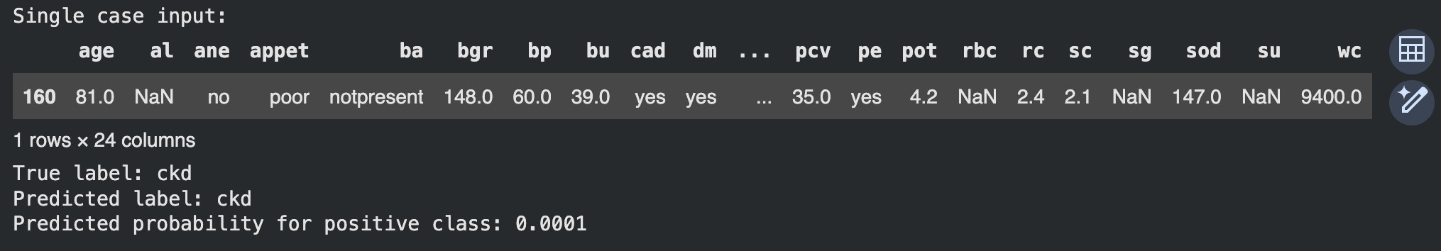
Figure 5.17: Single-case prediction walkthrough showing patient input, true label, predicted label, and probability output.
The results show that the system was extremely good at what it did on the dataset it was chosen from. In practical terms, the artefact demonstrated that routine laboratory and clinical evidence can be used for automated discrimination between CKD and non-CKD cases of high quality. This finding is consistent with previous studies in the field of CKD using machine learning algorithms, which have demonstrated the ability of structured health variables to yield strong classification results, even in the absence of complex multimodal architectures [7], [23]. More importantly, the explainability outputs enhanced the value of the prototype. Instead of reporting just a class score, the system revealed the role played by some core variables in decision making. This is a major strength because the adoption of healthcare AI is not only

dependent on performance but also on traceability and trust [57], [58]. The high degree to which the influential variables found in the model align with clinically meaningful variables lent interpretive credence to the results.
When the results are linked back to the project objectives, then the study can be judged a success. The first objective, that of designing an end-to-end modelling workflow, was a result of the complete notebook pipeline. The second objective, which was to compare the predictive performances under consistent conditions, was achieved through the execution of five algorithms under the same preprocessing and evaluation logic. The third objective, which was to produce explainability outputs, that identify the key drivers of the prediction of CKD, was achieved through permutation importance and SHAP. Among the models, Logistic Regression and SVM offered the best overall performance and Random Forest and XGBoost were a good balance measure between good prediction quality and rich explainability compatibility. KNN was still a valuable method of comparison but was worse in terms of precision and interpretability. This pattern is similar to broader literature in which simple models or models based on margins often can do quite well on clean tabular data sources, while tree-based models often have better integration with explainability tools [12], [35], [59].
The discussion also needs to be aware of limitations and otherwise imperfect elements. First of all, the held out dataset was small and apparently well separated which probably led to very high evaluation scores. This raises the possibility that the performance would degrade on larger or noisier or multicentre data. Second, as the notebook artefact did not incorporate a front end clinical interface or a database integration layer, it means that the artefact should be regarded as a research prototype and not as a deployable hospital system. Third, while explainability outputs were useful, they were still post-hoc analytics tools as opposed to guarantees of causality. The model explained the internal behaviour of the model and not the biological cause of CKD. Fourth, some model results were so good that they minimised the apparent evidence of comparative differences, particularly in the area of AUC. This means that future testing on more difficult datasets would likely be more revealing to rank models. Even with these limitations, the approach had obvious advantages: Transparent preprocessing, algorithmic diversity, good performance and clinically plausible explanations. Unexpectedly, however, the linear Logistic Regression model was as similar to the best nonlinear models, which hints that the predictive structure of the data set might be simpler and more linearly separable than one might have expected. That outcome is meaningful as it suggests that highly interpretable baselines should never be ignored in medical AI studies [1], [60], [63].

The strong performance of Logistic Regression and Support Vector Machine suggests that the dataset may be linearly separable or contains well-defined feature boundaries. This indicates that simpler models can perform competitively when the underlying data structure is well-organised. In contrast, more complex models such as Random Forest and Boost, while powerful, did not provide significant additional gains, suggesting limited non-linear complexity in the dataset.

The explainability results further reinforce the clinical relevance of the model, as key predictors such as haemoglobin, serum creatinine, and packed cell volume align with established medical knowledge. This consistency improves trust in the model’s outputs and supports its potential use in clinical decision-support contexts

CONCLUSION AND FUTURE WORK

Summary of Findings
This dissertation aimed to establish explainable artificial intelligence in order to achieve early prediction of chronic kidney disease using routine clinical laboratory indicators. The central problem was that often, machine learning models can predict CKD well but many such models are hard to interpret in ways that are meaningful for healthcare decision support. To solve that problem, this study applied quantitative, positivist and deductive methodology, using only secondary data, a complete machine learning workflow (python and google colab), and five algorithms: Logistic Regression, Random Forest, XGBoost, Support Vector Machine and K-Nearest Neighbour. The research then conducted an evaluation of each model, using cross- validation, held-out testing, classification metrics, confusion matrices, ROC curves and explainability outputs. The main conclusion was that the dataset supported very good prediction performance for all 5 models; Logistic Regression and SVM models achieved perfect testset accuracy, F1-score and AUC, and Random Forest and XGBoost also showed very competitive results. The findings therefore confirmed that routine structured indicators can support the classification of early CKD risks well, at least within the context of the dataset used.
A second major finding was related to interpretability. Explainability layer was not superficial and returned strong insight on what variables have the greater impact on the predictions of a model Permutation importance and SHAP plots routinely identified haemoglobin, specific gravity, packed cell volume, albumin, red blood cell count, serum creatinine and other related laboratory variables as central variables. These factors are not some sort of arbitrary statistical artefact. They are highly associated with the known clinical logic of the kidney dysfunction, with urine concentration abnormalities, protein-related measures, renal filtration measures and anaemia-linked measures frequently involved [5], [20], [57].

Research Contributions
The research made academic and practical contributions. Academically, it was a part of the recently growing number of publications on explainable AI in nephrology by providing a structured comparative analysis of 5 widespread used machine learning algorithms using a consistent preprocessing and evaluating framework. Many studies discuss CKD prediction or explainability separately, but this project collaborated both by having accuracy and interpretability as co-equal outcomes. The study also showed that highly interpretable or

relatively simple models such as Logistic Regression can still compete with complex models if the feature set is good and the data is well prepared. This is important because if complexity doesn't automatically lead to better or more useful medical AI this is a challenging assumption [12], [16], [35].
A further contribution is in the way the study conceptualised testing and evaluation. Instead of just looking at any one performance number, test cases, metric comparisons, graphical proofs and other explanatory outputs were used to assess whether the system was working as it was supposed to. This aided in establishing the dissertation into not simply a modelling exercise but a small scale system development project that has demonstrable artefact quality. The use of annotated screenshots, confusion matrices, roc curves and explanation plots made the final evaluation more transparent and in accordance with good practise for responsible health AI [57], [61].

Recommendations and Work for the Future
Despite the good results however there is still important work to be done before any real deployment can be thought about. The first recommendation is external validation on larger and more heterogeneous data sets. The dataset in question is useful for prototype development, but seems relatively clean and separable, which might have made the classification task easier than those in real-world clinical environments. Future research would therefore do well to test the same pipeline on multicentre data as well as regionally diverse populations and larger electronic health record datasets to see if the performance results generalises. This is of particular importance given previous nephrology research highlighting that predictive models can lose accuracy when transferred between the hospital/hospitals or population with different recording practises and population and demographic structures [60], [63]. A second recommendation is that of prospective validation. Retrospective secondary data are useful for proof-of-concept work, but prospective evaluation would demonstrate whether the model is reliable when fed with data as they occur in real time.
A third of the recommendations is to expand the framework of explainability. The present study used permutation importance and SHAP, which were effective and interpretable. However future work could compare these with other methods such as the LIME or counterfactual explanations to explanation frameworks, or uncertainty-aware explanation frameworks. That would aid in determining not only what features are influential, but also the stability or clinical utility of different types of explanation [19], [33]. A fourth recommendation is to enhance the data inputs. The project was deliberately focussed on routine laboratory and

clinical indicators because they are available and practical. However, in future, extensions can include multimodal or longitudinal data such as repeated laboratory data, medication data or connected imaging and cardiovascular data. Emerging work on omics, ECG data and precision nephrology pathways suggest that broader integration of data is a potential way to support even earlier or more individualised risk prediction [15], [21], [64].
From the standpoint of system design, another extension would be to go beyond a notebook artefact and develop a lightweight clinical dashboard or secure analytic interface. Such a step would require improved governance, role-based access, model and uncertainty monitoring, and clear communication of the uncertainty. Privacy preserving strategies or federated learning or decentralised health data arches may also be of consideration were future development to be in the form of an institutional patient data vs a public research data set [14], [41]. Finally, future research should involve human centred evaluation. The current dissertation did not involve clinicians, since it was a secondary data technical research [6], [36], [57].

Reference list
- J. He, X. Wang, P. Zhu, X. Wang, Y. Zhang, J. Zhao, W. Sun, K. Hu, W. He, and J. Xie, “Identification and validation of an explainable early-stage chronic kidney disease prediction model: A multicenter retrospective study,” eClinicalMedicine, vol. 84, 2025.
- S. Singamsetty, S. Ghanta, S. Biswas, and A. K. Pradhan, “Enhancing machine learning-based forecasting of chronic renal disease with explainable AI,” PeerJ Computer Science, vol. 10, 2024.
- A. Gaweda, E. Lederer, and M. Brier, “Use of artificial intelligence to identify new mechanisms and approaches to therapy of bone disorders associated with chronic kidney disease,” Frontiers in Medicine, vol. 9, 2022.
- M. Arifuzzaman, I. Ahmed, M. J. U. Chowdhury, S. Sakib, M. S. Rahman, M. E. Hossain, and S. Absar, “A novel ensemble-based deep learning model with explainable AI for accurate kidney disease diagnosis,” Advances in Artificial Intelligence and Machine Learning, vol. 5, pp. 3425–3445, 2024.
- C. Sabanayagam, R. Banu, C. Lim, Y. Tham, C.-Y. Cheng, G. Tan, E. Ekinci, B. Sheng, G. J. McKay, J. E. Shaw, K. Matsushita, N. Tangri, J. Choo, and T. Wong, “Artificial intelligence in chronic kidney disease management: A scoping review,” Theranostics, vol. 15, pp. 4566–4578, 2025.
- A. Nicosia, N. Cancilla, J. D. M. M. Guerrero, I. Tinnirello, and A. Cipollina, “Artificial intelligence in nephrology: From early detection to clinical management of kidney diseases,” Bioengineering, vol. 12, 2025.

- U. Upadhayay, A. Kumar, P. Pal, and G. Kaur, “Chronic kidney diseases prediction using machine learning algorithms,” International Journal of Scientific Research in Engineering and Management, 2023.
- Q. Pan and M. Tong, “Artificial intelligence in predicting chronic kidney disease prognosis: A systematic review and meta-analysis,” Renal Failure, vol. 46, 2024.
- J. Jiang, L. Chan, and G. Nadkarni, “The promise of artificial intelligence for kidney pathophysiology,” Current Opinion in Nephrology and Hypertension, vol. 31, pp. 380–386, 2022.
- P. Ramanaiah, “Feature selection AI technique for predicting chronic kidney disease,” American Journal of Artificial Intelligence, 2024.
- A. Fatima and S. Fatima, “Big data and machine learning based early chronic kidney disease prediction,” Journal of Scientific Research and Technology, 2024.
- A. Shivhare, A. C. Kumari, and K. Srinivas, “Predictive modeling for chronic kidney disease: A comparative analysis of machine learning techniques with explainable AI for clinical transparency,” International Journal of Education and Management Engineering, 2025.
- B. Stopic et al., “Biomarkers and predictors of adverse cardiovascular events in different stages of chronic kidney disease,” Dose-Response, vol. 20, 2022.
- V. Puri, I. Priyadarshini, A. Kataria, S. Rani, and H. Min, “Privacy-first ML for chronic kidney disease prediction: Exploring a decentralized approach using blockchain and IPFS,” IEEE Access, vol. 13, pp. 43178–43189, 2025.
- M. B. Lopes, R. Coletti, F. Duranton, G. Glorieux, M. A. J. Campos, J. Klein, M. Ley, P. Perco, A. Sampri, and A. Tur-Sinai, “The omics-driven machine learning path to cost-effective precision medicine in chronic kidney disease,” Proteomics, vol. 25, 2025.
- S. K. Ghosh and A. Khandoker, “Investigation on explainable machine learning models to predict chronic kidney diseases,” Scientific Reports, vol. 14, 2024.
- Y. Kurniawan, B. Susilo, S. A. Rahman, M. Mahadi, and D. Yuliana, “Artificial intelligence for chronic kidney disease early detection and prognosis,” 2025.
- R. Rakesh, G. S. Nishanthi, and S. K. Andrews, “Chronic kidney disease cast using SML technique,” International Journal of Research Publication and Reviews, 2024.

- A. Kusuma, P. Raju, B. Anoch, R. B. Mallela, A. Rapaka, and K. S. Pokkuluri, “Uncertainty and explainability in AI for chronic kidney disease: A comprehensive review,” 2025.
- A. Alobaidi, “Emerging biomarkers and advanced diagnostics in chronic kidney disease: Early detection through multi-omics and AI,” Diagnostics, vol. 15, 2025.
- L. Pastika et al., “Artificial intelligence-enhanced electrocardiography for the prediction of future chronic kidney disease,” European Journal of Preventive Cardiology, 2025.
- A. Simeri et al., “Artificial intelligence in chronic kidney diseases: Methodology and potential applications,” International Urology and Nephrology, vol. 57,
pp. 159–168, 2024.
- S. Salunkhe, P. Gaikwad, S. Humbe, S. Kale, and Lokhande, “Chronic kidney diseases detection using machine learning,” Proceeding International Conference on Science and Engineering, 2023.
- S. Gowsika, J. Jayapreetha, G. Jayasri, and P. Menaka, “Early chronic kidney disease detection and personalized treatment strategies using ML,” International Journal of Advanced Research in Science, Communication and Technology, 2025.
- M. K. Pasupuleti, “AI-powered predictive models for early diagnosis of chronic diseases using EHR data,” 2025.
- F. Khalid et al., “Predicting the progression of chronic kidney disease: A systematic review of artificial intelligence and machine learning approaches,” Cureus, vol. 16, 2024.
- “Prediction of chronic kidney disease using machine learning,” International Journal of Advanced Research in Science, Communication and Technology, 2022.
- A. Vinothini, B. P. Sankaralingam, U. M. Jayachandran, K. V. S. S. R. Krishna, S. Sundarraj, and M. Mohammed, “An explainable deep learning model for prediction of early-stage chronic kidney disease,” Computational Intelligence, vol. 39, pp. 1022–1038, 2023.
- D. Lim et al., “Prediction models used in the progression of chronic kidney disease: A scoping review,” PLoS ONE, vol. 17, 2022.

- M. E. Haque, S. M. J. Islam, J. Maliha, M. Shakhauat, H. Sumon, R. Sharmin, and S. Rokoni, “Improving chronic kidney disease detection efficiency: Fine tuned CatBoost and nature-inspired algorithms with explainable AI,” in IEEE Conference Proceedings (CSNT 2025), 2025.
- M. A. Isaza-Ruget et al., “Predicting chronic kidney disease progression with artificial intelligence,” BMC Nephrology, vol. 25, 2024.
- P. N. Wake and R. K. Pawar, “Review paper on early detection of chronic kidney disease using predictive AI,” International Journal for Research in Applied Science and Engineering Technology, 2024.
- T. B. Thapa and M. Bhandari, “Predicting chronic kidney disease using ML algorithms and LIME,” Technical Journal, 2023.
- P. Durggashre, D. Narmatha, S. Sabareeswari, and M. Swarna, “Deep learning models in early prediction and risk identification of chronic kidney disease,” 2025.
- K. M. T. Jawad, A. Verma, F. H. Amsaad, and L. Ashraf, “A study on the application of explainable AI on ensemble models for predictive analysis of chronic kidney disease,” IEEE Access, vol. 13, pp. 23312–23330, 2025.
- K. M. S. Hossain, J. Ul, Z. Kabir, F. I. Shakil, M. I. K. Joy, and A. R. Nabil, “Implementing explainable AI for early detection of chronic kidney disease: Strategic insights for health information systems management,” Journal of Computer Science and Technology Studies, 2025.
- J. Huang, L. Li, M. Hou, and J. Chen, “Bayesian optimization meets explainable AI: Enhanced chronic kidney disease risk assessment,” Mathematics, 2025.
- Y. Y. Tan et al., “Prognostic potentials of AI in ophthalmology: Systemic disease forecasting via retinal imaging,” Eye and Vision, vol. 11, 2024.
- S. K., “Prediction of chronic kidney disease,” International Journal of Scientific Research in Engineering and Management, 2023.
- S. Jettaboina and A. Sharma, “AI and machine learning approaches for chronic kidney disease progression: A systematic review,” International Journal of Scientific Research in Computer Science, Engineering and Information Technology, 2025.
- N. G. Rezk, S. Alshathri, A. Sayed, and E. E. Hemdan, “Explainable AI for chronic kidney disease prediction in medical IoT: Integrating GANs and few- shot learning,” Bioengineering, vol. 12, 2025.

- J. K. Nayak and P. Singh, Fundamentals of Research Methodology Problems and Prospects. New Delhi: SSDN Publishers and Distributors, 2021.
- M. Patel and N. Patel, “Exploring Research Methodology,” International Journal of Research and Review, vol. 6, no. 3, pp. 48–55, 2019.
- M. A. Ragab and A. Arisha, Research Methodology in Business: A Starter’s Guide. 2018.
- H. Snyder, “Literature review as a research methodology: An overview and guidelines,” Journal of Business Research, vol. 104, pp. 333–339, 2019.
- R. Acharyya and N. Bhattacharya, Eds., Research Methodology for Social Sciences. Boca Raton: Taylor and Francis, 2019.
- V. Bairagi and M. V. Munot, Eds., Research Methodology: A Practical and Scientific Approach. Boca Raton: CRC Press, 2019.
- N. Basias and Y. Pollalis, “Quantitative and qualitative research in business and technology: Justifying a suitable research methodology,” Review of Integrative Business and Economics Research, vol. 7, pp. 91–105, 2018.
- N. Greening, “Phenomenological research methodology,” Scientific Research Journal, vol. 7, no. 5, pp. 88–92, 2019.
- A. Gupta and N. Gupta, Research Methodology. New Delhi: SBPD Publications, 2022.
- R. Kapur, Research Methodology: Methods and Strategies. New Delhi, India: Department of Adult Education and Continuing Extension, University of Delhi, 2018.
- R. Kumar, Research Methodology: A Step-by-Step Guide for Beginners. London: Sage, 2018.
- S. K. V. Kumari, K. Lavanya, V. Vidhya, G. A. D. J. S. Premila, and B. Lawrence, Research Methodology, vol. 1. DARSHAN Publishers, 2023.
- N. Mahuika and R. Mahuika, “Wānanga as a research methodology,”
AlterNative: An International Journal of Indigenous Peoples, vol. 16, no. 4,
pp. 369–377, 2020.
- S. B. Mishra and S. Alok, Handbook of Research Methodology. 2022.
- H. K. Mohajan, “Qualitative research methodology in social sciences and related subjects,” Journal of Economic Development, Environment and People, vol. 7, no. 1, pp. 23–48, 2018.

- C. Sabanayagam, R. Banu, C. Lim, Y. Tham, C.-Y. Cheng, G. Tan, E. Ekinci, B. Sheng, G. J. McKay, J. E. Shaw, K. Matsushita, N. Tangri, J. Choo, and T. Wong, “Artificial intelligence in chronic kidney disease management: A scoping review,” Theranostics, vol. 15, pp. 4566–4578, 2025.
- S. K. Ghosh and A. Khandoker, “Investigation on explainable machine learning models to predict chronic kidney diseases,” Scientific Reports, vol. 14, 2024.
- S. Singamsetty, S. Ghanta, S. Biswas, and A. K. Pradhan, “Enhancing machine learning-based forecasting of chronic renal disease with explainable AI,” PeerJ Computer Science, vol. 10, 2024.
- J. He, X. Wang, P. Zhu, X. Wang, Y. Zhang, J. Zhao, W. Sun, K. Hu, W. He, and
J. Xie, “Identification and validation of an explainable early-stage chronic kidney disease prediction model: A multicenter retrospective study,” eClinicalMedicine, vol. 84, 2025.
- Q. Pan and M. Tong, “Artificial intelligence in predicting chronic kidney disease prognosis: A systematic review and meta-analysis,” Renal Failure, vol. 46, 2024.
- J. Huang, L. Li, M. Hou, and J. Chen, “Bayesian optimization meets explainable AI: Enhanced chronic kidney disease risk assessment,” Mathematics, 2025.
- M. A. Isaza-Ruget et al., “Predicting chronic kidney disease progression with artificial intelligence,” BMC Nephrology, vol. 25, 2024.
- M. B. Lopes, R. Coletti, F. Duranton, G. Glorieux, M. A. J. Campos, J. Klein, M. Ley, P. Perco, A. Sampri, and A. Tur-Sinai, “The omics-driven machine learning path to cost-effective precision medicine in chronic kidney disease,” Proteomics, vol. 25, 2025.

