Name: Saira Munshi
Module: Professional career Development
Student Number: 1813715
Lecturer: Joanna Walsh
Module Number: BMSK4005-LON

Table of Contents
INTRODUCTION: 2
My Lifeline: 2
SELF MOTIVATION: 4
SELF-EVALUATION: 4
Eisenhower Method of Time Management: 5
PERSONAL DEVELOPMENT PLAN (PDP): 6
Self-awareness: 6
QUALITIES EMPLOYERS ARE LOOKING FOR: 6
AWARNESS TO WHAT MOTIVATES ME: 6
SELF ASSESSMENT IN READINESS TO EMPLOYMENT: 7
The Five-Fold Grading System (Munro Fraser): 7
1 Impact on others 7
2 Acquired qualifications 7
3 Innate abilities 7
4 Motivation: 8
Maslow’s Hierarchy of Needs: 8
5 Adjustment 9
PERSONAL CAREER PLAN: 10
Skills I need for a profession: 10
SWOT: 10
Strength: 10
Weaknesses: 11
Opportunities: 11
Threats: 11
CONCLUSION: 11
REFERENCES: 11

INTRODUCTION:
In this assignment, I will be writing my personal development plan, by using different psychological tools to simplify the process of career development plan. I will also demonstrate my strengths and weaknesses by using these brilliant tools, which will help me identify my career goals and what skills do I need to achieve those goals.

My Lifeline:
The most challenging part of my personal development plan was to write a description about yourself and to do this effectively, lifeline was the first tool that gave me the kick to start with.
According to my lifeline tool graph, I had a chance to see the ups and downs in my life. As a child I grew up in Middle East, my father had a good job and we had a sound life, in spite being having a sound life, but nothing was secure as per policy of United Arab Emirates they reserve the rights to deport a person anytime they feel like, back to their origin.
When I was nine, my father lost his job and we moved to Pakistan, a change that was not simple to accept. I remember leaving my friends, toys and school. I was been placed in a school in Karachi which is the cosmopolitan city of Pakistan, where I had to study two new languages as a compulsory subject to promote to higher class. This made me academically incompetent. I was been compared with other girls of the family who were decent and can-do house chores. None of my skills were appreciated, also the shine of charm and fame of us coming from Middle east was fading gradually.
In my sixteen, I faced jealousy, insecurities in my friends, loosing friendships, taunts and all the other weapons were used to bring me down. Family criticism of dressing well and not good at making perfectly round chapatis was an everyday thing which brought my moral down.
People whom I wanted never got attracted and others did not interest me. While I was doing my Graphic designing, I had many proposals through parents, some were ten years older, some wanted a proper house wife or you may say a house maid, a child minder to take care of their sister’s kids or want huge dowry for an ugly looking person as he was a businessman. I got married at the age of nineteen, had a baby boy but was financially struggling with his care.
Time passed, my ex appeared to be very irresponsible and immature, he was not earning anything, did not bother about any rituals and use to lie every time. Although, he respected my family, he was handsome, very humorous, outgoing, not conservative, brave, adventurous but on the same time was very non serious about himself and our relationship.
Gradually, his father asked for loans on different occasions from my father with the offer of giving my father an adequate amount monthly on certain percentage, till he returns the taken amount fully but, it was just a false offer and it never happened.
It was getting difficult for my father to make the both ends meet and on other hand they were spending extra vagrantly and even after years nothing changed and my father n law passed away. Here is when my mother n law refused to pay my father’s money back and wanted his son to leave me and marry some other girl she knew.
I got divorced here, I was a young mother with a child, back to my father’s home. I had to struggle a lot for basics as my in ‘laws did pull all the money from my father. I decided to work but, did not have a degree or anything equivalent to get a good job. My English was not weak as I went to good schools in Middle East and Pakistan both, so I was able to secure a job in a school but on a very low pay scale. I had no money to complete my studies, which I felt could have helped me out in progressing. By chance I got the job in an airline as an air stewardess and I had to live away from my country, my family and my child in another country.
I thought to support my family and my child with the handsome salary I was drawing with the airlines. I always felt that I am the reason of stress and the downfall of my family, so I worked hard to get their happiness back to them. They were looking for someone to marry me before I cross the perfect age to get marry. A person who can accept a divorced woman along with a child, which was next to impossible to happen in my country.
I got married to someone chosen by my family who already had two children and was twenty-three years older than me. This was because he accepted me along with my child. He and his family looked down upon me as I was not well educated and lived in a small house. I and my son moved to UK with him and left my job. I had a baby girl, and the situation became more unbearable, I was not allowed to talk to my family, I had no pocket money and upon all the other problems his children were not accepting me in their home. All kind of domestic abuse was going on in that relationship, where my son was targeted too.
I got some guidance from a Radiographer as that was the only place my ex let me go without him. I still tried to sustain the relationship as I was very scared of the outside world in London. I had no knowledge about streets, places, laws and had difficulty in understanding British accent. I had no money and a four months old baby with my son.
One day I took an action against the ongoing domestic violence and ended up in a women’s refuge accommodation with my two children, where the first thing they asked me to go through was the rent agreement then policies and so on goes the list. I just signed all the document without understanding anything, because when I started to read, it was too difficult for me to understand.
I had to go through courts for all the cases my ex did pulled me in. I was been linked to legal aid solicitors and was been asked to write a statement which was in broken and translated English. I was been called in their offices and was asked to go and complete the statement properly as they have very limited time to spend with the client in meeting. I could not put any incident in chronological order and upon reading by my solicitor, I found out that no sentence was complete which totally changed the meaning of the sentence.
I could not concentrate and while writing I use to get very emotional. I do not want to think about anything what I left, I wanted to make it a past as soon as I can. I and my children were placed in one room and when I cried, they got very upset. There were bad times when due to lack of any information, no family or friends to help and powerful unknown attacks were taking place by my perpetrator. All these attacks and being homeless, moving from one accommodation to another in two hours’ notice with children were consuming my energy and frustration level was increasing. I never confronted any police or courts ever in my life before.
All this time that keep me going was my faith and hope that things are happening for better and one day I will figure it out.
After a long struggle of six years now I am enrolled in a University second semester of Certificate of Health and Social Care level 4, which is something I always wanted but was not too brave to work towards it.

SELF MOTIVATION:
“Self-motivation is the force that keeps pushing us to go on - it's our internal drive to achieve, produce, develop, and keep moving forward” (Mind Tools, 2019).
My children are the ones who keep me strong, their questions make me reflect on my actions and their appreciation rewards me more than anything in this world.
My son loves to eat nice food as my mother was his basic carer when he was young so I learned to cook on the level that he does not misses my mom and nice food on the table can cheer him up.
My daughter is very articulate, she always wanted to play outdoors so I managed to scan all the free places that excites her so I can manage her needs within my budget.
Recently, I have started pleasing myself, I reward myself with shopping when I achieve any of my target, that I have set in my action plan list. The main thing on my list of action plan is that I want to attain a UK degree which I can put proudly under the education on my resume. This is keeping me on the road of success.
.

SELF-EVALUATION:

Life experiences, including, force marriage, divorce, loss of a loved one and social discrimination, may cause an individual to swing between the ladder of needs and desire (McLeod, 2018).
I also believe my one failure or distraction shakes my thoughts and strength to thrive, I am not a brave person, I get scared, intimidated very quick so I try to where a mask of a Lion to stay protected and keep my children protected as well. According to the exercise performed on Johari windows, my level of anxieties accelerates when I am not provided with a plan. I am getting more practical now, my vision is clearer for what I want, I am still not able to detach myself smoothly from any emotion so I can focus on the thing in my planner.
My time management was very poor until I was been introduced to Eisenhower Method of Time Management. This method helps you to set your goals in ranking them according to what is most vital to perform first. This method saves my time and keeps me focused with my tasks.

Eisenhower Method of Time Management:

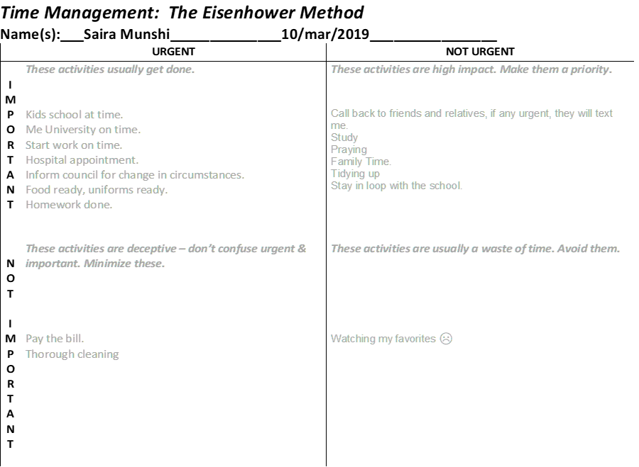
I had gone through countless ups and downs in my life, looking back in the past has made me realised that, I might have been lucky but never felt secure due to lack of education. I can see I was able to disguise myself in a very professional individual, but I always fear from reality I knew.
I see myself as a person who wants to deny the incident of life that makes one despair. I hoped that someone will come and put everything right and now I know that why mother use to say that “Even God only help those who help themselves.” I have started taking charge of the things than to wait for an avatar to come and do it for me, which has made me stronger in my faith.

PERSONAL DEVELOPMENT PLAN (PDP):

Self-awareness:
According to (McLeod, 2018)”one has a need to become everything they desire to become.”
Planning is very important in life and without setting realistic targets achieving success is not possible. After analysing my past where I found a pattern of relationship issues, I have noticed that I use to say things which I never meant, but the person used it always as their weapon to hit me hard. I get insecure very quick as I panic that anything might break up a relationship. I have understood this pattern through self-awareness and now I need to work on it by thinking before I speak.
The more I have tried to avoid all the problems; I have come across to it. I also have realised that there are no short cuts in life, I have stayed away from education, but life has brought me to a stage where education was the only rescue to me from my fears, insecurity and satisfaction from life.
I am trying to dedicate more time to find work that interest me with a good salary.

QUALITIES EMPLOYERS ARE LOOKING FOR:
The employers are mostly looking for the interpersonal qualities of honesty and integrity in an employee to run their business effectively, these are built in qualities which can form trust a long way.
An Employee who is humble to integrate quick and have good listening skills. Can communicate effectively and can exchange ideas confidently.
Academically competent, have good time management skills, work safely and can be focussed to the (from Moodle self-awareness).
Employers are also looking for a person with fine critical thinking skills. History and one’s culture have a significant impact on their critical thinking development which includes parenting style they received, past experiences and education (Anon,2020).

AWARNESS TO WHAT MOTIVATES ME:
Self-awareness and self-confidence are paramount to connect with your own personal development as it’s then a true indication of yourself to help to improve or adapt.
Am I motivated to achieve what I really want in life? And am I pushing that hard to get things done?
I may say I am stubborn but not motivated, at times my stubbornness gives me a push to start something but, I always want external powers to keep me determined. Motivation of maintaining my struggle towards my aim is like temperature that falls and rise with time and that the thought of that I do not have enough time as per my age concern that,often panics me out which I have realised is not good for my career, I need to overcome this weakness.

SELF ASSESSMENT IN READINESS TO EMPLOYMENT:
I would be using the decision-making tool below to assess my ability and willingness to work.

The Five-Fold Grading System (Munro Fraser):

1 Impact on others
(Lawyers, 2016) advocate the view that physical appearance should relate to the workplace ethics and tasks, keeping the organization’s image and complying with Health and Safety regulation.
Physical look that includes dressing, speech, body language, posture is an element to presence, only if it fits within the requirement and the nature of the desired job. I believe I have a good sense of dressing and presenting myself according to the job criteria. Using Johari window’s model, I found out from the quadrants that this is a quality in me which I take as my strength towards my career.

2 Acquired qualifications
An Employee should be fully equipped with education, trainings and work experiences to have a job (Mayhew, n.d.).
According to the job description of being a Cognitive Behavioural Therapist, I lack in relevant qualification, work experience and training. Moving forward I need to have it all to get to the job of my interest. Taking each step at time, education has already started giving me the serenity and confidence which one needs to develop.

3 Innate abilities
These are the inbuilt abilities that a person holds it genetically but how far we nurture them depends on other factors necessary to learn (AGREDA, 2013).
Upon carrying out the Honey and Mumford questionnaire in class, I found out that I am a Reflector. They prefer to learn by watching different activities, their imagination strengths are very strong and then on the other hand the outcome of VAK learning style was that I am a visual learner. I learn smoothly when I can see what the context means, like learning through flipcharts, pictures and videos.
When I read something, it makes it difficult for me to understand, I usually go through the text repeatedly to grasp the bottom line, whereas when I see something it stays in my mind as a clear picture of what it meant. Watching a YouTube video or doing a training in class is what I easily remember.
I did my fire drill four years back but, I still remember the face of the facilitator, his demonstration, what actions were performed and where me or others went wrong during the practical test. Even the insignificant details of what people were wearing, furniture and colour of the fire extinguisher is printed in my mind but, I can’t recall, other than few names, terminology and any context read.

4 Motivation:
In order to check with my motivation level, I found Maslow’s Hierarchy of Needs model very useful to me. It is a five-tier pyramid which helps to organize and arrange our progress going from basic level to higher level of needs. To acquire the topmost level of psychological satisfaction, one must start from the bottom most level of it.

Maslow’s Hierarchy of Needs:

Level 1 which is the bottom level of the pyramid, I was always been fulfilled moderately with basics like food, sleep, shelter etc, until I came across homelessness in UK after fled domestic violence. It took a long time to gain the least for me and my children and until now I was just maintaining it hard to keep the basics be always available to us. Now I am providing for my children and myself.
Level 2 where I stepped up to gain more future security by availing the opportunity of getting myself in education. I do not own any property but this year I am targeting to refurbish my temporary accommodation to live the way I want and to reward myself with comfort on my hard work.
Level 3 I miss my family who are not here to support me, I have few friends and my children are the ones who keep me going during the toughest moment of life.
Level 4, I am almost there, I am more hopeful now. The success of my term 1 has given me confidence to speak in class and I am gradually achieving that inner peace which was lost. I would like to add here that my incompetency with IT skills did made me loose marks in my assignment on being sending the draft copy instead. Since than I have been learning from You Tube videos and my son little things like how to default fonts and save documents etc.
Level 5 in the level where I am still under trial. I know I am there, but I still doubt my creativity, my ability to solve problems and to own my decisions. I have accepted the facts and I am trying to work around the available opportunities. This is the time where after achieving the basics, I am motivated to look into making friends, making my career of which I can be proud of, concentrating on my looks and posture, my health is giving me a vision - the hope and the urge to do better for me and my family, when I see in the past I have always been a fighter, the harder I was been hit to the floor the higher I flew. It was only that in those times, i was not prioritising which battle is to be fought first and which one can be fought later, and which battle is not even mine.
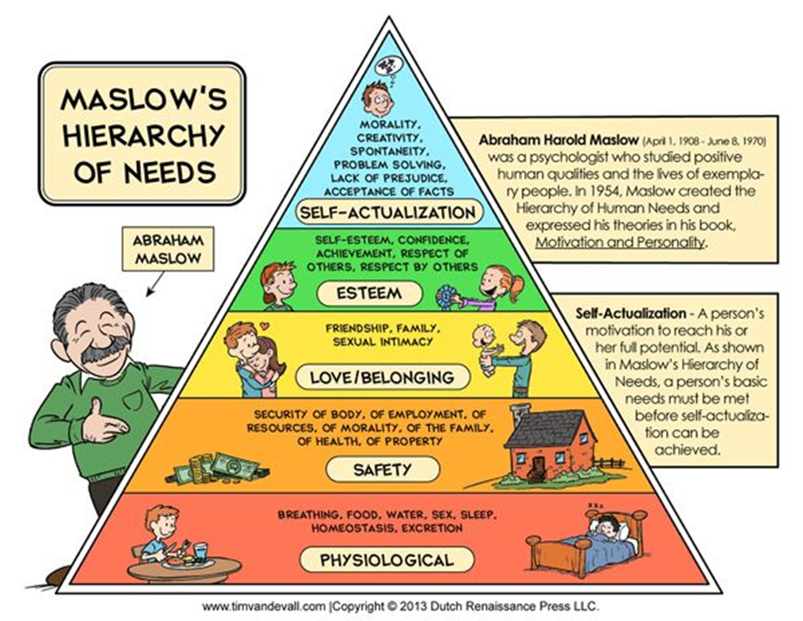

5 Adjustment

Managing ourselves & our relationships satisfactorily is Emotional Intelligence (Goleman, 2012). I am now more focused on reserving my own energy and working on the things which can result in increasing an open thinking. Working on skilful approaches towards my relationships are strengthening the bonds.
Reflecting in my past, even when I was writing statements, I was not focusing on solution instead I was focusing on what has already happened and exhausting myself by crying. Now I am not in that stage, may be bit Robotic approach but, in the end, it is minimising problems and helping me to build up future. I have stopped owning people’s behaviour towards me, I am responsible of my own actions and reactions only.

PERSONAL CAREER PLAN:

Skills I need for a profession:
By the end of term2 of the university for higher studies in health and social care, I understood that psychology is the path that interests me. After some research, I found a pathway towards Cognitive Behavioural Therapy which deals with different anxiety and stress levels.
It is a branch psychology where you find the root cause of a person’s action due to his own believes and past experiences. This is a therapy that encourages a person to establish their own goals and a plan to achieve them. (Peaks, 2018) concludes that Critical Thinking cannot be inherit, it can be shaped gradually with planning strategic sessions to tame the wild thoughts and actions into an energy that can work out to design a better situation of oneself. Clinical Psychological work together with high intensity therapists. They also work along with General Physician to understand any other medical needs (NHS,2016). (PWP) Psychological Wellbeing Practitioner work with the clients GP, family and other specialists to promote their health.
(IAPT) Improving Access to Psychological Therapy indicates that either a position should be secured as (PWP) to achieve a degree with work experience or enrol into a university and have a workplace while studying, where student loan will support the education and it would be compulsory to gain work experience to complete the degree.
To climb the ladder to success, skills are required, such as problem solving, advocacy, communicating etc. Hard skills like driving and digital skills is also required to perform the job efficiently. To have self-awareness of myself and to see where I stand from Employer’s perspective, I will do my SWOT analysis. It is a tool which discovers one’s strength, weaknesses, opportunities and threats to simplify their pathway to their goals (Mind Tools, n.d.).

SWOT:

Strength:
• I often get a compliment from my colleagues that my customer service is very good.
• I also carry myself according to the place I am working for.
• I also can read between the lines.
• My university folk say that I think deep and come out with good ideas.
• I am managing my time well as my and my children’s attendance did not fall since I am in education.

Weaknesses:
• Sometimes I freeze when I see a customer with a different attitude.
• I can read between the lines but, cannot interpret it very well.
• I forget names, places and due to lack of vocabulary, my expression of the sentence does not reflect the idea behind it.
• I take time to come out and react to any injustice that takes place.

Opportunities:
• I got an opportunity to work in a store I grabbed it.
• I got a chance to study and get back to university and I am studying now.
• I can grow more towards being a psychologist in future.
• I am also open to any ambition related volunteering or work, but my focus is to complete well with studies.

Threats:
• My health and age are a barrier to my dream job.
• My memory is also not very good; I get blank at many occasions.
• Any unforeseen circumstances that might come up.

I still can see my development, after all, I am on the path to success with education, it is only I need to stay active, hopeful and healthy to achieve my goals.

CONCLUSION:

Personal Development plan has motivated me to achieve my desired career and the education that can get me a decent job and that follows to a real independent life with whole different meaning to it, which is to hold on myself and my faith only. This time I know my weaknesses and how to deal with it and my strength for which I was never grateful for. Different mind tools have also helped me to figure out myself as a person and behaviour towards people in my life.
To get to know what to do in your career and life, a personal development plan is very useful. Not only it shows you what is a good career for you, it also guides you through the steps needed to get to your desired position in life.
Although I still do not agree with the set personality check questionnaire and results as it may keep on changing as a person is growing every day. I am a different person than I was even a year back and I will be different after finishing my education. People learn the environment and adapt it to survive.

REFERENCES:

AGREDA, Y. L., 2013. Child's Cognitive Development. [Online]
Available at: https://agredayungco.wordpress.com/tag/innate-abilities/
[Accessed 30 08 2019].
Anon., 2020. Strategies for nurse manager. [Online]
Available at: www.strategiesfornursemanager.com
[Accessed 11 01 2020].
Peaks, P.V. (2018). Developing Critical Thinking in Perioperative Staff Members. AORN Journal, 108(1), pp.81–85.
Goleman, D., 2012. Daniel Goleman Introduces Emotional Intelligence. [Online]
Available at: https://www.youtube.com/watch?v=Y7m9eNoB3NU&t=11s
[Accessed 03 05 2019].
Lawyers, S. a. G., 2016. Work Dress Code - Your Legal Rights in The UK. [Online]
Available at: https://www.youtube.com/watch?time_continue=3&v=MVuaTNNg7QE
[Accessed 29 07 2019].
Mayhew, R., n.d. Legal Requirements of Job Descriptions. [Online]
Available at: https://work.chron.com/legal-requirements-job-descriptions-20506.html
[Accessed 31 08 2019].
McLeod, S., 2018. Maslow's Hierarchy of Needs. [Online]
Available at: https://www.simplypsychology.org/maslow.html
[Accessed 19 08 2019].
Mind Tools, 2019. How Self-Motivated Are You?. [Online]
Available at: https://www.mindtools.com/pages/article/newLDR_57.htm
[Accessed 20 08 2019].
Mind Tools, n.d. Personal SWOT Analysis. [Online]
Available at: https://www.mindtools.com/pages/article/newTMC_05_1.htm
[Accessed 26 08 2019].

