University of Wales Trinity Saint David
LONDON CAMPUS
Individual Report
Module Name: Digital Skills and Research Methods
Module Code: LCHS 4007
Student name: Md Saidur Rahman
Student ID: 2515004
Lecturer’s Name: Md Sadeque Imam Shaikh

Table of Contents
Research Topic: Staff Shortage In NHS 1
Introduction 1
Problem Statement 1
Justification 2
Information Sources and Justification 3
Task 2: Research Methodologies 3
A brief overview of quantitative and qualitative research. 3
What type of research methodology I will use for my research and why? 3
Task 3: Data Collection 4
Overview of primary and secondary data collection 4
What form of data will be used to address my research problem, and why? 5
Conclusion 5
References 5

Research Topic: Staff Shortage In NHS

Introduction
Shortage of staff in NHS is impacting patient’s lives by making wating time longer and slow service. In 2025 shortage of staff is putting significant pressure on hospitals, clinics and long-term care facilities all over the United Kingdom. This problem not only endanger the quality of patients care but also requires rapid recognition and seeks infusion to make sure that every person receive the care they need (Tejares, 2025). This challenges the quality of services within the NHS, and in other healthcare settings. This research aims to discuss the fundamental issue within the NHS, and evaluate the consequences on healthcare services, with the ambition of pointing out necessary methodology for betterment.

Problem Statement
Recently shortage of NHS staff is a huge problem as it is affecting individuals lives during their time when they need care the most from the NHS. The staff vacancies continue to rise across the country making London is the at top with the rate of 7.7%. There are around 100000 vacancies in 2025/26--- equal to a 6.7% vacancy rate including nursing and medical staff (nhsproviders, 2025). Although this statistic shows the rate is slightly better than the previous quarter, but the gap is still significantly higher. This impact the quality of the service to the patients. This also risk the safety, and long-term feasibility in healthcare in United Kingdom.
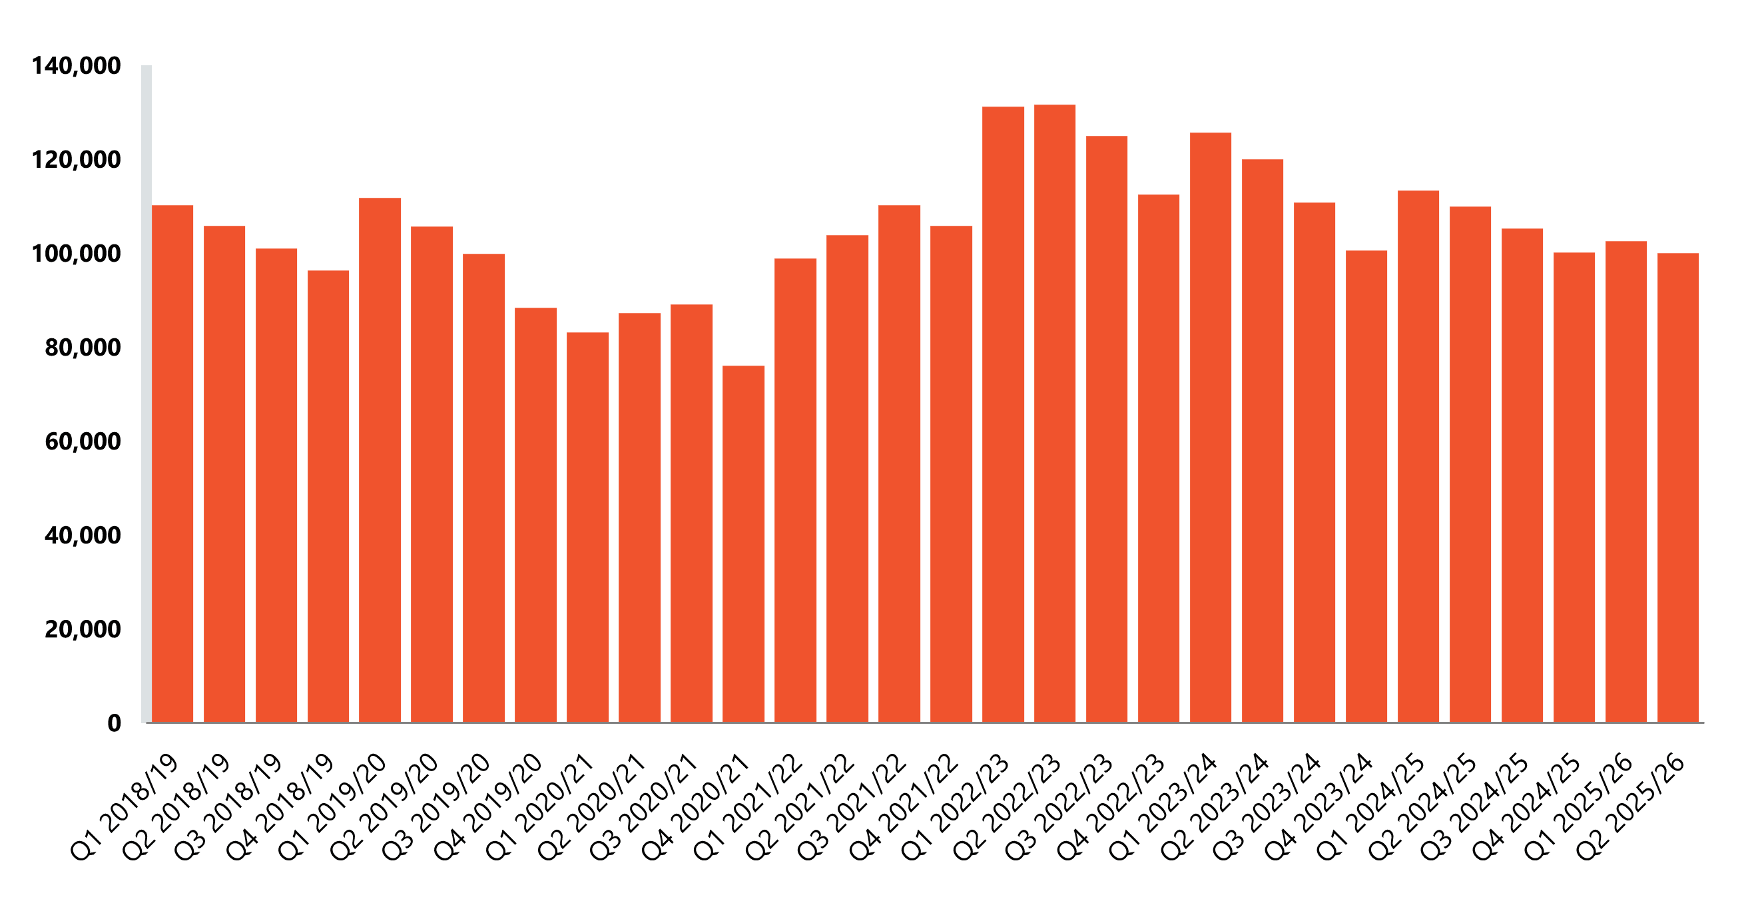

These shortages are just not in one profession. There are shortages in all professions such as doctors, nurses, healthcare workers, and primary care. According to British Medical Association (2025) it is described as “chronic workforce crisis”. United Kingdom is below the OECD countries on doctors according to the need of public demand. There are thousands of doctors, nurse, and healthcare professionals are needed to meet the demand of public. This is affecting patient care in a negative way, as less nurse positions will result of poor-quality care, as well as risk of harm (Royal College of Nursing, 2023). This indicates that a higher level of staffing is require for the betterment of the patients. The demand of doctors, nurses, and healthcare professionals continue to arise.
Thise is affecting patients’ lives in all areas of service in the health care sector all around the United Kingdom. In A&E patients waits around 3 hours to 7 hours. The waiting list for patient who need surgery or intensive treatment for long-term diseases are also significantly longer This makes patients problem even worst by not getting the attention when they are in desperate need. Shortage of GP doctors making it difficult for patient to get a GP appointment within one week. People who are dependent on carers are not getting the care. Some cases people are not getting the care at home leaving them alone for longer periods of time, which increases the risk of harm and dangers. This is also affecting NHS providers financially, as they are relying on bank and agency staffing. It is costing NHS more money than usual. If this goes on NHS will be in trouble to provide free care for patient in the future.
Overall, the issue is not just with understaffing in NHS, it is connected to financial, workforce and functional vulnerability which will affect better service delivery. In other words, shortage of is unsafe staffing in all over the service sector such as, words, GP practice, and care sectors. This will affect peoples lives by not receiving the care and service they need, and when they need.

Justification
Conducting research on shortage of staff in the NHS is based on people’s safety, quality of care and financial ability. Adequate staffing is crucial for better outcomes. Insufficient nursing staff increases the risk of unexpected situations, unsatisfactory care, and increasing the risk of safeguarding patients rather than proving quality care. Patients are on waiting for care and services longer and longer, which affecting their well-being.
Secondly, the staff vacancies in every sector of NHS are still significantly higher than normal. Vacancy statistic provides that approximately 100000 vacancies still open this year, pointing out the gap of safe staffing for patients need. This is causing the performance of A& E, and other sector below the targeted level. Thereby narrowing the gap between safe staffing and staff vacancies is essential. Shortage of staff is also affecting NHS financially as they are depending on temporary and agency staff. This is not long-term solution for NHS. To overcome this more structural, and long-term actionable plan is required.
Finally, staff shortage in NHS is justified as it points out people’s well-being, lower quality of life service delivery, and financial issues.

Information Sources and Justification
BMA (2025) medical staffing in NHS. Available at: NHS medical staffing data analysis (12/12/2025).
NHSproviders (2025) NHS digital workforce statistics-November 2025. Available at: NHS Digital workforce statistics – November 2025 (Accessed: 12/12/2025).
Royal College of Nursing (2023) Impact of staffing level on safe and effective patient care. Available at: Impact of staffing levels | Publications | Royal College of Nursing (Accessed: 12/12/2025).

Task 2: Research Methodologies

A brief overview of quantitative and qualitative research.
Quantitative research is based on numbers and data. It collects number of data and analyses data to answer how many and how much to finalise a research result. On there hand, qualitative method focusses on answering why and how by using interview, focus group. It is mainly small and in-depth. There are many different between these two methods, some of which is described in the table below.
Quantitative method | Qualitative method
Test theories, measure elements. | Investigate ideas, recognise experience
Numerical (statistic, counts) | Non-Numerical (word, image)
Surveys, structured date | Interviews, case studies.
Answers how many/how much. | Answers why/how

What type of research methodology I will use for my research and why?
In my research methodology I will use the mixed methods as it will give me both number based and experience-based research result. mixed methods research is a complete approach that put together both quantitative and qualitative methodologies in the same research to deliver a richer, more delicate understanding for compound questions. According to Creswell, this method provides firmness as numerical data disclose the measurements of the circumstance, in the meantime qualitive brings out the meanings and contexts. In research this method gives a better understanding of the subject. For topic like NHS staff shortage, quantitative data measures the variation of the vacancies, while qualitative data let out the independent and administrative experience.

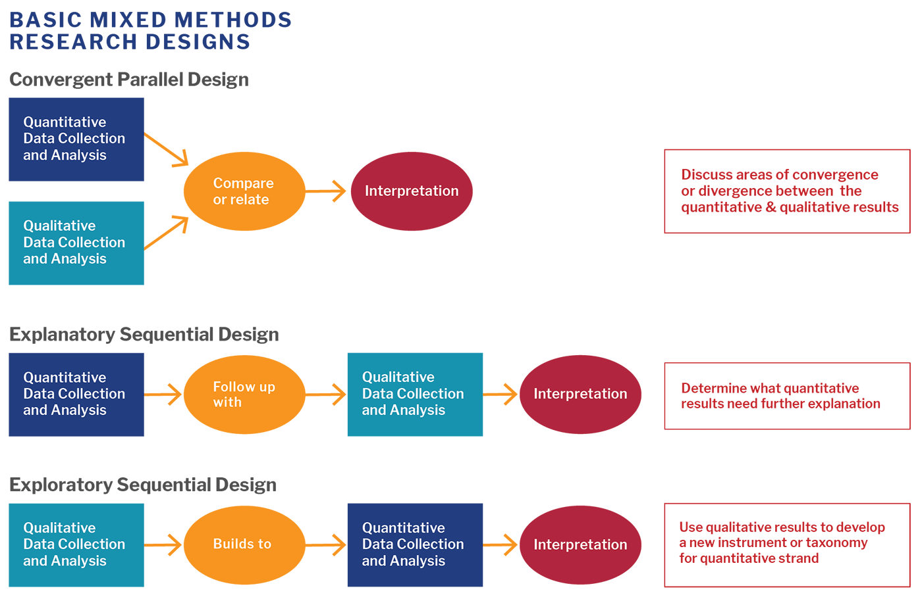

Task 3: Data Collection

Overview of primary and secondary data collection
Primary data is the first-hand collection of data by the researcher. It is first and foremost data collected directly from the origin namely interviews, surveys, experiments or observations. It is supposed to be accurate as it aimed for the exact research topic. On the other hand, secondary data is the data that is already available, and the research is done by someone else for similar purposes, or slightly different purposes. Most common examples of secondary data are government report, statistical data set, and academic journals. Some differences of the types of data is shown in the table below.
Details | Primary data | Secondary data
Origin | Gathered by the researcher | Gathered by someone else
Aim | It is determined for ongoing topic | Mainly for individual reason
Precision | It is very precise for the topic | Not as much precise for the study

What form of data will be used to address my research problem, and why?
To address research staff shortage in the NHS, this research report will need both primary and secondary data. Primary data will give more relevant information for the objectives by interview and statistic in the health care sector. In contrast, secondary data will be used from trustworthy sources such as government report and other NHS related authorities. Using both from of data will help justify this research report.

Conclusion
The shortage of staff in the NHS points out that there is a systematic provocation which questions the well-being of patients, quality of care and the durability of the operation. According to the staff vacancy rate it manifests that the gap between the demand and supply of workforce is significantly higher. This research shows that the issue within the NHS of low workforce, excessive costly operation, and poor quality of care.
With the mix-method technique this study intends to come up with better understanding of the issue. Finally rapid addressing this problem to resolve shortage of staff is essential to provide quality care for the patients.

References
BMA (2025) medical staffing in NSH. Available at: NHS medical staffing data analysis (12/12/2025).
Creswell, J.W. (2014) Basic mixed method research designs. Available at: Basic Mixed Methods Research Designs - Harvard Catalyst (Accessed: 12/12/2025).
NHSproviders (Nov 2025) Title of web page NSH digital workforce statistics-November 2025. Available at: NHS Digital workforce statistics – November 2025 (Accessed: 12/12/2025).
Royal College of Nursing (2023) Impact of staffing level on safe and effective patient care. Available at: Impact of staffing levels | Publications | Royal College of Nursing ( Accessed: 12/12/2025).
Tejares, S. (2025) The silent emergency: story behind 2025’s healthcare staffing shortage. Available at: Healthcare Staffing Shortages 2025: Causes & Impacts (Accessed: 06/12/2025).

