BMSW 5103
Understanding and Engaging in the Customer Experience

Organisation’s quality systems and customer relationship management

Alexandra Mintoiu (2111131)
Lecturer: Nishi Ramsurrun

Executive Summery
Successful business and a satisfying customer experience are both dependent on the quality of the company's customer relationship management (CRM). The London, England headquarters of the global consumer goods giant Tesco plc. Tesco sells a wide variety of products in many different categories, including beverages, fresh food, supermarkets, bakeries, home and entertainment, clothing, baby items, household appliances, pets, frozen food, electrical goods, consumer electronics, health and beauty products, and much more. One of the company's greatest advantages in the UK market is the resilience and robustness of its business approach. The varied yet ubiquitous nature of the company's product offering is the internal component that makes it a replacement for certain clients. PESTLE study emphasises the political, economic, social, technical, legal, and environmental variables impacting the firm, among the various external elements that operate as opportunities and risks. Tesco has opted for an analytical CRM architecture that considers the challenges the firm faces. There are advantages and disadvantages that must be considered.

Contents
Executive Summery 2
Introduction 4
Company Overview and Influence 5
Internal and External Environment 5
SWOT Analysis 5
PESTLE Analysis 8
IDIC Model 10
Value Chain Model 12
Introduction to the Models 13
Identifying a Model 16
Challenge and Recommendations 18
Conclusion 19
Reference 20

Introduction
Successful business and a satisfying customer experience are both dependent on the quality of the company's customer relationship management (CRM). Keiningham et al. (2020) argue that in order to compete effectively with the established market leaders, businesses should prioritise the quality of their customers' experiences. The point of advocating for CRM is to strengthen connections with customers and increase loyalty. When evaluating a CRM system's success, one must consider the amount of satisfaction reported by consumers. While it's true that investing in a CRM system takes a significant time and financial commitment, the payoff more than makes up for it. According to Juanamasta et al. (2019), enhanced connections with customers are a key advantage of CRM. Because of the enhanced quality of the service, a growing number of clients are buying the company's wares. CRM also helps businesses figure out which items and services are most profitable. Overall, the company's reputation and bottom-line benefit from quality procedures and customer relationship management. The study's goal is to investigate the factors, both internal and external, that have an impact on Tesco's customer relationship management process and quality assurance procedures.

Company Overview and Influence
Founded in 1906 and headquartered in London, Tesco plc is a British multinational retail and wholesale food and general merchandise retailer (Goyal, 2020). The firm first came on the market on 1999. Customers of all ages will appreciate the store's diverse selection. Food, ice cream, vitamins, coffee tea, supplements, minerals, morning cereal, cleaning supplies, cosmetics, water and air purifiers, personal care, toothpaste and pet food are all for sale. Products may be purchased in more than 193 countries across the world. In 2020, the firm's sales were 65 billion euros, and it controlled more than 350 different product lines (Kpoku, 2021). The large output is managed by three distinct departments: beauty and personal care, home care, and food and beverages. Tesco has laboratories in the China, Netherlands, the United States, India, and the United Kingdom.
The corporation's global reach grew over the twentieth century. Later in the 2012s, the company's leadership, then headed by Paul Polman, turned its emphasis to health and beauty (Kaur, 2020). As a result of the company's shift away from its food brand roots, its expansion was significantly delayed at that period. The firm is included in the FTSE 100 index and trades primarily on the London Stock Exchange. In addition to being included in the AEX index, it is also traded on Euronext in Amsterdam. The business's UK divisions and Tesco's Dutch operations will be combined on November 30, 2020 and will operate out of London as a single company (Kaur, 2020). The operations and quality management system of the organisation are being impacted by a wide range of both internal and external elements, COVID-19 among them. These are the elements impacting organisational needs and customer requirements. In this part, you'll analyse all the relevant elements with the use of the SWOT and PESTLE frameworks. The company's internal environment is outlined, and the company's position in the market is analysed, using the SWOT framework. PESTLE analysis is a means to determine the external economic, political, technical, social, legal, and environmental issues.

Internal and External Environment

SWOT Analysis
Following is a SWOT analysis of Tesco, breaking down the company's relative strengths, weaknesses, threats, and opportunities:
Strength
One of the company's main advantages in the UK market is its very sustainable and powerful business strategy. Business as usual continued to function well during the epidemic. Because of this extremely flexible business strategy, the organisation can keep overhead down and be ready for crises like COVID-19. The firm has been able to keep its growth rate relatively constant and its position as market leader by sticking to this business strategy. Tesco's collection of products is extensive and varied, which is a strength of the company. About 350 of Tesco's consumer goods are available in stores throughout the world right now (Kpoku, 2021). All these products are from well-known, healthy brands that are known all over the globe. Because of its extensive distribution system and worldwide presence, the corporation can reap more rewards. Products are sold in more than 193 countries (Cheng, 2021).
Every day, 2.8 billion people or more utilise a product from Tesco (Alim, 2021). The company's managerial skills are on display in the 28 million merchants it currently has access to in diverse regions throughout the globe (Alim, 2021). Strong rivalry has prompted the corporation to sharpen its marketing methods, which has resulted in rising global recognition and sales. It advertised its wares using both old-school methods and new-fangled web-based platforms. Promotion and marketing will cost the corporation $78.2 billion by 2020. (Kumar and Kumara, 2021). The company's popularity among consumers and other stakeholders rises as a result of internal elements that emphasise innovation and a sustainable business plan.
Weaknesses
The varied yet consistent nature of the company's product offering is the internal component that makes it an alternative for some clients. Customers may simply switch to a new brand since all of the company's goods are widely accessible on the market through a variety of distributors, merchants, and manufacturers. In addition, buyers may easily move to a competing brand since the switching cost is too cheap. As part of its plan to grow sales and dominate the global consumer products sector, Tesco has hired 28 million merchants (Lawrence, Rasche, and Kenny, 2019). However, the absence of forward integration is an internal element that acts as a hurdle, since it impacts the needs of the business. As a result of this situation, merchants have gained considerable power over the company's revenue. Many companies, including Tesco's competitors, have launched their own private label brands. Another internal element that shows out as a problem is the lack of variety in the product line up. The company's product portfolio is quite generic, including categories like "home care," "food and refreshment," "beauty," and "personal care." According to the data shown above, the company's lack of attention to product diversity is having a negative impact on the needs of their clientele.
Opportunities
Numerous things in the outside world provide opportunity for the business. With a growing middle class, developing countries provide new business prospects for Tesco. Customers have shown interest in both online and traditional distribution methods, so there is an opportunity to develop in both areas. Big profits for the business are in the near future's reach thanks to this. Technology developments such as cloud computing, social media, and big data provide a chance to guarantee stronger corporate growth, claim Sivarajah et al. (2020). The use of cloud computing, it can be argued, offers the organisation a wide range of advantages and helps it grow its competitive position. The business has a chance to advance its study of enzymes with the use of modern research tools. In addition, technology allows for the monitoring and evaluation of marketing campaigns and consumer interactions. Moreover, given the fierce competition, it is essential for the firm to expand the range of items it offers.
Threats
Competition in the market is one of the biggest challenges confronting the business. The corporation is under intense pressure to expand its distribution network while avoiding consumer market substitution. Newly discovered COVID-19 pandemic poses serious risk to business operations. Tesco's business is hampered by the government's frequent policy changes, including those that restrict travel, isolate citizens, and shut down businesses (Pandey et al., 2021). The possibility for a serious viral scenario poses a significant risk that the firm will again have to shut down operations for an extended period of time, thereby impacting its earnings profile. Raw material price increases drive up production costs. Expenses associated with shipping and packing have gone up due to inflation, which has an impact on a business' bottom line. After analysing the situation, the corporation decided to raise prices in certain markets, such as Argentina and Brazil. However, the price hikes are required under the terms of the contract.
Strength | Weakness
- It's built on a solid foundation of a successful company concept.  - Extensive catalogue of goods.  - Distribution and a physical presence on a global scale.  - Bad approach to advertising and public relations.  - Make originality your priority.  - Ecologically sound business plan. | - Several options, but there are also numerous alternatives.  - One should put less emphasis on forward integration.  - Disappointing lack of variety.
Opportunity | Threats
- Developing economies, etc.  - Modern advancements in digital, cloud, and social media infrastructure.  - Prospects for branching out. | - There is a lot of competition.  - Its COVID number 19, and it's a Pandemic.  - Excessive operational expenses.

PESTLE Analysis
Political Factor
In 2019, the UK's political stability index stood at 0.54; by 2020, it had dropped to 0.47. (The global economy, 2022). If the number is still very near to 1, there is little to no foreign political influence in that area. This rating indicates that terrorism and violent crime are unlikely to occur in this area. Additionally, the government shall not be destabilised via violent or unlawful methods, such as terrorism and violence driven by politics.
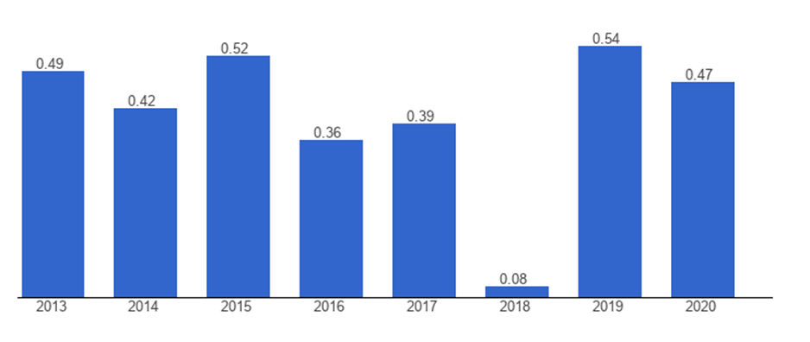
Figure 1: UK's political stability index
Source: The global economy (2022)
Economic Factor
If you look at Figure (2), you can see that the COVID-19 pandemic had a negative impact on the UK economy in 2019. The economy has tanked, and many people have lost their jobs, and other businesses have had to lay off workers because they can't afford to pay them. Nonetheless, by 2021, the country's economy will have expanded to a satisfactory level. In the fourth quarter of 2021, the national economy is expected to grow by 2.3%, up from the 0.9% expansion seen in the third quarter (Statista, 2022).
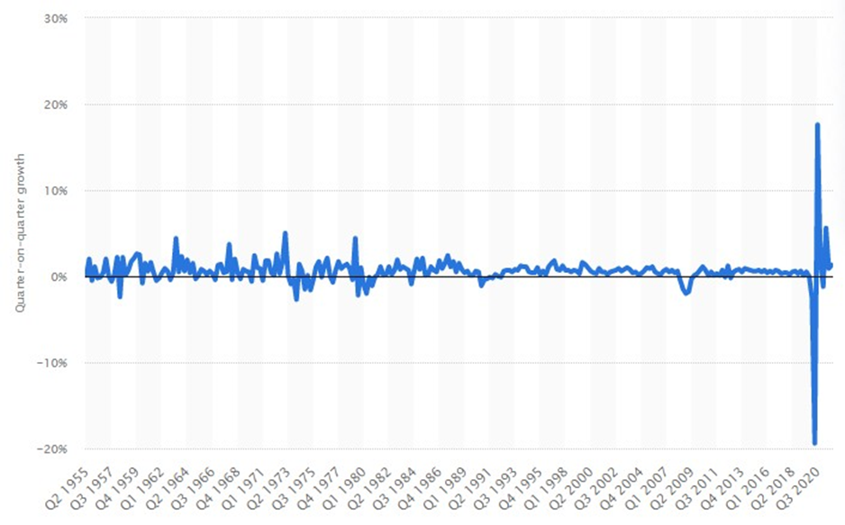
Figure 2: UK economy status
Source: Statista (2022)
Social Factors
Buyers' priorities have shifted in response to the COVID-19 crisis, with a greater emphasis placed on health and sustainability. The possibility of producing more environmentally friendly and healthier items during the pandemic has been raised (Galanakis, 2020). This is according to research (Galanakis, 2020). As a result of the pandemic, there is a growing market for personal care products including face masks, hand sanitizer, and hand wash.
Technological Factors
New methods of advertising and marketing these products provide a possibility to increase sales and earnings. In order to spread the word about the company's newest offerings, it uses digital mediums such as its website and social media pages. The company is now able to provide necessities to stores as fast as possible because to the enhanced level of automation (Caro and Sadr, 2019). To wit: (Caro & Sadr, 2019). This creates an opportunity for increased profits, enhanced brand recognition, and stable cash flow.
Legal Factors
The company has run into too many rules and laws as a result of its global expansion. About 350 brands in health, food, personal care, and other categories (Kpoku, 2021). There are several regulations that every storefront and label must follow, including those governing product and employee safety, intellectual property, workplace health and safety, and taxation.
Environmental Factors
Tesco is a leading example of a company that supports the use of eco-friendly practises and renewable energy. The company's own products are reliable enough for worldwide distribution. The business only uses eco-friendly materials in its design and packaging. The corporation may improve its environmental practises and help the cause of environmental protection. Getting closer to zero carbon emissions is a great way to get support from key constituencies. When a company participates in environmental activities, it is more likely to adopt corporate social responsibility practises inside the company, which in turn boosts the company's brand equity (Zahari et al., 2020).

IDIC Model
The Peppers and Rogers Group created the IDIC model to serve as a standard guideline for CRM implementation across different contexts. Identify, Differentiate, Interact, and Customize are the four steps in a customer relationship management (CRM) deployment.
Identify: The first stage is to get to know your consumers by name and by collecting data at every touchpoint so that you can build a complete profile of each one, including their demographics, interests, and purchasing habits.
The objective is to amass as much data as possible about each consumer to better comprehend their desires, requirements, and shopping habits.
Differentiate: The subsequent stage is to classify your clientele into distinct groups according to their present and future lifetime worth to your business. Keep in mind that not every consumer has the same value to the company.
To maximise profits, it's important to classify your customers according to how much they're worth to your business. This will allow you to devote more time and resources to nurturing relationships with your most profitable clients.
Interact: In the last phase, you put your customer relationship management strategies into action. After you've broken down your clientele into distinct groups, you'll be able to create individualised interactions with them. For instance, you may use loyalty programmes and other perks to keep your most valuable clients coming back and spending money with you.
Never forget that you can and should gain insight from every communication experience you have in order to enhance your future encounters.
Customize: Once you've tracked and analysed your contacts with customers, you can use that data to develop more tailored, one-on-one care. To do this, you must first identify and then specifically address each of your consumers' wants and expectations (or very narrowly).
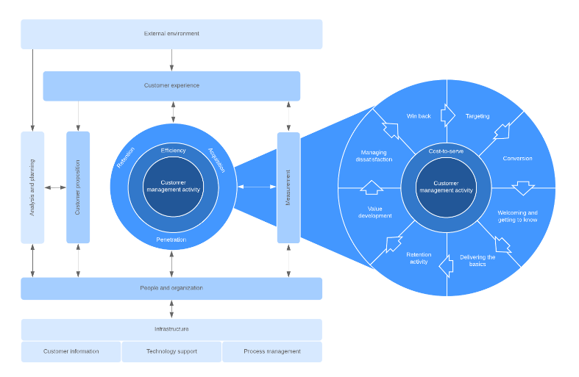

Value Chain Model
The word "value chain" describes the steps used to develop a product or service, from the sourcing of raw materials through the ultimate distribution (Cheng, 2021). The whole process, from obtaining necessary supplies to distributing the final product, is described in detail.
Each link in the value chain operations, inbound operations service, marketing and sales, and outward logistics, is dependent on the other links in the chain (Caro, and Sadr, 2019). The four tertiary functions are human resource management, purchasing and stocking, the support systems and technological development of the Tesco.
A value chain analysis is performed when an organisation dissects its processes. It is possible to learn more about the value chain's interconnections, relationships, and other patterns by doing a value chain analysis. To better categorise their primary and secondary functions, businesses might use the value chain framework.
Insight into the value chain's sub-activities, connections, and operations may help businesses better comprehend it as a system of interrelated functions (Alim, 2021). Then, organisations may evaluate each step or sub-step independently to see whether it contributes to the desired results and whether or not it might be done more efficiently.
The process through which a company applies the idea of the value chain to its own operations is referred to as value chain analysis. Fundamental actions include marketing, developing, sustaining and delivering a product or service. Here are some instances of such activities:
Activities performed upon arrival: The internal management and control of resources supplied by external entities, such as suppliers and other members of the supply chain (Faccia, 2019). Raw materials are only one example of the types of resources that might be classified as "inputs," which are defined as resources that come from outside the company.
Operations: Operations that take raw materials and transform them into a final product ready for sale and distribution to clients. These "outputs" are the main items that may be sold for more than the total of their costs, including labour and raw materials.
Managing the process of sending something away: Distribution of Products to Buyers. Methods often include gathering mechanism, consumer dissemination mechanism, and data repository (Cheng, 2021). The internal systems of a corporation must be managed, as must the external systems of its clients.
Advertising and product promotion: Marketing includes all the things that businesses do to get their products and services in front of potential customers, convince them to make a purchase, and increase demand.
Service: Long-term relationships with consumers who have already purchased a product or service may be fostered via a variety of channels, including customer service and product support.
Since management defects and inefficiencies are more quickly identified in the company's primary activities, cost advantages are often based on how well those operations are handled (Faccia, 2019). This demonstrates the company's ability to create goods and services at a cheaper rate than its rivals.

Introduction to the Models
The purpose of operational CRM is to cut down on mundane office chores. By introducing automation into the system, the CRM helps businesses guarantee that their work will be completed on time, every time. It provides a method to ensure higher quality service for your customers. Businesses may increase sales and hold on to their most valuable customers by implementing a customer relationship management strategy. The core features of the idea are automation in the areas of marketing, sales, and customer support. The approach eliminates manual data input and clerical hassles in the sales process using tools including an automatically populated client profile, lead organisation, database integration from several applications, and an automated lead-nurturing workflow. Using prospect-specific triggers, marketing-appropriate content, and automated email campaigns may improve marketing automation and its ability to reach out to potential customers. (Hoang, 2021). It's far easier to support clients who are having issues if you can automatically identify them, direct them to relevant resources, transmit follow-up communications, and look up their case histories. But only companies with customer engagement and support management needs may benefit from this strategy.
According to Gavval and Ravi (2020), analytical CRM addresses the challenge of information extraction from massive data streams. The CRM helps discover multiple touchpoints to create meaningful information on a business’s performance. Customer retention is greatly enhanced by this CRM architecture. A healthy client relationship is maintained automatically by arranging meetings, advertising offers and exclusive deals on certain days, and analysing more useful data from other parties to better meet their needs. The CRM also facilitates client acquisition by indicating which leads provide the most potential. It reveals which consumers have a higher propensity to buy your goods because of their pressing need for it. This approach also includes tools for data management and report creation. Nonetheless, the strategy works best for established companies with a large amount of consumer data and a focus on growth through data analysis.
Organizations may benefit greatly from using the CRM value chain model to create and execute a comprehensive CRM strategy. The methodology assists with customer portfolio analysis, client intimacy, network development, managing the customer life cycle and value proposition formulation. By using the CRM value chain, a company may examine its clientele in depth (Gallardo, et al., 2018). The examination of the existing and prospective client bases helps determine which consumers the firm wishes to service in the future and who will be ideal for high-profit gains. In terms of future income and profits, the approach reveals the most essential consumers to prioritise, who are those who are strategically significant. With this methodology, businesses in any sector may better understand their customers by gaining insight into their demographics, psychographics, purchasing habits, and other personal details. According to Svoboda et al. (2021), the CRM value chain helps businesses locate and maintain positive connections with members of their networks. This allows the company to focus on attracting and retaining employees who will be useful in developing and delivering value offerings to the target demographic. Partners, suppliers, vendors, owners, investors, and even key internal personnel may all be considered part of a network.
Expanding upon the "four Ps" of marketing, "the seven Ps of marketing mix" (Rahman et al., 2019). The seven Ps include the product itself, as well as its pricing, location, advertising, internal procedures, staff, and tangible results. Businesses may put marketing ideas to work when creating product and service marketing campaigns thanks to the seven Ps of marketing. However, the model becomes increasingly intricate as the 3 Ps are expanded. Furthermore, the model was deficient in that it failed to provide enough attention to the productivity factor in advertising. There is a failure to evaluate the company's performance and the benefits it has provided to customers (Mahmoud, 2018). It's important to remember that businesses don't have to sacrifice clarity in the marketing process for the sake of the three Ps. Despite the aforementioned drawbacks, the aforesaid framework is still the best option for social media marketing initiatives. Marketing initiatives that consider the five Ps tend to perform better and attract more customers.
The external factors that affect a business may be identified with the help of Porter's Five Forces Analysis. This approach is often used in marketing theory to identify the extraneous elements that have an impact on a company's marketing efforts. The model identifies competition, new entrants, substitution, suppliers, and purchasers as the five factors at play. The level of market competitiveness may be gauged with the use of this model. According to Chen, Mandler, and Meyer-Waarden (2021), a thorough examination of rivals' marketing approaches and client retention initiatives is required when deciding on a final plan. Market entry obstacles, such as government laws and existing monopolies, may be more easily identified when faced with the threat of new entrants. The danger of being replaced as a consumer option is the substitute’s threat inherent to this business. This allows you to compare the two similar products and decide which one to market to customers so that it doesn't become a substitute. Companies are forced to haggle with their suppliers, which helps to promote product pricing. According to Sudaryanto et al. (2019), many customers consider both price and quality before making a purchase. Establishing the buyer's budgetary constraints before rolling out a new approach is essential.
The term "marketing communications mix" is used to describe the many methods used to reach out to new and current clientele. The tools might include social media, product packaging, TV advertising, direct marketing, exhibits, events, and websites. In the light of Wu and Li (2018), research on the most popular and effective marketing mix helps to enhance the marketing process. Using all elements of the marketing mix allows for more thorough and effective customer-facing and market research-based interactions. However, the marketer has a challenge when using several channels since they must be managed simultaneously. Companies used to rely on broadcast media like television, newspapers, radio, and pay-per-click advertising (PPC) to spread the word about their wares, but these methods are losing ground to the more cutting-edge and dynamic digital marketing strategies. Since most people have always utilised social media, it's a great approach to reach a wide audience (Anderson and Jiang, 2018). Direct and digital marketing include not just email but also gamification and other digital channels. Other types of marketing communication mixes include press releases, sales presentations, and in-person networking.
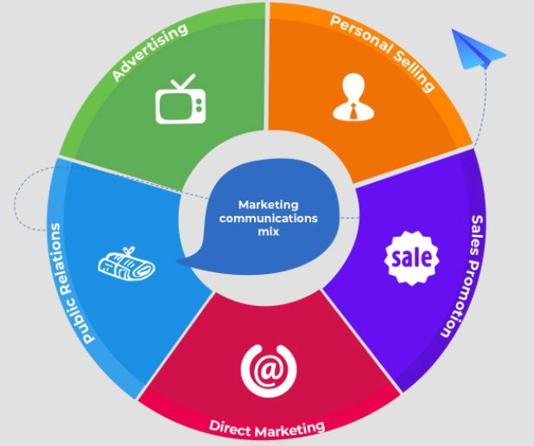
Figure3: Marketing communication mix

Identifying a Model
To solve its difficulties, Tesco opted for an analytical customer relationship management (CRM) strategy. The organisation now has a need to communicate with a wide variety of consumers as it expands into new areas. The CRM is outdated, and the firm struggles to leverage the most current information on client preferences and transactions. Customers make millions of purchases every day across the company's online and offline channels, making it challenging for the business to maintain and use the most up-to-date information. Analytical customer relationship management is helpful for businesses who deal with large amounts of data and want to utilise customer information from many years ago. Given the challenges now encountered by Tesco's quality team, the methodology is particularly applicable. This approach helps Tesco out on three different fronts. Deals, contacts, and leads can all be kept track of in one central location thanks to the customer relationship management system. Data storage is the first step, and the automation of marketing, critical sales, and customer care functions is the second.
The CRM approach is beneficial to enhancing the chatbot and feedback system. The third and highest-level CRM toolset is called analytical CRM. To better understand the history, present, and future of Tesco's sales, marketing data, and customer service, this tool is invaluable. In spite of the customer information, the analytical CRM tool makes use of this information to forecast future commercial performance. Because manufacturers do not think it is sufficient to only transmit nice charts and graphs to users and investors, this CRM enables real-time data reporting. The analytical CRM demonstrates its analytical skills by using artificial intelligence and machine learning, as discussed by Gavval et al. (2019). The analytical CRM's functionalities allow Tesco to dissect its historical and current sales data in the form of sales metrics. Along with this, the CRM model is helpful in drawing attention to the future predictions that can be made with the use of precise data processing and algorithms.
Business intelligence, as stated by Faccia (2019), allows for the precise identification of clients' spending habits. By using business intelligence, manufacturers in analytical CRM have uncovered previously unknown nuances in their consumers' purchase habits. This information is useful for Tesco since it reveals which users are the most engaged with the site. It stands in for the company's most dedicated repeat buyer. Therefore, the corporation may use this data to effectively prioritise the needs of its most loyal clients. Furthermore, analytical CRM reveals information about customers that are not yet loyal. Causes of the issue may be found by examination of these purchasers. Analytic CRM eliminates the requirement for companies to do customer research to learn why consumers are opting to go with competing brands. Tesco will be able to better target consumers via refined marketing and processing thanks to the analytical CRM's wealth of information.
Among the many advantages of analytical CRM, Nelson et al. (2020) noted that only with its help is it able to provide meaningful sales reporting. The programme can reliably provide sales reports for whatever time period you want. By doing so, Tesco will be able to determine its operational profit. The Tesco sales report is a useful tool for assessing the company's short- and long-term viability. According to Guenzi and Habel (2020), sales reporting may provide information on the nature of the company's clientele and the channels they use to learn more. Without a doubt, Tesco knows where its pipeline is weakest and can take steps to fix it. Sales reporting aids in comparing individual performance to goals, as stated by Samei et al. (2019). As a result, Tesco will have a better grasp of its sales representatives as individuals and their collective impact on the company. Furthermore, analytic CRM facilitates sales cycle modelling. Insight into Tesco's sales cycle is made easier using the CRM. The system records each customer's path, including all interactions. Whether it's a failed sale or a missed opportunity to re-engage, the model lays all the specifics.
The organisation is able to pinpoint the weak points in the client experience thanks to the insights provided by the analytical model. It gets rid of any potential problems that may arise during lead qualifying and conversion. By using this methodology, Tesco may learn more about how their products are received by consumers. Adding these capabilities to your organization's current analytical CRM will allow you to create more thorough answers to the issues you encounter. The analytical CRM's forecasting capabilities aid in the administration of assets, personnel, cash flow, and expansion. This is achieved by considering macroeconomic patterns, historical data, the current state of the industry, and precise forecasts based on the right collection of facts. According to Svoboda et al. (2021), CRM with advanced capabilities may compile information from many archives to create a picture of how things have been done in the past. Analytical customer relationship management (CRM) benefits from business intelligence since it helps to spot emerging industry trends and unlocks expansion possibilities.
Meeting client expectations and achieving organisational success may be difficult, despite the numerous advantages. Tesco has a significant problem in trying to persuade its employees of the need of this shift. Looking at the widespread usage of technology, the implementation and training of staff is projected to be the greatest obstacle. But before this, the most apparent and important issue is convincing the staff and management to agree to this change. Convincing higher management to go along with this CRM system transition would be challenging for Tesco. With such a large data collection being used by the CRM system, accurate analysis and interpretation of the information may be difficult. Additionally, it will be difficult to move such a large data repository to the cloud and maintain its security. According to Konttila et al’s (2019), being comfortable and competent with utilising cutting-edge technology is essential. Making the transition to analytic CRM easier for Tesco's staff will be a significant task. Further, the expense of implementation is a barrier to progress in the workplace.

Challenge and Recommendations
This section offers guidance on how to best apply the new strategy and make effective use of the CRM's analytical features to boost business performance. People need a training plan and motivational meetings to adopt the analytical CRM. Tesco’s management are crucial in influencing workers' decisions. Programs that stress the value of digital innovation and technical education to the organization's future success should be developed. Holding a training session on technological interventions and their role in organisational performance is a great way to boost morale among workers. The company's inventors had a similar challenge in convincing upper management to approve the implementation of the CRM model, and they too needed to compile a report outlining the model's quantifiable benefits. In this case, the efforts of every division are essential. The sales department will be able to report on how this model promotes sales, while the marketing department will emphasise the model's value in boosting consumer engagement and brand recognition.
The organisation may safeguard the safety of its cloud data by purchasing an SSL certificate, which prevents unauthorised users from accessing stored information. Additionally, it is suggested that the business leverage several CR software connectors provided by collaborating with several different technological firms. This will ensure that the software is always up to date, allowing Tesco to include cutting-edge technology features into its analytical customer relationship management system. Budgeting for CRM installation should consider the company's long-term objectives in order to deal with the concerns of high expenditures and budgeting. By using this strategy, we can save money and provide relevant training that's appropriate for the present moment.

Conclusion
For a business to expand and thrive, customer relationship management (CRM) programmes and quality assurance procedures are must-haves. The CRM is useful for learning about customers and their opinions, buying habits, and other purchasing behaviours. Companies like Tesco who are having difficulty managing their massive database might benefit from analytical CRM. Benefits of analytic CRM include a better understanding of consumer buying habits, the value of a loyal customer base, and the revenue cycle at Tesco. Management and staff buy-in, technology rollout and training, and accurate data interpretation are all obstacles the business may encounter.

Reference
Actors’ activity (on materials of Tesco Group) (Doctoral dissertation).
Alim, N.E., 2021. Identifying retailers’ satisfaction survey of Lever Bazar App.
Anderson, M. and Jiang, J., 2018. Teens, social media & technology 2018. Pew Research Center, 31(2018), pp.1673-1689.
Caro, F. and Sadr, R., 2019. The Internet of Things (IoT) in retail: Bridging supply and demand. Business Horizons, 62(1), pp.47-54.
Chen, Y., Mandler, T. and Meyer-Waarden, L., 2021. Three decades of research on loyalty programs: A literature review and future research agenda. Journal of Business Research, 124, pp.179-197.
Cheng, Y., 2021, February. Analysis on the Opportunities and Challenges of Tesco's Differentiated Competition by Using SWOT and PEST. In 6th International Conference on Economics, Management, Law and Education (EMLE 2020) (pp. 280-284). Atlantis Press.
Faccia, A., 2019, August. Data and Information Flows: Assessing Threads and Opportunities to Ensure Privacy and Investment Returns. In Proceedings of the 2019 3rd International Conference on Cloud and Big Data Computing (pp. 54-59).
Galanakis, C.M., 2020. The food systems in the era of the coronavirus (COVID-19) pandemic crisis. Foods, 9(4), p.523.
Gallardo, G., Hernantes, J. and Serrano, N., 2018. Designing SaaS for enterprise adoption based on task, company, and value-chain context. IEEE Internet Computing, 22(4), pp.37-45.
Gavval, R. and Ravi, V., 2020. Clustering bank customer complaints on social media for analytical CRM via multi-objective particle swarm optimization. In Nature Inspired Computing for Data Science (pp. 213-239). Springer, Cham.
Gavval, R., Ravi, V., Harshal, K.R., Gangwar, A. and Ravi, K., 2019. CUDA-Self-Organizing feature map based visual sentiment analysis of bank customer complaints for Analytical CRM. arXiv preprint arXiv:1905.09598.
Goyal, A., 2020. PROJECT SEMESTER REPORT (Doctoral dissertation, Thapar University). Guenzi, P. and Habel, J., 2020. Mastering the digital transformation of sales. California Management Review, 62(4), pp.57-85.
Hoang, A., 2021. Foodora's digital marketing performance and customers' responses in Finland.
Juanamasta, I.G., Wati, N.M.N., Hendrawati, E., Wahyuni, W., Pramudianti, M., Wisnujati, N.S., Setiawati, A.P., Susetyorini, S., Elan, U., Rusdiyanto, R. and Astanto, D., 2019. The role of customer service through customer relationship management (CRM) is to increase customer loyalty and a good image. International Journal of Scientific and Technology Research, 8(10), pp.2004-2007.
Kaur, A., 2020. UI/UX Development for Modern Trade Customer Portal (Doctoral dissertation, Thapar University).
Keiningham, T., Aksoy, L., Bruce, H.L., Cadet, F., Clennell, N., Hodgkinson, I.R. and Kearney, T., 2020. Customer experience-drivenness model innovation. Journal of Business Research, 116, pp.431-440.
Konttila, J., Siira, H., Kyngäs, H., Lahtinen, M., Elo, S., Kääriäinen, M., Kaakinen, P., Oikarinen, A., Yamakawa, M., Fukui, S. and Utsumi, M., 2019. Healthcare professionals’ competence in digitalisation: A systematic review. Journal of clinical nursing, 28(5-6), pp.745-761.
Kpoku, O.K., 2021. The positive negative influence of globalization on international business
Kumar, M.P. and Kumara, N.M., 2021. Market capitalization: Pre and post COVID-19 analysis. Materials Today: Proceedings, 37, pp.2553-2557.
Lawrence, J., Rasche, A. and Kenny, K., 2019. Sustainability as opportunity: Tesco’s sustainable living plan. In Managing Sustainable Business (pp. 435-455). Springer, Dordrecht.
Mahmoud, T.O., 2018. Impact of green marketing mix on purchase intention. International Journal of Advanced and applied sciences, 5(2), pp.127-135.
Nelson, C.A., Walsh, M.F. and Cui, A.P., 2020. The role of analytical CRM on salesperson use of competitive intelligence. Journal of Business & Industrial Marketing.
Pandey, R., Massand, A., Mulya, V.T., Sin, L.G., Naresh, V.P., Zamara, F.B., Kee, D.M.H., Zamri, S.K.B., Azmi, N.A.S.B., Hamdan, N.N.B.M. and Aditi, A., 2021. The Impacts of Covid-19 on Tesco. Journal of the Community Development in Asia (JCDA), 4(1), pp.34-43.
Rahman, M., Islam, M., Al Amin, M., Sultana, R. and Talukder, M., 2019. Effective factors of service marketing mix on tourist satisfaction: A case study. Asian Social Science, 15(7).
Samei, E., Bakalyar, D., Boedeker, K.L., Brady, S., Fan, J., Leng, S., Myers, K.J., Popescu, L.M., Ramirez Giraldo, J.C., Ranallo, F. and Solomon, J., 2019. Performance evaluation of computed tomography systems: summary of AAPM task group
Sivarajah, U., Irani, Z., Gupta, S. and Mahroof, K., 2020. Role of big data and social media analytics for business-to-business sustainability: A participatory web context. Industrial Marketing Management, 86, pp.163-179.
Statista, 2022. Quarterly GDP growth of the UK 1955-2021. Available at: https://www.statista.com/statistics/970941/quarterly-gdp-growth-uk/. Accessed on: April 19, 2022.
Sudaryanto, S., N ARI SUBAGIO, N., Awaliyah, I.N., Wulandari, D. and Hanim, A., 2019. Influence of brand image, price and promotion on consumer’s buying decision of fast-moving consumer’s goods with culture as a moderating variable in basmallah retail store in Indonesia.
Svoboda, P., Ghazal, T.M., Afifi, M.A., Kalra, D., Alshurideh, M.T. and Alzoubi, H.M., 2021, June. Information systems integration to enhance operational customer relationship management in the pharmaceutical industry. In The International Conference on Artificial Intelligence and Computer Vision (pp. 553-572). Springer, Cham.
Svoboda, P., Ghazal, T.M., Afifi, M.A., Kalra, D., Alshurideh, M.T. and Alzoubi, H.M., 2021, June. Information systems integration to enhance operational customer relationship management in the pharmaceutical industry. In The International Conference on Artificial Intelligence and Computer Vision (pp. 553-572). Springer, Cham.
The global economy, 2022. United Kingdom: Political stability. Available at: https://www.theglobaleconomy.com/United-Kingdom/wb_political_stability/#:~:text=United%20Kingdom%3A%20Political%20stab ility%20index,of%201.04%20points%20in%202000. Accessed on: April 19, 2022.
Wu, Y.L. and Li, E.Y., 2018. Marketing mix, customer value, and customer loyalty in social commerce: A stimulus-organism-response perspective. Internet Research.
Zahari, A.R., Esa, E., Rajadurai, J., Azizan, N.A. and MUHAMAD TAMYEZ, P.F., 2020. The effect of corporate social responsibility practices on brand equity: An examination of Malaysia's top 100 brands. The Journal of Asian Finance, Economics and Business, 7(2), pp.271-280.

