Student Name: Anisoara Valentina Cucoranu
Student ID: 2133014
Module: International Meetings Management for the Hotel Industry
Module code: BMIH6007
Lecture: Jemma Smith

Table of Contents
Feasibility Plan for an International Meeting 3
Introduction 3
About MICE Event 4
Technology and Innovation as Theme of MICE Event 5
Key Theme of the Event 6
Situational Analysis and Research 7
Target Market 7
Demand Analysis 7
Supply and Competition 8
Operational Factors 8
Venue 8
Skills and Resources Needed 9
Financial Factors 9
Cost and Revenue Breakdown 10
Funding Sources and Profitability 10
Justification of Feasibility 10
Conclusion 11
References 12

Feasibility Plan for an International Meeting

Introduction
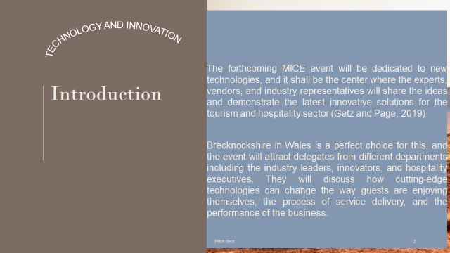
The forthcoming MICE event will be dedicated to new technologies, and it shall be the center where the experts, vendors, and industry representatives will share their ideas and demonstrate the latest innovative solutions for the tourism and hospitality sectors (Getz and Page, 2019). Brecknockshire in Wales is a perfect choice for this, and the event will attract delegates from different departments including industry leaders, innovators, and hospitality executives. They will discuss how cutting-edge technologies can change the way guests enjoy themselves, the process of service delivery, and the performance of the business.

About MICE Event
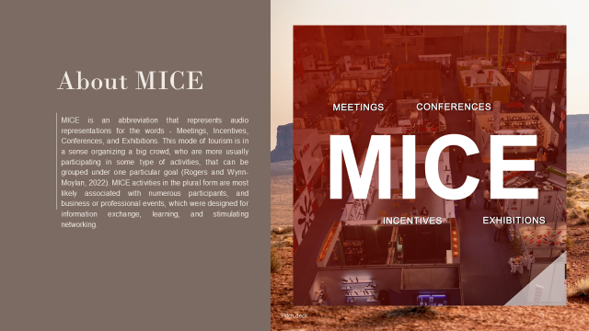
MICE is an abbreviation that represents audio representations for the words - Meetings, Incentives, Conferences, and Exhibitions. This mode of tourism is in a sense organizing a big crowd, who are more usually participating in some type of activities, that can be grouped under one particular goal (Rogers and Wynn-Moylan, 2022). MICE activities in the plural form are most likely associated with numerous participants, and business or professional events, which were designed for information exchange, learning, and stimulating networking.

Technology and Innovation as Theme of MICE Event
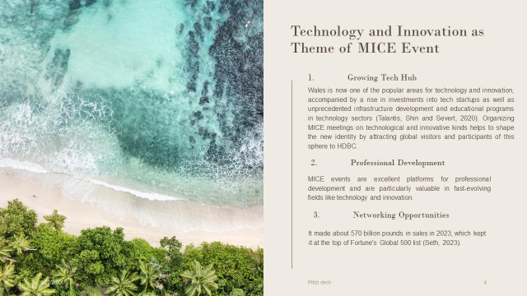

The decision to turn the "Technology and Innovation" theme into a MICE event in Wales is strategic for several reasons:
- Growing Tech Hub: Wales is now one of the popular areas for technology and innovation, accompanied by a rise in investments into tech startups as well as unprecedented infrastructure development and educational programs in technology sectors (Talantis, Shin and Severt, 2020). Organizing MICE meetings on technological and innovative kinds helps to shape the new identity by attracting global visitors and participants of this sphere to HDBC.
- Professional Development: MICE events are excellent platforms for professional development and are particularly valuable in fast-evolving fields like technology and innovation.
- Networking Opportunities: These events provide unparalleled networking opportunities with peers, industry leaders, and innovators from across the world like cross-pollination of ideas.
By choosing Wales as the venue for a technology and innovation-themed MICE event, organizers can capitalize on the region's strategic strengths, while also promoting further growth and development in the local and international technology sectors.

Key Theme of the Event
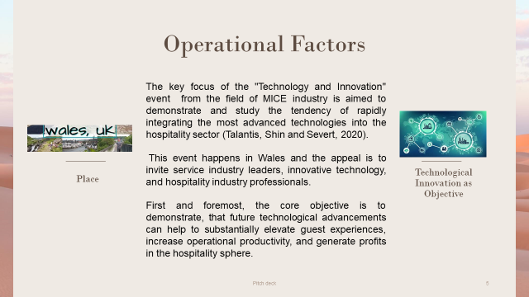
The key focus of the "Technology and Innovation" event from the field of MICE industry is aimed to demonstrate and study the tendency of rapidly integrating the most advanced technologies into the hospitality sector (Talantis, Shin and Severt, 2020). This event happens in Wales and the appeal is to invite service industry leaders, innovative technology, and hospitality industry professionals. First and foremost, the core objective is to demonstrate, that future technological advancement can help to substantially elevate guest experiences, increase operational productivity, and generate profits in the hospitality sphere.
The audience will learn by participating in a variety of activities such as participation in advanced topic discussions, observation of live demonstrations, and obtaining advice from experts on the implementation of novel technologies in their business (Smith, 2012). The event will host presentations discussing future developments like AI, VR, and automation, in the same vein as the practicality of their use in real customer-facing hospitality scenarios.
This convention is not just about audiovisual presentations but also, the audience participation is aimed at experiencing the new technology. This direct experience, in addition to seeing the various energy-efficient technologies firsthand, will assist participants in getting an understanding of what they will see in their enterprises (Dashper and Finkel, 2020). The event is purposely designed to emphasize technology as a key propeller in the revolution of the hospitality sector. Its goal is therefore to equip professionals with correct digital tools and knowledge to lead in a digital world. Therefore, the event is crucial for those who want to stay relevant in an industry that is transforming at a spellbinding speed.

Situational Analysis and Research

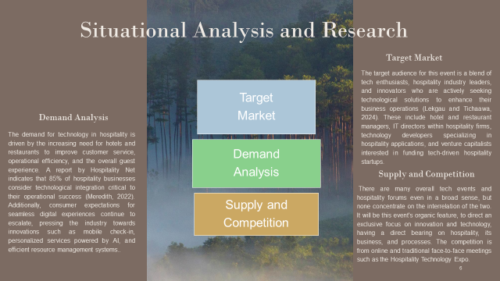Target Market
The target audience for this event is a blend of tech enthusiasts, hospitality industry leaders, and innovators who are actively seeking technological solutions to enhance their business operations (Lekgau and Tichaawa, 2024). These include hotel and restaurant managers, IT directors within hospitality firms, technology developers specializing in hospitality applications, and venture capitalists interested in funding tech-driven hospitality startups.

Demand Analysis
The demand for technology in hospitality is driven by the increasing need for hotels and restaurants to improve customer service, operational efficiency, and the overall guest experience. A report by Hospitality Net indicates that 85% of hospitality businesses consider technological integration critical to their operational success (Meredith, 2022). Additionally, consumer expectations for seamless digital experiences continue to escalate, pressing the industry towards innovations such as mobile check-in, personalized services powered by AI, and efficient resource management systems.

Supply and Competition
There are many overall tech events and hospitality forums even in a broad sense, but none concentrate on the interrelation of the two. It will be this event's organic feature, to direct an exclusive focus on innovation and technology, having a direct bearing on hospitality, its business, and processes. The competition is from online and traditional face-to-face meetings such as the Hospitality Technology Expo. This ceremony will stand out by providing deeper analysis and more precise networking activities, as well as a few technological exhibitions that will be specially customized for the hotel industry.

Operational Factors
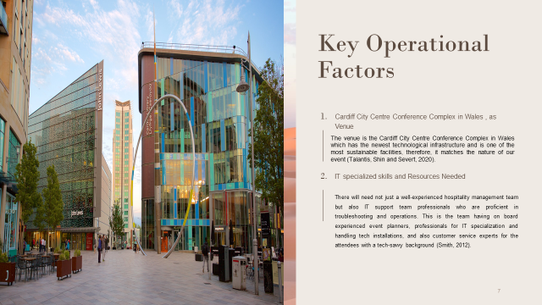

Venue
The venue is the Cardiff City Centre Conference Complex in Wales which has the newest technological infrastructure and is one of the most sustainable facilities, therefore, it matches the nature of our event (Talantis, Shin and Severt, 2020). The venue is situated at a central point that allows worldwide and local guests to access it very easily. Furthermore, this area has high-speed internet, and digital conferencing systems, while modern AV systems for exhibiting the technology demonstrations.

Skills and Resources Needed
There will need not just a well-experienced hospitality management team but also IT support team professionals who are proficient in troubleshooting and operations. This is the team having on board experienced event planners, professionals for IT specialization and handling tech installations, and also customer service experts for the attendees with a tech-savvy background (Smith, 2012). Resource needs are versatile, ranging from state-of-the-art technology such as AR and VR headsets to traditional attendant services that cater to used-to-be types of needs such as food, security, and transportation. The app for event management that members are going to develop specifically will focus on creating interactive experiences for the visitors through features like live polls, tech repair workshops, and Q&A sessions with direct speakers.

Financial Factors
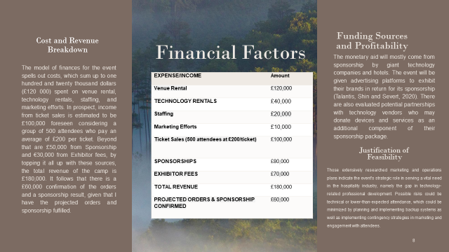

Cost and Revenue Breakdown
The model of finances for the event spells out costs, which sum up to one hundred and twenty thousand dollars (£120 000) spent on venue rental, technology rentals, staffing, and marketing efforts. In prospect, income from ticket sales is estimated to be £100,000 foreseen considering a group of 500 attendees who pay an average of £200 per ticket. Beyond that are £50,000 from Sponsorship and £30,000 from Exhibitor fees, by topping it all up with these sources, the total revenue of the camp is £180,000. It follows that there is a £60,000 confirmation of the orders and a sponsorship result, given that I have the projected orders and sponsorship fulfilled.
Expense/Income | Amount
Venue Rental | £120,000
Technology Rentals | £40,000
Staffing | £20,000
Marketing Efforts | £10,000
Ticket Sales (500 attendees at £200/ticket) | £100,000
Sponsorships | £80,000
Exhibitor Fees | £70,000
Total Revenue | £180,000
Projected Orders & Sponsorship Confirmed | £60,000

Funding Sources and Profitability
The monetary aid will mostly come from sponsorship by giant technology companies and hotels. The event will be given advertising platforms to exhibit their brands in return for its sponsorship (Talantis, Shin and Severt, 2020). There are also evaluated potential partnerships with technology vendors who may donate devices and services as an additional component of their sponsorship package. The profitability of an event can be guaranteed with a well-structured cost-control system and an efficient marketing campaign that is pinned on public expansion and sponsorship participation. Ticket sales during the early-bird night as well as the VIP packages will supernumerate several revenue streams and therefore meet or even exceed the specific financial goals.

Justification of Feasibility
Those extensively researched marketing and operations plans indicate the event's strategic role in serving a vital need in the hospitality industry, namely the gap in technology-related professional development. Possible risks could be technical or lower-than-expected attendance, which could be minimized by planning and implementing backup systems as well as implementing contingency strategies in marketing and engagement with attendees.

Conclusion
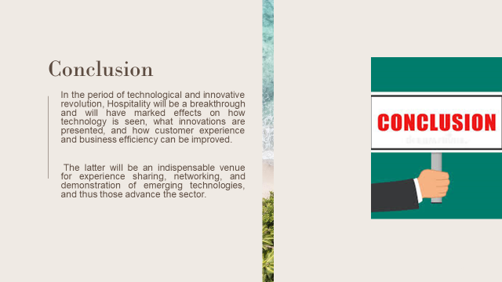
In the period of technological and innovative revolution, Hospitality will be a breakthrough and will have marked effects on how technology is seen, what innovations are presented, and how customer experience and business efficiency can be improved. The latter will be an indispensable venue for experience sharing, networking, and demonstration of emerging technologies, and thus those advance the sector.

References
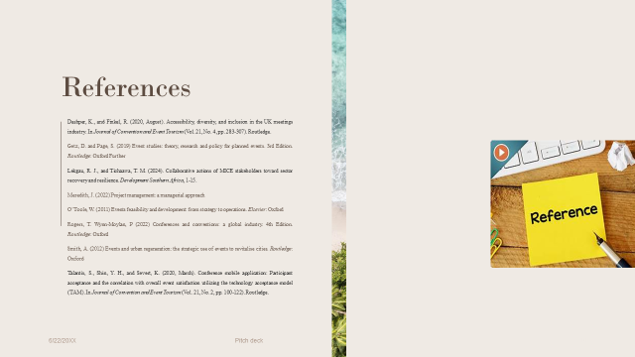
Dashper, K., and Finkel, R. (2020, August). Accessibility, diversity, and inclusion in the UK meetings industry. In Journal of Convention and Event Tourism (Vol. 21, No. 4, pp. 283-307). Routledge.
Getz, D. and Page, S. (2019) Event studies: theory, research and policy for planned events. 3rd Edition. Routledge: Oxford Further
Horng, J.-S., Wang, C.-J., Liu, C.-H., Chou, S.-F. and Tsai, C.-Y. (2016). The Role of Sustainable Service Innovation in Crafting the Vision of the Hospitality Industry. Sustainability, 8(3), p.223. doi https://doi.org/10.3390/su8030223.
Işık, C., Aydın, E., Dogru, T., Rehman, A., Sirakaya-Turk, E. and Karagöz, D. (2022). Innovation Research in Tourism and Hospitality Field: A Bibliometric and Visualization Analysis. Sustainability, 14(13), p.7889. doi:https://doi.org/10.3390/su14137889.
Kumar, V. (2020). Tourism Industry and COVID-19: Present Scenario. Journal of Tourism and Hospitality Education, 10(8), pp.179–185. doi:https://doi.org/10.3126/jthe.v10i0.28768.
Lekgau, R. J., and Tichaawa, T. M. (2024). Collaborative actions of MICE stakeholders toward sector recovery and resilience. Development Southern Africa, 1-15.
Mantelero, A. and Vaciago, G. (2015). Data protection in a big data society. Ideas for a future regulation. Digital Investigation, 15(8), pp.104–109. doi:https://doi.org/10.1016/j.diin.2015.09.006.
Mark, Kaur (2021). Covid-19: Impact of Lockdown on Tourism & Hospitality Industry. Journal of Tourism, Hospitality and Sports, 7(8). doi:https://doi.org/10.7176/jths/53-02.
Meredith, J. (2022) Project management: a managerial approach
Mills, K.A. (2019). Big Data for Qualitative Research. Routledge.
Nelson, C.E., Greaner, J. and Hack, R. (2016). Educational Researchers React to the ‘Educational Researcher’. Educational Researcher, 4(3), p.13. doi:https://doi.org/10.2307/1174801.
O’Toole, W. (2011) Events feasibility and development: from strategy to operations. Elsevier: Oxford
Petruk, T. (2020). CRISIS MANAGEMENT MODELS FOR THE HOSPITALITY INDUSTRY DURING COVID-19. Economic scope, 41(7). doi:https://doi.org/10.32782/2224-6282/159-21.
Rogers, T. Wynn-Moylan, P (2022) Conferences and conventions: a global industry. 4th Edition. Routledge: Oxford
Saunders, M., Lewis, P. and Thornhill, A. (2019). Research Methods for Business Students. 8th ed. Harlow: Pearson.
Smith, A. (2012) Events and urban regeneration: the strategic use of events to revitalise cities. Routledge: Oxford
Stallings, W.M. (2015). Confessions of a Quantitative Educational Researcher Trying to Teach Qualitative Research. Educational Researcher, 24(3), p.31. doi:https://doi.org/10.2307/1176023.
Talantis, S., Shin, Y. H., and Severt, K. (2020, March). Conference mobile application: Participant acceptance and the correlation with overall event satisfaction utilizing the technology acceptance model (TAM). In Journal of Convention and Event Tourism (Vol. 21, No. 2, pp. 100-122). Routledge.
Tracy, S.K. (2020). Qualitative Research Methods: Collecting Evidence, Crafting Analysis, Communicating Impact. 2nd ed. Chichester: Wiley-Blackwell.
Wahab, K. (2020). Impact of COVID–19 on the Hospitality Industry: Climbing Towards Recovery. SSRN Electronic Journal, 45(9). doi:https://doi.org/10.2139/ssrn.3737702.

