Bologna, local history and heritage.

In the heart of Northern Italy, the city of Bologna is flooded daily with tourists and students from across the globe.Not only is it the largest city in the Emilia-Romagna region but also the capital. The city holds many achievements, such as the oldest continuing operating university in the world, the longest porticoe in the world and has been referenced by literally greats such as Dante Alighieri.

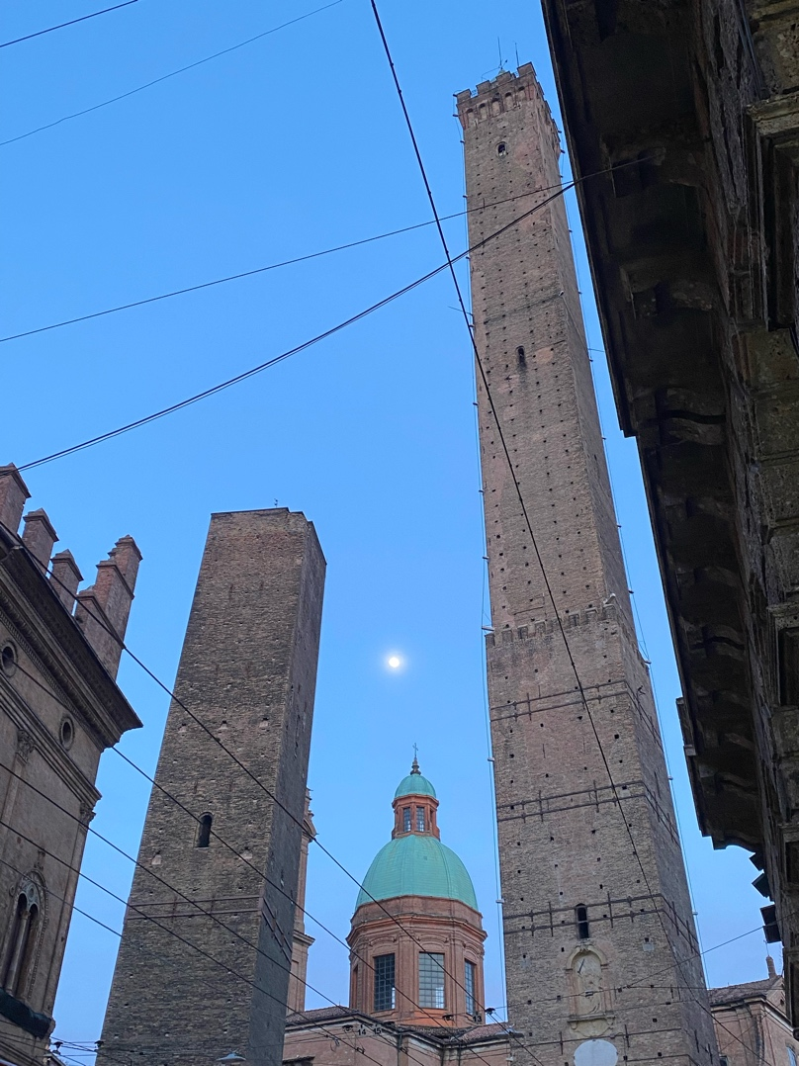
The iconic symbol of Bologna is irrefutably the Two Towers. Present day tourists could have climbed the Asinelli Tower built between 1109-1119 at the height of 97.2m making it the ‘tallest leaning medieval tower in the world’. Located in the centre of the city, one could have received a panoramic view of the city and to the south see the Bolognese Hills. However, the site is currently closed due to restoration and maintenance work of the smaller of the two towers, Garisenda, built by the Garisenda family either in 1109 or 1119. This was after Italy’s civil protection agency declared a yellow alert from its 3.2m tilt. The tower is receiving the same stabilising support as the Tower of Pisa which tilts at 3.97 after its own restoration work, there is no definite deadline on when the project will be completed but it's been estimated to last 10 years.
These towers were in high demand during the 12th and 13th centuries within wealthy families. To have a tower represented wealth and increased social prestige. These towers were not only for show, but also had practical functions, they were lived in and multi storied, allowing for spaces such as prisons, retail trade, spaces for craftsmanships. Towers also allowed families to spread their influence over neighbours and be used within military circumstances.
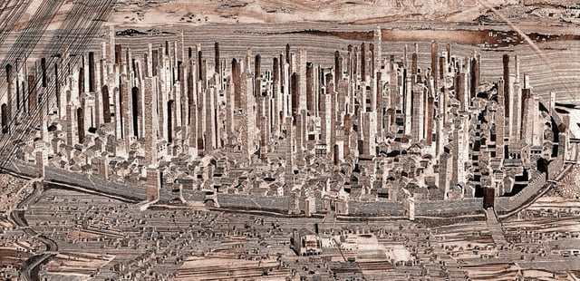
Out of the 100 towers to have been present during the medieval period, only 22 remain, however most have been deconstructed in height over the years due to safety. Some of the towers which remain have been adapted for modern purposes, such as the Azzoguidi tower at 61m (the second tallest tower in Bologna), built by the Azzoguidi family where the base is currently a watch shop and its neighbour Torre Prendiparte at 59m can be booked as a B&B or every Saturday one can enjoy a private tour climbing through the tower to the top terrace for a 360 degree view.
Photo 2, an artist's impression of medieval Bologna which includes the old walls (now destroyed) and 12 gates which are still preserved.

The towers of Bologna have been referenced in literature to the Late Middle Ages to present day. The most obvious citation of Bologna in Dante Alighieris’s work is in Inferno, canto XXXI ‘As when one sees the tower called Garisenda from underneath its leaning side, and then a cloud passes over and it seems to lean the more, thus did Antaeus seem to my fixed gaze as I watched him bend…’ Despite not knowing when the poet arrived in Bologna, it’s evident that Dante had a strong presence throughout Bologna with it being the second most cited city in his works (his first being Florence). The city has engraved quotations of his works referring to Bologna throughout the city centre walls. Charles Dickens in his ‘Pictures from Italy, Chapter 6 – Through Bologna and Ferrarra’ also mentions his brief visit through Bologna.
There are many modern recreational books based in Bologna, mostly thrillers, where readers can be immersed within Bologna’s landmarks while trying to ‘solve the case’ which can be found in numerous Bologna books stores in the English section.
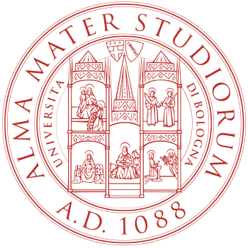
Bologna has also been the possible inspiration towards a fantasy city within the novel series ‘Discworld’ by Terrry Pratchett. In the series lies a medieval fantasy city with no clear ruler filled with giant towers built from competition between neighbours with scenes of aerial combat to gain power. Bologna being the source of inspiration behind the fantasy city has not been confirmed by the author but is a consensus thought among fans, with Bologna’s medieval function being undoubtably similar but in a science fiction/fantasy setting, and with the author having visited the city for book appearances.

Much of Bologna’s financial success in the medieval ages was due to the foundation of Alma Mater Studiorum in 1088, although the exact date is unable to be determined due to the nature of how the university was founded. Instead of being founded under the directive of a sovereign or an assemblage of teachers it was by the ‘outcome of the spontaneous and informal initiative of a few students for the scholarship of Canon law and Roman law.
This led to the city becoming quickly know as “La Grassa” (The Fat) city and “La Dotta” (The Learned) attracting wealthy people to reside within the city. This huge boom in population cause mass reformation in the city in the form of extending properties from the first storey, to below in the form of porticoes to support the extension to house the influx of students relocating to Bologna as the university expanded.
Image 3, Alma Mater Studiorum Università di Bologna seal.
Bologna during the 11th Ce was a commune, and during this time it held a symbiotic relationship with the university by passing laws which favoured and protected the university due to the university renting ares throughout the city such as the porticoes, monasteries and other city areas for assemblies and lessons.
The university has produced famous figures such as Bologna’s first female doctor of medicine Maria Dalle Donne and Mondino De’ Liuzzi (1275-1326) who implemented autopsy in the teaching of medicine, changing the sphere of teaching medicine from theory to more practice based.
The motto ‘Alma Mater Studiorum’ translates to the “nourishing mother of studies” is quite fitting due to it currently offering 101 first cycle degrees (BA, BSc, LLB equivalents) and 108 second cycle degrees (MSc equivalent) with 11 schools spread across the city centre:
- ‘School of Agriculture and Veterinary Medicine
- School of Economics, Management and Statistics
- School of Engineering and Architecture
- School of Foreign Languages and Literature, Interpreting and Translation
- School of Law
- School of Arts, Humanities, and Cultural Heritage
- School of Medicine and Surgery
- School of Pharmacy, Biotechnologies and Sport Sciences
- School of Political Sciences
- School of Psychology and Education Sciences
- School of Sciences’

Religion, also plays an important role in Bologna, and is responsible for another world record and Christian legend. The Sanctuary of San Luca sits on top of Guard Hill in the Bolognese hills overlooking the city of Bologna. The site is easily accessible by the almost 4km portico (the longest covered archway in the world), which is also included in the collective 62km of porticoes in Bologna which are listed as a UNESCO World Heritage Convention since 2021.
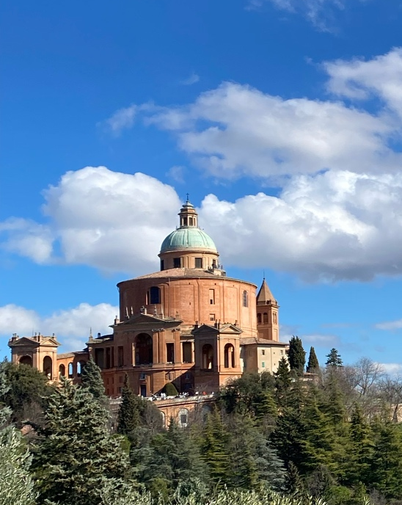
Image 4, San Luca, Bologna.
The icon of the Virgin Mary (apparently the work of Luke the Evangelist) was brought to Bologna, Guard Ηill, by a Greek Hermit from the Basilica of Hagia Sophia, Constantinople in the 12th CE.
The icon would be associated with later local legend during the 15 Ce dubbing it ‘the miracle of the rain’. The story goes that the region was plague for months by excessive rain, risking famine. However, when the Virgin Mary icon left San Luca for a three-day procession, the rain stopped and saved the crops. Since then, to commemorate the miracle an annual procession takes place on the first Sunday of July down Guard Hill, into the city centre and back again with the icon.
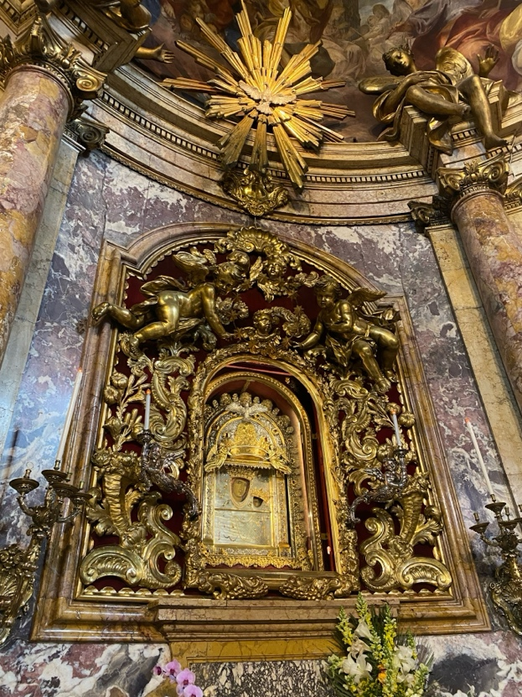
Image 5, Icon of the Virgin Mary held in San Luca, Bologna.
The porticoe leading from the city to San Luca was built in a community effort in 1674, everyone from Bologna was expected to contribute towards the funds to support the endeavour and was built to protect pilgrims from rain and the icons annual journey down to the city centre in July to celebrate the miracle.
In conclusion Bologna is still the lively city that it once was in the medieval period, but with a very drastic change of landscape compared to the 100 towers that would had occupied the medieval skyline. With the multi campus operation of Alma Mater Studiorum, the city of Bologna is guaranteed to be kept relevant in the academic world.

https://www.bolognawelcome.com/en/places/towers-historic-buildings/the-two-towers-garisenda-and-degli-asinelli-eng <Accessed on 02/06/2024>
https://www.lonelyplanet.com/italy/emilia-romagna-and-san-marino/bologna/attractions/torre-degli-asinelli/a/poi-sig/419361/359887 <Accessed on 04/06/2024>
IBID
Atkinson, Sam. C. Atkinson’s Casket, Volume 7, 1832. Pg. 409.
IBID
https://www.irishtimes.com/news/leaning-tower-of-pisa-loses-crooked-crown-1.980085 <Accessed on 07/06/2024>
https://www.atlasobscura.com/places/towers-of-bologna <Accessed 05/06/2024>
Divine Comedy, Infernno, XXXI, 136-140.Dante Alighieri (2000). "The Divine Comedy: Inferno". Translation by Robert Hollander and Jean Hollander. Princeton Dante Project. Retrieved 2 May 2007 <Accessed on 4/6/2024>
https://www.unibo.it/en/university/who-we-are/our-history/nine-centuries-of-history/nine-centuries-of-history <Accessed on 07/06/2024>
IBID
IBID
https://en.m.wikipedia.org/wiki/University_of_Bologna#/media/File%3ASeal_of_the_University_of_Bologna.svg <Accessed on 07/06/2024> https://en.m.wikipedia.org/wiki/University_of_Bologna#/media/File%3ASeal_of_the_University_of_Bologna.svg <Accessed on 07/06/2024>
https://www.unibo.it/en/university/who-we-are/our-history/nine-centuries-of-history/nine-centuries-of-history <Accessed on 07/06/2024>
https://www.unibo.it/en/university/who-we-are/our-history/famous-people-and-students/maria-dalle-donne <Accessed on 07/06/2024>
https://www.unibo.it/en/university/who-we-are/our-history/famous-people-and-students/mondino-de-liuzzi <Accessed on 07/06/2024>
https://en.m.wikipedia.org/wiki/University_of_Bologna <Accessed on 07/06/2024>
IBID
IBID
https://whc.unesco.org/en/list/1650 <Accessed on 3/6/2024>
Original image.
Original image.
https://www.bolognawelcome.com/en/places/religious-buildings/sanctuary-of-san-luca-eng <Accessed on 07/06/2024>

