Data Security and Compliance – Research and Case Scenario in Data Security and Compliance

Author: Liam Aaron Jarvis (2000388)
Data Security and Compliance (ACCA5034)
School of Applied Computing
Wales Institute of Science and ART
Date of Submission: December 7th

rESEARCH IN dATA sECURITY

AND cOMPLIANCE
Liam Aaron Jarvis
Student University of Wales Trinity St David, Swansea, Wales
2000388@student.uwtsd.ac.uk

Abstract- This research paper is part 1 of a 2-part paper on data security and compliance and the importance to businesses. This part in particular discusses various data security techniques, why they are used, and a detailed explanation for each technique chosen.
I. INTRODUCTION
The purpose of this research paper is to discuss why modern organisations need to implement data security techniques to protect the business’ and their employees’ data, and some techniques and strategies to achieve this.
II. PHYSICAL SECURITY
Often when looking to secure a business’ data, security professional will always look to secure data through software. This could include security technologies like a Firewall or VPNs, or using Intrusion Detection and Prevention Systems to analyse network traffic. What people tend to think of last and often put least resources into is physical security.
“Physical security refers to the protection of building sites and equipment (and all information and software contained therein) from theft, vandalism, natural disaster, manmade catastrophes, and accidental damage” [1]. A business can install all the software in the world within their network to ensure data is as protected from hacking as possible. But, if someone can simply walk into and steal or destroy the data of the business without any hassle, your data is simply not secured. Physical security also covers human error, i.e. the accidental damage of property, like spilling a drink over a laptop and destroying it.
With this being said, what are the ways a business can secure their business physically?
A. Physical Access Control
Firstly, a business should look to secure their business from sabotage and/or vandalism from outside forces. To minimise these risks, physical access controls can be used. “Physical access control systems (PACS) are a type of physical security designed to restrict or allow access to a certain area or building. Often, PACS are installed in order to protect businesses and property from vandalism, theft, and trespassing, and are especially useful in facilities that require higher levels of security and protection. Unlike physical barriers like retaining walls, fences or strategic landscaping, physical access control procedures control who, how and when a person can gain entry.” [2]
A business should start with introducing PIV (Personal Identity Verification) Credentials. This is arguably the most important component of a PACS, as it allows the use of many other PACS components and can allow security to ask individuals to identify themselves with their PIV if they suspect that individual is not an employee and/or is acting suspicious.
After this, a business should use an access point. An access point is an “Entrance point or physical barrier where an employee or contractor interacts with the PACS. Example access points include turnstiles, gates, and locking doors.” [3]. An access point is a great place to start as it allows the business to control and monitor people entering and leaving the business and stop unwanted individuals from gaining access to the site as easily as they wouldn’t be able to access the main entrance, and/or is harder to break into if for example a gate is used.
To further ensure the physical security of a business and to make access points even more secure, guards could be employed. They can ensure employees entering through the access point are not being tailgated, as well as roam the business and evaluate situations as they arise, I.E. a suspicious individual on the premise.
Another useful type of access control would be Readers and Keypads. These would be used at the main access point but could also be used within the business in rooms with valuable data and/or expensive hardware such as a server room. If an intruder were to gain access through the business’ access point, they would still be unable to access the data and hardware of the business without knowledge of the combination for the business’ keypads or without a PIV.
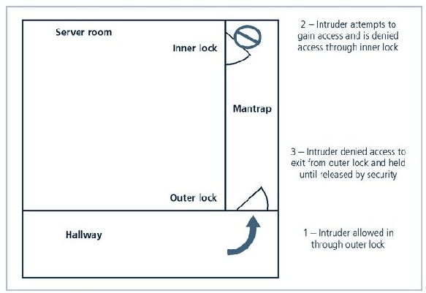
Mantraps are an easy way to secure areas that are crucial to the business’ operations. These rooms also tend to have expensive hardware in them, such as servers. Mantraps are “A small room or enclosure with separate entry and exit points, designed to restrain a person who fails an access authorization attempt” [4]. Below is an illustration of how a mantrap works:
Figure 1
This could be used in tandem with PIV to stop intruders from leaving the mantrap. This keeps the intruder and subsequently the threat contained and allows the company to call the police to deal with the trespasser. An alarm or camera could be installed within the mantrap to notify guards and employees of anyone stuck in the mantrap and allow them to deal with the situation appropriately.
Lastly and most obviously, a business should make use of alarms and alarm systems, as they are of use during non-work hours to help notify of the unwanted presence of an individual within the business. “Burglar alarms detect intrusions into unauthorized areas and notify either a local or remote security agency to react. To detect intrusions, these systems rely on different types of sensors, including motion detectors, thermal detectors, glass breakage detectors, weight sensors, and contact sensors.” [4]. This allows the business to quickly contain the threat and mitigate the damage to the business as much as possible.
B. Unforeseen Damage and Man-Made Errors
A business should also look to cover for any man-made errors within the business. As I said previously, a business cannot completely remove the errors we humans make as we are not robots. However, we can have steps in place so if mistakes do occur, the business is not hindered, and data is not lost.
As stated previously, alarms can be used within the business, but not just for intruders. Fire alarms can be used to not only warn employees and give them time to escape the building and/or put out any small fires, but also allows the business to enact any safety policies for ensuring damage to hardware and the data of the business in time before safely leaving the site, for example shutting off the network to stop any data transmission that could get suddenly stopped if power is lost which could cause data corruption.
Businesses should proactively be securing their devices and data in case of unforeseen and/or accidental physical damage. Donn B. Parker’s seven major sources of physical loss covers these:
“1. Extreme temperature: heat, cold
2. Gases: war gases, commercial vapors, humid or dry air, suspended particles
[6]
3. Liquids: water, chemicals
4. Living organisms: viruses, bacteria, people, animals, insects
5. Projectiles: tangible objects in motion, powered objects
6. Movement: collapse, shearing, shaking, vibration, liquefaction, flow waves, separation, slide
7. Energy anomalies: electrical surge or failure, magnetism, static electricity, aging circuitry; radiation: sound, light, radio, microwave, electromagnetic, atomic” [4]
Other sources could also be a sudden surge in electrical current to a PC, causing the computer to be damaged and its data possibly lost.
These risks are hard to mitigate as a lot of them are hard to predict and therefore hard to protect against. These do however statistically have a low chance of occurring when compared to the many other ways a business and its data can be harmed. Hardware nowadays also have built in protections to protect against these unforeseen risks, such as surge protection, thermal protection if a computers CPU reaches a certain temperature, etc… Since it is hard to protect against these sources of physical damage, it is critical that a business proactively has protections in place to secure a business and ensure its data is as safe as possible.
A business should use offsite backups in case of damage to the business data either to its hardware, or to an onsite backup if the business uses one. An offsite backup “is a method of digital data backup involving the use of a remote location as a means of securing data in the event of a disaster. Modern data backup employs the cloud, where a data copy is sent over a network to an offsite server.” [5] This ensures that if any of the mentioned unforeseen sources of physical damage occur, the business is equipped to get back up and running as quickly as possibly by using the offsite backups to restore any lost data.
Rooms with important data and equipment should also have walls that are firewall-grade. Not to be confused with a computer firewall, “A firewall is a fire ‐resistant structure which restricts the spread of fire and extends continuously from the foundation to or through the roof with sufficient structural stability under fire conditions to allow the collapse of the existing construction on either side of the wall to occur without allowing the collapse of the wall.” [7] It may be a good idea to put important equipment such as the server and/or the onsite backup in this room. If a fire was to then occur, the data of the business is as secure as possible from fire damage.
As stated previously, alarms can be used within the business, but not just for intruders. Fire alarms can be used to not only warn employees and give them time to escape the building and/or put out any small fires, but also allows the business to enact the proper safety procedure. The business should have systems in place to first detect fires. Once a fire is detected, the business’ fire alarm should sound warning employees of the danger and notify the authority of the fire hazard. Lastly, a Fire suppression system should be in place to suppress the fire. Sprinklers should be installed in rooms where possible, and where they are not, fire extinguishers should be present.
III. SECURITY TECHNOLOGY
“Technical controls are essential to a well-planned information security program, particularly to enforce policy for the many IT functions that are not under direct human control. Network and computer systems make millions of decisions every second, and they operate in ways and at speeds that people cannot control in real time. Technical control solutions, when properly implemented, can improve an organization’s ability to balance the often conflicting objectives of making information readily and widely available and of preserving the information’s confidentiality and integrity.” [4]
IT Technicians and Network Managers have many technical controls at their disposal to better protect a business’ data. These include the use of access control, Computer Firewalls, and VPNs.
A. Access Control
Firstly, “Access control is a security technique that regulates who or what can view or use resources in a computing environment. It is a fundamental concept in security that minimizes risk to the business or organization.” [8] We already discussed PACS earlier, but there is also logical access control, which “limits connections to computer networks, system files and data.” [8]. The 3 main types of access control include Mandatory Access Controls (MACs), Discretionary Access Controls (DACs), and Nondiscretionary Controls.
MACs “is a method of limiting access to resources based on the sensitivity of the information that the resource contains and the authorization of the user to access information with that level of sensitivity.” [11]
DACs “is a type of security access control that grants or restricts object access via an access policy determined by an object's owner group and/or subjects.” [12]. Nondiscretionary Controls are similar to DACs, the difference being that access controls are implemented by a central authority, rather than by the object’s owner group and/or subjects.
All Access Controls approaches mentioned will mainly consist of four elements. “Identification: I am a user of the system. Authentication: I can prove I’m a user of the system. Authorization: Here’s what I can do with the system. Accountability: You can track and monitor my use of the system.” [4].
Firstly, “Identification is a mechanism whereby unverified or unauthenticated entities who seek access to a resource provide a label by which they are known to the system. This label is called an identifier(ID), and it must be mapped to one and only one entity within the security domain.” [4]
Next, authentication is “a technique used to verify the identity of a user.” [9]. Authentication has 3 main factors taken into consideration. which are something you know, something you have, and something you are. This is also known as Multifactor Authentication (MFA).
First, something you know “relies on what the unverified user or system knows and can recall—for example, a password, passphrase, or other unique authentication code, such as a personal identification number (PIN)” [4] The password or pin shouldn’t be too complicated and long that the user would be unable to remember it without it being written down, but also should be so easy to guess that anyone that know the person could guess, for example a spouse favourite thing, DOB, etc… A good mix of letters, numbers, and one special character that is longer than 15 characters would be very secure.
Next, something you have “relies on something an unverified user or system has and can produce when necessary” [4]. Examples of this would be a card. There are two types of cards, a smart card, and a dumb card. A smart card “contains a computer chip that can verify and validate several pieces of information instead of just a PIN.” [4]. A dumb card on the other hand could include “ID cards or ATM cards with magnetic stripes that contain the digital (and often encrypted) user PIN, which is compared against the number the user enters.” [4]. One other example could be a fob which is also commonly used.
Lastly, some you are or can produce “relies on individual characteristics, such as fingerprints, palm prints, hand topography, hand geometry, or retina and iris scans, or something an unverified user can produce on demand, such as voice patterns, signatures, or keyboard kinetic measurements” [4] These are very secure as another employee will not have the same fingerprint or iris as a trusted employee with access. However, biometrics can often reject a trusted employee for a list of reasons, I.E. cheaper finger print scanner, poor positioning by the user, or dirty fingers to name a few.
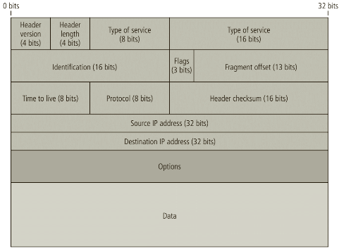
Moving on from authentication, authorisation “determines whether a user should be given access to data.” [9] Authorisation will usually use either an Access Control Matrix which “contains rows and columns. Rows represent the domain. It can be a user, process or a procedure domain. Columns, on the other hand, represent the objects or resources.” [10] or an Access Control List, which “refers to the permissions attached to an object that specifies which users are granted access to that object.” [10] When authorising a user, the system use either of these to determine the right and privileges of the user.
[4]
Lastly, accountability “ensures that all actions on a system—authorized or unauthorized—can be attributed to an authenticated identity. Accountability is most often accomplished by means of system logs, database journals, and the auditing of these records.” [4] System logs will record information such as “ailed access attempts and systems modifications. Logs have many uses, such as intrusion detection, determining the root cause of a system failure, or simply tracking the use of a particular resource.” [4]
B. Firewalls
Computer Firewalls are “a network security device that monitors incoming and outgoing network traffic and decides whether to allow or block specific traffic based on a defined set of security rules.” [13] A computer firewall can either be a separate piece of hardware, a piece of software, or both. Firewalls have four types of processing modes that define what type of firewall it is. These are:
Packet-Filtering
Application Layer Proxy
MAC Layer Firewalls
Hybrids
Firstly, packet-filtering firewall “examines the header information of data packets that come into a network.” [4] This type of firewall is installed and works on a TCP/IP based network and will function at the IP Layer. The firewall will determine whether to drop or forward a pack to its destination based on a set of rules defined by the user that are programmed into the firewall. The header of every incoming packet is examined and filtered by the firewall based on the header information. This includes information such as the “destination address, source address, packet type” [4] etc… Below shows a diagram of an IP Packets Structure:
Figure 2
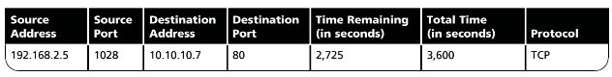
On top of scanning packets at the IP Layer of the TCP/IP protocol, it can also scan packets in the network layer of the OSI network model. Restrictions are set by the user for the firewall. If the firewall then finds a packet that matches one or more of these restrictions, it will stop said packet from travelling to its destination. Some restrictions commonly put in place include the “IP source and destination address” [4], the “Direction (inbound or outbound)” [4], the “Protocol, for firewalls capable of examining the IP protocol layer”, and “Transmission Control Protocol (TCP) or User Datagram Protocol (UDP) source and destination port requests, for firewalls capable of examining the TCP/UPD layer” [4].
[4]
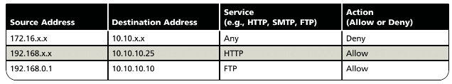
Below is an example of these restrictions within a firewall rule set:
[4]
Figure 3
This type of firewall allows the user to only allow packets from a set source IP address, Destination IP address and the service the packet is using. This is great for security, as this can ensure only packets from within the network, or packets from trusted addresses outside the network can be sent to the network whilst using a specific service. This minimises the chance of malicious packets being sent to the network, which could let an attacker gain access to the network and steal or remove company data.
There are three subsets of packet-filtering firewalls, which are different ways a packet-filtering firewall can enforce address restrictions to determine what packets can and cannot pass through the firewall.
Static packet filtering “requires that filtering rules be developed and installed within the firewall” [14]. Human intervention is required to make any changes to these rules. Dynamic Packet filtering however allows the firewall to “react to an emergent event and update or create rules to deal with that event. This reaction could be positive, as in allowing an internal user to engage in a specific activity upon request, or negative, as in dropping all packets from a particular address when an increased presence of a particular type of malformed packet is detected” [4].
Lastly, a Stateful Packet Inspection (SPI) uses a state table to keep track network connections between internal and external devices. A state is similar to the firewall rule set previously shown but includes more information. “A state table tracks the state and context of each packet in the conversation by recording which station sent what packet and when” [4].
Figure 4

SPI firewalls use packet filtering but takes the concept further, differentiating itself from the 2 previously mentioned subsets. An SPI firewall is able to expedite incoming pack in response to internal requests. “If the stateful firewall receives an incoming packet that it cannot match in its state table, it refers to its ACL to determine whether to allow the packet to pass.” [4].
Due to this, an SPI firewall requires additional processing to check packets against its state table. Skipping this processing altogether would leave the system and network vulnerable to either a Denial-of-Service attack (DoS), or a Distributed Denial-of-Service attack (DDoS). A DoS attack is where an attacker attempts to disrupt the normal flow of traffic of a network or server by “overwhelming the target or its surrounding infrastructure with a flood of Internet traffic.” [15] DDoS attacks are similar but make use of multiple compromised computers to send traffic to the network or server.
The next type of firewall processing mode is an application layer proxy firewall. An Application Layer Proxy firewall works “at the application layer of the TCP/IP protocol stack, providing proxy service for specific applications.” [16] This firewall is also capable at functioning as an application layer proxy server. An application proxy “provide one of the most secure types of access you can have in a security gateway. An application proxy sits between the protected network and the network you want to be protected from. [16]. This means that unlike packet filtering and SPI firewalls, there is not direct communication between the device on the network and the other communicating device. Packets instead travel between the external device and the proxy server. The packets are examined by the proxy to decide which packets are allowed to pass on.
This type of firewall will provide excellent security but can be a problem as each application needs its own proxy server to receive the security benefits. And since some software don’t allow or can’t use proxies, this is a solution for all applications.
The third firewall processing mode is the MAC layer firewall. This firewall operates at MAC layer, or Data Link layer of the OSI protocol. This enables the firewall to use a computers MAC address to decide what traffic can and cannot be sent to specific hosts on the network. “Using this approach, the MAC addresses the specific host computers are linked to ACL entries that identify the
specific types of packets that can be sent to each host, and all other traffic is blocked” [17]
Lastly, a hybrid firewall combines elements from the previous three firewall processing modes. For example, packet filtering and proxy services. A hybrid firewall may also “consist of two separate firewall devices: each is a separate firewall system, but they are connected so that they work in tandem.” [17]. Hybrid firewalls are great as not only do you get all advantages from each firewall processing method, but you can also upgrade the security of your firewall at any time to add packet filtering to the firewall for example, rather than having to completely change what firewall you are using.
With all these different types of VPN, how should a business go about deciding which is the best for them? First, they must decide which firewall offers the best bang for your buck. What protection does the company need, and how much they’ll have to pay to achieve that level of protection.
Second, they should check what features are included in the initial price of the firewall? And what features they’ll have to pay more for now and in the future. Third, they need to check how easy it is to set up the chosen firewall? If no one for the business can set up and maintain the firewall, then they will need to be trained to, which will cost time and money to do so.
Last and not least, can the firewall adapt to future expansions of the network? If not, this could cost more money in the long run. The most important point raised is the protection needs of the business, followed by the cost. The needs of the business should be put before cost, up to a certain amount, as for a lot of business, data is arguably invaluable.
C. Virtual Private Network (VPN)
A VPN is “an encrypted connection over the Internet from a device to a network. The encrypted connection helps ensure that sensitive data is safely transmitted.” [18]. This prevents hackers from eavesdropping on the traffic being sent to and from a device. This is great for employees who wish to work remotely as their connection will be encrypted, protecting the user and the business’ network from hackers. This basically allows a business network to be extended remotely whilst keeping the network secure.
A VPN will do the following three things to ensure the device and its connection are secure:
Encapsulation – Encapsulate “incoming and outgoing data, in which the native protocol of the client is embedded within the frames of a protocol that can be routed over the public network and be usable by the server network environment.” [4]
Encryption – Encrypt “incoming and outgoing data to keep the data contents private while in transit over the public network, but usable by the client and server computers and/or the local networks on both ends of the VPN connection.” [4]
Authentication – “Authentication of the remote computer and perhaps the remote user as well. Authentication and subsequent user authorization to perform specific actions are predicated on accurate and reliable identification of the remote system and user.” [4]
This allows the user to turn the internet into their own private network. VPNs have two modes at their disposal. The first being Transport Mode.
“Transport mode encapsulation retains the original IP header. Therefore, when transport mode is used, the IP header reflects the original source and destination of the packet. Transport is most often used in a host-to-host scenario, where the data endpoints and the security endpoints are the same. A transport mode encapsulated datagram is routed, or transported, in the same manner as the original packet.” [19]. This means the user can establish a secure connection with a remote host directly and only encrypt the data. However, this means hackers can still see the destination of the packet, and from there could try and compromise the device the computer is communicating to instead to get the encrypted data/
Tunnel mode however “builds a new IP header containing the source and destination address of the security endpoints. When tunnel mode is used, the outer IP header reflects the source and destination of the security endpoints, which might or might not be the same as the original source and destination IP address of the data connection.” [19]. This means a hacker cannot identify the destination for the packet
Conclusion
In conclusion, I think I have described in detail some important data security techniques that businesses have at their disposal, and why their importance in the modern digital age where keeping data secure is key. I have also used both references and diagrams to back up my claims, and to better describe and visualise these data security concepts.

Task 2

1. Introduction
For this task, I shall design a new information security unit for a fictional company named FlowTech. To do this, I shall discuss how to approach designing the security unit, including factors such as risk management, physical security, and security technology.

2. FlowTech
FlowTech are a fast-growing threat intelligence and consultancy company that specialises in combating and mitigating cyber-attacks. With this is mind, FlowTech must ensure that they can keep theirs and their customers information safe from hackers. To do this, I shall explain some of the key factors that FlowTech should consider in their Information Security Unit, as well as explaining how FlowTech can implement their new Information Security Unit with these factors in mind.
In basic terms, information security “is not only about securing information from unauthorized access. Information Security is basically the practice of preventing unauthorized access, use, disclosure, disruption, modification, inspection, recording or destruction of information.” [20]. When designing an Information Security Unit, or just generally deploying information security for a business there are 3 objectives to keep in mind. These are Confidentiality, Integrity and Availability (CIA).
Confidentiality “means information is not disclosed to unauthorized individuals, entities and process.” [20]. This means keeping password secure and disclosed from those who should not have them for example. Integrity is all about “maintaining accuracy and completeness of data. This means data cannot be edited in an unauthorized way.” [20]. This means keeping data restricted and only accessible and/or modifiable by those who should have access. It also means we should keep data up to date, as there is less reason to protect our data if it is out of data and/or unusable. Availability is self-explanatory. Information needs to be accessible when required by the business or customer. CIA should always be kept in mind when updating and changing a business’ Information Security policies, so those using the data are not effectively negatively with new changes to information security.

3. Risk Management
Risk Management “Is a combination of on-going profiling, assessment, evaluation, mitigation, validation, and monitory activities throughout the lifetime of any critical resource.” [21]. Risk management involves three major steps. These are identifying a risk, assessing how big of a risk it is, and then how to control said risk. This can be shown below:

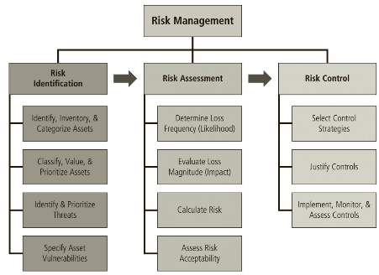

[4]

3.1 Risk Identification
Before we can deal with a risk we need to know of its existence. Risk identification is “The recognition, enumeration, and documentation of risks to an organization’s information assets” [4]. Risk Identification involves figuring out what assets could be at risk. For FlowTech, this could be customer data, hardware such as servers, computers the company owns, etc… From here, FlowTech should figure out what are the potential threats that could occur to said assets and data. For example, malicious interaction from outside forces, such as hackers stealing and/or destroying data, or servers breaking down on FlowTechs network. Lastly, FlowTech should identify what vulnerabilities are present that would allow these said threats to occur. For example, out of date virus software that could allow a new virus to get into the network. They should also consider the likelihood of a vulnerability could affect the business, so they can better prioritise what threats to tackle first. After FlowTech completes their risk identification, they should move onto risk assessment.

3.2 Risk Assessment
Risk Assessment is “A determination of the extent to which an organization’s information assets are exposed to risk.” [4] Risk assessment can be done by first calculating the risk an asset has: Risk = loss frequency x loss magnitude + an element of uncertainty. This formula can then be used to create a ranked vulnerability risk worksheet, shown below:

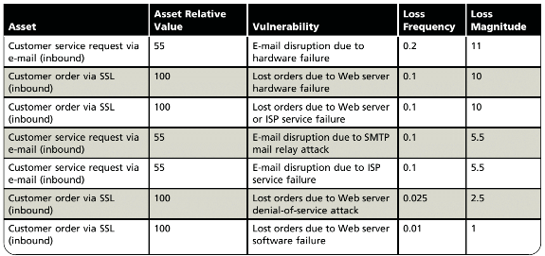
Loss frequency is an estimate of the likelihood that a vulnerability is to be successfully exploited. It is represented from 0 to 1.0 which is a representation of a percentage, from 0% to 100%. Loss Magnitude is calculated by multiplying the asset relative value by the loss frequency. After filling in the ranked vulnerability risk worksheet, FlowTech can use it to calculate risk, where Risk = loss frequency x loss magnitude + an element of uncertainty. Using this table, FlowTech can calculate what risks are of a higher risk, and plan to remove or control the associated risk.
[4]

3.3 Risk Control
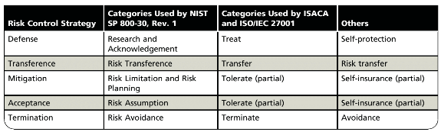
Risk control “involves three basic steps: selection of control strategies, justification of these strategies to upper management, and the implementation, monitoring, and ongoing assessment of the adopted controls.” [4]. After successfully prioritising its risks, FlowTech must choose a suitable strategy to control each of its risks. These strategies are summarised below:
[4]

3.3.1 Defence
The defence risk control strategy is a prevention strategy to prevent vulnerabilities from being exploited. This involves countering threats to a risk, limiting who can access assets, removing any vulnerabilities from an asset, and putting protective safeguards in place. Three common methods to achieve this strategy include:

“Application of policy
Education and training
Application of technology” [4]

3.3.2 Transference
Risk transference “involves shifting the risk to an entity that you perceive to be more resilient or better equipped to handle the situation.” [22]. Some methods to transferring risk include outsourcing to other business/organisations, as well as implementing service contracts with them, revising deployment methods and buying and making use of insurance.

3.3.3 Mitigation
Mitigation is important when defence is not an option. If vulnerabilities cannot be prevented or to a good enough standard, mitigation can be used to reduce the impact an expected attack. Mitigation involves the use of three contingency plans that are to be acted upon once an attack is successful, or whilst it is in progress.

Mitigation - Incident Response Plan
The incident response plan is initiated whilst an attack is currently in progress and enables a business to take action that is either predefined or reactive depending on the current circumstances.

Mitigation - Disaster Recovery Plan
This plan takes place after an attack is successful, and includes all preparations for the business to follow after a successful attack, as well as steps to limit damage during the attack.

Mitigation - Business Continuity Plan
The business continuity plan is the most calculated and long-term plan available. This plan includes a step-by-step plan to ensure the business can continue if an attack is too dangerous to properly combat and mitigate with the Disaster Recovery Plan. This can involve the relocation of critical business functions that may have been affected by the attack to other sites.

3.3.4 Acceptance
Acceptance is simply choosing to take no action to combat threats and vulnerabilities. This strategy is usually employed if either the chance of an attack is improbable, or if the cost to secure an asset is valued significantly higher than the asset it is meant to protect.

3.3.5 Termination
Termination involves getting rid of assets or stopping business activities that introduce uncontrollable risks, when said assets or activities do not provide more benefits than said risks.

3.4 The Use of Risk Management for FlowTech
Risk management is a great infosec tool for FlowTech to use, as it allows them to first gauge how secure their business and their assets are, to rank risks from most a threat to least, and then allows them to plan and take the necessary steps to deal with the biggest risks first and foremost. It’s a great starting point for any business to identify flaws with their existing data security and allows them to iron out these flaws before moving on to more specific infosec tools.
To implement risk management into their business, FlowTech should first identify their risks. To do this, they should identify and categorise their assets, and figure out their values. From here, they should identify the threats to each of their assets. After doing this, FlowTech should perform a risk assessment. This allows them to judge and rank the risks their business and assets have from most at risk, to least likely to be at risk. To do this, they should perform a risk calculation, using either risk calculation method stated previously. Ideally, if possible they should perform the more scientific method by actually calculating risk. If this is not possible however, the other method which doesn’t use actual values is also viable. After doing this, they can then rank their risks from most important to least, and decide which risks are acceptable to leave as is. Risks should only be deemed acceptable if the cost of removing the risk is more valuable than what it would cost the business if the risk was taken advantage of by an attacker.
Lastly, they should decide how they are going to control their risks. To do this, they should select controls for each risk and justify why they have chosen these controls for their associated risks. After this, they should implement these controls. Continuing to monitor and assess these controls aster implementation is also key, as it allows them to know if these controls are successfully working to mitigate the risk, and whether another control should be implemented and/or if a control is even still needed if the risk has gone down in priority.

4. Physical Security
As explained in part 1 of this paper, physical security refers to the security of the business location, as well as the physical equipment the business owns, as well as the data and software stored on the equipment. According to IBM Securities Cost of a Data Breach Report, 10% of malicious data breach root causes were due to physical security, shown below:
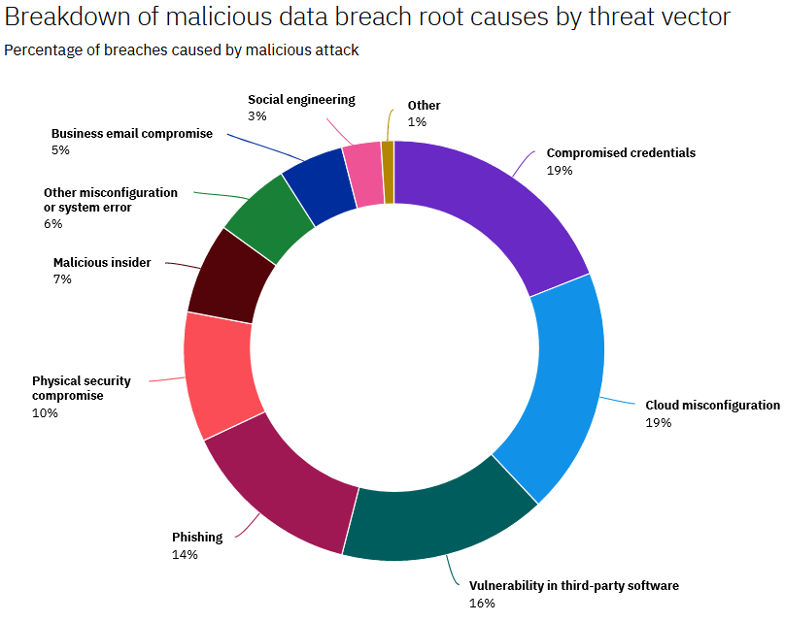
This means FlowTech should look to secure their business physically.
[23]

4.1 The Use of Physical Security to FlowTech
As physical security is a broad security tool, implementing all security tools within it would be far too time consuming and expensive. Instead, a business such as FlowTech should take its size and worth into account before deciding how they will secure themselves physically. Regardless of the business size however, FlowTech should make use of physical access controls.

4.2 Physical Access Controls
Most business, FlowTech included should give its employees PIV (Personal Identity Verification) Credentials, as this is a great base to implementing further physical access controls. PIV Credentials allow employees to verify their identity to people within the business, and to rooms of the business that would require them to do so. Using PIV Credentials allows FlowTech to implement both an access point to the business site, and key card readers to rooms with access to both important tech and data. The use of an access point would allow FlowTech to control who can access the site, and stops criminals from entering the site as easy, as they would not have the PIV Credentials required to gain access. An access point also allows FlowTech to monitor who enters the site at what times. This means that if something was to happen at the site, FlowTech can tell who was and wasn’t on site at the time of the event. Key card readers work similarly to access points as they restrict who can enter a room, as if you do not have PIV Credentials, access will be denied to the room. This means that if a criminal was bypass the access point, they would still require a key card to enter valuable rooms anyway, further increasing the physical security of FlowTechs business site.
Lastly, FlowTech should have an alarm system in place. These are very useful during non-work hours as they can help notify authorities and employees of unauthorised access to the business site. The use of alarms would notify FlowTech of the attempted attack and allows them to control and mitigate the threat quickly with the help of the authorities.
Physical Access Controls are great, as they would allow FlowTech to better control and monitor the flow of people in and out of the business, and helps to prevent the unauthorised access of criminals on the site, and if this fails, warns FlowTech of their attempted attack/theft and allows them to better deal with the situation as it develops, and mitigate the damage to the site.

4.3 Unforseen Damage and Ways of Combating it
Physical Access Controls are not the only way FlowTech can secure their business physically. Unforeseen damage, like Natural or man-made disasters are a risk to a FlowTech. However, the likelihood of these occurring is quite low. With this in mind, it would be very cost inefficient for FlowTech to physically secure their site from each of these disasters specifically. Instead, FlowTech should use an all-encompassing method so if these unforeseen accidents do occur, FlowTech can handle and recover from them quickly.
A great way of doing this is by using an offsite backup. An offsite backup allows FlowTech to have a separate location for storing their data. If anything was to then happen to the business site and its data, FlowTech would be able to still access their data from the offsite backup. This is a great way to combat unforeseen damage, as it allows FlowTech to recover lost of data the business needs, and allows business operations to start up again faster after a disaster. Another great way to combat unforeseen damage is the use of alarms. As I have recommended that FlowTech make use of an alarm system for detecting unauthorised acces, it would be much easier for them to integrate a fire alarm system as well. This would notify employees of the danger, allowing them to either deal with the fire quickly with the use of onsite fire extinguishers, or to give them enough time to exit the building if the fire is already out of hand.

5. Security Technology
As quoted in part 1, “Technical controls are essential to a well-planned information security program, particularly to enforce policy for the many IT functions that are not under direct human control. Network and computer systems make millions of decisions every second, and they operate in ways and at speeds that people cannot control in real time. Technical control solutions, when properly implemented, can improve an organization’s ability to balance the often conflicting objectives of making information readily and widely available and of preserving the information’s confidentiality and integrity.” [4] I recommend that FlowTech make use of two of these technical controls, these being logical access controls and firewalls.

5.1 Logical Access Controls
Logical access controls are similar to physical access controls, and are used to regulate who and what can use and/or view resources within a computing network or environment. FlowTech must first decide which type of access control to use. As discussed in part 1, these are MACs, DACs, and Nondiscretionary Controls. Each of these methods involve four elements. These are “Identification: I am a user of the system. Authentication: I can prove I’m a user of the system. Authorization: Here’s what I can do with the system. Accountability: You can track and monitor my use of the system.” [4]. Logical Access controls are great for restricting who can access important data within FlowTechs computer network and can help stop unauthorised parties from viewing and modifying these important files. It can also be used in tandem with physical access controls, specifically with fingerprint scanners and card readers, as an employees PIV credentials or fingerprint can be used to determine whether or not they can access a specific room, for example a server room. This means only higher ups, such as the network manager should be able to access this room, limiting the possibility of damage or theft of property and data from these rooms.

5.2 Firewalls
Firewalls are a type of security technology that monitors both incoming and outgoing traffic on a computer network, and decided to allow or block network traffic based on a defined rule set. A computer firewall can be either software or hardware. As described in part 1, firewalls have four types of processing modes, which are:
Packet-Filtering
Application Layer Proxy
MAC Layer Firewalls
Hybrids
Deciding which processing mode is dependant on four factors, these are cost-effectiveness for the protection FlowTech needs, what features are included in the initial price, how easy or difficult it is to set up, and can it adapt to future expansions of FlowTechs computer network. Firstly we can rule out the difficulty of setting up the firewall as a factor, as FlowTech are a fast-growing threat intelligence and consultancy company, and should employ someone who is already capable of managing computer networks and firewalls. FlowTech should consider a hybrid firewall.
Hybrid Firewalls combine elements from all the other 3 processing modes, meaning it will match the security needs of FlowTech as since they are a threat intelligence and consultancy company, I would argue they need to be secure which a hybrid firewall will help to achieve. It is also great for future expansion, as you can upgrade the firewall at any time to add any security features they may need in the future, which means the computer firewall can adapt to FlowTech fast growth. They are also arguably more cost effective in the long run, as instead of having replace the whole firewall if new security features are needed, they can instead just upgrade the existing hybrid firewall. Firewalls are a great way to monitor network traffic, and stop attacks before they can even be attempted which can be crucial to securing a business’ data, and even more critical for a business Like FlowTech that handles threat intelligence and consultancy. If they were to be on the receiving end of an attack sent through the network, many customers would lose FlowTechs services, leaving them potentially vulnerable as well, so stopping malicious data accessing FlowTechs network in the first place is crucial.

6. Conclusion
I believe for part 2 I have designed a new information security unit for FlowTech that would enable them to keep their information secure and their business operations running smoothly in case of an attempted attack using a mix of risk management, physical security, and security technology. If the security tools mentioned were unable to prevent an attack on FlowTech, then I have also outlined ways of which FlowTech can mitigate and recover from damage caused by these attacks, by using fire alarms, offsite backups, and contingency planning for any assets they deem necessary within their risk control.

Reference List
[1] NCES, “Protecting Your System: Physical Security”, nces.ed.gov, [Online] Available: https://nces.ed.gov/pubs98/safetech/chapter5.asp [Accessed Nov. 17, 2021]
[2] Openpath, “Understanding physical access control systems”, openpath, [Online] Available: https://www.openpath.com/blog-post/physical-access-control [Accessed Nov. 17, 2021]
[3] FICAM Playbooks, “What Is a Physical Access Control System?”, playbooks.idmanagement.gov, [Online] Available: https://playbooks.idmanagement.gov/pacs/what-is-pacs/
[4] M. E. Whitman and H. J. Mattord, Principles of Information Security, 6th Edition, Georgia: Kennesaw State University, 2018 [E-Book]
[5] SIRKit, “The Importance of Offsite Backups for SMBs”, sirkit.ca, March. 11, 2021. [Online] Available: https://www.sirkit.ca/the-importance-of-offsite-backups-for-smbs/
[6] SlideToDoc, “Physical Security”, slidetodoc.com, [Online] Available: https://slidetodoc.com/introduction-physical-security-addresses-the-design-implementation-and/
[7] D. M. Stuart, “Understanding Firewall Basics”, phdonline, 2016. [Online] Available: https://pdhonline.com/courses/g125/g125content.pdf
[8] B. Lutkevich, “Access Control”, techtarget, [Online] Available: https://www.techtarget.com/searchsecurity/definition/access-control
[9] IT Governance, “Cyber Essentials: Access Control & Administrative Privilege Management”, itgovernence.co.uk, [Online] Available: https://www.itgovernance.co.uk/access-control-and-administrative-privilege [Accessed Nov. 20, 2021.]
[10] Lithmee, “What is the Difference Between Access Control List and Access Control Matrix”, PEDIAA, Dec. 14, 2018. [Online] Available: https://pediaa.com/what-is-the-difference-between-access-control-list-and-access-control-matrix/
[11] IBM Corporation, “Mandatory access control (MAC) “, ibm.com, 2015. [Online] Available: https://www.ibm.com/docs/en/zos/2.2.0?topic=environment-mandatory-access-control-mac
[12] Techopedia, “Discretionary Access Control (DAC)“, techopedia.com, [Online] Available: https://www.techopedia.com/definition/229/discretionary-access-control-dac
[13] Cisco, “What Is a Firewall”, cisco.com, [Online] Available: https://www.cisco.com/c/en_uk/products/security/firewalls/what-is-a-firewall.html
[14] The University of Auckland, “3 subsets of packet filtering firewalls “, Course Hero, [Online] Available: https://www.coursehero.com/file/pacc2e/3-subsets-of-packet-filtering-firewalls-Static-filtering-requires-that/
[15] Cloudflare, “What is a DDoS attack?”, cloudflare.com, [Online] Available: https://www.cloudflare.com/en-gb/learning/ddos/what-is-a-ddos-attack/
[16] R. Cameron, B. Woodberg, M. K. Madwachar, K. Swarm, N. R. Wyler, M. Albers, R. Bonnell and J. L. Harrington, “Networking, Security, and the Firewall” and “Security Issues”, ScienceDirect, 2007. [Online] Available: https://www.sciencedirect.com/topics/computer-science/application-proxy
[17] DocsBay, “MAC layer Firewalls”, docsbay.net, 2018. [Online] Available: https://docsbay.net/iii-mac-layer-firewalls
[18] Cisco, “What Is a VPN? - Virtual Private Network “, cisco, [Online] Available: https://www.cisco.com/c/en/us/products/security/vpn-endpoint-security-clients/what-is-vpn.html#~how-a-vpn-works
[19] IBM Corporation, “Transport mode and tunnel mode “, ibm.com, 2015. [Online] Available: https://www.ibm.com/docs/en/zos/2.2.0?topic=encapsulation-transport-mode-tunnel-mode
[20] GeeksforGeeks, “What is Information Security?”, geeksforgeeks.org, Oct. 31, 2021. [Online] Available: https://www.geeksforgeeks.org/what-is-information-security/
[21] E. Wheeler, Security Risk Management: Building an Information Security Risk Management Program from the Ground Up, Syngress, Apr. 20, 2011. [E-Book]
[22] Chartered Accountants, “Five Effective Risk Control Strategies”, cuaccountants.co.nz, March. 15, 2019. [Online] Available: https://cuaccountants.co.nz/five-effective-risk-control-strategies/
[23] IBM Security, “Cost of a Data Breach Report 2020”, capita, 2020. pp. 36, [Online] Available: https://www.capita.com/sites/g/files/nginej291/files/2020-08/Ponemon-Global-Cost-of-Data-Breach-Study-2020.pdf

