Target 1 | To make sure that I proofread my work before uploading
Target 2 | To ensure that my referencing is correct, by using the Harvard referencing handbook for guidance
Target 3 | To critically evaluate throughout this assignment
Target 4 | To use current and reliable sources

How a school develops one aspect of its SDP: a report that critically reflects on the actions, impact and evidence base.

During my Professional Teaching Experience (PTE), I was placed in School A. At the time of their Estyn (2017) inspection, it was stated that the school had seven mixed-age classes and two specialist teaching facilities (STF) with students with moderate-severe learning difficulties. The percentage of pupils with additional learning needs is above the national average, 38%. Furthermore, as the catchment area is larger due to the STF, the number of pupils receiving free school meals is 23%, which is slightly higher than the national average (Estyn, 2017). As a part of this report, I will be critically looking at making a School Development Plan (SDP) and the different elements which make it a tool for school improvement. After speaking to the Headteacher, the school felt that their major priority was to improve reading standards throughout the school. I have chosen this as my aspect to explore.

When forming an SDP, it is important to understand that it is a strategic improvement plan (Department of education, 2020). However, the Headteacher is responsible for implementing actions and planning (Welsh Government A, 2016). The Department of Education (DoE) (2020) insists that the responsibility of the SDP must be with the whole school, as they have the best insight into the areas in most need of development. This demonstrates that the Welsh Government would expect the Headteacher to have the overall decision with strategies being put in place. The implementation of an SDP is essential to ensure school improvement. Schmoer (1999) stated that there needs to be a broad agreement within the school that measuring student progress and setting goals are fundamental to ensure development. In 2015, it was made statutory that all schools need to have an SDP with a 3-year plan (Welsh Government A, 2016). This highlights that the Welsh Government wants schools to have long-term goals to show real progression and development. When speaking to the Headteacher, she emphasised that reading was identified as an issue due to the school having a small population and two STF units onsite. However, she still wanted to ensure that it became a whole-school priority. My chosen aspect is reading within school A. Using the cross-curricular skills framework highlighted that phonological and phonemic awareness is an important skill to have when learning to read (Welsh Government, 2019). By practising these skills, the individual will begin to discriminate between different sounds, blend sounds and develop a knowledge of written and spoken words. Furthermore, the cross-curricular skills framework discusses how higher-level reading skills such as understanding, response and analysis, are the signs of a high-level reader (Welsh Government, 2019). Therefore, strategies which can encourage punctuation development, understanding of vocabulary and recalling events and reasons within text are essential.
The strategy which school A chose is ERIC reading. ERIC reading stands for: Explain meaning of words, Retrieve e.g. how many items in…? Interpret e.g. Why do you think the character has done this? Choice e.g. Why has the author done this? (Wilson, 2016 and Kirby Hill, 2021). Conversely, Greenhill (2019) disagreed and stated that ERIC stands for “Everyone reading in class”. This suggests that each school may have a different interpretation based on their pupils. Unfortunately, I was unable to be a part of this during my PTE, but I observed the differentiated questioning, and the pupils increased confidence. Kirby Hill Primary school (2021) decided to use DERIC, which is very similar to School A’s approach. However, the letter D stands for Decode as they want to focus on phonics and sounding out words, which was supported by Welsh Government (2019). Kirby Hill (2021) continue by demonstrating that DERIC is with the whole class, which includes differentiated questioning and targeted communication. However, they also implement independent reading as well as reading at home. This additional practice will promote independence as well as positive relationships between parents and the teacher. Similarly, Greenhill (2019) reinforced this by publishing their ERIC guidance, where they firstly promote independent reading within the classroom. The pupils would be expected to complete activities with specialised resources. The pupils will then be involved in an adult-led conversation before finally responding to the text in a class discussion. One strength of DERIC reading within Kirby Hill (2021) is that they encourage reading different texts, in a cross-curricular manner. Furthermore, reading fiction and non-fiction texts will allow them to access the wider curriculum and broaden their vocabulary and imagination. Bruner (1966) disagreed with the constructivist view as he believed that learning is an active process that needs prior knowledge when facing new ideas, and only when this happens does new learning take place. As Bruner is a behaviourist so, therefore, he believed that language was centrally important. Besides, pupils need to have the time and opportunity to develop their understanding and prior knowledge. However, there is a risk of over prioritising one aspect; Bruner (1966) felt that learning should be active and practical. However, if a school focussed on reading independently heavily, the pupils would miss out on practical discussions. Supporting this, Gamble (2020) spoke about the 4XR project, which conducted lesson observations. However, one of the initial conclusions was that pupils had little opportunity for the exploratory talk, which meant that the pupils understanding was underestimated, so time management should be carefully planned to avoid rushing. Another strength of ERIC reading shown in Kirby Hill (2021) was that whole class reading lead to rapid progression within lower-ability pupils due to higher-order questions. Providing picture stimulus with a comprehension focus can support additional learning needs (ALN) and English Additional Language (EAL) learners. However, I could not see this in school A, as the class focused on reading different types of text with an adult. Conversely, Gamble (2020) suggested that after the observations, the teachers involved were told they needed to create a more structured exploratory talk to assess the pupils understanding and encourage participation.

School A’s SDP was made in 2019, and they were unable to update it for this year due to the uncertain times of the COVID-19 pandemic (Appendix 1). However, when I conducted an informal conversation with the Headteacher, she recommended that I focus on reading as a priority within the SDP (2019). The target I am going to be looking into to is within priority 2:
“develop curriculum – attainment, assessment and use of tracking procedures” p4.
This priority investigated the strategies to develop reading within the school and assess this. In the SDP (2018), their target was to update their assessment tracking for the pupils reading age following the National tests (Appendix 2). Therefore, in the SDP (2019), the target is to review how the staff deliver reading and introduce a strategy that develops independent, confident readers and higher learner outcomes. This new strategy is the ERIC reading which takes place twice weekly (Appendix 1).
Within the SDP, it is a form of strategic planning. It helps the school to reach its goals and produce a future-focused vision (Driscoll, 2016). Every strategic plan needs to be collaborative to ensure that the community and students can get involved. It will need to be practical both financially and contextually to ensure all circumstances are tailored (Driscoll, 2016). The production of an SDP is all about self-evaluation, as specified by the DoE (2020) who emphasised that it was the school’s responsibility to organise this strategic plan. Furthermore, they also reinforced that the schools needed to self-evaluate to levels of sustained school improvement (DoE, 2020) This is reiterated when Welsh Government A (2016) demonstrated that the schools would be expected to self-evaluate student achievement, performance data, compare with local schools and consider national priorities before making the SDP. This demonstrates the high levels of commitment and suggests that the prior knowledge and expertise surrounding the school’s performance are essential (Welsh Government A, 2016).
Within this source, I believe that there are several similarities within school A. However, this source was made for HR management which suggests that its reliability may not be fully relevant (Creighton, 2019). When it comes to self-assessments, within an establishment, it is important that individuals feel they have ownership surrounding their work, to recall tasks and state improvement and successes. However, perceptions can be deceiving and different from what occurred, so self-assessment can be too subjective (Creighton, 2019). Self-assessment is very important as it provides managers with valuable insight, possibly to the standard of teaching or performance levels. This will help the senior staff to develop leadership skills and understand what is going on in the school (Creighton, 2019). Contrastingly, self-assessment can lack validity as some employees may find it difficult to attain their objectivity and may overestimate their performance. Therefore, the Headteacher would need to set performance objectives so that teachers can measure themselves against them (Creighton, 2019). Self-assessment within education is a key strategy to ensure continuous professional development; this ensures that teachers are regularly critical of their practice (Järvinen-Taubert, 2020). Moreover, self-evaluation does present some issues as it can be time-consuming and different assessment criteria could be confusing (Chan, 2010).
When approaching data analysis within education, there is often a lack of formal training in dealing with data analysis. This suggests that staff members may feel overloaded when trying to conclude from different data sets (Learning Point, 2004). Therefore, teachers require a data-driven process to make well-informed decisions. According to Learning Point (2004), there are four steps to initiate school improvement. The first step is to prepare for data exploration to ensure there is a positive data culture, within the school to identify goals and reflection. This is reinforced by Halcomb (1999), who believed that looking at data for an SDP should not be rushed and be a gradual process. The second step is to collect and organise the data. They will mainly concentrate on achievement data, focusing on standardised test scores, classroom assessment and information on learning (Learning Point, 2004). The third step is to analyse the data by using a data retreat approach by setting aside a whole day to examine data and gather materials of student achievement data. This suggests that the SDP needs to be strategically and meticulously planned to ensure all conclusions drawn are correct and accurate. The final step is to explain the results to stakeholders and staff members in a meeting where they generate a hypothesis and action plan by evaluating the data (Learning Point, 2004).
When measuring impact, it can be done in several ways. One way to measure impact is through test-based scores and information on the standard of learning and holds schools accountable (Masters, 2012). Furthermore, in the United States of America (USA), they use test scores to measure their school’s performance and accountability. When measuring the impact of a strategy like ERIC, there may be some unintended consequences, such as clarifying standards of what is needed to achieve (Masters, 2012). On the other hand, Hamilton (2004) found in a piece of research that classroom incentives will result in surface-level responses. Therefore, from the teacher’s perspective, short-term gains were at the expense of deeper long-term improvements. These unintended consequences highlighted that the teacher needs to be aware of surface-level replies. Also, this was found in a study in the USA, as they found that large gains from important reading tests were not reflected as an ‘improvement’ within their reading levels (Koretz and Barron, 1998). This suggests that within the ERIC reading program assessments, all forms of measuring impact should show the same level of improvement to display the actions taken. When creating an SDP, it is important to consult with all stakeholders and the community. In article 13, the 1998 Education Order stated the duty of the governors is to manage and revise the development of the SDP (DoE, 2020). Furthermore, Welsh Government A(2016) similarly mentions that the governing body should monitor and revise progress made as Estyn will review it. This suggests that the school needs other perspectives to see whether the SDP is accurate. This is supported by Welsh Government A (2016) who emphasised that the school should consult registered pupils, parents and governing bodies before publishing. The importance of all stakeholders is emphasised when perception data can only be examined when all stakeholders are satisfied with the statements and goals, emphasising that it is a collaborative approach as stakeholders can help reduce blind spots (Learning point, 2004).

As a part of their way to find a solution to improve reading standards within the school. They decided to implement a Building Blocks system and collaborate with another school to develop a bespoke tracking system. However, the SDP (2018), they admit that the teaching staff had to refamiliarize themselves with the system, due to the introduction of the Curriculum for Wales and found that the system was not then fulfilling the requirements (Appendix 2). This implies that the school could identify when a strategy was unsuitable and decide collaboratively between the staff and stakeholders that it needed to be replaced. In the SDP (2019), it was stated that after reviewing the standards of teaching in reading and spelling, there needed to be a new approach which was to introduce ERIC reading (Appendix 1). I was able to see for myself in the Year 3-4 classroom that many pupils benefited from having that one-to-one support from a teacher and reading both fiction and non-fiction made the pupils excited about reading. While the class teacher and the teaching assistant were reading with pupils individually, I was interested that the rest of the class were put into groups, in a carousel, to read magazines, word searches and word problems which allowed them to practice additional reading skills independently. One strategy that I would implement in my own practice would be to incorporate differentiated group work into the carousel, which would administer the More Knowledgeable Other (MKO) (Vygotsky, 1978). The MKO would suggest that the more able pupils are able to reinforce their skills and scaffold learning for others whilst improving confidence and communication. Moreover, I briefly spoke to the Year 4-5 class teacher about their ERIC reading routine, and it was very independent. The pupils knew the routine well and, the teacher had the opportunity to work with lower ability pupils who needed more scaffolding. Within the SDP (2019) and a conversation I had with the Headteacher, she spoke about how, as a result of the ERIC reading program, there were regular progress meetings to monitor all pupils discussing the reading assessments twice a year. This highlights that school A is data-driven and wants to have the evidence to justify any decisions made to meet their goals. Within this conversation, the Headteacher emphasised the impact that the teachers found was impressive as pupils had more confidence surrounding their reading. There was more consistency for assessing reading and establishing a positive reading routine with two staff members twice a week. I would suggest creating a questionnaire for pupils to answer surrounding the ERIC reading approach to gain more feedback which can be transferred into quantitative data for the SDP. This questionnaire should propose both open and closed questions on the pupil’s opinion of their ability, confidence and enjoyment to understand their feelings towards about the approach fully. Mahmutovic (2020) re-emphasises the importance of receiving student feedback, but I must be aware that his statements are trying to get people to use his online survey tool. Mahmutovic (2020) suggested that questionnaires can reveal problems that teachers may be unable to identify, but he recommended making them anonymous so that pupils will be more forthcoming. In addition, he mentioned that a questionnaire might improve relationships with the community, as they paint a more accurate picture of pupils’ opinions and improve public opinion of the school (Mahmutovic, 2020).

As a part of this academic writing, I have had the opportunity to observe a reading strategy that I have not done before. ERIC reading provides pupils will comprehension skills to analyse and evaluate non-fiction and fiction texts which develops their overall literacy skills. I was able to see through observation the standards for success became higher with more expectation for independence. As a part of the SDP, the school was able to continuously reflect and monitor attainment to pinpoint the areas of development. They were able to identify when a strategy was not appropriate and took steps to find one compatible with the Curriculum for Wales. In my future practice, I would like to incorporate ERIC reading, alongside my group work suggestion, within my classroom as it improves confidence and skills within many other areas of learning and experience.

Reference List
- Bruner, J. (1966). Toward a Theory of Instruction. Cambridge, MA: Harvard University Press.
- Chan C. (2010) Assessment: Self and Peer Assessment, Assessment Resources@HKU University of Hong Kong (http://ar.cetl.hku.hk) Accessed: 20 April 2021
- Creighton, K., (2019). Pros and Cons of Employee Self-Assessments - HR Daily Advisor. [online] HR Daily Advisor. Available at: <https://hrdailyadvisor.blr.com/2019/04/01/pros-and-cons-of-employee-self-assessments/> [Accessed 2 May 2021].
- Department of Education, (2020). School Development Planning. [online] Education. Available at: <https://www.education-ni.gov.uk/articles/school-development-planning> [Accessed 10 April 2021].
- Driscoll, M., (2016). Future-focused strategic planning for schools: the ‘what’ and the ‘why’ need a ‘how’ - Think Strategic for Schools. [online] Think Strategic for Schools. Available at: <https://thinkstrategicforschools.com/strategic-planning-for-schools/> [Accessed 1 May 2021].
- Estyn, (2017). A report on Whitestone Primary School. [online] Estyn: Her Majesty's Inspectorate for Education and Training in Wales. Available at: <https://primarysite-prod-sorted.s3.amazonaws.com/whitestone-primary-school/UploadedDocument/a274edcb1fc54596867ca66e4559d134/whitestone-primary-school-estyn-report.pdf> [Accessed 1 May 2021].
- Gamble, N., (2020). 'Reading: whole class or small groups?': The problem with the question. — Just Imagine. [online] Just Imagine. Available at: <https://justimagine.co.uk/2020/06/07/reading-whole-class-or-small-groups-why-the-question-is-a-problem/> [Accessed 22 April 2021].
- Greenhill Academy, (2019). Greenhill Academy- ERIC Reading Session- Guidance 2019. [online] Greenhill.theharmonytrust.org. Available at: <https://www.greenhill.theharmonytrust.org/serve_file/423524> [Accessed 17 April 2021].
- Holcomb, E. (1999). Getting excited about data: How to combine people, passion, and proof. Thousand Oaks, CA: Corwin Press.
- Hamilton, L. (2004). Assessment as a policy tool. Review of Research in Education, 27, 25-68.
- Järvinen-Taubert, J., (2020). Self-assessment as a tool for teacher’s professional development. [online] Lesson App. Available at: <https://lessonapp.fi/self-assessment-as-a-tool-for-teachers-professional-development/> [Accessed 19 April 2021].
- Kirby Hill, (2021). The Teaching of Reading at Kirby Hill CE Primary School. [online] Kirbyhillprimary.org.uk. Available at: <https://www.kirbyhillprimary.org.uk/Curriculum/Reading/> [Accessed 1 May 2021].
- Koretz, D., & Barron, S.I. (1998). The Validity of Gains on the Kentucky Instructional Results Information System (KIRIS). MR-279-PCT/FF. Santa Monica, CA:RAND.
- Learning Point, (2004). Using Data to Guide School Improvement. North Central Regional Educational Laboratory, [online] (7), pp.1-14. Available at: <https://files.eric.ed.gov/fulltext/ED518630.pdf> [Accessed 20 April 2021].
- Masters, G., (2012). Measuring and Rewarding School Improvement. [online] Research.acer.edu.au. Available at: <https://research.acer.edu.au/cgi/viewcontent.cgi?article=1014&context=policy_analysis_misc> [Accessed 10 May 2021].
- Mahmutovic, J., (2020). Why Getting Student Survey Feedback is So Important. [online] SurveyLegend. Available at: <https://www.surveylegend.com/education/discounted-student-surveys-pricing-for-teachers-educators/> [Accessed 10 May 2021].
- Schmoker, M. (1999). Results: The key to continuous school improvement (2nd ed.). Alexandria, VA: Association for Supervision and Curriculum Development.
- Vygotsky, L. S. (1978) Mind in Society : the development of higher psychological processes. Cambridge, MA; London: Harvard University Press.
- Welsh Government, (2016) A. School Development Plans. [online] Gov.wales. Available at: <https://gov.wales/sites/default/files/publications/2018-03/school-development-plans.pdf> [Accessed 10 April 2021].
- Welsh Government, (2016) B. Chapter 28: School Development Plans. [online] Gov.wales. Available at: <https://gov.wales/sites/default/files/publications/2018-03/28-school-development-plans.pdf> [Accessed 10 April 2021].
- Welsh Government, (2019). Cross-curricular skills frameworks - Hwb. [online] Hwb.gov.wales. Available at: <https://hwb.gov.wales/curriculum-for-wales/cross-curricular-skills-frameworks> [Accessed 8 April 2021].
- Wilson, (2016). Free ERIC Starters to support Reading Lessons. [online] Miss Wilson says. Available at: <https://misswilsonsays.wordpress.com/2016/10/09/free-eric-starters-to-support-reading-lessons/> [Accessed 10 May 2021].

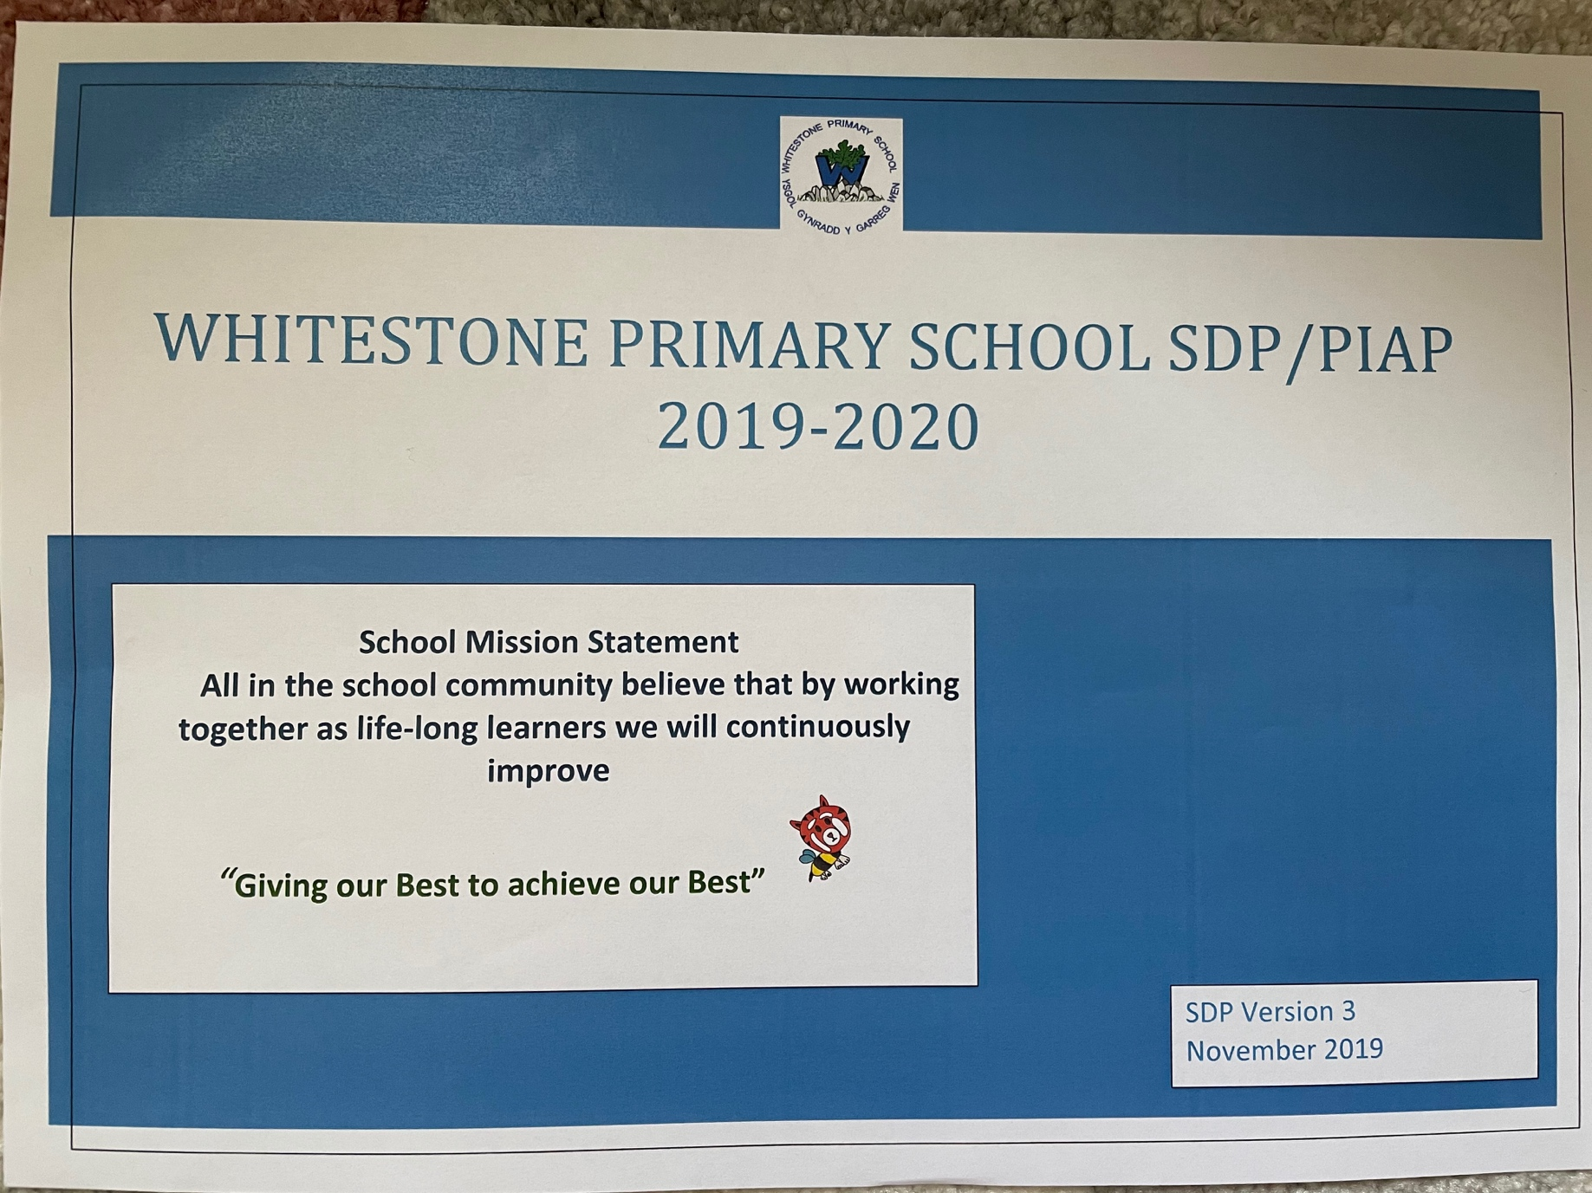
Appendix 1 – School Development Plan 2019

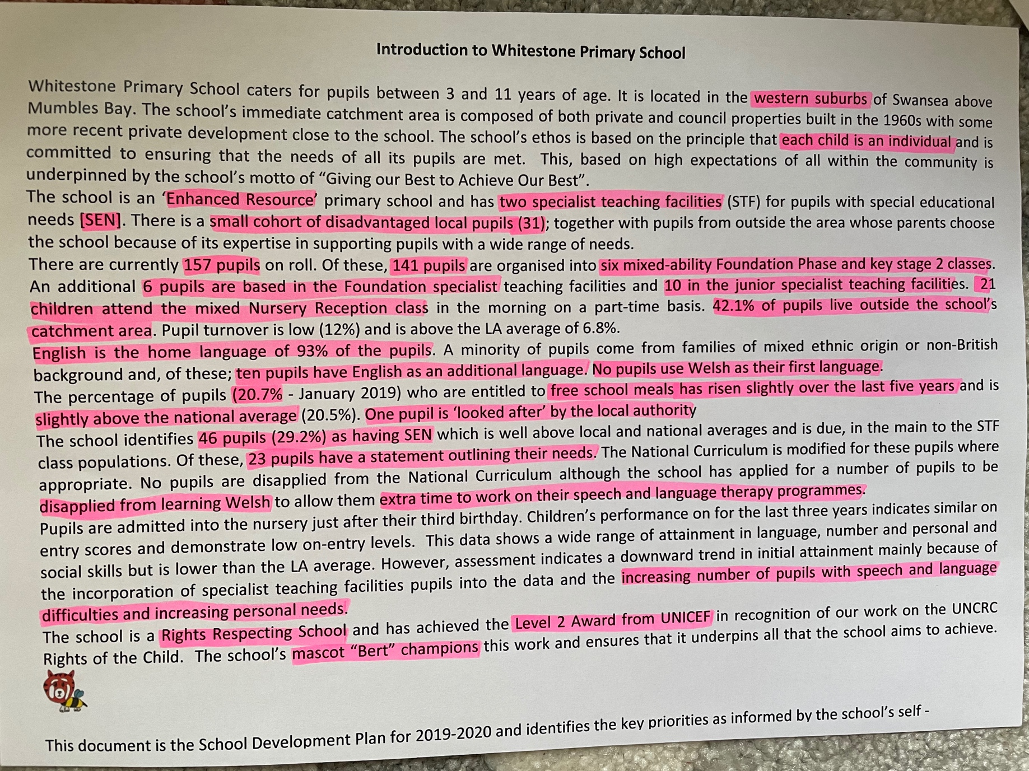

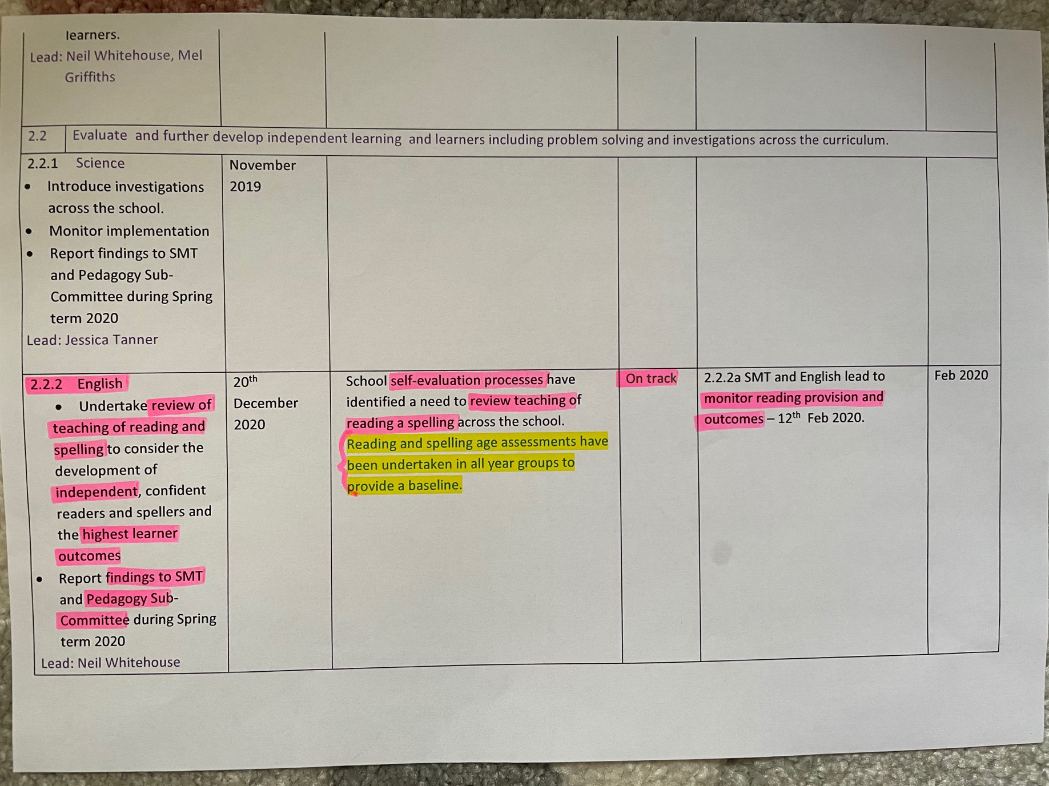

Appendix 2 – School Development Plan 2018


