University of Wales Trinity Saint David
Wales Institute of Science &Art

Application of Computer Aided Engineering Processes
Structural Design and Analysis (ACHA6010)

Owain Wilcox (2003601)
December 2023
Contents

1 Introduction 1
2 Literature & Analysis 2
3 Validation Examples 4
3.1 Cantilever Beam Bending 4
3.2 Bi-Metallic Strip 5
4 Methodology 7
4.1 Rigid Dynamics Study 8
4.2 Thermal Study and Piston Mesh Quality Study 8
4.3 Static Structural Study 12
5 Results and Analysis 13
5.1 Thermal Study Results 13
5.2 Static Structural Study Results 14
6 Conclusion 18
7 References 19

Equation 1: Element Stiffness Calculation 2
Equation 2: UDL Cantilever Beam Equation 4
Equation 3: Dimensionless Coefficient K1 Equation 6
Equation 4: Bi-Metallic Strip Deflection Equation 6

Figure 1: Linear spring diagram, (K. Lake, UWTSD) 2
Figure 2: Stiffness Matrix, (K. Lake, UWTSD) 2
Figure 3: UDL Cantilever Beam Validation 4
Figure 4: Bi-Metallic Strip Validation 5
Figure 5: ANSYS Workbench Studies 7
Figure 6: Ansys 20mm and 2mm Mesh Quality Graphs 9
Figure 7: Piston Mesh Quality by Element Number Graph 9
Figure 8: Piston Mesh Quality by Element Percentage Graph 10
Figure 9: Piston Element Quality 11
Figure 10: Manual Mesh 11
Figure 11: Thermal Stress Results 13
Figure 12: Piston Stresses 14
Figure 13: Piston Stresses - Adjusted Scale 15
Figure 14: Piston Deformation 16
Figure 15: Piston Stress and Deformation - No Thermal 17

Table 1: UDL Cantilever Beam Validation Mesh Sizes 5
Table 2: Bi-Metallic Strip Validation Mesh Sizes 6
Table 3: Engineering Data for Aluminium 6061-T6 7
Table 4: Piston Mesh Sizing 8

Introduction

This assignment revolves around optimising Ansys Workbench simulation models to produce accurate results. To ensure the software performs correctly, verification models will be made to compare the simulated results against calculated results. An iterative design process was used to simulate an aluminium 6061-T6 piston using dynamic, thermal, and static structural studies to analyse the stresses and deformation. The next objective was to redesign the piston with the intention of reducing weight without compromising the structural integrity. The iterative process was then be repeated with the modified piston to compare the results to the original design. Mesh independence studies were carried out to ensure a good quality mesh for both the original and modified piston.

Literature & Analysis

Structural design is an iterative Computer Aided Engineering (CAE) process that engineers undergo when developing or improving products. It is an instrumental process that involves simulating and analysing the structural integrity of components to ensure it is fit for purpose before prototyping/manufacturing. The simulations use the Finite element Method (FEM) to break complex models/components into smaller tetrahedral elements consisting of 4 nodes. When a force is applied to these elements, there will be a displacement between nodes. This displacement generally has a linear relationship with force and can be written as F = Kx. A 2D representation of this is displayed in Figure 1:

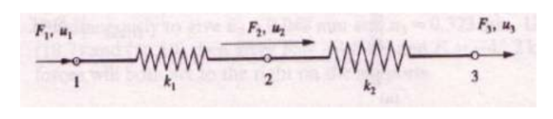
Figure 1: Linear spring diagram, (K. Lake, UWTSD)

In Figure 1, the spring displacement is denoted as ‘u’ rather than ‘x’. The force (F) is a known variable. The stiffness matrix (K) and nodal displacement are unknown variables. The element stiffness can be calculated:
Equation 1: Element Stiffness Calculation
$$K_{n}= \frac{AE}{L}$$

To find the overall stiffness of a component, these individual stiffnesses are combined into a global stiffness matrix that characterises the entire system:
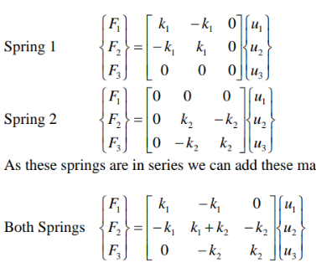

Figure 2: Stiffness Matrix, (K. Lake, UWTSD)
Once the stiffness has been defined, solving the equations using methods such as Gaussian elimination provides the nodal displacements, which in turn can be used to calculate the strains and stresses of the components (Zienkiewicz and Taylor, 2005). Any skew in the tetrahedral nodes result in errors that may be carried and multiplied up to hundreds of thousands of times, depending on the number of elements/nodes within the assembly. This highlights the importance of a high-quality mesh within FEA.

Regarding the piston, it weighs 255.77 grams and is composed of aluminium 6061-T6, an isotropic material frequently used within the automotive and aerospace industries for its lightweight and high strength properties. It is an alloy that contains blends of aluminium, magnesium and silicon which are proven to increase the hardening of the material. It is then T6 heat treated to further improve its strength by artificially aging the material before quenching it. This increases the yield strength to approximately 240MPA and the ultimate tensile strength (UTS) of approximately 290MPa, without sacrificing its formability (Ozturk et al., 2009) (Lee and Tang, 2014). Compared to standard cast iron piston, aluminium 6061-T6 proves to be lighter, reducing inertia forces and has better heat dissipation. However, they are less durable than cast iron and expand at different rates to the cylinder walls and compression rings. Due to their lower durability, simulating the correct stresses experienced by the piston becomes priority to avoid failures. Failures can occur at the piston skirt where they have deformed, and a crack propagates. Cyclic loading causes this to expand and cause serious damage to the piston and surrounding components (Adam Havale and Wankhade, 2017) (Mehmood, Kumar Singh and Kumar, 2018)

Validation Examples

These examples are used to ensure that the simulation software can provide an answer within an acceptable percentage error in comparison to calculated results. Two examples are evaluated, a cantilever beam and a bi-metallic strip.

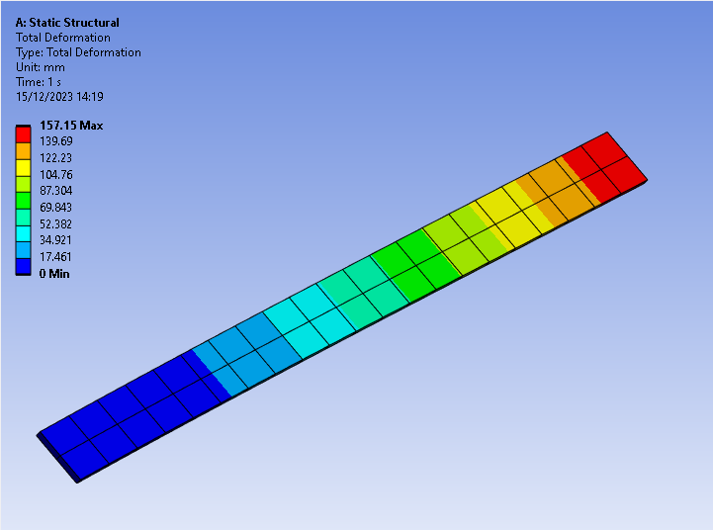
Cantilever Beam Bending
Figure 3: UDL Cantilever Beam Validation

This validation case involves loading a beam with dimensions (L,w,t) 1m x 0.05m x 0.005m that is fixed at one end, with a uniform load (P) of 2750Pa and an Elastic Modulus (E) of 210000MPa. The deflection of the beam can be calculated via the equation below:

Equation 2: UDL Cantilever Beam Equation
$$Y_{z}Max=\frac{3PL^{4}}{2Ew^{2}t}=157.143mm$$

Various mesh sizes were used, and their data recorded, displayed in Table 1. This displays that ANSYS can simulate this simplified bending case without errors.
Table 1: UDL Cantilever Beam Validation Mesh Sizes

Bi-Metallic Strip

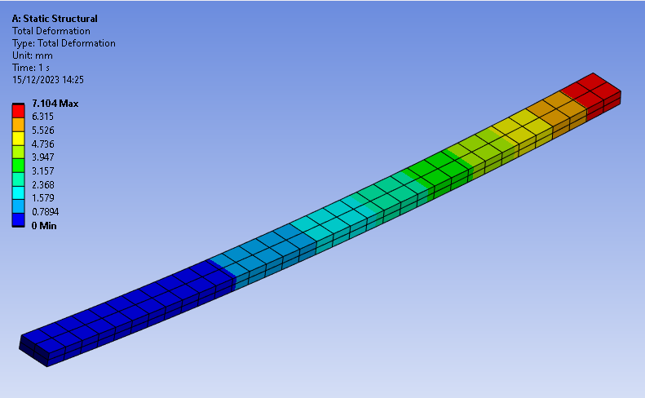
Figure 4: Bi-Metallic Strip Validation

This validation involved applying a temperature difference (Tc) of 100°C to a beam comprised of two different materials: Invar and Copper. The Invar component has dimensions of 100mm x 5mm x 1mm, has a coefficient of thermal expansion ($α_{I})$of $1.2{x10}^{-6}°C^{-1}$, a Poisons ratio of 0.28, and a Modulus of Elasticity of 137000MPa. Copper shares the same dimensions but has a coefficient of thermal expansion ($α_{C})$ of $2{x10}^{-5}°C^{-1}$, a poisons ratio of 0.354, and a modulus of elasticity of 130000MPa. The different rates of thermal expansion cause the materials to expand at a different rate, inducing a measurable deflection.
The deflection of the strip can be calculated via the equations below:

Equation 3: Dimensionless Coefficient K1 Equation
$$K_{1}=4+6\left(\frac{t_{C}}{t_{I}}\right)+4{\left(\frac{t_{C}}{t_{I}}\right)}^{2}+\left(\frac{E_{C}}{E_{I}}\right) ×{\left(\frac{t_{C}}{t_{I}}\right)}^{3}+ \frac{E_{I}t_{I}}{E_{C}t_{C}}$$

Equation 4: Bi-Metallic Strip Deflection Equation
$$Y_{z}Max=\frac{6\left(α_{I}- α_{C}\right)\left(t_{I}- t_{C}\right)Tc}{t^{2}K_{1}} ×\frac{L^{2}}{2}=7.049mm$$

Various mesh sizes were used, and their data recorded, displayed in Table 2. This displays that the mesh size can vary both deflection and stress values when applying a thermal condition. It suggests that a coarser mesh results in fewer carried calculation errors. This factor will have to be considered when applying the thermal condition to the piston.
Table 2: Bi-Metallic Strip Validation Mesh Sizes

Methodology

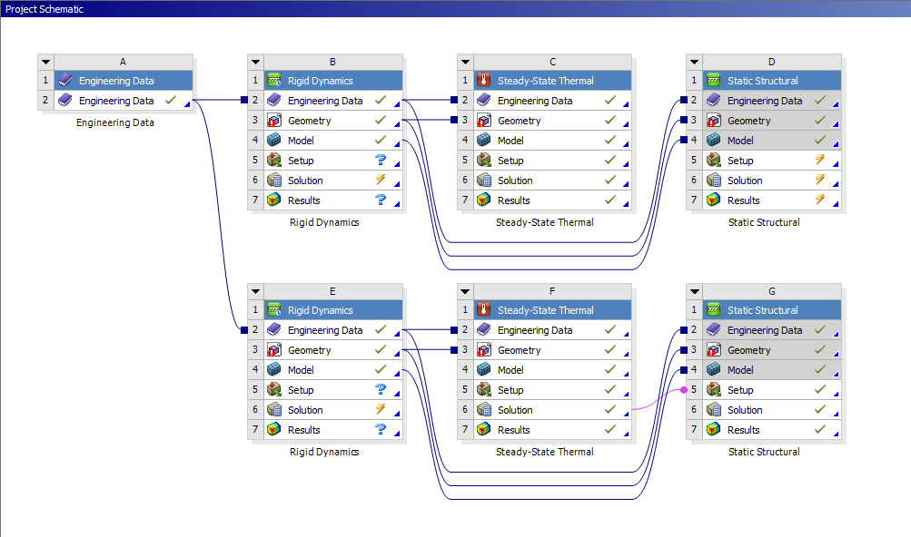
Regarding the piston, several studies were combined to simulate its working conditions. These consisted of an interlinked study, looking at a rigid dynamics study, a thermal study, and a static structural study, shown in Figure 5. The top study analysed the original piston design, while the bottom study analysed the new piston design.
Figure 5: ANSYS Workbench Studies
Engineering data was set up, defining the pistons material properties such as heat coefficients and Youngs modulus. The material properties are displayed below:
Table 3: Engineering Data for Aluminium 6061-T6

Rigid Dynamics Study

The rigid dynamics study was developed to analyse the forces experienced at the connection point between the piston and the gudgeon pin. For this, an assembly of the crankshaft, con rod, gudgeon pin, and piston was imported as a step file from SolidWorks. Aluminium 6061-T6 was applied to the piston, and the components were set to rigid behaviour. Revolute joints were used within ANSYS to allow a single degree of freedom, in this case, rotation about the relevant component axis. This joint type was used on the connections between the piston and gudgeon pin, gudgeon pin to con rod, con rod to crankshaft, and the crankshaft to ground. A general joint was used on the piston skirt that allowed translation about the Y-axis to simulate a piston oscillating between TDC and BDC. The crankshaft was set to revolve at a velocity of 6000 RPM and the maximum and minimum forces experienced by the piston were exported as a motion load text file to be used in the static structural study.

Thermal Study and Piston Mesh Quality Study

The thermal study required a mesh to be created to simulate, therefore some analysis was required to determine the optimum mesh size. Based on the Thermal validation results, a courser mesh carried less error calculations and produced the closest displacement value to the calculated value. This suggested that the mesh should be left fairly course in areas that are not of interest to maintain accuracy, in addition to reducing the computational load and time. A mesh study was run to evaluate the best mesh sizing within a range of 20mm to 2mm. The results are shown in Table 4.
Table 4: Piston Mesh Sizing

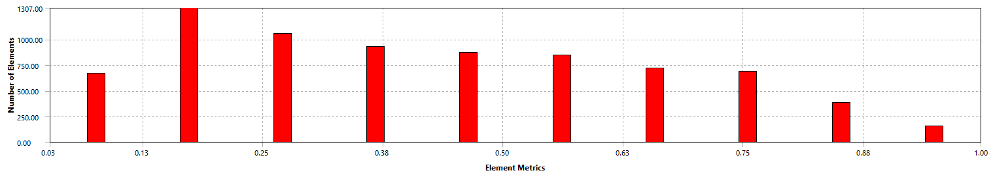
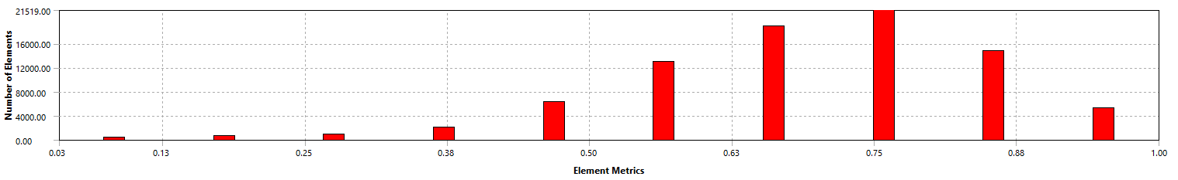
Akin to the thermal validation results, there is a wide range of both displacement and stress values. To determine which were correct, the quality of the mesh elements was analysed to verify which size consisted of the least deformed elements.
Figure 6: Ansys 20mm and 2mm Mesh Quality Graphs

These are the ANSYS graphs produced. They display the quality on the X-Axis as a value between 0 and 1. The Y-Axis contains the number of elements. The top chart displays the element quality for the 20mm mesh, while the bottom graph displays the quality for the 2mm mesh. This chart was recreated in excel using estimated values to provide a better visual representation, displayed in figure 7.
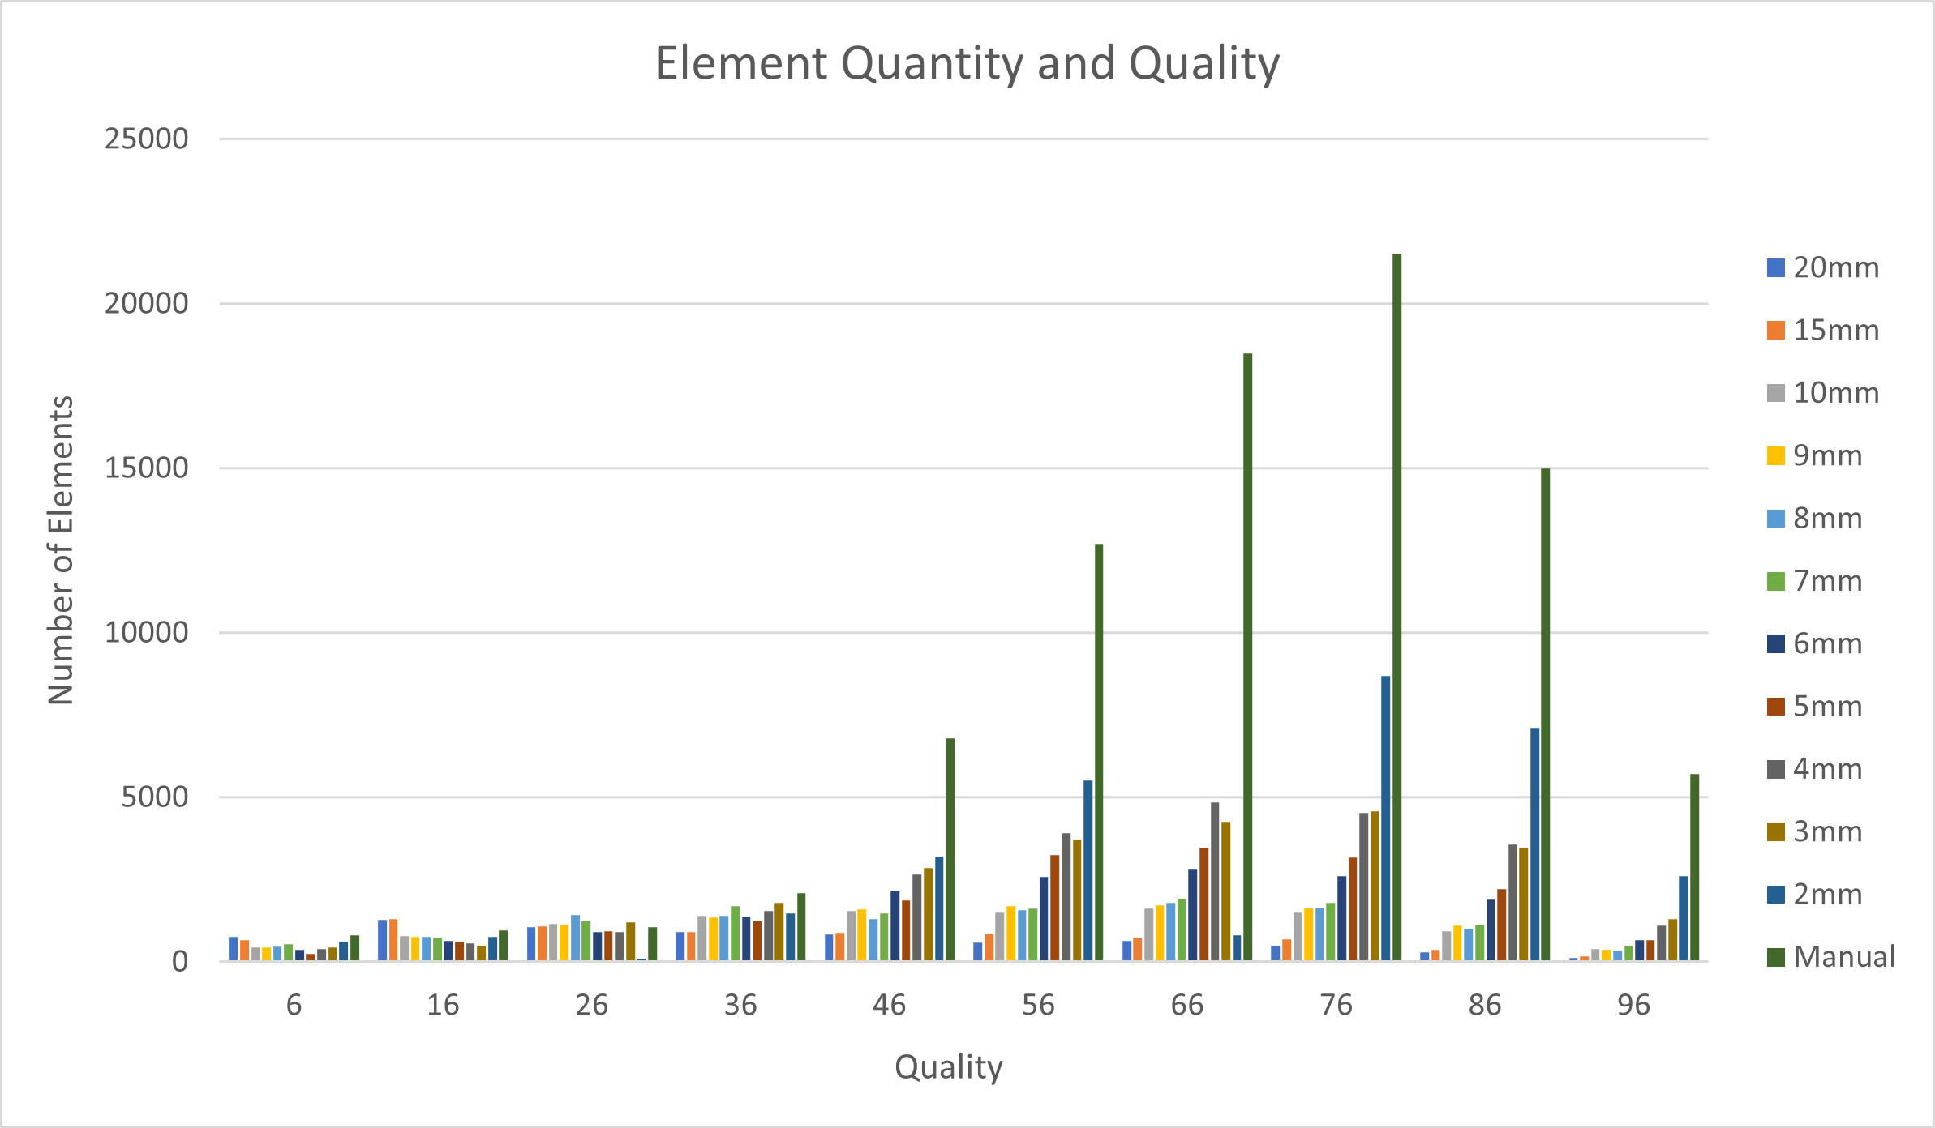
Figure 7: Piston Mesh Quality by Element Number Graph
Figure 7 graph displays the relationship between element number of elements and quality. This is misrepresented as when the elements size is reduced, the number of elements increases. To resolve this, the data was converted into a percentage to allow for direct comparison.
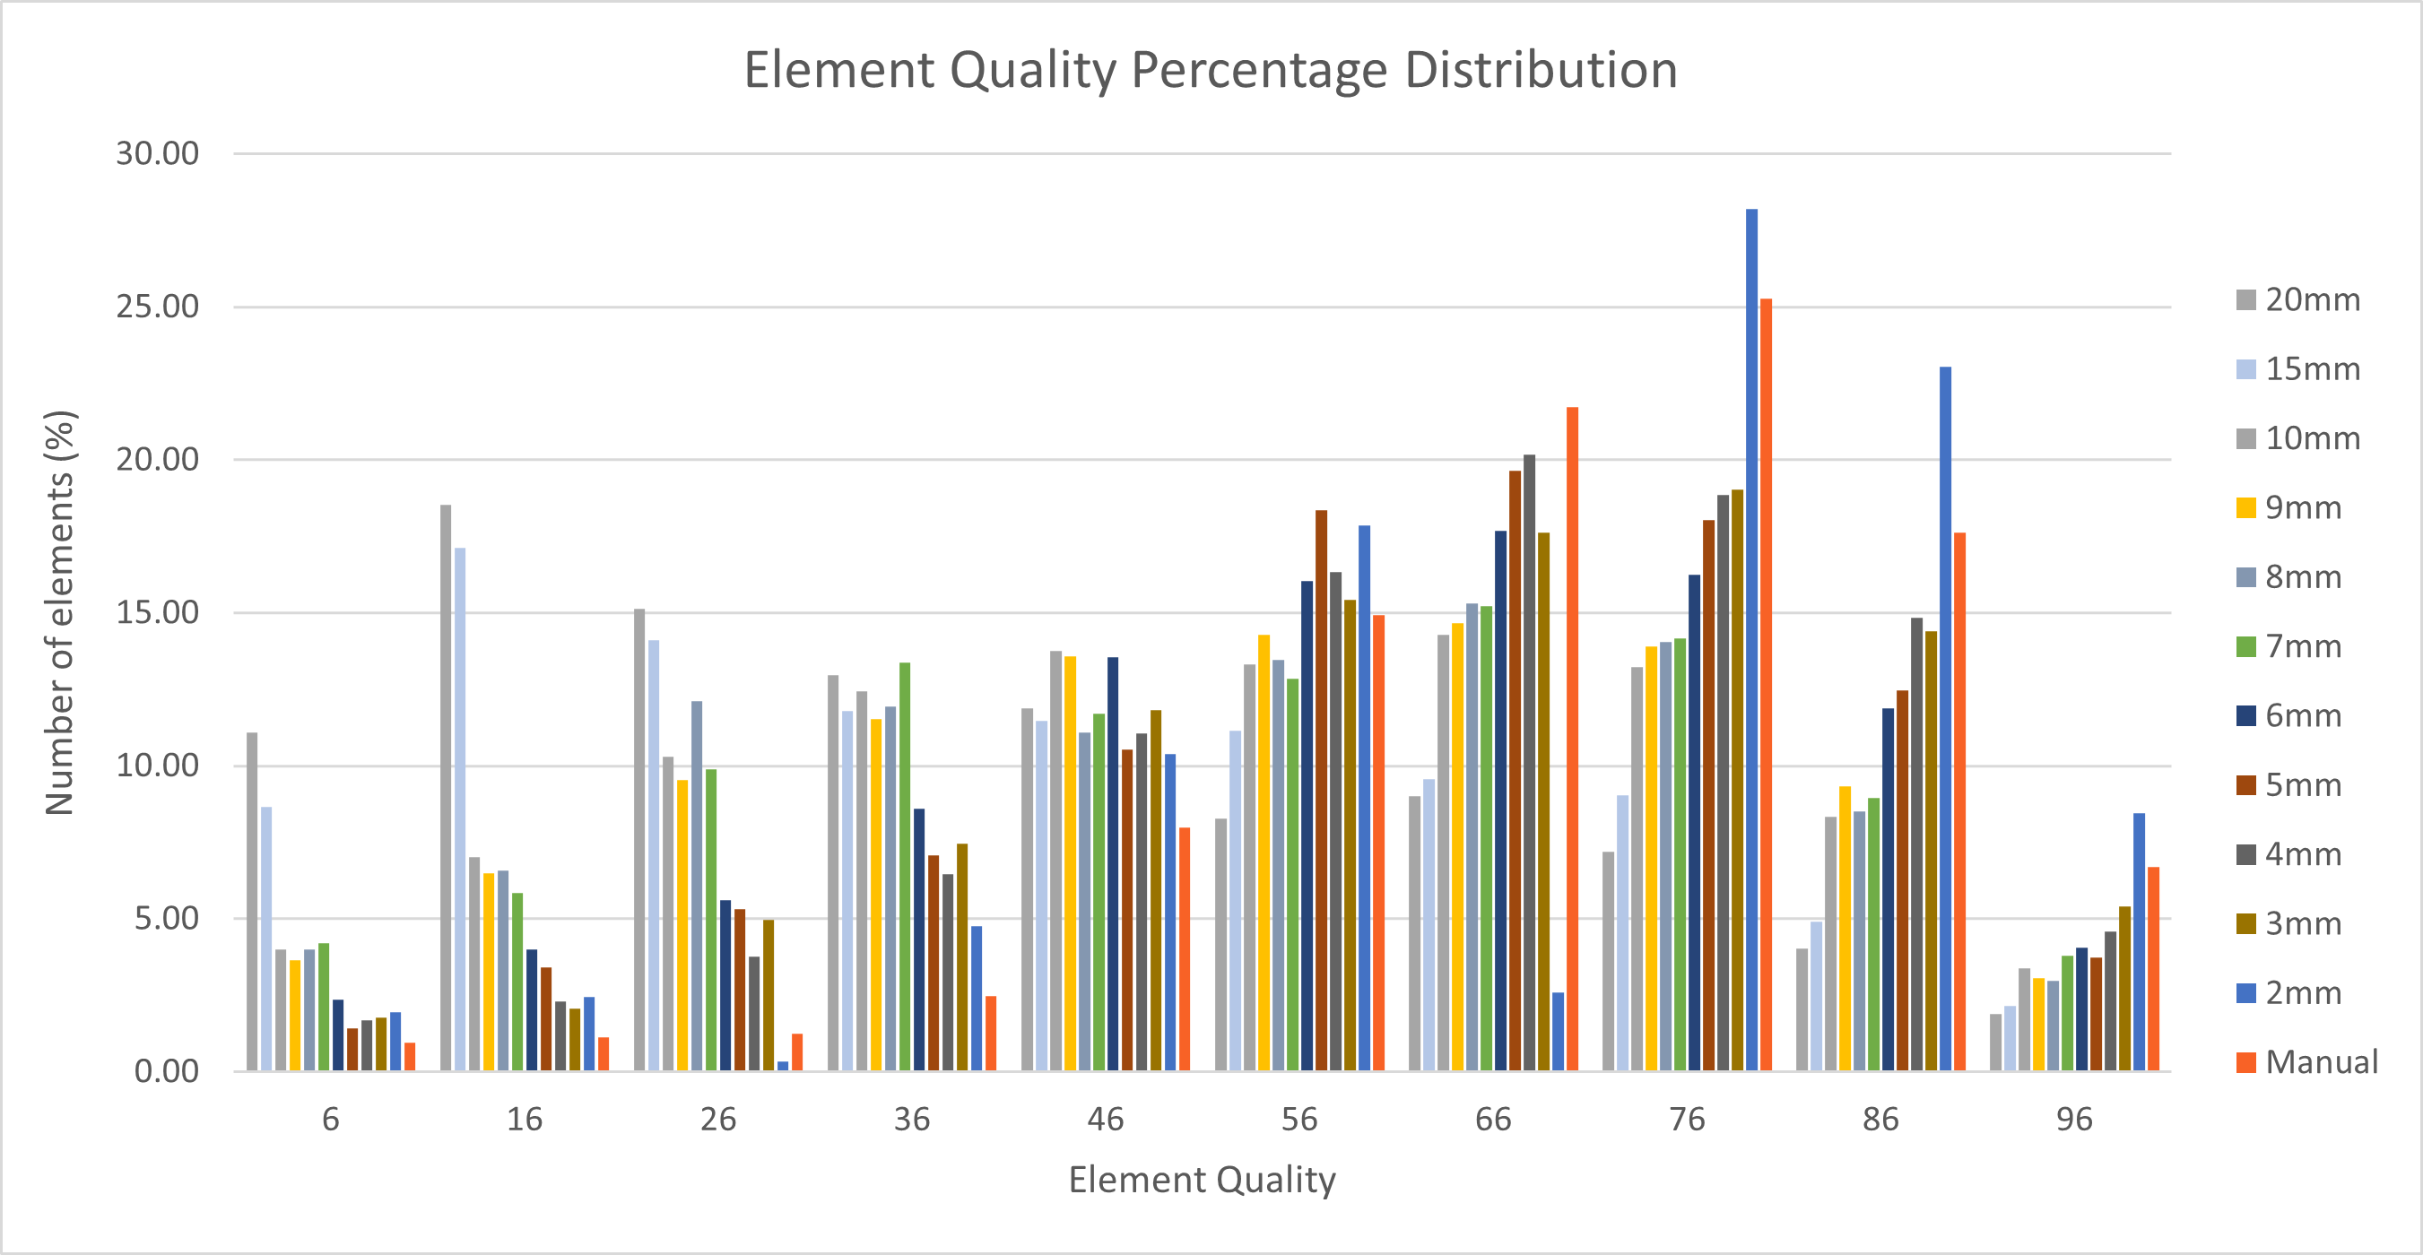
Figure 8: Piston Mesh Quality by Element Percentage Graph
Figure 8 shows that a larger element size tends to decrease the quality of the mesh, displaying a greater population of poor elements below 50% quality for the 20mm and 10mm mesh size. As the mesh size reduces, the percentage of low-quality elements reduces. The 2mm mesh proved to be high quality, however the thermal validation proved that a lower mesh size reduced the accuracy of the results. As a compromise, a custom size mesh was developed, annotated as ‘Manual’. This Manual mesh was created using the data from Figure 8 and observing the location of the poor elements as shown in Figure 9. A finer mesh (0.5-2mm) was used at the points of interest and complex geometry, such as the piston crown, gudgeon pin holes, and compression/oil ring grooves. This is backed by Liu et al. who identified during his research that the piston crown and ring grooves had a high heat flux and required refinement, however he did not state his mesh size (Liu, Wang and Liu, 2017). A coarser mesh (6mm-10mm) was used for the piston skirts and some features of the underside, displayed in Figure 10. This mesh was kept consistent throughout all aspects of this project to maintain consistency.

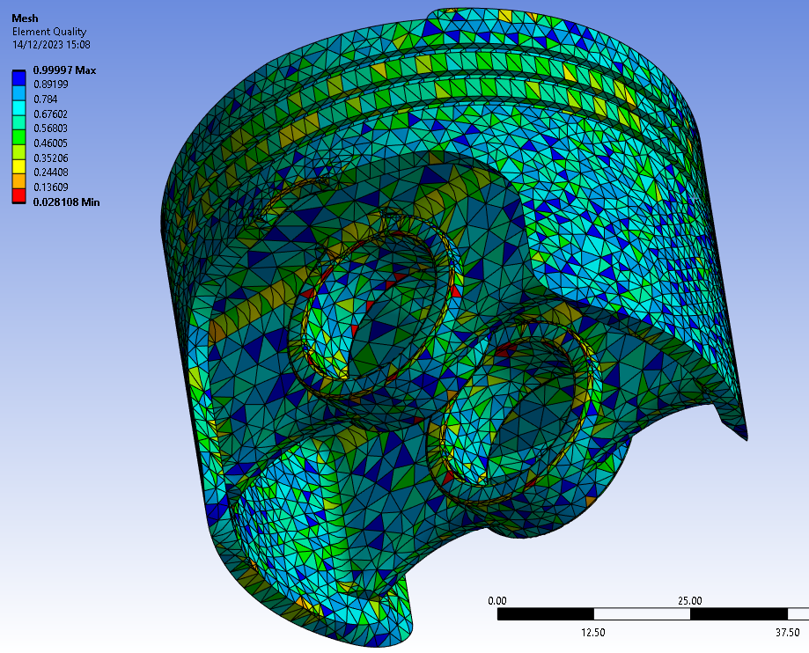
Figure 9: Piston Element Quality

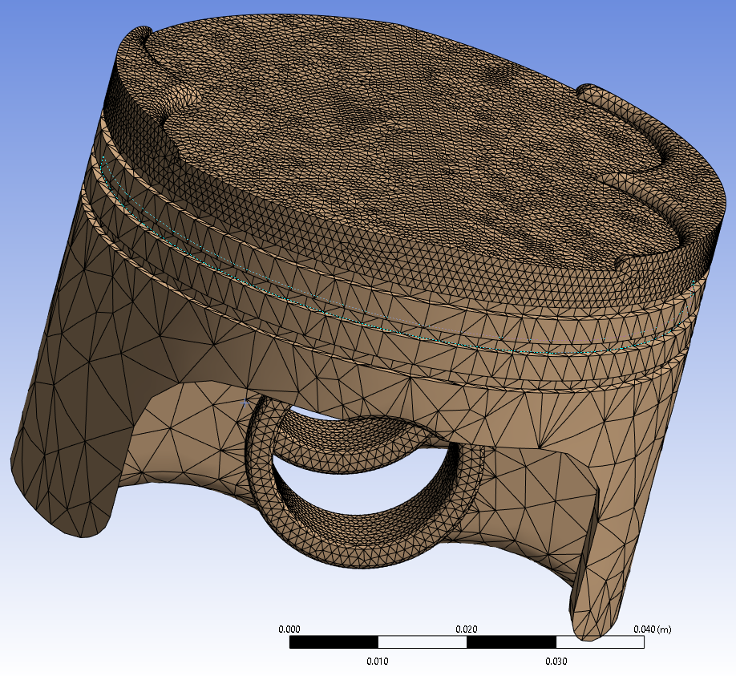

Figure 10: Manual Mesh

Once a mesh was established, the thermal study was conducted to simulate the stresses induced by the heat produced from friction and combustion. Only the piston needed to be analysed, so the other assembly components were suppressed. The piston was set to flexible to ensure that deformation could occur. Using the convection feature within ANSYS, heat was applied to the surfaces based on the locations and values stated in Table 3.

Static Structural Study

The static structural study combines the results from the dynamic and thermal studies, allowing for analysis of the total stresses experienced by the piston. Mirroring the thermal study, all assembly components bar the piston were suppressed and the piston was set to flexible, allowing it to deform. The mesh was recreated using the same sizing parameters that were described in section 4.2. A pressure of 10537060 Pa was applied to the crown surface to replicate the forces exerted by the combustion gasses. The model was restrained using the weak springs function on ANSYS. The piston could have been restrained using a fixed point at the gudgeon pin hole, however nodes about the fixed geometry are fully restrained and cannot deform. This would be a misrepresentation of how the gugdeon pin supports a piston and would have provided inaccurate results.

Results and Analysis

This section will look at the results from the study. Both pistons will be analysed at the same time, directly comparing the two, highlighting any differences. For all figures, the top left and right refer to the original piston, the bottom left and right refer to the modified piston. The scales were manually set to be identical for consistency. The piston modifications consisted of adding filleted slots into the bosses and filleted holes into the skirts. This reduced the piston weight from 255.77 grams to 250.75 grams, saving 5.02 grams and reducing the weight by 1.96%.

Thermal Study Results
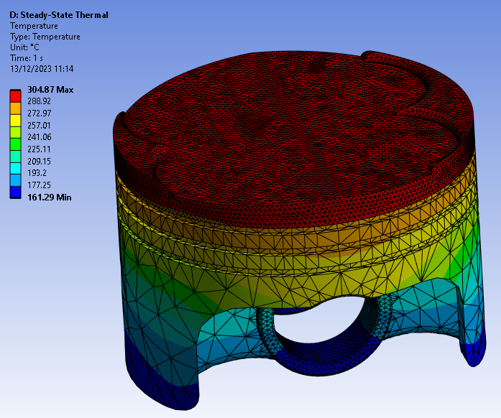
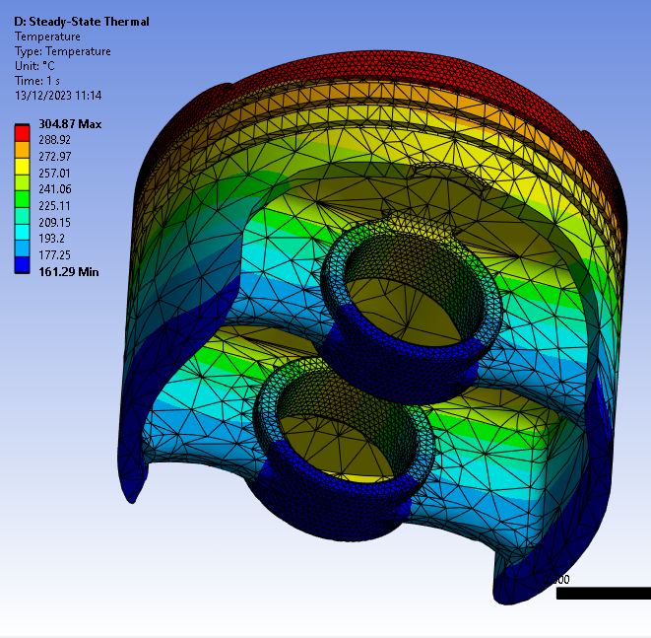
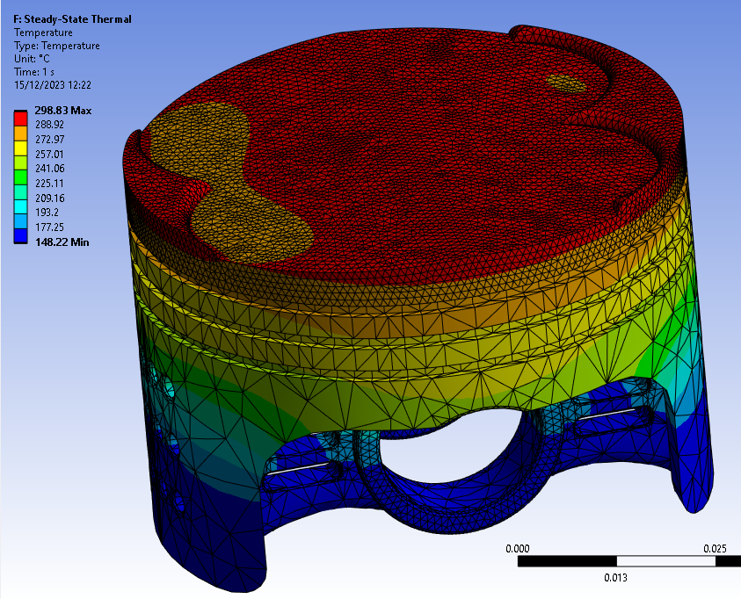
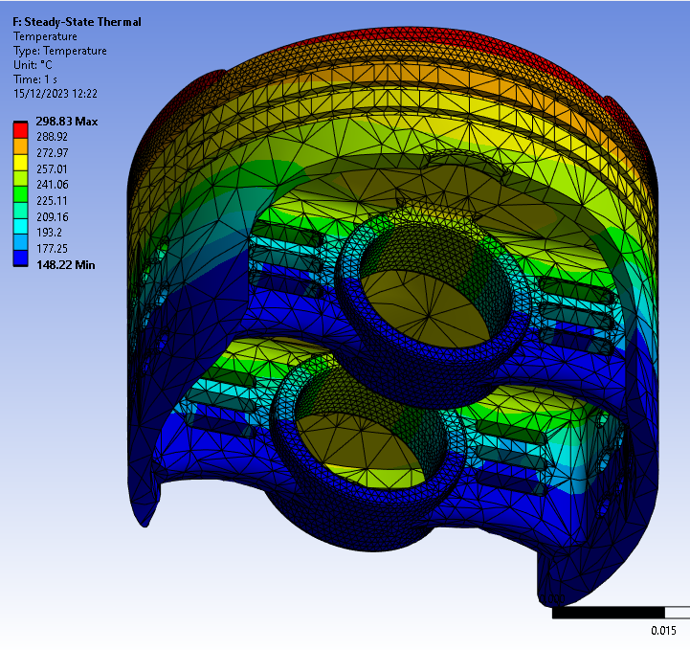
Figure 11: Thermal Stress Results

The original piston displays a higher maximum and minimum temperate in comparison to the redesigned piston. The dark blue section (148-177.25°C) extends higher up the piston skirts and underside on the modified design, leading to reduced temperatures throughout the piston. The temperature trend behaves as it should in comparison with other publishers’ literature (Kumar, 2017)(Calbureanu et al., 2013).

Static Structural Study Results
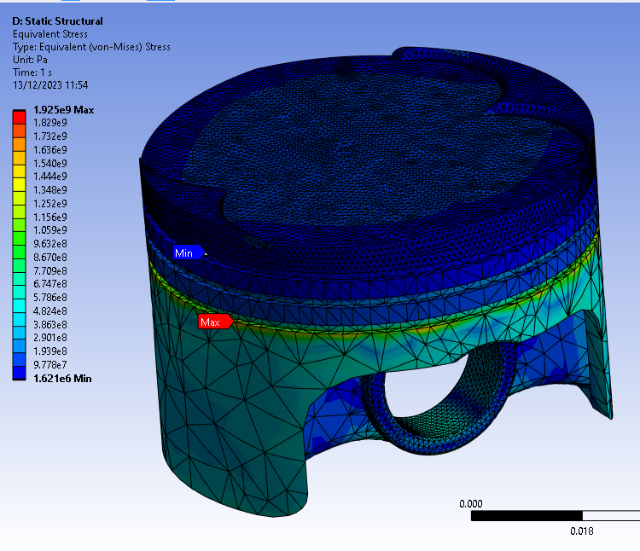
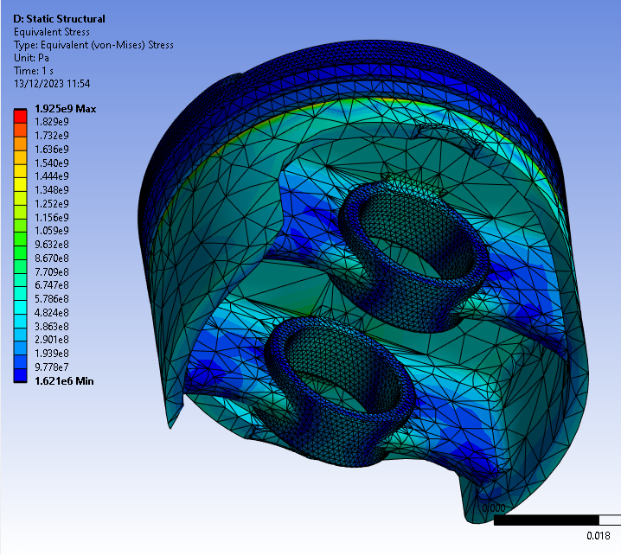
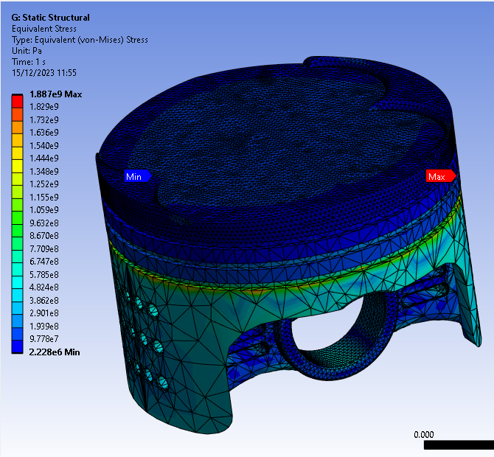
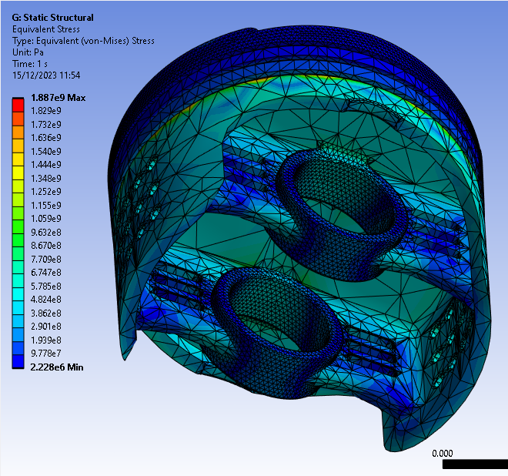
Figure 12: Piston Stresses
Figure 12 highlights that both pistons have a high stress point at the bottom of the oil ring groove, indicated by the Max indicator. This value displaces the scale and hides the detail on the top of the piston. Figure 13 displays an adjusted scale, it highlights the stress regions within the piston and provides data on which surfaces could be reduced/redesigned to further reduce weight.
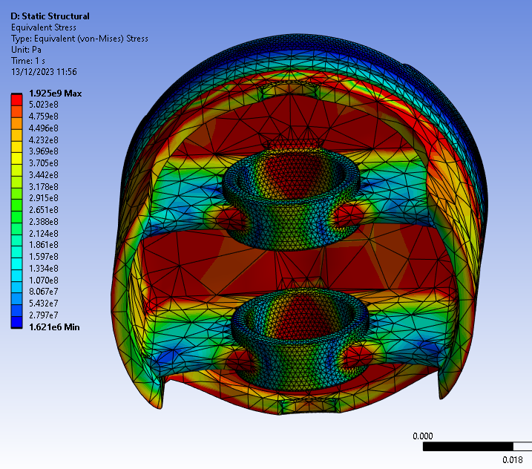
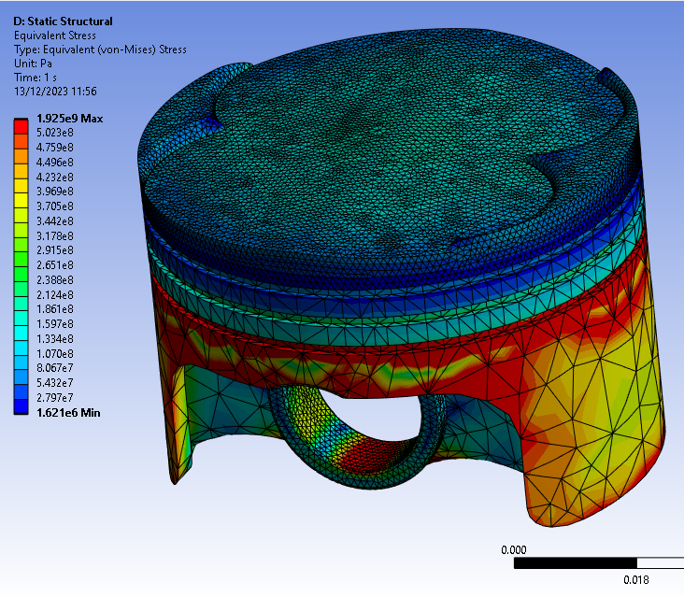
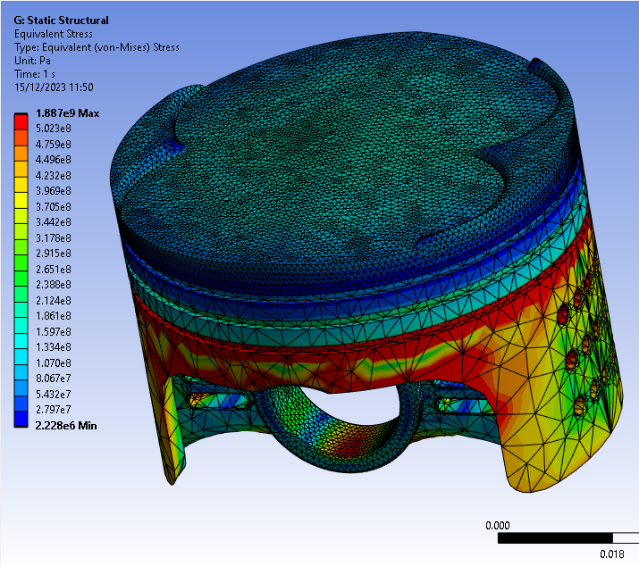
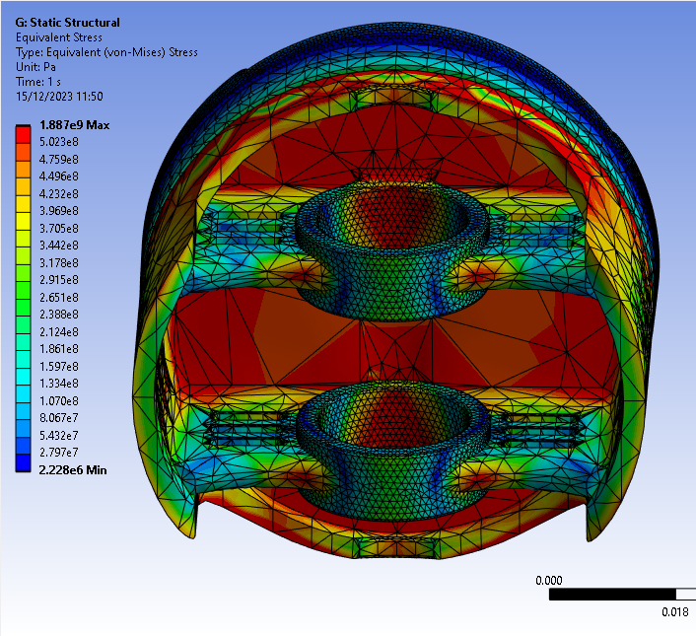
1
2
3
4
Figure 13: Piston Stresses - Adjusted Scale
Figure 13 displays that the pistons have failed. The stresses at the skirt and underside have far exceeded the yield and ultimate tensile strengths for the piston (2.4e8 Pa – 2.9e8 Pa). This was realised too late.

There is a high stress concentration around the oil ring groove, that spreads down into the skirts (Text box 1). The underside of the crown (2) experiences high stresses along with the top and bottom of the gudgeon pin holes (3), caused by the inertia from the dynamic study, however this appears to have reduced marginally with the redesigned piston. The connection between the gudgen pin holes and bosses (4) show a reducion in stress for the redesigned piston. The results show that the redesigned piston experiences a lower maximum stress.

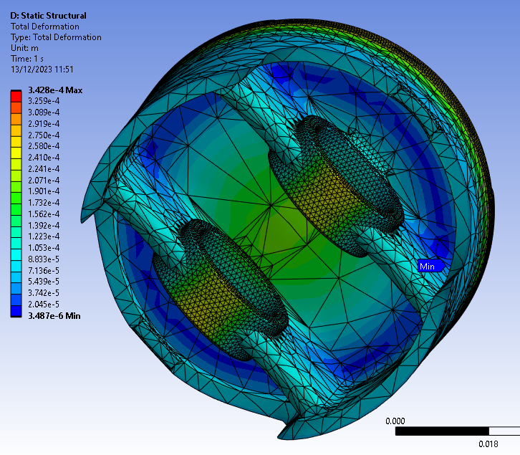
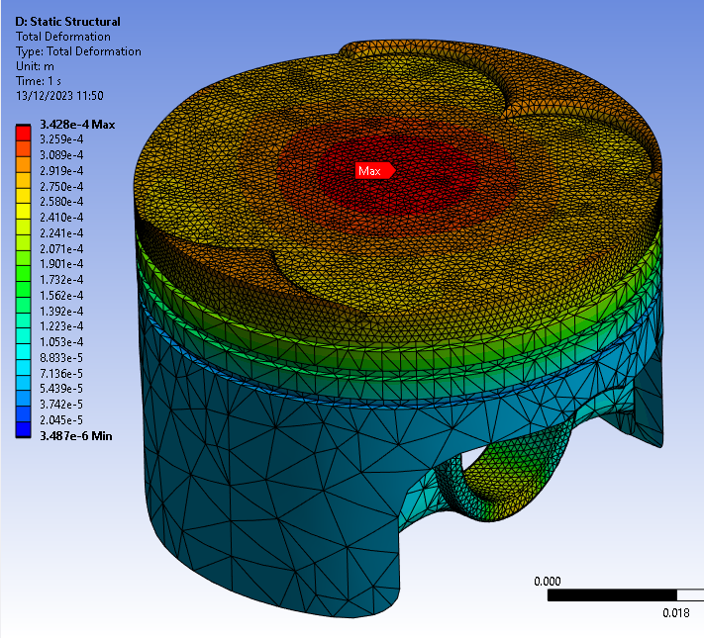
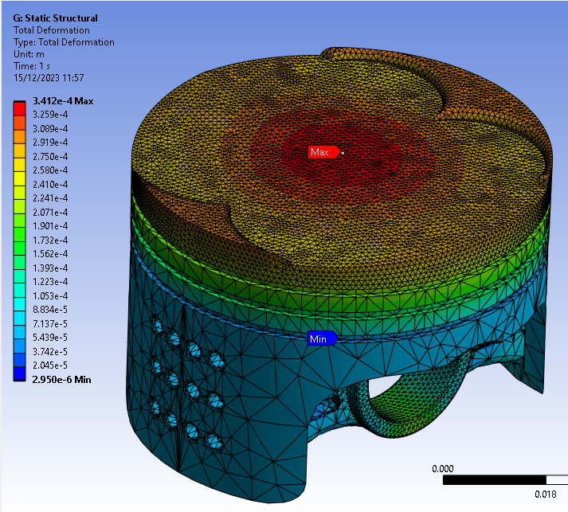
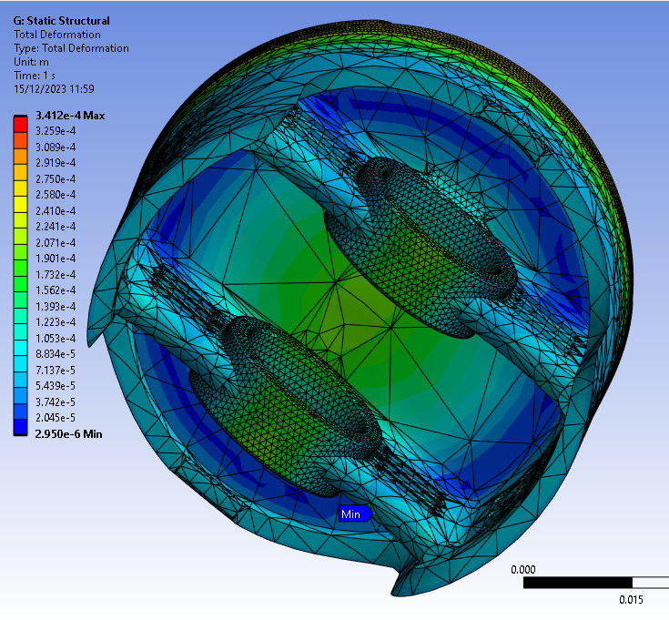
Figure 14 shows the deformation of the two pistons. They are almost identical; however, the maximum deformation value is negligibly higher on the original piston. It also shows a reduction in deformation at the pin holes for the modified piston.
Figure 14: Piston Deformation

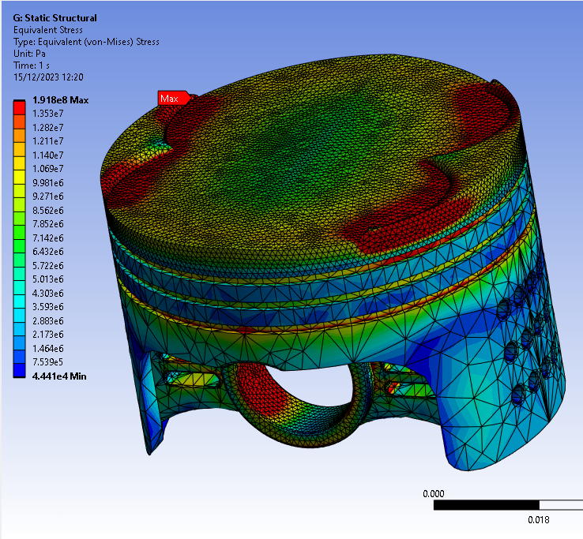
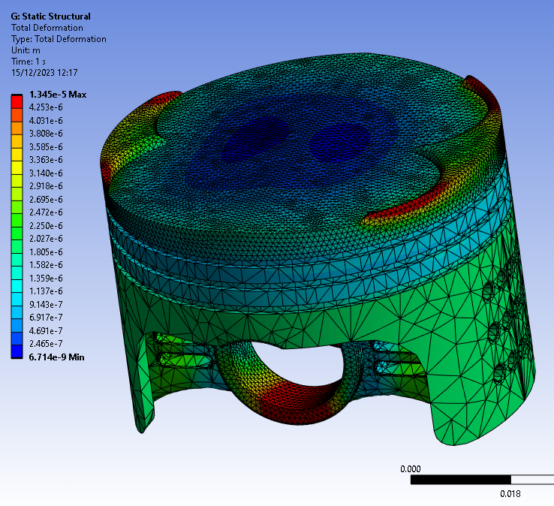
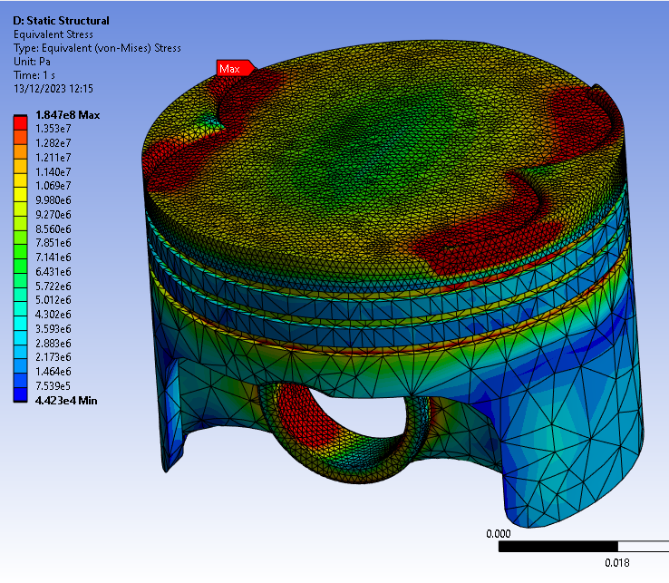
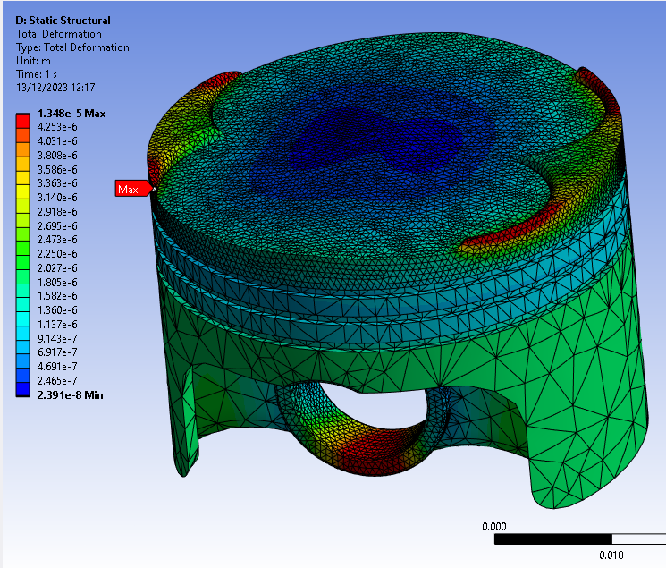
Figure 15 shows the pistons when the thermal study is not applied. It highlights the effect that thermal has on the piston, comparing to Figures 12-14, the stresses and displacements have reduced and migrated to different areas of the piston. Negating the thermal energy, this piston returns to within its material’s yield range as the maximum stress is around 190MPa, further highlighting the effects of thermal stress on aluminium 6061-T6.
Figure 15: Piston Stress and Deformation - No Thermal

These results are good for comparison against one another however the results show that the component failed. There have been some assumptions made when creating this model. It is assumed that during the rigid dynamics study that the assembly is completely rigid, however at 6000RPM, there will be minor deflections in components that will contribute to a shift in local stress points and/or alter the maximum values. Another assumption is that there is an even distribution of heat being applied during the thermal study. This may not happen in reality as controlling the flame front burn rate at 6000RPM can be difficult due to the turbulent air, therefore the mix may not ignite uniformly, creating localised hot spots.

Conclusion

To conclude, this study highlighted the results of analysing and optimising an aluminium 6061-T6 piston using ANSYS Workbench. Validation studies were conducted, and it was found that the thermal study produced a wide range of values dependant on mesh size. This was considered while optimising a mesh for the piston based off element quality, reducing the number of low-quality elements to prevent continued error calculations. Dynamic, thermal, and static studies were conducted to assess the forces and moments experienced by the piston during operation, as well as including the thermal effects of friction and combustion. These combined results produced stresses that caused the piston to critically fail. The maximum stresses seen at the oil ring edge exceeded the ultimate tensile strength of the aluminium by 1635MPa. Even if this was a localised spot due to an error, the rest of the piston, especially the top of the skirts, experienced stresses double of the UTS.

Ignoring the fact the part failed, the piston was then altered by removing material and reducing component weight by 5.02 grams. The 3 studies were repeated with the same inputs and mesh and produced a stress of 1.89GPa, and a deformation of 0.341mm. These results displayed an overall improvement in comparison to the original piston and emphasises the practical use of FEA simulations regarding product development and design.

References

Adam Havale, S. and Wankhade, S. (2017) ‘DESIGN, THERMAL ANALYSIS AND OPTIMIZATION OF A PISTON USING ANSYS’, International Research Journal of Engineering and Technology [Preprint]. Available at: www.irjet.net.
Calbureanu, M. et al. (2013) ‘The finite element analysis of the thermal stress distribution of a piston head’, International Journal of Mechanics, 7(4), pp. 467–472.
Kumar, M. (2017) ‘A Finite Element Thermo-Mechanical Stress Analysis of IC Engine Piston’, International Research Journal of Engineering and Technology [Preprint]. Available at: www.irjet.net (Accessed: 17 December 2023).
Lee, W.-S. and Tang, Z.-C. (2014) ‘Relationship between mechanical properties and microstructural response of 6061-T6 aluminum alloy impacted at elevated temperatures’, Materials & Design, 58, pp. 116–124. Available at: https://doi.org/10.1016/j.matdes.2014.01.053.
Liu, X.F., Wang, Y. and Liu, W.H. (2017) ‘Finite element analysis of thermo-mechanical conditions inside the piston of a diesel engine’, Applied Thermal Engineering, 119, pp. 312–318. Available at: https://doi.org/10.1016/J.APPLTHERMALENG.2017.03.063.
Mehmood, A., Kumar Singh, A. and Kumar, A. (2018) ‘Numerical validation of thermal analysis of an automobile piston using ANSYS’, International Journal of Research in Engineering and Innovation, 2(4), pp. 384–391. Available at: http://www.ijrei.com (Accessed: 17 December 2023).
Ozturk, F. et al. (2009) ‘Influence of aging treatment on mechanical properties of 6061 aluminum alloy’. Available at: https://doi.org/10.1016/j.matdes.2009.08.017.
Zienkiewicz, O.C. and Taylor, R.L. (2005) The Finite Element Method: Its Basis and Fundamentals - Olek C Zienkiewicz, Robert L. Taylor, J.Z. Zhu - Google Books. Sixth. Elsevier. Available at: https://books.google.co.uk/books?hl=en&lr=&id=YocoaH8lnx8C&oi=fnd&pg=PP1&dq=Zienkiewicz&ots=ic0x2uOQiK&sig=lK0B57kUzS4pCRoObUECzWjk1sw&redir_esc=y#v=onepage&q=Zienkiewicz&f=false (Accessed: 3 October 2023).

