ABAQUS Assignment
Fraser Goodwin 2222111
Physics ACDB 4007
Contents
Introduction 1
Theory 1
The Experiment 1
Model for Simulation 1
Material Properties 2
Simulation 3
Results 3
Steel Projectile 3
Tungsten projectile 5
Sheer Stresses 7
Velocity Graphs 8
Discussion 8
Conclusion 9
References 9

Figure 1 - Projectile before revolved 360 degrees around centre axis 3
Figure 2 - Target plate before it was extruded 0.304m 3
Figure 3 - Steel Projectile Max Principle (1) 5
Figure 4 - Steel Projectile at initial impact 5
Figure 5 - Steel Projectile Max Principle (2) 6
Figure 6 - Tungsten projectile Max principle (1) 6
Figure 7 - Tungsten projectile at initial impact 7
Figure 8 - Tungsten projectile at end point 7
Figure 9 - Tungsten Projectile S23 stress 8
Figure 10 - Steel Projectile S23 stresses 8
Figure 11 - Tungsten Velocity/time graph 9
Figure 12 - Steel Velocity/time graph 9

Introduction
The purpose of this report is to create a model on ABAQUS to evaluate how the stress and strain values are affected by different materials. This was done by creating an impact simulation of a projectile of steel and of tungsten penetrating an aluminium target plate at 1200 ms⁻¹. The steps taken to create the simulation will be shown and the Johnson-Cook values obtained for the materials. This report will discuss the differences in stress and strain values for each material and will display the velocity/time graphs for each material. The results gathered from these simulations will be shown by screenshots taken from the ABAQUS software.

Theory
Stress is defined as the restoring force acting per unit area of a body. So, when a deforming force is applied to an object, the object deforms and to bring itself back to its original shape there will be an opposing force generated inside the object. This force will be equal in magnitude and opposite in direction to the applied force. Stress is denoted using the Greek letter Sigma (σ), and can be calculated using the following equation: [1]
σ = $\frac{F}{A}$
Where,
- F is the restoring force (N)
- A is the cross-sectional area (m²)
- σ is the stress (Pa)
Strain is a ratio of the amount of deformation experienced by a body in the direct of force applied to it, over the initial size of the body. This gives a value which is representative of how much a body can deform under force relative to its original size. Strain is denoted by the Greek letter Epsilon ($ε$), and can be calculated using the following equation: [2]
$$ε= \frac{∆L}{L}$$
Where,
- $ε$is the strain (unitless)
- $∆L$ is the change in length due to applied force (m)
- $L$ is the original length (m)

The Experiment

Model for Simulation
The models for the aluminium target plate and the steel projectile were already provided for this simulation. To compare, Johnson-Cook values for the material properties of Tungsten metal were obtained online and entered into the ABAQUS material module. This report consists of two identical simulations, one with a steel projectile penetrating an aluminium plate and the other with a tungsten projectile penetrating the same plate. The models for the projectile and target plate will be displayed in the following images.
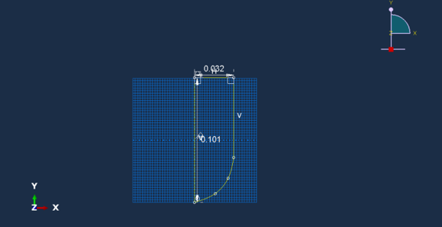
Figure 1 - Projectile before revolved 360 degrees around centre axis

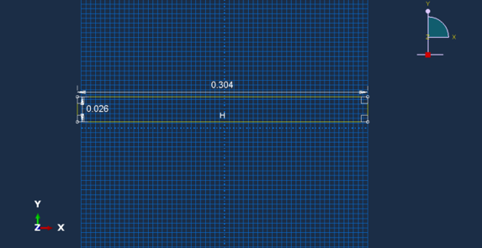
Figure 2 - Target plate before it was extruded 0.304m
After these models had been created, the next job was to use the mesh module to pair the two objects together and ensure that the projectile will interact with the plate as normal and return accurate values for stress and strain.

Material Properties
The materials used in these simulations was steel, tungsten and aluminium. The Johnson-Cook values for steel and aluminium were already provided and research was done to choose a different material and obtain Johnson-Cook values for the materials properties. Tungsten was chosen as it is a much harder metal than steel and would provide a good comparison. The values obtained included Johnson-Cook damage values, mass density, Young’s modulus, Poisson’s ratio and plasticity values. The values used for this experiment are as follows. [3]
Johnson- Cook damage values | 2 | 1.77 | 3.4 | 0 | 0 | 1723 | 300 | 1

Mass Density | 17600

Young’s modulus | 314000000000

Poisson’s ratio | 0.29

Plasticity values | 1506000000 | 177000000 | 0.12 | 1 | 1723 | 300

Simulation
Before the simulation was tested the only thing left to do was set the start and finishing velocities of the projectile. The initial velocity was set to 0 ms⁻¹ and the final velocity was set to 1200 ms⁻¹. This was done to emulate a bullet coming from rest out of a gun and gaining speed towards its target.
All the above steps and dimensions were applied to the ABAQUS model and to run the simulation a job must be created. This was done by selecting the job module and selecting create job. This function takes all the parameters set by the and runs the simulation to its end point and allows the user to repeat the simulation as many times as necessary once it is saved. When the job was first created, the number of steps that was programmed was too little thus not allowing to see the exact moments when the projectile hits the plate. This was modified and the number of steps that the job takes to carry out the simulation was increased drastically, and this gave much better results.

Results

Steel Projectile
The first screenshot illustrates the steel projectile penetrating the aluminium plate. The stress waves that are produced can be seen and as the projectile travels through the plate the waves start to dissipate towards the edge of the material and the bottom of the material starts to rupture due to the stress cause by impact. Around where the projectile has entered, where the highest stresses are, a value of 1.04e+08 can be seen.
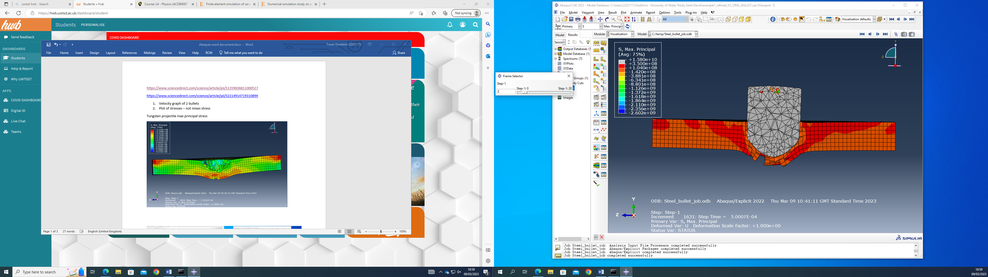
Figure 3 - Steel Projectile Max Principle (1)
The next screenshot shows the plate after initial impact from the steel projectile. As can be seen, the stress waves ripple outwards to the side of the material with a value of 4.849e+08 being displayed towards the outside of the plate.
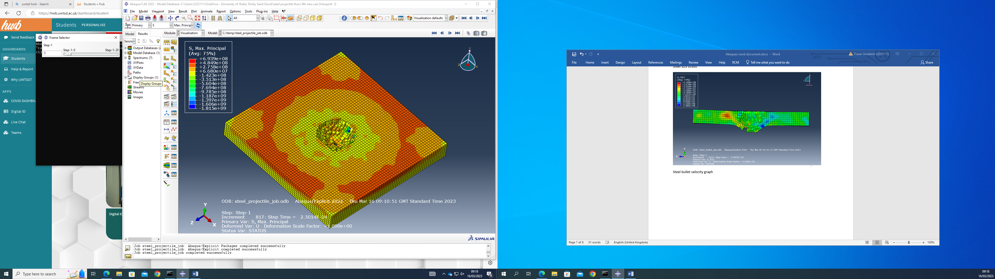
Figure 4 - Steel Projectile at initial impact

The next screenshot shows the plate at a slightly further on point than the previous one. This shows that the high stress points return to around the projectile after the initial impact waves had gone through the material recording a highest value of 2.704e+08.

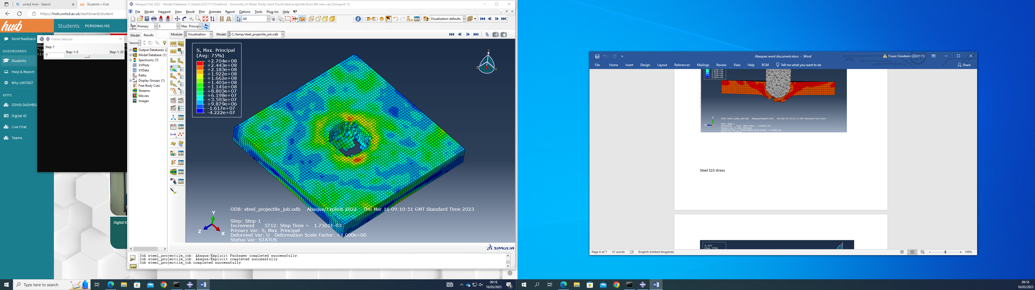
Figure 5 - Steel Projectile Max Principle (2)

Tungsten projectile
The first screenshot displays the tungsten projectile entering the aluminium plate and causing considerable disruption to the material. As soon as the projectile entered the material, immediate deformation can be seen as the dense tungsten metal smashed through the aluminium. Stress levels of 4.709e+09 can be seen on the plate.
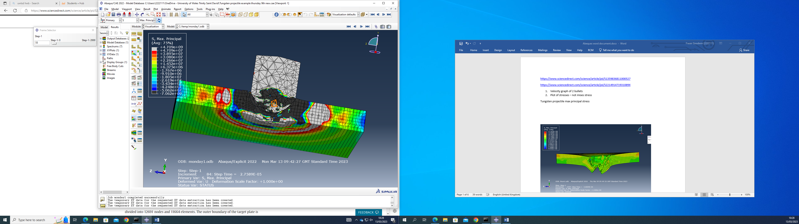
Figure 6 - Tungsten projectile Max principle (1)
The next screenshot shows the aluminium plate at initial impact of the tungsten projectile. As can be seen it instantly sends stress waves rippling through the material. More vigorous than the steel projectile.
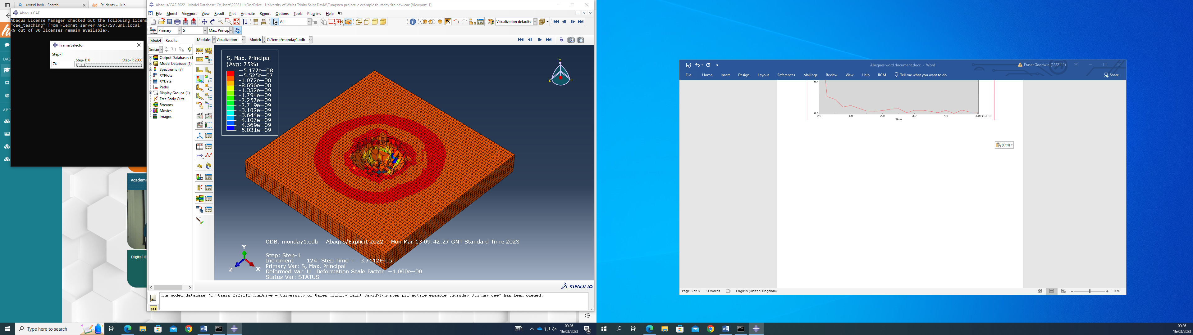
Figure 7 - Tungsten projectile at initial impact

The next screenshot shows the end point of the tungsten projectile simulation, and the plate has suffered devastating effects due to the density and hardness of the projectile. It has caused debris to fly off of the plate due to the sheer force of the bullet.
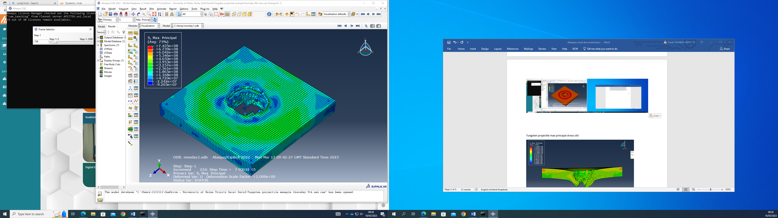
Figure 8 - Tungsten projectile at end point

Sheer Stresses
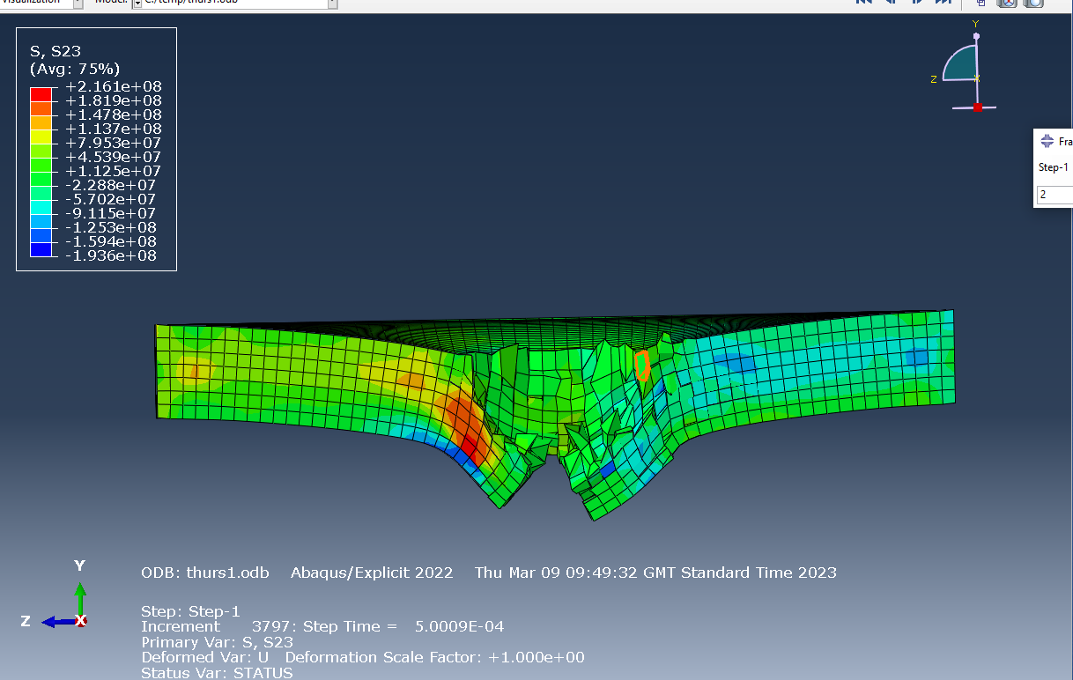
Figure 9 - Tungsten Projectile S23 stress
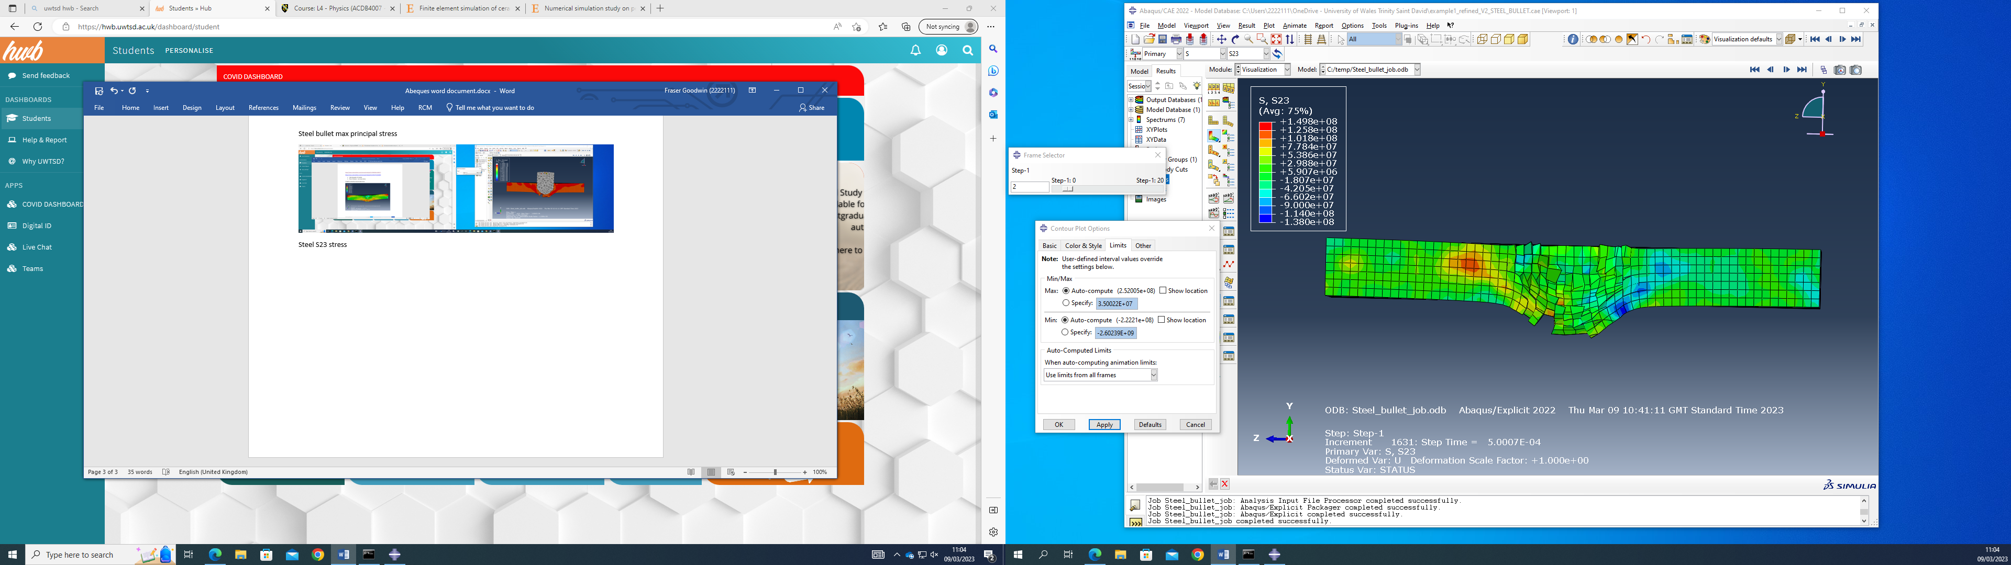
Figure 10 - Steel Projectile S23 stresses
Figure 9 and Figure 10 illustrate the difference in sheer stress across the two different materials of projectile. In Figure 9 the projectile practically destroys the plate as the sheer stresses were too much for the material to stay intact. On the other hand, in Figure 10, the projectile has started to break the plate, but the stresses are offering a greater deal of resistance than Figure 9.

Velocity Graphs
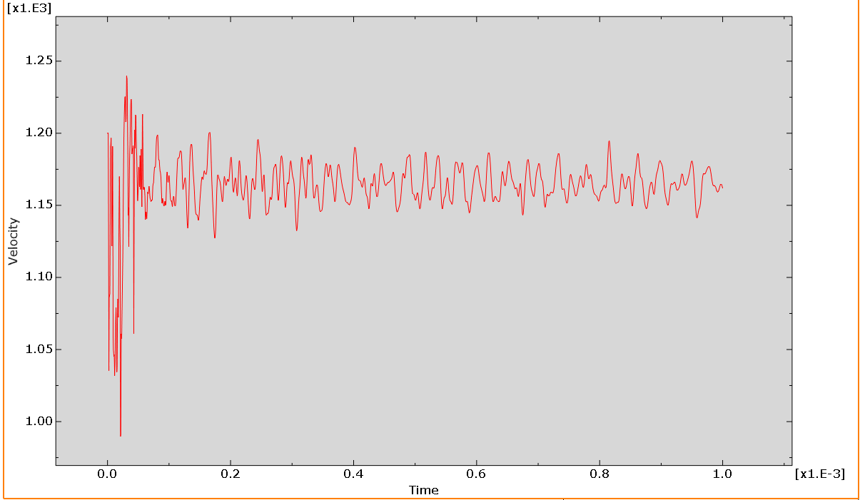
Figure 11 - Tungsten Velocity/time graph
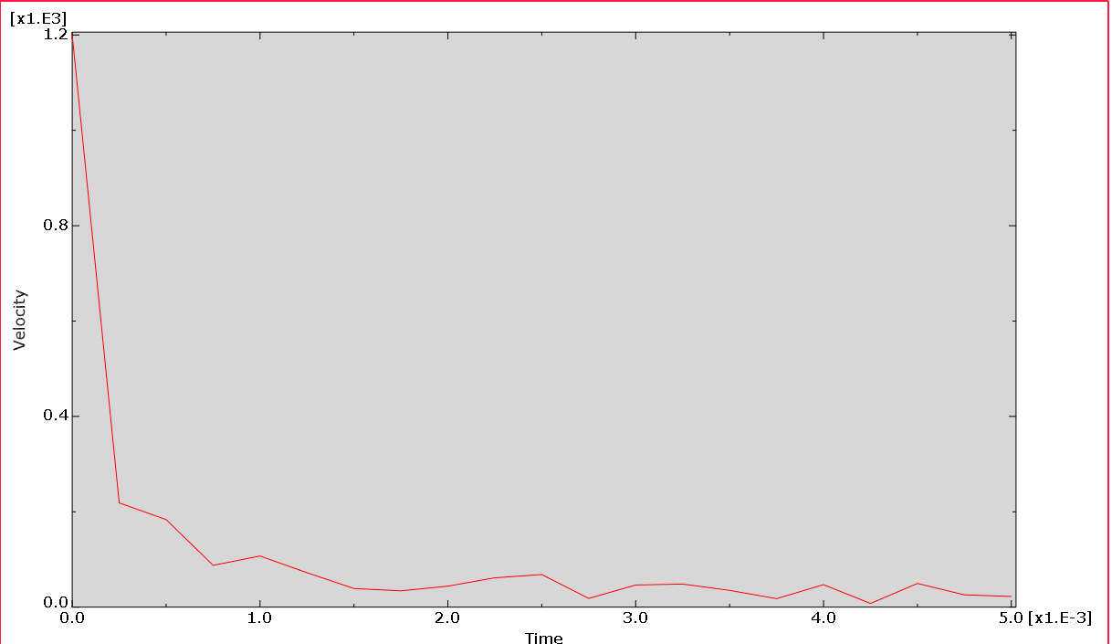
Figure 12 - Steel Velocity/time graph
It can be seen from Figure 11 and Figure 12 the differences in the velocity/time graphs that each simulation produced. Figure 12 produced a much smoother graph than Figure 11, this is because it didn’t cause as much disruption as the Tungsten projectile.

Discussion
From the results gathered some variables within the experiment could be a source of error. Firstly, the values obtained for the material properties for Tungsten could be wrong leading to inaccurate results. Another thing leading to inaccurate results could be because of the user being inexperienced at using the ABAQUS software and therefore better results could have been obtained. During the creating of the job phase, there was multiple times when the job got aborted and this was due to the material property values being inputted incorrectly. After it was rectified, the job proceeded to work.

Conclusion
In conclusion, this experiment gave a good insight into the effect of material change on stress levels. Although it did give limited observations and it was difficult to try and set the parameters for the stress values correctly to display good stress waves. It was observed that that the areas of stress were more concentrated and shorter for the Tungsten simulation than the Steel one, this was because the material is much harder than steel and therefore caused less fuss in shooting through it. If this experiment was to be done again, a change in velocity would also be added to analyse the effect of velocity on stress values. More time would also be spent on getting to know the ABAQUS software and how to use it.

References

[1] | “Stress - Definitions and Types,” BYJU's, [Online]. Available: https://byjus.com/physics/stress/. [Accessed 15 May 2023].
[2] | “Stress and Strain,” BYJU's, [Online]. Available: https://byjus.com/physics/stress-and-strain/#what-is-strain. [Accessed 15 May 2023].
[3] | Y. C. G.-l. Z. Fu-lin Zhu, “Numerical simulation study on penetration performance of depleted Uranium (DU) alloy fragments,” Defence Technology, vol. 17, no. 1, pp. 50-55, 2021.

