

SamanthaJade Williams - 2205436
Applied Programmable Logic Controllers – ACDA6000

Factory Control

Literature Review 3
Honeywell ControlEdge 3
Siemens Simatic 3
Mitsubishi Melsec 4
Schneider Electric Modicon 4
Omron Sysmac 5
ABB AC500 5
Summary 6
System Brief 6
System Design 7
System Operation 8

Literature Review

Honeywell ControlEdge
Honeywell ControlEdge is a family of next-generation industrial automation controllers and solutions designed to modernise control systems. At its core, the ControlEdge platform includes programmable logic controllers (PLCs), Remote Terminal Units (RTUs), and process controllers (such as the HC900) tailored for a wide range of industries including oil & gas, water and wastewater, power, chemicals, and manufacturing.
ControlEdge PLCs provide connectivity across plant and business systems, supporting open standards like Open Platform Communications Unified Architecture (OPC UA) and industry protocols that enable seamless integration with diverse equipment and systems. They are designed as IIoT-ready platforms, meaning data from field devices can be leveraged more effectively for analytics and decision-making. Combined with Honeywell’s Experion Distributed Control System (DCS), they help reduce integration costs, simplify configuration, and lower total cost of ownership through streamlined operations.
Cybersecurity is a key feature of ControlEdge; embedded security hardens devices against threats with capabilities such as secure boot, firewalls, and robust development practices. Some ControlEdge PLC models have earned industry certifications like ISASecure Level 2, highlighting their strong security posture for industrial environments.
The broader ControlEdge family also includes the ControlEdge RTU for remote automation with rugged, low-power operation suited to field installations, and the ControlEdge HC900 for process and safety control with modular scalability. These products help plants improve reliability, reduce manual work, and support flexible control architectures across diverse applications.

Siemens Simatic
Siemens SIMATIC is one of the longest-established and most widely deployed programmable logic controller (PLC) families in industrial automation. First introduced in 1958, the SIMATIC line has evolved through multiple generations to meet increasingly complex automation needs, with the current focus on the S7 family (including S7-1200, S7-1500, and ET 200 distributed systems). The controllers are designed to execute control logic, interface with sensors/actuators, and integrate deeply with plant systems via industrial networking standards such as PROFINET and Ethernet/IP.
Siemens emphasises modularity, scalability, and robustness, enabling solutions that range from small machine control to large, distributed production facilities. Programming is primarily done through the TIA Portal software package, which unifies PLC, HMI, and motion control engineering in one platform, helping engineers streamline design and diagnostics. SIMATIC PLCs also incorporate diagnostics, safety, and communications features to support digital transformation in Industry. Their global reach, extensive support, and integration with broader Siemens automation and digital-twin technologies make SIMATIC a dominant choice across automotive, pharmaceuticals, energy, and large-scale manufacturing sectors.

Mitsubishi Melsec
Mitsubishi Electric’s MELSEC series PLCs are central to the company’s automation portfolio, offering a broad range of controllers suited from entry-level to high-performance industrial applications. Mitsubishi PLCs are noted for their compact and scalable design, fast scan times, and strong motion-control and network capabilities, often used in manufacturing, packaging, automotive assembly, and electronics production.
The MELSEC line includes several sub-families such as the compact FX series, the modular Q and iQ-R series for larger systems, and the iQ-F series that blends compactness with integrated functions. Programming typically utilises Mitsubishi’s GX Works3 or related software tools, which support IEC 61131-3 languages like ladder logic and structured text.
Mitsubishi PLCs support a variety of industrial networks (including CC-Link IE and Ethernet standards), facilitating integration into modern automated systems. Their reputation for reliability, energy efficiency and connectivity has made them especially strong in the Asia-Pacific region and among OEM machine builders worldwide.

Schneider Electric Modicon
Modicon, originally developed as the world’s first commercial PLC, remains a foundational component of Schneider Electric’s industrial automation strategy. Over decades of development, Modicon PLCs have expanded into a comprehensive range of controllers designed for machine automation, process control, infrastructure, and energy management applications. Modern Modicon families, such as the M221, M241, M251, M340, and M580, provide scalable solutions from compact standalone control to high-availability, process-level automation systems.
One of the defining strengths of Modicon PLCs is their integration with Schneider Electric’s EcoStruxure architecture. This open, IoT-enabled platform connects control hardware with software, analytics, and services, enabling improved operational efficiency, predictive maintenance, and energy optimization. Modicon PLCs feature strong native support for Modbus, Ethernet/IP, PROFIBUS, and other industrial protocols, ensuring interoperability with both legacy and modern systems.
Schneider Electric places particular emphasis on energy efficiency, sustainability, and cybersecurity, which is reflected in Modicon’s design and system architecture. Many Modicon controllers include embedded web servers, advanced diagnostics, and secure communication features to support modern digitalised operations. The platform is widely used in water and wastewater treatment, power generation, oil and gas, transportation infrastructure, and building automation. By combining robust PLC hardware with a broader energy and automation ecosystem, Modicon remains a strong choice for industries seeking integrated control and energy management solutions.

Omron Sysmac
Omron’s Sysmac platform represents a modern, highly integrated approach to industrial automation, particularly focused on machine control, motion, robotics, safety, and vision systems. Rather than treating the PLC as a standalone controller, Sysmac unifies multiple automation functions into a single architecture centred around the NJ and NX series controllers. These controllers are designed for high-speed, deterministic performance, making them well suited for complex machines that require precise synchronization and real-time control.
A major strength of Sysmac is its unified engineering environment, Sysmac Studio, which allows engineers to develop logic, motion, safety, and vision applications within one software tool. This integration reduces system complexity and improves maintainability, especially in advanced machine applications. Sysmac systems are built around high-performance industrial networks such as EtherCAT and EtherNet/IP, enabling fast communication between controllers, drives, sensors, and vision devices.
Omron’s strong background in sensors, vision systems, and robotics gives Sysmac a unique advantage in applications requiring advanced machine intelligence. PLCs can directly integrate vision inspection, safety control, and multi-axis motion without the need for separate controllers or software packages. This makes Sysmac particularly attractive for packaging, material handling, robotics, electronics manufacturing, and pharmaceutical production. By emphasising integration, precision, and adaptability, Omron Sysmac supports modern manufacturing strategies such as mass customisation, flexible production lines, and smart factories.

ABB AC500
The ABB AC500 PLC family is designed to provide flexible, scalable, and robust automation solutions across a wide range of industrial sectors. It supports applications from simple machine control to complex, distributed automation systems used in infrastructure, utilities, and heavy industry. The AC500 platform offers a modular architecture with multiple CPU options, extensive I/O modules, and a wide selection of communication interfaces, allowing systems to be tailored precisely to application requirements.
Engineering and configuration of AC500 systems are performed using ABB Automation Builder, a comprehensive software suite that supports PLC programming, safety control, motion, and HMI development within a single environment. The platform complies with IEC 61131-3 standards and offers advanced diagnostic and simulation capabilities. A key strength of AC500 is its broad support for modern and legacy communication protocols, including PROFINET, OPC UA, Modbus, MQTT, and others, enabling seamless integration with industrial networks and higher-level systems.
ABB places strong emphasis on reliability, cybersecurity, and long-term availability, making AC500 suitable for mission-critical applications. The platform also supports functional safety up to high safety integrity levels, allowing safety and standard control to coexist within a unified architecture. AC500 PLCs are widely used in manufacturing, transportation, water and wastewater, power distribution, and infrastructure projects. When combined with ABB’s extensive electrification, robotics, and digital solutions, AC500 serves as a versatile and future-ready control platform for modern industrial automation.

Summary
PLC Model | Advantages | Disadvantages
Honeywell ControlEdge | Universal I/O | Memory limitations
Siemens Simatic | User friendly interface | High initial cost
Mitsubishi Melsec | Affordable hardware | Limited online resources
Schneider Electric Modicon | Minimised energy consumption | Complex interface
Omron Sysmac | Only requires one software package | Training required for unique programming
ABB AC500 | Reliable in extreme conditions | Challenging communication setup

System Brief
The proposed brief described a factory for a system to sort a variety of boxes by size and weight. The proposed system was to include a minimum of 4 conveyor belts, 2 pushers, a conveyor scale, 2 diffuse sensors, an emergency stop, 2 buttons (presumably start and stop buttons), a siren, a warning light, and 2 stack lights. The system also requires a HMI with a root screen, a fault and warning screen, and an engineering screen.
On the root screen there should be buttons for starting and stopping the system, an emergency stop button, a button to reset the counters, counters for the packages, a replication of the stack lights, as well as fault and warning indicators.
The fault and warning screen is to show the alarm states and must include a warning for each counter to show when a specified number has been exceeded.
The engineering screen includes data entry points for pre-setting counter warning numbers.
The package emitters and removers must be manually controlled, and there should be a manual reset for the alarm states.

System Design
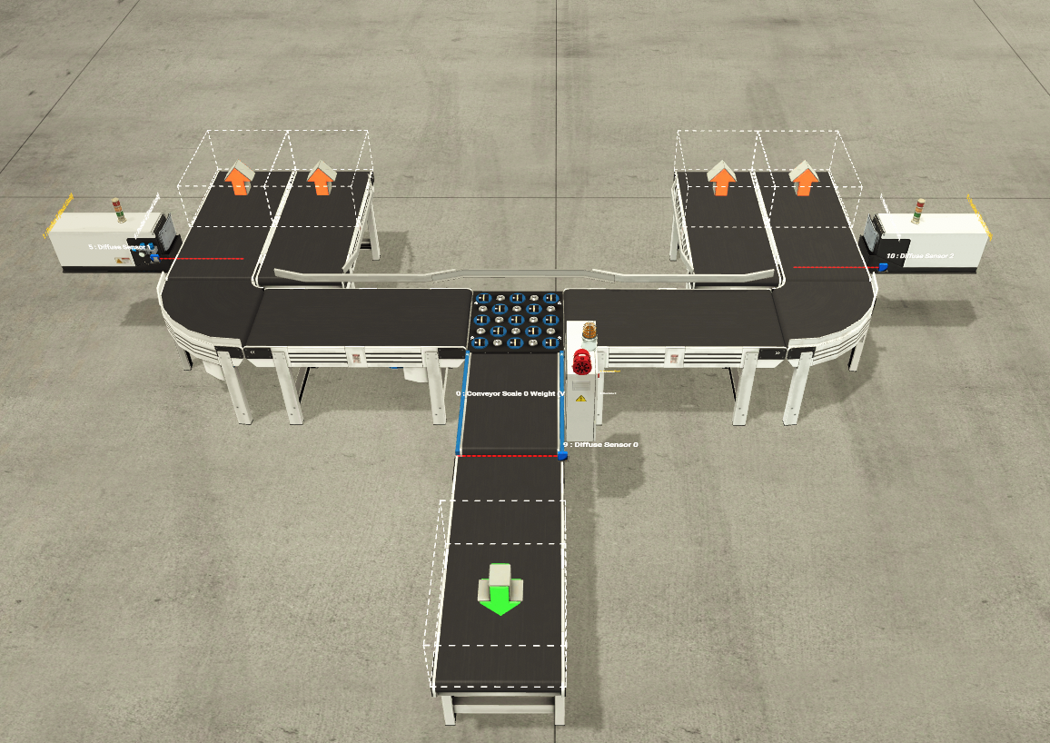
Figure 1: Factory I/O design.
Shown in Figure 1 is a screengrab of the Factory I/O system design. The system represents a conveyor-based sorting and weighing process, commonly used in industrial material handling and logistics environments. The layout is symmetrically arranged and designed to demonstrate controlled product flow, measurement, and diversion using a combination of conveyors, sensors, actuators, and operator interface devices.
At the centre of the system is a straight belt conveyor that serves as the main infeed line. Products enter the system from this conveyor and travel upward toward the central processing area. Integrated along this conveyor is a conveyor scale, which is used to measure the weight of each item as it passes over the weighing platform. This allows the system to make control decisions based on weight data, which is a common requirement in quality control and sorting applications.
The left and right sides of the system each consist of a straight conveyor, then a curved belt conveyor followed by a straight belt conveyor. The curved conveyors allow the products to change direction smoothly, enabling an efficient and compact layout. The straight conveyors on each side transport the products toward their final endpoints. At the end of each outbound conveyor, removers are installed to simulate the removal of items from the system, representing packaging, storage, or dispatch operations.
Diffuse sensors and an emitter are positioned at key points along the conveyors to detect the presence and movement of products. These sensors provide essential feedback to the control system, ensuring that the sorter activates at the correct time and that products are accurately tracked throughout the process. Sensor data also helps prevent collisions and ensures safe and reliable operation.
In addition to the material handling components, the system includes operator control and safety devices. A stack light is mounted near the central section of the system to provide visual status indication, such as normal operation, warnings, or fault conditions. The instrument panel includes a start button, stop button, and emergency stop button, allowing the operator to control system operation and respond quickly to abnormal situations. Audible and visual alerts, such as a siren and warning light, are used to signal errors or emergency conditions.

System Operation
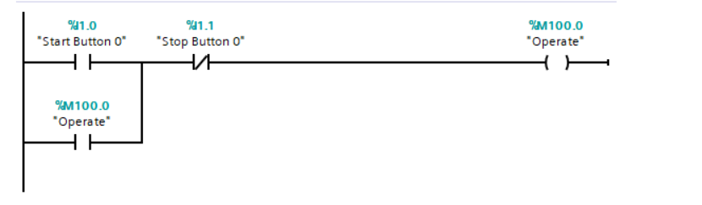
Figure 2: Network 1, Start button operation.
The ladder logic shown in figure 2 represents a basic start–stop control. The rung begins with a normally open contact labelled %I1.0 “Start Button 0”. When this push button is pressed, the contact closes and allows current to flow through the rung. In series with the start button is a normally closed contact labelled %I1.1 “Stop Button 0”, which ensures that the system can only operate when the stop button is not pressed.
At the end of the rung is the output coil %M100.0 “Operate”, which represents an internal memory bit used to indicate that the system is in an operational state. A parallel branch around the start button contains a normally open contact also labelled %M100.0 “Operate”. This creates a latching, or seal-in, circuit that keeps the system running after the start button is released.
When the stop button is pressed, the normally closed contact opens, breaking the circuit and resetting the operate bit, which stops the system safely.
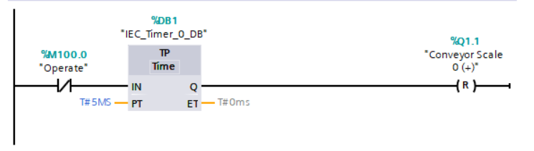
Figure 3: General reset for conveyor scale.
Shown in figure 3 is a section of the ladder logic which represents a general reset function for the conveyor scale using a timer-based control. The rung begins with a normally open contact labelled %M100.0 “Operate”, which ensures that the reset logic is only active when the system is in its operational state. When the operate bit is true, it enables the timer block %DB1, configured as a TP (pulse timer).
The timer has a preset time (PT) of T#5ms, meaning it generates a short pulse lasting five milliseconds. When the timer is triggered, its output Q becomes true for the duration of the preset time. This output is used to activate the reset instruction at the end of the rung.
The output coil %Q1.1 “Conveyor Scale 0 (+)” is marked with (R), indicating a reset coil. When energised by the timer pulse, it resets the conveyor scale signal, clearing previous measurements or states. Using a timed pulse ensures the reset occurs briefly and reliably without remaining active continuously, which helps prevent incorrect readings or unintended behaviour during operation.

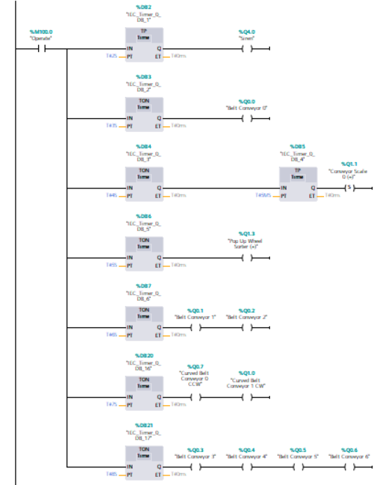
Figure 4: Conveyor operation
The ladder logic shown in figure 4 represents a time-sequenced startup routine for multiple conveyors, indicators, and the conveyor scale using a series of IEC on-delay (TON) timers. The entire sequence is enabled by the internal memory bit %M100.0 “Operate”, which acts as a master control signal. When this bit is true, the program begins executing the sequence from top to bottom.
Each rung contains a TON timer with a preset time that increases by one second for each subsequent rung. For example, the first timer is set to 2 seconds, the second timer to 3 seconds, the third to 4 seconds, and so on. This staggered timing ensures that system components are started in a controlled and orderly manner rather than all at once. Such an approach helps reduce mechanical stress, prevents sudden load changes, and improves overall system safety.
Once each timer reaches its preset value, its output (Q) becomes true and energises the associated output on that rung. Early timers activate the initial belt conveyors allowing products to begin moving through the system gradually.
One of the intermediate rungs uses a set (S) coil to enable the conveyor scale, ensuring that weighing only occurs once the upstream conveyors are fully running and stable. This prevents inaccurate measurements caused by premature activation. Another timed rung activates the top stack light, providing a visual indication that the system has reached a normal operating state.
Further down the sequence, paired outputs are activated together to control the curved belt conveyors simultaneously. The final rungs enable multiple conveyors simultaneously, indicating that the full system startup sequence has completed successfully.
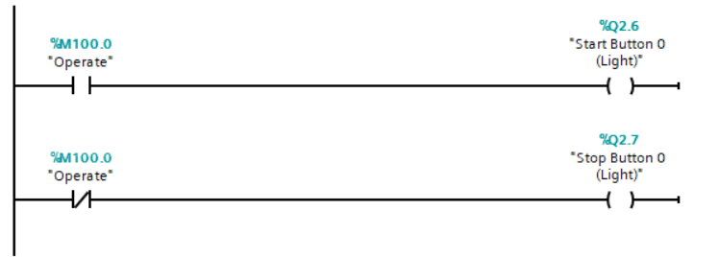
Figure 5: Light operation for buttons
Shown in figure 5 is the ladder logic to control the start and stop button lights. The sequence is also enabled by the internal memory bit %M100.0 “Operate”. When this bit is true, the program enables the output “%Q2.6” connected to the start button light.
The second rung of the network shows that when the system is not in its operating state, the output “%Q2.7” which is connected to the stop button light is enabled.
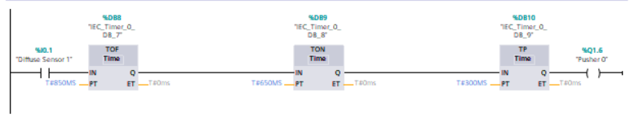
Figure 6: Operation for pusher 0.
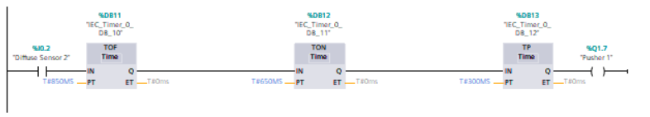
Figure 7: Operation for pusher 1.
Shown in figures 6 and 7 are the networks responsible for the operation of the pushers. Pusher 0, connected to the output “%Q1.6”, is activated when diffuse sensor 1, connected to input “%I0.1”, senses an object. When diffuse sensor 2, connected to input “%I0.2”, senses an object, pusher 1 is activated through output “%Q1.7”. On both networks, a series of timers are used to control the pushers.
When the diffuse sensor bit is true in either case, it enables the timer blocks %DB8 and %DB11, configured as TOF (time off delay), both with preset times of 850ms. This is then followed by the timer blocks %DB9 and %DB12, both configured as TON with preset times of 650ms, followed by timer blocks %DB10 and %DB13, both configured as TP with preset times of 300ms. When the timers are triggered, the outputs “%Q1.6” and “%Q1.7” become true for the duration of the preset times. This output is used to activate the pusher instructions at the end of each rung.
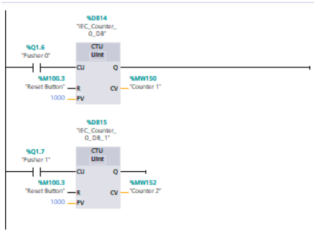
Figure 8: Network for counters.
Figure 8 shows the network responsible for counters 1 and 2. The first rung contains counter 1 which is triggered by pusher 0. The second rung contains Counter 2 which is triggered by pusher 1. Each valid pulse increments the counter value by 1.
Both counters have a common reset signal which is the reset button "%M100.3”. When this reset is activated, the counter values are both cleared and reverted to 0.
The preset value (PV)for both counters is set to 1000. When the current value (CV) reaches or exceeds the preset, the counters Q output becomes TRUE, indicating that the target count has been achieved.
Each counter stores the current value in a separate memory word: %MW150 for counter 1, and %MW152 for counter 2, allowing for the values to be displayed or used elsewhere in the control logic.
Separate data blocks (%DB14 and %DB15) are used to ensure the counters maintain their own data independently from each other.

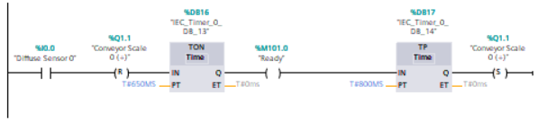
Figure 9: Network to set the conveyor scale.
Shown above in figure 9 is the ladder logic used to control the conveyor scale. When diffuse sensor 0, connected to input “%I0.0”, detects an object, it resets the conveyor output (%Q1.1) using a reset (R) coil, stopping the conveyor immediately. At the same time, the signal activates a TON with a preset time of 650ms. This timer ensures a short delay allowing the object to stabilise on the scale before further action.
Once TON finishes timing, its Q output turns on and enables the next stage, provided the “Ready” bit is true. This condition triggers a TP with a preset time of 500ms which generates a fixed-duration pulse.
The Q output of the TP timer sets the conveyor scale using a set (S) coil, restarting the conveyor for a controlled period.
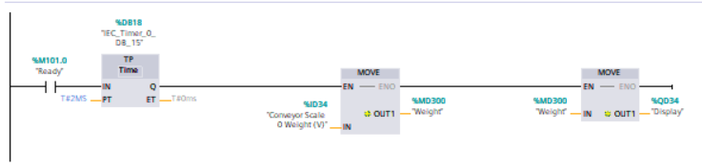
Figure 10: Network for weight measurement and display.
Figure 10 shows a ladder logic network used to periodically sample and display a conveyor scale weight using a timer and MOVE instructions.
The logic begins with a normally open contact with the “Ready” instruction. When this bit is true, the TP block %DB18 is enabled. The TP is configured with a preset time of 2ms, meaning that a short pulse is generated when the “Ready” signal transitions from false to true. During this pulse, the timers Q output becomes true, allowing the downstream logic to execute.
When the timer output Q is active, it enables the first MOVE instruction. The MOVE block copies the current conveyor scale value, stored in %MD24 and labelled “Conveyor scale weight (V),” into memory location %MD300 labelled “Weight”. This step effectively captures a snapshot of the weight at the precise moment defined by the timer pulse, rather than continuously updating it.
Following this, a second MOVE instruction is executed. It takes the value stored in %MD300 (Weight) and transfers it to %QD34, labelled “Display”.
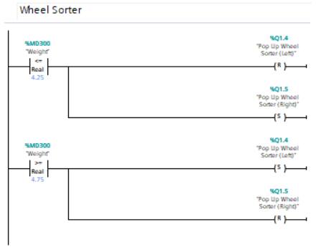
Figure 11: Network for wheel sorter operation.
Shown in figure 11, is the ladder logic network to control the direction of the popup wheel sorter, based on the weight stored in %MD300. The logic uses real-number comparisons with defined weight thresholds to determine which solenoid should be activated, ensuring the correct product routing or positioning.
In the first rung, the value of %MD300 is compared using a real-number “less than or equal to” condition against a threshold of 4.25. when the measured weight is less than or equal to 4.25, two actions occur simultaneously. The left popup wheel solenoid (%Q1.4) is reset using (R), turning it off, while the right popup wheel solenoid is set using (S), turning it on. This condition directs lighter products toward the right side of the conveyor by activating the right popup wheel and ensuring the left popup wheel remains inactive.
In the second rung, the same weight value is compared using a real-number “greater than or equal to” condition against a threshold of 4.75. When the measured weight is greater than or equal to 4.75, the logic reverses the solenoid states. The left popup wheel solenoid (%Q1.4) is set, activating it, while the right popup wheel solenoid is reset, deactivating it. This causes heavier products to be directed toward the left side of the conveyor.
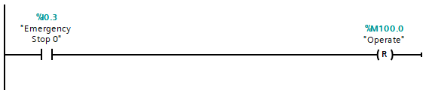
Figure 12: Emergency stop operation.
The network responsible for the operation of the emergency stop is shown in figure 12.
The logic begins with a normally open contact labelled “Emergency Stop 0” with the address %I0.3, which represents the button itself on the Factory I/O software. When the condition for this bit is met, the “Operate” instruction is reset using (R).
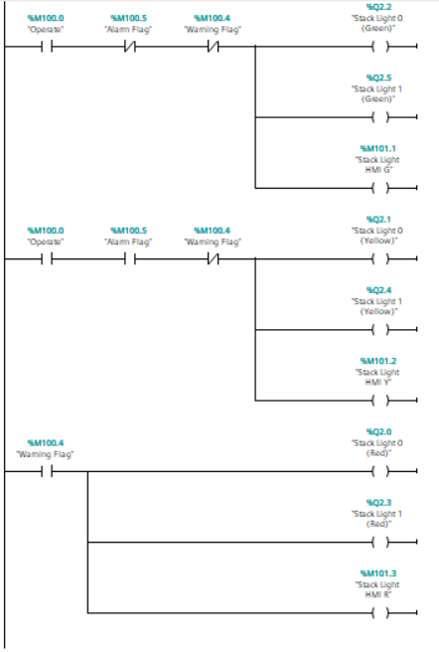
Figure 13: Network for HMI stack lights operation
Figure 13 shows a ladder logic network for control of a status-indication system using stack lights and HMI indicators to clearly communicate the operating condition of the system. The logic is divided into three main functional states – normal operation (green), abnormal or caution condition (yellow), and warning or fault condition (red). Each state is driven by a combination of internal status flags and directly controls both physical stack lights and HMI indicators, ensuring consistent feedback to operators on the interface.
The green stack light represents normal operation. This condition is active when the operate enable bit (%M100.0 “Operate”) is true, confirming the system is running or permitted to run. Two additional conditions must also be met: the alarm flag (%M100.5) and the warning flag (%M100.4) must both be inactive. These flags are implemented as normally closed contacts, meaning the green lights will turn off immediately if an alarm or warning condition arises. When all conditions are satisfied, the logic energises multiple outputs in parallel: two physical stack lights and one HMI indicator. This ensures that both local personnel and remote operators can quickly recognise that the system is healthy and operating as expected.
The yellow stack light logic represents an intermediate or cautionary state. This rung also requires the operator bit to be active, indicating the machine is running. In this case, the alarm flag (%M100.5) is used as a normally open contact, while the warning flag (%M100.4) remains normally closed. This combination allows yellow to indicate a non-critical abnormal condition where attention is needed, but the system has not reached a full warning or fault state. When these conditions are met, the yellow lights on both physical stack light towers and the HMI are energised. This design gives operators early visual notice of an issue while allowing continued operation.
The red stack light logic represents a critical condition or active warning. This rung is driven solely by the warning flag (%M100.4). When this flag is set, the logic energises all red outputs—two physical red stack lights and the HMI red indicator—regardless of operator status or alarm conditions. This ensures that critical faults are always visible and cannot be masked by other states. The red indication typically signals that immediate action is required, such as stopping the system or performing corrective maintenance.

