Level 6 Hotel Placement – Weekly Progress Tracker
Task: Maintain a weekly progress tracker documenting your experiences, tasks performed, challenges faced, and lessons learned. Bullet points format is welcome. You must submit this document to the designated Turnitin link by [Friday 7th March 2025] at 23:59pm.
I asked a wise man, “Tell me sir, in which field could I make a great career?”. He said with a smile, “Be a good human being. There is a huge opportunity in this area and very little competition.” --Jalal ud Din Rumi

Week 1
Experiences/Tasks/Challenges/Lessons  (outline hotel department) | Shift  (Date/Time) | Student Signature | Hotel Mentor Signature
Induction Experience

During the induction, we were welcomed just as we were in the first year. At the reception, when I mentioned that I was a student there for the induction, I was given an elevator access key and directed to the conference room where the session was being held.
Once the induction began, each student had to state their availability. When it was my turn, I explained that I could only attend on weekends (Sundays from 9 AM to 5 PM), and the same for Saturdays, with some exceptions. If an emergency arose at my workplace that required my presence in the morning, I would attend practice in the afternoon instead. Catherine from HR was supposed to cover the Health and Safety and Fire Procedures, but that did not happen. She said the Maintenance Manager was too busy and would cover these topics on the first day of our shifts instead.

Before starting my Placement
The next day, when I received my rota, I didn’t have the chance to check it immediately. However, when I finally did, I noticed I had been scheduled for Friday and Sunday despite my explicit availability request. I sent a message to HR, reminding them and politely asking for my days to be changed, but I never received a response.
All the knowledge I need to complete my assignments this year comes from my placement in the first year. I had expected this year to focus on gaining the necessary skills and knowledge to complete our academic work.
Ironically, the only thing I have “learned” this year is how to vacuum and wipe down tables, as you will read in the below stories:

Since I had requested Saturday and Sunday shifts and reminded HR about them, my schedule started on those days. I already knew most of the staff from my first-year placement, so I was somewhat familiar with the environment.  On my first shift, I was assigned to vacuum a 380-square-meter conference room. The carpet was filthy, and I wanted to do a thorough job because I tend to be a perfectionist. If I start a task (whether I enjoy it or not), I need to do it properly. While vacuuming, I decided to take a short break and asked where the smoking area was.  At that moment, an employee from Food and Beverage whom I knew from my previous placement, responded rudely, telling me I could only take a break after vacuuming the entire room. Given the carpet's dirty, I knew it would take a while, but I didn’t argue. I didn’t want to upset her further, especially since we had a good working relationship before. I figured she might just be having a bad day, so I complied without pushing back.  It took me almost four hours to finish vacuuming.  While working, I also had to move power supply extension leads scattered around the room. These were running 220V electricity, and although they were damaged and taped with insulation tape, I had not received any health and safety training at that point.  As a qualified motor engineer in Romania and the UK, I understand the risks of working with faulty electrical equipment. I wasn’t particularly concerned for myself but for my colleagues, who wouldn’t recognise the dangers unless they had prior training.  Once I finally finished, I went on my lunch break, which was supposed to last 30 minutes, but I only took 10 minutes to eat. Since I still had 20 minutes left, I asked the same person who give me the task, if I could take a smoke break.  She responded in the same rude tone, saying I had already taken a break, even though I had barely used a third of my allocated time. The conversation continued, and she sarcastically asked if, in my regular 8-hour job (even though I often work more), I take breaks whenever I want.  I didn’t want to turn the exchange into an argument or make it seem like I was trying to assert superiority, so I chose not to answer. The reality is that in my workplace, I take breaks when needed and allow my employees to do the same because I believe in giving people the freedom to manage their own time.  She still seemed irritated. After going to the kitchen, she returned and, in the same frustrated tone, told me to go home. So, I did.  I reported the entire situation to the Deputy Manager, who assured me this would not happen again. | First Week

Week 2
Experiences/Tasks/Challenges/Lessons  (highlight hotel department) | Shift  (Date/Time) | Student Signature | Hotel Mentor Signature
Shift Issues and HR Communication Failures  During my second week, I worked my first shift in Food and Beverage, cleaning tables and tidying up the restaurant, still scheduled for Saturday and Sunday as agreed.  At the end of my shift, I asked my colleagues if it would be an issue for me to miss Sunday, as it was my daughter’s birthday. By this point, HR was fully aware that I was only available on weekends since she had finally replied to my message (seven days after I had sent it). However, despite acknowledging my availability, she still had not updated the rota.  Before finishing my shift, I went to the reception and saw Angie, the Deputy Manager. Since I knew she had more authority, I told her directly about my situation, explaining that I couldn’t come in on Sunday because of my daughter's birthday. She assured me that she was already in contact with HR and would message her about it right away.  However, as soon as she sent the message, HR stopped responding and didn’t even read her messages. | Second Week

Week 3
Experiences/Tasks/Challenges/Lessons  (highlight hotel department) | Shift  (Date/Time) | Student Signature | Hotel Mentor Signature
Miscommunication, Frustration, and a Broken System  During the week of February 3rd, I received an email from Jessica, my university tutor, asking why I had missed four shifts and had only shown up once on a different day than scheduled. Since I wasn’t sure how to respond, I asked my colleague Anamaria to check with Catherine, the HR, about the situation.  When Anamaria asked, Catherine seemed irritated and told her to tell me to call her directly, making it clear that "we can’t just do whatever we want." I did call her, I have been told that “I need to comply with the hotel needs, not the other way around” and after clarifying the issue, she updated my rota. However, the first update was still incorrect. It took another correction before she sent the final version, but the rota remained wrong even then.  Meanwhile, I heard from my colleague that the situation had also changed for other students. She overheard the General Manager speaking with the F&B Manager, instructing him to assign students as many tasks as possible.  I have a demanding job, and when I enrolled in university, I accepted the workload that would come with it. I knew it wouldn’t be easy. But I didn’t expect to be put in a position where I felt humiliated simply for wanting to be more educated and learn. It’s incredibly disappointing, considering how much emphasis has been placed on inclusion and fairness in education (and not only) over the past few years.  Feeling frustrated, I scheduled a meeting with my tutor, Jessica. I wasn’t just upset about how I had been treated; I was also concerned that other students could face the same issues. The rota problems and how we were being treated weren’t just affecting me; they were part of a bigger pattern.  A System That Exploits, Not Educates  The reality is that students in this placement are being used as free labour. We are not learning anything relevant to our coursework. And without gaining the proper knowledge and experience, how are we supposed to write our assignments or graduate with the skills we were promised?  As a business owner, Southampton University contacted me asking if I would take students for placements. I refused because I didn’t have a large enough team to support and train them properly. If I were to accept students, I would need to assign a dedicated staff member to mentor them, ensuring they actually learn something instead of just doing menial work.  Taking in students to make them do basic cleaning or grunt work is not a placement; it’s exploitation. Students should be shadowing professionals, learning what the job entails step by step, not replacing paid workers by doing the most undesirable tasks.  This week, I was once again assigned to the F&B department.  Reflecting on my experience so far, I’ve realised that hard work is not necessarily rewarded. If you work extremely hard, follow all the rules, and do everything without question, they might let you leave two hours early. But if you push back or question anything, they will ensure you stay for your full eight hours, even if there’s nothing to do. | Third Week

Week 4
Experiences/Tasks/Challenges/Lessons  (highlight hotel department) | Shift  (Date/Time) | Student Signature | Hotel Mentor Signature
Resistance, Retaliation, and a Sudden Change in Attitude  This week, I was assigned to Front Office yet again given restaurant tasks instead. They asked me to clear tables and serve food, but this time, I refused. Before making my decision, I asked how many staff members were working in the restaurant, and I was told there were three employees, more than enough to handle the workload. My main reason for refusing wasn’t just the staffing situation; it was the fact that my rota only had me scheduled for one week in F&B, yet I had been placed there repeatedly.  When I explained this to the Deputy Manager at the Front Office, she stared at me, visibly irritated, even more so than before, because I had refused the restaurant tasks. She then told me that she didn’t have time for me that day because she was busy training a new employee and that it would be better if I went home.  At that point, I told her that I would actually love to sit in on the training, as it would also be valuable for my learning experience. She refused and insisted that I leave. So, I left.  Before leaving, I asked if they needed me to come in the next day. No one answered me.  A Student’s Work Taking Hours from Paid Employees  That same day, I also learned something concerning: the hotel had several employees on zero-hour contracts in the F&B department. One of them was a young gentlemen who was really looking forward to work, but he was not being called in for shifts anymore.  It turned out I had been taking shifts that should have gone to him. When I refused to work in F&B, he was suddenly called in again. This was a clear example of how students were being used as free labour at the expense of actual employees trying to earn a living.  On Sunday, I returned to complete my scheduled shift. This time, the Deputy Manager suddenly became very friendly to me.  Instead of the usual cleaning and food service, I was given tasks typically reserved for management, including:  - Check the leisure club (pool and spa) hourly and inspect rooms after housekeeping finishes cleaning, then update the system.  - Reviewing the online database for rooms reviews.  - Handling social media posts for the hotel.  She was genuinely satisfied with my work for the first time and had a completely different attitude; the change was almost too drastic to ignore.  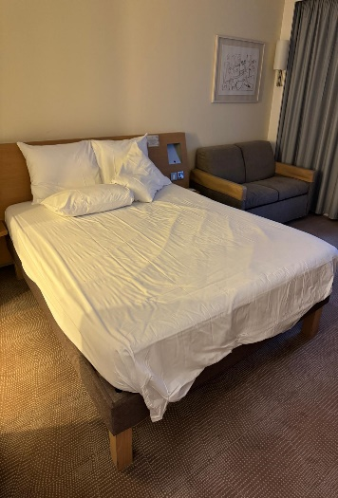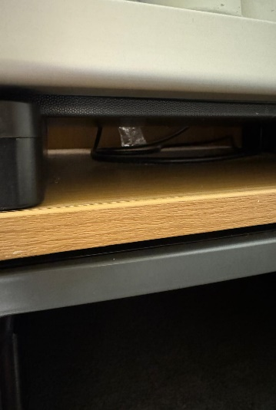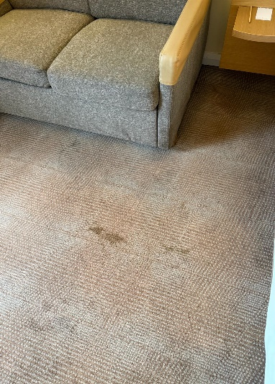  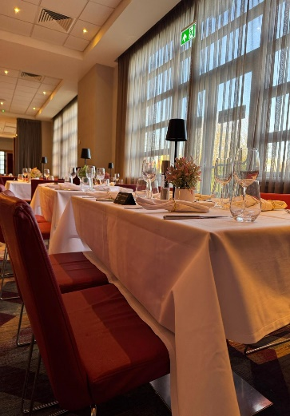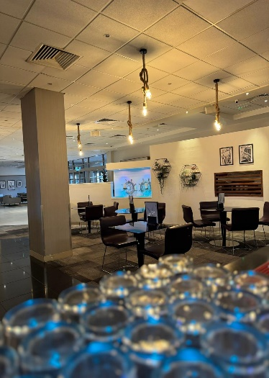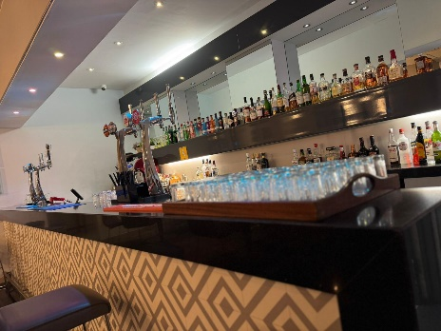  By the end of the day, I also rekindled my friendship with that staff from the F&B who give me the task to hoover on my first day. Given that we had known each other since my first placement, I questioned her previous attitude and asked what had happened.  At first, she seemed a bit embarrassed, but she admitted that she was put from someone in a higher position to act like that. She explained that if she didn’t follow their instructions, she would have had problems at work (at best), a tense environment, at worst, serious consequences.  She apologised, saying she knew she had treated me unfairly, but at the time, she didn’t know how else to handle the situation. She also admitted that she felt guilty about it afterwards.  I noticed something strange when I went to sign my attendance sheet at the end of my shift. The Deputy Manager Angie had written a comment in my section for the previous day, she wrote: “walked off.”  I found this odd because I hadn’t left voluntarily, she had told me to go home. | Week 4

Week 5
Experiences/Tasks/Challenges/Lessons  (highlight hotel department) | Shift  (Date/Time) | Student Signature | Hotel Mentor Signature
Shuffled Between Hotels and a Test of Boundaries  On this day, I was transferred from Novotel (the hotel where I had been doing my placement) to Ibis, which is managed by the same team.  When I arrived, a Front Office employee greeted me and handed me two sheets of paper. On them were the floor plans of two conference rooms that needed to be set up for upcoming events. The rooms were empty, and I was responsible for arranging everything from scratch: setting up the tables and chairs, placing the cutlery, and ensuring the entire setup was completed.  From how I was assigned this task, I could sense that the receptionist’s attitude carried a sense of superiority; it wasn’t a request but more of a delegation with an expectation that I would just accept it without question.  Seeing how much heavy lifting was required, I politely refused. I explained that I couldn’t do the setup alone because I understood how much physical work entailed. There were a lot of heavy tables and chairs that needed to be moved from storage into the conference room. However, I also clarified that I would be happy to help if it were a team effort.  Upon hearing my response, the receptionist immediately changed his stance, saying that he has no time to do that right away and told me he has nothing else for me.  I was careful with my words because I never wanted to come across as arrogant or dismissive; I wasn’t refusing the task out of pride. But I have a problem when people try to take advantage of others, mainly when they prey on those who are emotionally or mentally vulnerable.  What I understood from this situation was clear: students are being treated as free labour. The receptionist even admitted that the Deputy Manager had instructed him to give me those tasks. That, to me, was incredibly disappointing. Those in management used regular staff to pass down orders instead of taking direct responsibility.  After that exchange, I decided to return to Novotel. When I arrived, the Deputy Manager greeted me with a rhetorical question:  “What am I going to do with you, Cosmin?”  Honestly, I wasn’t sure how to interpret her tone. She wasn’t smiling, but she also wasn’t frowning. Ultimately, she gave me the same tasks as the previous week, and just like before, I had a good day at work. Everyone was satisfied, and there were no conflicts.  Since I wasn’t feeling well on Sunday, I sent Angie a message to inform her about my situation. She replied understandingly, saying it wasn’t a problem.  Having worked from a young age, I understand management dynamics and how to handle people. These aren’t just theoretical principles I learned at university; I practised them long before studying them.  From running a farm with my parents as a child to owning my own auto repair business in England, and even through various jobs along the way, I have experienced what it means to work under pressure and manage responsibilities.  The kind of attitude and pressure I’ve seen in this placement, however, can be damaging, especially for people who are more emotionally vulnerable. Not everyone can set clear boundaries or mentally withstand this kind of treatment.  In my case, I was fortunate to process everything internally, playing out different scenarios in my head about how conversations could go, imagining arguments with some people while finding understanding with others. But these thoughts never stopped running in the background, even as I did my usual work.  I don’t know how I would have handled this situation if I hadn't been mentally strong. Setting boundaries was crucial, and I am incredibly grateful to my tutor Jessica for providing guidance and support. Without that, things could have been much more challenging to deal with. | Week 5

Week 6
Experiences/Tasks/Challenges/Lessons  (highlight hotel department) | Shift  (Date/Time) | Student Signature | Hotel Mentor Signature
A Surprising Shift at IBIS Reception  This week, I was assigned to the reception at IBIS, and to my surprise, everyone treated me well. The atmosphere was noticeably different from my previous experiences, and I was given real responsibilities instead of just being used as extra labour.  While the receptionist on duty was handling tasks at the bar and restaurant, I was in charge of check-ins and check-outs, interfere with customers, and I was being showed how booking documents for reservations are made through Booking.com.  I wasn’t expecting to be given such responsibilities, so it was a pleasant surprise to be trusted with meaningful tasks.  Booking.com Documentation – More Complex Than Expected  One of the tasks that stood out to me was handling Booking.com documents. I found them complicated, and I questioned whether the effort was worth it—especially since learning the process takes time, particularly for someone unfamiliar with computerised booking systems.  It took me more then five minutes to process one document because I have a strong memory and can retain information quickly. However, even the team leader at reception admitted that these documents take a long time to complete, even for her.  Given what I saw, I personally wouldn’t recommend using Booking.com for reservations at all, especially since bookings can already be made through:  - The hotel’s website  - Phone reservations handled by reception (via ResaWeb)  - Expedia, which is also integrated into the booking system  Considering the unnecessary paperwork required for Booking.com, I think the hotel would benefit from shifting its focus to direct booking methods, which could simplify operations and reduce administrative workload for reception staff. | Week 6

Notes
Experiences/Tasks/Challenges/Lessons  (highlight hotel department) | Shift  (Date/Time) | Student Signature | Hotel Mentor Signature
The Reality of Placement  1. Vasile – A Hardworking Student Ignored by Management  My colleague Vasile is one of the most hardworking and kind people I have met. What struck me the most about him was that he still showed up for his placement despite having undergone surgery on his leg. He was also diagnosed with diabetes, a condition that only made healing from any surgical procedure more difficult. Managing his health meant keeping strict control over his condition, which required extra effort on his part.  Despite these challenges, no one took his health condition into account. He was assigned to carry extremely heavy tables and chairs, even though his physical condition was visibly compromised. His struggles became even more apparent when the blood vessels in his eyes burst, making his condition painfully obvious.  Still, with a family to support at home and fearing that speaking up could jeopardise his studies, Vasile never complained. He simply accepted every task, regardless of how inappropriate or unfair.  2. Justina – A Risk to Herself and Others  On another placement day, Justina, my colleague, showed up to work with a severe cold. She was initially supposed to work in the housekeeping department, but when the manager wasn’t available, she was sent to the restaurant instead.  Even though she was coughing heavily, they still placed her among customers, walking between tables.  Seeing this, I went to Angie, the Deputy Manager. I asked if she thought it was appropriate to send someone clearly contagious into a restaurant full of guests, especially considering that we had just come out of a pandemic. Justina was in the early stages of her illness, meaning she was highly likely to spread germs.  After my intervention, Angie finally acted, moving Justina to the back office, but only because I pointed it out.  Later, Angie tried to persuade the housekeeping manager (who had arrived in the meantime) to place Justina back in his department. When he asked me about her situation, I explained her condition, and seeing the issue the same way I did, he decided to send her home.  Despite this decision, Angie refused to let Justina leave. Instead, she reassigned her to making beds, completely disregarding the decision made by the housekeeping manager himself. | Student Stories
As of March 3, 2025, I still have not received any Health and Safety or Fire Procedures training despite being told it would be conducted during first day. | Health and Safety Training Still Missing (March 3, 2025)
Theory vs. Reality: What Students Expect vs. What Happens

I researched Novotel, Ibis, and other well-known hotel chains when writing our previous assignments. However, what I found in academic sources and official hotel policies had no real connection to what happens on-site.
From sustainability efforts to leadership models, what is written on paper differs entirely from the reality in these hotels.

The Purpose of Student Placement

I believe the student placement experience should align with the university handbook's expectations so that we have something meaningful to write about in our reports.
Some aspects of our work align with the university's requirements but are very few.
Let’s assume a hotel receives six students for placement. These students should be shadowing experienced staff, even if they assist with tasks.
Hotels should take advantage of the fact that universities send students for free, but they should do so in a way that benefits both the business and the students.
A proper student placement program should have a designated staff member responsible for training students (which should have been the HR manager in our case). This setup would save hotels money in several ways:
- Reducing recruitment costs
- Minimising onboarding and training expenses
- Preventing productivity losses
- Lowering administrative and contractual costs
- Improving team efficiency

If managed correctly, a placement program could function as a probation period without the hotel having to pay students or officially hire them. The hotels receive money for placing students at their locations, but the money could be reinvested to benefit both parties (in training, for example).
This approach would create a win-win situation, ensuring that students gain meaningful experience while the hotel benefits from recruiting and training potential future employees at a lower cost.

Students Are Not Free Labor

Another significant issue is that university education is not free.
Students pay a significant amount for their education, an amount that even an average person would struggle to repay, even with the help of student finance.
Because of this, placements should offer more educational value. The fact that we are students should not be an excuse for treating us as cheap labour. Instead, hotels should leverage this arrangement in a mutually beneficial way.
I understand that not all students will fit the industry perfectly. Still, considering the high number of students placed in hotels, a significant percentage will be genuinely interested and capable.
Interestingly, after speaking with multiple colleagues and acquaintances, many of us enjoy working in the hospitality industry.
Despite the mismanagement and poor treatment, we have realised that this field is dynamic and engaging with significant growth opportunities.

Not Everyone Will Speak the Full Truth

It’s also important to mention that not all of my colleagues will feel comfortable sharing the whole truth about their experiences. Some might hold back details or avoid discussing specific issues out of fear that it could negatively impact their grades. This is understandable, but it also means that the reality of our placements might not always be fully reflected in the feedback given to the university, nor that the university will understand it.

If I shift the focus to leadership, one key observation is that true leaders do not treat their employees with superiority.
A great example of effective leadership is Craig Poole, a highly respected hospitality professional known for his innovative management style and deep commitment to his team and community.
I first learned about Craig Poole in one of my previous university modules. His approach should be promoted across the hotel industry, mainly because this leadership approach fits this industry. He is a leader who makes a real impact, and remaining indifferent to his work is impossible.

I do not want this to come across as “complaining” or snitching. My goal is to raise awareness about a very real problem.
Many students fear speaking up because they worry about losing their education due to academic challenges or financial constraints.
But the truth is, we need to look out for one another, just as we are taught in all DEI (Diversity, Equity, and Inclusion) programs.
Change starts with us. Everyone is responsible for being an example, no matter where they stand in society.

Issues Observed

1. Kitchen Stock
- The kitchen often lacks essential ingredients, leaving customers with limited menu options.
- Restaurant staff must run back and forth between the kitchen and dining area to check which dishes are available, wasting time due to poor communication between departments.
2. Maintenance
- The maintenance team only works Monday to Friday, meaning that on weekends, only one person is on duty.
- However, one person is not responsible for fixing issues, they are only present in case of an emergency.
- Any maintenance problems reported on weekends remain unresolved until Monday at 9AM.
3. Conference Room
- Conference room management falls under the Food and Beverage department, adding extra workload to already overloaded restaurant staff.
4. Leisure Club
- The Leisure Club (pool, gym, and spa) is too small for the number of guests, especially during peak summer seasons.
- Cleanliness is well-maintained, but housekeeping issues are common in the hotel rooms.
- There are frequent complaints about bathroom mould and dust in hard-to-reach places.
5. Front Office
- The Front Office team is responsible for managing the Leisure Club, which adds to their workload instead of allowing them to focus on guest services.

The root of the problem? Leadership.
At the end of the day, all these problems stem from poor management.
But that’s a discussion for another time.

