Blog 1: Private company Coka-Pep Company. January 2021
Introduction.
The following blog reviewing/analysing Coka-Pep Company (C-P Co.) was written at a time when the Covid19 virus pandemic was still prevalent. Sources were used from several countries where this international corporation was trading. As a Multinational Enterprise (MNE) C-P Co. must be sensitive to different trading conditions and ethical standards in the regions it does business. Covid-19 conditions restricted the freedom of all organisations to operate in their normal way. C-P Co. however in selling a food product (soft drinks and related consumable goods) was exempt from trading lockdowns where food items could be sold, unlike non-essential products, apart from extreme regions where a full lockdown operated for short time periods. As Torres et al (2012) case analysis shows, definitions of CSR are complex and controversial and international companies’ data can be obscure and difficult to evaluate. Therefore, it is unlikely that this analysis will be accepted by all schools of thought.
01-01-21
Coka-Pep Company it was reported (International Marketing Today, 2021) has won an award for the most recognised international brand. It is reported that C-P Co. has been in the top 10 recognised brand list for the last 40 years, often being number 1.
Analysis.
In terms of C-P Co.’s CSR this story demonstrates that the company is a long-established operation, with international reach and is highly popular with its customers. As an established company, it should be expected to have a well-developed CSR policy and awareness of its general responsibilities. Younger or newly established companies may have a defence that they have not had time to develop their CSR approach and are still in their fragile commercial stage of the Product/Company Life Cycle, see Fig. 1. A young company at introduction or growth stage may be vulnerable to attack by competitors. To survive it may need to focus on profits. Established companies like C-P Co. are likely to use CSR as part of their brand extension strategy to maintain their operation in the face of new innovative entrants to the market.
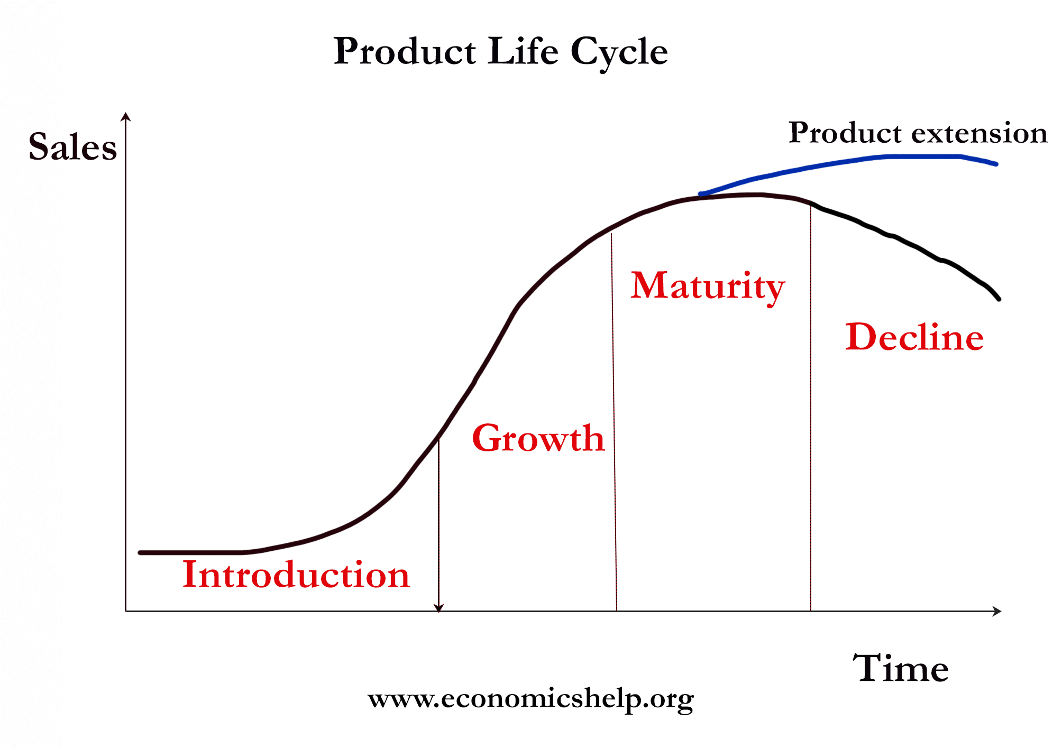
Figure 1: Product Life Cycle.
https://www.economicshelp.org/blog/140934/business/product-life-cycle/
As the Anderson Model (Anderson, 2000) demonstrates CSR policy evolves, starting with adoption of mission, policies, assignment of responsibilities and then internal and external audit of performance. This can take time. Few have achieved the final external audit stage.

Figure 2: Cornerstones of a Business Ethics Programme (Andersen, 2000)
C-P Co. has had many decades to develop this. Should it not be delivering CSR it would be open to criticism by ethical commentators and campaigners. As a private company it should be responsible to shareholders (Friedman, 1971) but also to the wider societies in which it trades (Freeman, 2004). As an international company it may need some flexibility in its policies or operating methods to respect different ethical, historical and legal conditions in the different countries it trades in. Therefore, the story creates a checklist of items which will be of interest for further investigation. Some MNE’s only pay minor attention to CSR (Sha, 2018) and may be accused of cosmetic PR statements, such as greenwashing, about environmental claims. (A Considered Life, 2021. https://www.aconsideredlife.co.uk/2019/09/what-is-greenwashing-examples.html). Sometimes called Blue Washing (Hamilton, 2015).
Interestingly C-P Co. does not appear in Truth in Advertising’s top 10 bad company list, unlike rival Coca Cola which is criticised in several categories (Truth in Advertising, 2021. https://www.truthinadvertising.org/?s=coca+cola)

02-01-21
The website of Coke-Pep Co. (www.c-pc.com) was interrogated to identify company statements of mission, policy and examples of policy implementation.
It appears that C-P Co.’s mission does have CSR elements, including commitment to healthy eating, workers’ rights and sponsoring sport and other philanthropy. At face value it seems that it could make a claim for being at every level of the Pyramid of Social Responsibility. Examples xxxxxx.

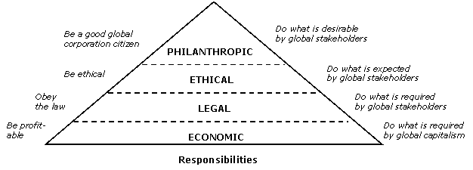

Figure 3 - Pyramid of Corporate Social Responsibility and Performance (Carroll and Buchholtz, 2003)
As stated, if the company is using its CSR to extend the brand, adopting good CSR might be both an ethical AND commercial/profitable development. Customers are increasingly sensitive to social concerns, willing to pay premium prices for ethical products and will give their loyalty to these. (Ethical Leadership, 2020). https://ethicalleadership.nd.edu/assets/256012/ethics_pays.pdf
Various policies are in evidence on the web site including:
- xxxxx
- Yyyyyy
- Zzzzz

Apart from changing some packaging and translation of brand logo, there does not appear to be different ethical standards in the different countries it trades in, therefore avoiding the allegation of moral relativism. (Crane et al, 2016)
In its stakeholder map, see Fig 4, the company lists all expected stakeholder, however it does not say how it communicates with them, establishes their wishes or what priority it gives. Since different stakeholders may have contradictory needs, it is important for the company to set priorities and explain its methods for doing this. Perhaps using Mendelow (Fig.5).
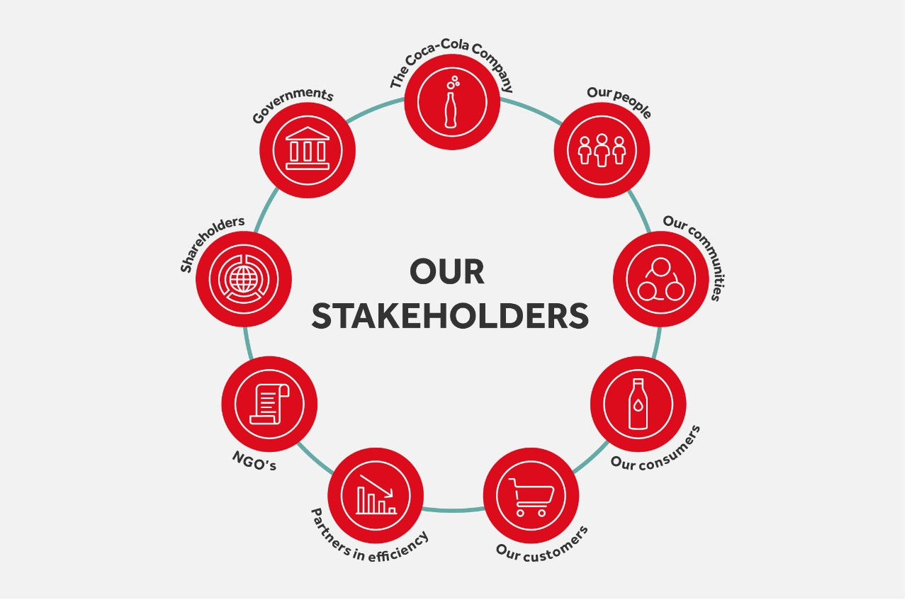
Figure 4: Drink company stakeholder map.
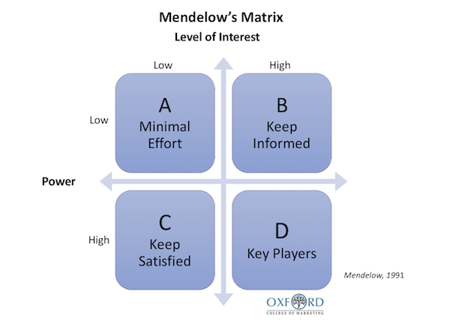
Figure 5: A mechanism to establish stakeholder priorities
Discussion xxxxxxxxxxxxx.
03-01-21 A search was made for negative stories about the company.
- An academic article (Sucros, 2018) analysed the soft drinks industry stating it overused sugar, additives and caffein. C-P Co. was mentioned as being in the list of companies. The company website (C-P Co. 2021) says that it is developing low sugar/no sugar alternatives, however it believes that consumers should be given a choice to buy these new and the full sugar older products.

Parental campaign groups also highlight this issue wanting to ban high sugar products (We hate fizz, 2019). The UK has introduced a Sugar Tax (the Soft Drinks Levy, 2018) as reported in Wired (2020). https://www.wired.co.uk/article/uk-sugar-tax#:~:text=In%202018%20the%20Soft%20Drinks,than%20%C2%A3340m%20per%20year.
However, it is not certain that it has changed consumer behaviour in favour of low-calorie drinks. It could be argued that customers should have the freedom to buy unhealthy products if they wish.
- Manufacturing does create environmental negative externalities. All manufacturing will have an impact -P Co. states that it is trying to minimise harms and is sponsoring a project at WuLee University to investigate more sustainable production and distribution of its projects (WuLee University Research Website, 2020)

However, in terms of packaging C-P Co. has developed biodegradable bottles which makes it more eco friendly compared with major competitor Coca Cola, voted worst plastics polluter for another year (Independent, 2019).
https://www.independent.co.uk/life-style/coca-cola-pollution-plastic-environment-coke-a9168921.html
- Like Coca Cola, C-P Co. also has a policy of recycling water as much as practicable. (Coca Cola, 2020) https://www.coca-colacompany.com/au/faqs/how-does-coca-cola-help-the-environment

- Use of water in manufacturing diverting supplies from local farmers, has been an issue in India (Gajupta, 2019). A wealthy MNE can sometimes buy facilities, despite objections from poorer locals to get what it wants. This would be a serious criticism of any global company. The Company defends itself by saying it pays above local prices and pays above local wages for the employees it uses in this region. It can therefore be debated whether C-P Co. is a net benefit to these regions or not.

- There was little evidence of consultation with stakeholders. Some consumer focus groups were reported. There was little direct response to campaign groups or demonstrators outside company headquarters in Fizzville, Florida. Therefore, stakeholder engagement was weak.

- Making false claims for good CSR causes disillusionment in the company workforce alleges Forbes (2016). Consistent CSR and good ethics must permeate the organisation if contradictions, hypocrisy and demotivation are to be avoided.

https://www.forbes.com/sites/danpontefract/2016/09/24/faking-corporate-social-responsibility-does-not-fool-employees/?sh=44e30bdc7994
- Radical organisations are unlikely to positively review MNEs (Ethical Consumer, 2020. https://www.ethicalconsumer.org/company-profile/coca-cola-company). However, their criteria are controversial, since they disapprove of animal testing, promote veganism, do not like political contributions etc. For most MNEs it would be difficult to please such anti global campaigners.

04-01-21
A news story (Wall Street Journal, 2021) alleges that C-P Co. has moved finance between different countries to avoid corporate taxes. It moves raw ingredients, semi manufactured syrups, development costs, to increase costs and lower prices in high tax and make profits in low tax countries, moving between its various corporate businesses. See organisational chart Fig 6.
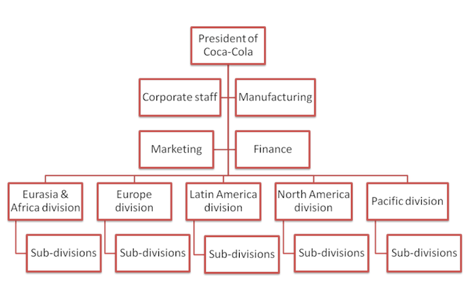
Figure 6: Coka-Pep Company Organisational Chart (Source, C-P Co. website)
The organisation is complex, and each division can be managed as a separate enterprise thereby creating an internal market to move ingredients and products to avoid tax.
The company denies that it is breaking any laws but is legally avoiding tax “like all other similar businesses in the industry” (Sam Dollar, C-P Co. International Finance Manager). Following the practice of other similar companies may not be a good guide to what the company should be doing.
Conclusion.
The ultimate rating of C-P Co. as a good or bad CSR example is problematic. As a large multinational it may show different faces in different countries. Its international presence may allow it to escape regulation of tax responsibilities.
However, it is very visible and often MNEs are targets for anti-globalisation protesters or the defenders of local small business interests.
Like most MNEs is states mission and policy which has CSR components. It does have policies and shows examples of good behaviours. Hence defining it as bad may be harsh. However, as a $ZZZbn operation which has been in business for almost 100 years, it might be seen as weak in its leadership role campaigning for improved health, environment and social welfare. As in the industry study in UK, many still believe companies are not fully committed but saying enough to avoid regulation or action by government (Topić et al, 2021).
Perhaps ‘good but not good enough’ for those who follow Freeman. From a Friedman perspective they may be doing too much since many of their policies go further than necessary as defined by legal obligations.
In the moral-amoral-immoral spectrum, C-P Co. can make a case for at least saying moral things, but may also show some examples of amoral behaviour, prioritising profit making. Immortality may be too harsh a criticism since it does sell a valued product and does have examples of good behaviours.
https://www.writersdigest.com/write-better-fiction/a-moral-vs-amoral-vs-immoral-grammar-rules#:~:text=Here%20are%20a%20couple%20examples%3A&text=Correct%3A%20An%20immoral%20person%20knows,Math%20is%20an%20immoral%20subject.
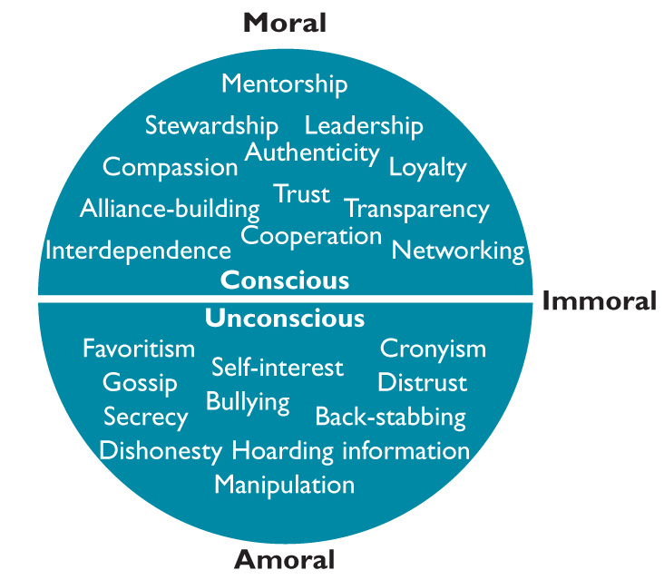
Figure 7: Immoral-Moral spectrum. https://thesystemsthinker.com/organizational-politics-using-your-power-for-good/
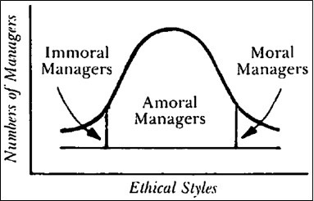
Figure 8: Carroll’s view https://ibsiblog.haas.berkeley.edu/beyond-yourself-moving-management-from-amoral-to-moral/
As Carroll stated most of us are in the Amoral section and need to improve.

Bibliography.
Andersen, A. (2000) Ethical Concerns and Reputation Risk Management. London, Arthur Andersen.
Bowie, N.E. & Werhane, P.H. (2005) Management Ethics, Oxford, Blackwell.
Campbell, J.L. (2007) Why Would Corporations Behave in Socially Responsible Ways? - An Institutional Theory of Corporate Social Responsibility, Academy of Management Review, Vol. 32 No.3, pp. 946-67.
Cannon, T. (1996) Corporate Responsibility, London, Pitman.
Carroll, A.B., and Buchholtz, A.K. (2003) Business and Society: Ethics and Stakeholder Management, 5th ed. New York, Thomson South-Western.
Crane, A., Matten, D., Glozer, S. & Spence, L. (2016) Business Ethics, Oxford, OUP.
Elkington, J. (1997) Cannibals with Forks: the Triple Bottom Line of 21st Century Business, London, Capstone.
Ethical Consumer (2020) Soft Drinks CSR, https://www.ethicalconsumer.org/food-drink/shopping-guide/soft-drinks, (Accessed 02-01-21)
Freeman, E.R., Wicks, A.C. and Parmar, B. (2004) Stakeholder Theory and ‘The Corporate Objective Revisited’, Organization Science, Vol.15 No.3, pp. 364-69.
Friedman, M. (1970) The social responsibility of business is to increase profits, The New York Times Magazine, 13 September, Vol. 13, No. 32-33, pp. 122-126.
Hamilton, J.M. (2015) The EKOCENTER: A Case Study in Coca-Cola, Corporate Social Responsibility, and Bluewashing, MBA Thesis UNIVERSITY OF MINNESOTA.
Topić, M., Bridge, G. and Tench, R. (2021), "Mirroring the zeitgeist: an analysis of CSR policies in the UK’s food, soft drink and packaging industries", Journal of Global Responsibility, Vol. ahead-of-print No. ahead-of-print. https://doi.org/10.1108/JGR-04-2020-0047
Torres, C.A.C., Garcia-French, M., Hordik, R., Nguyen, K. & Olup, L. (2012) Four Case Studies on Corporate Social Responsibility: Do Conflicts Affect a Company’s Corporate Social Responsibility Policy? Utrecht Law Review, http://www.utrechtlawreview.org | Volume 8, Issue 3 (November) 2012 | URN:NBN:NL:UI:10-1-112903

Topić, M., Bridge, G. and Tench, R. (2020), "Mirroring the zeitgeist: an analysis of CSR policies in the UK’s food, soft drink and packaging industries", Journal of Global Responsibility, Vol. ahead-of-print No. ahead-of-print. https://doi.org/10.1108/JGR-04-2020-0047

Abstract

Purpose
The purpose of this paper is to explore changes in corporate social responsibility (CSR) policies in food, soft drinks and packaging industries to capture changes in CSR implementation given increased environmental activism. The paper takes an exploratory approach in reviewing CSR policy changes to explore to what extent companies change CSR policies with increased environmentalism.

Design/methodology/approach
A comparative website analysis was used to analyse CSR policies of companies in the food, soft drinks and packaging industries in the UK. The companies were selected for the analysis based on their annual turnover and 23 companies were analysed (seven for the soft drinks industry, eight for the food industry and eight for packaging industry). Five interviews were conducted with packaging and retail professionals, and the findings were analysed by using thematic analysis, which captured trends in responses.

Findings
The findings show that companies are implementing and communicating CSR policies heavily focussed on reducing the environmental impact of their work and matching social debates on human rights, with which traditional CSR policies (corporate governance, supporting local communities and consultation with stakeholders) are fading away. Instead, companies have shifted attention towards the gender pay gap, modern slavery and extensive environmentalism. The interviews with packaging professionals and CSR managers from the retail industry show that the packaging industry designs CSR policies in line with requests from supermarkets, which are, in turn, influenced by consumer activism.

Practical implications
This paper shows the circular relationship between media coverage, consumer activism, which comes as a result, and the impact and changes this brings to the industry. To avoid reputation damage, companies should closely follow media debates to pre-empty consumer criticism and activism.

Social implications
The findings show that companies are “mirroring the zeitgast” and going with trends to meet consumer expectations, which brings into question the sincerity of CSR policies and revives the criticism of capitalism and raises a question whether CSR is used by companies as a smokescreen that on the outset makes a difference to the society but keeps status quo intact.

Originality/value
The paper provides an insight into CSR implementation of three industries that faced heavy criticism from campaigners and the general public for their environmental impact. The paper shows how the CSR policy shifted to match this expectation and thus provides a good ground for studying the evolution of CSR using a case study from three selected industries.

Torres, C.A.C., Garcia-French, M., Hordik, R., Nguyen, K. & Olup, L. (2012) Four Case Studies on Corporate Social Responsibility: Do Conflicts Affect a Company’s Corporate Social Responsibility Policy? Utrecht Law Review, http://www.utrechtlawreview.org | Volume 8, Issue 3 (November) 2012 | URN:NBN:NL:UI:10-1-112903

