APPROACHES TO RESEARCH AND ACADEMIC COMMUNICATION
LCDB 7000
Habib Ayodeji (1812672)



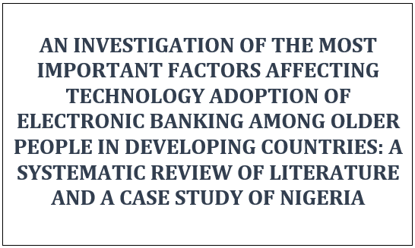

Table of Content
Table of Contents
Table of Content 2
1.0 PART ONE 3
1.1 Introduction 3
1.1.1 Introduction 3
1.2 Systematic Review Methodology and Summary of Results 3
1.3 Literature Review 6
1.3.1 Why Study Factors Affecting Adoption of E-Banking by Older Adult in Nigeria? 6
1.3.2 Literature Re-Occurring Themes and the Factors Affecting Older Adults’ Adoption of Electronic Banking 7
1.4 Summary 9
2.0 PART TWO 10
2.1 Discussion of one of the Research Works 10
3.0 Conclusion 15
References 16
Appendices 20
Screenshot of Systematic Literature Review without much refinement 20
Screenshot of Systematic Literature Review with more refinement 20

1.0 PART ONE

1.1 Introduction

1.1.1 Introduction
From trade-by-barter to cash payment, the payment for goods and services has been central to human development right from time immemorial. This payment for good obtained or service rendered has however undergone various transitions in alignment with human civilization. With the rapid development of technological advancement and the consequent leveraging of technological power to solving some of the world’s contemporary problems, the use of electronic banking (e-banking) services has gained huge momentum in the world over. Jayshree (2013), however, argued that despite the enormous advantages and potentials of e-banking, most developing countries economy are still cash-driven. But how can it be considering the advantages far outweighs the little demerits provides a lingering question which needs answers.
From a historical perspective on the Nigeria banking industry, it was argued in extant literature that e-banking provided the needed platform to realizing the dual focus set by the Central Bank of Nigeria after her 2005 consolidation exercise. During this process, the apex bank argued that maximising returns and optimizing profitability was the major milestone which exacerbated the need for e-banking in the biggest economy in Africa (Akpan, 2009; Olalekan, 2011). While expanding on this, Olalekan (2011) argued that one of the ways of achieving these aforementioned focus set by the apex bank is through increased customer base with better satisfaction which can be easily facilitated by e-banking. However, while its use has been established in extant literature and echoed by industry practitioners alike as the solution to the many problems of traditional banking, the adoption has not correlated with the potentials and even its use in western worlds. It is however, pertinent, to say while this has been documented, more of the younger population is believed to adopt e-banking system as compared to the older adults, people from 50 years. This as such provide a huge market yet to be captioned.

1.2 Systematic Review Methodology and Summary of Results
With the need to review literatures in my field that spans ten years period, it was believed that a systematic review would be most appropriate with the timespan criteria scheduled to meet up with this given yardstick. Consequent upon this, this adopted research methodology is best depicted in the figure below:
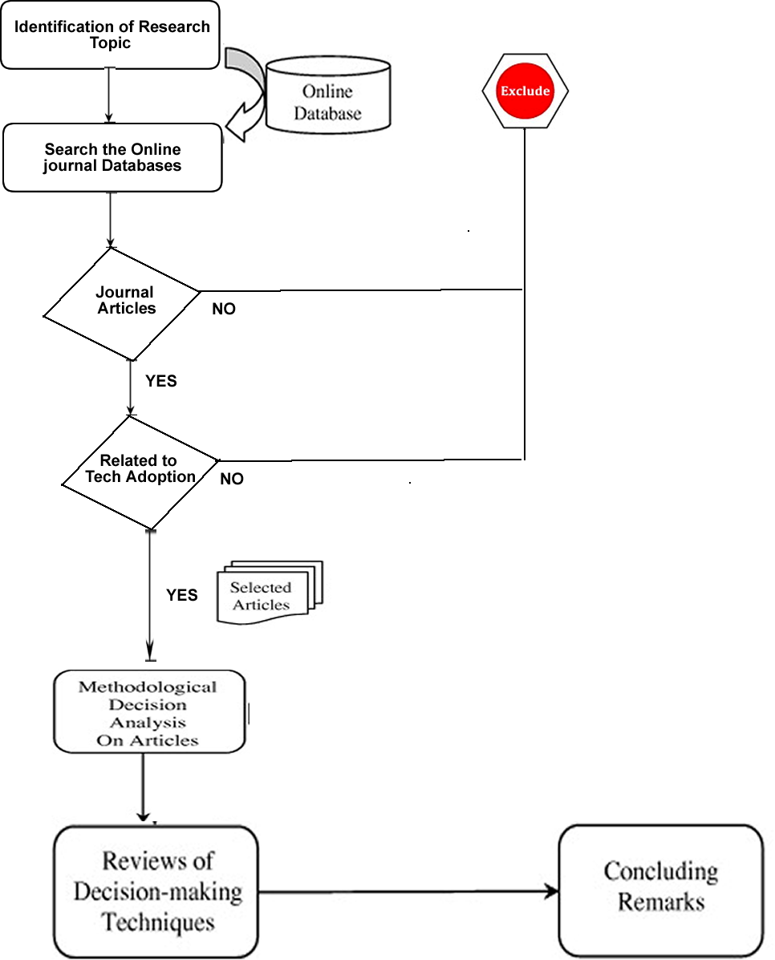
Figure 1: Systematic Literature Review (Adapted from Chai & Ngai (2013))

Thus, we define the conditions to limit the search results in other to enhance the resulting relevance and manageability of the results. The assumptions and/ or conditions are below thus:
- Only published articles in computer science, decision science or business-management related fields were selected because those articles will most possibly be in harmony with the topic under discourse. Journal databases like EBSCO host, ABI/ INFORM, Scopus, Science Direct, ProQuest and IEEE Xplore among others were searched. This method of reviewing articles from leading journal article database is a contemporary practice adopted by many a researchers like Wamba (2013), others (like 4 others). It simply constitutes what’s termed systematic review of literature. The literature being only articles. Wamba (2013) gave justification for this by further positing that academic researchers mostly use journals as they represent constant work in progress for researchers and industry leaders alike.
- Except research work that are foundational to technology adoption research area like Davis (1989) which was foundational for the Technology Acceptance Model (TAM), and Fishbein (1975) which was foundational for the Theory of Reasoned Action (TRA) among others, a ten year period, 2010-2010 was used to refine the relevance and the contemporariness of the articles. This is also in alignment with the requirement definition detailed in the module.
- To enhance the relevance even more, international journal articles with certain level of acceptance were selected.
Summarily, the results of the ten-years’ record is depicted below thus:

Table 1: Reviewed Database for Journal Articles
S/N | DATABASE/ Journal | The organic Results without ‘older adults’, and other filters. However, it includes the 10 years period. | With other filters including older adult keywords, peer reviewed journals, English language, disciplines,
1 | ProQuest Central (new) | 11,516 | 224
2 | ABI Inform Complete | 10,317 | 141
3 | Directory of Open Access Journals | 375 | 37
4 | SpringerLink | 392 | 11
5 | PubMed Central | 98 | 6
6 | Oxford Journals | 98 | 6
7 | Sage Journals | 183 | 6
8 | Science Direct Journals (Elsevier) | 38 | 1

However, with all the filters and after removing the redundancies of the articles published on those journal articles, we have only 247 articles left from a potential 21,719 articles. Out of these 247 articles, none was in the same context as this work. This further provide the needed justification for this research work.

1.3 Literature Review

1.3.1 Why Study Factors Affecting Adoption of E-Banking by Older Adult in Nigeria?
The world demographics is changing – and doing so – rapidly. According to the United Nation’s forecast of all member countries, world population would grow to a staggering 9.8 billion from its present 7.6 billion. Among the ten most populous countries, Nigeria which stand as the 7th most populous country is however growing faster than the rest (United Nation, 2017). While looking at the implications of this population growth and the world’s changing demographics, United Nation (2019) stated that Nigeria, with a projected populationn of 411 million (Provost, 2013), would be the third most populpus country in the world behind only India and China in that order by 2050. With this huge projected population growth, it’s suffix to say it would affect the economy massively. Nigeria, at the moment, remains the largest economy in not just West Africa but Africa at large (Wright, 2014) and it’s rightly regarded as one of the fastest growing economies in the world with the potential to become an economic powerhouse. Consequenly, it is only understandable to see why many an investors are investing in the country for their long term benefits.
Another insight from the changing demographic dynamics is in the older population. In fact, the United Nation (2017) projected that in relation to 2017, the number of people aged 60 or above is expected to double by 2050 and triple by 2100. That is; from a figure of 962 million people globally, it will skyrocket to a staggering 2.1 billion by 2050 and 3.1 billion by 2100. This figure represents a huge market that needed to be exploited and more importantly would change the dynamics of the market and require a better understanding of the underlying intricacies. Considering e-banking is a trillion dollar market in Nigeria, understanding the factors affecting the technology adoption of older adults in Nigeria would generally see to a better adoption rate and prosperity.
Besides the need to look at the older adults in the context of developing countries, and Nigeria in particular, which has been well established from the business parlance, there seems to be paucity on a research with the same context in extant literatures. In fact, on putting ‘older adults’ as a key word to search the journal databases, the results which is in twenties of thousands reduced so drastically to a meagre two hundred plus. While there are examples of countries from developing countries: for instance; Nasri’s (2011) peer-reviewed journal article which looked at the factors influencing the adoption of internet banking in Tunisia (a detailed research article but which did not look at the same demographics and same country); Yee’s (2013) which looked at the gender and age effect on acceptance of internet banking in United States and Malaysia from cultural perspectives (a research article which prides itself in the comparison of two countries – one developed and one developing countries but not an extensive look on either of the country); and Akturan & Tezcan’s (2012) research which looked at mobile banking and directed its research demographic to the youth market among others. As such, as with the need in the practical business world, there is paucity of such in the academia and as such also provide another justification to look at this exact context.

1.3.2 Literature Re-Occurring Themes and the Factors Affecting Older Adults’ Adoption of Electronic Banking
In extant literatures, several models or theories were foundational and the basis upon which a lot of contemporary studies on technology adoption were built. These include the Theory of Reasoned Action (TRA), the Technology Acceptance Model (TAM), the Diffusion of Innovation (DOI), Theory of Planned Behaviour (TPB), Decomposed Theory of Planned Behaviour (DTPB) and the Unified Theory of Acceptance and Use of Technology (UTAUT) among others (Akturan & Tezcan, 2012; Bambore & Vikas, 2017; Chai & Ngai, 2013; Dixit & Datta, 2010; Gücina & Berka, 2015; Haque, et al., 2009; Nasri, 2011; Olalekan, 2011; Yee, 2013; Yi, et al., 2006). These theoretical underpinnings and assumptions span various industries and sectors like healthcare (Abdekhoda, et al., 2015; Fan, et al., 2018; Garavand, et al., 2016; Gücina & Berka, 2015; Hossain, et al., 2019; Idoga, et al., 2018; Or, 2014; Wamba, 2013; Zayyad & Toycan, 2018); banking services (Akpan, 2009; Akturan & Tezcan, 2012; Bambore & Vikas, 2017; Dixit & Datta, 2010; Nasri, 2011; Olalekan, 2011; Yee, 2013); and others.
Generally, however, these theories were basically classified into two streams: the diffusion of innovation and the other models that look at the intention which includes TRA, TAM and TPB. The diffusion of innovation, introduced by Rogers (1995), investigates determinants such as those characteristics on innovation, individual adopter, information sources and communication. While buttressing this submission Rogers (1995) further argued that characteristics of innovation traditionally consists of observability, trialability, complexity, relative advantage and trialability among others which are related to the adoption of a technology solution. The other category which places emphasis on the intention include TRA, TPB and DPTB. While Fishbein & Ajzen’s (1975) theory of reasoned action, perhaps the earliest of these popular theories, put the determinants of people’s intention to include the duo of attitude and the social influence, the theory of planned behaviour further added perceived behavioural control (PBC) to the duo of attitude and subjective norm to make the variables three. Just like the TPB is an upgrade of the TRA, the decomposed theory of planned behaviour (DPTB) is also a modified version of TPB and it structurally reflects these improving changes by adding set of decomposed belief structures which has relatively better diagnostic values. For TAM, two changes were noticeably present. One is the removal of social norm and the other is the addition of the duo of perceived usefulness and perceived ease of use to its determinants of behavioural intention. These variables come as re-occurring themes in many research work.
It is, however, pertinent to emphasize that these re-occurring themes/ variables from various reviewed articles were tested on their applicability to various contexts: countries, industries, sectors and demographics among others. For instance: Bambore & Vikas (2017) used perceived usefulness and perceived ease of use, the original variables of Davis’ (1989) Technology Acceptance Model (TAM), to investigate the factors affecting e-banking adoption and it’s impact on customer satisfaction; as well as the amalgamation of all the variables from eight models or theories in the Unified Theory of Acceptance and Use of Technology (UTAUT) which the likes of Kim, et al. (2015), Venkatesh, et al. (2012) and Zuiderwijk, et al. (2015) as well as others used.
As stated earlier, Perceived Usefulness (PU), which is an important and a second part of the technology acceptance model, is believed to affect technology adoption in various industries including banking (Ezzi, 2014). Davis (1989) defined PU as the degree to which someone believes that a particular system would enhance his/ her job performance. In technology adoption knowledge area, there have been varying level of correlation between this PU and technology adoption: from e-library and students (Yusoff, et al., 2009) to 3G mobile services and the subscribers as well as in e-banking services (Akturan & Tezcan, 2012; Bambore & Vikas, 2017; Nasri, 2011), this raises that lingering question: could perceived usefulness be a factor affecting technology adoption of electronic banking by older adults in Nigeria? Providing fact-based answers to this in a scientific manner would surely make for an interesting research objective.
Besides the perceived usefulness, Zaid, et al. (2010) while looking at the need to adopt electronic banking also highlighted the Perceived Risk or Security as one of the factors of technology adoption and, in particular, in e-banking. An empirical investigation by Bestaws also gave credence to this theoretical assertion which postulated that people are generally scared of sharing their financial details online. While also highlighting the importance of perceived risk as a factor with huge importance to e-banking adoption, Zaid, et al. (2010) described it as a sad “potential for loss in the pursuit of a desired outcome of using e-banking services” Several researchers are also in alignment with this and believe that perceived risk affect the consumer adoption. Whether it is particularly applicable to this context is a potential huge topic of discourse
Another important recurring theme, which make up the technology acceptance model in addition to the aforementioned perceived usefulness, is perceived ease of use (PEOU) (Bambore & Vikas, 2017; Davis, 1989; Idoga, et al., 2018). Consequently, it was also established in many literatures as a determinant factor on the adoption of e-banking services. However, whether it is applicable to the exact context remains to be seen. Looking at the description of PEOU which Ilham, et al. (2012) which he described as “the degree to which a person believes using a particular system would be free of effort”, could this be a huge factor than others considering higher percentage of the Nigeria population is not computer or information technology literate in relation to the western world.
In the same vein, subjective norm which refers to a consumer’s perception of the social pressure to do or not do something go a long way in judging potential usage of a product or services including those of e-banking. While some research work shows this is substantially and significantly supported, others are not therefore creating further need for understanding the intricacies as it pertains to this context.
More so, besides the perceived usefulness (PU), perceived ease of use (PEOU), perceived risk and security (PRAS) and subjective norms (SNs), there are other recurring themes that those reviewed journals intermittently and sparingly overlaps across literatures. Prominent among them is the internet connectivity/ accessibility which would have never came as a hindrance in western countries considering the well-entrenched internet connectivity. But it’s sure to come up in a country with less than 40% internet penetration.

1.4 Summary
Consequent upon the need for literature review, the author went for a strategic literature review owing to the insights it gives. As such, several re-occurring themes were noticed. The first being the use of the foundational models and theories of technology adoption like technology acceptance model (TAM), theory of reasoned action (TRA), theory of planned behaviour (TPB), decomposed theory of planned behaviour (DTPB), and unified theory of acceptance and use of technology (UTAUT) among others. And the other being the use of the determinants fetched from these theories which were eventually used in testing various applications of technology acceptance. These are the perceived usefulness, perceived ease of use, perceived risk and security, subjective norms and others like internet connectivity.

2.0 PART TWO

2.1 Discussion of one of the Research Works
TITLE: Factors Affecting E-Banking Adoption and Its Impact on Customer Satisfaction: Case Study of Ethiopian Banks.
OVERVIEW OF RESEARCH: Bambore & Vikas’ (2017) looked at the factors affecting e-banking adoption and its impacts on customer satisfaction while using Ethiopian Banks as case studies. Having shown the paucity with research article of the same context in the extant literature, it is imperative to choose one which bears a close resemblance. More importantly, that the central theme which is to look at the factors affecting e-banking adoption as well as the use of a developing country as a case study make it appropriate. It adopted a quantitative research methodology in which data was collected via a self-administered survey from selected banks in Ethiopia. It is pertinent to say, the work is based on the David’s (1989) Technology Acceptance Model (TAM) in that it is upon the variables from the theory that the research hypotheses for this study was built.
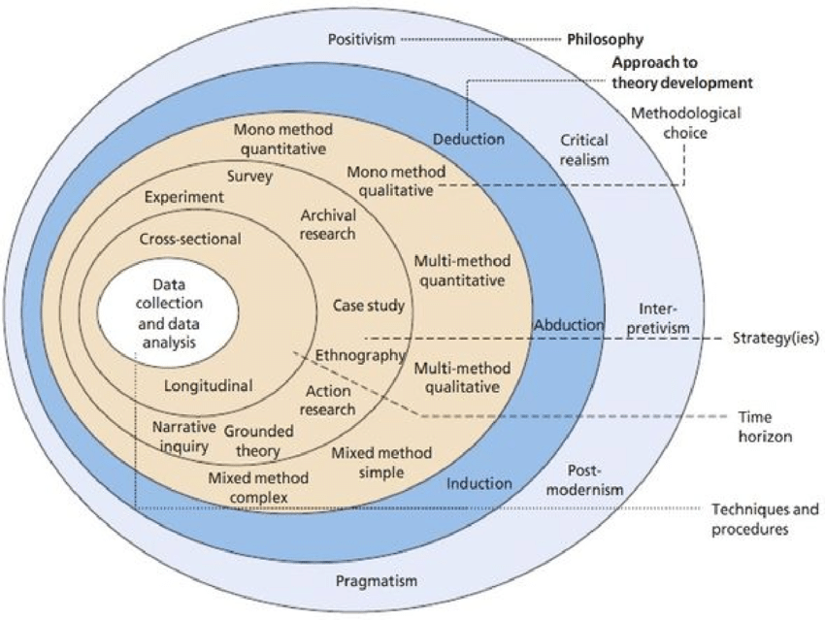

Using Saunder’s research onion, it is easy to follow the organized way of the adopted research methodological constructs and review the article based on such.
On Research Philosophy: In this research, a positivistic research philosophical stance was adopted. While there are many research philosophies, the positivist philosophy allows the researcher to adopt structured approach to the investigation as argued by Saunders, et al. (2009). Gill and Johnson (2002) also buttressed this and argued that it allows for proposition testing by investigating the applicability of the constructs of theories on a given situation. In this case, it is even understandable considering technology acceptance model (TAM) constructs were checked to see if they are applicable and if they are factors that affect internet banking in Ethiopia. This stance was not archaic to these kinds of studies. In fact, based on the systemic review of the articles used in this research. About 95.75% of the 47 articles reviewed adopted positivistic research philosophical stance therefore providing a justification of the adoption. This includes Nasri’s (2011) research on the factors influencing the adoption of internet banking in Tunisia; Akturan & Tezcan’s (2012) research which looked at mobile banking of the youth market and Yee’s (2013) work which looked at the gender and age effect on acceptance of internet banking in United States and Malaysia among others. The list is endless.
On Research Approach: While there are three popular research approaches, deduction always goes with the positivistic philosophical stance as, according to Collis & Hussey (2003), it allows for testing previously designed theory; in this case TAM instead of induction which allows for the formulation of new theories.
On Methodological Choice: As with other research methodology paradigms, there are several choices here which can be broadly classified as mono-methods (the research process that made use of a single method), multi-methods (the research process that made use of two or more methods – usually, either quantitative methods or qualitative methods) and mixed methods (the research process that allow for various method and which allows combining the qualitative and the quantitative methods). In this research, a mono-method of quantitative was adopted. This is also the dominant practice in research in this knowledge area of factors affecting technology adoption.
On Research Strategy and Time Horizon: Just as I intend to adopt a case study, Nigeria, for this work, this research under review also adopted a case study approach using Ethiopian banks. While case study research allows for an extensive research to be conducted on a single entity, the unsuitability to generalize the findings is its main demerit, Saunders (2012) posited. For instance, the factors affecting technological adoption of internet banking in Ethiopia might – and would most possibly – be different from that of Nigeria yet both are developing countries and in Africa. As such, a singular case can be faulty in generalizing research findings.
More so, most research work in this knowledge area are cross-sectional too and as such not surprising to find this one as such. Though a longitudinal research approach can be handy at times, considering it’s a research that take place over a long period of time, it could be pricey especially when research grants are not involved.
On Data Collection: A properly structured questionnaire was used in collecting data from the respondents who have, at one time or the other, used internet banking before. While the sampling size was properly calculated, I am of the opinion that the enormous resources expended on the data collection would have been better utilized by increasing the spread of the bank customers that participated in the study instead of increasing the branches of the same bank. This is further exacerbated by the fact that e-banking applications and products in different branches of the same banks are the same and as such more probable to generate the same results and experience. However, these e-banking applications and products are different from banks to banks and they could have potentially great influence on the research outcome. Summarily, while a lot of people were surveyed, they can be regarded as homogeneous as against a potential heterogeneous population that spread across a lot of Ethiopia banks.
On the Theoretical Model and the Knowledge Framework: As clearly written in the report, the constructs used in this study were technology acceptance model (TAM) which were highlighted and tested if they affect the Ethiopian Banks. This is depicted in the figure below thus:

Figure 2:Research Framework based on TAM (SOURCE: David (1989, cited in Bambore & Vikas, 2017))
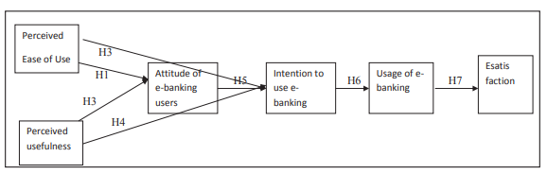

More so, while TAM is the most popular of all technology acceptance theories or models and has provided bases for various similar research works like Holden, et al. (2016) it has been argued that it, some researchers have argued that the model is now archaic and not entirely applicable to all technology acceptance studies (Idoga, et al., 2018). Other researchers, especially the promoters of Unified Theory of Acceptance and Use of Technology (UTAUT), have particularly promoted this as a better model in that it encompasses previous theories or models like the Theory of Reasoned Action (TRA), Theory of Planned Behaviour (TPB), Technology Acceptance Model (TAM), and five more. Because it is an amalgamation of eight models/ theories, it is believed to be mire encompassing, better and applicable to wider subjects (Kim, et al., 2015; Venkatesh, et al., 2012; Zuiderwijk, et al., 2015).
On Questionnaire Design: While the reviewer does not have access to the questionnaire, it is of my hope that the instrument is very easy and not one with leading questions as this would distort the research.
More so, on the research instrument, it was pointed out that a five-point likert scale was adopted for the research. This is in alignment with a lot of previous research which used similar scales and as such would not need for the researcher to re-scale before comparison of results. However, with the potential accruable benefits of a seven-point likert scale, I might be tilted to use it only if one could have access to the questionnaire instruments. John Dawes however argued on three instances to outline the nuances of the 5-point and 7-point likert scale as mean score; variations in the measuring constructs; and the duo of kurtosis and skewness. In terms of mean score, both the five and seven scale likert offers higher mean score than the ten-point scale and this difference is statistically significant. Saunders et al. (2012) further buttressed this and argued that it is understandable to believe that the 5-point likert scale is more popular in extant research because it offers slightly more mean score than its seven-point counterpart. However, the seven-point likert scale allows for more variations in measuring any researched construct. However, an important caveat is given here in that if you have a lot of constructs to test, then this becomes difficult for the respondents. As such, Dawes (2008) advised that this should be mostly used if the questionnaire instruments is less than 10 and with large sample sizes. Of the skewness and kurtosis, there are little, almost inconsequential, differences between the two.
Considering the questionnaire items are unknown, it is difficult to say which point is best suitable. In this case, I would evangelize for the five-scale likert scale. However, with the large sampling size, if the questionnaire items are less than 10, I would suggest a 7-point likert scale irrespective of the previous studies.
On Data Analysis: The data analysis was good. Prior to getting the data, a pilot test was conducted with the internal reliability checked with Cronbach’s Alpha and Exploratory factor analysis (EFA) there improving the main data collection. After the pilot test, that a usable 590 usable questionnaires were gotten is good for EFA as it requires a minimum of 200 sample sizes which this didn’t just meet but far exceeds. It is also good that the data are homogeneous and the outliers removed. Summarily, the exploratory factor analysis (EFA), confirmatory factor analysis (CFA) and structural equation model (SEM) were properly used and results were excellent except perhaps in one which will be looked at in the validity and reliability issue
On Normality, Validity and Reliability: Bambore & Vikas’ (2017) argued that the standardised estimate which is the slope coefficient was normalised to between -1/ +1. The reliability of the research instruments was ensured by first conducting a pilot study and Cronbach’s Alpha as well as EFA which was used to ensure its reliability before eventually rolling it out. While this Cronbach’s coefficient was not known (i.e., it was not disclosed) as it is part of the pilot stage, considering it was argued in the report to be good, then I’ll believe the value is between 0.8 and 0.9 in which Or (2014) denotes shows a good reliability image. The author did reliability testing by asking professionals that are informed of the knowledge area to comment. More so, the face validity, construct validity and reliability, convergent validity, discriminate validity, were all done and found correct based on the outputs.
On Research Ethical considerations: Having read through the report, the below was noted:
- That the research was not sponsored by someone with the hope of influencing the research findings.
- That there is respect and dignity for research recipient and they were not subjected to any hard or so whatsoever.
- That the respondents’ response was reported in summary format only thereby enhancing the confidentiality of the collected information.
- That there is due acknowledgement of work of others with full referencing as when due.
- There is no use of offensive or discriminatory messages on the report.
As such, it is of my professional view that the work attained the required level of ethical considerations during the course of the research.

3.0 Conclusion
Besides the conclusion which take hold of section 3, this report is mainly divided into two sections: section one and two. For brevity, section one represents the literature review of a knowledge area in the last ten years (2010 - 2020) as requested. It nevertheless contains some references outside these years boundaries and are not just considered foundational to the knowledge area, they are also very significant. Section two, on the other hand, details an extensive article review of one of the sources used in the report using the Saunder’s onion structured approach so as not to miss any research paradigm.
Summarily, the need for this research isn’t borne out of industry’s need alone, there is an established paucity in academic in this particular context. As such, the report can lay credence to certain level of originality.

References
Abdekhoda, M., Ahmadi, M., Gohari, M. & Noruzi, A., 2015. The effects of organizational contextual factors on physicians’ attitude toward adoption of Electronic Medical Records. Journal of Biomedical Informatics, 53(1), pp. 174 - 179.
Akpan, I., 2009. Cross Channel Integration and Optimization in Nigerian Banks. Telnet Press , 20(1), pp. 1-4.
Akturan, U. & Tezcan, N., 2012. Mobile banking adoption of the youth market. Marketing Intelligence & Planning, 30(4), pp. 444-459.
Bambore, P. L. & Vikas, S., 2017. Factors Affecting E-Banking Adoption and Its Impact on Customer Satisfaction: A Case Study of Ethiopian Banks. International Journal of Marketing & Business Communication, 6(1), pp. 16-28.
Chai, J. & Ngai, E. W. T., 2013. Application of decision-making techniques in supplier selection: A systematic review of literature. Expert Systems with Applications, 40(10), pp. 3872-3885.
Christopher, G., Mike, C., Visit, L. & Amy, W., 2006. A Logit Analysis of ELctronic Banking in New Zealand. International Journal of Bank Marketing , 24(3), pp. 360-383.
Collis, J. & Hussey, R., 2003. Business Research: A Practical Guide for Undergraduate and Postgraduate Students. 2nd ed. Basingstok: Palgrave Macmillan.
Curran, J. M., Meuter, M. L. & Suprenant, C. F., 2003. Intentions to use self-service technologies: a confluence of multiple attitudes. Journal of service research, 5(3), pp. 209-224.
Davis, F. D., 1989. Perceived usefulness, perceived ease of use and user acceptance of information technology. Management Information System (MIS) Quarterly, 13(3), pp. 318-340.
Dawes, J., 2008. Do data characteristics change according to the number of scale points used ? An experiment using 5 point, 7 point and 10 point scales. International Journal of Market Research, 50(1), pp. 1 - 20.
Dixit, N. & Datta, S., 2010. Acceptance of E-banking among Adult Customers: An Empirical Investigation in India. Journal of Internet Banking and Commerce, 15(2), pp. 1-17.
Ezzi, S. W., 2014. A theoretical Model for Internet banking: beyond perceived usefulness and ease of use. Archives of Business Research, 2(2), pp. 31-46.
Fan, W., Liu, J., Zhu, S. & Pardalos, P., 2018. Investigating the impacting factors for the healthcare professionals to adopt artificial intelligence-based medical diagnosis support system (AIMDSS). Annals Operation Research, pp. 1 - 26.
Fishbein, M. & Ajzen, I., 1975. Belief, attitude, intention and behaviour: An introduction to theory and research. Reading: Addison-Wesley.
Garavand, A. et al., 2016. Factors influencing the adoption of health information technologies: a systematic review. Electronic Physician, 8(8), pp. 2713 - 2718.
Gill & Johnson, P., 2002. Research Methods for Managers. 3rd ed. London: Sage.
Gücina, N. Ö. & Berka, Ö. S., 2015. Technology acceptance in health care: An integrative review of predictive factors and intervention programs. Procedia - Social and Behavioural Science, 195(2015), p. 1698 – 1704.
Haque, A., Ismail, A. Z. H. & Daraz, A. H., 2009. Issues of E – Banking transaction: An Empirical Investigation on Malaysian Customers Perception. Journal of Applied Sciences, 9(10), pp. 1870-1879.
Holden, R. J. et al., 2016. Nurses' perceptions, acceptance, and use of a novel in-room pediatric ICU technology: Testing an expanded technology acceptance model. BMC Medical Information Decision Making, 16(1), pp. 145 - 153.
Hossain, A., Quaresma, R. & Rahman, H., 2019. Investigating factors influencing the physicians’ adoption of electronic health record (EHR) in healthcare system of Bangladesh: An empirical study. International Journal of Information Management, 44(2), pp. 76 - 87.
Idoga, P. E., Toycan, M., Nadiri, H. & Çelebi, E., 2018. Factors affecting the successful adoption of e-health cloud based health system from healthcare consumers' perspectives. IEEE Access, 1(1), p. 99.
Ilham, S., Bambang, B. S., Chee, W. M. & Nik, K. N. M., 2012. A Structural Equation Modeling of Internet Banking Usage in Malaysia. Journal of Arts, Science & Commerce, 3(1), pp. 75-86.
Jayshree, C., 2013. Internet Banking - Benefits and Challenges in an Emerging Economy. International Journa of Research in Business Management, 1(1), pp. 19-26.
Johnson, 2005. Overview of Electronic Payment Systems in Nigeria: Strategic and Technical Issues. Central Bank of Nigeria, 29(2), pp. 68-71.
Kim, S., Lee, K.-H. & Hwang, H. a. Y. S., 2015. Analysis of the factors influencing healthcare professionals' adoption of mobile electronic medical record (EMR) using the unified theory of acceptance and use of technology (UTAUT) in a tertiary hospital. BMC Medical Information Decision Making, 16(1), pp. 12-26.
Nasri, W., 2011. Factors Influencing the Adoption of Internet Banking in Tunisia. International Journal of Business and Management, 6(8), pp. 143-160.
Olalekan, A., 2011. E-banking Patronage in Nigeria: An Exploratory Study of Gender Difference. Business Intelligence Journal, 4(2), pp. 243-252.
Or, C. e. a. 2., 2014. Private primary care physicians' perspectives on factors affecting the adoption of electronic medical records: A qualitative pre-implementation study. Work. A qualitative innovetive , 48(4), p. 529–538.
Owoseye, O., 2019. It’s Official: Nigeria gravely lacks doctors to address citizens’ health needs. [Online]
Available at: https://www.premiumtimesng.com/health/health-investigations/309633-its-official-nigeria-gravely-lacks-doctors-to-address-citizens-health-needs.html
[Accessed 25 April 2019].
Pickett, L. et al., 2012. Ajzen's Theory of Planned Behavior as it Relates to Eating Disorders and Body Satisfaction. North American Journal Of Psychology, 14(2), pp. 339-354.
Provost, C., 2013. Nigeria expected to have larger population than US by 2050. [Online]
Available at: https://www.theguardian.com/global-development/2013/jun/13/nigeria-larger-population-us-2050
[Accessed 25 April 2019].
Rogers, E. M., 1995. Diffusion of Innovations. 4th ed. New York: The Free Press, a Division of Simon & Schuster Inc..
Saunders, M., Lewis, P. & Thornhill, A., 2012. Research Methods for Business Students. 6th ed. Harlow: Pearson.
United Nation, 2017. World population projected to reach 9.8 billion in 2050, and 11.2 billion in 2100. [Online]
Available at: https://www.un.org/development/desa/en/news/population/world-population-prospects-2017.html
[Accessed 30 November 2019].
United Nation, 2019. World Population Prospects 2019. [Online]
Available at: https://population.un.org/wpp/Publications/Files/WPP2019_Highlights.pdf
[Accessed 30 November 2019].
Venkatesh, V., Thong, J. Y. & Xu, X., 2012. Consumer acceptance and use of information technology: Extending the unified theory of acceptance and use of technology. MIS Quaterly, 36(1), pp. 157 - 178.
Wamba, S. F., 2013. A literature review of RFID-enabled healthcare applications and issues. International Journal of Information Management, 33(1), pp. 875 - 891.
Wright, C., 2014. After The BRICS Are The MINTs, But Can You Make Any Money From Them?. [Online]
Available at: http://www.forbes.com/sites/chriswright/2014/01/06/after-the-brics-the-mints-catchy-acronym-but-can-you-make-any-money-from-it/
[Accessed 23rd January 2015].
Yee, Y., 2013. Gender and Age Effect on Acceptance of Internet Banking: Cultural Comparison between United States and Malaysia. International Journal of Business and Management, 8(18), pp. 1-11.
Yi, M. Y., Fiedler, K. D. & Park, J. S., 2006. Understanding The Role of Individual Innovativeness in The Acceptance of IT-Based Innovations: Comparative Analyses of Models and Measures. Journal of Decision Sciences, 37(3), pp. 393- 426.
Yusoff, Y., Muhammad, Z., Pasah & Robert, E., 2009. Individual Differences, Perceived Ease of Use, and Perceived usefulness in the E-Library Usage. Computer and Information Science, 2(1), pp. 76-83.
Zaid, A.-B., S, A. M. R. & Halima, S. R., 2010. Do we really need to adopt electronic banking?. Singapore, IACSIT Press .
Zayyad, M. A. & Toycan, M., 2018. Factors affecting sustainable adoption of e-health technology in developing countries: an exploratory survey of Nigerian hospitals from the perspective of healthcare professionals. PeerJ, 6(4), pp. 1 - 15.
Zeithaml, V. & Bitner, M., 2003. Services Marketing: Integrating Customer Focus Across The Firm. 3rd ed. Boston, MA: McGraw-Hill Irwin.
Zuiderwijk, A., Janssen, M. & Dwivedi, Y., 2015. Acceptance and use predictors of open data technologies: Drawing upon the unified theory of acceptance and use of tech nology. Government Information Quarterly, 32(4), p. 429–440.

Appendices

Screenshot of Systematic Literature Review without much refinement
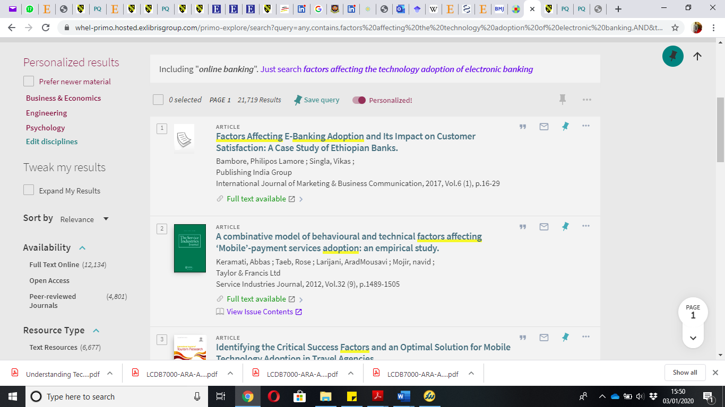

Screenshot of Systematic Literature Review with more refinement


