BSC HEALTH AND SOCIAL CARE BMHP5003_BIRM
INTRODUCTION TO PHYSIOLOGY
TUTOR-MUMTAZ GHOOLAM

Poster Presentation THE DIGESTIVE SYSTEM

NAGEENA AHMED 1808213
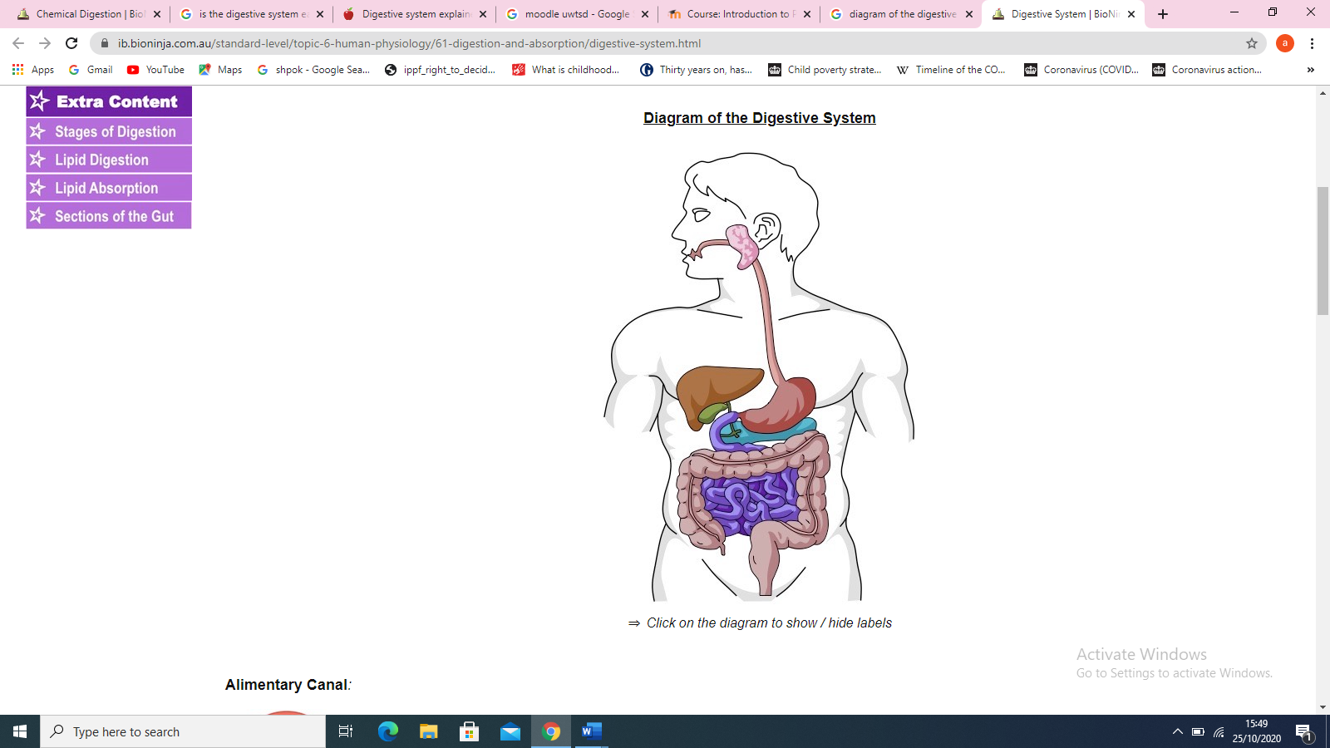
The Digestive System
SALIVARY GLAND gets active to start the process of chewing

LIVER produces bile to breakdown fat
GALL BLADDER stores bile
LARGE INTESTINE compacts waste material
SMALL INTESTINE- made of 3 parts duodenum, jejunum, ileum
OESAPHUGUS carries food to the stomach
STOMACH turns food to chyme
PANCREAS secretes juices and produces insulin
RECTUM/ANUS waste exits the body
The Physiology and Analogy of the Digestive system is made up of different organs working together in the process of digesting food we consume daily. Homeostasis plays a vital role in maintaining the human body systems, homeostasis regulates the internal environment to process energy and ultimately survive, an imbalance may cause threat to health even life ( Waugh.Grant 2014)

(Cleveland clinic n.d)

(Image taken from bio ninja, n.d)
The digestive system divides its organs into two main categories. The first group is made up of the alimentary canal whilst the second group is made of the accessory organs. The accessory group consists of the liver, pancreas, salivary glands and gallbladder these are vital for the function of the digestive system.
(Dworken 2020)

Wall of the alimentary Canal
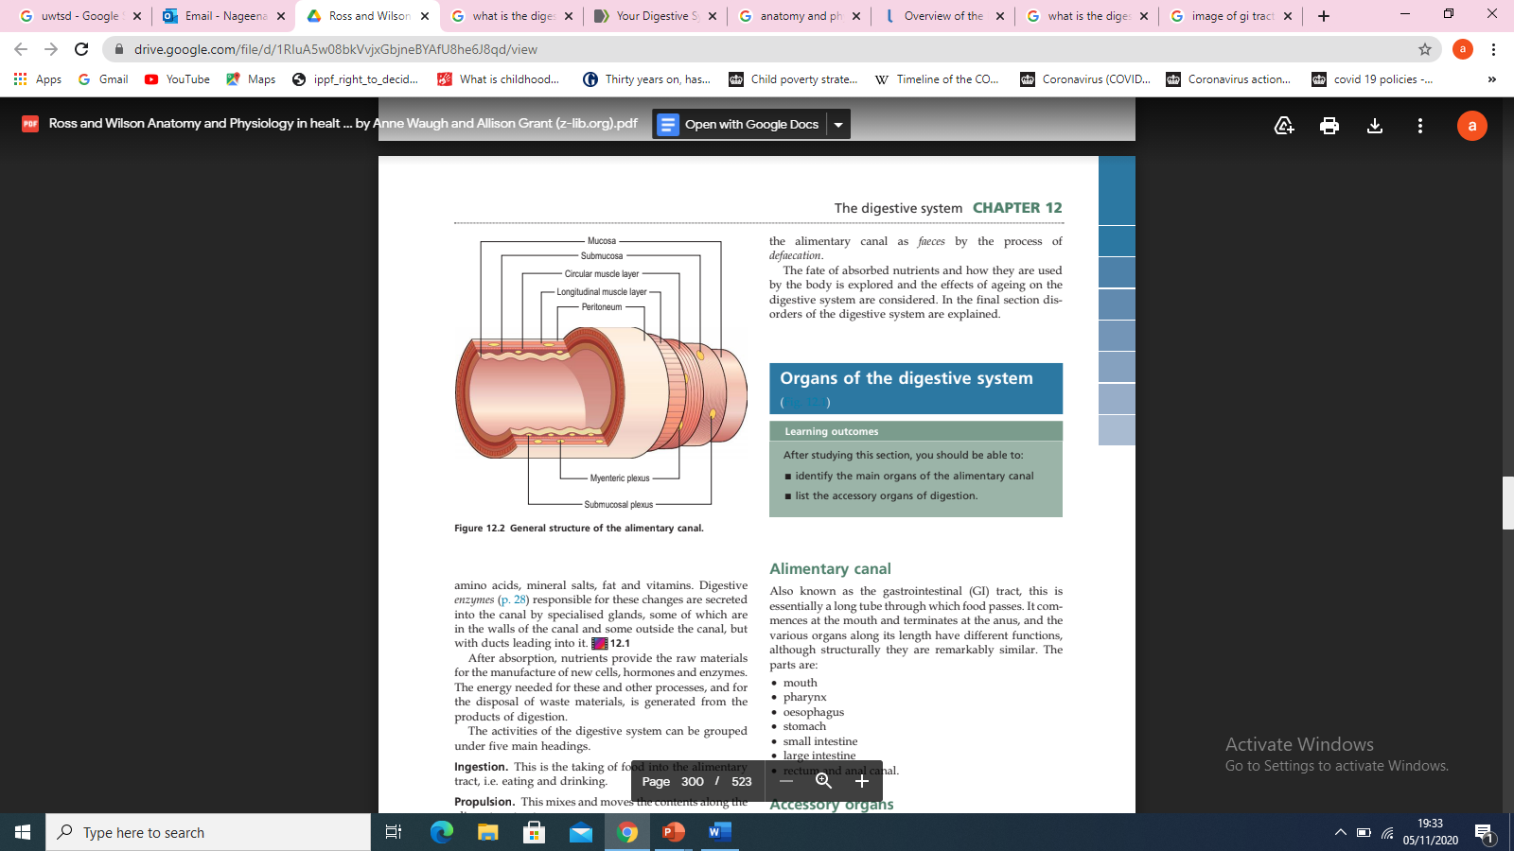
Submucosa
Muscularis

Serosa

Mucosa

( Image sourced: Ross and Wilson, edition 12)
6 Processes of Digestion
EXCRETION OF WASTES – the closing function of the digestive system is the excretion of waste also known as defecation. This process removes indigestible substances from the body, so they don’t sit in the gut. Defecation is controlled by the brain and must take place on a regular basis (Taylor, 2020)

ABSORPTION OF NUTRIENTS – This stage is when the body is ready to absorb simple molecules such as water and alcohol are absorbed directly into the bloodstream the rest of the absorption takes place in the walls of the small intestine. Small blood and lymphatic vessels in the intestinal walls pick up molecules and carry them to the rest of the body, The large intestines allow the absorption of water and vitamins B and K before the faeces exit the body (Taylor 2020).

DIGESTION OF FOOD INTO SMALLER PIECES – Digestion is breaking down of foods mechanically and chemically. Mechanical digestion is when the food is chewed and broken down into small pieces, this begins with the chewing of the food with the teeth and continues through to the stomach and intestines using the muscles for mixing. Bile which is formed in the liver also helps break down fats into smaller molecules.
Chemical digestion begins in the mouth using the salivary amylase in the saliva separating complex carbohydrates into simple carbohydrates. The enzymes and acid in the stomach continue with the digestion. Most of the digestion takes place in the small intestine with the help from the pancreas, the pancreas secretes a strong digestive cocktail called pancreatic juice which can digest lipids, carbohydrates, proteins, and nucleic acids. Finally, when the food has left the duodenum it has been formed into a chemical building block consisting of fatty acids, amino acids, monosaccharides, and nucleotides (Patricia. Dhamoon, 2020)

MIXING AND MOVEMENT OF FOOD AND WASTE – The three main processes to move and mix food are swallowing using the skeletal muscles in the mouth, tongue and pharynx to chew the food and push it into the pharynx and then into the oesophagus. Peristalsis is a muscle that travels the length of the GI tract moving the partially digested food down the tract. It takes many waves of peristalsis for food to travel through the digestive system to reach the end of the GI tract. Segmentation happens in the small intestine the intestine contracts helping the food to mix allowing it to absorb all the nutrients increasing its contact with the walls of the intestine (Taylor,2020)

INGESTION OF FOOD – The mouth is responsible for this function the food enters the body, The mouth and stomach become storage for food as it waits to be digested. The storage space allows the body to eat a few times each day and to ingest more food than it can process at one time (Taylor,2020)

SECRETION OF FLUIDS AND DIGESTIVE ENZYMES In a day the digestive system secretes around seven litres of fluid, this fluid includes saliva which contains salivary amylase helping moisten dry food, digestive enzymes begin the digestion of the carbohydrates consumed, mucus is a protective barrier inside the GI tract, hydrochloric acid helps to digest food chemically and helps kill bacteria present in our food in the stomach, enzymes which are tiny biochemical machines that breakdown large macromolecules like protein, carbohydrates, and lipids into smaller components. Lastly bile is used to emulsify large amounts of lipids into tiny droplets for easy digestion (Taylor, 2020)

Gallstones
Gallstones are small stones which sit in the gallbladder, these stones are thought to develop because of an in balance of the chemical makeup in the gallbladder. Due to high cholesterol levels in the bile the excess cholesterol become stones. (NHS 2018)
The causes of gallstones are changes in the composition of bile affecting the solubility of its constituents, High levels of cholesterol in the body, diabetes, females are more commonly affected, being obese puts you at high risk of gallstones and women who have had several pregnancies can also be affected by gallstones especially if they are overweight ( Waugh, Grant 2014)
Symptoms of gallbladder are pain in the upper right abdomen especially when foods high in fat are consumed, the pain usually lasts few hours other symptoms include nausea, vomiting, dark urine, indigestion and dioreha (Macon 2019)
Treatment for this disease is not always necessary unless they are causing pain. Sometimes gallstones can pass through the intestines without a person knowing, surgery is recommended if pain continues in rare cases medication is used (Macon 2019)

(Image sourced: Dr Mark Bocolla)

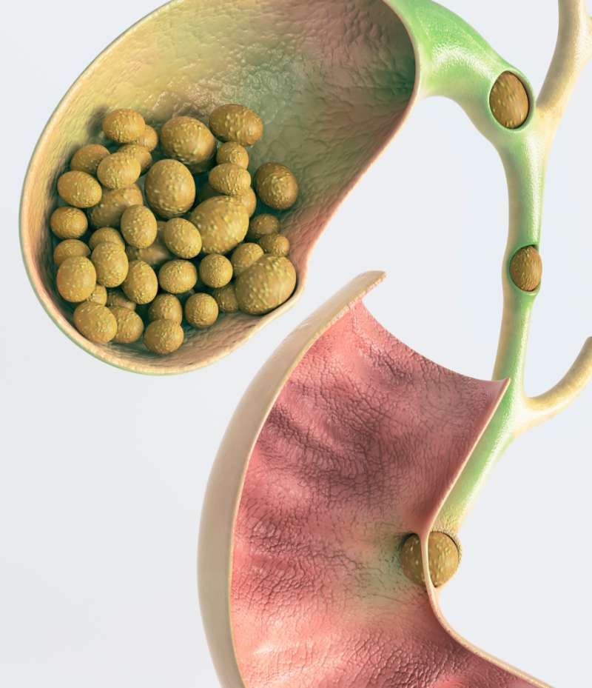
References

Bio ninja, (n.d) Digestive system, Available at, https://ib.bioninja.com.au/standard-level/topic-6-human-physiology/61-digestion-and-absorption/digestive-system.html, Accessed on (25th October 2020)
Boccola M (n.d) Gallstone Surgery, Available at https://drmarkboccola.com.au/surgery/gallstone-surgery/ Accessed on (5th November 2020)
Cleveland clinic (n.d) The structure and function of the digestive system, Available at https://my.clevelandclinic.org/health/articles/7041-the-structure-and-function-of-the-digestive-system Accessed on (5th November 2020)
Dworken J Harvey (2020) Human Digestive System, Available at https://www.britannica.com/science/human-digestive-system Accessed on (5th November 2020)
Justin J. Patricia, Amit S. Dhamoon, (2020) Physiology Digestion, Available at, https://www.ncbi.nlm.nih.gov/books/NBK544242/ Accessed on( 4th November 2020)
Macon L, (2019) Understanding Gallstones: Types Pain and more, Available at https://www.healthline.com/health/gallstones Accessed on (5th November 2020)
NHS,(2018) Overview Gallstones, Available at, https://www.nhs.uk/conditions/gallstones/#:~:text=Gallstones%20are%20thought%20to%20develop,Gallstones%20are%20very%20common. Accessed on (5th November 2020)
Taylor. T, (2020) Digestive System, Available at, https://www.innerbody.com/image/digeov.html#:~:text=The%20digestive%20system%20is%20responsible,of%20fluids%20and%20digestive%20enzymes Accessed on (4th November 2020)
Waugh A, Grant A, (2014) Ross and Wilson Anatomy and Physiology in Health and Fitness, 12th edition.

