
A Hybrid LSTM-Attention Intrusion Detection System for Internet of Things Networks
Postgraduate Research Proposal
MSc Cyber Security
Module: ACFA7004 – Research Methods and Professional Development
University of Wales Trinity Saint David, London Campus
Student Name: Aviral Tyagi
Student ID: 2530743

Table of Contents
1. Introduction 3
1.1 Context and Background 3
1.2 Research Problem 3
1.3 Research Aim and Objectives 4
1.4 Significance of the Research 5
1.5 Research Questions 5
1.6 Conceptual Framework 5
1.7 Novelty of This Research 5
2. Literature Review 6
2.1 Recurrent and Hybrid Approaches 6
2.2 Attention on Top of LSTM 6
2.3 Cross-Domain Work and Explainability 7
2.4 Datasets, Class Imbalance and Reporting Practice 7
2.5 Tensions and Contradictions in the Evidence 7
2.6 Where This Study Sits 7
3. Research Design and Methodology 8
3.1 Research Philosophy and Design 8
3.1.1 Hypotheses 9
3.2 Research Methods and Materials 9
3.2.1 Methods 9
3.2.2 System Architecture 10
3.2.3 Materials 11
3.3 Threats to Validity 12
3.4 Research Risks and Mitigation 13
4. Expected Outcomes, Contributions and Limitations 13
4.1 Anticipated Results 13
4.2 Academic Contribution 13
4.3 Methodological Contribution 13
4.4 Practical and Industrial Contribution 14
4.5 Limitations 14
5. Timeline 14
6. Overall Presentation of the Proposal 15
7. References 15

1. Introduction

1.1 Context and Background
The Internet of Things is one of the largest attack surfaces in today's computing world. Billions of small, connected devices communicate with each other and with the wider internet with minimal human oversight [2] – it's all about automation, without continual human intervention as much as anything. It also means that these devices are poorly secured, for most devices are designed with cost and power savings as the primary objective, and then security [2, 3].
It's not the setting where an intrusion detection system was initially envisioned. But as soon as a new traffic pattern arises, signature-based systems will not be matched until the database is updated, and IoT attacks are quicker than the signature database can be updated [1, 4].
Classical machine-learning classifiers do a little bit better, but they typically treat each record as a standalone piece of information, which is not the case when they detect a slow “evolving” attack, and a detector should be able to recognize the sequential nature of network traffic.
That's where Long Short-Term Memory (LSTM) networks come in the literature. The LSTMs are able to identify temporal patterns created by a stealthy attack by using a gated memory cell to carry the information from one time step to the next [5] [6]. Recently, attention mechanisms (originally proposed for machine translation [15] and later made popular by transformer architecture [16]) have been layered atop these recurrent layers, enabling the model to learn the best parts of the traffic sequence to attend to [5, 16].
Wei et al. [5] used an evolving LSTM with attention and it successfully captured the minority classes of attacks with considerable improvement over a standard recurrent baseline. To obtain good performance on the standard benchmarks, Dai et al. [8] integrated the convolutional feature extraction with BiLSTM-attention layer. The Mirai botnet is the classic warning as to why it is important: Hundreds of thousands of poorly secured IoT devices were compromised with default credentials to facilitate some of the largest DDoS attacks on record, and the vulnerabilities they took advantage of are still prevalent today.
Together, this set of work poses two questions: (1) what types of generalization improvements can be garnered by attention augmentation over different IoT traffic, and (2) what types of improvements they report on are due to attention augmentation, and what other modulations they have been enacting concurrently [11]? This will take care of that void.

1.2 Research Problem
Even with the advances made, achieving high detection accuracy in minority and evolving attack classes for IoT traffic remains a challenge without significantly increasing false positives. A plain LSTM simply has the same weight on each time step, and thus may not track the short, subtle sequences typical of quieter attacks [5, 6]. This problem is associated with three key research gaps:
- Methodological gap: most attention augmented IDS studies vary multiple aspects (architecture, pre-processing, hyperparameters) between the baseline and proposed model, it is seldom that it is possible to determine how much of the reported gains stem from attention and how much are due to the other changes made along with attention [8] [11].
- Confidence in the results on the more imbalanced TON_IoT traffic or CSE-CIC-IDS2018 [4] is limited, as few studies confirm the findings for more than one, heterogeneous IoT dataset; most report results on NSL-KDD traffic alone [4], [10], [12].
- Practical gap: Despite the fact that the end goal of IoT security is to work on a resource constrained gateway, almost no work in this space reports the computational overhead of the proposed model, [2] and [3]. There are a few very recent studies that are beginning to close this gap (Alashjaee [21] reports sub-35ms inference latency, and Raman et al. [23] benchmark latency under simulated streaming traffic) but this is the exception; in Section 3.2.3, latency is measured directly as an afterthought.
This study thus aims at designing and testing a hybrid LSTM-Attention model against a well-chosen baseline model — namely a LSTM only network — on three datasets relevant to the IoT domain and to see whether attention actually provides a consistent advantage in terms of a genuine measurable gain, directly, and in practice where possible within the scope of the project.

1.3 Research Aim and Objectives
Aim: to design, implement and evaluate a hybrid LSTM-Attention intrusion detection system and determine whether it can improve the accuracy and reliability of attack detection in IoT systems compared with the LSTM baseline.
Objectives:
- Conduct systematic literature review for LSTM/Attention based deep learning for IoT IDS.
- Establish the pre-processing, feature-selection and class-imbalance requirements of the NSL-KDD, CSE-CIC-IDS2018 and TON_IoT datasets.
- Design and train a hybrid LSTM-Attention model and a standalone LSTM baseline model with the same experimental pipeline.
- Train and evaluate both models on all three datasets, using accuracy, precision, recall, F1-score and false-positive rate.
- Compare the hybrid model with the baseline model, test the results statistically, and critically evaluate conclusions drawn about the results.

1.4 Significance of the Research
This study brings one more controlled, multi-dataset comparison to the literature that often fails to separate out the contribution of attention from an LSTM baseline [8] [11]. Of course, IoT security teams have limited staff and compute resources, and a model that helps them more accurately maintain a manageable number of false positives is one they can realistically use. The application of IoT devices also has implications for those who depend on healthcare, home-safety and critical-infrastructure systems, as more reliable detectors become commonplace in these systems [10].

1.5 Research Questions
The aim and objectives above translate into three specific research questions:
- RQ1: Is the use of an attention mechanism in an LSTM-based IDS superior to an LSTM only baseline when detecting IoT network traffic in terms of macro-F1 performance?
- RQ2: On which datasets and attack categories does the attention mechanism provide the greatest improvement in macro-F1 performance?
- RQ3: Is the attention mechanism able to further improve the false positive rate compared to LSTM baseline, while introducing a non-significant decrease in the false negative rate for minority attack classes?

1.6 Conceptual Framework
Figure 1 sets out the study’s conceptual framework: attention (present/absent) is the independent variable applied within an otherwise identical LSTM-based IDS, and detection performance, measured through five dependent metrics, is the outcome of interest.
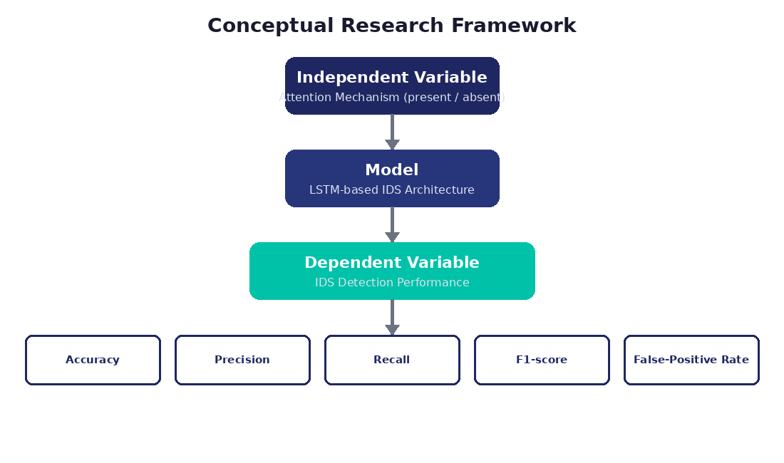
Figure 1: Conceptual framework linking the independent variable (attention) to IDS performance outcomes.

1.7 Novelty of This Research
Concretely, this research contributes:
- A comparison of an LSTM baseline model and the LSTM-Attention model within a single baseline study instead of across studies.
- Evaluation using three heterogeneous datasets NSL-KDD, CSE-CIC-IDS2018, and TON_IoT instead of one dataset only as a benchmark.
- Statistical validation (paired t-test / Wilcoxon signed-rank test) of performance difference instead of a single run accuracy number.
- A deliberate effort to hold architecture and pre-processing constant elsewhere – a more clean separation than most studies in Section 2 manage, although not a complete clean separation due to the intermingling of these effects demonstrated.
The question then arises whether a controlled comparison is considered research if no new architecture is suggested. It does: dozens of papers rely on attention to capture while altering multiple aspects of the architecture at the same time (Section 1.2), and even when such evidence of attention exists, it doesn't scale to heterogeneous data sets or come with any kind of statistical testing (Alashjaee [21] provides evidence of attention within one architecture, and in one data set). The field has a lack of a matched cross-dataset comparison with statistical support, which includes a null or marginal result. It's a self-deprecating statement, but one that is important because of its proof, not its novelty.

2. Literature Review
This section reviews the literature related to deep learning-based IoT intrusion detection, starting from the LSTM theory [14] and attention theory [15], [16] and going on to IoT security-specific applications [1] and beyond [2] — the intersection of these three streams is the literature gap of Section 1.2.

2.1 Recurrent and Hybrid Approaches
Khan et al. [4] created an RNN-GRU hybrid model for testing on TON_IoT, which achieved a max accuracy of 99% but with only one dataset. Altunay and Albayrak [3] used CNN with LSTM for an Industrial IoT IDS but they did not mention false-positive rates for attack classes. A similar recipe to Zhang et al. [22] which achieved above 99% accuracy with a CNN-BiLSTM-Transformer stack resurfaces the attribution problem in 2025 work. These studies confirm the superiority of recurrent architectures over static classifiers, but differ on what constitutes evidence, as there is no common protocol for conducting the studies.

2.2 Attention on Top of LSTM
A similar idea was used by Wei et al. [5] who introduced an evolving LSTM with attention, but their architecture search was optimized together with the attention, so the two mechanisms were intertwined. Part of their improvement is attributed to attention without a matched ablation, which is something Alashjaee study 2025 [21] overcomes for their architecture, stating that ablation of attention results in a loss of 3-4 points of F1 and MCC. Priyadarshini et al. [9] used a similar model to consider just one type of attack, so the applicability of the findings is restricted. These research studies exhibit a collection of practices: testing with a solitary data set, tangled changes, restricted attack range, failure to perform significance testing.

2.3 Cross-Domain Work and Explainability
Alalwany et al. [10] used a BiGRU-LSTM-Attention network for both medical and industrial IoT traffic, and achieved satisfactory cross-domain performance (but not for the attention layer alone). Alabbadi and Bajaber [11] integrated attention-guided fusion, residual LSTM and explainable-AI layer on TON_IoT, NSL-KDD and CICIoMT 2024 datasets with an accuracy of more than 99%. They both say it's important to do test across domains but they differ on how much architecture it should have. As in this example, eliminating the trade-off by keeping the architecture as simple and minimal as possible enables one to isolate one variable.

2.4 Datasets, Class Imbalance and Reporting Practice
NSL-KDD is still included for its own use for comparison purposes because it corrected known redundancy in KDD Cup 99 [17] but it was never designed for IoT traffic [4]; TON_IoT adds IoT traffic, and CSE-CIC-IDS2018 adds new diversity of attacks. Another problem is that the majority of almost every IDS data set consists of normal traffic and a few common attacks; reporting aggregate accuracy only may result in less attention to the less common, more dangerous attacks. Some use SMOTE [19] and achieve better minority recall at little accuracy cost [9] while the better studies provide precision, recall, F1 and per-class confusion matrices [4] [5].

2.5 Tensions and Contradictions in the Evidence
These studies are juxtaposed, and the accuracy above 99% is observed in some studies (Khan et al. [4] and Alabbadi and Bajaber [11] on similar problems; while other studies report very modest gains in attention (Wei et al. [5] and Dai et al. [8] on similar problems). One reason for the difference is that NSL-KDD and TON_IoT are both difficult datasets, as they include too many near-duplicate records to learn anything that can be generalised to the rest of the dataset and retain accuracy [17]. Part is probably inadequate splitting, a phenomenon that few papers report, and part it might be due to publication incentive. A second, smaller tension sits inside the minority-class story. While the benefits of attention in improving recall for rare attack classes are consistently reported, Priyadarshini et al. [9] and Wei et al. [5] do not include a precision/FPR comparison; only a matched recall comparison is reported. It remains to be seen if it's more real attacks that are being found or more often just the class of attack that is being predicted — a difference Section 3.2.3's protocol is designed to clarify.

2.6 Where This Study Sits
Pulling this together, adding attention to LSTM or GRU layers seems to help with minority and complex attack detection, and more and more people are testing this with multiple datasets — but there's still a lack of a statistically sound comparison of a multi-dataset attention-free baseline vs. a multi-dataset attention-based variant. This single test of one recurring architectural claim is reported per dataset and by attack class as opposed to as one number.

3. Research Design and Methodology

3.1 Research Philosophy and Design
This study adopts a positivist approach: Detection performance is considered as an objective phenomenon that can be measured by quantitative metrics collected in controlled conditions and, therefore, not interpreted, as it is a measure of the engineering outcome rather than a subjective component of meaning. The research questions did not require a qualitative strand and this was considered but rejected. Deductive approach, beginning with H1 (Section 3.1.1) which is based on literature and is then tested in an empirical way. A mono-method quantitative design is then followed as the outcome of interest is all numerical. Design Science Research (DSR) is used as an overall approach as the study focuses on an artefact, the hybrid LSTM-Attention model, rather than a claim about a social setting [1]. The DSR cycle followed is shown in figure 2: problem (Section 1.2) to objectives (Section 1.3) to design (Section 3.2.2) to development and evaluation of models to communication (Dissertation and viva).
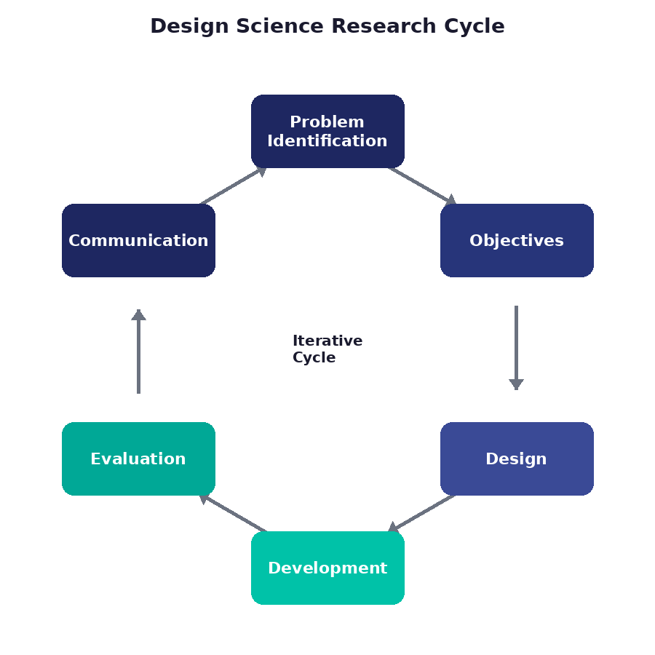
Figure 2: Design Science Research cycle followed by this project.
The experimental method for evaluation paired with DSR is the hybrid approach and matched evaluation of the train and test, meaning any performance difference would be reasonable to link to the architecture. The time frame is cross sectional, as suitable in the context of a taught modules project.

3.1.1 Hypotheses
- H0 (null): There is no statistically significant difference in F1-score between the LSTM baseline and the hybrid LSTM-Attention model.
- H1 (alternative): The hybrid LSTM-Attention model achieves a statistically significant macro-F1 improvement over the LSTM baseline.

3.2 Research Methods and Materials

3.2.1 Methods
The method used is quantitative and comparative experimental method. Two models are compared: a stand-alone LSTM baseline model and a hybrid model with an attention layer placed on top of the LSTM hidden outputs before classification. They both share the same input representation, layer size, optimiser and training schedule, wherever possible, keeping the impact of attention as clean as the architecture allows [11, 5].
Why LSTM instead of a transformer which, despite being a relatively new architecture, has become very popular since Vaswani et al. [16]? Most of the IDS literature in Section 2 was based on LSTM or GRUs, so results remain comparable when using an LSTM baseline, and transformers require larger data sets and increased number of computational resources, plus the quadratic cost of self-attention is a significant limitation in an IDS project that runs for a single 14-week workstation. RQ1–RQ3 are not “does adding attention to LSTM help?” but are “does adding attention to an LSTM help?”, the latter of which is the most pertinent question, aside from obviously asking “can transformers beat LSTMs?”.
The criteria for the selection of the datasets were very explicit: Publicly available datasets, pre-labelled datasets, datasets used in at least two comparable published datasets, and not superseded datasets (e.g. KDD Cup 99 was superseded by NSL-KDD [17]). This left us with NSL-KDD, CSE-CIC-IDS2018 and TON_IoT. All three datasets are used separately for each model to train and test, with the ratio of 70/15/15 for train/validation/test. Furthermore, evaluation is conducted through accuracy, precision, recall, F1-score, FPR and per-dataset confusion matrix as a single accuracy measure may mask a failure to perform well on the minority class [4], [5]. Macro-averaged F1 is the primary outcome measure, the rest are secondary/supplementary.
The experiment is designed using a controlled ablation, allowing to have two phases to remove the effects of the attention being mixed with the effects of the other hyperparameters. In Phase 1 a single configuration — sequence length, number of LSTM units, dropout, optimiser, learning rate, batch size and early-stopping rule — is fixed based on the validation performance of the LSTM baseline. In Phase 2 both models are trained with the exact same (frozen) configuration, identical splits and seeds, with the only difference being the presence or absence of the attention layer; nothing is re-tuned on a model-by-model basis. Both are evaluated once, with held-out test split and per dataset and per attack class without any information from the test set used to select the model.
It is important to remember that a better macro-F1 alone is not sufficient to accept H1, the difference needs to be statistically significant. Each model trains multiple independent seeds and hence one paired observation per seed per dataset. Primary hypothesis family: three dataset-level paired comparisons, alpha = 0.05. A Bonferroni correction is applied across the three primary dataset-level comparisons, and a paired t-test (or Wilcoxon signed-rank test where normality does not hold) is performed for each comparison. The tests that are reported separately are per-attack-class tests for RQ2 and RQ3, which are exploratory tests. A paired effect size (Cohen's d for paired samples [20]) is reported with a 95% CI where the result is statistically significant.

3.2.2 System Architecture
The shared pipeline is shown in Figure 3. All traffic records go through the same pre-processing, class-balancing and feature-selection steps before they arrive at the model, the only true difference is the attention layer between the LSTM and classification layers. For each input sequence it is defined as a fixed-length, sliding window of consecutive records from the same flow that are strictly contained within one split and that are all timestamp-ordered, with window length chosen in Phase 1 based on the validation performance of the baseline model, and then fixed and equally applied to both models. The split is done first, to avoid leakage, class-balancing and scaling parameters are fitted only on the training partition, then used without change on validation and test data.
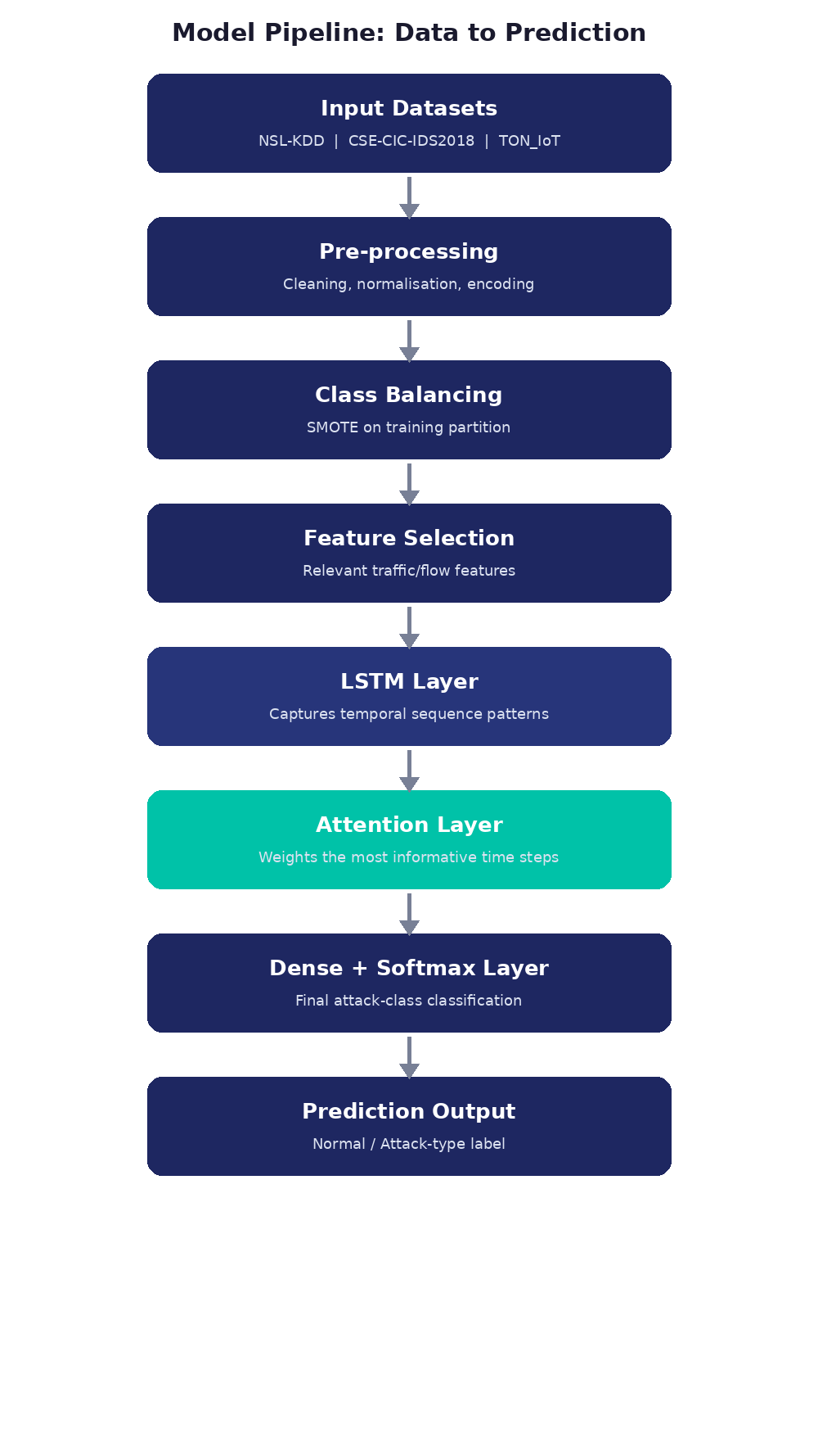
Figure 3: End-to-end pipeline from raw traffic data to prediction (attention layer applies only to the hybrid model).

3.2.3 Materials
Table 1 compares the three datasets against the selection criteria above.
Dataset | Year | Focus | Advantage | Limitation
NSL-KDD [17] | 2009 | General network intrusion | Standard, widely-cited benchmark; fixes KDD'99 redundancy | Not IoT-specific traffic
TON_IoT [12], [13] | 2020 | IoT/IIoT telemetry & network | Realistic, purpose-built IoT/IIoT testbed data | Newer, less cross-study coverage
CSE-CIC-IDS2018 [18] | 2018 | Modern multi-attack traffic | Large, contemporary attack diversity | Not IoT-specific; heavier compute needs
Table 1: Comparison of the three benchmark datasets against the inclusion criteria.
No live network data is collected; all data comes from the official public repositories above.
Evaluation metrics (TP/TN/FP/FN = true/false positives/negatives):
- Accuracy = (TP + TN) / (TP + TN + FP + FN)
- Precision = TP / (TP + FP)
- Recall = TP / (TP + FN)
- F1-score = 2 × (Precision × Recall) / (Precision + Recall)
- Macro-F1 (primary metric) = unweighted arithmetic mean of the per-class F1-scores, so every attack class counts equally regardless of its size in the dataset
- Multi-class FPR = computed per class using a one-vs-rest split (that class as positive, all others as negative), then macro-averaged across classes for a single comparable figure
- False-Positive Rate = FP / (FP + TN)
- ROC-AUC and Matthews Correlation Coefficient (MCC) reported as supplementary, imbalance-robust measures
Ethics: all three sets of data are anonymous, public benchmarks with no personal information. Responsible AI practice is followed in the study: access controlled storage, per class (not just aggregate) reporting, fixed seeds, no selective reporting and code that is accessible to examiner review. The completed ethics form is submitted separately via Moodle; per the module specification it is compulsory.
The software used are Python 3, TensorFlow/Keras, pandas, NumPy, scikit-learn and Matplotlib, and the statistical tests were conducted using SciPy, all run on a GPU-enabled workstation, with Google Colab as an alternative GPU cloud environment.
The computational overhead evaluation is performed on the same GPU enabled workstation, under the same conditions for both models. Each model and dataset shows the training time, inference latency (mean and 95th percentile, as in Raman et al. [23]), throughput, peak GPU memory, and model size. Energy is estimated (not measured) from the power draw of the GPU as reported by nvidia-smi, following the spirit of similar studies reporting sub-35ms latency [21] or streaming latency [23]. It's not a deployment study, but it's a question of overhead vs benefit.

3.3 Threats to Validity
- Internal validity: controlled through the two-phase design (Section 3.2.1), which freezes one hyperparameter configuration and sequence length from Phase 1 and applies it unchanged to both models in Phase 2, so no per-architecture tuning can confound the comparison; residual risk remains from the comparison's sensitivity to that single frozen configuration, which is not itself re-validated across multiple configurations.
- External validity: while three datasets provide better generalisability than single-dataset studies, none of them is a live, adversarial IoT traffic.
- Construct validity: F1 score, precision and recall are widely adopted representations of ‘detection performance' but do not measure ‘inference latency'.
- Reliability: Achieved by running multiple times, fixing of seeds, and complete documentation of the pipeline.

3.4 Research Risks and Mitigation
In addition to the validity risks outlined, there are four delivery risks which could jeopardize the delivery over the fourteen week period. They each have a hardwired mitigation – not an add-on.
- Dataset risk: public datasets are occasionally revised or taken offline, which could quietly change results mid-project. Mitigation: versions and checksums are recorded at download time, with local access-controlled copies kept for the project’s duration.
- Compute risk: GPU access is not guaranteed on a shared university workstation, and training two architectures across three datasets and multiple seeds is compute-intensive. Mitigation: Google Colab is confirmed as a fallback, and the hyperparameter search is deliberately bounded rather than exhaustive.
- Reproducibility risk: results can drift across library versions or hardware, undermining the statistical comparison this study depends on. Mitigation: seeds, library versions and hyperparameter ranges are fixed and logged, and the software stack is documented.
- Timeline risk: fourteen weeks leaves little slack if training or analysis overruns. Mitigation: the Gantt chart (Section 5) sequences lower-risk work — literature review, pipeline setup — before training, and treats CSE-CIC-IDS2018, the heaviest of the three datasets, as the first candidate to scale back if time runs short.

4. Expected Outcomes, Contributions and Limitations

4.1 Anticipated Results
Attention is expected to improve macro-F1 and minority-class recall over the LSTM baseline, based on the pattern reported across Section 2, but the study is designed to accept whatever the statistical test shows — a clear improvement, a marginal or non-significant difference, or no improvement at all — rather than to confirm a predetermined result.

4.2 Academic Contribution
A controlled, statistically-tested data point on what attention actually adds to an LSTM-based IDS, addressing the methodological gap identified in Section 1.2.

4.3 Methodological Contribution
A reusable, documented experimental protocol (matched pipeline, multi-dataset evaluation, significance testing) that later studies, including this student’s own subsequent MSc project, can adopt or extend.

4.4 Practical and Industrial Contribution
Evidence-based guidance for practitioners choosing an IDS architecture for IoT deployment, and a starting point for weighing attention’s accuracy gain against its computational cost on constrained gateways.

4.5 Limitations
- Findings are bounded by the three chosen datasets and may not generalise to unseen attack types.
- Benchmark datasets, however realistic, do not fully reflect live, adversarial IoT traffic.
- GPU/compute constraints limit the hyperparameter search that is practically feasible.
- Both models remain sensitive to hyperparameter choices; results are one instantiation, not an exhaustive search.
- LSTM-Attention models remain comparatively black-box; interpretability is not the focus of this study.
- Class imbalance, even after SMOTE, may still affect the rarest attack categories.
- Findings on computational overhead (Section 1.2) are reported only where feasible within the project timeframe, not as a full deployment study.

5. Timeline
The project is planned over fourteen weeks; Figure 4 shows the plan as a Gantt chart.
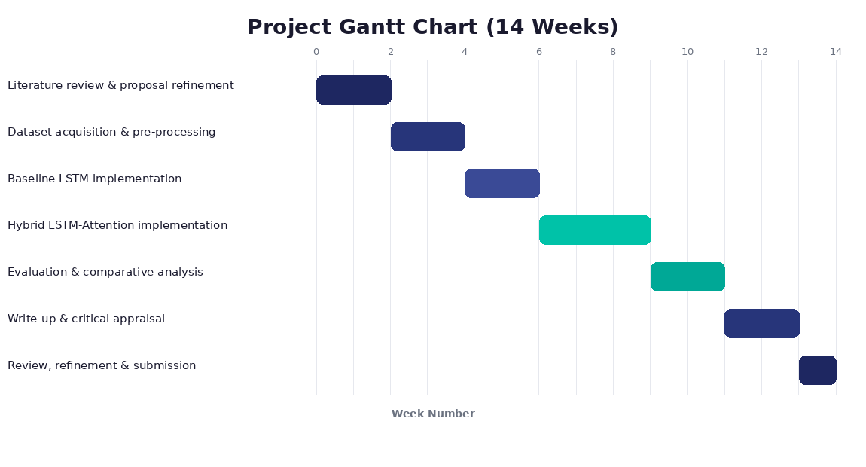
Figure 4: Project Gantt chart across the fourteen-week timeline.
Milestones: M1 gap finalised; M2 pipeline and splits frozen; M3 baseline validated; M4 attention model completed; M5 experiments completed; M6 statistical analysis completed; M7 final report completed.
Table 2 sets out the resources this plan depends on and the fallback for each.
Resource | Purpose | Backup / mitigation
GPU workstation | Model training and hyperparameter search | Google Colab (cloud GPU)
Python / TensorFlow-Keras | Model implementation and evaluation | Version-pinned environment file
Storage | Datasets, checkpoints and logs | University cloud storage backup
Git / version control | Code and pipeline reproducibility | Regular commits, local repository
Table 2: Resource allocation and mitigation for the fourteen-week plan.

6. Overall Presentation of the Proposal
Structure, figures, tables and formula-based metric definitions are used throughout to keep the research design traceable from problem to method, with IEEE in-text citations and a full reference list supporting every claim made.

7. References
[1] M. A. Ferrag, L. Maglaras, S. Moschoyiannis, and H. Janicke, "Deep learning for cyber security intrusion detection: Approaches, datasets, and comparative study," Journal of Information Security and Applications, vol. 50, p. 102419, 2020, doi: 10.1016/j.jisa.2019.102419.
[2] M. A. Ferrag, O. Friha, D. Hamouda, L. Maglaras, and H. Janicke, "Edge-IIoTset: A new comprehensive realistic cyber security dataset of IoT and IIoT applications for centralized and federated learning," IEEE Access, vol. 10, pp. 40281–40306, 2022.
[3] H. C. Altunay and Z. Albayrak, "A hybrid CNN+LSTM-based intrusion detection system for industrial IoT networks," Engineering Science and Technology, an International Journal, vol. 38, p. 101322, 2023.
[4] N. W. Khan, M. S. Alshehri, M. A. Khan, S. Almakdi, N. Moradpoor, A. Alazeb, S. Ullah, N. Naz, and J. Ahmad, "A hybrid deep learning-based intrusion detection system for IoT networks," Mathematical Biosciences and Engineering, vol. 20, no. 8, pp. 13491–13520, 2023.
[5] W. Wei, Y. Chen, Q. Lin, J. Ji, K. C. Wong, and J. Li, "Multi-objective evolving long-short term memory networks with attention for network intrusion detection," Applied Soft Computing, vol. 139, p. 110216, 2023.
[6] R. Yao, N. Wang, Z. Liu, P. Chen, and X. Sheng, "Intrusion detection system in the advanced metering infrastructure: A cross-layer feature-fusion CNN-LSTM-based approach," Sensors, vol. 21, no. 2, p. 626, 2021.
[7] A. Gueriani, H. Kheddar, and A. C. Mazari, "Enhancing IoT security with CNN and LSTM-based intrusion detection systems," in Proc. 2024 6th Int. Conf. on Pattern Analysis and Intelligent Systems (PAIS), IEEE, 2024, pp. 1–7.
[8] W. Dai, X. Li, W. Ji, and S. He, "Network intrusion detection method based on CNN, BiLSTM, and attention mechanism," IEEE Access, vol. 12, pp. 53099–53111, 2024.
[9] I. Priyadarshini, P. Mohanty, A. Alkhayyat, and R. Sharma, "SDN and application layer DDoS attacks detection in IoT devices by attention-based Bi-LSTM-CNN," Transactions on Emerging Telecommunications Technologies, vol. 34, no. 6, e4758, 2023.
[10] E. Alalwany, B. Alsharif, Y. Alotaibi, A. Alfahaid, I. Mahgoub, and M. Ilyas, "A robust cross-domain IDS using BiGRU-LSTM-Attention for medical and industrial IoT security," arXiv preprint arXiv:2508.12470, 2025.
[11] A. Alabbadi and F. Bajaber, "X-FuseRLSTM: A cross-domain explainable intrusion detection framework in IoT using the attention-guided dual-path feature fusion and residual LSTM," Sensors, vol. 25, no. 12, p. 3693, 2025, doi: 10.3390/s25123693.
[12] A. Alsaedi, N. Moustafa, Z. Tari, A. Mahmood, and A. Anwar, "TON_IoT telemetry dataset: A new generation dataset of IoT and IIoT for data-driven intrusion detection systems," IEEE Access, vol. 8, pp. 165130–165150, 2020, doi: 10.1109/ACCESS.2020.3022862.
[13] N. Moustafa, "A new distributed architecture for evaluating AI-based security systems at the edge: Network TON_IoT datasets," Sustainable Cities and Society, vol. 72, p. 102994, 2021.
[14] S. Hochreiter and J. Schmidhuber, "Long short-term memory," Neural Computation, vol. 9, no. 8, pp. 1735–1780, 1997.
[15] D. Bahdanau, K. Cho, and Y. Bengio, "Neural machine translation by jointly learning to align and translate," in Proc. Int. Conf. on Learning Representations (ICLR), 2015.
[16] A. Vaswani, N. Shazeer, N. Parmar, J. Uszkoreit, L. Jones, A. N. Gomez, L. Kaiser, and I. Polosukhin, "Attention is all you need," in Advances in Neural Information Processing Systems (NeurIPS), vol. 30, 2017.
[17] M. Tavallaee, E. Bagheri, W. Lu, and A. A. Ghorbani, "A detailed analysis of the KDD CUP 99 data set," in Proc. 2nd IEEE Symp. on Computational Intelligence for Security and Defense Applications (CISDA), 2009, pp. 1–6.
[18] I. Sharafaldin, A. H. Lashkari, and A. A. Ghorbani, "Toward generating a new intrusion detection dataset and intrusion traffic characterization," in Proc. 4th Int. Conf. on Information Systems Security and Privacy (ICISSP), 2018, pp. 108–116.
[19] N. V. Chawla, K. W. Bowyer, L. O. Hall, and W. P. Kegelmeyer, "SMOTE: Synthetic minority over-sampling technique," Journal of Artificial Intelligence Research, vol. 16, pp. 321–357, 2002.
[20] J. Cohen, Statistical Power Analysis for the Behavioral Sciences, 2nd ed. Hillsdale, NJ: Lawrence Erlbaum Associates, 1988.
[21] A. M. Alashjaee, "Deep learning for network security: an Attention-CNN-LSTM model for accurate intrusion detection," Scientific Reports, vol. 15, p. 21856, 2025, doi: 10.1038/s41598-025-07706-y.
[22] C. Zhang, J. Li, N. Wang, and D. Zhang, "Research on intrusion detection method based on Transformer and CNN-BiLSTM in Internet of Things," Sensors, vol. 25, no. 9, p. 2725, 2025, doi: 10.3390/s25092725.
[23] R. Raman, R. Kumar, B. Edwin Raj, and V. Akre, "Attention integrated deep learning models for interpretable multi-class IoT intrusion detection using SHAP," Frontiers in Artificial Intelligence, vol. 9, art. 1825655, 2026, doi: 10.3389/frai.2026.1825655.

