Study Skills report

Table of Contents
Section 1 2
Introduction 2
Presentation skills 2
Section 2 2
High education skills 2
Transferable skills 2
Section 3 2
Self-evaluation 2
action planning 2
Section 4 3
Looking after data 3
Time management 3
Section 5 3
Conclusion 3
Evaluation 3
Section 6 3
References 3
Section 7 3
Appendices 3

2000 words needed

Section 1

Introduction

Presentation skills

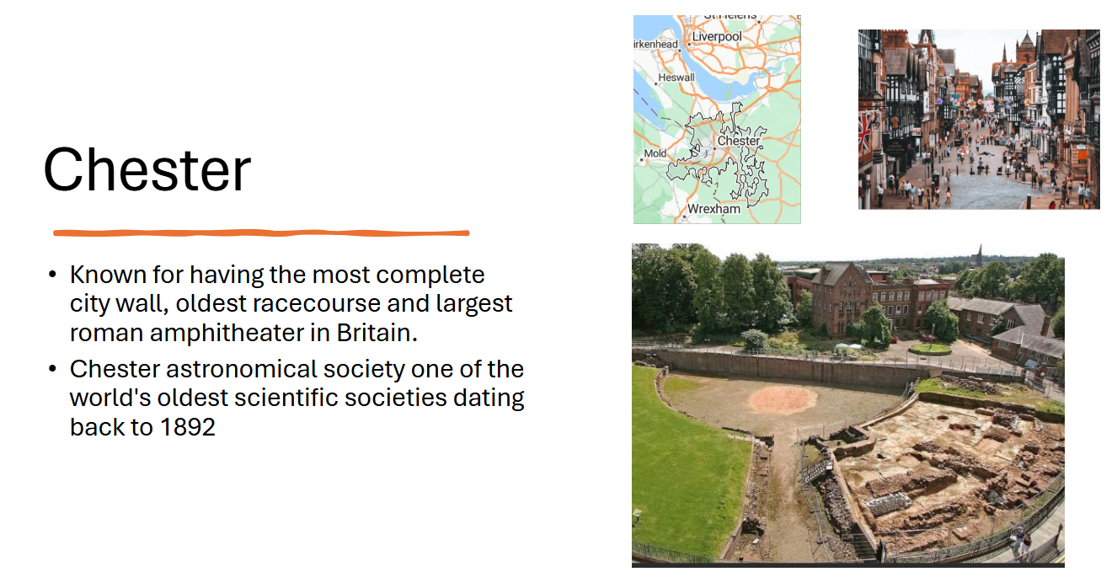

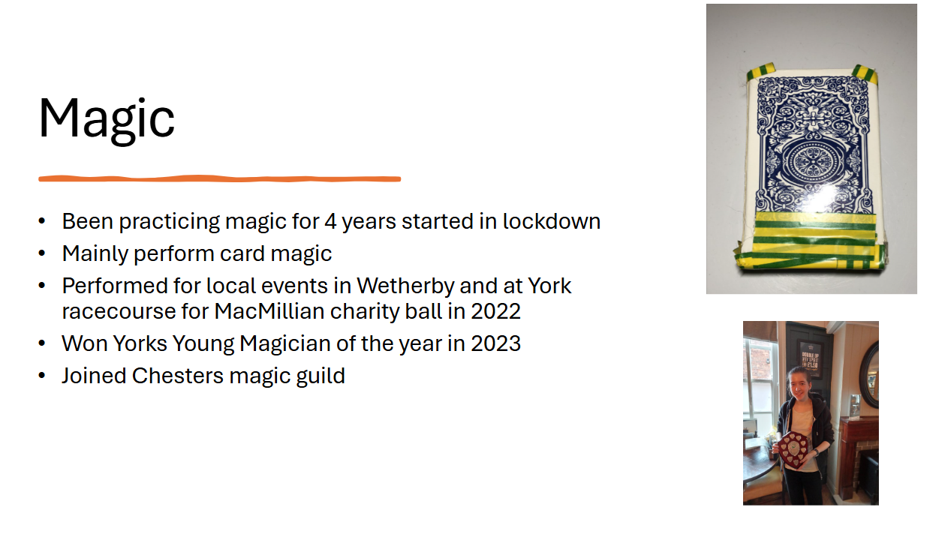
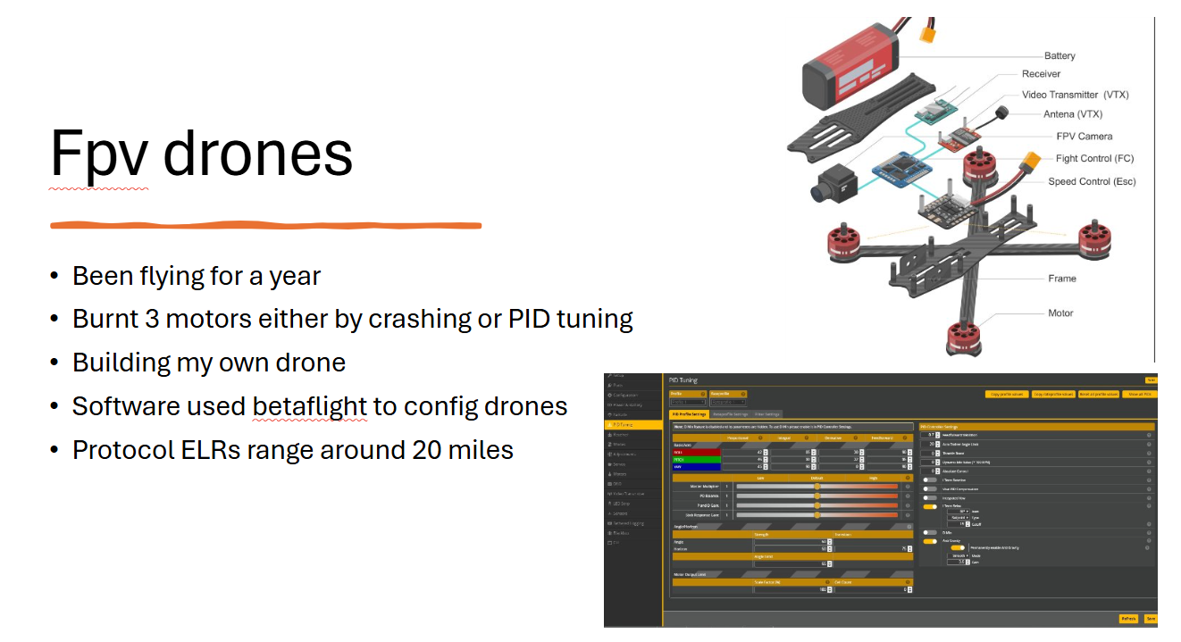
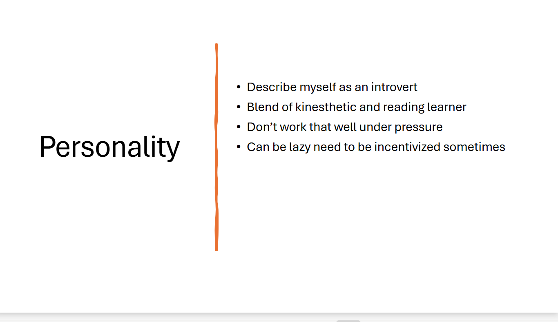

The author of the presentation describes themselves as a quiet introverted individual whose main hobbies are performing card magic and drone flying. They mention that they originally lived in a small-town Wetherby near Leeds, however, they have moved to Chester for their job. This can be seen above in the screen grabs from the presentation.

Key points taken from presenting
- PowerPoint slides must be readable on larger screens when presenting.
- Slides must contain a balance between picture and text.
- Speaker needs to have the presentation memorized
- When delivering the presentation, the presenter noted how unprepared they felt
Feedback from both spectators and the lecture showed that while they enjoyed the presentation it was mentioned the presentation was too short and that the speaker needed to be louder and more confident in their delivery. The speaker noted that they would practice delivering presentations and public speaking in their team so they for the next presentation they would be more confident in the delivery.

Section 2

High education skills
The skills the author of the report believes are needed to succeed in higher education are the ability to analyze information from sources and then to present the findings in a clear and logical manner. Being organized and willing to do independent research [1]

Transferable skills
When speaking to other colleagues and industry professionals about transferable skills one of the key skills looked for is the ability to work as part of a team…….

Section 3
Self-evaluation
The author performed a variety of personality tests to see their personality type. The Carl Jung personality test was invented by Carl Jung a Swiss psychiatrist who is best known for his research into psychological types inventing the term introvert and extrovert. His test involved having two personality attitudes extrovert and introvert while having four functions/modes of orientations thinking, sensing, intuition and feeling. The results are shown below in figure 1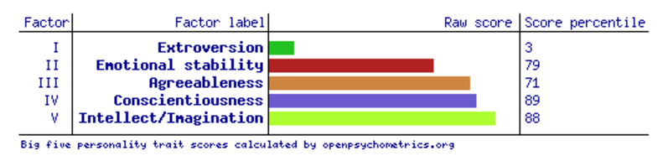
Figure 1 results from the initial big 5 test
The results in figure 1 show that the author displaces more introverted tendencies which are also backed up in the Jung personality test result which can be seen in figure 2.
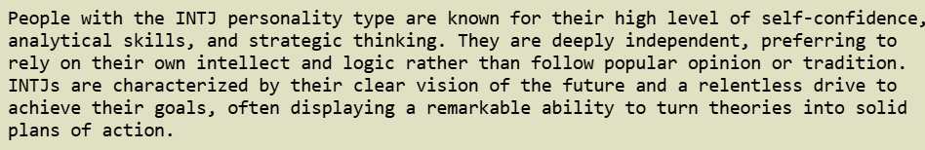
Figure 2 Carl Jung test results
The results of both tests indicate that the author displaces introverted tendencies comparing these with the authors presentation some points line up as the author describes themselves as being a quiet introverted person however the point in the Carl Jung test about having a relentless drive to achieve their goals contrast with the authors view that they can be lazy and sometimes need incentivizing. What the author learnt from the exercise was that they were more introverted than they realized and that they need to work on their people skills. The improvements the author is going to take going forward are to try and engage with people more in group activities and to take on board the opinion of others more.

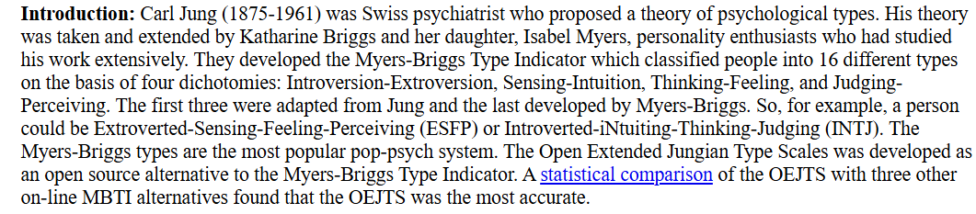

Action planning
Goals Short term
- Swim at least once a week to keep fitness level
- Learn and perform a coin routine
- Collaborate more at work with others
Goals Long term
- Become proficient in C language for work
- Decide whether I prefer hardware or software for work

Section 4

Looking after data
The steps the author has taken to mitigate potential data losses on work for university and their job was to have three different ways they store data to provide a robust method of data protection for both Uni work and for their job. They have both a personal and work OneDrive account for both Uni and work this means that not only can they access there work on any laptop but also means that if the device they were working on malfunction they would still be able to access any important documents on another device. A USB stick is also used as a backup so that if OneDrive was compromised somehow they would still have a copy of their files which aren’t connected to the internet therefor less vulnerable to attacks. A final means of data protection is a hard drive which is used in case the USB stick fails and the hard drive is backed up once a week to allow for a more up to date file system compared to the USB stick which is update once a month. While these data store age methods aren’t perfect they can withstand some ransom ware attacks as ……

Time management
Steps taken to enhance productivity is to organize a calendar for the week with goals of what must be achieved in the week.

Section 5

Conclusion

Evaluation

Section 6

References
Smale, B., & Fowlie, J. (2009). How to Succeed at University: An Essential Guide to Academic Skills and Personal Development (1st ed.). SAGE Publications. https://doi.org/10.4135/9781446279731

Section 7

Appendices

