Critically Examine the Literary and Artistic Representations of Medusa in the Graeco-Roman World
To understand representations of Medusa, a researcher must look at both literary and artistic resources. While the main plot of the myth has not changed, curiously, the way in which Medusa is depicted has shifted greatly. Early imagery depicts a monstrous and beastly figure but over time depictions have become more human and feminine. This change in representation of Medusa from monstrous to feminine needs to be examined. Furthermore, the retellings of the Medusa myth have emphasised different aspects of Medusa. There is much scholarly debate on the interpretation of these different depictions and how they may have influenced artistic representations. Multiple messages can be found within the myth and different interpretations show the many layers of meaning embedded in the story. The changing literary representations of Medusa through the Archaic to the Classical period have blurred the line between monster and human, and have given rise to changes in imagery that reflect a more sympathetic view of Medusa’s lost humanity.
First presented in Hesiod’s Theogony, Medusa is said to be one of the three Gorgon sisters birthed to Phorcys and Ceto. There is very little information given about the lives of the Gorgons. All that is known is that Medusa was the only mortal one of the three sisters. The Medusa myth appears in a number of ancient works, most notably in Ovid’s Metamorphoses but also in Apollodorus’ Library and the twelfth Pythian ode by Pindar.
The literary history of the Medusa myth can be traced from the Archaic to the Classical periods of the ancient world. The earliest version of the Medusa story appears briefly in Hesiod’s Theogony from the late eighth century BCE and has little detail. Hesiod writes “Medusa who suffered a grim fate […] and when Perseus cut off her head from her neck, out sprang great Chrysaor and the horse Pegasus”. Here he describes her encounter with Perseus which follows a brief introduction to her family relations and her sexual encounter with Poseidon who is referred to as “the god of the Stable Locks”. The story of Medusa is also the subject of Pindar’s Twelfth Pythian Ode which was written for Midas of Acragas. The odes were written for victors in the Panhellenic festivals in the fifth century BCE. As the odes were written for winning in a competition, the myth used would reflect the area of competition. While this ode includes the story of Perseus and Medusa, its main source would have been following a different myth about the creation of the flute. The reference to “melodies of the flute” show the link between the competition and this myth. In this ode, Pindar refers to Medusa as “fair-cheeked”. This shows that she was viewed as a more feminine figure. The next significant appearance of the myth comes in Apollodorus’ Library and is presented in more detail. The Library covers Greek myth from the creation of the universe up to the Trojan War and was written in the second century BCE. Within this story is a more detailed description of the Gorgons, saying that they have “heads with scaly serpents coiled around them, and large tusks like those of swine, and hands of bronze, and wings of gold”. In this depiction, the Gorgons can be envisioned as more monstrous creatures. In his Metamorphoses, Ovid provides the lengthiest telling of the myth and it is this version that is most widely known today. This being one of the later versions of the myth, written in 8CE, the depiction of Medusa can be viewed as the most popular representation. Ovid presents Medusa as being a maiden before she was a monster and making it so the reader will regard her with an air of sympathy.
Images of Medusa are recorded as early as the Archaic period. These early examples include pottery and antefixes that would have decorated buildings within the Graeco-Roman world. Depictions of Medusa have continued to appear throughout the classical period. These depictions differ greatly from those of the Archaic period, as they show a more feminine side to her. The fascinating and monstrous imagery of Medusa has inspired artist for generations. Her image is still as popular in modern times as it was throughout Greek and Roman history.
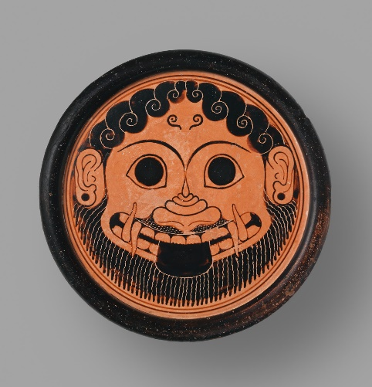
During the Archaic period, Medusa is depicted artistically as a monstrous head, with large eyes and a bearded face. This depiction is seen commonly in temple decoration from the period. For scholars focusing on the archaic representations, the removal of Medusa’s head is seen as an attempt by men to remove female power. By doing this, the myth of Medusa could be viewed as a way of legitimising the positions of men and women within Greek society, with the idea of a woman with power being seen as monstrous and unfeminine, something separate from humanity. The myth, therefore, at one level, shows that in the eyes of society, women in Greece should not hold power.
Figure 1 Terracotta Stand, 570BCE, MET museum
The archaic terracotta stand (fig.1) depicts a grotesque Medusa face on. She has large tusks, wide eyes, protruding tongue and a beard. Her hair is not represented as snakes but rather as tight curls on the top of her head. Her features are enlarged and emphasised, making her appearance uglier. The addition of the earrings may be a way of showing that she was a woman before she was a monster. This idea that she was once a woman makes her more monstrous as her appearance is opposite to the view of the ideal woman. This depiction is unlike that of the literary representations. The written sources from the archaic period do not give much of a description of Medusa, meaning the artistic depictions have, most likely, come from unwritten oral narratives of the myth. These accounts may have been written down at a later period as this depiction is close to the one given by Apollodorus in his Library. This may mean that the story of Perseus and Medusa was not popular throughout the Greek world in the archaic period, with a focus on chronology and epic rather than on heroic sagas.
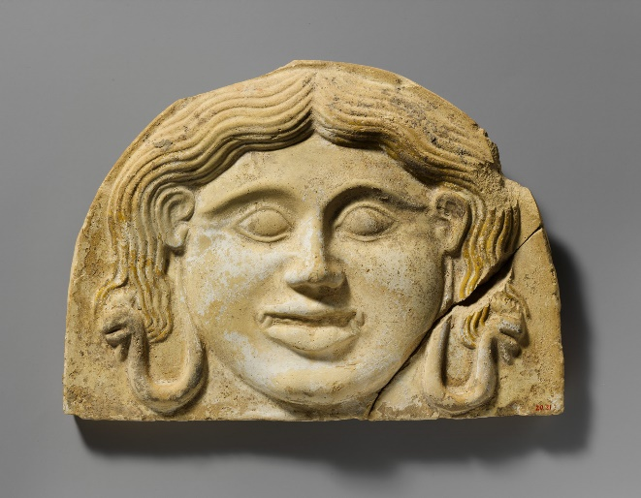
In the Classical and Hellenistic periods representations of Medusa change from the monstrous face to one of a more feminine nature. She was still recognisable as she maintained her confrontational appearance always being depicted face on. This aspect of her depiction is extremely unusual in artistic representations of people. Rarely is anyone depicted face on, with artists favouring the profile view in almost all cases. This face on depiction is most commonly used when only her head is being depicted. This could suggest that depictions of Medusa’s head had apotropaic functions. An example of this might be that the head was sometimes depicted on the helmets and shields of Greek soldiers. The image of her head was seen as a way for the Greeks to ward off a greater threat or as a form of protection against evil. The terracotta antefix (fig.2) depicts a more feminine Medusa. The instantly recognisable feature is the pair of snakes, one hanging either side of her head. As well as this, she has the confrontational look that is depicted in earlier artistic representations. Her mouth is still large and her eyes are wide. This depiction shows that she is still the monstrous being she is presented as in earlier depictions. However, the more feminine nature of her appearance in comparison to the archaic representation shows that she is being viewed as more female by artists. This antefix is from a transitional phase between the Archaic and the Classical periods. This could explain why she still possesses some of the same features, such as the large mouth and eyes. The snakes could be a way of shifting the representation of her as a monster, meaning the artist is also able to present her as feminine. This more feminine representation does not follow the literary sources. Within the classical literature, Medusa is depicted as monstrous and in no way feminine when Perseus confronts her. This depiction is closer to the Archaic artistic depictions than it is of the classical. Therefore, it may be seen that the literary representations follow that of the artistic ones, rather than the other way.
Figure 2 Terracotta Antefix, 5th century BCE, MET museum
The confrontational imagery of the Medusa demands a response from the viewer that creates a link between the art and the viewer of the art. Medusa was used by Roman poets as a way of exploring the link between art and viewership, with her face being seen as a way to display female power over male viewers. The power that Medusa possesses can be interpreted as a passive, feminine power. Her ability to turn onlookers to stone does not require her to physically do anything. Instead, it is the viewer that must look at her for her power to work. She captures onlookers by their choice to look upon her. This is reflected in the way a viewer would be captured by looking at her image in art. In the same way as the myth, the viewer is metaphorically turned into a statue by looking upon a depiction of her face.
A Structuralist interpretation of the Medusa myth can be used to explain the change in the artistic depictions of Medusa. Structuralist theory often works in binaries; as such, each myth can be seen as a division between two concepts. The story of Perseus can be interpreted as a story of good against evil in its most basic form. However, there are more conflicts at play as it is also the story of human against monster as well as man against woman. Structuralist theory views women as “the other”. This is reflected in the way that monsters are often perceived. The idea of the other makes the subject appear non-human and different. This belief means that the subject is viewed as from outside of society and is therefore bad. Depictions of Medusa show her as both a monster and a maiden. This duality of two negative aspects shows her to be a villain in two regards.
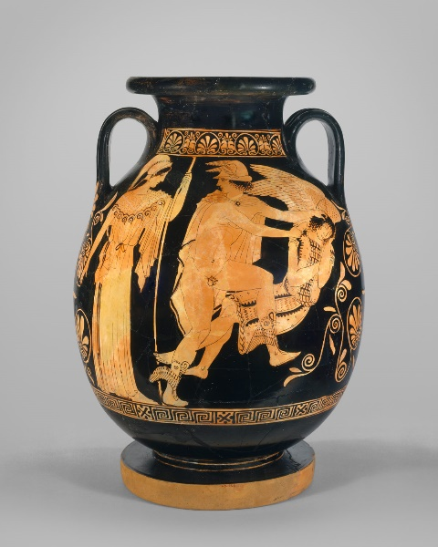
The format of the myth can be interpreted in differing ways. One obvious way is the heroic story of Perseus killing a monster. In this regard, the myth follows the same basic formula that other heroic myths typically follow. In the majority of cases, a heroic saga will follow a nine-part structure consisting of: origins, malicious destiny, enters the service of a king, suicide mission, help with the task (be that divine or other), journey, completing task, journey home, aftermath. The story can also be seen as a perversion of an abduction myth. The myth follows the same basic idea as that of abduction myths, with a maiden being pursued by a man. The Pelike vase (fig.3) shows Medusa as a beautiful woman with the only non-human aspect being her wings. This kind of outstanding beauty would have made her the pursued female figure of a traditional abduction myth with her sisters representing the chorus. However, in some ways, the myth of Medusa reverses the typical abduction myth. One way being that her Gorgon sisters chase Perseus rather than flee from him. Another is that rather than kidnap and rape her, Perseus kills her instead. These changes mean that the myth does not fully fit into the category of abduction myth. In an alternative view, the death of Medusa can be interpreted as a form of sacrifice. On the pithos (fig.4), Medusa is represented as part gorgon, part horse. In Topper’s view, this representation could be a link to the idea of the sacrificial maiden that is depicted in later tragedies. Her depiction on the pithos shows her as passive and accepting of her fate rather than fighting, as may be expected. This more accepting nature could have her interpreted as more of a victim than a vicious monster.
Figure 3 Pelike Vase, 450-440BCE, MET museum
Figure 4 Pithos, Topper, 2010, p.111
As it has been seen, the depictions of Medusa show her as both monstrous and feminine. She is neither a monster or a woman and is yet both at the same time. This mix in representation shows that in some circumstances the line between what is human and what is a monster is blurred. How she is depicted is dependent upon how she is perceived by the artist. In the Archaic period, although nothing much is said in literary sources, artists viewed her as a monster. This changed in the Classical period where she became more feminine. What is most interesting about her depictions is how her monstrous side is shown. In Archaic imagery where she is represented as a monster, it is obvious that she is not fully human. However, later depictions focus on certain characteristics. The Classical period emphasised her confrontational look with large eyes and mouth. In the modern day, she is depicted as a beautiful woman with snake hair. What this shows is that although her main monstrous feature changes throughout time, the aspect of her that makes her truly monstrous is that she is a woman with power. This being that a monster is created as an enemy to man, for man would see his greatest enemy as a powerful woman.

Bibliography
Ancient
Apollodorus, The Library, R. Hard (trans), 2008, Oxford: Oxford University Press
Hesiod, Theogony, M.L. West (trans), 2008, Oxford: Oxford University Press
Pindar, The Pythian Odes, G.S. Conway (trans), 1972, London: J.M Dent and Sons Ltd
Modern
Conway, G (1972) The Odes of Pindar, London: J.M. Dent and Sons Ltd
Garcia, B (2013) ‘Medusa’ Ancient History Encyclopaedia, Available at: https://www.ancient.eu/Medusa/ (Accessed: 10/05/2019)
Glennon, M (2017) ‘Medusa in Ancient Greek Art’ Heilbrunn Timeline of Art History, Available at: https://www.metmuseum.org/toah/hd/medu/hd_medu.htm (Accessed: 10/05/2019)
Griffiths, E (2006) Medea, Abingdon: Routledge
Hard, R (2008) Apollodorus: The Library of Greek Mythology, Oxford: Oxford University Press
Lowe, D (2018) Monsters and Monstrosity in Augustan Poetry, Michigan: University of Michigan Press
Matyszak, P (2017) The Greek and Roman Myths: A Guide to the Classical Stories, London: Thames and Hudson
MET Museum (2017) Terracotta Gorgoneion Antefix (Roof Tile), Available at: https://www.metmuseum.org/toah/works-of-art/20.215/ (Accessed: 10/05/2019)
Murgatroyd, P (2013) Mythical Monsters in Classical Literature, Bristol: Bristol Classical Press
Raeburn, D (2004) Ovid: Metamorphoses, London: Penguin Books Ltd
Topper, K (2007) ‘Perseus, the Maiden Medusa and the Imagery of Abduction’ Hesperia: The Journal of the American School of Classical Studies at Athens, 76(1), pp.73-105, Available at: https://www.jstor.org/stable/25068013 (Accessed: 16/05/2019)
Topper, K (2010) ‘Maidens, Fillies and the Death of Medusa on a Seventh-Century Pithos’, Journal of Hellenic Studies, 130, pp.109-119, Available at: https://www.cambridge.org/core/journals/journal-of-hellenic-studies/article/maidens-fillies-and-the-death-of-medusa-on-a-seventhcentury-pithos/2AC79F5EBF5C3C0C45D40A215B62B099 (Accessed: 16/05/2019)
Images
MET Museum (2017) Terracotta Gorgoneion Antefix (Roof Tile), Available at: https://www.metmuseum.org/toah/works-of-art/20.215/ (Accessed: 10/05/2019)
MET Museum (2017) Terracotta Pelike (Jar), Available at: https://www.metmuseum.org/toah/works-of-art/45.11.1/ (Accessed: 10/05/2019)
MET Museum (2017) Terracotta Stand, Available at: https://www.metmuseum.org/toah/works-of-art/31.11.4/ (Accessed: 10/05/2019)
Topper, K (2010) ‘Maidens, Fillies and the Death of Medusa on a Seventh-Century Pithos’, Journal of Hellenic Studies, 130, pp.109-119, Available at: https://www.cambridge.org/core/journals/journal-of-hellenic-studies/article/maidens-fillies-and-the-death-of-medusa-on-a-seventhcentury-pithos/2AC79F5EBF5C3C0C45D40A215B62B099 (Accessed: 16/05/2019)

Glennon, 2017
Garcia, 2013
Garcia, 2013
Garcia, 2013
Hes. Th. 272-281
Hes. Th. 276-281
Hes. Th. 278
Conway, 1972, p.165
Conway, 1972, p.xi
Pind. P. 12
Pind. P. 12
Hard, 2008, pp. vii, ix
Apollod. 2.4.2
Raeburn, 2004, p.xii
Murgatroyd, 2013, p.107
Glennon, 2017
Glennon, 2017
Lowe, 2015, p. 98
Apollod. 2.4.2
Glennon, 2017
Glennon, 2017
Glennon, 2017
Glennon, 2017
MET museum, 2017
Lowe, 2015, p. 97
Collins, 1978, p.13
Griffiths, 2006, p.61
Glennon, 2017
Matyszak, 2017, p.127-8
Topper, 2007, p.80
Topper, 2007, p.81-2
Topper, 2007, p.84
Topper, 2010, p.109
Topper, 2010, p.110

