

Assessment 1 – Reading Task Template
Upload your photo of your A3 in-class notes here:
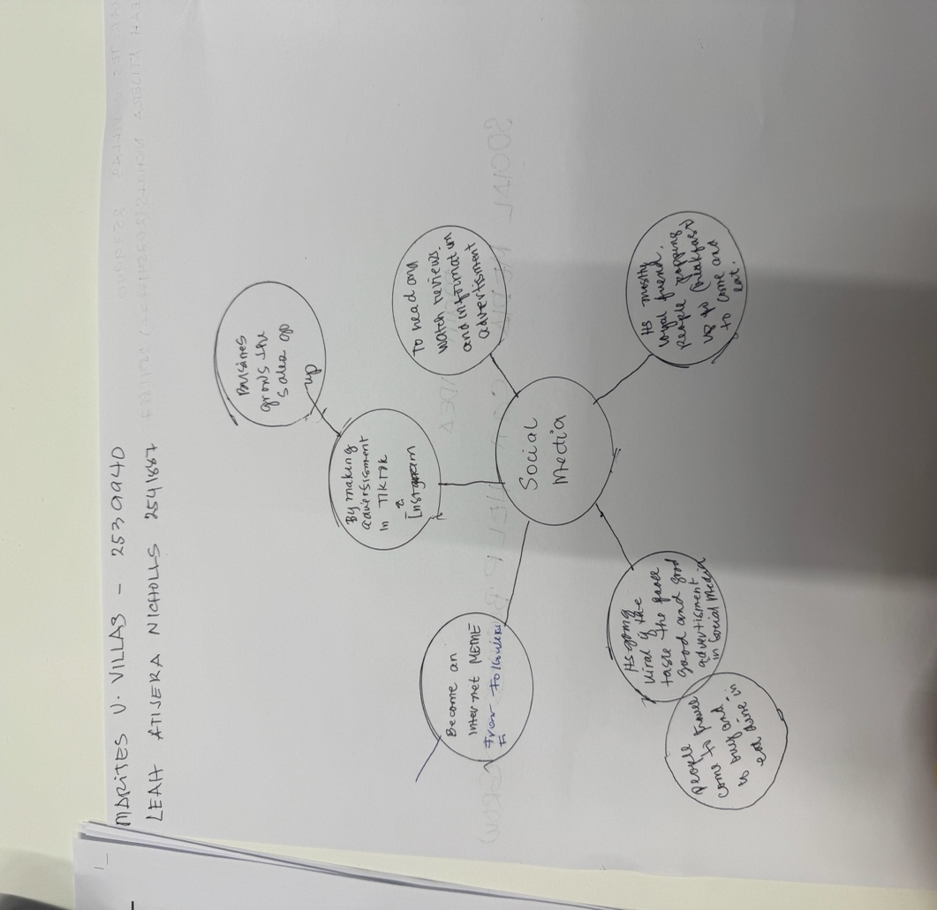

1. Answer these questions using the sentence starters below
a. What is the main idea of the text?
The main idea is that how social media helps the sale performance and the future of the business.
b. What are two key points?
One key point is growth, and how the business uses social media.

Another key point is
c. What part of the text did you find most important? Why?
The most important part is how to connect people on social media to advertise the business.
d. Was anything unclear or difficult to understand?
I was not sure about how to use the computer using social media to advertise the business.
e. How did your group help you understand the text better?
My group helped me by collective ideas.
2. One sentence reflection
Question: What did you find challenging about this task?
The hardest part was using the computer and navigating the materials.

