
Programme: MSc Public Health and Social Care in Practice
Module name:
Module code:
Student name:
Student ID:
Lecturer:

Table of Contents
Blog A 2
Blog B 5
References 8
Posture 9

Blog A
Navigating Irregular Menstrual Cycles: Insights and Solutions with the Flo App
Understanding Irregular Menstrual Cycles
An irregular menstrual cycle refers to variations in the timing, length, or flow of periods that deviate from the typical cycle of 21 to 35 days (Bull et al, 2019). Common causes include stress, hormonal imbalances, medical conditions like polycystic ovary syndrome (PCOS), or lifestyle factors (Naz et al, 2020). In the UK, around 14-25% of women report experiencing irregular cycles, making it a prevalent concern among reproductive-age individuals (Attia et al, 2023).
The Flo App: A Digital Companion for Period Health

The Flo App is a leading health tracking platform designed to assist women in monitoring menstrual cycles, predicting ovulation, and understanding reproductive health. Launched with the mission to empower women through technology, Flo has over 50 million active users globally, cementing its reputation as a go-to solution for cycle management (Tylstedt et al, 2023). This app is already existing in the UK.
(Flo Health UK, 2024)
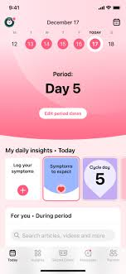
Features of the Flo App
- Cycle Tracking and Predictions: The app records menstrual cycle data, providing personalized predictions for upcoming periods and ovulation days. It adapts to irregular patterns, improving accuracy over time (Scatterday, 2021).
- Health Insights and Education: Flo offers scientifically-backed articles, videos, and expert advice on reproductive health, hormones, and wellness (Tylstedt et al, 2023).
- Symptom Logging: Users can log symptoms such as mood changes, cramps, or fatigue, helping identify patterns and triggers (Scatterday, 2021).
- Health Assistant with AI Integration: Flo uses AI to offer tailored recommendations and insights, addressing users' unique health concerns (Tylstedt et al, 2023).
(Flo Health UK, 2024)
- Pregnancy and Fertility Mode: Flo tracks ovulation and fertility windows for those trying to conceive. It also supports pregnancy tracking, providing week-by-week insights (Tylstedt et al, 2023).
- Community Support: Anonymised forums enable users to connect with others experiencing similar challenges, fostering a sense of support (Scatterday, 2021).
Advantages of the Flo App
(Stockimage, 2024)
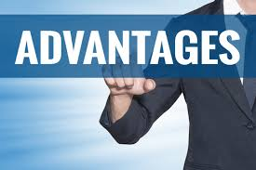
- Personalised Health Insights: The app’s AI algorithms create tailored health profiles, making addressing specific reproductive health needs easier (Tylstedt et al, 2023).
- Convenience and Accessibility: Flo offers a seamless, user-friendly interface, making it accessible to users of all ages (Tylstedt et al, 2023).
- Educational Empowerment: The app serves as a knowledge hub, enabling women to make informed decisions about their health (Tylstedt et al, 2023).
- Comprehensive Health Tracking: Beyond periods, Flo monitors symptoms, mood, sleep, and physical activity, offering a holistic view of health (Scatterday, 2021).
- Data Privacy: Flo prioritises user privacy with strict data protection measures (Scatterday, 2021).
Disadvantages of the Flo App
(Stockimage, 2024)
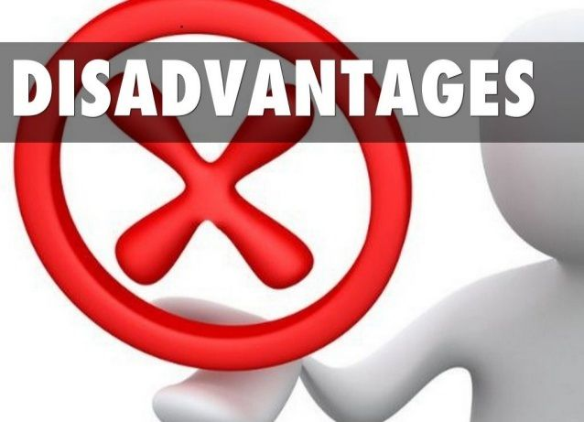
- Inaccuracy in Predictions for Highly Irregular Cycles: While Flo learns from user data, its predictions may falter for individuals with extremely erratic cycles (Beramand, 2023).
- Dependence on User Input: The app’s accuracy relies heavily on consistent data entry, which can challenge some users (Tylstedt et al, 2023).
- Subscription Costs: Advanced features require a premium subscription, which may deter some users (Scatterday, 2021).
Approaches to Address Challenges
- Investing in advanced AI to refine predictions for irregular cycles can enhance user satisfaction (Beramand, 2023).
- Providing tutorials and reminders can encourage consistent data entry (Beramand, 2023).
- Offering more features in the free version can make the app accessible to a broader audience (Beramand, 2023).
- Integrating Flo with telehealth services can offer users professional medical advice directly through the app (Beramand, 2023).

Blog B
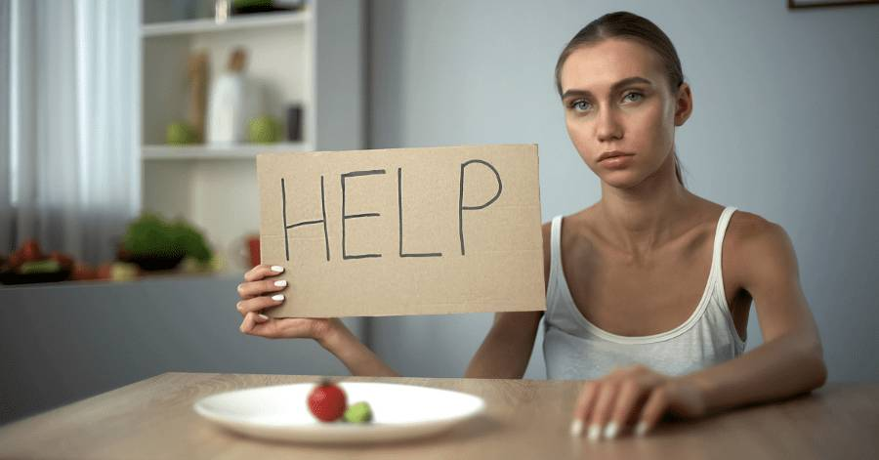
Finding Balance: Eating Disorders and the Role of Technology in Recovery
(Brighter Vision, 2024)
Understanding Eating disorders
Eating disorders are complex mental health conditions marked by unhealthy relationships with food, eating habits, and body image (Izydorczyk, 2022). These disorders, including anorexia, bulimia, and binge eating disorder, often stem from a combination of psychological, environmental, and genetic factors. They can severely impact physical health, emotional well-being, and social life (Izydorczyk, 2022). In the UK, it is estimated that over 1.25 million people live with an eating disorder, affecting individuals of all ages and genders (Batchelor et al, 2022).
Introducing the Body Balance App
The Body Balance App is a new digital tool designed to support individuals battling eating disorders, including anorexia nervosa. Combining evidence-based techniques with user-friendly features, the app offers a comprehensive approach to recovery. It is developed with input from healthcare professionals and individuals who have experienced eating disorders, ensuring it caters to real-world needs (Chiang et al, 2023).
Key Features of the Body Balance App
- Personalised Meal Planning: Creates customisable meal plans based on nutritional needs and preferences (Naccache et al, 2021).
- Mood and Thought Tracker: Helps users identify triggers and patterns in their thoughts and emotions (Chiang et al, 2023).
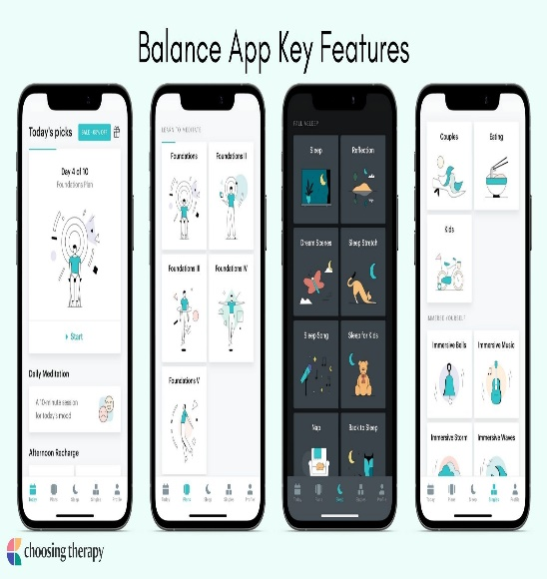
- Professional Guidance: Includes virtual consultations with dietitians and therapists (Naccache et al, 2021).
- Community Support: Offers forums for peer support and recovery stories to inspire users (Naccache et al, 2021).
- Progress Monitoring: Tracks physical and emotional progress using graphs and summaries (Naccache et al, 2021).
- Crisis Support Links: Provides immediate access to emergency helplines (Chiang et al, 2023).
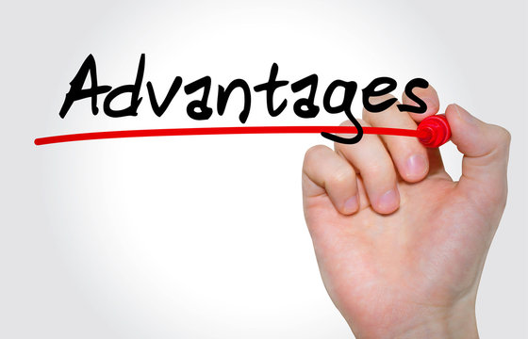
Advantages of the App
- Convenience: Accessible 24/7, allowing users to seek help at their own pace (Chiang et al, 2023).
- Holistic Support: Combines emotional, nutritional, and psychological tools in one place (Naccache et al, 2021).
- Engagement: Gamified features encourage adherence to recovery goals (Naccache et al, 2021).
- Confidentiality: Ensures privacy, offering a safe space for users (Chiang et al, 2023).

(Stockimage, 2024)

Disadvantages of the App
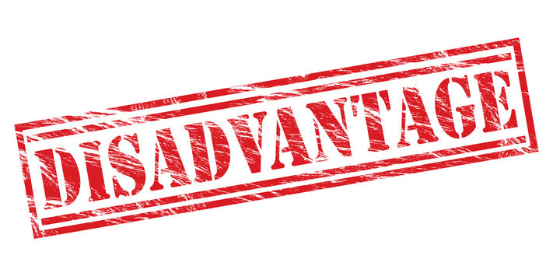
- Limited Accessibility: Requires stable internet and compatible devices, potentially excluding underserved populations (Naccache et al, 2021).
- Dependence on Self-Motivation: Users need the commitment to engage with the app actively (Fardouly et al, 2022).
- Lack of Personalization in Crisis: Automated responses may not fully address complex emotional needs (Chiang et al, 2023).
(Stockimage, 2024)
Approaches to Overcome Challenges
- Enhancing Accessibility: Develop offline modes and affordable versions for wider reach (Fardouly et al, 2022).
- Strengthening Engagement: Incorporate AI-driven reminders and motivational messages (Fardouly et al, 2022).
- Integrating Human Touch: The Blend app features regular in-person counselling to balance technology with personal care (Naccache et al, 2021).
By blending technology with empathy and innovation, tools like the Body Balance App can empower individuals to regain control over their health, paving the way for recovery and resilience.

References
Attia, G.M., Alharbi, O.A. and Aljohani, R.M., (2023). The Impact of Irregular Menstruation on Health: A Review of the Literature. Cureus, 15(11).
Batchelor, R., Cribben, H., Macdonald, P., Treasure, J., Cini, E., Nicholls, D. and Kan, C., (2022). The experiential perspectives of siblings and partners caring for a loved one with an eating disorder in the UK. BJPsych Open, 8(2), p.e76.
Beramand, L., (2023). The Cost of Convenience: An Exploration of the Privacy Aspects in Period-Tracking Applications: A mixed-method study of perceived privacy by users in period-tracking applications.
Bull, J.R., Rowland, S.P., Scherwitzl, E.B., Scherwitzl, R., Danielsson, K.G. and Harper, J., (2019). Real-world menstrual cycle characteristics of more than 600,000 menstrual cycles. NPJ digital medicine, 2(1), p.83.
Chiang, C.P., Hayes, D. and Panagiotopoulou, E., (2023). Apps targeting anorexia nervosa in young people: a systematic review of active ingredients. Translational Behavioral Medicine, 13(6), pp.406-417.
Fardouly, J., Crosby, R.D. and Sukunesan, S., (2022). Potential benefits and limitations of machine learning in the field of eating disorders: current research and future directions. Journal of Eating Disorders, 10(1), p.66.
Izydorczyk, B., (2022). Body image in eating disorders: Clinical diagnosis and integrative approach to psychological treatment (p. 152). Taylor & Francis.
Naccache, B., Mesquida, L., Raynaud, J.P. and Revet, A., (2021). Smartphone application for adolescents with anorexia nervosa: an initial acceptability and user experience evaluation. BMC psychiatry, 21, pp.1-14.
Naz, M.S.G., Dovom, M.R. and Tehrani, F.R., (2020). The menstrual disturbances in endocrine disorders: a narrative review. International journal of endocrinology and metabolism, 18(4).
Scatterday, A., (2021). This is no ovary-action: femtech apps need stronger regulations to protect data and advance public health goals. NCJL & Tech., 23, p.636.
Tylstedt, B., Normark, M. and Eklund, L., (2023). Reimagining the cycle: interaction in self-tracking period apps and menstrual empowerment. Frontiers in Computer Science, 5, p.1166210.

Posture


