Critically examine the literary and artistic representations of chthonic deities in the Graeco-Roman world
The definition of chthonic means “of or relating to the underworld” (Merriam-Webster 2010), this theme appears in religions all around the world, it can be used as a societal construct to control the masses with fear, which could explain why it is so prominent globally. The chthonic gods, Pluto (Roman) and Hades (Grecian) are depicted similarly in Greco/Roman art and literature, as are most of the Gods shared between these two cultures. Braund and Gill (2003: 315) state Grecian myth “pervaded” Roman life in most of the artistic representations of the gods. Moreover, of Cicero’s “exempla” using non-Roman themes in his work, Greek themes are the most prominent (Van Der Blom, 2007: 157). As well as the quite similar link between academic works of the time, there was also a similar use of artistic methods, shown through sculptures such as Hermes Richelieu which although crafted in imperial Rome, nonetheless had obvious Grecian origins. Due to the melting of Grecian bronze statues for “reuse” (Hemingway and Hemingway, 2003) these Roman works are the only interpretation we have of what the originals may have looked like. Thus, showing that Grecian and Roman life was intertwined quite prominently and why the term Greco-Roman is so commonplace amongst academics. In this essay I am going to critically examine pieces from both cultures and explore to what extent they showed similarities, I will do this by looking at classic Grecian myths and their Roman counterparts, such as Persephone and Proserpina, wives of the chthonic rulers and Hermes and his counterpart Mercury, guides to the underworld in various tales.
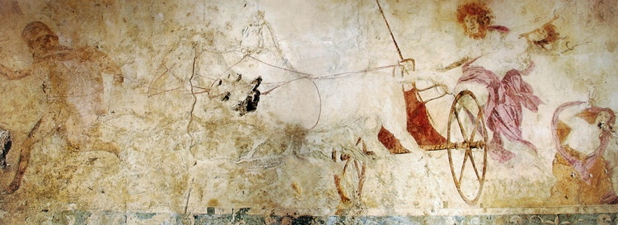
The myth of Persephone has some of its earliest origins from Homer’s Ode to Demeter, which tells of Persephone’s abduction by Hades to the underworld, in order to make her his bride he allegedly tricked her. Although Persephone is the main victim, the tale tends to focus on the grieving mother Demeter and uses her emotions to explain the order of the seasons. The use of Demeter’s discontinued fertilisation of the Earth due to grief at the loss of Persephone to explain why we have winters shows us how mythology was an educating system. It was a way of making sense of the world around them with themes that they understand, like the god’s emotions and their effects on humankind and the Earth. A lot of the surviving paintings we have from Greece seem to come from the fourth century such as the wall painting used above. The painting itself was found at the archaeological site of Vergina where many royal tombs were discovered by Professor Andronikos, from the content found it was probable that the tombs contained remains of royal descendants (Grant, 2020). In this main wall painting one can see a large man grasping a helplessly flailing women, aboard a chariot. This representation reinforces the story that is well known, of the innocent Persephone being abducted by the powerful Hades. The art style is very realistic, with accurate facial features and body proportions as well as normal body contortions, it is very reminiscent of what you would see during the renaissance. The subjects near the main portion seem to be running or raising their arm in defence to show fear of the god and his actions, this tell us of how the artist feels hades actions would have been perceived in Greecian society. Therefore, by telling us that barbaric actions like this would not have been accepted we can see that the Greeks were orderly, and that they used these chthonic deities to represent social morals through artwork. Within his work, Ode to Demeter Homer speaks of how Persephone was “seized” (Homer C6/7 B.C: line 3) and spent her time aside Hades “under duress” (Homer, C6/7 B.C: line 344). This could all tell us that chthonic deities much like demons in Christianity were evil and performed atrocious acts that shared no values with the writers, however most of the gods were noted for rape, murder and revenge upon petty behaviours.
Hades abducting Persephones, J. Paul Getty Museum, 4th Century B.C
Hades abducting Persephones, J. Paul Getty Museum, 4th Century B.C
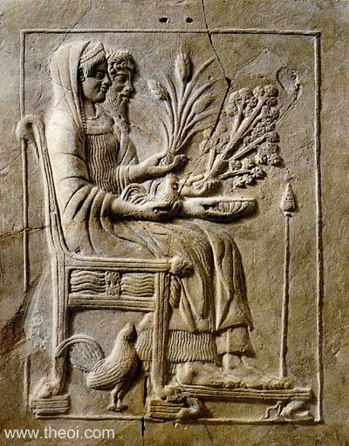
In Roman artwork there are many works called The Rape of Proserpina in sculpting and painting, moreover literature also speaks of her as a “ravished maid” (Ovid, 8 A.D: line 598). Ovid also tells us that Proserpina “did break her fast on three grains enclosed in the tough rind of a pomegranate” (Ovid, A.D. 8: line 598/9). This presents us with the picture that she although unwillingly, broke under pressure of fasting. Thus, having more autonomy than Persephone who was forced to eat the pomegranate before departing from the underworld. From this, one can see that the chthonic deity Pluto, although forceful like Hades, was more forgiving, giving Proserpina the chance to go home if she had enough willpower. The Romans show us a reasonable picture of Pluto, who with these tests is construed as a fair ruler. In artwork such as the one shown below from Imperial Rome, Proserpina is presented enthroned next to Pluto. They seem to be smiling pleasantly and comfortable, holding crops and livestock. This is very evocative of Zeus and Hera, showing a different side to the tale of the Rape of Proserpina. However, from a feminist perspective this could be a tale of the suppression of women at the time. Although taken against their will, women should always behave properly and submit to their husbands, such was expected and normal in ancient times. This type of relief was common in Rome, with the usual subjects being commanders and emperors, an example of this would be the Column of Marcus Aurellius. When looking at the detailed intricacies of other reliefs during the Imperial Roman period, one can see that this relief is quite plain and basic, however it was not uncommon and is similar to the marble relief of Hermes found at Ephesus.
(Hades & Persephone, anon n.d)
From the two types of literary evidence, there are similarities revealed between the physical act of kidnapping Persephone/Proserpina, as well as the presentation of it being upsetting to Demeter/Ceres. This tell us that from one of the most popular and prominent representation of Hades we have, there is a cruel undertone in his behaviour. From looking at symbols, the tale of Persephone/ Proserpina could be a metaphor for death. For instance, Hades/Pluto emerging suddenly could be viewed as death taking away a youth in her prime, shadowing the suddenness of death itself. Moreover, the extreme grief of Demeter portrays the role that women were meant to play as doting mothers. I specifically chose two types of art forms that differ because it lets us see the different techniques used to produce an image of their parallel pantheons. The art shows us that although Cthonic rulers can be publicised as the counterparts to other religious demons like Satan, they are more like their fellow gods, all committing similar acts. Hades and Pluto are presented as gods of the dead, this could be where the negative connotation comes into play, as death is a commonplace fear by most of the population. This negative connotation can be seen for other major players in the underworld such as Charon/Charun, who is portrayed as something you’d see in the bestiary from the modern media receptions, like Clash of the Titans. Alternatively, there are exceptions to this rule as can be seen by Hermes/Mercury, although a guiding hand through the underworld he is viewed separately. This could be due to the fact he does not reside there, or that he is one of the central figures in many myths not involving the underworld. In the next part of this essay we will look at Hermes/Mercury’s representation and role in the underworld and how this is translated through art and literature.
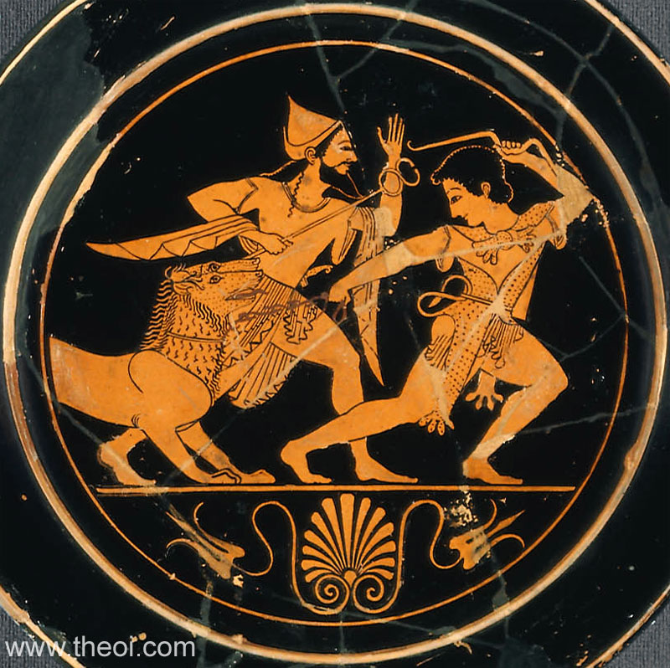
There are many stories of Hermes/Mercury, he is often depicted as a messenger between gods, meaning that he appears in many myths, not solely focussed on him. Hermes/Mercury like Charon/Charun is depicted as a psychopomp “a conductor of souls to the afterworld” (Merriam-Webster 2020). An example of this would be Jupiter’s use of him to take the nymph Lara to the underworld as punishment (Ovid, A.D. 8: line 598). The first piece of Grecian art I am going to use as reference to Hermes association with the underworld is an archaic plate. In Greek myth Hermes was the guide of Heracles on his mission to the underworld to fight and capture Cerberus, as shown through Greek art. The piece of art I will be looking at is a plate from the archaic period, it is a red figure plate which means the background is painted and the figures are left the colour of the vase, this came about as an opposite to the popular black figure art style. This style change from the traditional geometric pattern has been said to originated from eastern influence through trade with the Levant (Department of Greek and Roman Art 2003). In the painting Hermes is walking alongside Heracles who is pulling Cerberus on a leash. The Nemean lion pelt is seen worn by Heracles, whereas the god Hermes has his serpent wand, these traits painted on by the artist allow us to discern each of the characters. This also shows that details of the other labours by Heracles like the battle with the Nemean lion were well known by the artists who made these plates. From the faces of both Hermes and Heracles we can see they are happy due to the upwards motion the mouth is painted as making. This representation of a helpful Hermes differs a lot from the chthonic deity Hades capturing Persephone. This can tell us that the artists from the archaic period viewed Hermes as a helper, helping the heroes they treasured so much, thus linking Hermes to a more positive status than other chthonic deities in Greece. The painting itself is the departure of Hermes and Heracles, this can reveal a symbol of accomplishment, in that Hermes is not simply staying in the underworld after the battle, he is also taking a prideful walk alongside Heracles up to the Earth.
(Plate with Heracles pulling Cerberus 510-520 BC.)
The Roman chthonic association of Hermes going to the underworld is an interesting one as it can act as a metaphor to Mercury in retrograde in astrology. As mentioned earlier, Homer speaks of Mercury’s guiding of Lara to the underworld, showing a similar role to Hermes as he guided Persephone and Heracles. In art however Mercury during his activities as a Psychopomp is hard to find and briefly mentioned in different verses. Therefore, we are going to look at the common heavenly interpretation, comparing how opposite it is to the chthonic title he has been bestowed. In the Orphic hymns we the hymn To Mercury the author describes the main features and traits of the god, as if he is in awe of the god’s majesty. The source is from a cult that worships Orpheus, as made evident by the title. Orpheus himself was a mythical character who had travelled to and from the underworld to retrieve his love Eurydice unsuccessfully in Virgil’s Georgics. The hymns do not solely focus on Hermes but speak off all the gods, thus showing that with no specific aims towards Mercury, we do not need to question the motive of portraying him a certain way excessively. In the text we can see that mercury is called a “Celestial messenger”, although Mercury was a messenger to the underworld and Earth, this title does not have any chthonic undertones, only ethereal. He is also described as “friend of man” and a “Great life-supporter”, this a very familiar and friendly expression to use, derived from the tales of his helpfulness to Heracles during his labours as we saw in the Grecian art. The hymns sound very grateful to Mercury as he has done much for mankind and as though the cult see him as an ally to mankind. From the wording used it’s clear that the author/s view Mercury as an ally of sorts who helps mankind is their times of need, as well as being their “friend”. Overall this section of the literature shows that Mercury was not viewed in a negative sense due to his travels to the underworld. In opposition to this thought, there is also the fact that as this is a letter to the deity, the language used will be very complimentary. Meaning that the author/s believed that Mercury did not want to be addressed as his chthonic identity, but as a celestial being in the same sense as other members such as Apollo.
Celestial messenger, of various skill, whose pow'rful arts could watchful Argus kill: With winged feet, 'tis thine thro' air to course, O friend of man, and prophet of discourse: Great life-supporter, to rejoice is thine, in arts gymnastic, and in fraud divine
-The Hymns of Orpheus, C2nd/3rd B.C.
Between the Grecian and Roman interpretations of Hermes/Mercury one can see that there is a main theme of helping and acting as an ally to humans. This can be seen by Mercury being referred to as a “friend” in The Hymns of Orpheus and by the representation of Hermes helping Heracles and smiling in the plate painting. When researching Hermes and Mercury there was not that much evidence of his actions in the underworld, apart from the story of Persephone and Heracles. This could mean that although classed as a chthonic deity people were too preoccupied with his actions from other myths, thus leading to less and less art and literature portraying him this way, which makes it much harder to research him in this light for a piece of academic research.
From looking at Hades it could be interpreted that he is used to show barbaric actions that Greek society would not have deemed tolerable, however as an underworld being, he is different from a Christian religion as the other gods also performed barbaric actions. Moreover, in Rome he is viewed happily on his throne with Persephone showing, that there was no endless suffering for Persephone but a return to calmness. Hermes was viewed differently that Hades as his role as a chthonic worker was almost hidden away, this could possibly be due to his role in famous literature, people’s main idea of him from the most popular tales of the time are as a helper of Heracles and Odysseus. Overall there is a mixed view of chthonic deities, not necessarily scary as you would imagine from modern media like Disney’s Hercules, but when looking at a movie like Clash of the Titans one can see that Zeus was as much an antagonist to Perseus as Hades, telling us that modern media understands that there are no “bad guys” in Greco/Roman Mythology. This could show a distinct difference between monotheism and polytheism, as the gods perform more human like actions and make mistakes, whereas in Christianity and Judaism there is a clear-cut line between good and bad, with each side being of two extremes. From this essay one could say that although chthonic deities are grouped together as a category, apart from meaning that they are involved in the underworld they do not differ from the rest of the pantheon.
Bibliography
[anon.] [n.d] Hades & Persephone. [online] Available from: https://www.theoi.com/Gallery/R14.1.html [accessed 31/05/2020]
[anon.] 2020. The Hymns of Orpheu: The Invocations used in the Eleusinian. Translated by Thomas Taylor. 2nd edition. California: CreateSpace Independent Publishing Platform
Braund, D. and Gill, C. (eds) 2003. Myth, History and Culture in Republican Rome: Studies in Honour of T.P. Wiseman. Liverpool: Liverpool University Press.
“Chthonic”. 2020. Merriam-Webster. Merriam-Webster.com. Available from: https://www.merriam-webster.com/dictionary/chthonic [Accessed30/05/2020]
Department of Greek and Roman Art. 2003. Greek Art in the Archaic Period. The Met. Available from: https://www.metmuseum.org/toah/hd/argk/hd_argk.htm [Accessed on 01/06/2020)
Grant, D. 2020. The Royal Macedonian Tombs at Vergina. Ancient History Encyclopedia. Available from: https://www.ancient.eu/article/1490/the-royal-macedonian-tombs-at-vergina/ [Accessed 31/05/2020]
Hemingway, C. and Hemingway, S. 2003. The Technique of Bronze Statuary in Ancient Greece. The Met. Available from: https://www.metmuseum.org/toah/hd/grbr/hd_grbr.htm [Accessed on 31/05/2020]
Plate with Heracles pulling Cerberus. (510-520 B.C.) [ceramic, red figure]. Museum of Fine Art Boston. 01. 8025. Available from: https://collections.mfa.org/objects/153852 [Accessed 01/06/2020]
Homer. C6/7 B.C. Ode to Demeter. Translated by Gregory Nagy. Centre for Hellenistic Studies. Available from: https://chs.harvard.edu/CHS/article/display/5292 [Accessed 31/05/2020]
Ovid. A.D. 8. Fasti II. Translated by Frazer, J. Theoi. Available from: https://www.theoi.com/Text/OvidFasti2.html [Accessed 01/06/2020
Ovid. A.D. 8. Fasti IV. Translated by Frazer, J. Theoi. Available from: https://www.theoi.com/Text/OvidFasti4.html [Accessed 31/05/2020]
“Psychopomp”. 2020. Meriam-Webster. Merriam-Webster.com. Available from: https://www.merriam-webster.com/dictionary/psychopompos [Accessed 01/06/2020]
The J. Paul Getty Museum. 4th Century B.C. Hades abducting Persephone. [online] Available from: http://getty.edu/museum/programs/lectures/life_and_afterlife_lecture.html [Accessed 31/05/2020]
Van Der Blom, H. (2007). GRAECOPHILE OR GRAECOPHOBE? CICERO'S CHOICE BETWEEN GREEK AND ROMAN "EXEMPLA". The Classical Outlook, 84(4), 157-162. [Online: https://www-jstor-org.ezproxy.uwtsd.ac.uk/stable/43939740?readnow%3D1%23page_scan_tab_contents=&seq=1#metadata_info_tab_contents] [Accessed 31/05/2020]

