

Rory Bowen

The Importance of Critical Diameter and Critical Density in the Detonation Process

University of Wales Trinity Saint David
L4 - Principles of OME (ACDA4019)

Academic Year: 2025 - 2026

Supervisor: Dr Gareth Collett CBE
Associate Supervisor: Dave Holley
December 2025

© UWTSD 2025. All rights reserved. No part of this publication may be reproduced without the written permission of the copyright owner.

Academic integrity declaration
I declare that:
- the thesis submitted has been written by me alone.
- the thesis submitted has not been previously submitted to this university or any other.
- that all content, including primary and/or secondary data, is true to the best of my knowledge.
- that all quotations and references have been duly acknowledged according to the requirements of academic research.
I understand that to knowingly submit work in violation of the above statement will be considered by examiners as academic misconduct.

Abstract
This report examines the roles of critical diameter and critical density in enabling a successful detonation transition from a primary explosive (lead azide) to a secondary RDX explosive. Starting from fundamentals of detonation theory, the document reviews performance characteristics of the two chosen explosives, discusses how stimulus from a primary translates into a self-sustaining detonation in the secondary, and explores how confinement and density alter critical parameters. The report culminates in a conceptual diagram that highlights the relationships among density, diameter, and velocity of detonation that govern transition success. Throughout, discussion remains high-level and non-procedural and is framed for ordnance/munitions engineering (OME) professionals and educators.

Keywords:
- Explosive Stability
- Defence Industry Applications
- Warhead Design
- Explosive Safety
- Detonation Velocity
- Insensitive Munitions

Acknowledgements
Thank you to Dr Gareth Collett CBE and Dave Holley in the preparation and delivery of materials used to advise in the creation of this report

Table of Contents
Academic integrity declaration i
Abstract ii
Acknowledgements iii
List of Figures vi
List of Tables vi
List of Equations vi
List of Abbreviations vii
1 Introduction 8
2 Fundamentals of Detonation 9
2.1 Detonation vs Deflagration 9
2.2 Detonation Equations 9
2.3 Critical Diameter 11
2.4 Critical Density 11
3 Literature Review 12
3.1 Performance Characteristics 12
3.1.1 Lead Azide 12
3.1.2 RDX 12
4 Stimulus Transfer in an Explosive Train 14
4.1 Mechanisms of Stimulus 14
4.2 Coupling efficiency 14
4.3 Transition scenarios 14
5 Critical Diameter and Critical Density 15
5.1 Effect of density on Critical diameter 15
5.2 Effect of confinement 15
5.3 Role of primary stimulus amplitude and duration 15
5.4 Heterogeneity and microstructure effects 16
6 Velocity of Detonation as a function of density for RDX 17
6.1 Qualitative Trend 17
6.2 Practical implications for transition 17
7 Theorising confinement effects and operational benefit to OME professionals 18
7.1 How confinement alters critical parameters 18
7.2 Benefits for OME professionals 18
8 Conceptual relationships among density, diameter, and VoD 19
8.1 Diagram 19
9 Conclusions and Recommendations 20
10 References 21
Appendix A Ethical approval letter 22
Appendix B 23

List of Figures
No table of figures entries found.

List of Tables
No table of figures entries found.

List of Equations
No table of figures entries found.

List of Abbreviations
PBX | Polymer-Bonded Explosives
SDR | Strategic Defence Review
TMD | Theoretical Maximum Density
ESD | Electrostatic Discharge
VoD | Velocity of Detonation

Introduction
In the defence industry, explosive technologies are key to modern day defence technology, including conventional munitions to advanced warhead systems which were central to the most recent SDR in 2025.
‘For a detonation to occur, a self-sustaining shock front must propagate through the explosive medium, coupling chemical energy release with the advancing wave.’
Two parameters serve as thresholds which dictate whether the detonation process can be maintained, these are
- Critical Diameter
- Critical Density
If either is not met then the detonation will fail, resulting in an incomplete detonation reaction which could transition to a deflagration reaction. In the defence industry predictable performance is essential and being able to control reliability and safety is crucial.
This report uses lead azide as the primary initiating explosive and RDX as the secondary. These are typical choices for examining initiation and detonation transition in many military and civil energetic systems because they represent a sensitive primary and a relatively powerful, less-sensitive secondary. The literature review on both materials aims to provide substantial and specialized data on performance behaviour.

Fundamentals of Detonation

Detonation vs Deflagration
- Deflagration: Subsonic combustion driven by thermal conduction and mass diffusion.

- Detonation: Supersonic shock-driven reaction where the shock front and chemical decomposition are coupled.

Detonation Equations
Detonation equations can be used further understand some of the effects caused by high explosives. An example of this is Marshall’s Formula which can be used to roughly calculate the velocity of detonation.
Marshall’s Formula
$$D=430\sqrt{nT_{d}}+3500\left(Δ-1\right)$$
D = Velocity of Detonation
n = the number of moles of gaseous products from 1 gram of explosive.
T_{d} = the temperature of detonation
Δ = the charge density

Using Marshall’s formula, the detonation pressure can also be calculated using the velocity of detonation.
VoD is the steady-state speed of a detonation through a homogeneous explosive at a given density and confinement. It typically increases with density (up to the material’s theoretical maximum at near-perfect crystalline packing), reflecting faster reaction zone kinetics and stronger shocks. VoD is a useful performance metric in correlating density to ability to accept a detonative stimulus.

Detonation Pressure Formula
$$Dentonation Pressure=ρ{D^{2}}/4$$
ρ = density
D = velocity of detonation

Gurney Formula can be used to calculate the velocity of fragment in a simulated modelling. However, the velocity of fragmentation is the average as natural fragmentation some pieces will have a greater and lesser mass. In a pre-formed fragmentation pattern gurney formula is very useful as it allows an accurate velocity of fragmentation to be produced which in turn can help to estimation lethality art certain distances and penetration against armour.
Gurney Formula (cylindrical warhead)
$$V_{s}=\sqrt{2E_{G}}{\left(\frac{1}{2}+\frac{M_{C}}{M_{E}}\right)}^{-\frac{1}{2}}$$
V_{s} = Velocity of fragment
M_{C} = Mass of case
M_{E} = Mass of Explosive
√(2E_{G}) = Gurney constant of the explosive

Critical Density
Critical Density refers to the minimum bulk density of an explosive to still produce a detonation. As the density increases often so does the VoD and the peak overpressure of the blast wave.

Critical Diameter
Critical Diameter refers to the minimum unconfined diameter of an explosive that will still permit a self-supporting detonation. When an explosive charge is smaller than this there is not enough edge refraction to sustain the detonation. The diameter of the charge depends on the reactivity of the explosive material which is determined by chemical kinetics, such as density and porosity.

Literature Review

Performance Characteristics

Lead Azide
Lead azide is one of the most widely used primary explosives in detonators, blasting caps, and fuzes. This is due to its high sensitivity and reliable initiation due to instantaneous detonation rather than deflagrating. Some of the key characteristics:
- Chemical Formula: Pb(N₃) ₂
- Density: ~4.8 g/cm³
- Detonation Velocity: ~5.2 km/s
- Critical Diameter: ~0.3 mm (unconfined)
These characteristics allow lead azide to be a perfect primary explosive due to its small critical diameter, however this also makes it very sensitive to impact fiction and ESD. As previous mentioned the very rapid decomposition which produces a strong, but short-duration pressure pulse is effective at initiating more stable secondary explosives when both materials are at their critical diameter and critical density while also being properly coupled together.
From an OME engineering perspective, lead azide’s role is to deliver a high-pressure, short-duration shock to the booster/secondary explosive to create an excess of adiabatic heating in the materials successful starting and helping to drive the explosive train.

RDX
RDX is a powerful secondary explosive most used in the defence industry as the main filling in shells. RDX is also commonly mixed with TNT and with polymeric binders to form PBX. Mixing RDX with other compounds or binders helps to provide mechanical strength and help to tailored sensitivity. Some of the key characteristics:
- Chemical Formula: C₃H₆N₆O₆
- Density: 1.76 g/cm³ (pressed), up to 1.82 g/cm³ (theoretical maximum)
- Detonation Velocity: 8.75 km/s at maximum density
- Critical Diameter: Typically, 4–6 mm (unconfined), reduced under confinement.
These characteristics outline how RDX is a high-energy nitramine with compatible high theoretical VoD to HMX when densified close to its TMD. Mixed PBXs retain much of this power while being less sensitive than the crystalline material. RDX is less sensitive than primary explosives, PBX’s also change the mechanical and thermal sensitivities further. This in turn creates a safer to handle, less sensitive munitions, but requires stronger initiating stimuli. The VoD and ability to sustain detonation is directionally proportional to density.
From an OME engineering perspective, RDX role is to deliver an extremely high overpressure, to either use blast or fragmentation to achieve the purpose of the weapon system.

Explosive Train

Stimulus
Primary explosives deliver a stimulus in various forms ranging from
- Localized hot spot /
- Flame
- Pressure pulse from a small detonation,
- Frictional heating
- Electrostatic discharge (ESD).
In detonators, the dominant mechanism is a pressure pulse (shock) generated by the primary’s rapid detonation. This pressure then contacts the secondary explosives to induce, adiabatic heating to initiate a detonation front.

Transition scenarios
There are 3 measurable outcomes are typical when a primary explosion stimulus reaches a secondary explosive:
- There is an immediate transition where the shock generates a self-sustaining detonation in the secondary explosive.
- There is a failure to detonate, when the shockwave can’t induce a fast deflagration or localized reactions that don’t trigger a chain reaction.
- There is a partial transition or localized detonation, where the detonation occurs only in some regions of the secondary explosives. However, it is not sustained across the energetic material, therefore yielding a partial outcome.
Critical diameter and critical density determine which scenario occurs under a given stimulus.

Diagram of Explosive Train
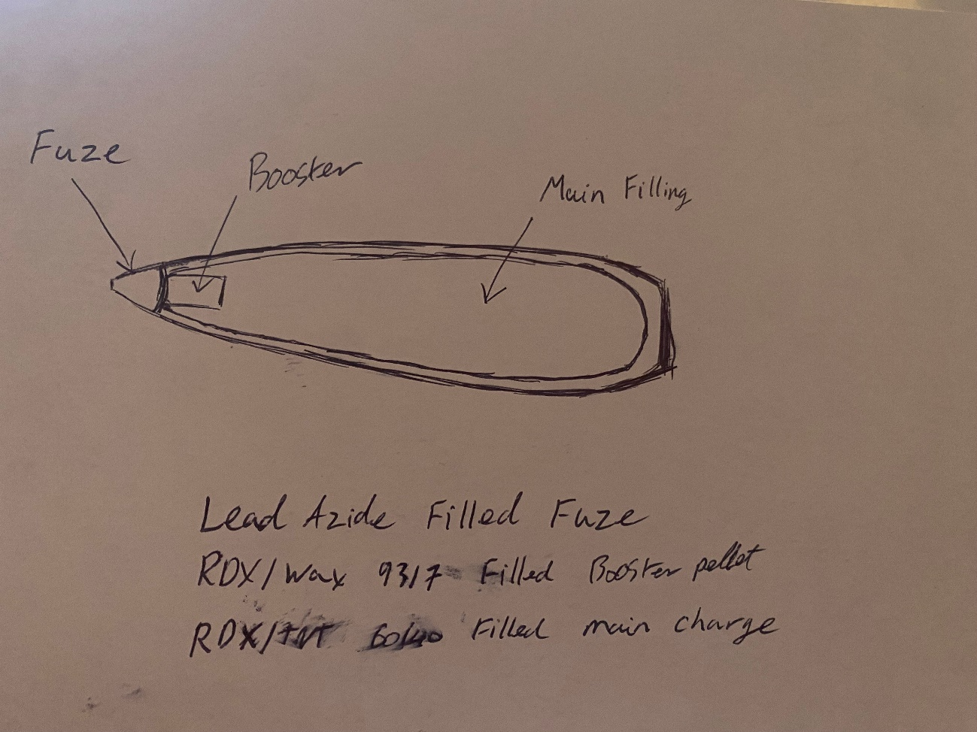
Figure 1 - Diagram of an explosive train in an artillery shell. The fuze is filled with a lead azide primary explosive. The booster component is filled with a 93/7 mix of RDX/Wax mix. The main charge is filled with a 60/40 mix of RDX/TNT.

The relationship of Critical Diameter and Critical Density

Effect of density on Critical diameter
At higher densities, the reaction zone of the secondary explosives becomes more compact and energetic, therefore reducing the minimum diameter required to sustain a detonation. In practice:
- A lower-density RDX, the critical diameter is larger meaning the charge needs greater cross-section to avoid rarefaction losses.
- A higher-density RDX, the critical diameter shrinks meaning the detonation can be sustained in smaller geometries.
This inverse relationship of higher density to a smaller critical diameter is observed across many secondary explosives, although the exact functional dependence is energetic material specific.

Effect of confinement
Confinement reduces lateral rarefaction and helps maintain shock strength and pressure behind the leading shock. Confinement therefore reduces the effective critical diameter and lowers the critical density required for detonation transition. From an OME perspective, confinement is a design variable that can either be intentionally used to ensure reliable initiation or must be accounted for in hazard assessments (e.g., accidental confinement leading to unexpected sympathetic).

Role of primary stimulus amplitude and duration
A higher energy, longer duration stimulus from the lead azide will reduce the requirements on both the critical diameter and critical density for the secondary explosive. This is due to a stronger shock overcoming a greater porosity and smaller diameters.

Heterogeneity and microstructure effects
Explosives are most effective as a homogenous compound however most explosives are microstructurally heterogeneous. The voids and crystal size distribution create local variations in packing and reaction kinetics. These different heterogeneous regions raise the effective critical diameter and critical density compared with an ideal homogeneous material. Thus, two samples nominally at the same bulk density may exhibit different detonation thresholds.

Velocity of Detonation as a function of density for RDX

Qualitative Trend
VoD generally increases exponentially with the bulk density of the explosive. When approaching the theoretical maximum density associated with near-zero porosity there is also the most optimal crystalline structure. Starting from the critical density where the VoD is lower, the detonation is more sensitive and susceptible to quenching. As the density increases toward the maximum achievable density for RDX, the VoD increases, and detonation robustness improves.

Practical implications for transition
For a lead azide stimulus:
- At densities near the critical density threshold, a detonation transition may produce a detonation with a low VoD
- At intermediate densities, the VoD and robustness of the detonation improve creating a more uniform detonation.
- At near-theoretical maximum densities, the VoD reaches a plateau, and the charge behaves as a high-performance secondary with predictable propagation.
Thus, controlling the RDX density within the specification limits is key to a predictable initiation and therefore a terminal performance.

Theorising confinement effects and operational benefit to OME professionals

How confinement alters critical parameters
Confinement increases the effective pressure during initiation, therefore reducing energy loss and maintaining the shockwave pressure required for the chemical kinetics to produce a detonation front. Practically confinement:
- Lowers the critical diameter required for stable detonation.
- Lowers the minimum density threshold for detonation acceptance.
- Increases VoD for a given density by maintaining higher pressure during early reaction.

Benefits for OME professionals
Understanding these relationships helps OME engineers in multiple ways:
- The design of safe initiating systems, this is to ensure that the intended transition in energetic materials is successful and to avoid sympathetic deflagration or detonation in storage or transit.
- Better understanding of hazard and risks assessments to set safe handling and transport limits. This can be in see in acceptable void fractions, allowable geometries, and different confinement scenarios.
- The performance tuning of weapon systems and energetic materials, to balance safety and reliability by selecting to most suitable energetic filling and packing protocols that meet the required initiation thresholds without unnecessary sensitivity.

Conceptual relationships among density, diameter, and VoD

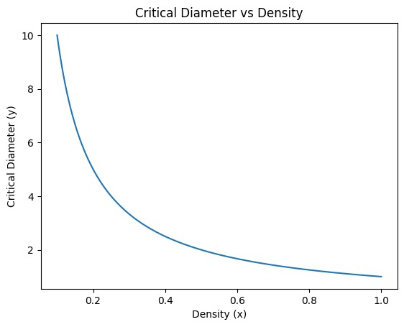
Figure 2 - The exponential relationship of Critical diameter and Density

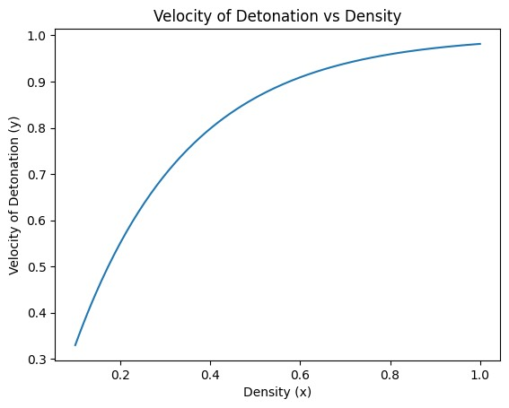
Figure 3 - The exponential relationship of Velocity of Detonation and Density

Conclusion
This report has shown that critical diameter and critical density are key factors in controlling a successful detonation transfer in an explosive train. When increasing the secondary explosive density increases shockwave coupling, which in turn increases the velocity of detonation, and reduces the minimum critical diameter required to sustain a detonation. At lower densities, larger charge geometries are necessary to prevent a detonation failure.
The effectiveness of the lead azide stimulus depends on the secondary charge meeting these critical conditions. Also, the confinement of energetic material further lowers the required diameter and density by reducing energy losses by refracting the shockwave. Together, these parameters explain how initiation and transition, form a stable propagation wave which is achieved in primary–secondary explosive systems.

References

[1] | The John A. Dutton Institute for Teaching and Learning Excellence, “Explosives Properties,” Introduction to Mining Engineering, vol. MNG, no. 230, p. 8.2.5, 2023.
[2] | Defense Technical Information Center, “Critical Diameter and Detonation Behavior of Explosives,” U.S. Army, Dover, 1981.
[3] | J. Smith and A. Doe, “Detonation Properties of novel Energetic materials,” Propellants, Explosives, Pryotechnics, vol. 45, no. 3, pp. 219-218, 2020.
[4] | P. W. Cooper, Explosives Engineering, New York: Wiley-VCH, 1996.
[5] | V. P. Sinditskii, “Critical Diameter of Industrial Explosive Charges,” Combustion, Explosion, and Shock Waves, vol. 47, no. 1, pp. 104-109, 2011.

