

LCBB 4001

ACCOUNTING FUNDAMENTALS

ASSIGNMENT 1

Student name: Vali Daniela Pantazi
Student number: 2212835

Lecturer: David Jenkins

Task 1

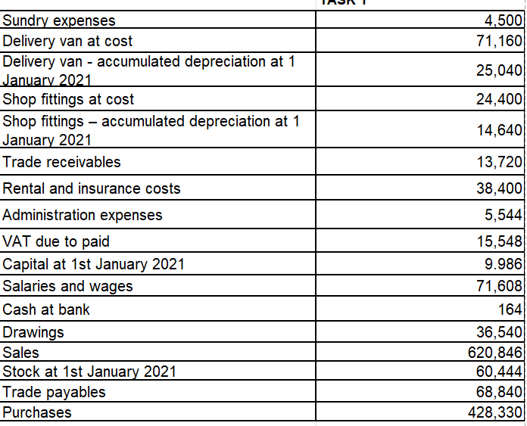
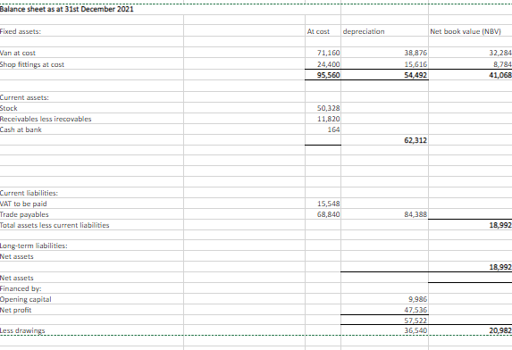

Van depreciation=(71,160- 25040)*30%= 13,836
Shop fitting depreciation- carrying value =9760,
Depreciation =976

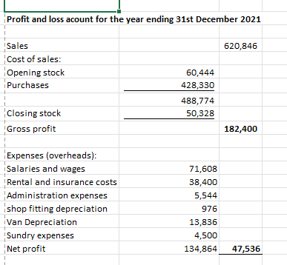

TASK 2
Capital account
Date | Transaction | Amount | Date | Transaction | Amount
 |  | £ |  |  | £
1 Apr | Balance c/d | 40,000 | 01 Apr | Balance b/d | 40,000
 |  | 40,000 |  |  | 40,000
 |  |  | 1May | Balance b/d | 40,000
 |  | Van
1 April | Balance b/d | 25,000 | 1May | Balance c/d | 25,000
 |  | 25,000 |  |  | 25,000
1 May | Balance b/d | 25,000
 |  | Bank
1 Apr | Balance b/d | 10,000 | 2 Apr | Advertising | 450
9 Apr | Receivables | 2,000 | 3 Apr | Payable | 4,400
15 Apr | Receivables | 1,800 | 7 Apr | Drawings | 800
 |  |  | 11 Apr | Petrol | 120
 |  |  | 18 Apr | Insurance | 750
 |  |  | 30 Apr | Purchases | 2,100
 |  | 13,800 | 30 Apr | Balance c/d | 5,180
2 May | Balance b/d | 5,180 |  |  | 13,800
 |  | Receivables
31 Mar | Balance b/d | 17,000 | 9 Apr | Bank | 2,000
21 Apr | Sales | 1,900 | 15 Apr | Bank | 1,800
 |  |  | 30 Apr | Balance c/d | 15,100
 |  | 18,900 |  |  | 18,900
1 May | Balance b/d | 15,100
 |  | Payables
3 Apr | Bank | 4,400 | 31 Mar | Bank | 12,000
 |  |  | 20 Apr | Purchases | 2,500
 |  | 4,400
 |  |  | 30 Apr | Balance b/d | 10,100
1 May | Balance c/d | 10,100
 |  | Advertising
02-Apr | Bank | 450 | 30 Apr | Balance c/d | 450
1 May | Balance b/d | 450 |  |  | 450
 |  | Drawings
7 Apr | Bank | 800 | 30 Apr | Balance c/d | 800
 |  |  |  |  | 800
1 May | Balance b/d | 800
 |  | Petrol
11 Apr | Bank | 120 | 30 Apr | Balance c/d | 120
 |  | 120 |  |  | 120
1 May | Balance b/d | 120
 |  | Insurance
18 Apr | Bank | 750 | 30 Apr | Balance c/d | 750
 |  | 750 |  |  | 750
1 May | Balance b/d | 750
 |  | Purchases
20 Apr | Payable | 2,500 | 30 Apr | Balance c/d | 4,600
30 Apr | Bank | 2,100 |  |  | 4,600
1 May | Balance b/d | 4,600
 |  | Sales
 |  |  | 21-Apr | Receivables | 1,900
 |  |  |  |  | 1,900
1 May | Balance b/d | 1,900 | 30 Apr | Balance c/d | 1,900

 | TRIAL BALANCE
 |  | Debit | Credit
 |  | £ | £
 | Capital |  | 40,000
 | Drawings | 800
 | Van | 25,000
 | Bank | 5,180
 | Receivables | 15,100
 | Payables |  | 10,100
 | Sales |  | 1,900
 | Purchases | 4,600
 | Insurance | 750
 | Petrol | 120
 | Advertising | 450
 |  | 52,000 | 52,000

TASK 3

Depreciation is an accounting method that represents how much of an asset’s value has been used. Companies can earn revenue from owning assets by paying them over a certain period. It is very important for companies to account for depreciation as if not, it can impact on the profit; also, companies can depreciate long terms assets for accounting purposes or tax (Tuovila, 2022).
There are four types of depreciation used in accounting: straight-line method, declining balance, sum-of-the-years' digits, and units of production (Tuovila, 2022).

The straight-line method is the simplest and most commonly used. The company estimates the useful life of an asset and the scrap value at the end of its life. Depreciation calculated through this method must be expensed every year of the asset’s estimated life (Tuovila, 2022). This method is better for small businesses and sole traders.
The formula is:
Depreciation: (cost of the asset – scrap value)/useful life

The reducing balance type is an accelerated depreciation used to write off depreciation costs earlier in an asset’s life, this way reducing tax exposure. Through this method, fixed assets depreciate more in early life rather than evenly over the estimated useful life (Kazel, 2022). This method is best for companies with assets that lose more of their value in the early years (Kazel, 2022).
The formula is:
Depreciation: current book value x depreciation rate
Through the sum of the year’s digits method, depreciation is accelerated but not as much as through the declining balance method. This method is more appropriate to use when an asset loses value more quickly or has a bigger production capacity during its early years (Kazel, 2022).
The formula is:
Depreciation: (remaining lifespan/SYD) x (asset cost – scrap value)

According to Kazel (2022), the units of production type of depreciation assign an equal expense rate to each unit produced. This method is used when an asset is evaluated in the number of units produced rather than its life.
The formula is:
Depreciation: (asset cost – scrap value)/estimated units over asset's lifetime x actual units made
By calculating depreciation, a company can determine the part of an asset’s cost that can be deducted in a certain year. Depending on the method used, the amount can be the same every year or larger in the first years and lower as the life of the asset decreases (Tuovila, 2022).

References

Kazel, M. (2022). What Are the Different Ways to Calculate Depreciation? [online] Investopedia. Available at: https://www.investopedia.com/ask/answers/021815/what-are-different-ways-calculate-depreciation.asp#:~:text=The%20four%20methods%20for%20calculating [Accessed 27 Feb. 2023].
Tuovila, A. (2022). Depreciation. [online] Investopedia. Available at: https://www.investopedia.com/terms/d/depreciation.asp [Accessed 27 Feb. 2023].

