NETWORK AND CYBERSECURITY ESSENTIALS  ACCA 4024 |  | Theresa Darzins  Student No. 1909721
Dr. Nitheesh Kaliyamurthy &  Dr. Carlene Campbell | LAB 4  Design and Implement a Home Network | 24 October 2020

Task 1 Switch Configurations (Using Topology 1)
- Used Calculator to determine appropriate IP Addresses for 4 PC’s (192.168.72.30/40/50/70)
- Created the topology as given in Packet Tracer and configure IP address and Subnet Mask for PC0, 1,2, and 3
- Pinged all successfully

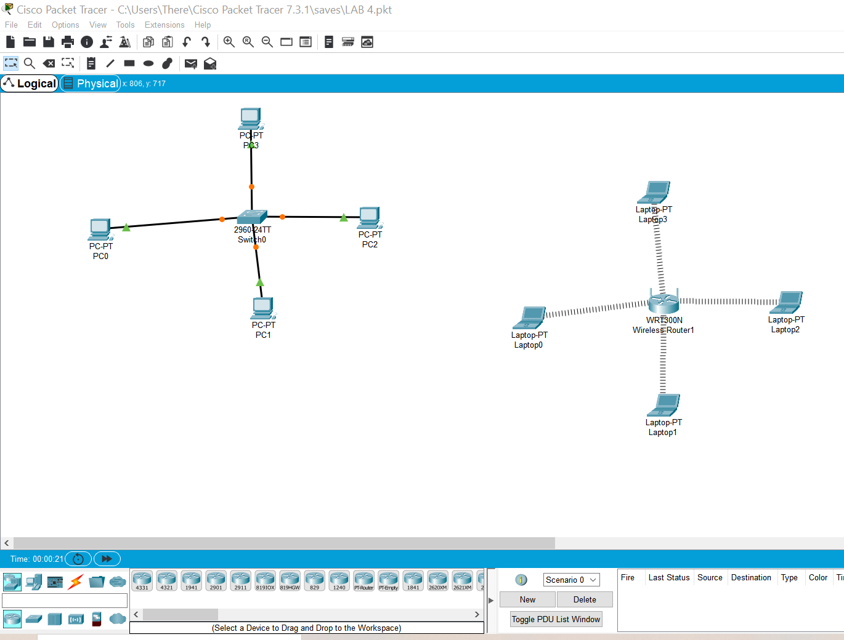

PC0 192.168.72.30
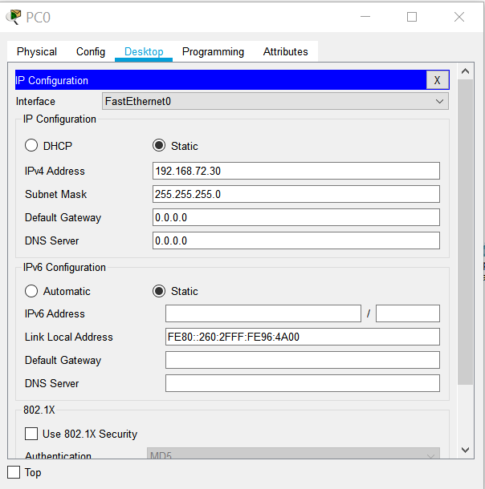
Pinged 0 to 1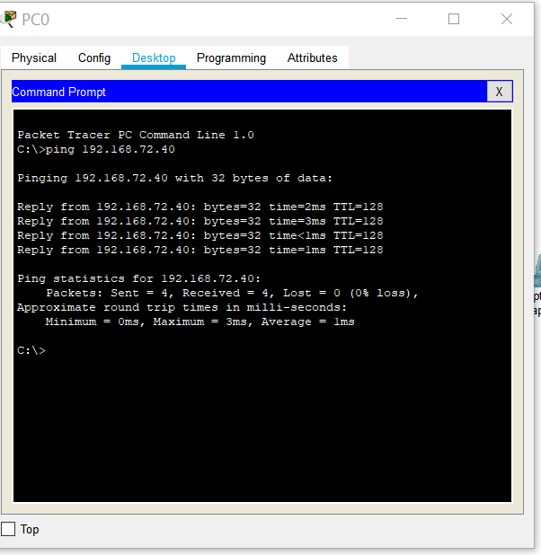
PC1 192.168.72.40
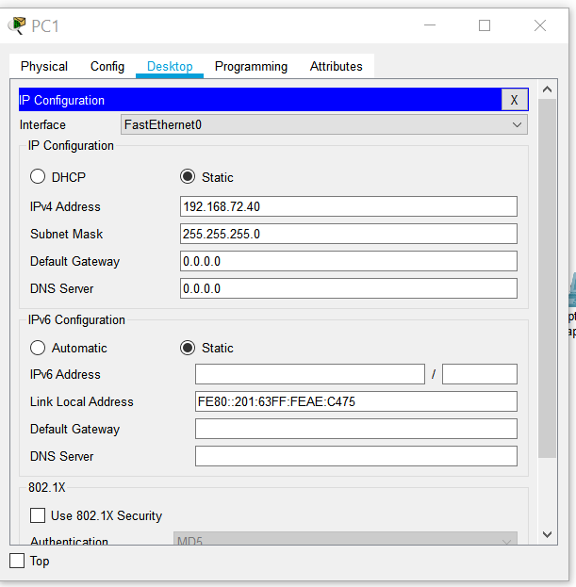
Pinged 1 to 2 (40 to 50)
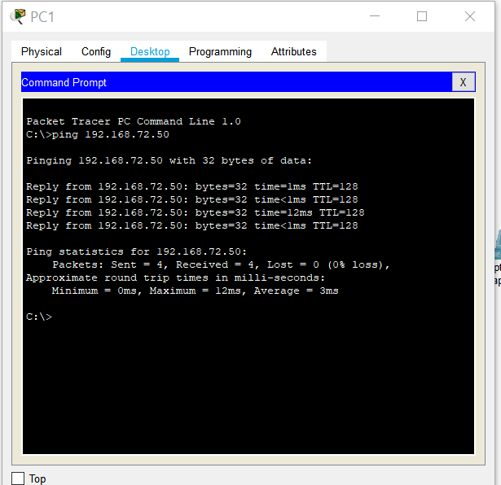
PC2 192.168.72.50
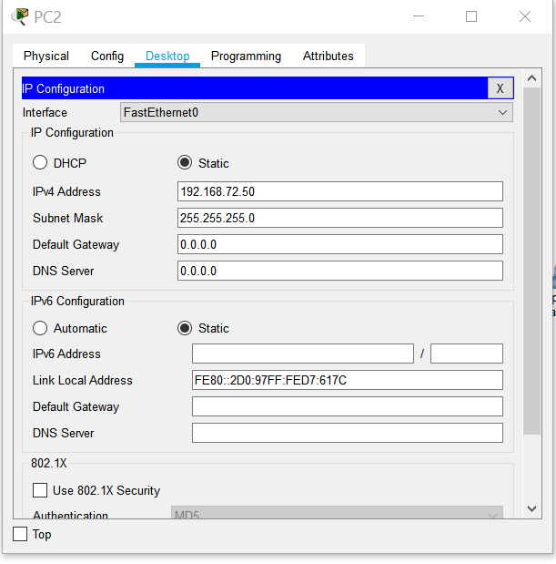
Pinged 2 to 3
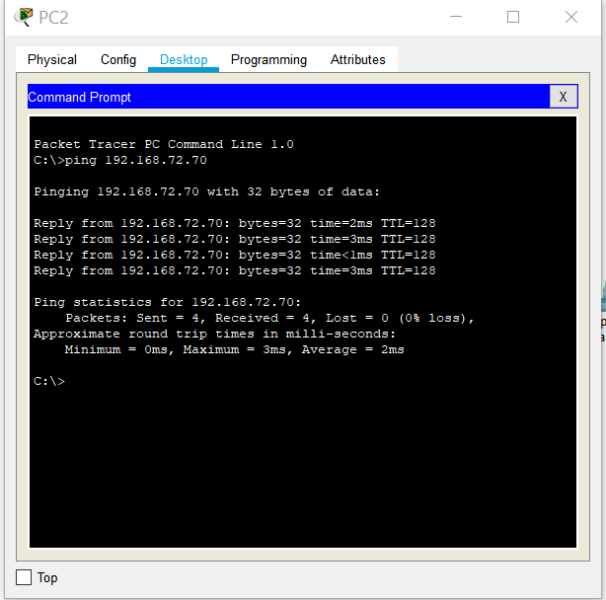
PC3
192.168.72.70
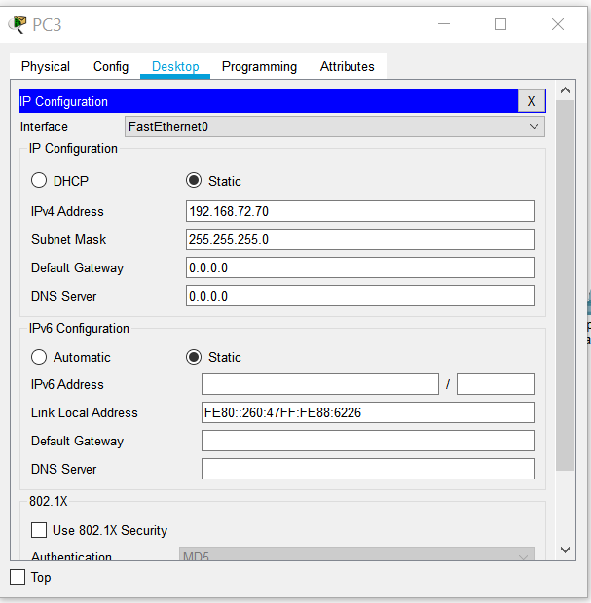
Pinged 3 to 0
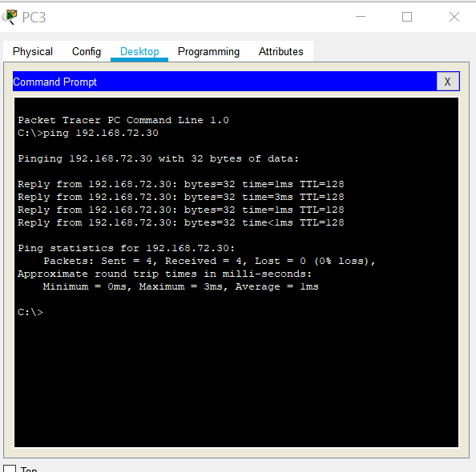
SUBNET MASK 255.255.255.0 FOR ALL 4
BASIC SWITCH CONFIGURATIONS
- User Mode, Privilege Mode, Global Configuration Mode:
- Give HOST a name: SwTMyFirstSwitch
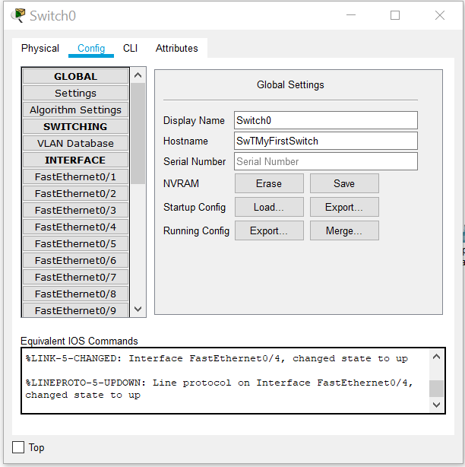
In configure mode on Switch changed the Hostname as advised

- Passwords (Basic Security) Configure console password: cisco 123:
>enable
# Config t
Line Console 0
Password cisco 123
Login
Exit
#
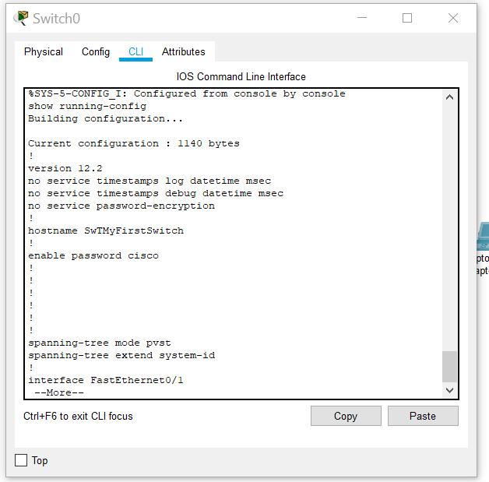
This shows I went in and out and THEN it shows my password

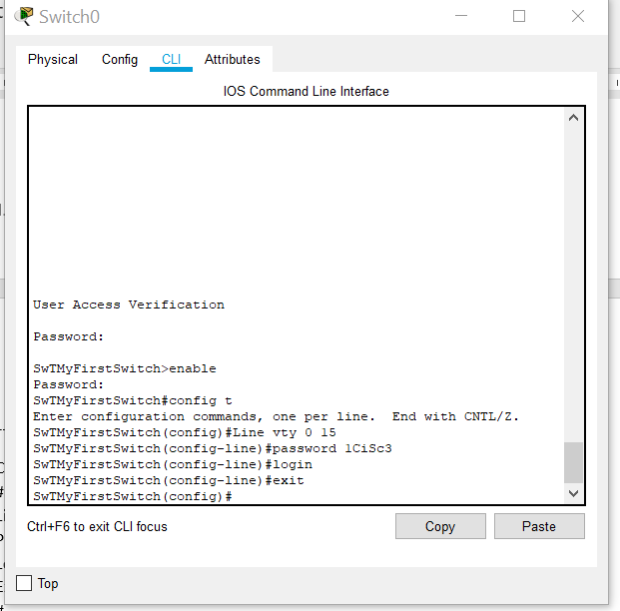
- Configure vty password 1CiSc3 (allows you to access device remotely)
# Config t
Line vty 0 15
Password 1CiSc3
Login
Exit
#

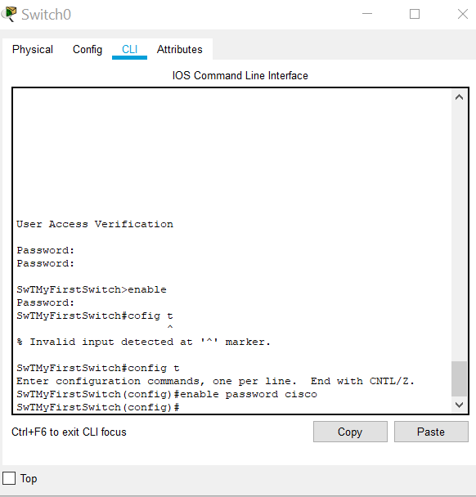
- Enable Privileged Password >enable
# Config t
Enable password cisco

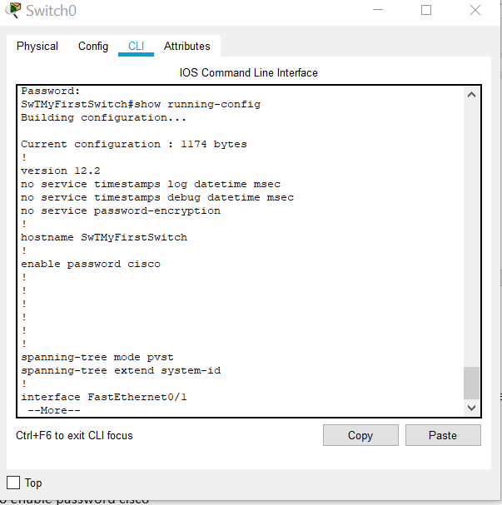
PREVIOUSLY COULD SEE PASSWORD

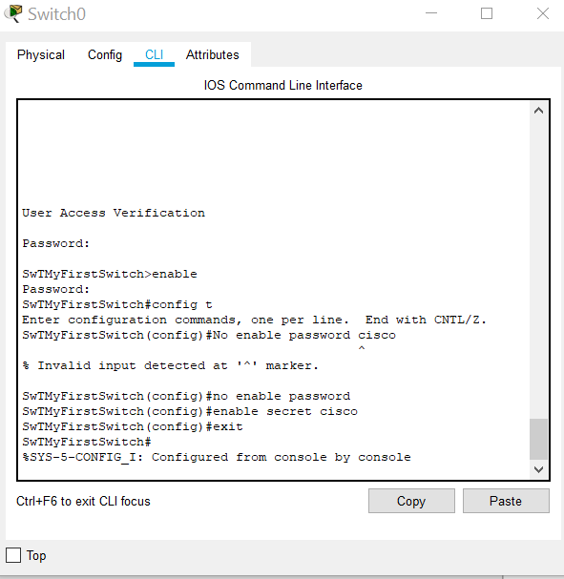
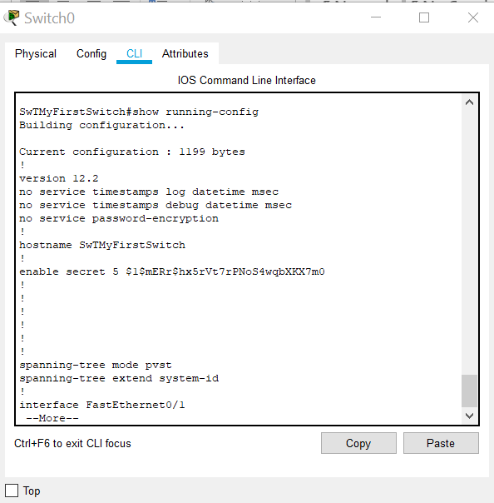
BUT IN THIS ONE IT IS ENCRYPTED
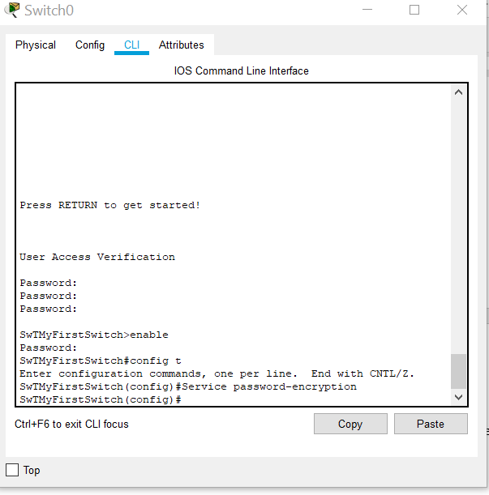
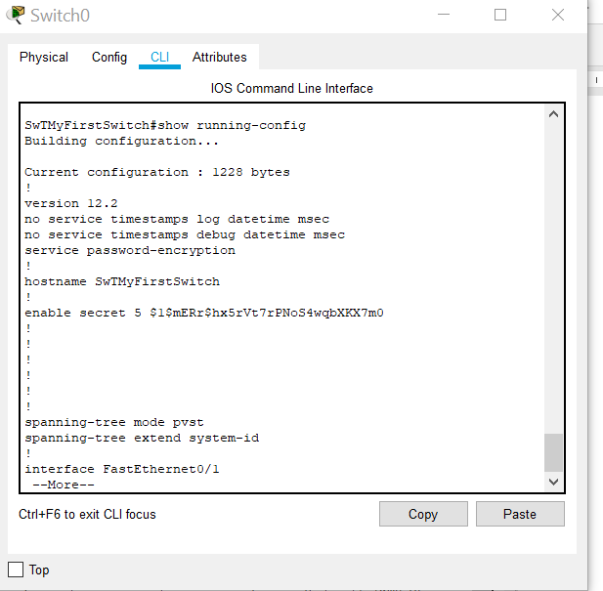
Different Bytes
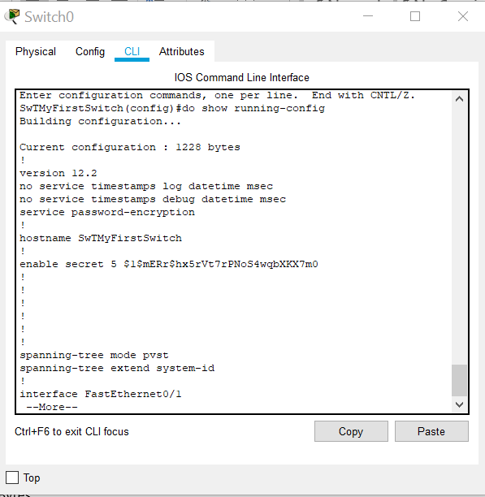

- Do show interfaces

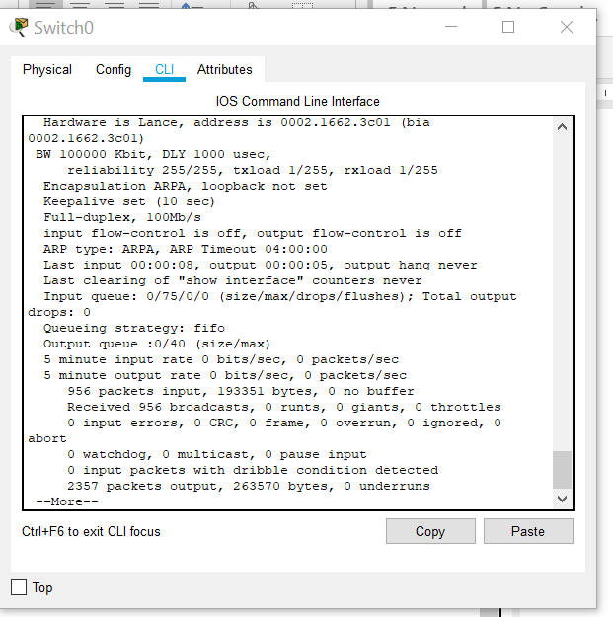

- DO SHOW ARP DIDN’T WORK
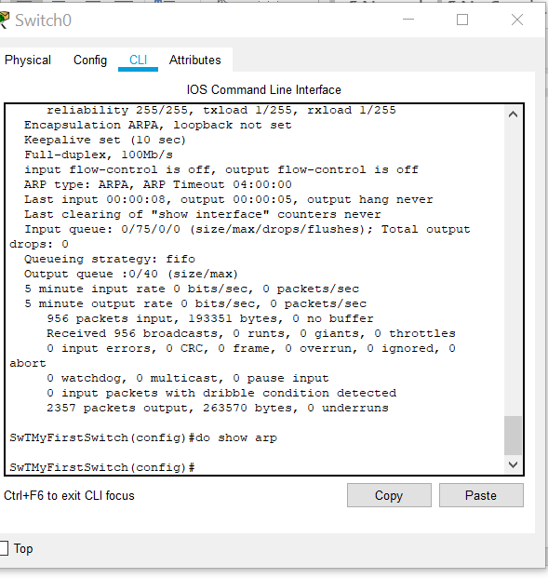

- Do show version
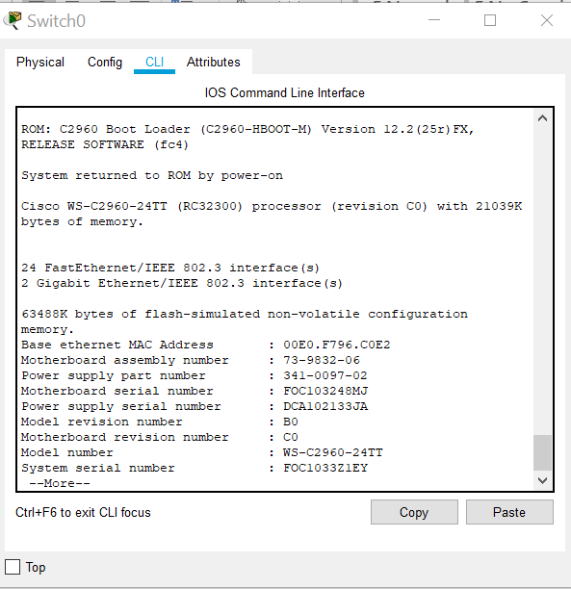

- Do Erase Startup-config
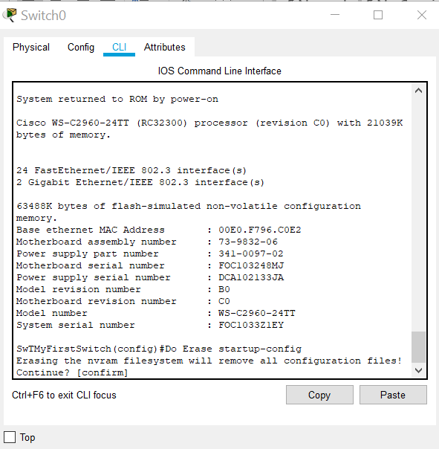

- Do Reload
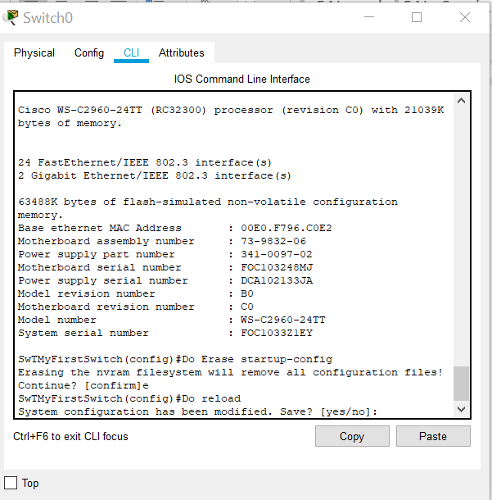

Text message Welcome to Switch GF and copy run startup ??
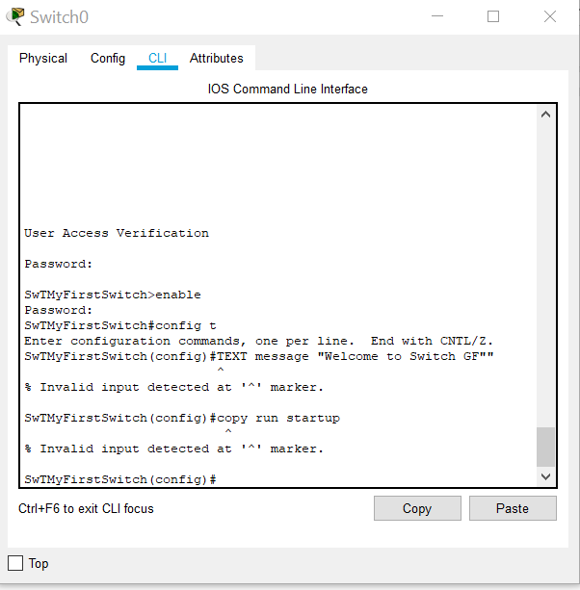
Observe the running configuration of your switch and note the configuration; is your privileged password shown in running config?/how is it displayed?
Now remove the privileged password; go to config mode (Privileged Executive mode)
- # Config t
- No enable password cisco
- AND TYPE enable secret cisco (Done)
Observe the running configuration of your switch again and note difference between password and secret (secret doesn’t show)
How are the other passwords?
Now go to config mode (Privileged Executive Mode) again
- #Config t
- Service password-encryption
Observe the running configuration of your switch again and note the difference now
The DO Command
Allows you to execute any EXEC mode command from within any configuration mode, e.g.
- #Config t
- Do show running-configuration

- IP Address
- SwTMyFirstSwitch
- >en/#config t
- (config)#interface vlan1
- (config-if)#/ip address 192.168.72.254 255.255.255.0
- (config-if)#no shut
- (config-if)#exit

- Show Commands/show running-config/show interfaces/show arp/show version (didn’t work)

- Save Configurations; copy run startup/write memory (didn’t work)

Try out Add router do same as above and record reflections

TASK 2 WIRELESS CONFIGURATIONS
Created Topology using Cisco Packet Tracer
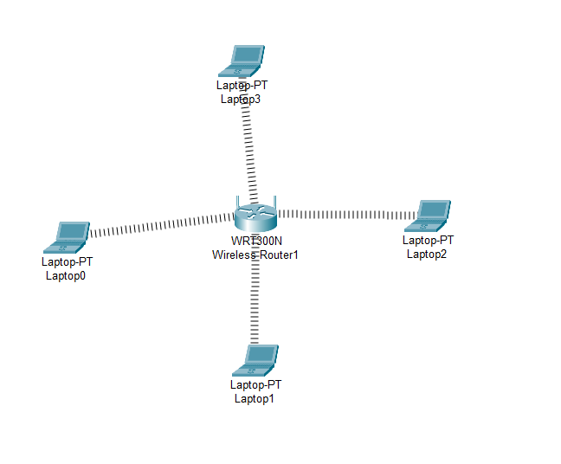
1 | Set Up Router IP Address 192.168.10.1
2 | Enable DHCP
3 | Set Start as 192.168.10.20
4 | Maximum No. of users: 3
5 | Save the configuration
6 | Set the network mode: Mixed
7 | Name your network: MyNetwork
8 | Enable Broadcast
9 | WPA2 Personal Security
10 | Encryption AES
11 | Passphrase: 123456789
12 | Router Password: Cisco
13 | Enable Remote Management

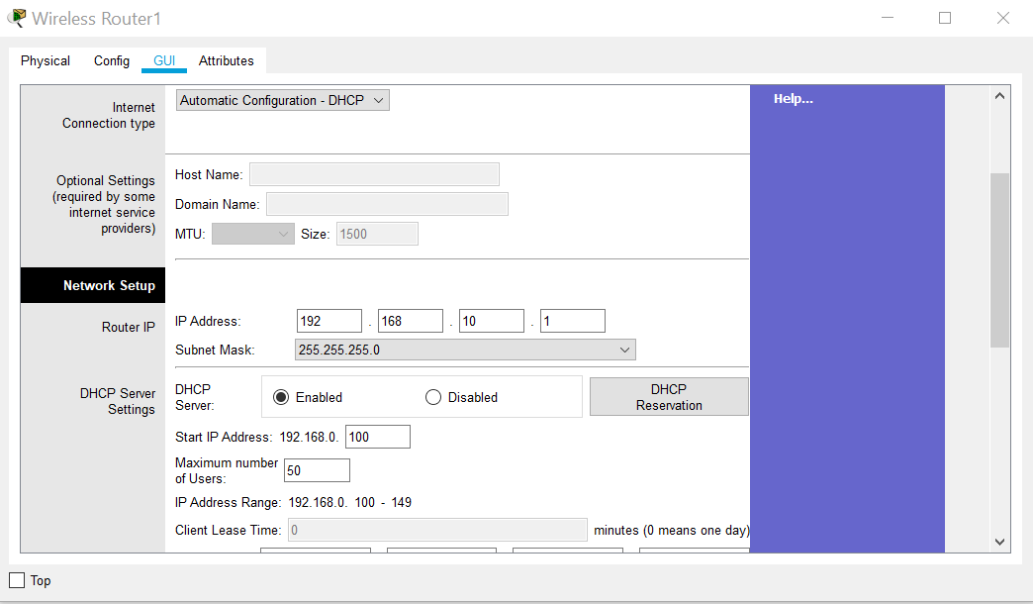
- 1Set up router, changed IP Address and DHCP enabled (SAVED)
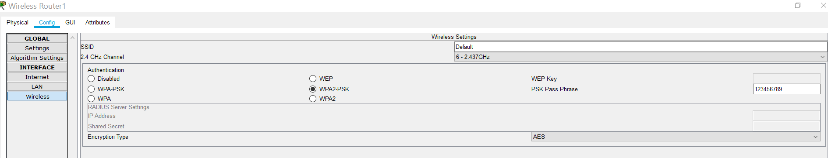

- Set Password andWPA2 to 123456789
- Set Maximum users to 3(!) sure this is causing trouble later as four laptops
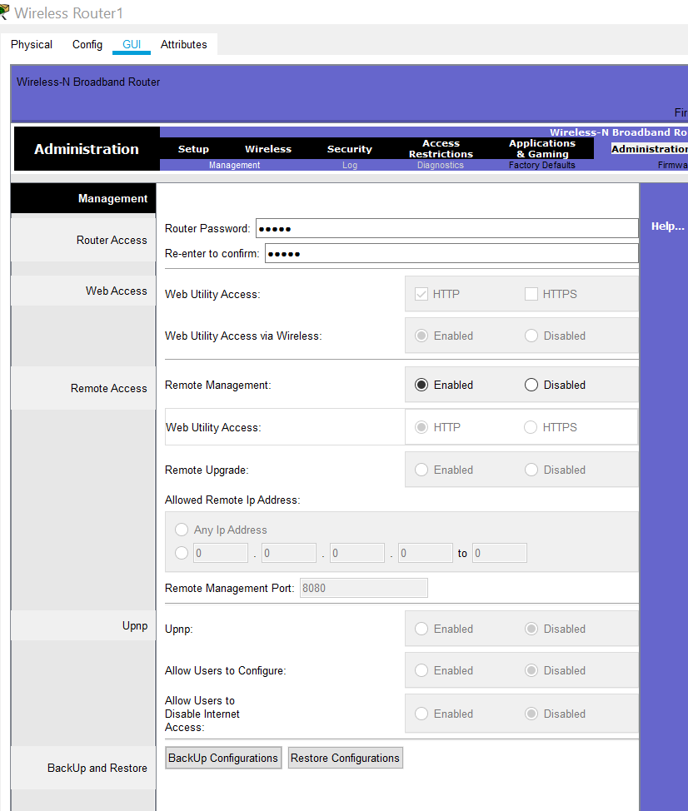
- Router Password CISCO and remote Management enabled

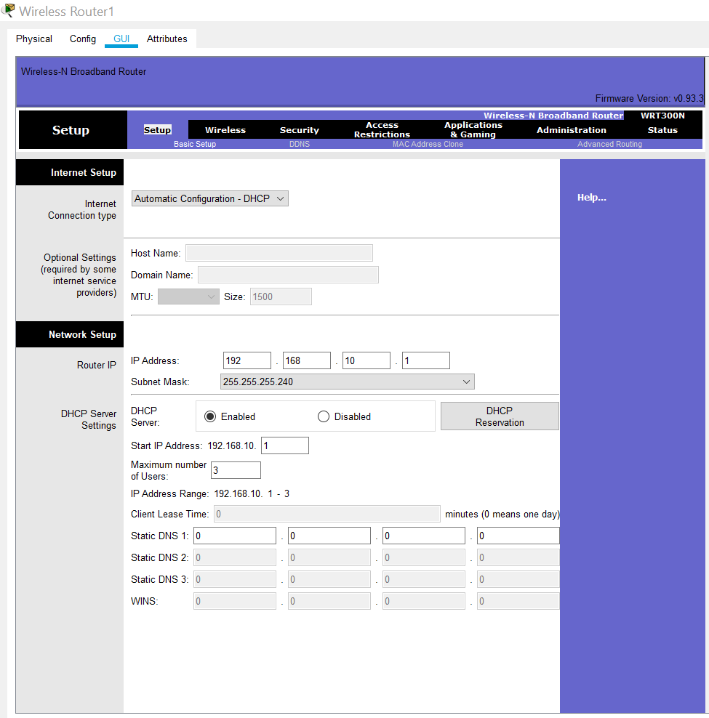

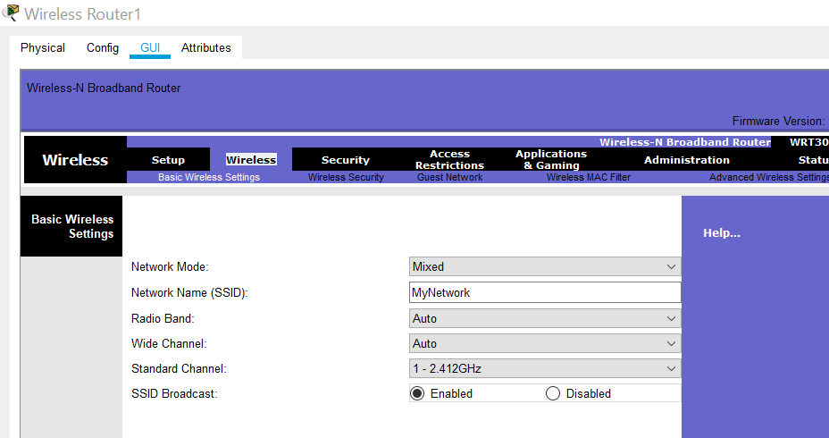
- Named network MyNetwork and Mode set to Mixed and Broadcast Enabled

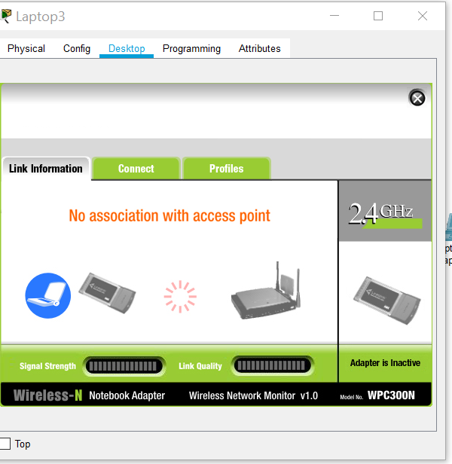
- Took out network cards from all laptops and replaced with Wireless ones (remembering to turn off first then turn back on.

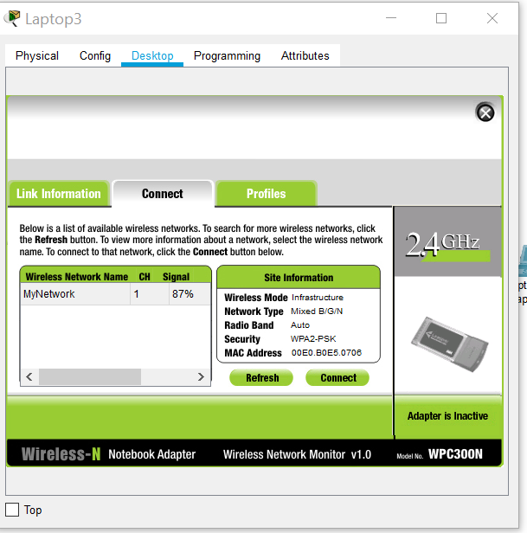
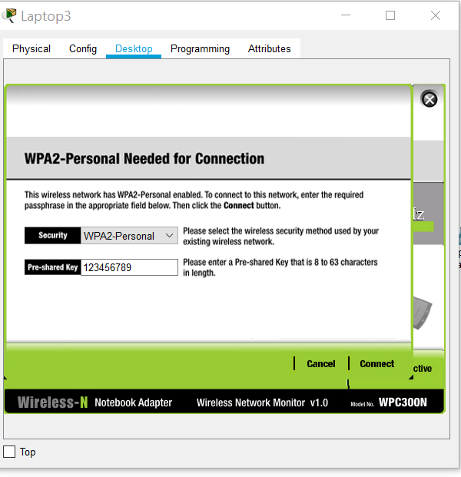
- pinged from each laptop to the router (192.168.10.1) here is laptop 0
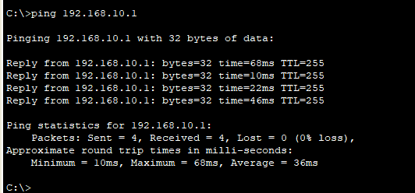

- Pinged laptop 1
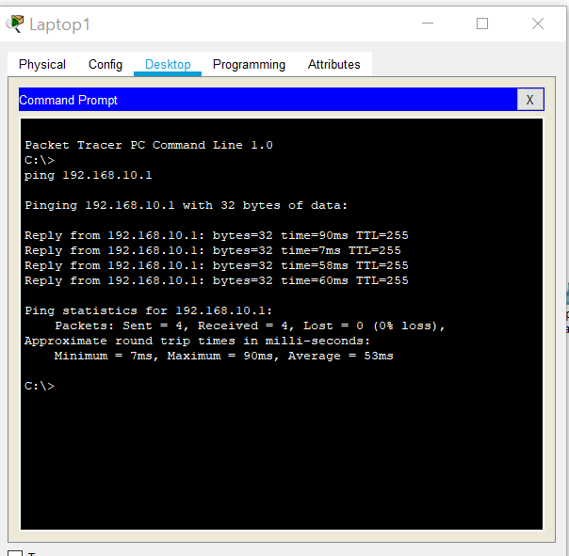

- Pinged laptop 2 and was unsuccessful
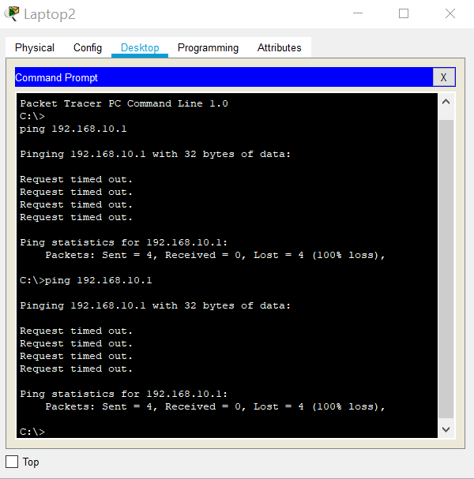
- Pinged Laptop 3 and this was also unsuccessful
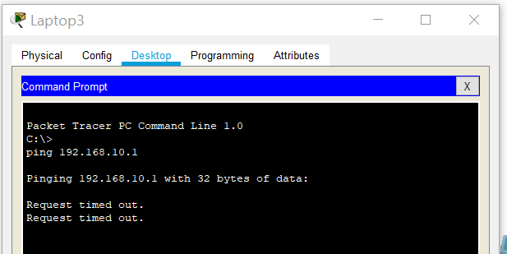
- This was because max users set at 3 (and router counts as one); going into max user and increasing to 5 to enable all laptops to ping

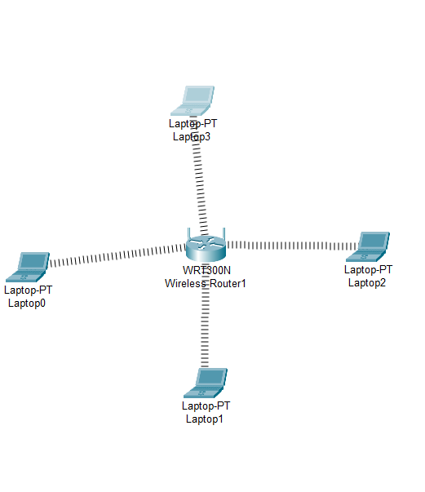
0 | Laptop | 192.168.10.2 (successful ping)
1 | Laptop | 192.168.10.3 (successful ping)
2 | Laptop | 169.254.26.212/192.168.10.4 (After increasing max users to 5)
3 | Laptop | 169.254.37.194/192.168.10.5 (After increasing max users to 5)
 |  | Because max users only 3 and router included in the 3 ping wouldn’t work until max users changed to 5

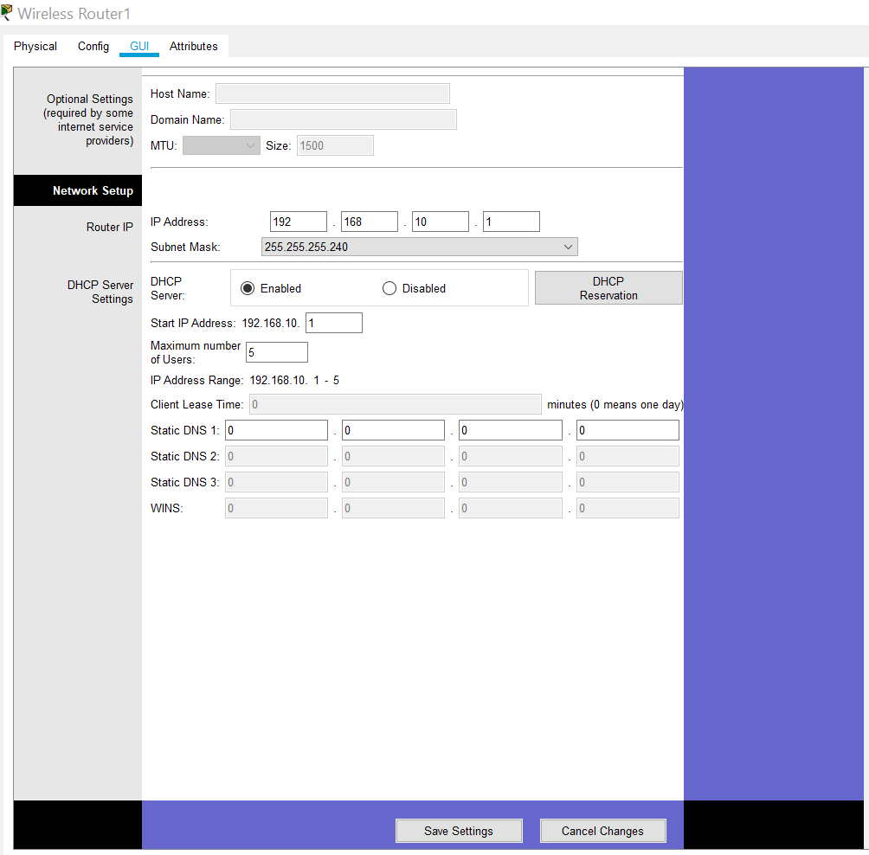

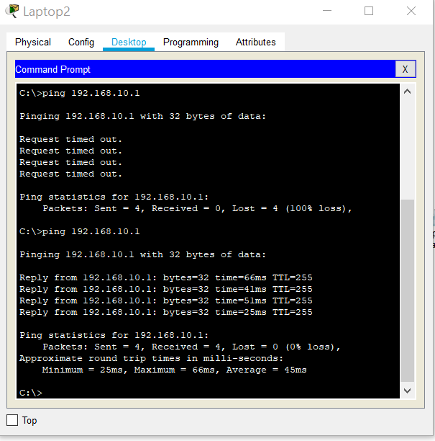
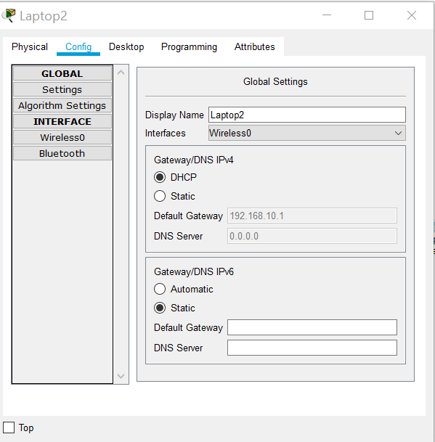
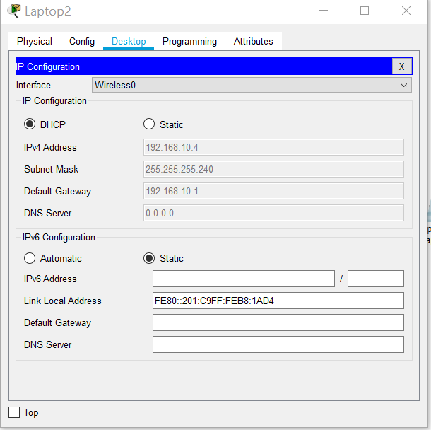
Now the IP Address changed as max user increased to 5 so this Laptop 2 is now part of same network and now 192.168.10.4

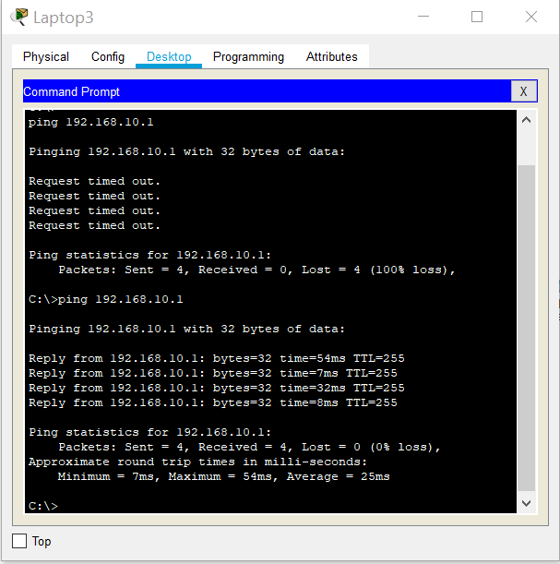
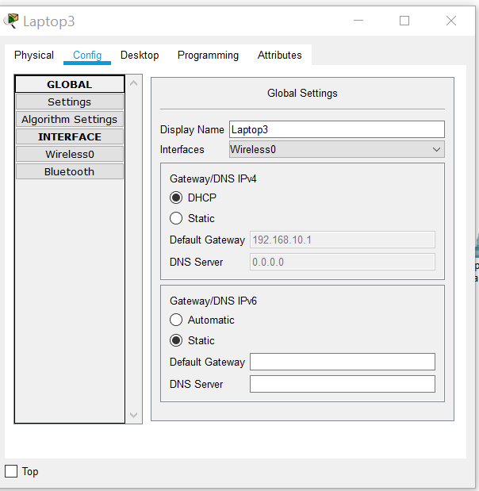
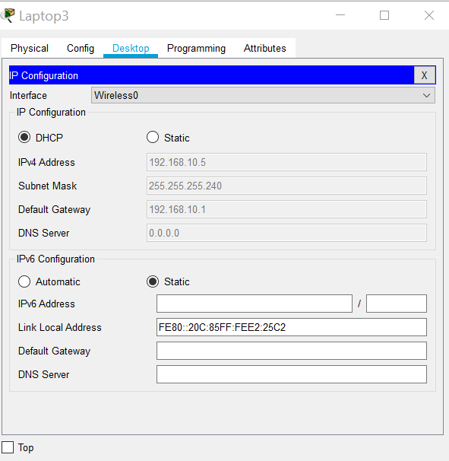
Laptop 3 is now 192.168.10.4
Pinged to router:
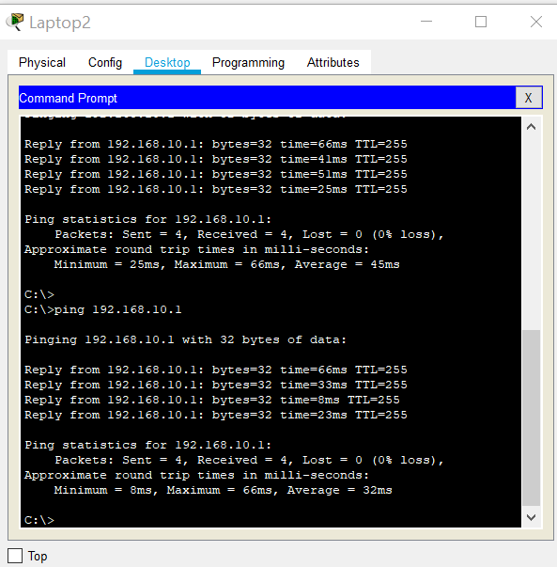
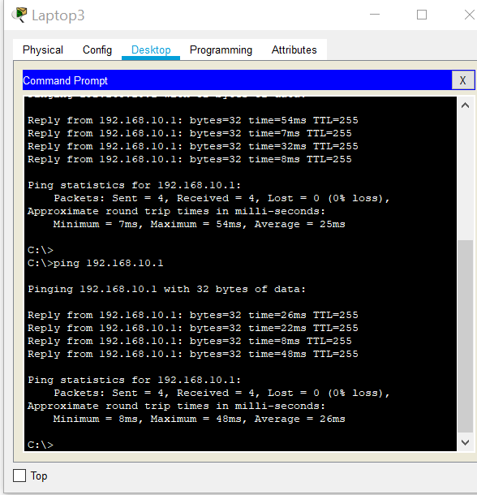

All laptops connected
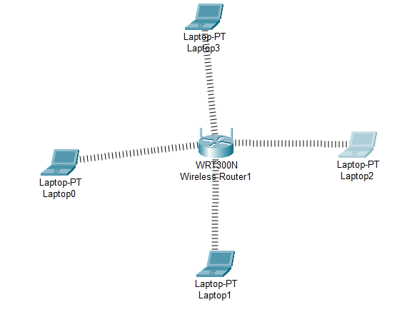

Banning Laptop 2 & 3 (2 below MAC or Physical Address) IPConfig / all

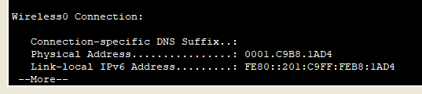
Laptop 3
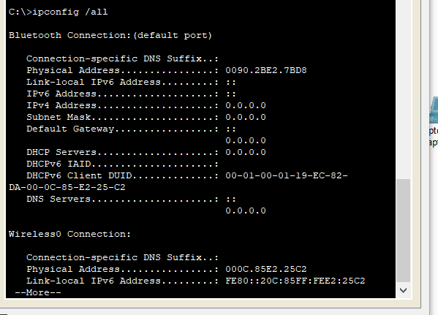

The MAC Addresses of PC’s 2 and 3 have been entered on the router
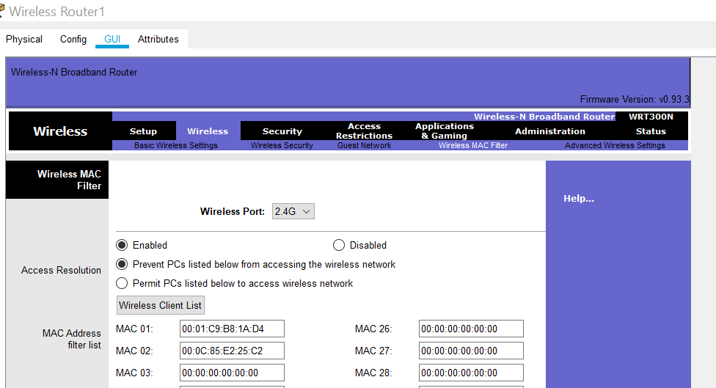

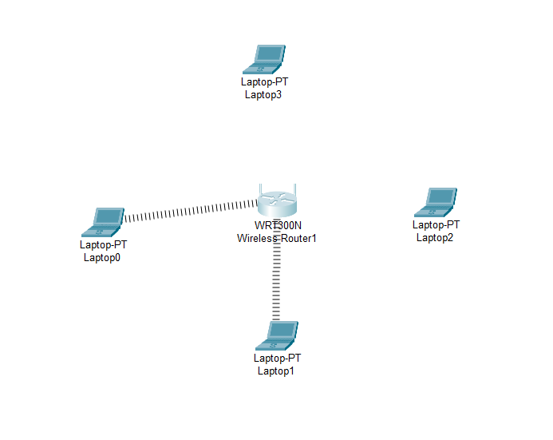
Now the laptops 2 and 3 are banned from the network.


