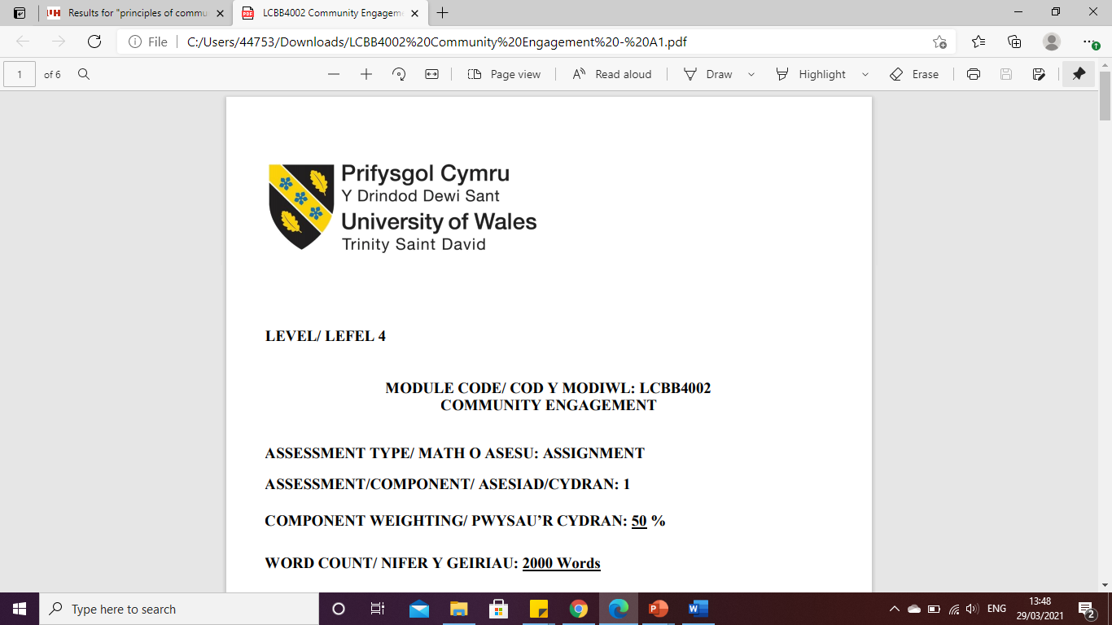

LEVEL 5

Evaluation of the Cross Rail Project
MODULE CODE: LCBB5005
PROJECT MANAGEMENT

ASSESSMENT TYPE: ASSIGNMENT
ASSESSMENT/COMPONENT: 1
COMPONENT WEIGHTING: 50%
WORD COUNT: 2 539 Words
SUBMISSION DETAILS:
Name: Cosmin Adrian Mitu
Student Number: 2021613

Table of contents

1. Introduction 3
2. Analysis of the Cross Rail project 3
2.1. Analysis of what went well 4
2.1.1. Cost of the project to the people of London 4
2.1.2. Digital aspects of the Crossrail project 4
2.1.3. Sustainable aspects of the Cross Rail project 5
2.2. Analysis of what went bad 5
2.2.1. Cost overruns 5
2.2.2. Evaluating the scene of cost overrun in the Cross Rail project: 6
3. Project completion delay 7
4. Risk factors 8
5. Conclusion 9
References 10

Introduction
The practice of carrying out specific project goals within the defined time, space, budget and techniques by using specific skills and knowledge is known as project management. Final project management outputs are subject to time and money restrictions. Additionally, it involves documenting and analysing specific project deliverables and goals based on its scopes and features. With explanations depending on the project delays and overruns, this report will have a significant relation to numerous instances. Furthermore, the particular crossrail construction is one of the biggest transportation projects now in the planning stages in the UK. The specific project has a defined objective via renovation with a growth in economic office and retail space.
On the other hand, the projects will have to deal with a wide range of sources, such as new project approaches. Then only, it will have a suitable connection to Cross-rail and is linked to the Bentley systems.
Thus, this report aims to evaluate the given case study of Cross Rail Project (Elizabeth Line) and to analyse the components, such as time, quality, budget and other risk factors.

Analysis of the Cross Rail project
The Cross Rail project (Elizabeth Line)
On May 24, 2022 was the Elizabeth line's first day of service. On this date, the Paddington to Abbey Wood service was offered to the people of London. The project started from 2008 and ended in 2022. Around 16 Billion GBP was the overall budget fixed at the initial stage of the project. TfL Rail rebranded the Elizabeth line on this day for its services between Reading and Heathrow to Paddington mainline and Shenfield to Liverpool Street mainline (Bbc.com, 2020). The rail track was 73 miles in overall length with approx 41 rail stations along with its journey path. The major section of the railway, which runs through the heart of London from Paddington to Abbey Wood, was used by more than 30 million passengers in its first six months of operation, indicating the fantastic reception the railway has received (Theguardian.com, 2020). The Elizabeth line is a high-tech rail system with new stations, additional infrastructure, new track, and train services. It was crucial that now the Elizabeth line launching be done in stages to ensure that it is safe, reliable, efficient, and supported. It indicates that the entire project was divided into multiple project phases, which indicated the project to follow the agile methods (Gómez-Cabrera et al. 2020).

Analysis of what went well
    - Cost of the project to the people of London
It is estimated that around more than 200 million passengers would utilise Cross-rail yearly, according to the thorough planning. Each of the several organisations contributes money to the project's budget. If Crossrail were genuinely a government financed project, this would be run by a separate, publicly listed company with private hands (Railway-technology.com, 2022). Additionally, the project had 80 logistics with building projects assigned, and about 31 contractual agents were working on it. Six delivery functions in the areas of the economy, high-quality surroundings, health & security, and interpersonal interactions are provided by the suitable working framework, which also helps (Dlamini and Cumberlege, 2021). It indicates that the Crossrail project is bringing ease to the everyday journey of the London people and minimising their travel time, pace and hassles.
    - Digital aspects of the Crossrail project
The ability to outsource manufacture and design to a larger extent due to flexibility creates new systems integration issues for both projects and organisations. With explicitly defined interfaces and buffers between and within each component system, systems integration takes place at several levels within the infrastructure project, engaging the client and its delivery associate at a meta-systems integrated levels and construction companies at the systems level (Sharma and Goyal, 2019). When subcontractors are involved in the supply of services over an extended length of time, design, funding, construction, operation, and management are all interwoven.
The Cross Rail project included the motto of “Three Cs”; that is, culture, collaboration and capability. It was an “Open-sharing ecosystem” (Constructionnews.co.uk, 2019). Context of NEC3 Engineering aspects were followed while developing the planning and execution phase of the project. However, the particular project incorporates innovation through digital components. The digital representation of the specific project offers aid by examining design, and building, along with the crucial process of the railway's operations.
At the earlier stage, the project team used basic and off-the-shelf software packages that helped to deploy quality project plans and innovative project solutions. The main challenge of this mode of working was difficulty in providing response to the learnt lessons. For this reason, the project team had shifted their focus on technology use. It was decided to switch to a platform in 2016 that utilised dynamic web pages, more modern technology, and interactive discussion forums as opposed to the prior platform's usage of static web pages. The new platform enhanced functionality and allowed the creative community to use a variety of devices to navigate the portal. However, carbon emissions have decreased by 18.6% at the later stage of the Cross Rail project, which helped the project to achieve the significant grades of sustainability. Thus, it can be said that digital innovation in the Cross Rail project helped the deliverables to be reached with great efficiency.
    - Sustainable aspects of the Cross Rail project
A number of acceptable parameters were also defined at the commencement of the specific project, which led to its successful completion. This factor indicated the sustainability aspects of the particular project (Kerzner, 2018). Working together on a sustainable development plan was part of the Cross-Rail planning process. However, London Transport and the transportation division have a relationship that has produced sustainability goals for project completion. The particular initiative will help increase social, economic, and environmental sustainability. In contrast to that, Industrial emissions have decreased by over 83% compared to every technology that lowered emissions (Whyte, 2019). There is a potential that competition may rise if travel times are shortened. 55000 new work opportunities were made possible when a construction project was correctly launched, which helped to lessen the unemployment rate of the UK. In such a scenario, the property's value will increase by more than $10,6 billion. Contrastingly, it was observed that an external BIM advisory board was there, which was composed of engineering students from different information management teams.

Analysis of what went bad
    - Cost overruns
In construction projects, budget overrun has become a global issue. The basic explanation of a cost overrun is an excess of real price above budget (Zarei et al. 2018). One of the major problems that prevents building projects from moving forward is cost overruns since they reduce the firm's profit, which causes considerable losses and puts the project in a tough situation (Zidane and Andersen, 2018). The expense of the development's construction is among the most critical success criteria during the course of the project, according to many in the construction industry.
Different factors are there which lead to cost overflow of a construction project:
(i) Uncertainty in planning and controlling phase of construction:
Gaps within project planning can affect construction phases. If minute details of the construction tasks are missed within planning, then the project can suffer from budget overflow while in execution phase. Even in the project controlling phase, lack of proper plan and execution factors can affect budget overflow (Hasan et al. 2018). Insufficient planning on risk assessment and risk management can affect the project’s expenses. In that case, two scenarios happen. First, the project gets delayed and the expense gets higher than the planned one (Nicholas and Steyn, 2020). In the second scenario, the project gets stopped, due to lack of resources and procurement.
(ii) Influence on human resources involved in the project:
Labour strikes, labour turnover and labour shortage issues can act as three major reasons for expense overrun. Lack of proper skills in labourers can extend the working hours of the project, which insists the contractors to pay for overtime to the labourers. It increases the actual expense compared to the budgeted expense in a project (Idrees and Shafiq, 2021). Absence of smart working procedures, improper training measures at work, task errors in labour gangs, poor supervision at work, and extensive high demand of labour suppliers of the contractors are some of the major reasons for human resource related problems in cost overrun. In contrast, some evidence suggests that increased absenteeism in human resources is also a significant reason for expense overrun issues within a construction project.
(iii) Material cost overrun in construction projects:
Inaccurate estimation of raw materials involved within the construction projects is the main cause which affects project’s estimated budget. Sometimes, contractors try to procure raw materials from different sources in bulk quantities to get various discounted rates. However, it is seen that overall, it affects the estimated pricing via project delay, quality issues of procurement and other aspects. Improper supervision in logistics and procurement planning are some of the significant factors that affect a project's budget (Idrees and Shafiq, 2021). Increased waste materials during the construction phase are some major factors that affect a project’s cost. No optimum utilisation of products during development is significant reasons for budget overrun.

Evaluating the scene of cost overrun in the Cross Rail project:
In July 2018, the railway failed to start the trail run and the ministry announced that the project was completed by 93%. Hence, the extended deadline of the project increased the estimated cost of the project. Again in November 2018, the project got delayed for the next year and left the cost burden of around £210m in the estimated budget. In May 2019 also, the railway ministry claimed that the compensation events submitted by the contractors of the project were significantly higher as £900m, which had already added a significant amount of cost burden among the project planners. In that year, the railway ministry announced the project deadline to be unachievable against the project budget and project deadline. Same as earlier, in November 2019, the railway ministry has not provided any specific date for project completion and extended the deadline of the project. At this time, the announced estimated budget was more than £18bn and the project delays have contributed to at least £400m-£650m budget burden to the government.
By analysing the scenario of the Cross Rail project it can be said that the project was a historic landmark of cost overrun (Enr.com, 2019). Unplanned execution phases, unplanned labour, unplanned aspects of raw materials, contractors and procurement were some of the reasons, for which the project was affected with significant delay and cost overrun.

Project completion delay
As seen in the previous section, the Cross Rail project has been delayed by at least 4-4.5 years. Project delay is a significant risk factor of project lifecycle that affects project outcomes also. There can be several causes of project delay that can often lead to project failure (Whyte and Davies, 2021). These are summarised as follows.
Delays in payment from the end of contractors are significant issues of project delay. If the contractors do not release the payments of labourers regarding their actual working times and other overworking hours, then labour strikes and labour mismanagement happens. In that case, the project gets delayed due to labour issues. Poor planning and project scheduling issues are very much common in construction projects that can contribute to project delays and failures. Poor site management and consecutive failures are some of the major issues that are noted in different construction projects (Levy, 2018). It is seen that unskilled workers are working without any supervision or with minimal supervision in the project sites, which leads to failure of developing proper deliverables. It increases the chances of reworks within the project and leads to project delay.
Incomplete and improper design of project schedule can also affect project delay. For instance, in the Cross Rail project, it is noted that there was no proper project schedule. The date of review, the date of completion all were non-specific. For this reason, the project’s fate was almost unpredictable at the end of 2018 or 2019.

Risk factors
Risk management is an essential part of project management. It includes the three basic criteria, being risk identification, evaluation, and risk management (Smith and Merritt, 2020). In any case, the evaluation of risk and its assessment are critical components of the project management lifecycle. The Crossrail project's several incidents, however, demonstrate the necessity for strengthening the risk assessment procedures. On the other side, throughout the month of November 2019, a significant fire involving an electrical box was noted. The specific explosions are connected to a cascade of problems, including electrical delays across important tunnels. This caused delays in crucial testing on various platforms. The ramifications of the specific occurrence also span a three-month labour programme that was late. However, research found that the sufficient explosion was not the main reason for project delays (O'Malley, 2019). Through November 2018, it became clear that the work team does not have a good grasp on the aspect that may be followed in the event that the new chief is nominated. If the project team's members are unable to manage the delivery of tasks that must be finished by a specified deadline in order to calculate the specific project. An evaluation of the individual project Crossrail found no evidence of systematic failure in the plan.
On the other perspective, it indicates the specific business that has been unable to grasp the magnitude and complexity of the project. It is also an improvement because construction in 2016 caused the primary schedule for building stations to be delayed (Wuni et al. 2022). The pressure of missing the project's particular deadlines led to a bias in thinking about what may be initially completed to avoid pressures in the future.
If somehow the Cross-Rail Ltd. initiative fails to recognise the project's overall dangers. In order to ensure the crucial transparency of the approved protocol may be followed, the specific committee is highly invited to get in touch. However, by comparing the evaluation and revision of the programme teams with the project schedules, it should have been verified that there was direct engagement with the committee (Sweet, 2019). If the total cost of all the individual expenditures exceeded £3 billion and special consideration was not provided, the taxpayers' money was overpriced. On the contrary, it's important to choose people with solid talents by reducing contextual delays and cost expansion, which might aid by maintaining programme value.

Conclusion
In conclusion, it is clear that the Crossrail project in London is one of the most important projects in the UK, which has shown significant delay and project cost overrun due to various reasons. The project report has identified the benefits gained from the project and the challenges of the project. Overall, it was clear that the project was delayed because of improper planning and execution aspects. In project management, it is a golden rule to maintain proper scheduling, budget and resource plan so that the project can be completed within the estimated time frame. However, in this case, absence of the proper supervision, follow-up, budget, scheduling and other necessary factors have affected the outcome of the project.

References
Bbc.com, 2020. Crossrail needs extra £450m and delayed until 2022. https://www.bbc.com/news/uk-england-london-53847738
Constructionnews.co.uk, 2019. Crossrail: A history of missed deadlines and cost overruns. https://www.constructionnews.co.uk/civils/crossrails-history-missed-deadlines-cost-overruns-12-11-2019/
Dlamini, M. and Cumberlege, R., 2021, February. The impact of cost overruns and delays in the construction business. In IOP Conference Series: Earth and Environmental Science (Vol. 654, No. 1, p. 012029). IOP Publishing.
Enr.com, 2019. London Crossrail Faces New Cost Overruns and Schedule Slippage. https://www.enr.com/articles/48113-london-crossrail-faces-new-cost-overruns-and-schedule-slippage
Gómez-Cabrera, A., Salazar, L.A., Ponz-Tienda, J.L. and Alarcón, L.F., 2020, July. Lean tools proposal to mitigate delays and cost overruns in construction projects. In 28th Annual Conference of the International Group for Lean Construction 2020, IGLC 2020.
Hasan, A., Baroudi, B., Elmualim, A. and Rameezdeen, R., 2018. Factors affecting construction productivity: a 30 year systematic review. Engineering, Construction and Architectural Management, 25(7), pp. 916-937.
Idrees, S. and Shafiq, M.T., 2021. Factors for Time and Cost Overrun in Public Projects. Journal of Engineering, Project & Production Management, 11(3).
Kerzner, H., 2018. Project management best practices: Achieving global excellence. John Wiley & Sons.
Levy, S.M., 2018. Project management in construction. McGraw-Hill Education.
Nicholas, J.M. and Steyn, H., 2020. Project management for engineering, business and technology. Routledge.
O'Malley, J., 2019. Big Project, Big Delay?. Engineering & Technology, 14(9), pp.70-73.
Railway-technology.com, 2022. A timeline of Crossrail delays. https://www.railway-technology.com/analysis/timeline-crossrail-delays/
Sharma, S. and Goyal, P.K., 2019. Fuzzy assessment of the risk factors causing cost overrun in construction industry. Evolutionary Intelligence, pp.1-13.
Smith, P.G. and Merritt, G.M., 2020. Proactive risk management. Productivity press.
Sweet, R., 2019. Damned if they did: A defence of Crossrail. Construction Research and Innovation, 10(2), pp.32-38.
Theguardian.com, 2020. Crossrail delayed again until 2022 and another £450m over budget. https://www.theguardian.com/uk-news/2020/aug/21/crossrail-delayed-again-until-2022-and-another-450m-over-budget-tfl-covid-19
Whyte, J. and Davies, A., 2021. Reframing systems integration: a process perspective on projects. Project Management Journal, 52(3), pp.237-249.
Whyte, J., 2019. How digital information transforms project delivery models. Project management journal, 50(2), pp.177-194.
Wuni, I.Y., Shen, G.Q., Osei-Kyei, R. and Agyeman-Yeboah, S., 2022. Modelling the critical risk factors for modular integrated construction projects. International Journal of Construction Management, 22(11), pp.2013-2026.
Zarei, B., Sharifi, H. and Chaghouee, Y., 2018. Delay causes analysis in complex construction projects: a semantic network analysis approach. Production Planning & Control, 29(1), pp.29-40.
Zidane, Y.J.T. and Andersen, B., 2018. The top 10 universal delay factors in construction projects. International Journal of Managing Projects in Business. International Journal of Managing Projects in Business, 11(3), pp. 650-672.

