Emily McDonagh (1804515)
1804515@student.uwtsd.ac.uk
David and Paula Stevens
34 Glanffrwd Terrace, Ebbw Vale, Gwent, NP23 6HD
01495 301505
paulastevensxx@aol.com
Consultancy Report
D.Stevens Minibuses

Contents
Executive Summary 2
Introduction 2
Project Aim 3
Project Objectives 3
Research Methods 3
Collected Data 4
Survey Results and Analysis: 4
Question 1 & 2 4
Question 3 5
Question 4 5
Question 5 6
Question 6 7
Question 7 7
Question 8 8
Question 9 9
Analysis of Survey Results 9
Interview Results: 11
Local Residents 12
Conclusions 13
Recommendations 13
Bibliography 14

Executive Summary
This report reviews and analyses the products and services which are provided by D. Stevens Minibuses. The company offers several different services for transport via their minibuses but struggle to make an income during the summer months, due to the end of school term and not having any school contracts until the start of the new school year.
Competition is a very big part of the travel and tourism industry, especially when it comes to transportation. This is due to companies offering different services at different prices. One service which was highlight as popular is minibus transfers to the airport. D. Stevens do not currently offer this service, but figures show that there is a popular demand for it.
D. Stevens Minibuses have been a part of the transport industry since the year 2000. The business has tried to expand their business by introducing new products and services in the past, however these new services weren’t successful. The business owners and local residents both blame this failure on the advertisement strategies of the business. This is something which needs much improvement.

Introduction
This is the final report for an organisational consultancy report on D. Stephens, which is a small minibus company situated in the locality of Ebbw Vale, in Blaenau Gwent. The owners currently have seven different sized minibuses. The company provides a range of different services for local residents and pretty much anyone who needs transport via a minibus. The family run company has created a strong bond with their regular customers. Due to being a small business, it’s important that they keep their customers satisfied so that they return. Companies should produce products and services that can meet customer requirements in order to be able to exist in the market. For companies to make profit, they should determine the market requirements. According to Bilgili, B et al (2011) the general aim of marketing is accepted as “creating living standards and conveying them to the masses; availing individuals and societies of those.” They suggest there is a marketing process which operates as the following;
- Comprehensive determination of demands and requirement of consumers,
• Planning and developing products and services to meet the demands and requirement,
• Determination of the most suitable pricing, promotional and distribution strategy and presenting these applications.
Nowadays, customers are more sophisticated than ever and are continuously demanding value. However, businesses are being advised to be ‘high value’ marketers and provide satisfaction if they want to continue to be profitable.
The market research for this project has been moulded around D. Stephens’ business goals of boosting its number of customers throughout the school holidays. Throughout various means of primary and secondary research, the consultant has gathered data to assist them in finding ways of dealing with this business difficulty of receiving less custom during the summer months when there are no school contracts running.

Project Aim
The aim of this project is to critically evaluate the strategies of the business is struggling and to find out if airport transfers would be a feasible new project for the company to introduce.

Project Objectives
•To analyse the current practises of other similar companies.
•To review the business’ current marketing and advertising strategies.
•To make recommendations to the company with how to improve their promotional strategies and increase their public trade.

Research Methods
According to Bryman (2008), for research to be reliable it is important that both qualitative and quantitative research takes places. He suggests that various strengths of both methods of research can be capitalised upon whilst the weaknesses are somewhat offset. Supporting this, a mixture of primary and secondary research should be used so that the research is as reliable as possible.
As previously discussed in the Project Initiation Document, the consultant believed that this study would be best used with the mixed methods approach. Meaning a mixture of qualitative and quantitative research took place throughout the project. The quantitative research that took place was carefully considered customer surveys and questionnaires, such as Survey Monkey. As stated previously, this was uploaded to different online social media sites, including Facebook and Twitter, in order to achieve answers from a wide range of people. This allows the consultant to achieve an overview of what is wanted from the public and whether there is a gap in the market for it.
The researcher conducted several interviews with people in the locality, as well as with the business owners. This enabled the consultant to gather some qualitative data and form hard facts and statistics to help the management with future decisions.
The latter is a combination of primary research, as well as this the consultant conducted some secondary research as this is a cost-effective way of gathering information that is already on the market. The consultant looked closely at research which has already been undertaken, whilst bearing in mind that it may not have been as accurate or as useful as the primary research they gathered.

Collected Data

Survey Results and Analysis:

Question 1 & 2
A total of 45 people responded to the questionnaire that was submitted on to several social media sites, including Facebook and Twitter. This was seen to be there most effective was of gathering data from a variety of people so that the results cannot be considered biased. The consultant posting a link to the survey on their Facebook page allowed them to retrieve information from mainly people who live in the locality of the business, D. Stevens Minibuses.
After analysing the consultants survey, it was seen that 44 of the 45 respondents live in the South Wales Region, supporting that the consultant’s way of gathering information was a success as the aim was to preferably retrieve answers from people who live near the company. Therefore, people living in the region of south Wales. The survey was created in order for the consultant to see a basic overview of what the public’s opinion is on minibus companies, why or why people do not use minibus companies and also what facilities are the most common for these types of companies.
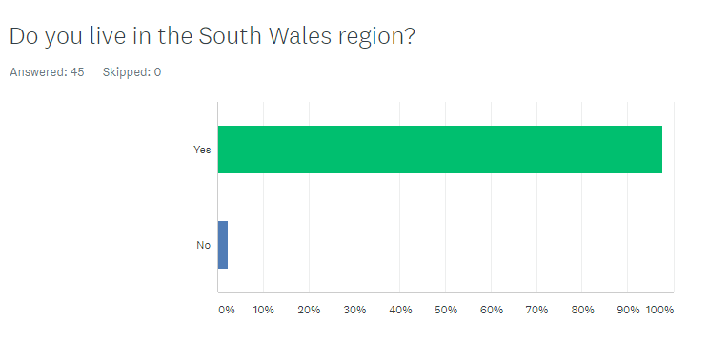

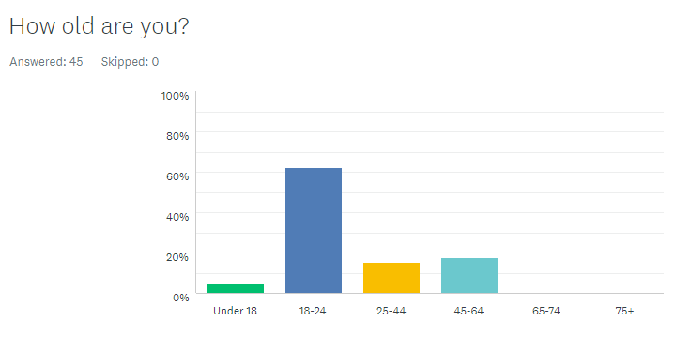

The first few questions of the survey consist of simple check box answers in order to allow the consultant to have an idea of who the respondents are. For an example, the first question has already been discussed as it asks if the respondent lives in the South Wales Region. Question two asks the respondent what their age is. Out of the 45 answers, two of them were under the age of 18, a number of 28 people were between the ages of 18 and 24, seven people were between the ages of 25 and 44, meaning the remaining eight respondents were between the 45 and 64 years old, as none of the respondents said they were above the age of 64. With only the first two questions, the consultant already knows that almost all the respondents are from south Wales and that most of them are between 18 and 24 years old. The one remaining respondent who answered no to living in the South Wales Region commented that they live in the East Midlands.

Question 3
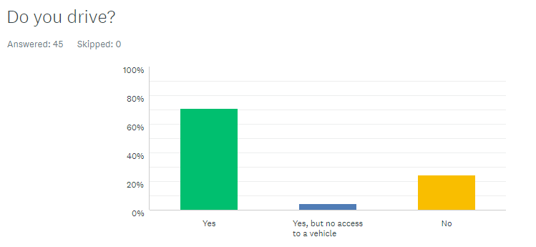

The next question on the survey was asking if the respondent was able to drive. Looking at the results, 71.11% of the 45 respondents answered “Yes,” while 24.44% said no, and the remaining 4.44% of people answered “Yes, but no access to a vehicle.” Asking this generic question will allow the consultant to see if there are any themes relating to regarding if a person drives effects the likelihood of them using minibuses as a form of transport.

Question 4
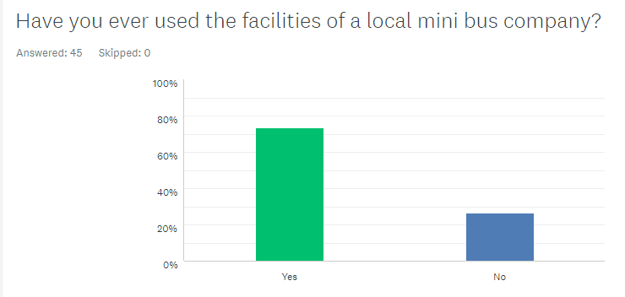

The next question on the survey was “Have you ever used the facilities of a local mini bus company?” 33 people (73.33%) responded yes but the remaining 12 people (26.67%) said no. Analysing these results in a deeper context, out of the 12 people who said they have never used the facilities of a local mini bus company, only one of these respondents also said they cannot drive. This could suggest there is a link between having the ability to drive and the use of public transport.

Question 5
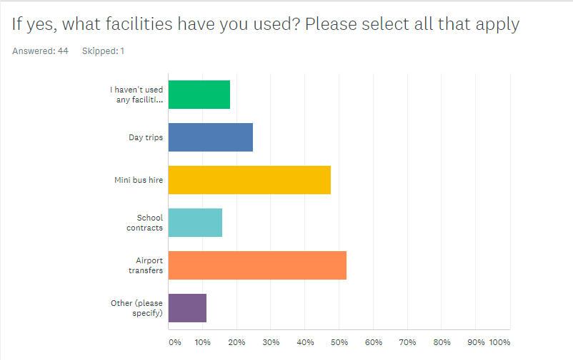

“If yes, what facilities have you used?” was the next question. Here, the respondent was able to tick all the apply, or select “Other” if there are facilities that they have used which weren’t on the list. The consultant retrieved a range of results here.
- I haven’t used any facilities of a minibus company – 18.18%
- Day trips – 25.00%
- Minibus hire – 47.73%
- School contracts – 15.91%
- Airport transfers – 52.27%
- Other – 11.36%

The feedback from the participants for this question varies. The most common answer being “Airport transfers” which was selected by over half of the respondents.
With regards to the “Other” section, 4 participants left their own response, these being;

- “Nights out” – Respondent 19
- “Night out” – Respondent 39
- “For a wedding” – Respondent 43
- “Getting home after a night out” – Respondent 45

Question 6
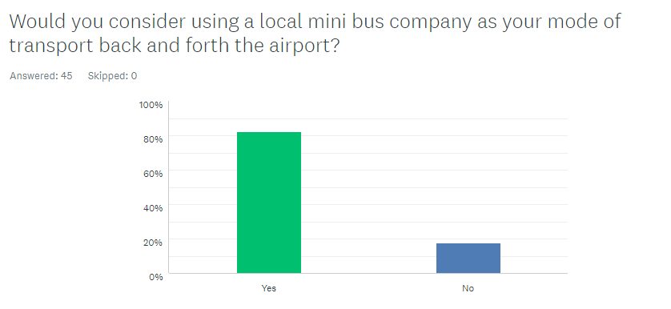

The next question asked by the consultant was “Would you consider using a local mini bus company as your mode of transport back and forth the airport?” The outcome of the question is that 82.22% of the 45 respondents said that they would consider using a local minibus company as their mode of transport back and forth the airport, whereas the remaining 17.78% of participants said they would not. In order to see a bigger picture and find out the reasons for this response, the consultant produced the next three questions so that the participants of the survey are able to say what they think is most important with regards to minibus companies, and this allows the consultant to analyse the findings.

Question 7
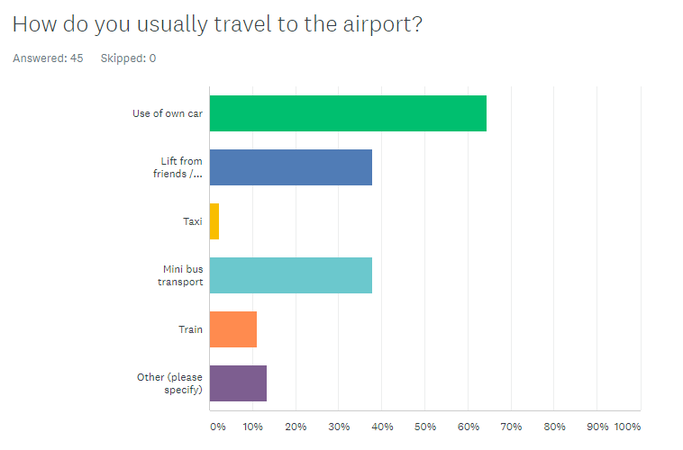

Question 7 of the survey asked the participants how they usually travel to the airport. There were a range of different responses to the question;

- Use of own car – 64.44%
- Lift from friends / family 37.78%
- Taxi 2.22%
- Minibus transport 37.78%
- Train 11.11%
- Other 13.33%

The respondents that selected the “Other” box specified that they travel to the airport via different bus companies including the Mega Bus and National Express coaches. One participant also answered with “Car hire.”

Question 8

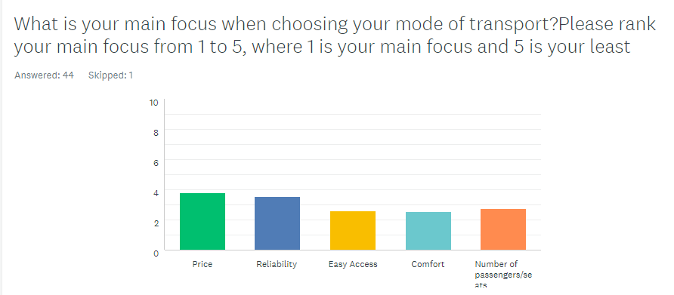

The consultant saw a good variety of responses when asking the following question; “What is your main focus when choosing your mode of transport? Please rank your main focus from 1 to 5, where 1 is your main focus and 5 is your least.”
The options were ranked so that price was considered the most important, followed by reliability, easy access comfort and lastly the number of passengers or seats.

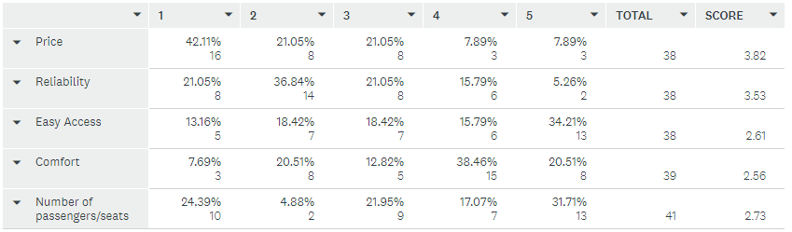
A total of 42.11% of the respondents said that price is the most important factor. 24.39% of the people responded that the number of passengers or seats decides what mode of transport they would use. Probably as there is more chance of a large group of people using a minibus as transport to the airport rather than a couple or a family of four. 13 participants voted “easy access” as the least important factor overall, as well as 13 also ranked that the number of passengers or seats was the least important aspect while choosing a mode of transport.

Question 9
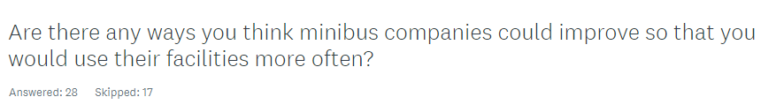

Following on from previous questions, it was important to find out what the respondents think minibus companies could do in order to improve their service so that people would use their facilities more often. Questions in this form can be tricky to gain responses as many respondents will skip the question as they are expected to form their own response instead of ticking a box. For instance, here 17 of the 45 participants skipped the question. Here are some of the responses the consultant received:

- “Better advertisement and lower prices” – Respondent 5
- “More advertisements as I really don't see many for minibus hiring” – Respondent 12
- “Affordability” – Respondent 17
- “More advertisement/online booking” – Respondent 23
- “Having more marketing services” – Respondent 26
- “Loyalty memberships to reduce costs for more frequently used trips” Respondent 34
- “Because of driving, I haven’t used any facilities for the past couple of years. The last time I used a minibus company I thought it wasn’t very spacious. Perhaps that could be improved but it could have been that one particular experience that wasn’t too spacious and comfortable.” – Respondent 45

Although being considerable points, it must be noted that D. Stevens Minibuses is a small local business which has many competitors nearby therefore can’t afford to lose money by lowering prices too much.

Analysis of Survey Results
One question the consultant wanted answers for is if having the ability to drive affects whether people use the facilities of their local minibus companies. According to the results recorded, driving could possibly have an impact. 71.11% of the participants said they drive and have access to a vehicle. It’s arguable that having use of your own car could be considerably cheaper than paying to use someone else’s facilities. However, alongside this, 73.33% of the total number of respondents selected yes when being asked if they had ever used the facilities of a minibus company.
Looking back at question 5, it’s clear that the most popular minibus facility used by the 45 participants who took part in the survey is transport back and forth the airport. This become a surprise to the consultant, as this is a service which D. Stevens Minibuses is yet to provide. Also, three out of the four participants who selected the “Other, please specify” option said that they had used minibuses as a mode of transport on a night out. This service seems to be becoming more popular as it’s a less expensive option for larger groups of people instead of booking multiple taxis.
Question 6 asked whether the respondents would consider using a minibus company to transport them to an airport and back. A total of 82.22% of the participants answered “yes.” This is a surprising result to the consultant as the company D. Stevens do not offer this service however the results show there must be a demand for it. The question following on from this asked how the respondent usually travels back and forth the airport. The most common response with 64.44% was the use of their own car. Next voted was a lift from friends or family members, as well as minibus transfers, these were both selected by 37.78% of the respondents. For this question 13.33% said “other” and specified that they opt to use companies such as the Mega Bus and National Express Coaches. The consultant believes that this could be purely down to economising on price, as the Mega Bus is known for its cheap fares and the National Express is usually relatively affordable. As, with companies like these the passengers pay for one ticket for where they’re heading, whereas when using a minibus for airport transport the passengers have to fund the whole journey, regardless of how many passengers there are.
Looking at the next question, the consultant asked the participants to rank their main focus of what matters when choosing a mode of transport, where 1 is most important and 5 is considered the least important. The results show that “price” and “reliability” were considered to be the most important factors whilst choosing a mode of transport. This could suggest why many people opt to travel with companies such as the Mega Bus, as the prices for the transport from one location to another is very inexpensive. However, more or less the same number of respondents said that reliability is the most important, hence why many people use minibus transfers to arrive at the airport as generally this is a more reliable option. This is down to the fact minibus companies are usually family run businesses who strive on customer satisfaction, whereas companies such as the Mega Bus and the National Express are multinational companies and aren’t considered as reliable. Transport to the airport is important aspect to consider as travellers need to arrive there within a certain time frame in order to check in on time and not miss their flights.
Also, regarding question 8, only three participants voted that “comfort” was the most important aspect they consider while choosing a mode of transport to the airport, where on the other hand 16 participants said that “price” was the most important. This shows that nowadays most decisions people make is based on the price aspect before anything else is considered.
For the last question, the consultant left the question open for people to give their own responses instead of answering tick boxes. This can be risky during online surveys as many respondents do the easy option of skipping the question instead of forming an answer, in this case 17 out of the 45 participants skipped the last question. However, out of the 28 people who did respond, the most common answers for ways in which the participants thought minibus companies could improve their facilities and gain more custom, was to have a better advertisement strategy and to be more affordable.
According to Kotler, P (2018) “Pricing is the only element in the marketing mix that produces revenue; the other elements produce costs.” This suggests that even though the participants suggest that minibus companies need to lower their prices, often the companies can’t afford to do so as this is the only way the company produces revenue.

Interview Results:

Some data for the report was also obtained through face to face interviews. The consultant’s interview with David and Paula Stevens, the business owners, was a success. The interview tended to highlight the owner’s wishes in order for the business to be successful. Their insight knowledge on current customer’s habits, likes, dislikes has been useful for this report.

Staff Comments
Bus Decor | -In their opinion some of the buses are slightly old fashioned and they feel like customers sometimes go with companies who have more modern buses.  -Some of the stickers on the outside of the buses are peeling off or are faded.
Advertisement | -It was considered that there is not enough promotion of the business.  - The owners don’t do much in terms of advertising due to not having adequate time.  - There is advertising on the sides of the buses (stickers).  - There is a Facebook page for the company, but it’s never used.
Website | -The business does not currently have a website, only a social media page which rarely gets updated.
Complaints | -The business owners discussed the common customer complaints they receive, and the reasons these may occur.
Facilities | -The company has seven minibuses in total, four of them have great accessibility including ramps for wheelchair users.  -The minibuses they own are a mixture of different seaters, some being small and some having a larger number of seats.
Services | -The services offered by D. Stevens Minibuses were discussed in great detail.  -The company provides many services including minibus hire, school contracts, day trips and transport for nights out.  -Services which the business doesn’t currently offer was also talked about.

Possible solutions for some of these concerns would be to look deeply into the advertisement strategies of the company and try to make improvements to them. For an example, the buses could be made much more appealing, and more modern of the owners were to renew the advertisement stickers on the outside of the buses. The owners could also begin to use social media more often and update their Facebook page with the facilities and the types of minibuses they offer so that the public are more familiarised with the business.

Local Residents

- Bethan Davies – A student who studies history at Cardiff University. She is a resident living in Ebbw Vale, which is the small town in which D. Stevens minibuses is based. The main findings during the conversation were that the interviewee had in the past used the company’s services for transport for a number of different nights out with her friends. She recalls that the business owners are very friendly and kept in touch with Bethan during the evening, informing her of what time they were arriving to pick her friendship group up and where in the busy city centre they would be located.
Following the owner’s opinion on their advertising issues, Bethan was asked to discuss the company’s advertising. It came to the consultant’s knowledge that the interviewee only knew about the business due to her friends having used their facilities in the past. Bethan was not aware of the different services the company has to offer, and neither did she know that the business has a Facebook page; she does not follow them.

- Ethan Pickett – Another resident living in Ebbw Vale, who works in a local factory repairing car parts. The interviewee was asked to discuss similar factors as the last interviewee. Ethan is aware of the minibus company due to living 0.9 miles away from the location. He stated that if he didn’t happen to live so near to the business then her probably wouldn’t be familiar with their name. He also stated that due to the company being involved with some local school contracts then this is a good advertisement strategy as the buses are always driving around during the busy rush hour, allowing large numbers of the public to see them.
Ethan informed the consultant that he had never used the services of the company due to being able to drive. Using his own car is the cheaper and hassle-free option. However, he did state that he had used the services from a different minibus company in the past, which cannot be named due to confidential reasons. He said that due to the last experience he had, then he isn’t keen to use a minibus company as his way of transport as he doesn’t think they are very reliable.

Regarding the informal interviews conducted with two local residents. The Consultant thinks it’s clear that the advertisement strategies of the company aren’t great. Both of the residents said comments which also backed this up. Although Bethan Davies has used to company as a mode of transport in the past, this was due to her hearing about the company through word and mouth of her friend, not due to the company’s own advertisement.

Conclusions

Market research is required to take place frequently in order to keep up with new customer trends and changes while running a business. This isn’t the only way possible to access customer feedback. A simple way to retrieve customer feedback is asking customers how they feel their experience went with the business and asking some simple informal questions. The feedback received can be utilised in order to improve the company’s service and improve its overall customer satisfaction. The knowledge the owners have of their current and potential customer can help the business create new services and generating successful sales.
There is also an urgency to improve other areas of the business, specifically the advertisement for the company. D. Stevens Minibuses lacks completely with advertisement. The business doesn’t have a website, only a social media page which is rarely even used.
The findings from the consultant’s research shows that many participants have used minibuses as a way of transporting to and from the airport, and a good quantity of them said they would consider this method of transport. The company doesn’t currently offer this service, however the research undertaken supports that this would be a feasible new project for the business to introduce. Investment in advertising and promoting will be essential for a new service like this to be successful.

Recommendations

From the data collected it is evident that the key issue circling this business is advertisement. D. Stevens could have strategies in place in order to improve this. They could update their social media pages, posting exactly what services they have to offer. People in the surrounding areas tend to be unaware that the company owns a variety of different minibuses with different numbers of seats. Residents are also unaware of the services the company has to offer, therefore will choose the easy option of using a different company that they know already offers the service that they want.
It is recommended that the business offers the new service of airport transfers as there is clearly a gap in the market for this considering 82.22% of the participants who took place with the primary research said that they would consider using a minibus company as their mode of transport to and from the airport. This could help generate D. Stevens Minibuses more income throughout the summer months in particular. This is due to them not having their school contracts between the months of June and September. Coincidentally, these are the months most British holiday makers travel abroad, hence why more people will be looking to travel back and forth the airport during this period of time.

Bibliography

Bilgili, B et al (2011). Kano model application in new product development and customer satisfaction. 4th ed. Turkey: Elsevier Ltd. p830-831.0

McDonagh, E. (2019). Transport Survey. Available: https://www.surveymonkey.com/analyze/KtPhGHwa1z6dma7yKS2Dt0uMemxwm7iQv8YlUxEMaBbOUbqQIDeg_2B0OLHgG23k9u. Last accessed 8th May 2019.

Kotler, P. (2018). Pricing Quotes. Available: http://pricing-hub.com/resources/quotes/#sthash.nLMSy08r.dpbs. Last accessed 7th May 2019

Patel, N. (2018). The Benefits and Importance of Customer Satisfaction. Available: https://neilpatel.com/blog/benefits-and-importance-of-customer-satisfaction/. Last accessed 8th May 2019

https://www.yell.com/biz/d-stevens-minibus-hire-ebbw-vale-6668914/

