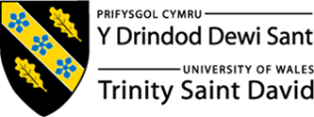

Employability and Career Developing

Sol Andrea Rincon Osorio.
Card Number: 2325933

key skills in two roles and similarity.
Skills | Job advert 1: Marketing Operations Assistant | Job advert 2: Social Media Assistant | Similarities
Communication Skills | Communicate with influencers, suppliers and stakeholders. Strong written and verbal communication required. | Coordinate with influencers, create marketing copy and communicate with customers through email and social media. | Both roles require excellent written and verbal communication with different audiences.
Organisation & Time Management | Manage multiple projects, coordinate events, schedule meetings and organise marketing materials. | Manage several marketing activities, content calendars and campaigns while meeting deadlines. | Both require strong organisational skills and the ability to manage multiple tasks effectively.
Digital Marketing Knowledge | Knowledge of digital marketing, SEO, social media platforms and marketing tools. | Experience with Shopify, Instagram, TikTok, SEO, email marketing and analytics. | Both require knowledge of digital marketing, social media and online marketing platforms.
Teamwork | Works with different departments. | Collaborates with the marketing team. | Both require teamwork.
Creativity | Supports campaigns and content production. | Creates engaging social media content. | Both require creativity.

Comparing Two Job Advertisements
After reading both job advertisements, I noticed that communication is one of the most important skills they have in common. Even though one role is a Marketing Operations Assistant and the other is a Social Media Assistant, both jobs involve working with different people every day.
To be honest and in my opinion I believe communication is an essential skill because it helps people work together and achieve the same goals.
Communication means sharing information clearly, listening to others and making sure everyone understands what needs to be done. In both job advertisements, employees need to communicate with colleagues, customers, influencers and other departments. If communication is poor, projects can be delayed, mistakes can happen and customers may not have a good experience.
Nowadays, people marketing use communication all time. They speak to customers, work with other departments, answer emails, attend meetings and sometimes deal with suppliers or business partners. Communication is an important skill where they also need to communicate when they are planning campaigns, solving problems or sharing ideas with the team. Good communication helps everyone stay organised and work more efficiently.
From my own experience, I know how important this skill is. When I worked as an External Sales Executive in Colombia, I visited business customers every day, prepared quotations and built long-term relationships with clients. I learned that listening carefully to customers helped me understand what they really needed. This allowed me to offer better solutions and build trust.
Afer this, I became a Cleaning Supervisor in the UK, communication became even more important. I was responsible for supervising a team, I was training new employees and making sure everyone understood their daily tasks. Sometimes problems happened unexpectedly, so I had to communicate clearly and stay calm to find a solution.
In my current hospitality role, communication is still part of my everyday work. During corporate events, plans can change at the last minute, and I need to work closely with my colleagues to make sure everything is ready for the client. I have learned that good communication is not only about speaking well, but also about listening, being respectful and working as part of a team.
Overall, I think communication is one of the most valuable skills in both job advertisements. It helps teams work better, improves customer satisfaction and makes marketing projects more successful. From my previous jobs, I have developed this skill and I believe it will continue to help me build a successful career in marketing.

Task 2: SWOT and Reflexibe Assessment.

SWOT
Strengths (Internal Factors) | Weaknesses (Internal Factors)
 | - Limited Professional Marketing Experience – Although I have completed a Digital Marketing qualification and I am studying Business Skills, I have not yet worked in a marketing position.  - Limited Professional Network in the UK Marketing Industry – I am still building connections with professionals and employers within the marketing sector.
  - Strong Communication Skills – Developed through over 20 years of experience in B2B sales, customer service, team leadership and hospitality, allowing me to build strong professional relationships.
  - Adaptability – Successfully adapted to living and working in the UK, learning new roles, improving my English and progressing professionally while studying.
  - Organisation and Time Management – Experienced in coordinating teams, managing priorities, organising corporate events and balancing work with university studies.
  - Continuous Learning and Growth Mindset – I actively seek opportunities to develop my knowledge through further education, professional qualifications and practical experience.
  - Professional English Confidence – I communicate effectively in everyday situations, but I want to become more confident in presentations, meetings and professional discussions.
  - Limited Experience with Advanced Marketing Tools – I would like to strengthen my skills in Google Analytics, Meta Ads, Adobe Creative Suite and advanced SEO tools.

Opportunities (External Factors) | Threats (External Factors)
  - Growing Demand for Digital Marketing Professionals – The UK job market continues to offer opportunities in marketing, communications and digital media.
  - University Studies and Professional Qualifications – Completing my Business studies and continuing to gain marketing knowledge will improve my employability.
  - Technology and AI Tools – Digital platforms and AI provide new opportunities to improve productivity, creativity and marketing skills.
  - Networking Opportunities – LinkedIn, university events, internships and professional workshops can help me build valuable industry connections.
  - High Competition – Many candidates apply for entry-level marketing positions, making it more competitive to secure a role.
  - Experience Requirements – Many employers prefer candidates with previous UK marketing experience.
  - Rapid Industry Changes – Marketing trends and digital platforms change quickly, requiring continuous learning and adaptation.
  - Economic Uncertainty – Changes in the economy may reduce recruitment or marketing budgets in some organisations.

Reflexion assessment

When I started this SWOT analysis, I realised something I had never really thought about before. Every job I have had, this has helped me developing skills that I am still using nowadays. Although my main experience is sales, customer service and hospitality, each role has taught me something valuable that I can now apply to a career in marketing. This reflection made me look back at my journey and recognise both my strengths and the areas where I still need to improve. It also reminded me that changing careers does not mean starting from the beginning. Instead, it means using everything I have learned over the years to build a new future, this mean more experiences and knowledge.
The first strength I identified was communication. Looking back, I can see that this has always been one of my strongest skills. When I worked as an External Sales Executive in Colombia, I met millions of customers every day, I prepared quotations and I built long-term business relationships. I learned that communication is not only about explaining products or services. It is also about listening carefully, understanding what people need and finding the best solution for them. This helped me build trust with my customers and develop strong professional relationships.
Another strength is adaptability. Moving from Colombia to the UK was one of the biggest changes and missions in my life. I had to improve my English as also I had to understand different culture and start a completely new career. At first, everything felt unfamiliar, but little by little I became more confident. I started working as a Cleaner and later became a Cleaning Supervisor. That experience taught me that being willing to learn and having a positive attitude can open new opportunities, even when you begin from zero again.
Organisation and time management are also strengths that I have developed throughout my career. In my current hospitality role, I help preparing corporate events where the priorities can change very quickly. Being organised helps me stay calm, work well with my colleagues and make sure everything is ready for the client. At the same time, I have been balancing work with my university studies. Although it is not always easy, it has taught me how to plan my time, stay focused and keep working towards my long-term goals.
While thinking about my strengths, I also realised that I still have areas where I want to improve. One thing I still need is professional marketing experience in the UK. I have completed a Digital Marketing qualification level 2, I am studying Business Skills, but I know that working in a real marketing team will help me understand the industry much better. This is one of the reasons why I am applying for marketing roles, because I want to put my knowledge into practice and continue learning.
Another area I want to improve is my confidence when using professional English. I communicate well with customers and colleagues every day, but I would like to feel more confident when giving presentations, sharing ideas in meetings or discussing marketing strategies. I also want to improve my knowledge of marketing tools such as Google Analytics, SEO and Adobe software. I do not see these as weaknesses that stop me. Instead, I see them as goals that will help me grow professionally.
After reflecting on my strengths and weaknesses, I started thinking about the opportunities and challenges that I may face in the future. One of the biggest opportunities is the growth of digital marketing in the UK. More businesses are investing in online communication, social media and digital advertising, which means there are many new career opportunities. I believe that continuing my studies and developing new digital skills will help me become more competitive in this industry.
I also believe that technology offers many opportunities to learn. Today there are online courses, AI tools and digital platforms that make learning easier than ever before. I enjoy learning new things, and I know that marketing is always changing, so I want to continue improving my skills throughout my career. Building a professional network through university, LinkedIn and future work experience is another opportunity that can help me grow and learn from others.
Of course, I know there will also be challenges. Marketing is a competitive industry, and many employers look for candidates with previous experience. I also understand that trends, technology and customer behaviour change very quickly. This means I will always need to keep learning and adapting. However, when I think about everything I have already achieved, I feel confident that I can overcome these challenges. Moving to another country, learning a new language and building a new career have shown me that I can adapt and continue to move forward.
Overall, this SWOT analysis has helped me see myself from a different perspective. Before completing it, I was mostly thinking about finding my first marketing job. Now I realise that I already have many transferable skills that will help me succeed in this new career. My experience in sales, customer service, leadership and hospitality has given me a strong foundation, and my studies are helping me build the marketing knowledge I need.
This reflection has also reminded me that professional development is a continuous journey. I still have goals to achieve, such as gaining marketing experience and becoming more confident in professional English, but I now feel much more positive about my future. I know that every new experience, every course and every challenge will help me become a better marketing professional. Most importantly, I have learned that success is not about where you start, but about being willing to keep learning, adapting and moving forward.

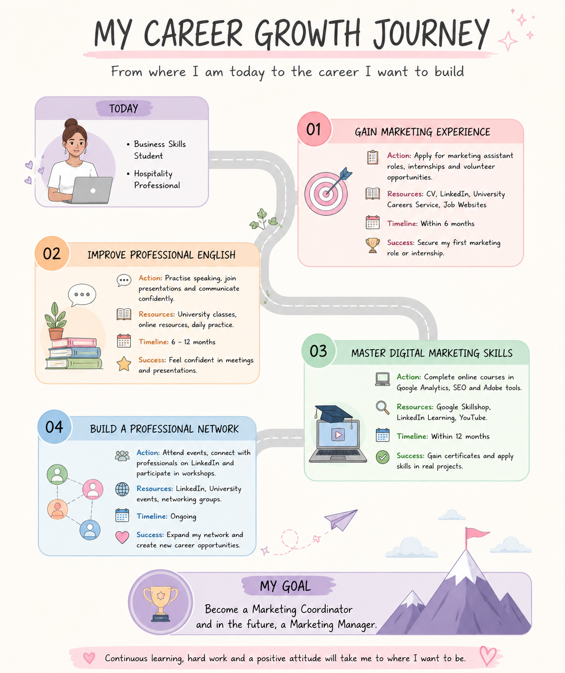

Personal Development Plan (Reflection)

One of my main career goals is to start working in marketing because it combines many of the skills I have developed throughout my previous jobs, especially communication, organisation and customer service. Although my experience has been in sales and hospitality, I believe these transferable skills will help me succeed in a marketing role.
My first short-term goal is to gain practical marketing experience. To achieve this, I will continue applying for Marketing Assistant positions and internships where I can learn from experienced professionals and apply the knowledge I have gained through my studies. I also plan to improve my professional English by practising presentations, participating more confidently in class and using English as much as possible in my daily life.
Another important goal is to continue developing my digital marketing knowledge. Marketing is constantly changing, so I want to keep learning about SEO, Google Analytics and Adobe software through online courses and practical projects. This will help me become more competitive in the job market and prepare me for future opportunities.
In the long term, I would like to build a successful career in marketing where I can continue learning, take on more responsibility and eventually progress into a Marketing Coordinator or Marketing Manager role. I also want to build a strong professional network because I believe that learning from other professionals and sharing experiences is an important part of career development.
Creating this personal development plan has helped me understand that achieving my goals requires commitment, patience and continuous learning. I know that career development is a step-by-step process, and I am motivated to keep improving my skills and taking every opportunity that brings me closer to the career I want.

