PRACTICAL ASSESSMENT 2019/2020 Answer Sheet

SCHOOL OF ENGINEERING

NAME OF COURSE/PROGRAMME: | BEng Motorcycle Engineering
YEAR OR LEVEL: | Year 1
NAME OF MODULE/UNIT/ASSESSMENT PAPER: | Motorcycle Technology
MODULE NO: | M4X00392
DATE OF ASSESSMENT: | 28th April 2020
START TIME: | 09.00
FINISH TIME: | 11.30
TIME ALLOWED: | 2.5 hours

INSTRUCTIONS TO CANDIDATES:

Answer all questions.

Use the data set provided to answer all questions.

You can use screen shots of the data to help with your answers.

QUESTION ONE
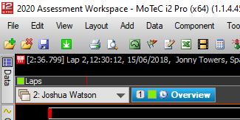
1a.

Right click and insert new workbook, enter workbook name. Once in the new workbook, right click on the worksheet and rename to Overview, click okay.
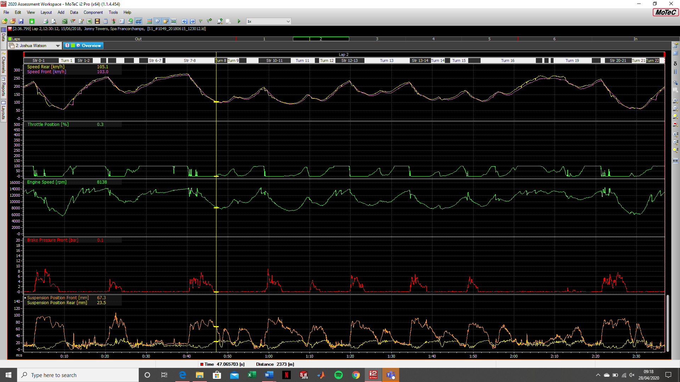
In the add bar at the top, insert a time/distance graph and then add all the listed channels ensuring to add a group wherever necessary using the add group button.

1b.
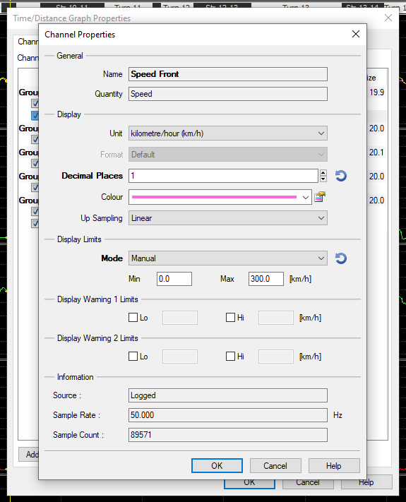
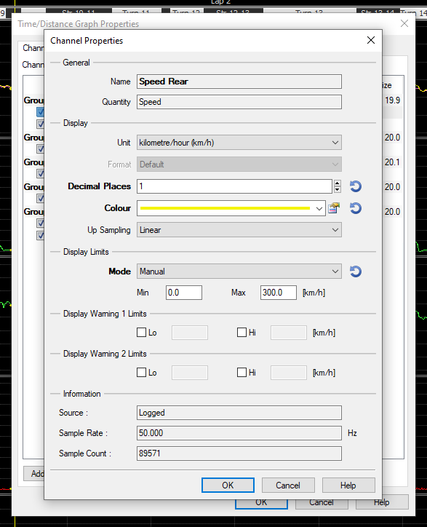

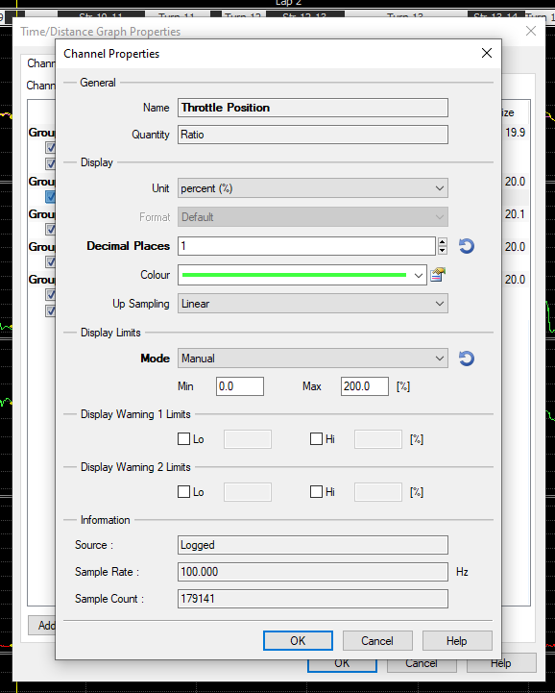
Limits set for front and rear speed changed to 0-300kmh by right clicking in main window, opening properties window and then double clicking on each channel to edit them within the display limits section.

Throttle position channel limit set to 0-200% to enable the data to be easier read while not being too large within the data window. Set using the same method as above.
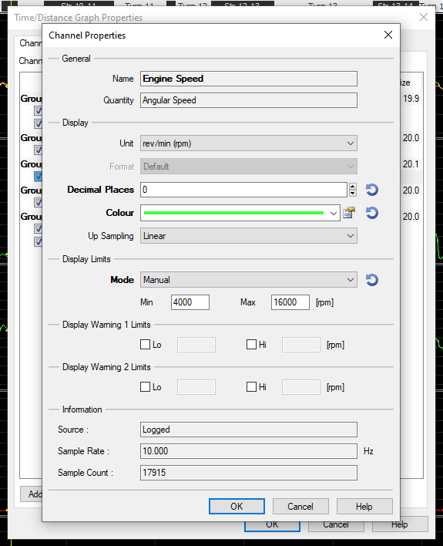

Throttle position channel set to 4000-16000rpm to make the data more widespread across the channel as rpm isn’t going below 4000 much within the data set. Set using the same methods as previous channel.
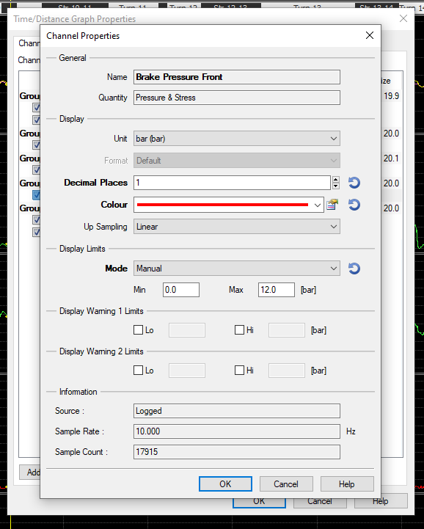

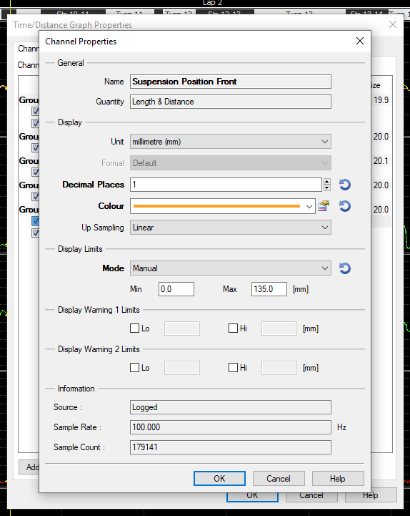
Front brake pressure set to 0-12 bar so that the data is easier to read and slight peaks within the data are now easier to be seen rather than having to zoom in completely like previously needed. Set the same way as previously said.

Front and rear suspension travel limits set, front suspension travel set to 0-135mm as the travel on front forks will not exceed 125mm and the rear is set to 0-65mm as the rear suspension unit will not exceed 50mm. Set the same way as specified before.

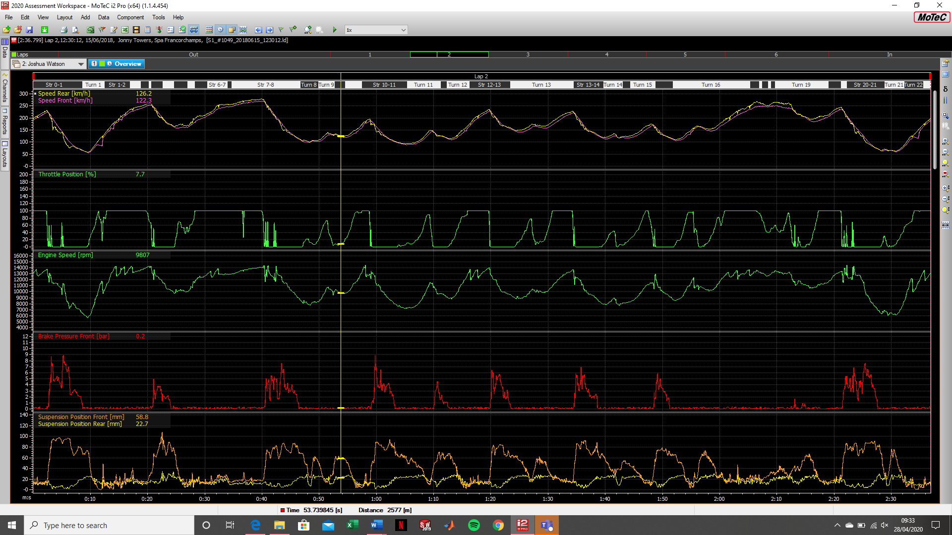
The screenshot above shows the channels in the data view window with the new channel limits set, these channel limits allow for the data to be easily read and viewed easier rather than they were before needing to zoom in to view specific points in the data. To confirm the channel limit changes, ensure to confirm on the OK button in the channel windows.
1c.
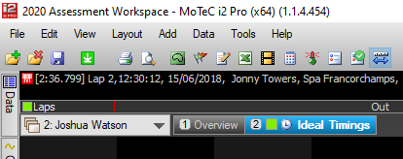
Worksheet named Ideal Timings.
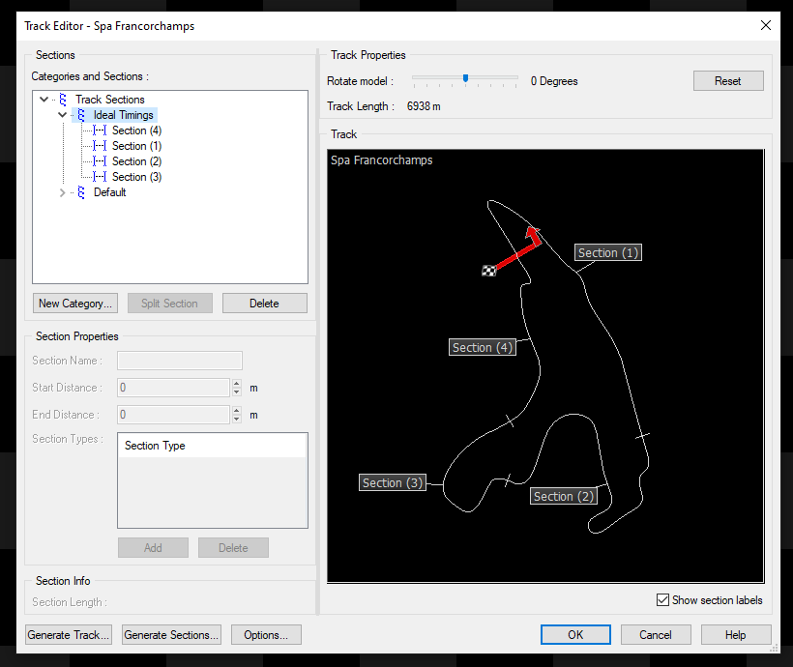

In track editor, generated sections called “Ideal Timings” and generated four sections ad set distances, used the split section button to split larger sections into multiple. Select OK to confirm.

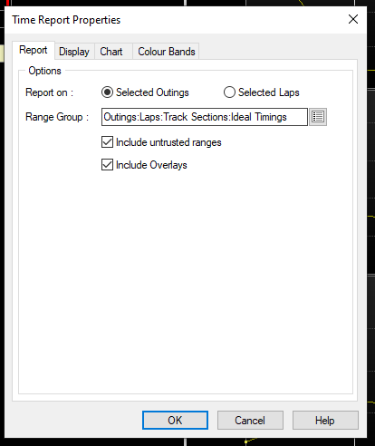

In the add menu, insert a time report and in this menu, change from default lap timings to Ideal timings that I have created, include untrusted ranges so that out laps and in laps are included in the time report. Confirm with OK.
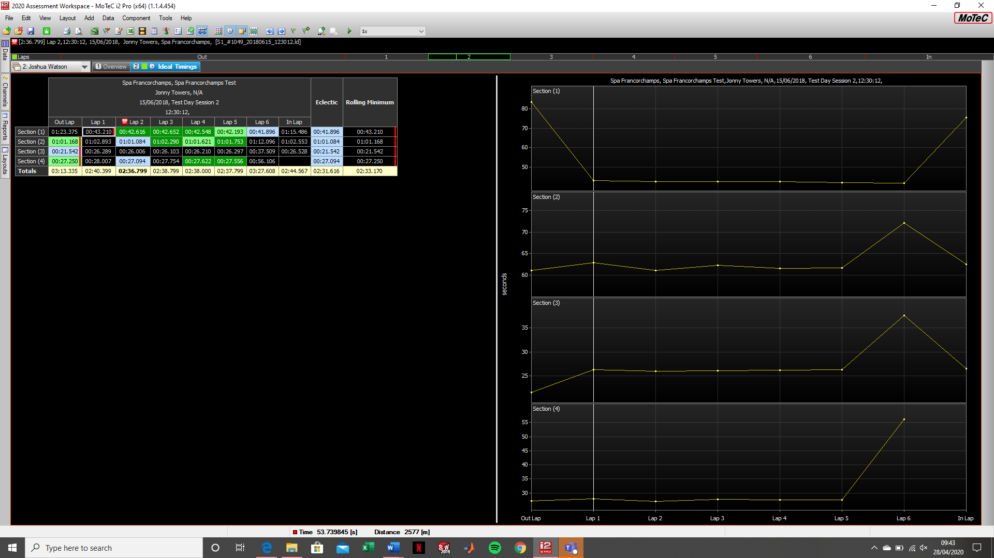
This is the time report that shows the ideal times regarding the sections that were determined within the track editor. The colours in the time report reflect the lap prediction.

QUESTION TWO
Histograms
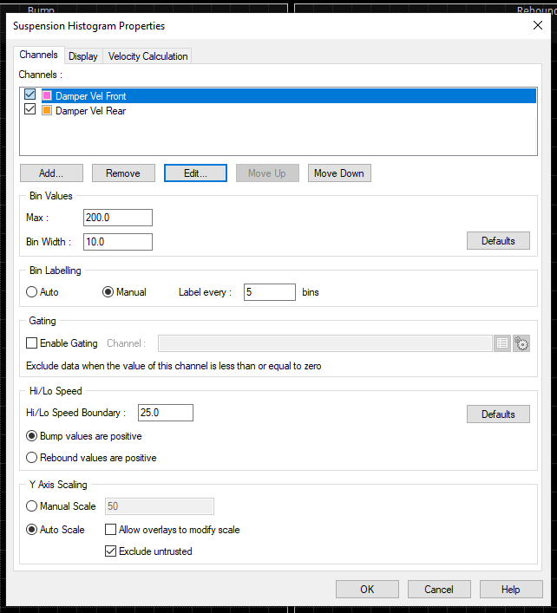
Created a new worksheet named “Suspension Histogram” and then added a suspension histogram to this worksheet and used Damper Velocity Front and Damper Velocity Rear to the histograms and confirmed OK.
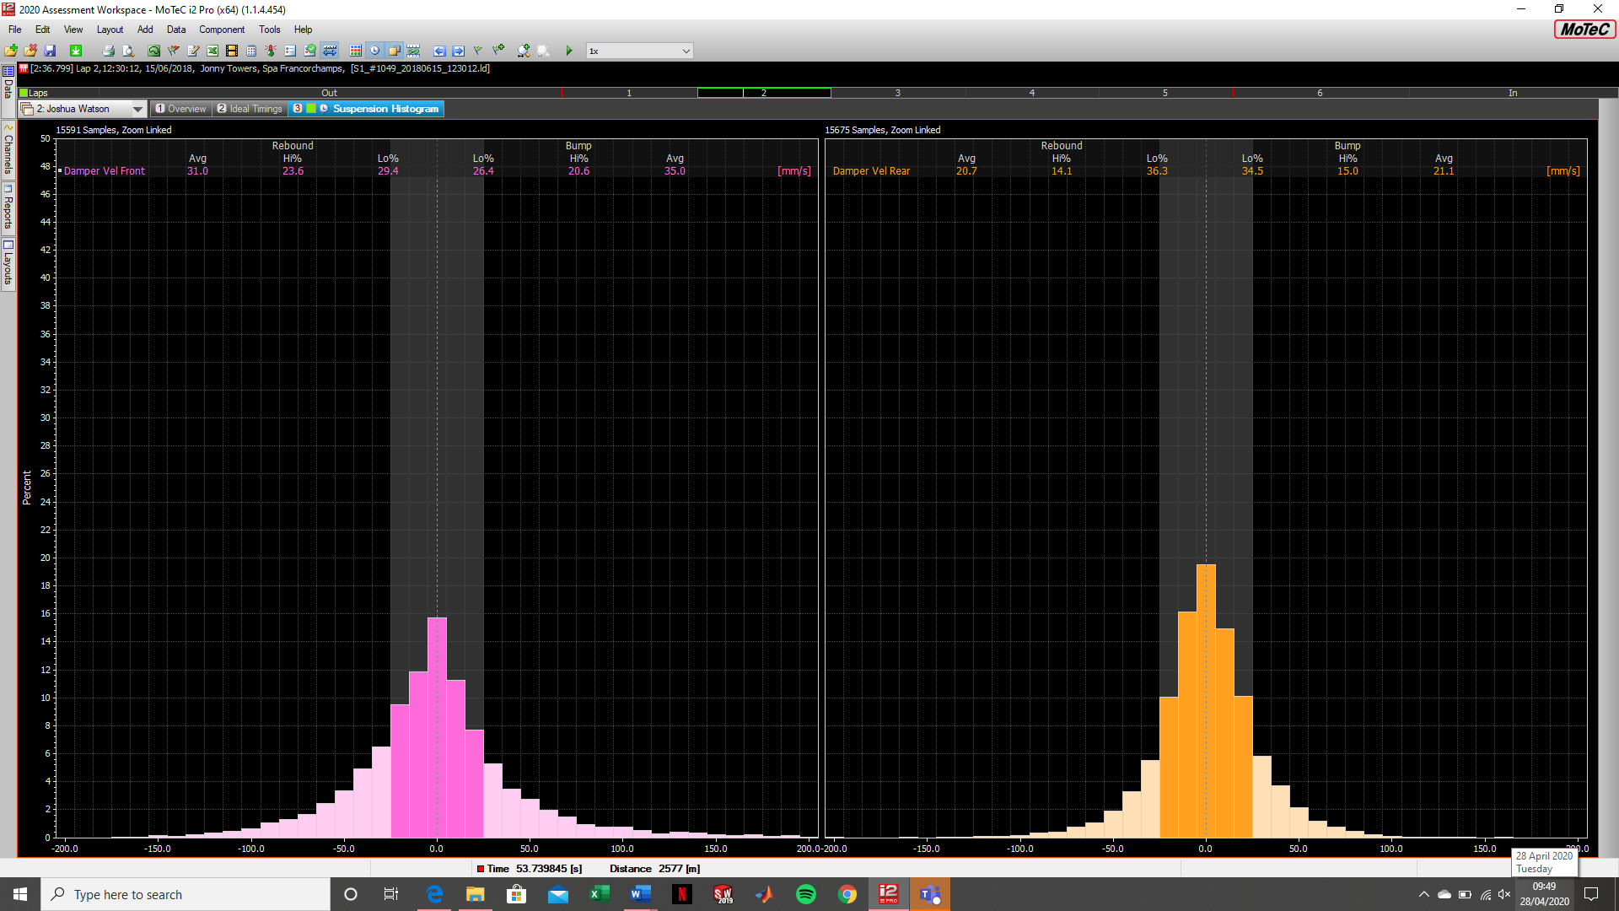
This shows the two histograms for the damper velocities front and rear, they are within the suspension Histogram worksheet. These can be used to analyse whether the bump and rebound suspension settings are working correctly as the histogram shows positive and negative values. This helps when testing suspension settings at a circuit.

Channel Report
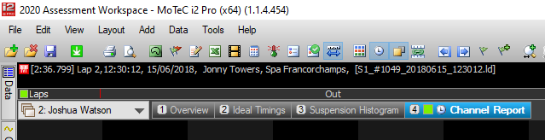

Created a worksheet called channel report to home the channel report using the channels.
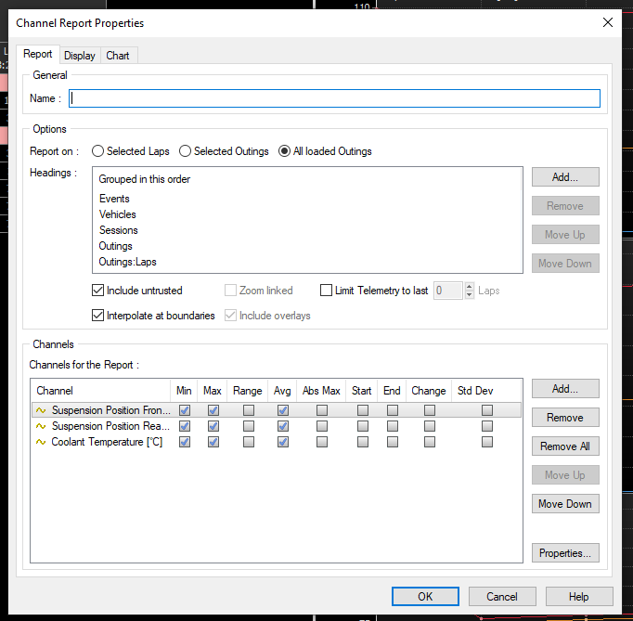
In the add menu, insert a channel report, and select “All Loaded Outings” and then click on include untrusted ranges so that in/out laps are included. Then add Suspension Position Front and Rear, and also coolant temperature. Select the min, max and average value box as this is what will be shown in the channel report. Confirm OK.
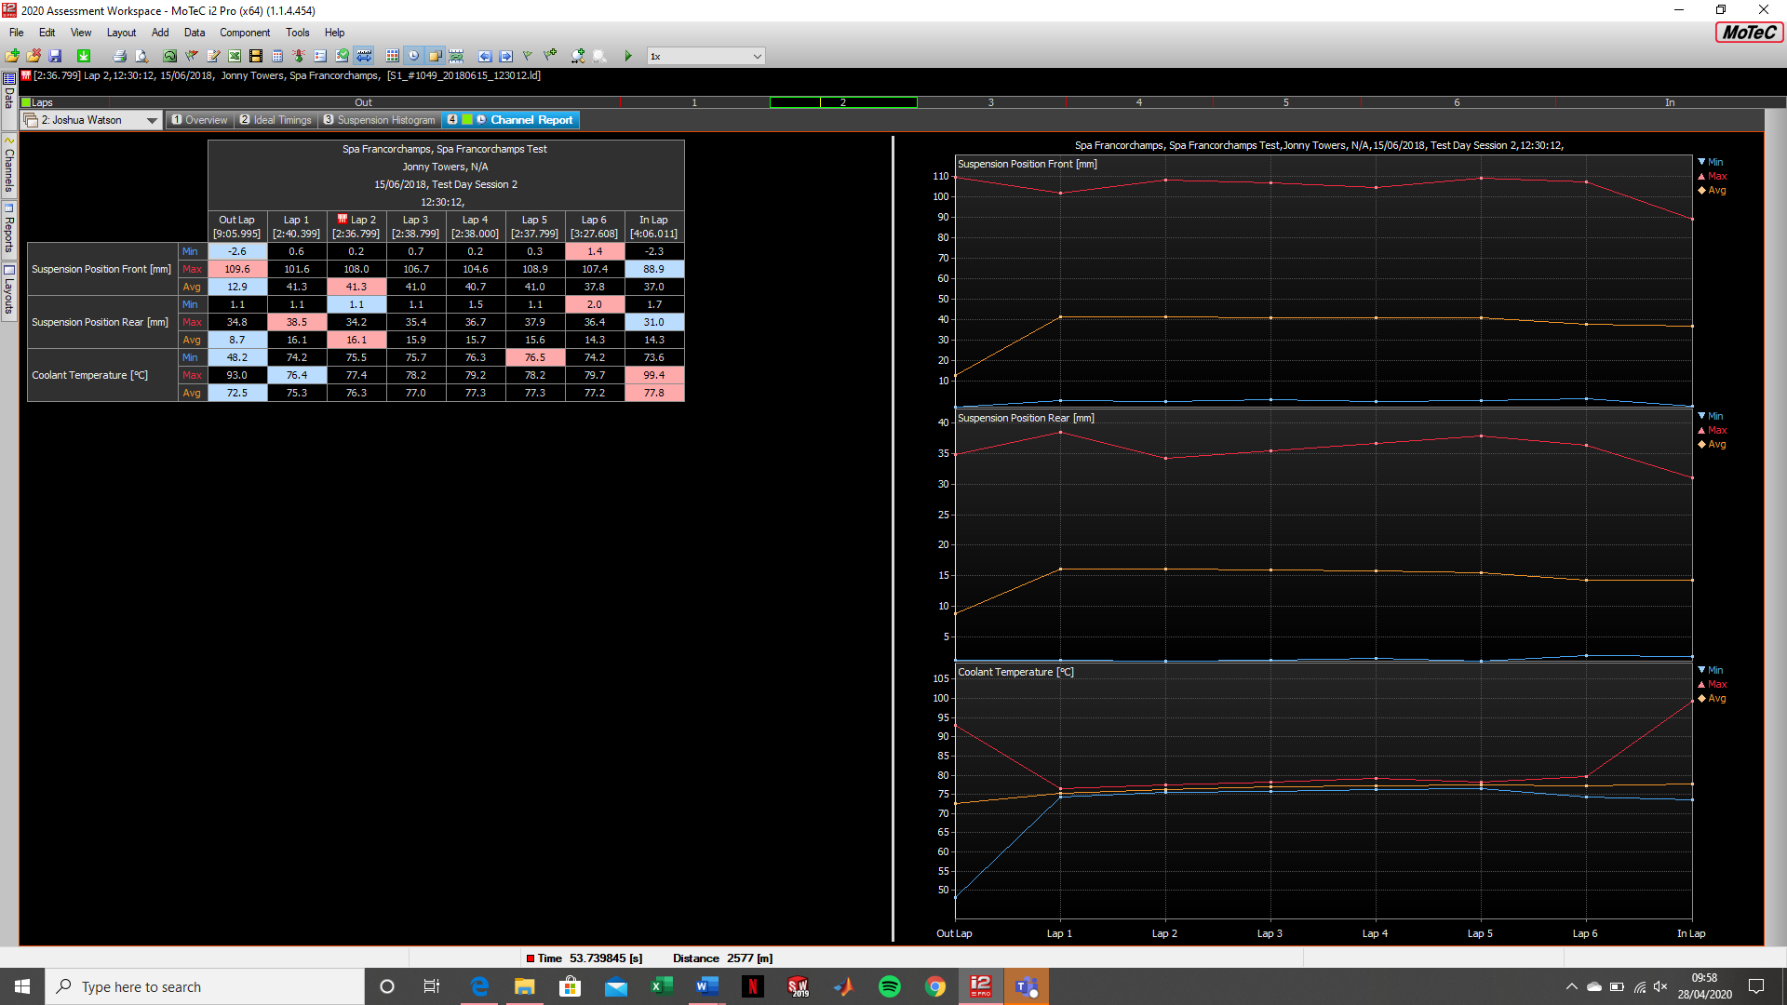
This is the channel report added within the worksheet with the specified channels. These are useful to monitor whether the bike is utilising its suspension travel or whether the suspension settings could be adjusted to use more/less and also based on the temperature, the coolant level is important as it could determine whether the bike was running too cold or too hot.

Track Report
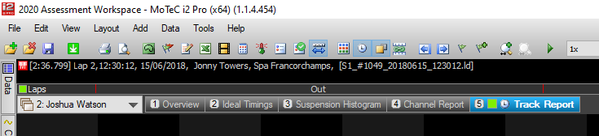
Create worksheet called Track report.
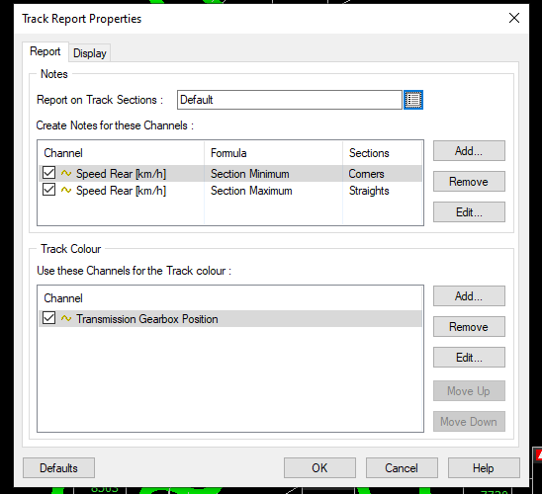
In the add menu, add a track report and then in this menu add speed rear with the formula as minimum and filtered to corners, while also showing engine speed and transmission gearbox position in the additional channels box, repeat this with speed rear and use formula maximum and filter it for straights, whilst showing engine rpm and transmission gearbox position in the additional channels box. Then for the track colour box use transmission gearbox position. Confirm OK.
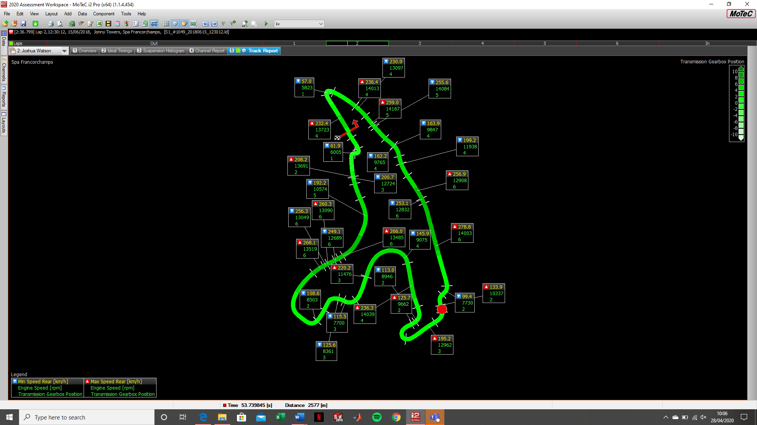
This is how the track report will look. These are useful to monitor speeds and rpms in certain corners to determine whether the gearing ratio is correct and saves having to waste test sessions trying different gearing configurations when the answer could be easily found using a track report.

QUESTION THREE
3a. Traction Control controlling spin
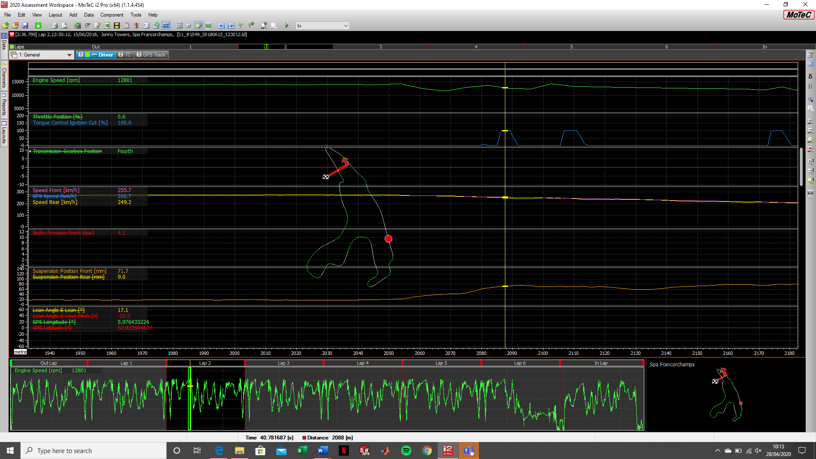
At this point in the data I believe there is evidence of traction control coming in to aid the rider, this is because there is evidence of the difference in the front vs rear wheel speed has increased (slip), there is also evidence of ignition cut which is shown on the yellow marker and also at that point in the data the front suspension travel increases suggesting there is less load on the front fork, these are all signs of traction control coming into effect.

3b. Wheelie Control Active
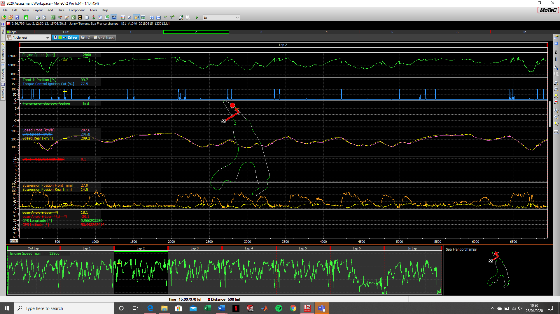
At this point in the data I believe there is evidence of wheelie control as this point of the data is on the exit of a corner where it would be most likely to find wheelie control, there is also a slight dip in rear suspension travel and a rise in front suspension travel which is accompanied with ignition cut at the same time which although it may not be possible to have a full wheelie, this could be a part of the circuit where wheelie control could prevent a wheelie from occurring.
3c. Slip Percentage
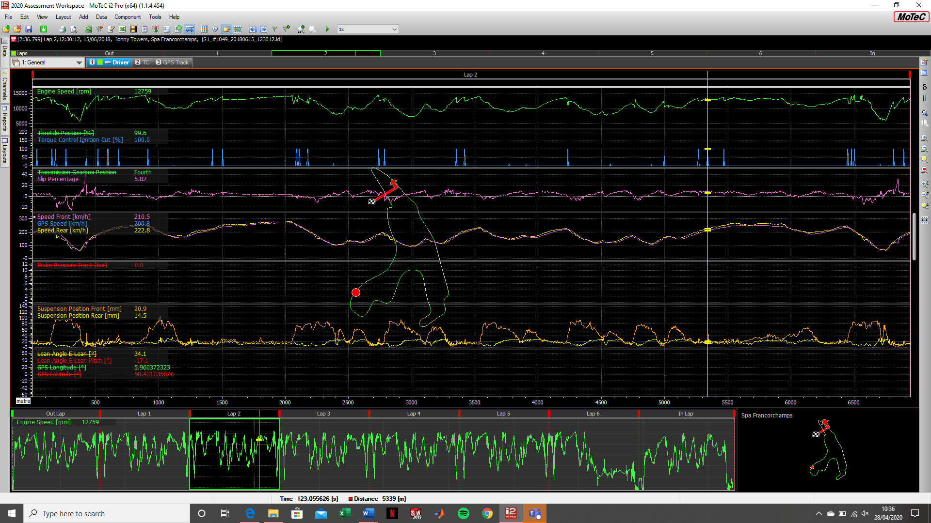
At this point in the data the slip percentage channel is showing 5.82 at a point where I believe there is traction control coming into play because of the reasoning I explained in question 3a.
QUESTION FOUR
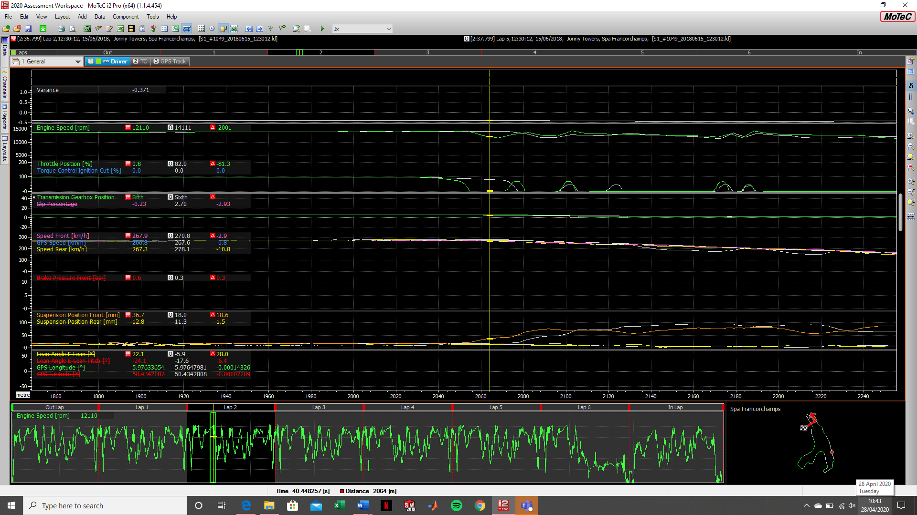
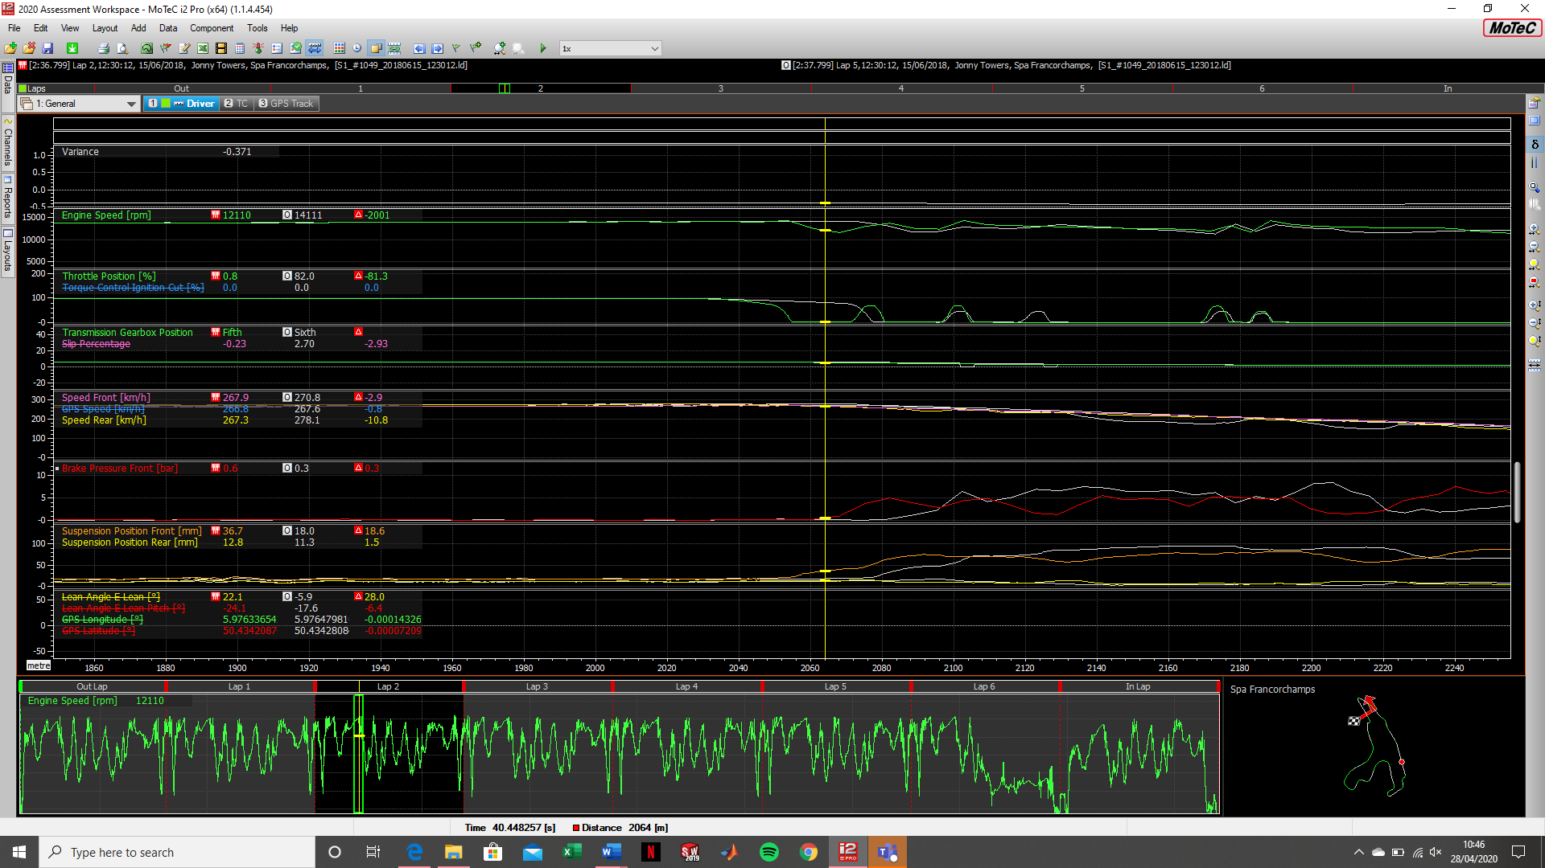
At this point in the data that I have zoomed in to I found that at this point on the circuit on lap 5 the rider shut the throttle and therefore braked later than on the fastest lap which at this point meant on lap 5 at this point in the circuit the rider was -0.371s quicker as shown on the variance in the below screenshot.

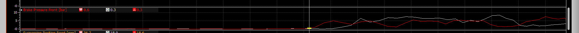
The data also shows below that the front brake pressure doesn’t rise until later in the lap which again suggests that the rider braked later on lap 5 than he did on the fastest lap. This is why this section of lap 5 was actually quicker than that of the fastest lap.

QUESTION FIVE
5a.
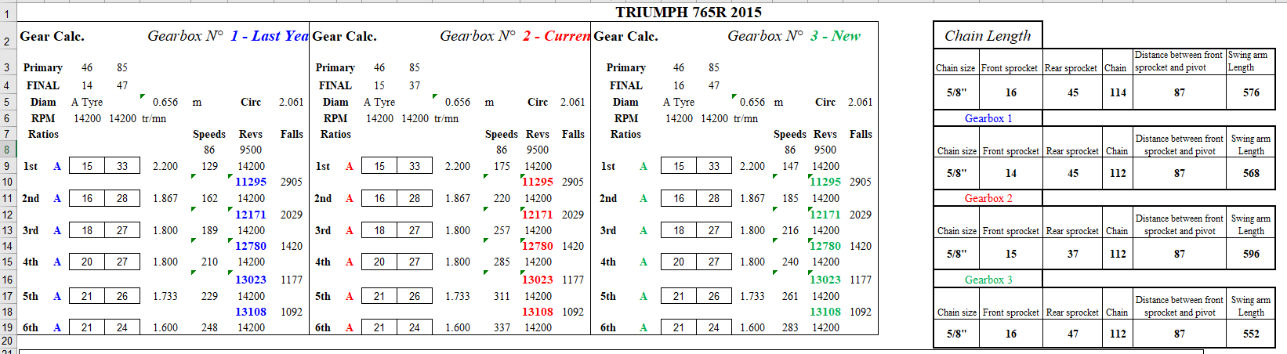
As shown above from the gearing calculator, the tyre type in gearbox 1 is set to A, and in the chain length section on the right hand side of the screen, the chain has 112 links and the swingarm length is 568mm when using 14-45 sprocket sizes.
5b.
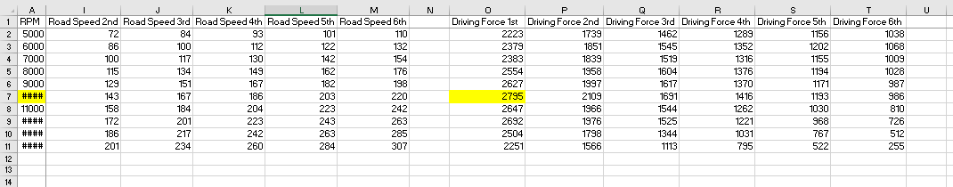
As shown in the screenshot above. Based on sprocket sizes 15-40 at 10,000rpm in1st gear the driving force is at 2795 which is the maximum shown in the chart.

