Programme: BA International Hotel Management
Module code - BMIH6002
Module: Managing Food and Beverage Operations
Assignment Title: Student Learning Log
Lecturer Name: Neil Dyer
Student ID: 2109020
Student Name: Syed Ariful Islam

Table of Contents
Introduction 1
Overview of Rosewood London 1
Learning objectives of the placement within the department 2
Gibbs reflective cycle 2
Conclusion 4
Reference list 5

Introduction
According to Fallon and Rutherford (2010), placement is an activity of connecting the particular individual and the employer to build an efficient employment relationship. Also, the student learning log aims to highlight a placement development record and is designed for the students to reflect on the experience of a supervisory position in the food and beverage department. The assessment will provide a brief overview of Clarion Hotel's food and beverage operations. Then, the assignment will state learning objectives and finally, the assignment will reflect on the placement experience using the Gibbs reflective cycle.

Overview of Clarion Hotel
Clarion Hotel was opened in 1991 and is a brand of Choice Hotel’s brand. The hotel has 7000+ hotels in 50+ states with 40+ territories and countries (Clarion Hotel, 2024). This hotel believes that life is better when people get together as the hotel makes it convenient to connect with customers and people. The hotel offers a lounge, full-time service, bars, a fitness centre, a pool to dive, and free Wi-Fi services inside the hotel. The hotel contains 5000+ employees who are dedicated to obtaining customer satisfaction within the hospitality industry (Vallen, Vallen and Jerome, 2014). Recently, Clarion Hotel opened 280+ hotels in different locations in Asia, Europe, the United States, and South America as well as in different destinations of the US like Atlanta, New York and Nashville (ASET, 2017).
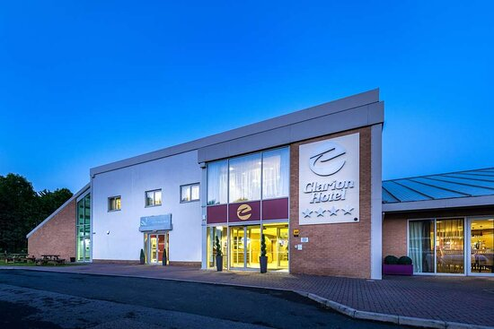
Figure 1: Clarion Hotel.
Source: (Clarion Hotel, 2024).
In Lats year, Clarion Hotel obtained £6.6 million in revenue last year as the hotel is a four-star hotel in the hospitality industry (Clarion Hotel, 2024). The hotel also offers accommodations for gatherings and celebrations of clients as the hotels, meeting space and rooms are offered for any events, restaurants, catering, and bars to enjoy the most of time with family and friends (Johnston, Clark and Shulver, 2012).

Learning objectives of the placement within the department
- To learn guest service within the food and beverage department of Clarion Hotel.
- To improve communication skills for taking orders from customers and explaining food items effectively in Clarion Hotel.
- To obtain collective work skills to work efficiently within a cooking team of Clarion Hotel.
- To develop the personal skill to understand customer requirements properly to work in a professional food and beverage department at Clarion Hotel.

Gibbs reflective cycle
According to Hagg (2013), Gibbs's reflective cycle is the review of events and critical analyses of an experience or situation. This cycle consists of six stages which are description, feelings, evaluation, analysis, conclusion and action plan (Johnston, Clark and Shulver, 2012). These stages are described below: -
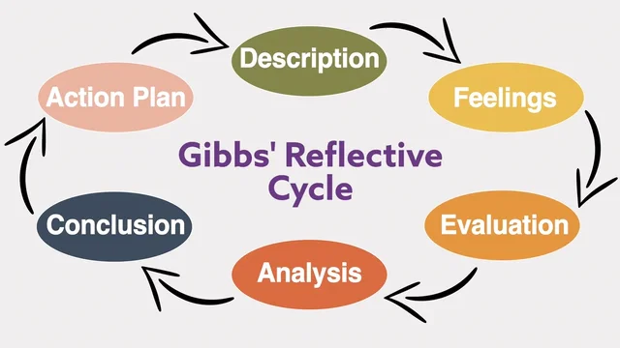
Figure 2: Gibbs reflective cycle to present placement experience in Clarion Hotel.
Source: (Fallon and Rutherford, 2010).
Description – The description is the first step which requires the description of the experience. The experience of the student log is a placement in Clarion Hotel’s food and beverage department (Fanthorne, 2004). Moreover, the position of the placement is a supervisory position to supervise the food and beverage department of Clarion Hotel. Mainly placement supports students in obtaining practical work knowledge so that the learner can work in a corporate and professional environment with confidence (Iverson, 2019). The term placement in a hotel means placing college or university students to obtain practical experience in managing activities of a hotel business (Wood, 2013). The placement was completed in Clarion Hotel where I worked as a supervisor for managing basic working duties like cleaning, refilling the stock and putting stock away, serving foods and beverages, taking payments and settling tables appropriately (Fallon and Rutherford, 2010). To develop the work-based knowledge of a supervisory position of working in a food and beverage department, I attended training at Clarion Hotel where my duty was serving beverages, and drinks, set tables, hoovering, organise rooms, learning to collect payments and so on during the placement at the hotel.
Feeling – The feeling is the second stage which requires describing the feelings of the individual during the experience. So, it was mixed feelings about me in the placement of working as a supervisor in the food and beverage department of Clarion Hotel (ASET, 2017). I was scared by thinking that the duties of a supervisor would be very tough and I would not be able to collaborate with the other members of the department. Yet, I was much happier because the co-workers were much more friendly, and supportive and the duties were explained by the manager very smoothly. I understood all my duties properly and completed the objective of the placement successfully.
Evaluation – The evaluation is the stage to determine which activity went well and which activity did not go well in the entire experience (UWTSD, 2019). Some activities of the placement working as a supervisor at Clarion Hotel were amazing as I learned the way of communicating with coworkers and customers in terms of taking food orders (Johnston, Clark and Shulver, 2012). I also learned the correct time of refilling stocks which improved my analytical skills. I have properly adopted the table setting and room cleaning duty as this experience supported me in developing my technological skills, organising skills and presenting skills. Another good part was I developed knowledge of placement and business activity of hotels (Johnston, Clark and Shulver, 2012). Yet, some activities did not go well which as learning to take payment from customers and wrongly calculating some of the bills which wasted much time of mine and the customers (Vallen, Vallen and Jerome, 2014). Also, I failed to manage complex guests and meet their guest service standards which resulted in me obtaining a low mark for learning the guest service. Also, another issue I identified is that the hotel management does not instruct them to wear hand masks and have them covered while attending to the customers. I also identified some hygiene issues in the cooking section. So, those were the good and bad parts of the placement in the Clarion Hotel.
Analysis – An analysis describes which activity could helped or hinder the situation. I think refilling the stock of food table setting, and room cleaning part went well as I had past knowledge of these works I used to stay in a hostel which made me handle my self-activity of refilling stock, leaning room and other stuff (Fallon and Rutherford, 2010). This activity impacted positively my placement to develop analytical, communication, technological, organizing and presenting skills in the form of the customer. Also, my team tasks, guest service and task management did not match with standard as I calculated wrongly some bills, was nervous about managing complex customers and it negatively impacted my placement experience at Clarion Hotel (Wood, 2013). Moreover, the hygiene issue was another reason why I failed to meet guest service standards as the cooking sections were a little less hygienic (UWTSD, 2019). So, this was a positive and negative area of the placement of Clarion Hotel.
Conclusion – The conclusion portion outlines drawing conclusions by analysing available options (Fanthorne, 2004). I think if I could wear a mask and cover my hair then I could handle my more efficiently to my complex customers. If I used a calculator then it would helped me to learn the correct bull payment within the shortest time. I could also research online about placement in a hotel and watch videos which would help me to complete my placement more efficiently (Vallen, Vallen and Jerome, 2014). I could also remain confident in the time of facing any guest which would support me in finishing the placement efficiently.
Action plan – This is the last step that highlights the plan based on the action to handle similar situations more efficiently next time. If I get the opportunity for placement net time, then I will use a calculator in the billing time (Hagg, 2013). I will also cover myself with a proper mask and cover my head to meet guest standards. I will also communicate with the management about the hygiene issue to develop the service of the Clarion Hotel. I will try to research online about hotel placement and watch videos on YouTube so that I can gather knowledge for placement and complete my placement successfully with a good grade (Johnston, Clark and Shulver, 2012). This will help me to develop time management, technical and critical thinking skills during the placement.

Conclusion
To sum up, the student log is covered on Clarion Hotel which started its journey in 1991. Clarion Hotel is a four-star hotel that has 7000+ hotels in 50+ states with 40+ territories and countries. The learning objective for the student is to develop communication, guest service, teamwork and personal skills. In the placement, the students completed the duty of refilling stocks, arranging tables and cleaning the room properly. Yet, billing and hygiene issues limit the learner to meet guest standards. If the learner used a calculator or hand mask then it would help the learner to obtain the desired skill and finish the placement successfully in the Clarion Hotel.

Reference list
ASET. (2017). Good Practice Guide for Workbased and Placement Learning in Higher Education, ASET, Sheffield
Clarion Hotel (2024) Clarion® Hotel by choice hotels – book on Official Site, Choice Hotels. Available at: https://www.choicehotels.com/clarion (Accessed: 22 February 2024).
Fallon, M. and Rutherford, D. (2010). Hotel Management and Operations, Wiley, London.
Fanthorne, C. (2004). Work Placements – Survival Guide for Students Macmillan, Basingstoke
Hagg, E. (2013). Internship Guide Eleven, The Hague
Iverson, C. (2019). Placement. AMA Manual of Style. https://doi.org/10.1093/jama/9780195176339.022.359
Johnston, R. Clark, G. and Shulver, M. (2012). Service Operations Management, Pearson, London
UWTSD. (2019). Quality Handbook Chapter 10, Carmarthen
Vallen, G.K. Vallen, and Jerome, J. (2014). Check-in check-out: managing hotel operations Ninth edition.; Pearson new international.,
Wood, R. (2013). Key Concepts in Hospitality Management, Sage, London

