Learning in the Digital Era
Assignment 2: Personal Development Plan (PDP)
Morgan Jones
2210512
Computer Games Design

Table of Contents

- Self-evaluation
- Personal Development Plan
- Learning to learn – Agile Learning
- Presentation

- Self-Evaluation

Strengths | Weaknesses
Time management | Academic literature
Artistic knowledge (anatomy, colour theory, perspective and 3D volumes) | Advanced sculpting knowledge (ZBrush)
Leadership | Retopology
3D ModElling Basic Knowledge (ZBrush) | Texture painting (Adobe substance painter)
Creativity (Game environments and character concepts) | Lack of self-confidence (work projects)

Strengths Summary:
I like to think that I have good time management skills. Whenever I am given a task I make sure that the work is completed well before the deadline to ensure I can get feedback and incase of any unpredicted circumstances that may prolong completing the task at hand.
I’ve always loved drawing as a hobby, but it wasn’t until 2019 I really wanted to expand on my artistic knowledge. To do this I studied hours of youtube tips and tutorials and then eventually I enrolled on to an online art school which really helped me build up my knowledge of the fundamentals of art.
Leadership is another strength that I’d like to include. Aside from university studies, I work as a delivery manager for a delivery network that cover 80% of South Wales. Strong leadership skills are required for such a key role in the fast-paced, ever-changing delivery business. I am also able to translate this skill into different scenarios in day to day life whether it’s a group project or an online team based video game.
I’ve recently gotten the hang of the basics in ZBrush, and I’d like to think that I have pretty good grasp of the basics; being able to sculpt an everyday object from a simple cube/sphere.
The final strength I’ve noted can go hand in hand with almost every other strength on the list (not just for concept design). After expanding my visual library through studies, I like to think that I have good creative skills. Whether it’s to help problem solve and help out with my leadership/time management skills; or if it’s used for creating concepts for models, drawings and environments.

Weaknesses:
Firstly I’d class academic literature as a weakness. What I mean by this is, when I’m writing an assignment I may sometimes come across as unprofessional by using “slang”. This isn’t done on purpose, it’s only when I properly get stuck into the work I sometimes forget that it is an assignment and that wording should be kept professional. I can combat this by reading over the work more than once and correcting any bad punctuations, replacing “slang” words etc, before submitting for feedback.
The next weakness would be advanced sculpting in ZBrush. As mentioned in the strengths I’d like to say I’ve familiarised myself with the basics of ZBrush, however there are quite a few brushes and tools that I haven’t learned about or used. This skill can be easily worked on by studying these features more as well as getting familiar with the feature and using them myself.
Another weakness for me would be my knowledge of retopology. I understand topology quite well and the concept of retopology, however I wouldn’t really know where to start. I know that retopology is done in programmes like Maya; however that is as far as my knowledge of the subject goes. Again I can study this through university resources or online tutorials to help understand this feature in programmes like Maya.
The next weakness that I’d like to work on is texture painting in programmes like Adobe substance painter. When I sculpt models in ZBrush, you are quite limited to actually placing coloured textures on to your model. But I’m aware that you can export a ZBrush model into Adobe substance painter and paint the model in this programme. Adobe substance painter is a industry standard programme which allows the user to paint on detailed textures to a model. I am yet to use this programme for myself; however, it is something that I will be working with in the near future as I’d like to familiarise myself with the programme.
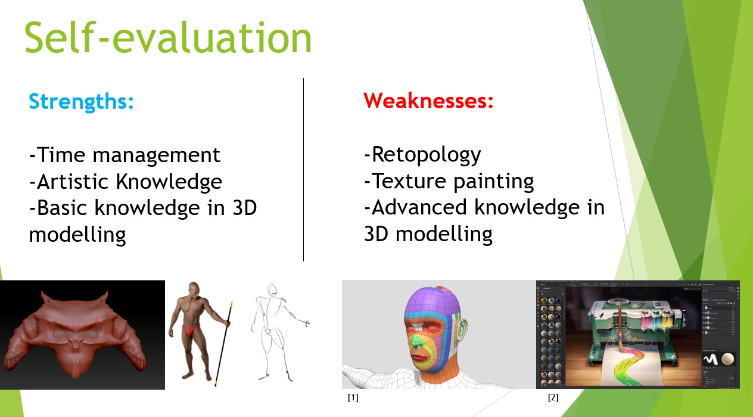
The final weakness on the list would be lack of self-confidence when it comes to work/personal projects. A lot of the times I may spend hours working on a drawing/model and sometimes I set my standards bar too high, so if I’m not confident that the work is good I’ll just delete the model/erase the drawing. This wastes a lot of time and resources, when really all I’d need to do is ask for feedback or tidy up the work/redo certain areas of the work.
- Personal Development Plan

Name: Morgan Jones Student Number: 2210512
Covering the period from: 01/11/2022 To: 31/04/2022
What do I want/need to learn or develop?  (Specific & Relevant) | What will I do to achieve this?  (Specific) | What resources or support will I need?  (Achievable) | What will my success criteria be?  (Measurable) | Target dates for review and completion  (Timebound)
The basics of how to use Adobe substance painter. | -University studies.  -Online courses.  -Online tutorials.  -Using the programme myself. | -Adobe substance painter.  -Internet sources (tutorials and guides from youtube, Reddit etc.)  -Advice from lecturers. | Once I have learned to use Adobe substance painter; my success criteria would be placing textures on models I have created in ZBrush. | 31/01/2022
How to correctly use retopology in Maya. | -University studies.  -Online courses.  -Online tutorials.  -Using the programme myself. | -Maya 2023.  -Internet sources (tutorials and guides from youtube, Reddit etc.)  -Advice from lecturers. | Once I have gotten a grasp on how retopology works, I will create a new mesh that simplifies the original high-resolution asset of one of my models from ZBrush. | 31/04/2022
Be able to quickly sculpt a basic character model in ZBrush as a foundation for a character. | -University studies.  -Online courses.  -Online tutorials.  -Using the programme myself. | -ZBrush.  -Internet sources (tutorials and guides from youtube, Reddit etc.)  -Anatomy studies.  -Advice from lectures. | Once familiar with some of the advanced tools in ZBrush; I will base my success on being able to create a basic foundation of a character (torso, head and limbs), with correct proportions within a couple of hours of work (2-4 hours). | 31/03/2022

Download Link (One Drive): https://1drv.ms/w/s!AqOa3EgICFJPjCB-P7XUm-Rb3O5d?e=sTGQtW

- Learning to learn – Agile Learning

My presentation will cover the topic “Learning to lean”, specifically Agile learning. First the presentation will cover my self-evaluation and my own personal development plan. After this I will cover Agile learning. This will include topics such as self-reflecting, feedback, anatomy of learning and a summary.
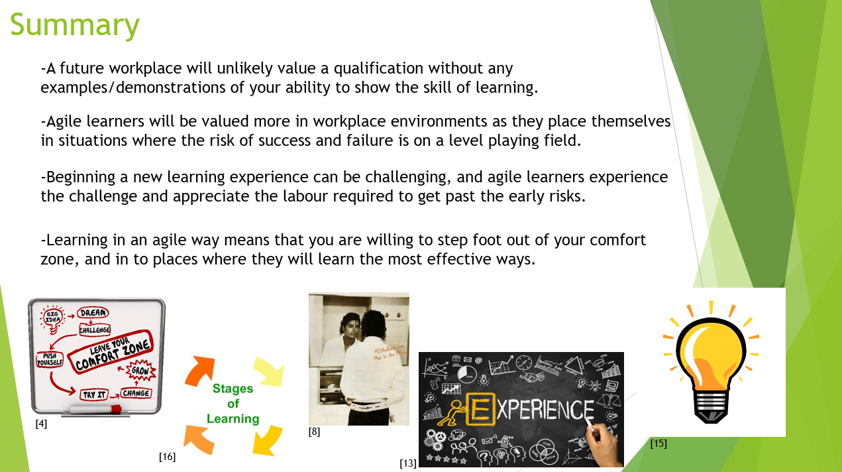

- Presentation
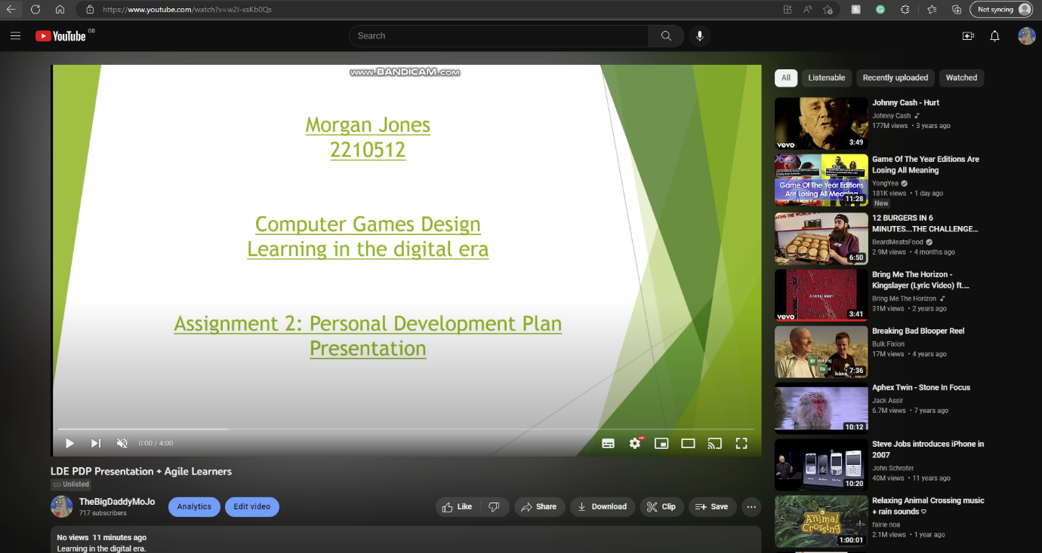
https://youtu.be/w2I-xsKb0Qs

Download Link (One Drive) https://1drv.ms/p/s!AqOa3EgICFJPjByeOLxZucObvcwN?e=CfxbSw
Presentation references:

[1] JaworenkoFollow, E. (1968) How to: V1 retopology for Animation - 3D model by Edward Jaworenko (@edwardmakesthings), Sketchfab. Available at: https://sketchfab.com/3d-models/how-to-v1-retopology-for-animation-05665d714d344253b992bc7e11869561 (Accessed: December 8, 2022).
[2] Substance 3D painter - substance 3D painter (no date) Substance 3D Painter | Substance 3D Painter. Available at: https://substance3d.adobe.com/documentation/spdoc/substance-3d-painter-20316164.html (Accessed: December 8, 2022).
[3] (no date) UWTSD moodle 2022/23: Log in to the site. Slide 5 Available at: https://moodle.uwtsd.ac.uk/mod/scorm/player.php?a=4471¤torg=unit_4_topic_1_ORG&scoid=9787&sesskey=JWaPJLS2kh&display=popup&mode=normal (Accessed: December 8, 2022).
[4] Pandey, R. (2020) Storytelling:creating narratives with data, Welcome to Vizartpandey. Available at: https://vizartpandey.com/art-of-storytelling/ (Accessed: December 8, 2022).
[5] MichaelKaregeannes (2019) Exercise is medicine, Treating TMJ. Available at: https://www.treatingtmj.com/treatment/exercise-medicine/ (Accessed: December 8, 2022).
[6] (no date) UWTSD moodle 2022/23: Log in to the site. Slides 2,3,5,7,8,14,22 Available at: https://moodle.uwtsd.ac.uk/mod/scorm/player.php?a=4471¤torg=unit_4_topic_1_ORG&scoid=9787&sesskey=JWaPJLS2kh&display=popup&mode=normal (Accessed: December 8, 2022).
[7] Leedsley (2020) Self-reflection: Moving beyond "I yam what i yam", Peoplethink. Available at: https://www.peoplethink.biz/self-reflection/ (Accessed: December 8, 2022).
[8] As I pull up the covers on... er... I meant collar...: Michael Jackson thriller, Michael Jackson Smile, Michael Jackson (2014) Pinterest. Available at: https://www.pinterest.com/pin/392024342537757200/ (Accessed: December 8, 2022).
[9] (no date) UWTSD moodle 2022/23: Log in to the site. Slides 8,9 Available at: https://moodle.uwtsd.ac.uk/mod/scorm/player.php?a=4471¤torg=unit_4_topic_1_ORG&scoid=9787&sesskey=JWaPJLS2kh&display=popup&mode=normal (Accessed: December 8, 2022).
[10] Jessica Steblyk Social Media and Content Strategist (2022) Implementing EEF feedback recommendations with Showbie and socrative, Showbie. Available at: https://www.showbie.com/implementing-eef-feedback-recommendations-with-showbie-and-socrative/ (Accessed: December 8, 2022).
[11] (no date) UWTSD moodle 2022/23: Log in to the site. Slides 24,25,26 Available at: https://moodle.uwtsd.ac.uk/mod/scorm/player.php?a=4471¤torg=unit_4_topic_1_ORG&scoid=9787&sesskey=JWaPJLS2kh&display=popup&mode=normal (Accessed: December 8, 2022).
[12] Anatomy of learning. - ppt download (no date) SlidePlayer. Available at: https://slideplayer.com/slide/14663919/ (Accessed: December 8, 2022).
[13] Farooquie, K. (2019) Sell an experience, not a product or a service, Medium. nextgenninja. Available at: https://medium.com/nextgenninja/sell-an-experience-not-a-product-or-a-service-cf51ab3e15bc (Accessed: December 8, 2022).
[14] (no date) UWTSD moodle 2022/23: Log in to the site. Slide 26 Available at: https://moodle.uwtsd.ac.uk/mod/scorm/player.php?a=4471¤torg=unit_4_topic_1_ORG&scoid=9787&sesskey=JWaPJLS2kh&display=popup&mode=normal (Accessed: December 8, 2022).
[15] Download free vectors, clipart graphics, Vector Art & design templates (no date) Vecteezy. Available at: https://www.vecteezy.com/free-vector/light-bulb-idea (Accessed: December 8, 2022).
[16] Stages (no date) The Peak Performance Center. Available at: https://thepeakperformancecenter.com/educational-learning/learning/process/stages/ (Accessed: December 8, 2022).

