13th December 2024
Luke Hunt (2220977)
Word Count: 2735
Prepared for: Rhodri Thomas
Construction Technology Report
Advanced Construction Technology (ACBA 6009)

Contents
1.0 - Executive Summary 2
1.1 - Introduction 2
2. 0 – Site restrictions and Off-Site Construction 3
2.1 – Site Conditions 3
2.2 – Off-Site Construction Types and Foundation suitability 3
2.3 – Innovative Construction Methods and Materials 4
2.4 – Case Study: Kings Road Swansea 6
2.5 – Offsite Construction conclusion 6
3.0 - Distinctive appearances 7
3.1 - Building Appearance 7
3.2 - Envelope types and suitability 8
4.0 - Methods of efficient heating and cooling (Passive and Active) 9
4.2 - Fire Safety and Intelligent Buildings 10
4.4 – Most Suitable System 11
5.0 - Evaluative Conclusion 12
6.0 - References 13
7.0 – Bibliography 16
7.1 – Foundation Types 17
7.2 – Borehole Logs of maritime Quarter 18
7.3 – Swansea Bay Campus construction 19
7.3 – Elevation/site location of Modular build in Swansea 20
7.4 – Material Envelope finishes 21
7.5 – Grenfell Case Study 23
7.6 – Fire Safety floor plans and elevations 24
7.7 – CIBSE Guidance – Ventilation 25

- Executive Summary
This feasibility report will aim to identify and examine some key considerations regarding a wealthy client’s interest in the construction of a block of luxury flats in the Maritime Quarter of the SA1 region in Swansea. This project will entail some distinct site-specific challenges, including the restricted nature of the location, and the incorporation of modern construction techniques in order to meet the clients’ expectations for unique architecture, sustainability and advanced building services. Such aspects will comprise of off-site construction, unique building envelope designs, efficient passive and active heating and cooling systems with reference to intelligent buildings, and innovative construction method and materials. Fire safety measures are also key components of the design for this project.

1.1 - Introduction
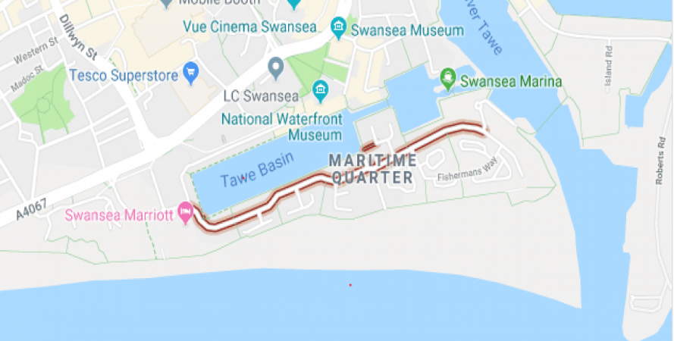
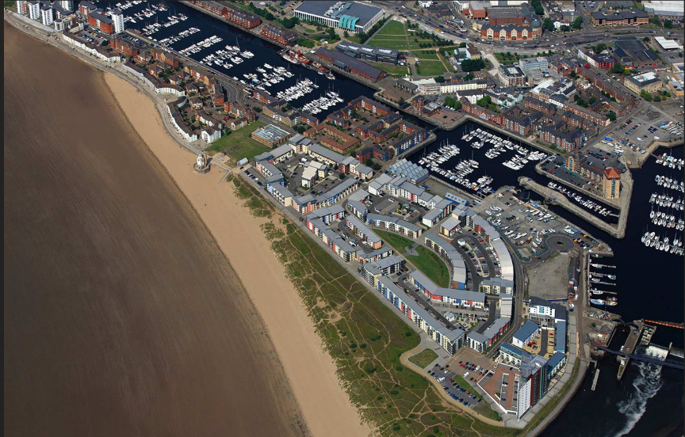
The Maritime Quarter is a newly flourishing and highly populated area in Swansea with a range of upcoming residential, commercial and recreational developments. Located near to the waterfront, it provides residents and new developments with much desired views and nearby amenities. However, due to building space constraints, the Maritime Quarter provides some logistical challenges for developers. The client has specified the need for a unique design that separates its distinction in appearance from the other buildings that surround it. This luxury development is to address and adhere to modern standards of sustainability and efficiency whilst incorporating innovative construction materials and methods. This feasibility report addresses such factors by outlining, explaining and evaluating suitable envelope types in order to justify all the choices made. Figures 1 and 2 below show a map and arial photograph of the desired location.
Figure 1 (Webb Aviation, 2024)
Figure 2 (Google, 2024)

2. 0 – Site restrictions and Off-Site Construction

2.1 – Site Conditions
The SA1 Maritime Quarter is an already dense and rapidly growing area for development. With its restricted access yet frequent use, there are challenging factors to be considered. Traditional on-site construction would come with insurmountable difficulties for such a unique and luxurious block of flats. It would require rapid erection with high-quality materials and finishes in order to meet the clients’ requirements. Therefore, off-site construction is key to the success of this project, allowing for large sections of the construction, appearance and services to be prefabricated whilst embedding sustainability and modern techniques into the building fabric.

2.2 – Off-Site Construction Types and Foundation suitability
Traditional methods of construction would require a large amount of space for materials and plant, whilst maintaining constant coordination of traffic and public in the highly populated area. It is therefore key to consider the use of off-site construction due to the restricted nature of this area. Identifying a certain type of off-site construction in the pre-construction phase will allow for the future planning of the superstructure and its foundation type. Below will identify various types off-site construction methods that can be considered for the superstructure and its foundation type. This will give the client a clear understanding of the choices being made for their project.

2.3 – Innovative Construction Methods and Materials
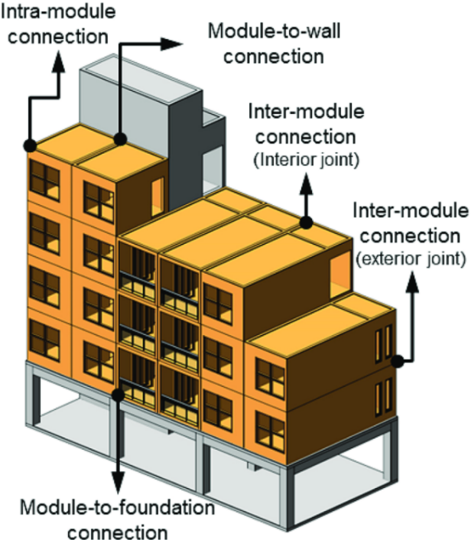
Volumetric Construction is the process whereby 3 dimensional units are built in a factory setting which provides primary quality assurance and control before being delivered and fixed into place on site – like building blocks. This type of construction can be built using timber, metal or concrete which can open opportunistic doors for sustainable and innovative methods and practices. The image to the right shows how this process is undertaken (The Constructor Building Ideas, 2021).
Modular Construction is similar to the Volumetric process; however, the key difference is that key components like services and utilities are prefabricated and ready for installation (National Construction Council, 2024).
Figure 3 (Research Gate, 2023)

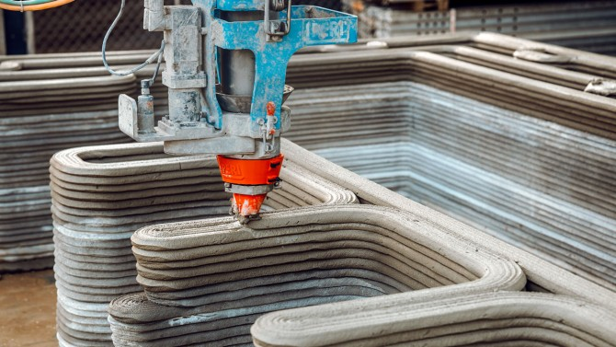
3D printing diverges slightly from the previously mentioned volumetrics. This is a process of automated layers of concrete to build up an outer cast. Not so popular in large buildings but a potentially successful and innovative building method, as mentioned by Bjorn Ter Haar in the journal, Automation in Construction (2023).
Figure 4 (Leslie Lok, 2022)

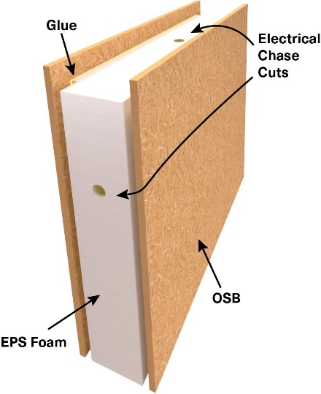
Panelised Construction is a more popular type of offsite construction which incorporates timber. One variation if this is SIPS, or Structurally insulated Panelling Systems. This is where a section of a building is built in factory settings to procure a high-performance structure, utilising innovative and sustainable methods and materials. A foam board is sandwiched between two pieces of board, in a design that allows it to be designed built and transferred onto site ready for erection (Structural Insulated Panel Association, 2024).

Figure 5 (Modern House Plans, 2024)

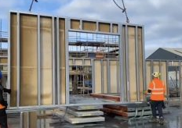
Panelised systems also include the use of steel which can provide strong yet light weight structures of a larger size (IntraStack, 2022). This will support the clients wishes for good sustainability and reduce the impact of onsite environment.

Figure 6 (Veitchi Frame, 2024)

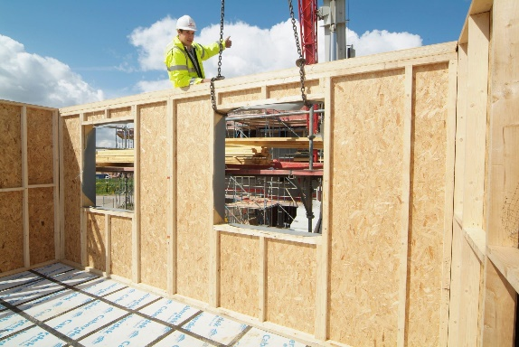
Timber frame is similar in that sections of a structure can be prefabricated in house, correct to the measurements for site, which provides a more sustainable and renewable approach to building. However, timber frame is not so great for large scale buildings such as flats, but is better suited to single, two or three storey houses (Lizzie, 2021).
Figure 7 (Built It, 2019)

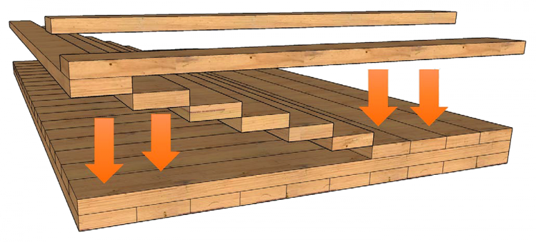
CLT, or Cross Laminated Timber is a prefabricated method of alternating lumbar timbers in a stack creating a durable structure for a building. It is sustainable and again is prefabricated offsite and ready made for site, with incredible thermal performance (Offsite Construction Network, 2023).
Figure 8 (Sterling, 2024)

In terms of foundations, there is a choice between, raft foundations, strip foundations, pile foundation and pad foundations, for more information please see bibliography on page 14 and 15.

– Case Study: Kings Road Swansea
The Kings Road in Swansea is home to many flats and university accommodations that rely on similar designs and use of innovative construction methods as the luxury building our client wishes to build. This case study gives an example of how this building could potentially develop, but improve efforts to reduce energy consumption, and maximise sustainability. The building in question used modular construction in order to develop this building and so demonstrates why this might be method of choice. The material choice was steel modules. These modules were prefabricated on site and then welded together once onsite. In terms of foundations, the building sits on pile foundations, like many of the buildings within the area. This is down to the nature of the substrata, the history and the location of the area. The borehole logs associated with this building are in the bibliography on page 17. Along with this information are the elevations of said building and google map images of its construction giving a clear picture of what modular construction looks like and how it can be altered for tailored use.

2.5 – Offsite Construction conclusion
In order to provide the most suitable option for the client, we must take into consideration the luxury, sustainability, location and innovation of the build. It has been identified that the client has no such limit on cost for the building. This helps us to look in the direction of good quality, which is what the client wants in terms of luxury. It also supports the drive for sustainable and innovative designs and construction methods. Furthermore, given the nature of the site location, it minimises disruption within the area.
Using steel modules as a method is a great because it creates a lightweight superstructure with plenty of space to build in services and fire safety systems. Having each module built in a quality-controlled environment allows for high performance systems, services and thermal performances to be integrated before use.
As mentioned in the case study, Pile foundations are the appropriate choice for this area. Not only does it follow suit with other buildings in the surrounding area, but it will offer the best support for such a large building.
Therefore, modular construction or Hybrid Construction is the way to go for this project. Hybrid Systems are a combination of Volumetric Construction and Panelised Systems. They allow for the be best of both methods to be use on a building, providing flexibility in terms of design and build of the superstructure (Offsite Builder, 2022). The design of each module can have good attention to detail, can be of good quality, and will reduce the space, and labour needed on site at any given time. Modular construction also factors in the potential for an innovate appearance envelope as a variation of facings can be used. Furthermore, modular construction is beneficial in that it reduces waste by up to 90%, saves up to 50% on time and introduces quality control (Exploring the Advantages and Disadvantages of Modular Construction, 2019).

3.0 - Distinctive appearances
The client has asked for the appearance of the building be distinctive and unique with the intention that it will stand out in the Maritime Quarter. Therefore, its building envelope is critical when it comes to the external walls, roof, windows and any cladding that may be used.

3.1 - Building Appearance
There are vast amounts of exterior building materials to chose from on a building such as this. But although this may be the case, the surrounding environment place a huge part in this decision. Due to the location of the building; on the seafront, it is crucial to consider some weather resistant materials to ensure longevity of the building, and to help maintain its unique and distinctive appearance. This subsequently narrows down the choices to a couple of options.
Materials include - Refer to pages 18 and 19 for images:
Concrete is a strong and durable building material ideal for the seafront, withstanding high winds, erosion, and saltwater exposure. While it may lack aesthetic appeal compared to traditional materials, it is cost-effective and energy-efficient due to its excellent thermal properties.
Glass enhances modern design by providing stunning views and abundant natural light. Advances in glass technology have made it more durable against coastal weather, though privacy concerns and heat gain should be considered in designs featuring large glass elements.
Steel is valued for its strength and structural integrity, making it ideal for luxury flats facing harsh winds and saltwater. While it may be more expensive initially, its longevity, non-combustibility, and performance in extreme weather make it a smart investment.
Cladding enhances a building's aesthetics, provides insulation for energy efficiency, and protects the structure from weather elements, extending its lifespan. It also offers sound insulation, requires low maintenance, and improves durability and weather resistance, especially with materials like metal, stone, or fibre cement ( buildingmaterialreviews.co.uk , 2023).
Render - Rendering a building near the seafront provides weather protection, enhances aesthetics, improves insulation, and requires low maintenance. However, saltwater can accelerate wear and tear, leading to potential damage, frequent maintenance, and higher initial costs. Poor application can also result in moisture issues inside the building (Paragon, 2021).
Many of the buildings around kings Road in Swansea and the Maritime quarter appear to have render or brick as an envelope type. This case study will identify why although render is a good choice to begin with, it doesn’t sit well in an environment with sea salt water and high winds. The building in this case study is the Great Hall in Swansea – Refer to page 19.

3.2 - Envelope types and suitability
The options above provide a good indication for the client as to how the building could look. However, as the client is looking for a distinctive, unique but luxury building. With this in mind, glass with cladding would give the client the best chances of achieving their goal. The glass would allow for hear gains which would benefit the intelligent building services while maintaining a luxury and modern, yet protective environment. Furthermore, the cladding would be a good aesthetic wrap to cover the rest of the building as it can be designed in many fashions and colours, whilst providing good, cost-effective and thermal properties.

4.0 - Methods of efficient heating and cooling (Passive and Active)
Building Services are another great way of maximising the sustainability of a building. The client has expressed interest in both passive and active methods for heating and cooling. The choice of system will need to be energy-efficient, cost-effective, and suitable for the luxury living environment. There are two types of heating and cooling systems, these are passive and active – Refer to page 23 for Information.
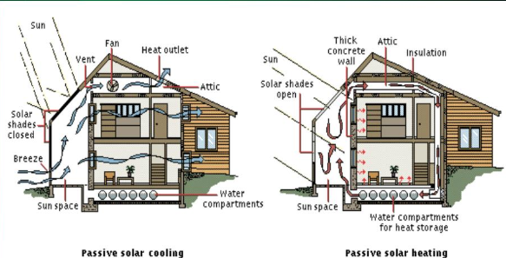
Passive Cooling and Heating systems use natural elements to cool or heat a building. Natural Ventilation is a cooling method that utilizes the flow of air through a building to cool spaces. In luxury flat developments such as ours, strategically placed windows, atriums, and vents would facilitate this airflow, ensuring that the building stays cool without relying on mechanical systems. Again, this relies on good design and engineering in the pre-construction phase and a quality build to ensure maximum performance (Shine, 2023).
Figure 9 (SolarEnergy, 2012)
Other methods include Solar Gain, a process whereby the orientation of the building is arranged to be out in the sun as much as possible, thereby passively heating the interior during colder months. For maximum gain, high-performance glazing should be utilised to capture and retain heat from the sun while minimizing heat loss.
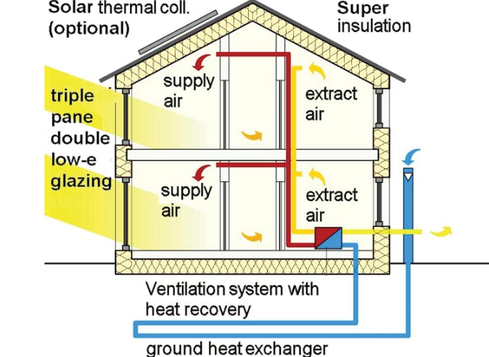
Active Heating and Cooling systems, however, rely on technology for maintaining comfortable temperatures. The Ground Source Heat Pumps use the stable underground temperature of the earth for heating and cooling buildings. These are very efficient and sustainable systems but involve a greater initial investment and space, as far as the bore holes are concerned. Air Source Heat Pumps alternatively, are more flexible and cost-effective. These systems provide both heating and cooling using external units. The installation of Air Source Heat Pumps is less demanding than that of Ground Source Heat Pumps, especially for urban areas where space is very limited (Moor, 2023).
Figure 10 (Beverly, 2020)
These systems may be good, but to ensure maximum performance and sustainability for the long term, it is necessary to marry these technologies up with the materials being used for the superstructure and building envelope. Ensuring the best performance glazing and insulation will ensure the best thermal performance of the building and make it that much more effective.

4.2 - Fire Safety and Intelligent Buildings
In any high-rise building, fire safety is of utmost importance. With previous incidents occurring over the years due to a lack of care taken when using materials and suitable methods of construction, it is paramount to ensure that this luxury block of flats has good fire safety measures – Refer to page 21 for Case Study. One way in which this can be achieved is by using intelligent building technologies. This is where advanced systems are put into place to mitigate any risks. The following points identify such ways in which to do this:
- Automatic sprinkler systems should be installed throughout the building, to help control fires quickly before they spread.
- Non-combustible materials such as concrete, steel, and fire-rated glass should be used in the construction of walls, floors, and ceilings to prevent the spread of fire.
- Advanced smoke and CO2 detection systems should be installed in all areas to ensure early warning in case of fire.
- The building should be designed with fire-resistant compartments to contain fires and prevent them from spreading across the structure (Gov.uk, 2022).
Each of the above points will mitigate risk of fire, but taking into consideration innovative methods and materials will mitigate it further. By using modular construction, for example, the building can be designed to take fire prevention methods, like compartmentalisation into account – Refer to page 22 for images.
Intelligent building models will further allow building control by automating these methods. By doing this, the design can cast out human error before construction has even begun.

4.4 – Most Suitable System
Due to the client’s financial situation, it is entirely possible to integrate the vast majority of systems mentioned above. By designing all the above into the building fabric prior to construction and spending time on ensuring the quality of engineering works is at peak performance, the building could become a completely intelligent building. A combination of Air Source Heat Pumps and solar panels would be ideal. The Air Source Heat Pumps system provides an efficient means of heating and cooling while being relatively easy to install in an urban environment. Coupled with solar panels to generate electricity for the system, this solution supports the client’s sustainability goals.
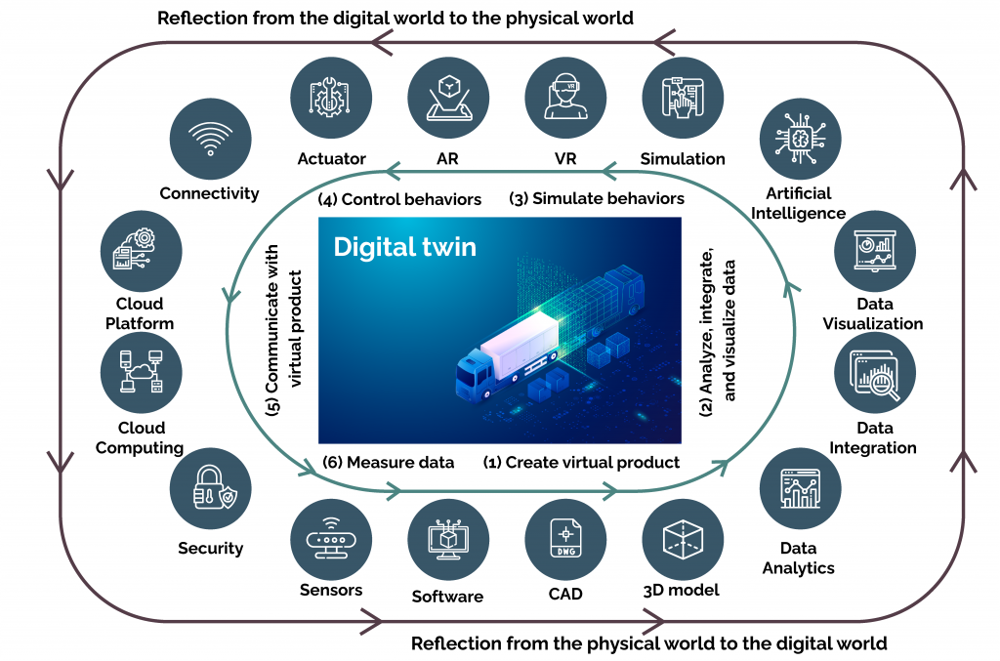
An intelligent system such that of a digital twin would completely revolutionise this building. By combining all of the above heating and cooling systems, fire safety systems, methods and materials, data could be collected and placed into a digital twin. This would allow the client or building itself to control the environment and comfort of the luxury flats without people having to intervene at all (hse.gov.uk, 2021).
Figure 11 (Radient, 2024)

5.0 - Evaluative Conclusion
After careful consideration, and thorough research, it is clear that modular construction is the way forward for the fabrication of this project. By combining the modular method with sustainable and innovative materials like glazing, cladding, and steel, will ensure that this building will achieve its aim of sustainability, cost-effectiveness and efficiency. The building will not only comprise of cutting-edge technologies like heating and cooling systems, but it will be distinctive in terms of architectural significance making it a landmark in the area. Furthermore, the choice of technologies, methods and materials will provide a safe environment where an intelligent building such as this will reduce the risk of fire hazards, whilst keeping thermal comfort at an optimum. All of this would provide a safe luxury block of flats as the client requested.

6.0 - References
buildingmaterialreviews.co.uk , 2023. Which Materials Are Preferred For Coastal Homes In The UK?. [Online]
Available at: https://buildingmaterialreviews.co.uk/which-materials-are-preferred-for-coastal-homes-in-the-uk/
[Accessed 9th December 2024].
Base 4, 2024. USING STEEL MODULES FOR YOUR MID- TO HIGH-RISE STRUCTURES. [Online]
Available at: https://www.base-4.com/modular-p4-steel-unit/
[Accessed 9th december 2024].
BBC News, 2019. Grenfell Tower: What happened. [Online]
Available at: https://www.bbc.co.uk/news/uk-40301289
[Accessed 10th december 2024].
Beverly, R., 2020. Designing a Passive House Means Putting Ventilation Front and Center. [Online]
Available at: https://www.achrnews.com/articles/143762-designing-a-passive-house-means-putting-ventilation-front-and-center
[Accessed 10th december 2024].
Bjorn Ter Haar, J. K. G. v. Z., 2023. Off site construction with 3D concrete printing. Automation in Construction, 152(1).
British Geological Survey, 2024. British Geological Survey. [Online]
Available at: https://mapapps2.bgs.ac.uk/geoindex/home.html?layer=BGSBoreholes
[Accessed 9th december 2024].
Built It, 2019. Timber Systems: A Tried & Tested Building Method. [Online]
Available at: https://www.self-build.co.uk/guide-to-timber-frame-construction/
[Accessed 7th December 2024].
CIBSE, 2015. Top Tips - Ventilation in Buildings (2015) (webpage). [Online]
Available at: https://www.cibse.org/knowledge-research/knowledge-portal/ventilation-in-buildings-top-tips?id=a0q20000006oamlAAA
[Accessed 10th december 2024].
dreamstime , 2017. Monolithic concrete high-rise building. Side view of the high-rise buildings made of reinforced concrete. [Online]
Available at: https://www.dreamstime.com/stock-photo-monolithic-concrete-high-rise-building-side-view-buildings-made-reinforced-image77738060
[Accessed 9th december 2024].
Exploring the Advantages and Disadvantages of Modular Construction, 2019. Exploring the Advantages and Disadvantages of Modular Construction. [Online]
Available at: https://www.hpdconsult.com/advantages-and-disadvantages-of-modular-construction/
[Accessed 9th December 2024].
Google Maps, 2014. Google Maps. [Online]
Available at: https://www.google.co.uk/maps/place/Fabian+Way,+Crymlyn+Burrows,+Skewen,+Swansea+SA1+8EP/@51.6191279,-3.8825963,700m/data=!3m1!1e3!4m14!1m7!3m6!1s0x486e8b2a86bbd419:0xf099f0ae01bb82a9!2sSwansea+University+Bay+Campus!8m2!3d51.6191246!4d-3.8800214!16s%2Fg%2
[Accessed 9th december 2024].
google maps, 203. google maps. [Online]
Available at: https://www.google.co.uk/maps/place/South+Quay/@51.6180023,-3.9277004,3a,90y,358.43h,105.31t/data=!3m7!1e1!3m5!1swBN87Hj6kgPYFg1lvm54Tg!2e0!6shttps:%2F%2Fstreetviewpixels-pa.googleapis.com%2Fv1%2Fthumbnail%3Fcb_client%3Dmaps_sv.tactile%26w%3D900%26h%3D600
[Accessed 9th december 2024].
Google, 2024. Maritime Quarter. [Online]
Available at: https://www.google.co.uk/maps
[Accessed 24th November 2024].
Gov.uk, 2022. Approved Document B (fire safety) volume 2: Buildings other than dwellings, 2019 edition incorporating 2020 and 2022 amendments. [Online]
Available at: https://www.gov.uk/government/publications/fire-safety-approved-document-b
[Accessed 10th december 2024].
hse.gov.uk, 2021. Thermal comfort. [Online]
Available at: https://www.hse.gov.uk/temperature/thermal/
[Accessed 10th december 2024].
IntraStack, 2022. IntraStack. [Online]
Available at: https://www.intrastack.co.uk/
[Accessed 07th December 2024].
Leslie Lok, S. Z., 2022. First-of-its-kind 3D-printed home blends concrete, wood. [Online]
Available at: https://news.cornell.edu/stories/2022/09/first-its-kind-3d-printed-home-blends-concrete-wood
[Accessed 08th December 2024].
Lizzie, 2021. Offsite timber frame manufacture: the pros and cons. [Online]
Available at: https://tasarchitects.co.uk/design/offsite-timber-frame-manufacture-the-pros-and-cons/
[Accessed 7th December 2024].
Medium, 203. Deep Pile Foundations. [Online]
Available at: https://medium.com/@solidearthtech/deep-foundation-pile-1517bfda628c
[Accessed 9th december 2024].
Modern House Plans, 2024. Modern House Plans. [Online]
Available at: https://www.smallhousecatalog.com/blog/structural-insulated-panels-sips-transforming-modern-construction
[Accessed 07th December 2024].
Moor, T., 2023. HVAC. [Online]
Available at: https://www.hvac.com/expert-advice/heat-pump-pros-and-cons/
[Accessed 10th december 2024].
National Construction Council, 2024. Off-Site Construction Methods and The Benefits They Offer. [Online]
Available at: https://www.ncc.org.uk/builders/off-site-construction-methods-and-the-benefits-they-offer/
[Accessed 7th December 2024].
Offsite Builder, 2022. The Final Word: Hybrid construction is the future of offsite. [Online]
Available at: https://offsitebuilder.com/the-final-word-hybrid-construction-is-the-future-of-offsite/
[Accessed 8th December 2024].
Offsite Construction Network, 2023. What Is Cross-Laminate Timber?. [Online]
Available at: https://offsiteconstructionnetwork.com/cross-laminated-timbers/
[Accessed 7th December 2024].
Paragon, 2021. Pros And Cons Of Rendering. [Online]
Available at: https://paragontools.ie/2021/11/30/house-rendering-pros-and-cons/
[Accessed 9th December 2024].
Pinterest, n.d. Pinterest. [Online]
Available at: https://uk.pinterest.com/pin/461548661783823236/
[Accessed 9th december 2024].
Radient, 2024. Digital Twin - Converging the Virtual and Physical worlds to Accelerate Transformational Innovation. [Online]
Available at: https://www.radiant.digital/digital-twin-converging-the-virtual-and-physical-worlds-to-accelerate-transformational-innovation/
[Accessed 10th december 2024].
Research Gate, 2023. Research Gate. [Online]
Available at: https://www.researchgate.net/figure/Connection-systems-in-a-volumetric-building_fig1_370182135
[Accessed 07th December 2024].
Roofing Today, 2020. Replacement of Dangerous Cladding on High Rise Homes Too Slow. [Online]
Available at: https://roofingtoday.co.uk/replacement-of-dangerous-cladding-on-high-rise-homes-too-slow/
[Accessed 9th december 2024].
Shine, E., 2023. Attainable Home. [Online]
Available at: https://www.attainablehome.com/pros-and-cons-of-passive-houses-worth-it/
[Accessed 10th december 2024].
SolarEnergy, 2012. Slideserve. [Online]
Available at: https://www.slideserve.com/allison/team
[Accessed 9th december 2024].
Sterling, 2024. CLT (Cross-Laminated Timber) Mats 101. [Online]
Available at: https://www.sterlingsolutions.com/blog/clt-mats-101-cross-laminated-timber/
[Accessed 7th December 2024].
Structural Insulated Panel Association, 2024. What are SIPs?. [Online]
Available at: https://www.sips.org/what-are-sips
[Accessed 07/12/24 December 2024].
The Constructor Building Ideas, 2021. What is Offsite Construction. [Online]
Available at: https://theconstructor.org/building/offsite-construction-features-methods/38319/#google_vignette
[Accessed 7th December 2024].
UWTSD, 2024. Kings Road. Swansea: University Lecturer.
UWTSD, 2024. Kings Road. Swansea: Univrsity Lecturer.
UWTSD, 2024. Kings Road. Swansea: University Lecturer.
Veitchi Frame, 2024. Lightweight Steel Framing. [Online]
Available at: https://www.veitchiframe.com/lightweight-steel-framing/
[Accessed 7th December 2024].
Webb Aviation, 2024. Webb Aviation. [Online]
Available at: https://www.webbaviation.co.uk/aerial/picture.php?/28567
[Accessed 24th November 2024].

7.0 – Bibliography

7.1 – Foundation Types
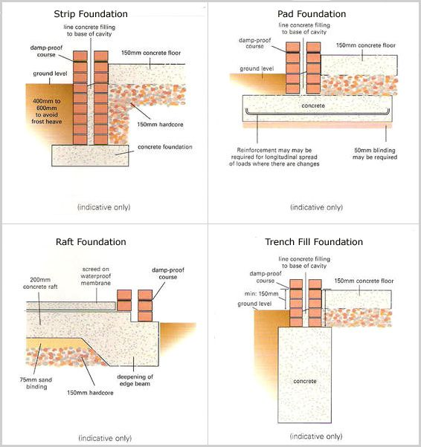
Below are the different types of foundations, for the clients information
Figure 12 (Pinterest, n.d.)

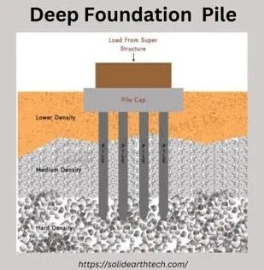
Figure 13 (Medium, 203)

7.2 – Borehole Logs of maritime Quarter
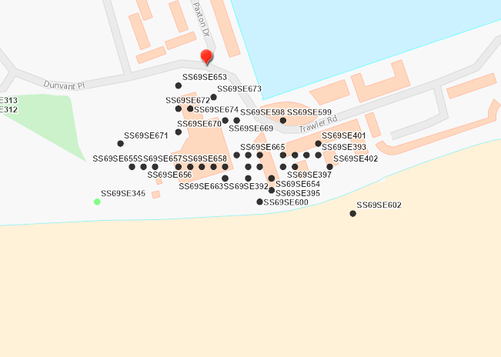

Figure 14 (British Geological Survey, 2024)

As can be seen from this borehole log from British Geological Survey, borehole logs have been done all over the Maritime Quarter. This shows the buildings that most likely have piles as foundations in the area, giving good reason for this choice.

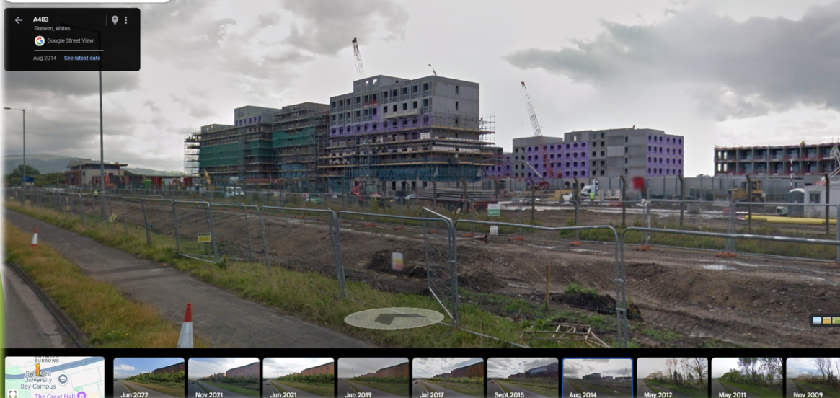
7.3 – Swansea Bay Campus construction
Figure 15 (Google Maps, 2014)

This image shows part of the Swansea Bay Campus being constructed using modular construction methods. This is another visual for the client to show how their building may look using this method.

7.3 – Elevation/site location of Modular build in Swansea
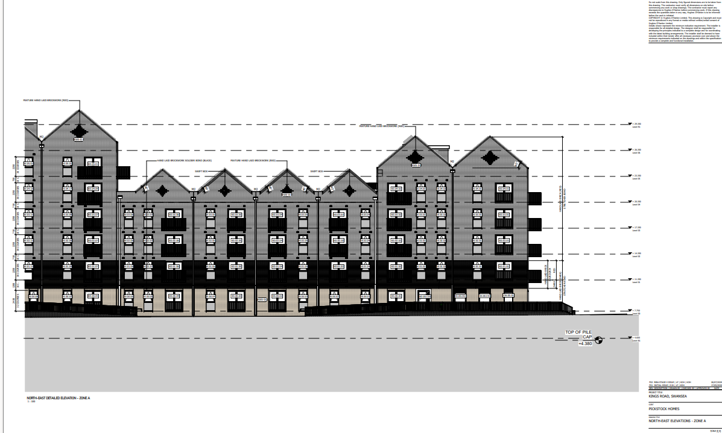
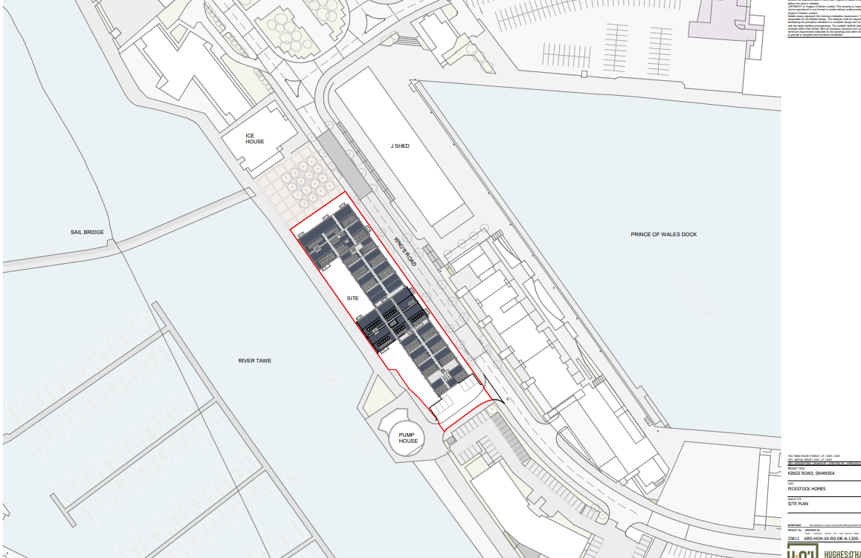
Figure 16 (UWTSD, 2024)
Figure 17 (UWTSD, 2024)

7.4 – Material Envelope finishes
Below are examples of various envelope types as mentioned above:
Concrete:
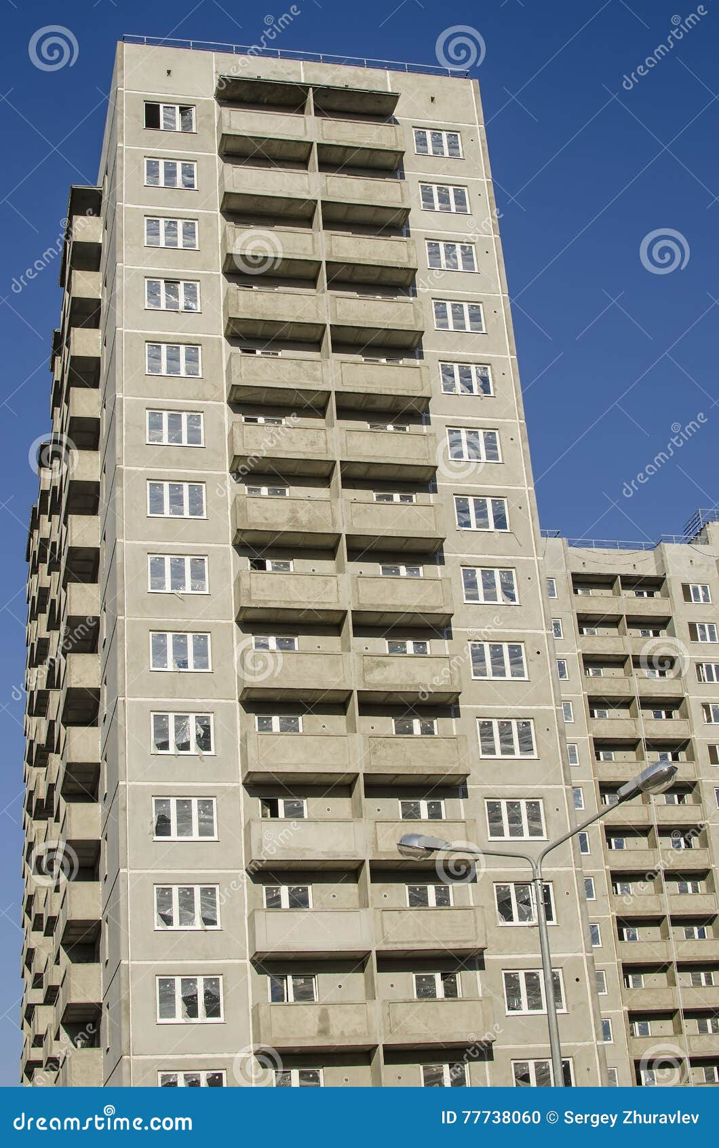

Figure 18 (dreamstime , 2017)

Glass:
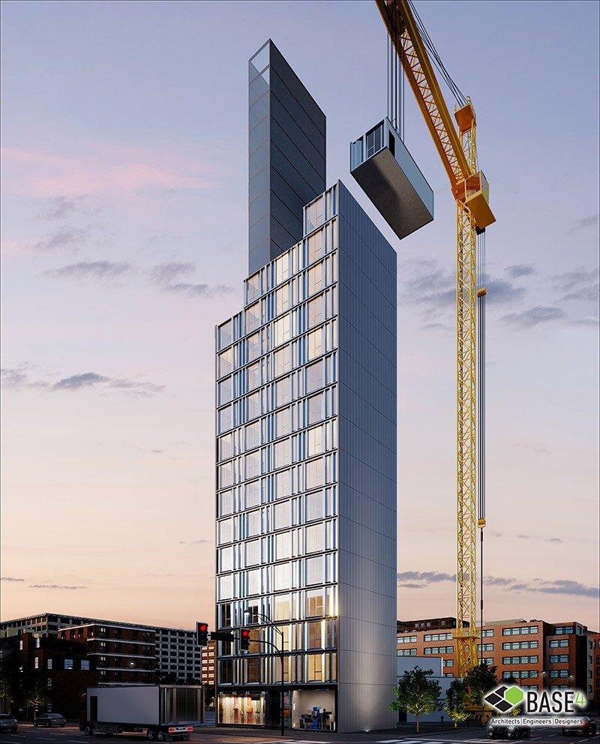

Figure 19 (Base 4, 2024)

Cladding:
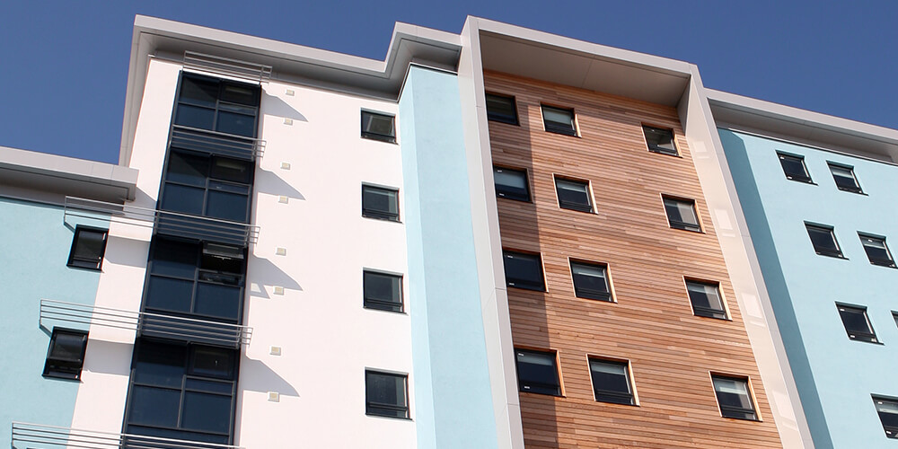
Figure 20 (Roofing Today, 2020)

Render:
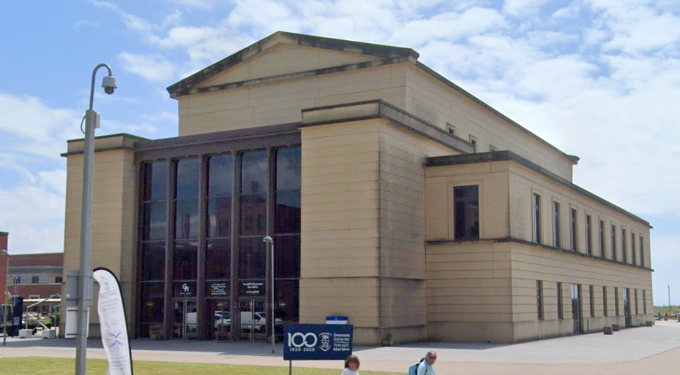
This shows the Great Hall in Swansea – you can see the weathering on the block work even though the building is only a few years old.
Figure 21 (google maps, 203)

7.5 – Grenfell Case Study
The Grenfell Tower fire, which occurred on June 14, 2017, in London, is one of the deadliest fires in recent UK history. The 24-story residential building, which housed predominantly low-income families, was engulfed in flames after a malfunction in a fridge freezer. The fire spread rapidly due to the cladding system installed on the building, which included flammable material. The cladding, made of aluminium composite material (ACM) with a flammable polyethylene core, played a significant role in the fire's rapid spread, despite previous warnings about its fire risks.
The fire claimed 72 lives, injured many others, and caused significant trauma to the local community. The disaster highlighted major issues with building regulations, particularly around fire safety, materials used in construction, and the lack of adequate safety measures in social housing. In the aftermath, there were calls for stricter building regulations and a nationwide review of cladding materials. The tragedy also sparked ongoing discussions about social inequality, housing conditions, and government accountability. The Grenfell Tower Inquiry was launched to investigate the causes and provide recommendations for preventing similar incidents in the future (BBC News, 2019).

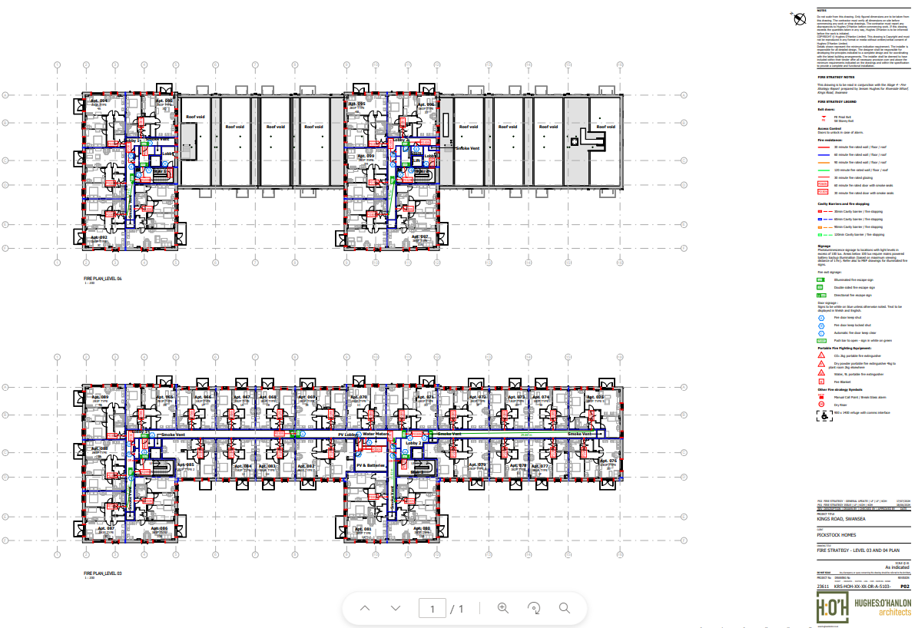
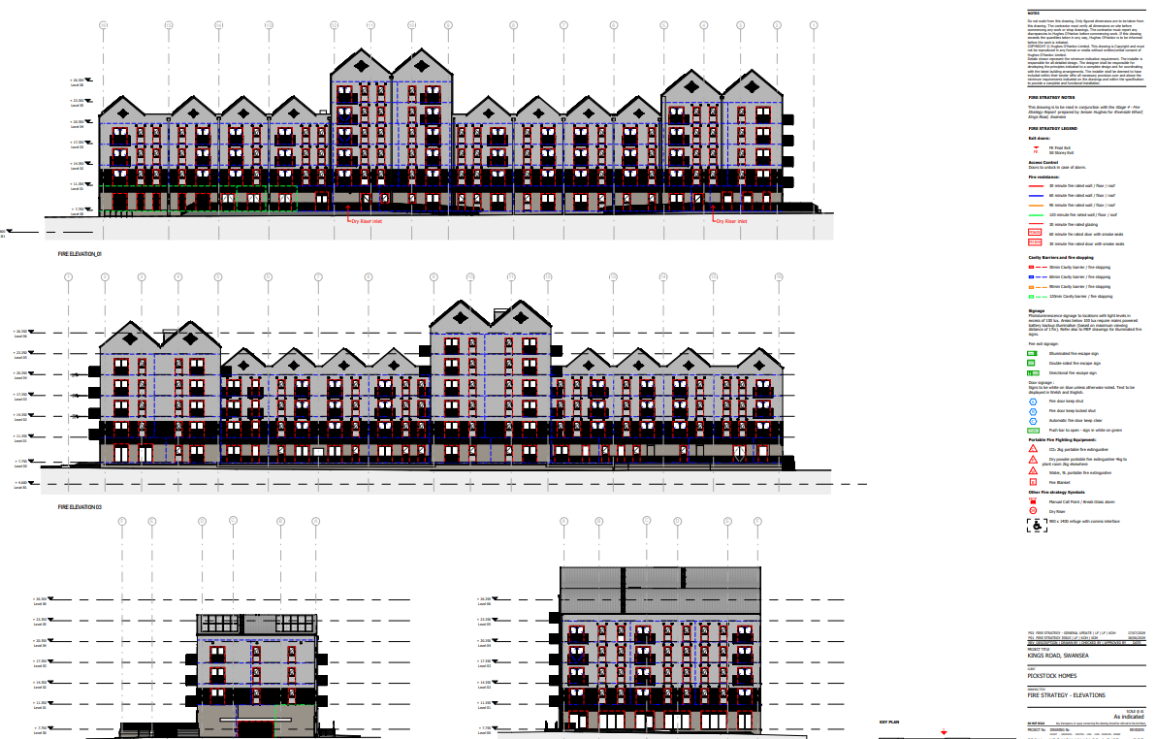
7.6 – Fire Safety floor plans and elevations
Figure 23 (UWTSD, 2024)
Figure 22 (UWTSD, 2024)

7.7 – CIBSE Guidance – Ventilation
CIBSE, 2015. Top Tips - Ventilation in Buildings (2015) (webpage). [Online]
Available at: https://www.cibse.org/knowledge-research/knowledge-portal/ventilation-in-buildings-top-tips?id=a0q20000006oamlAAA
[Accessed 10th december 2024].

