Module Name-Hotel Placement Research Project 6008
Student Name-Ana Ndreka
Student ID-2118393

Abstract
Global staff shortage is a critical challenge which directly impacts the operations of a business. This study has talked about staff retention strategies adopted by Ibis Chesterfield North along with challenges and their potential solutions. Organizations need to detain their best employees to enhance their brand reputation to retain deserving employees in the workforce. Organizations always stay focused on developing employee retention strategies to mitigate any risks related to employee turnover. Companies that do not rely on strategies might face challenges. Employee lifecycle has been aligned to reflect its importance to companies while retaining their employee base. Besides that, other strategies have been pointed out, that are often used by the hotel sector to retain employees in an impactful manner. Along with that, secondary qualitative research has been conducted in this research in which multiple literature sources such as books, articles and journals have been analysed. The descriptive information of Ibis Chesterfield North has been explained in the report. Along with that, a SWOT analysis of this company has represented its strengths and weaknesses of the company. Based on this, potential opportunities as well as threats of Ibis Chesterfield North have been identified. However, PESTLE and competitor analysis has been included as another section of the report. Ibis Chesterfield North should gain a wide range of innovative strategies to improve its employee retention activities. They can focus on the personalized developed plans for each workforce that should be considered with their skill gaps and career aspirations. The global hospitality brands face disruptions in implementing the strategies of retaining their staff. The report has covered the workplace related challenges that are faced by Ibis Chesterfield North. Along with that, high expenses of training are another challenge for the company that has been demonstrated. The compensation issue of the employees in Ibis Chesterfield North has been elaborated in this report. Modern businesses have to establish an effective range of techniques to increase the skills related to their employees by providing an immense range of training options to them. It can also help them to provide more significant value during the completion of any kind of complicated project. Finally, summarising the whole research, the researcher has highlighted some key findings of the study. Along with that, for effective staff retention strategies, Ibis Chesterfield North has been suggested key tactics to increase the effectiveness of its staff retention policies and reduce turnover. At the end of the study, the researcher demonstrated the experience during the research process using reflective writing.

Table of Contents
Introduction 6
Research Background 6
Research Rationale 6
Research Aim and Objectives 6
Research Questions 7
Literature Review 8
Introduction 8
Identification of the key strategies of hotel businesses in terms of employee retention 8
Analysis of the challenges that the hotel sector faces while leveraging retention strategies within the context of global staff shortage 9
Evaluation of the strategies that the hotel sector can use to overcome challenges 10
Literature Gap 11
Summary 12
Methodology 13
Research Design 13
Data Collection Methods 13
Data Analysis 14
Materials and Instruments 14
Procedure 14
Ethical Considerations 14
Limitations 15
Case study of Ibis Chesterfield North 16
Descriptive Information 16
Key Analysis 17
Technical Factors 20
Thematic Analysis and Findings 25
Thematic Analysis 25
Discussion for Improvements 34
Conclusion and recommendation 35
Conclusion 35
Recommendation 35
Future Implication 37
Reflective Writing 38
References 41

Introduction

Research Background
Staff shortage is a critical challenge that businesses must come across in their business operation. Businesses develop various forms of strategies and policies to increase their employee retention and address issues related to employee shortage (Cottrell, 2014). In an industry like hospitality where customer service is foremost important, the role of staff retention strategies is very vital. Henceforth, this research will aim to examine the impact of global staff shortage on employee retention strategies of hospitality businesses. For better and more practical understanding, a case study of Ibis Chesterfield North will be drawn which will provide precise information.

Research Rationale
The issue of global staff shortage has been growing at a rapid pace and is affecting businesses all around the world. As per the data by Statista, in the last six years, around 80% of businesses in the United Kingdom have been affected by global staff shortages (statista, 2024). This issue certainly has affected the hospitality industry. Thus, this research will aim to evaluate the impact of global staff shortage in the hospitality industry. This will give an insight into staff shortage issues and will help understand strategies adopted by big hospitality businesses like Ibis Chesterfield North.

Research Aim and Objectives
Aim
To investigate the impact of global staff shortage on the employee retention strategies of hospitality businesses: A case study of Ibis Chesterfield North.
Objectives
1. To identify key strategies of Ibis Chesterfield North in terms of employee retention.
2. To analyse the challenges faced by Ibis Chesterfield North while implementing staff retention strategies in the context of global staff shortage.
3. To evaluate strategies that Ibis Chesterfield North can use to address challenges associated with staff retention strategies considering global staff shortage.

Research Questions
1. What are the key strategies of Ibis Chesterfield North in terms of employee retention?
2. What kind of challenges does Ibis Chesterfield North face while implementing staff retention strategies in the context of global staff shortage?
3. What sort of strategies can Ibis Chesterfield North use to address challenges associated with staff retention strategies considering global staff shortage?

Literature Review

Introduction
Employee retention is one of the effective strategies and especially, in the competitive and fast-moving marketplace for the labor industry, leveraging employee retention strategy is crucial. This literature context will highlight the efficacy of maintaining strong staff retention strategies within the context of staff shortages (Wren, 2020). Challenges that the hotel sector faces while leveraging retention strategies will be analyzed. Furthermore, some strategies will be pointed out, through which business can mitigate their issues effectively.

Identification of the key strategies of hotel businesses in terms of employee retention
Recently, various reports on employee engagement have revealed that many staff from the hotel sector have left their current job due to inadequate salaries, poor work-life balance and many more (Gelencsér et al., 2023). Therefore, to avoid the circumstance, various hotel sectors have followed effective employee retention strategies, which are described in the below section.
Competitive salaries
Competitive salary is one of the crucial variables that many hotel industries adopt to generate regular income for the employees to lower their reluctancy from the job tasks. As per Saks (2022), competitive salaries based on the work efficacy of the staff attract the eye of the employees to retain top employees in the workforce.
Following a hybrid work mode
According to Staniec and Kalińska-Kula (2021), doing the same work in a similar way in daily life can be boring and for this reason, many companies leave their jobs. Working from the office might be good for maintaining a strong communication chain but offering work-from-home facilities helps employees to maintain their lives while working in the same company. This strategy is used by various hotel sectors to retain their employee base effectively.
Reward and recognition
As opined by Riyanto et al. (2021), Reward and recognition are considered a form of appreciation that companies provide to specific employees, who put effort into job tasks. Giving respect in the name of rewards to employees allows them to boost their confidence level in the job field. Therefore, they start to believe in their growth in the same company.

Analysis of the challenges that the hotel sector faces while leveraging retention strategies within the context of global staff shortage
Employee retention is the foremost factor that allows companies to avoid staff shortages within the workforce to safeguard the company’s brand standard (Schulz, 2024).
Toxic work policies
Many hotel sectors in the UK follow an autocratic leadership style to control their workforce negatively, which lowers the chances of employee retention significantly. Employees are the backbone of the firm and without understanding their preferences, the entire business performance of the companies might not be maximized. According to Verčič (2021), toxic work policies hamper the minds of the employees, which force them to leave their current workforce.
Lack of appreciation
Companies that do not appreciate their employees for their hard work and efforts might not be successful in holding their employees for the long term in the context of business dealings. According to Kim and Kim (2020), Sometimes, top authorities in the hotel sector get busy with the aspect of increasing profitability and the brand reputation without appreciating their employee base. As a result, employees feel frustrated and decide to give up on the specific companies.
Finding better opportunities elsewhere
As directed by Moore and Hanson (2022), the hotel industry is dynamic and employees while doing their work in a company might switch to another company. This switching of jobs is often to get benefits like appropriate salaries, wellness initiatives and others. Sometimes, the alternate hotel companies provide a lot more effective options for employees. Therefore, choosing the specific companies cannot be difficult for them, which further hampers the business reputation negatively.

Evaluation of the strategies that the hotel sector can use to overcome challenges
Understanding the Employee life cycle
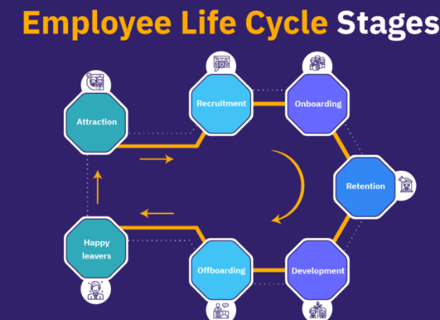
Figure 1 Employee life cycle
Source: (Ibis, 2024)
As per He et al. (2021), understanding the employee lifecycle is important to enhance the clarity of the business objectives effectively. Seven stages of the employee lifecycle must be followed and understood to understand their preferences. This includes attraction, recruitment, onboarding, retention, as well as development, offboarding and happy leaves. After attracting the minds of the employees through recruitment, companies must retain their employee base by choosing appropriate strategic methods. Developing several opportunities for employees to help them gain new expertise can support companies in managing their employee base. After that, managing the entire process with a positive mindset while employees leave is also important for businesses to maintain a standard. This includes taking feedback from the employees, providing certificates and others to make their employees happy and satisfied while leaving their jobs.
Employee training and development
Employee training and development is another core resource that can allow the business to enrich the knowledge of its personnel effectively. As per Catlett (2024), sometimes employees have less knowledge and ideas about their field but still, they expect appreciation and incentives for their work. Therefore, in this situation, companies can provide and arrange training sessions for them, so that they can recognize the effective strategies that they should be applied to enhance their future.
Understanding their preferences
As per Samašonok (2024), understanding the preferences of the employees helps companies establish an effective plan. Companies can retain more and more employees who will be deserving candidates towards the workforce by understanding their demands. The more employees will be listened to and valued, the more the hotel sector can detain employees in an impactful manner.

Literature Gap
This portion of the context has identified various gaps in the entire research. As per Catlett (2024), the hotel industry can lower the chances of high employee turnover by providing efficient training to employees, who have less idea about the hotel sector. This will help to uplift their knowledge. Conversely, as per Verčič (2021), autocratic leadership is not prioritized by employees in the workforce and they can switch their jobs at any time after dealing with some negative circumstances. Therefore, it can be assumed that only effective training will not be a beneficial strategy to retain employees, companies should look upon their leadership strategies to change the texture of the workforce. Further research has been carried out to clear up the conception of employee retention strategies.

Summary
This context has highlighted some effective retention strategies for employees to shape the business texture positively in the marketplace. In today’s competitive business world, the hotel sector needs to understand the algorithm to keep their employees in the workplace. Various negative challenges have been explored such as finding better opportunities, lack of proper appreciation and others. Furthermore, strategies have been recommended and the literature gaps have been revealed based on the above context.

Methodology
Methodology is an essential step to be conducted in research in a systematic and justified way, that presents the core beliefs and assumptions of the researcher during the conduction of the research study. Therefore, the methodological background of this research project is mentioned below by exploring the elements of the research proceedings.

Research Design
Research design normally refers to the strategy and the framework that a researcher significantly uses for conducting the study. A wide range of research designs are presented for conducting the research project in a justified way including the phenomenological, ethnographic, grounded theory, case study research and many more (Saunders et al., 2012). The researcher has selected a case study of Ibis Hotel to complete this research project in a rational manner. The researcher's beliefs about knowledge and reality along with the researcher's disciplinary area have been illustrated in this section.

Data Collection Methods
Data collection activities and initiatives become an essential aspect of completing research work in a rational manner. Based on the collected data, the researcher analyses the findings and simultaneously extracts the major relevant information from the research activities (Veal, 2006). The researcher has only collected the secondary data and information to complete this research work and therefore based on Google Scholar all the relevant data and information have been collected within this research work.

Data Analysis
A research project significantly seeks a deep analysis of the collected data which helps the researcher to increase the quality of the research report. All the secondary data have been analyzed through a qualitative approach, where secondary thematic analysis has been conducted to align a better quality within the research work (Ocaña-Fernández and Fuster-Guillén, 2021). On the contrary, through analyzing all the relevant data through viable information has been gained that helped the researcher to present a significant research project.

Materials and Instruments
Qualitative research materials have been utilized within this research work as the information regarding employee retention within a business is considered as the qualitative resource. Research instruments are also considered an important element which presents the ultimate validity of the research activities (Habu and Henderson, 2023). Thus, Google Scholar is being utilized as the research instrument within the proceedings of the research project.

Procedure
All the research activities have been conducted in a systematic and steady manner which presented the improved quality of the research activities. As the ethical angles and academic integrity have been followed justifiably within this research work, this research project can reflect increased reliability and validity.

Ethical Considerations
Ethical consideration within a research work significantly displays the exploration of all the ethical angles and ethical proceedings to complete the research work justifiably (Dzwigol, 2022). Contextually, it can be highlighted that the researcher has completed this research work by following all the rules and regulations in a justified manner. Instructions given by the module leaders, class lecturers and university teachers have also been aligned within this research work.

Limitations
The only limitation of this research work that could be optimized is if the researcher conducted this research through a mixed research method instead of a mono research method. Incorporation of the mixed research method could be more effective in gathering major relevant data within the mentioned research context in this research project.

Case study of Ibis Chesterfield North

Descriptive Information
The well-known vibrant economy hotel Ibis Chesterfield North operates successfully within the market with the cooperation of parent organisation Accor Brand. The purpose of this organisation is to deliver affordable hotel services with additional facilities to the wide range of guests. Some examples of extra services of this hotel include on-site car parking, charging stations for EVs, private bathrooms, wireless internet accessibility, airy bedrooms with Freeview TVs, delicious foods and many more. Ibis Chesterfield North has introduced different intensified prevention and hygiene measures for ensuring safety of the guests as well as staff. The ALLSAFE label of this organisation depicts newly implemented cleanliness protocols and necessary standards. It has more than 5,584 hotels across 110 nations.
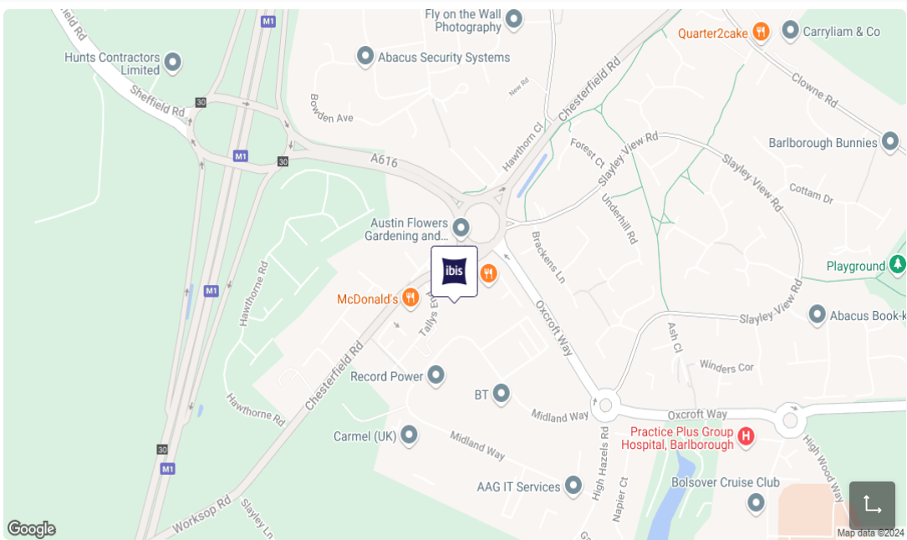
Figure 2 Location of Ibis
Source: (accor, 2024)
It is situated within 16 km distance from Sheffield Doncaster Airport and 12 km from Chesterfield railway station. Ibis hotel is in Barlborough, an attractive little village around five miles far from the centre of Chesterfield. The distance between this hotel and junction 30 of the M1 Motorway is less. The consolidated revenue of the parent hotel group of Ibis in 2024 is recorded as £2.23 million, which is around 11% more than the past year. The Accor group has employed more than 3,30,000 talents to deliver authentic and excellent experiences to customers and connect the entire world (accor, 2024). This hotel brand is committed to providing value to all stakeholders, and partners and ensuring the well-being of the communities and planet while offering reasonable and exceptional services to the customers and clients.

Key Analysis
SWOT analysis
Strengths | Weaknesses
1. Brand reputation: Ibis Chesterfield North has become a remarkable and well-established brand for its appropriate location, exclusive offerings, affordable accommodation packages and others. Being part of Accor Hotel Group, the company is aimed at delivering outstanding services to the customers and maintaining customer loyalty (accor, 2024). The extensive range of services such as accommodation, food and other services with reliability allows this brand to maintain its reputation and goodwill in the UK market.  2. Competitive pricing: It is one of the notable advantages of the hotel brand. The affordable rates of hotel rooms and other essential hospitality services helps the company to appeal to the price-sensitive guests, families and travellers. The exclusive pricing, and offerings grab the attention of travellers who prefer quality and value-for-money accommodation packages (accor, 2024). | Ageing infrastructure: The respective hotel organisation is not focused on the yearly renovations and regular maintenance of the hotel to keep the prices of hotel rooms budget friendly. Therefore, several areas have become worn and outdated which affect the guest experiences significantly.  Lack of skilled staff: It is one of the greatest weaknesses of the chosen hotel brand. The budgetary nature of Ibis Chesterfield North has restricted it from investing in the training and career advancement programs of staff. The inadequate skilled employees are unable to improve the guest experiences and satisfy them with personalised recommendations (accor, 2024).
Opportunities | Threats
1. Sustainable practices: The implementation of different environment-friendly and safety and security allow Ibis Chesterfield North to attract the eco-active travellers and meet the stakeholder values. It has the positive impacts on expansion of brand presence in the market in the future.  2. Expansion of digital services: The investment in the digital technology enables Ibis Chesterfield North to enhance the guest experiences and gain the competitive advantage. Easy and digital check-in, contactless payment systems, automation and AI-directed customer services of the selected case study hotel satisfy its guests. The seamless operations of the company improve the job satisfaction of the workers in the business settings. | 1. Competition: The hotel industry is massively competitive which makes the regular hotel operations of Ibis Chesterfield North more challenging. There is the presence of more hotels in Chesterfield and those hotels are more likely to offer similar type of accommodation packages or better amenities at competitive pricing (accor, 2024). It impacts the market share of Ibis Chesterfield North negatively.  2. Changing customer demands: A significant rise in the consumer preferences towards tailored travel offerings, vacation rentals, personal recommendations and online travel experiences can create challenges for this hotel brand while operating within the hospitality sector of the UK.

PESTLE analysis
Political factors: The changes in the political rules and regulations related to travel and hospitality standards may impact the operations of Ibis Chesterfield North. The modifications in the visa requirements and travel restrictions of European visitors after the Brexit event have impacted the sales volume of hotel organisations in the UK negatively (George, 2021). However, the government's supportive measures, tax deductions and financial support on the local tourism of Chesterfield have delivered positive impacts on the revenue stream of the hotels like Ibis Chesterfield North.
Economic factors: A few factors such as interest, inflation, unemployment, exchange rate and others have a strong influence on the business activities of the hotels of the UK. The purchasing patterns of the travellers are significantly controlled by the fluctuating exchange rates. The current inflation records of 1.7% is impacting the cost of living and disposable income of travellers positively (ons, 2024). In this period, consumers are more likely to spend on tourism which may drive the sales and profit margin of the hotels in the Chesterfield area.
Social factors: The trend of weekend gateways can increase the demand for rooms of hotels like Ibis Chesterfield, North. The expectations of guests regarding safety and cleanliness have become high since the pandemic. The unique offerings of travel and accommodation packages provide positive influences on consumer bookings. The increased preferences of consumers for specialised services have a major impact on the sales volume of the hotels (Olya et al., 2021). The offerings of local cuisines can lead to a significant surge in the booking of hotels including Ibis Chesterfield, North. This organisation can provide these opportunities with promotional offers or specialised packages.
Technical Factors: Technology plays an important role in the development of the hospitality sector. Technical factors like digitalisation, research infrastructure or connectivity are crucial factors for the growth of tourism. Digital technologies have supported tourism companies to improve marketing. Ibis has used digital platforms to conduct online marketing to target a global audience. It has supported the company to enhance its brand image and gain a large customer base. Besides digital technologies, AI-linked technologies are also becoming popular in the hospitality sector of the UK. The AI-linked technologies support hospitality companies to process gigantic amounts of data (Doğan and Niyet, 2024). The company uses AI technologies to process customer data. It also helps the leaders to make business decisions by providing valuable insight related to future market trends. The local government of the UK has created a sustainability plan to motivate the hospitality sector to adopt eco-friendly technologies. The Ibis company has shifted its focus to sustainable technology to reduce its carbon footprint. It had invested in sustainable technologies to optimise its business operations. Technology related to Virtual Reality has become popular in the UK. It has created opportunities for the companies to improve the experience of the customers.
Environmental Factors: There are factors related to pollution, carbon emission, waste management and bio conservation that impact the hospitality sector. The hospitality sector is considered to be one of the prime carbon-emitting sectors in the world. It also requires a huge number of natural resources that creates pressure on the local environment. The concept of sustainability focuses on the negative aspects of the hospitality sector (Streimikiene et al., 2021). It motivates the companies to adopt sustainable business models to reduce carbon emissions. Sustainable technologies are expensive to maintain. It has become a challenge for the Ibis company to maintain its business growth along with their sustainability target. The company has adopted sustainable technologies to de-carbonise its business operations. The company has also motivated tourists to follow sustainable tourism practices to reduce their carbon footprint. Pollution and waste management become major challenges for most companies to manage their business. The brand has invested in unsustainable waste management infrastructure to recycle its waste.
Legal Factors: Legal factors like environmental laws, corporate laws, labour laws and safety laws. The government of the UK has passed the Environment Law to protect the resources of the country. These laws possess strict regulation for the hospitality companies across the UK. The Ibis company has to follow the labour laws and safety regulations of the UK which increases the financial burden on the company. Apart from that, events like Brexit have also impacted the hospitality sectors of the UK. Brexit has increased regulations for Ibis companies to operate in EU countries which has increased the burden on the revenues.

Competition Analysis of Ibis
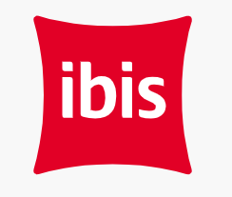
Figure 3 Ibis
Source: (Ibis, 2024)
Brand Reputation and Brand Positioning
The Ibis Hotel is considered one of the most popular luxury hotel brands in the UK. The company has more than 2500 branches in the world (Ibis, 2024). The brand owns 13% of the total market share in the UK. Many customers perceive the brand as an affordable and premium quality hotel chain. The latest surveys have revealed that 79% of the total population of the UK is aware of the Ibis group of hotels. The company has three distinct types of hotels Ibis, Ibis Style and Ibis Budget. The brand aims to provide a comfortable and budget-friendly broadening experience to the customers. The Ibis hotels provide modern and comfortable hotels for the customers. The hotel Ibis Style has a unique design based on different modern themes and Ibis Budget includes affordable basecamp designs. The company organises music events to attract customers from different corners of the world. It arranges community events to promote global and domestic tourism. The main competitor of the company is the Ritz Charlton which is a leading hospitality brand in the UK.
Target Audience
The Ibis company targets the working-class population of the society who likes to go on vacation more often. The population of the UK is more than 68 million and 75% of the population comes under the working age (Statista, 2024). The brand targets customers and likes to avail of customised hospitality services at moderate prices. The brand has shifted its focus on the business communities to organise company events in their hotels. The brand has also started targeting young travellers through the help of their tech-friendly designs. The brand has incorporated sustainable designs to improve its brand image.
Locations and Reach of the Hotels
The Ibis Hotel has a significant presence at the global level and the local level in the UK. Most of the hotels own more than 47 hotels in the UK (Accor, 2024). These hotels are in the Tourist hotshots like London, Birmingham, North Chesterfield and Manchester. The hotels of the company are accessible through public and public transport systems. The company has used social media platforms like Instagram and Facebook to connect with customers. The brand posts information related to its services through marketing channels. The Ibis Hotel also uses email market channels to attract customers.
Pricing and Value
Pricing strategies are one of the significant aspects of hospitality management. There are three types of pricing policies value-based, cost-based and competitive pricing strategies that are used by most companies to market their services. The value-based depends on the perception of the customers about the products or services. The cost-based pricing includes the entire cost of product development, production, packaging and marketing. The competitive pricing strategies rely on the pricing policies of the competitors. The Ibis company uses a value-based pricing system to market their products. The price of the services differs in each range of hotels. Most of the services come under the moderate price range. The brand also provides a 15% discount on special holiday seasons (Ibis, 2024).

Thematic Analysis and Findings

Thematic Analysis
Identify Key Strategies for Ibis Chesterfield North
Theme 1: Fostering a Positive Work Environment
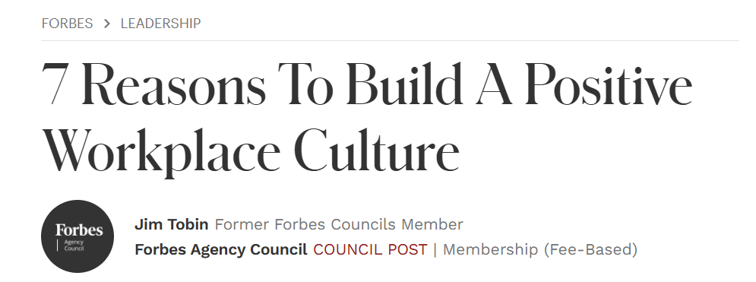
Figure 4: Reasons to Build a Positive Workplace Culture
Source: (Jim Tobin, 2024)
A positive work environment is essential for workforce satisfaction and retention. Employees who feel valued and empowered towards their workplace generally reflect more interest in being engaged in the organizational goals. An engaged workforce leads to being more innovative and productive and more loyal to accomplishing all tasks of the business effectively. There are several strategies to create an immense range of positive working culture in the workplace of Ibis Chesterfield North.
Establish Transparent Ethos and Values for the Organization: The hotel businesses must set transparent organizational core values that are transmitted efficiently and discussed with the workforce, so they generally feel part of it. It is identified as a strong commitment that an organization makes effective policies to continue its business process by meeting the recent market trends. It also helps the employees of businesses to research the recent market trends that can put more unique values to their entire business operations to meet the market trends. It can also help them to increase the relationship level between their business process and customers. Hotel sectors such as Ibis Chesterfield North should prioritize the recent sustainable preferences of modern travelers and people to continue the growth of their entire business process (Jim Tobin, 2024).
Foster Collaboration and Communication: A proper set of management styles and leadership principles generally encourage teamwork, honesty, and open communication at the workplace. It is also crucial to producing a positive feeling towards the entire workplace. Honest and open communication towards the workplace of Ibis Chesterfield North means regular audits should be taken on how their employees interact with the customers and each other. The employees should be humble with the guests and each other, which can always help them to increase awareness of their entire business process effectively (Arinaitwe, 2021).
Theme 2: Investing in Employee Development
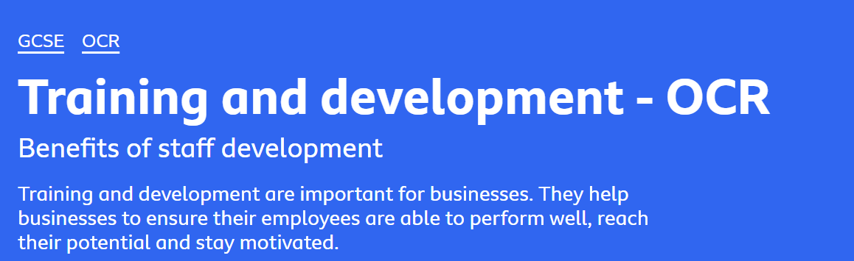
Figure 5: Why businesses train their workers
Source: (BBC, 2024)
Modern businesses should establish an effective range of strategies to increase the skills of their employees by providing an immense range of training options for them. It can help them to provide more significant value during the completion of any kind of complicated project. Training workforces’ costs money, however, it significantly enables employees to accomplish work to a high range of standards and it can give a few advantages to a particular business.
Improved Customer Service: Ibis Chesterfield North should leverage the factors related to their customer services that can help them to build an immense range of trust towards the people related to their business activities. They should provide an effective range of training in different languages, using automation technologies in customer services and others. Staff who have been effectively trained can have a chance to complete theirs to a higher standard. For example, employees who are trained in a multi-language domain can provide an effective range of services to any kind of traveler (BBC, 2024).
Improved Motivation and Productivity: Productivity considers a high amount of work produced by an employee within a specific time. Trained employees are often capable of working more effectively as they are also able to provide more hospitality services to customers. Motivation denotes how driven and engaged an employee is towards their role. Therefore, offering training can make employees value completing their major work. The business leaders of Ibis Chesterfield North focus on improving the relevant skills of the employees to boost their motivation and self-esteem to handle complex situations at the workplace (Mehale et al., 2021).
Theme 3: Competitive Compensation and Benefits
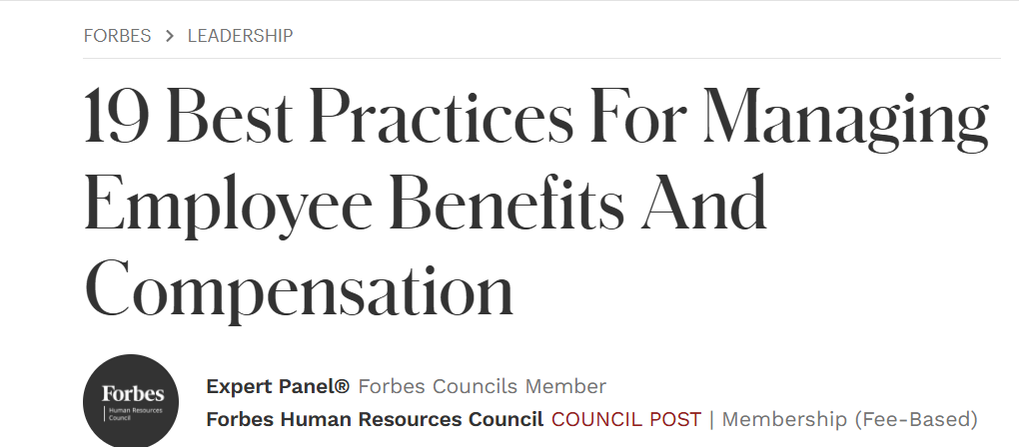
Figure 6: 19 Best Practices for Managing Employee Benefits and Compensation
Source: (Forbes, 2024)
Workforce benefits and compensation management is identified as a heart related to a thriving organization. As the landscape of business especially evolved and workforce expectations constantly shifting, it is essential for businesses to remain strategic and agile in their approach to retaining and rewarding talent. There are some strategies to leverage competitive compensation and benefits.
Align The Total Rewards Model with the Strategy of a Company: The hotel businesses should align the total rewards framework with the strategy of an organization and requirements related to the workforce base. They should build agility towards its deployment to effectively allow for all kinds of personalization whilst maintaining the robustness related to the framework. It can help them leverage all kinds of elements related to providing recognition and rewards to employees (Forbes, 2024).
Measure Both Senior and Staff Level Expectations: It should be a primary thing to measure all kinds of expectations for staff as well as senior management. Therefore, the HRM department of Ibis Chesterfield North should understand the expectations of the staff and senior management. It can help them in designing an effective range of reward policies for this hotel. It may help to increase the motivation level of their employees in completing complicated work (Werner and Balkin, 2021).
Challenges of Ibis Chesterfield North in implementation of staff retention
Theme 4: Working environment related challenges
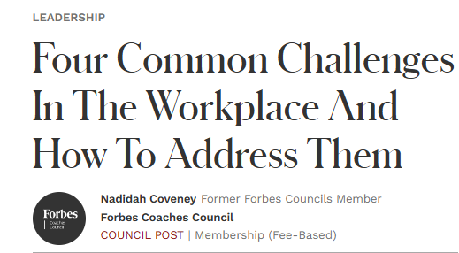
Figure 7: Four Common Challenges in The Workplace and How to Address Them
Source: (Coveney, 2020)
The regular activity of the organisation along with effective challenges can be silently created in the working environment. Due to this, most of global organisations face workplace-related challenges. Some challenges can be identified that are faced by Ibis Chesterfield North while they try to implement staff retention strategies.
Inadequate transparency in leadership: leadership approaches can be consisted of transparency lack that adversely impacts on fostering positive work culture in a company (Coveney, 2020). It is noticed that inadequate considerations of the leadership for the migrant workers in Ibis Chesterfield North deprive them of getting essential benefits. However, transparent traits of the leadership make them trustworthy among the employees and it is beneficial for addressing the changes.
Workplace conflict: The critical fact is that employee relationships are not harmonious for all time. Ibis Chesterfield North has witnessed of misunderstandings among employees as well as a set of conflicts in the workplace. Conflict in the working workplace of hotel brands can be defined as miscommunication and complications during official meetings.
Theme 5: High cost of training programmes and development
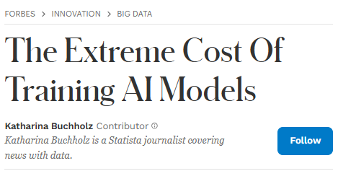
Figure 8: The Extreme Cost of Training AI Models
Source: (Buchholz, 2024)
Training is one of the crucial parts of the global hospitality industry that has witnessed of changes due to technological advancement. It signifies that Ibis Chesterfield North must face some key obstacles in shaping their workforce by incorporating diverse training.
Costly expenses of training: Training on Artificial Intelligence (AI) has become a vital part of international hotel brands. Due to this, Ibis Chesterfield North must invest in their AI training programme for adopting AI technologies in their operational area. These AI training programs are expensive for the business and increase the operational cost of the business (Buchholz, 2024). However, without AI training initiatives the company cannot compete in the modern landscape of business.
Different learner types: Being a global brand, Ibis Chesterfield North consists of different types of learners that can be considered as learners. The company is forced to formulate multiple training programmes to strengthen the employee’s abilities. It increases the expenses of Ibis Chesterfield North which creates a financial burden for any business.
Theme 6: Compensation and benefit-related challenges
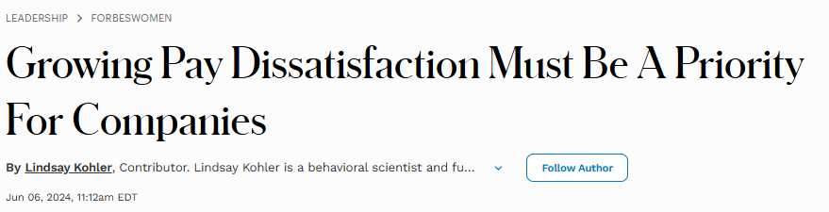
Figure 9: Growing Pay Dissatisfaction Must Be A Priority For Companies
Source: (Kohler, 2024)
A wide range of employees prioritise their salary benefits that lead to their performance. Ibis Chesterfield North must face diverse compensation-related problems while competitive pay plays a crucial role in modern companies.
Employee dissatisfaction: Employees expect that they are compensated fairly based on their skills and abilities (Kohler, 2024). Due to this, high expectations of the employees along with its differences impact on Ibis Chesterfield North. It adversely impacts on satisfying the employees as well as motivating them for better performance.
Misalignment with talents: Compensations along with benefits challenges issues include alignment of compensation with the talent (Brown, 2024). As per this context, Ibis Chesterfield North witnessed employee turnover while the company becomes failed to align organisational values and the aspirations of employees. Along with that, it insists the company to empower its employee by raising their feedback on expected compensations.
Identifying the Strategies for Mitigating the Challenges Associated with Staff Retention Strategies Considering Global Staff Shortage
Theme 7: Attractive Benefit Packages
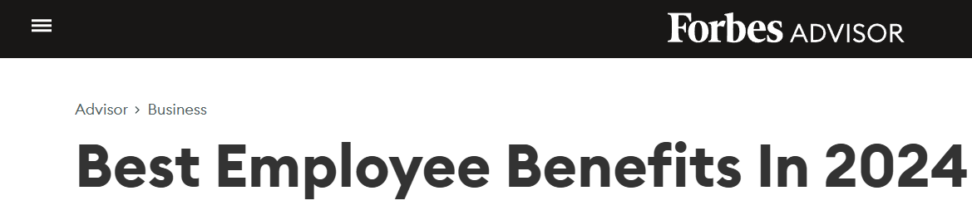
Figure 10: Best Employee Benefits In 2024
Source: (Miranda, 2023)
Flexible Hours: The above report shows that most workers mentioned that flexible hours should be a huge concern related to office life so businesses should leverage flexible working schedules. It is also important to motivate the workforce towards their working procedures effectively. A flexible working schedule always helps employees maintain an effective range of balance between their personal and professional lives. It also helps to create a positive working culture at the workplace as the motivated workforce generally tries to maintain a good relationship with each other as well as management groups. Moreover, professional development options should be provided to improve their skills. The business managers or leaders of Ibis Chesterfield North should prioritize several benefit packages such as life insurance, employer-covered healthcare, mandatory paid time off and others. All these things should be prioritized which helps to motivate people towards their entire working procedures effectively (Miranda, 2023).
Performance-Based Pay and Regular Salary Reviews: The business managers of Ibis Chesterfield North should conduct regular market research to effectively ensure competitive compensation packages. They should implement performance-based pay to effectively reward top performers. It also motivates other employees to give more value and innovations towards completing their work. The business leaders of Ibis Chesterfield North should conduct regular salary reviews to effectively manage compensation elements as needed (Ronda and De Gràcia, 2022).
Theme 8: Cost-Effective Training Solutions
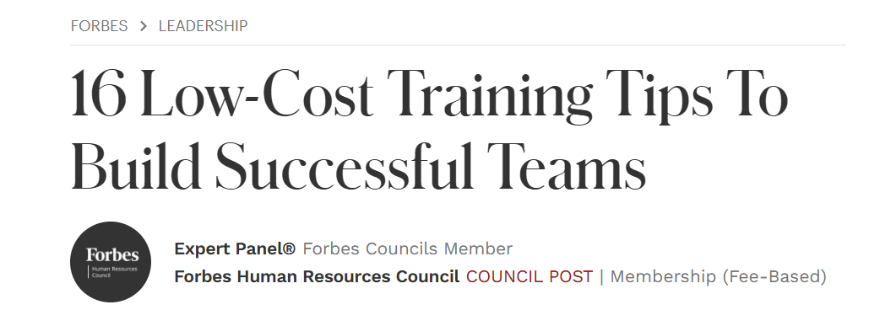
Figure 11: 16 Low-Cost Training Tips To Build Successful Teams
Source: (Forbes, 2022)
Leverage Internal Experts: Ibis Chesterfield North should leverage internal experts to assist in cross-skilling and upskilling the workforce on a wide range of topics. For example, they can engage the designers to introduce a design thinking workshop that may be offered to the employees of Ibis Chesterfield North for innovation and effective problem-solving skills. These kinds of workshops are also essential as hotel industries need to create effective content for leveraging their marketing activities (Forbes, 2022).
Support Cross-Departmental Training: Cross-departmental training is identified as the most cost-effective training process. Therefore, the business leaders of Ibis Chesterfield North should encourage and arrange for workforces in a distinct range of divisions related to the same department to sit along with their counterparts and learn more about what they do is very effective and valuable. Workforce learning from each other gives an effective range of extensive understanding related to the work that is completely done to support all business elements (Forbes, 2022).

Discussion for Improvements
Based on the analysis related to the strategies and challenges discussed, Ibis Chesterfield North can gain more innovative strategies to improve its employee retention activities. They can focus on the personalized developed plans for each workforce that should be considered with their skill gaps and career aspirations. The business managers of Ibis Chesterfield North should conduct continuous performance reviews to give a wide range of constructive feedback, set transparent expectations and recognize achievements. It can also increase the experience of the workforce that can also encourage them to contribute an immense range of creativity in completing tough projects. Ibis Chesterfield North can implement comprehensive wellness programs that should be involved in mental health support, stress management workshops and others. The findings of literature reviews also meet these suggestions which also address reward, and recognition should be considered a form of appreciation that companies provide to specific employees, who put a high range of effort into job tasks. Business managers should provide respect in the name of rewards to employees, allowing them to boost their confidence level in the job field. Therefore, they start to believe in their growth in the same company. The business Managers of Ibis Chesterfield North should understand the preferences related to the employees and help companies establish an effective plan. Businesses can retain more and more workforces who will be deserving candidates towards the workforce by understanding their demands. The thematic analysis part highlights that employees generally prioritize flexible working arrangements. Therefore, businesses should meet this demand by motivating their employees to be engaged in completing their all personal and professional activities within time.

Conclusion and recommendation

Conclusion
Concluding the above research, it has been found that with global staff shortage, employee retention strategies of businesses can be effective. These strategies can help businesses boost the motivation of employees and foster employee engagement in the workplace. In this regard, the research has investigated the impact of global staff shortage on business operations and the way staff retention strategies can help address this issue. The staff retention strategies of Ibis Chesterfield North have been evaluated. A literature review has been conducted to understand the credibility and feasibility of the research subject. In the review, various literature sources such as books, articles and statistical data have been incorporated. The key strategies of hotel businesses regarding staff retention have been examined along with the challenges businesses have to come across while implementing those strategies. The literature review has also showcased the literature gap in which multiple gaps in literature has been highlighted. In this study, secondary research has been conducted in which thematic analysis has been performed using different books, articles and journals. Following the research methodology, different themes have been illustrated such as fostering a positive work environment, investing in employee development and competitive compensation and benefit. Finally, based on the research findings, the researcher has suggested several key strategies to Ibis Chesterfield North for effective staff retention strategies.

Recommendation
Fostering a positive working environment: A positive work culture has a significant impact on employee retention and boosts the morale of employees in the workplace. It also increases employee engagement which leads to increased employee retention. Recently published data highlights that 94% of employers have agreed that a positive workplace increases employee retention rate (shrm.org, 2021). Thus, it is suggested that Ibis Chesterfield North should incorporate strategies and policies to develop a positive work environment in the workplace. This will increase engagement among employees. In this context, the hotel business can promote effective communication and establish feedback-giving and taking culture. It will positively impact its operation and increase employee retention rate.
Provide professional growth opportunities: Career and professional growth opportunities play a vital role in increasing employee motivation and boosting their morale to work in the company. A study has shown that around 58% of employees consider career development opportunities as an essential aspect while selecting a company (Lindner, 2024). It increases employee engagement in the workplace and increases the efficiency and productivity of employees. Thus, it is crucial for Ibis Chesterfield North to provide career and Professional growth opportunities to its employees. In this regard, the business can incorporate dedicated skill development and career growth training sessions which would upskill employees and increase their retention rate.
Offer Competitive Compensation: Competitive compensation and lucrative salary are probably the biggest motivation for employees. This increases the motivation of employees and encourages them to work effectively. By providing competitive compensation and remuneration, businesses can save their turnover expenses and increase their employee retention rate (businessleadershiptoday, 2024). Considering this aspect, it is recommended that Ibis Chesterfield North should provide competitive compensation to employees. Regarding this, the brand can set small targets for employee and provide small monitory remuneration to employee. It will appear to be an additional income source to employee which will boost their motivation and foster them to be part of the company for a longer duration.

Future Implication
The research findings will be helpful for other researchers to understand topics associated with employee motivation and staff retention. The researchers will be able to find various themes that would help them understand the topic effectively. In addition to this, this research will be very helpful for different hotel businesses that will be able to understand challenges that may have to encounter while leveraging effective staff retention strategies (Collis and Hussey, 2014). In this study, several key strategies have been suggested to Ibis Chesterfield North for enhancing its staff retention strategies and policies. These strategies and policies can also be considered by businesses and can incorporate strategies based on their business demand.

Reflective Writing
Reflective writing can refer to the description of personal experiences of a researcher gained during the conduction of research work in an appropriate and systematic way. Conduction of the research project is a complex and lengthy process where the researcher needs to invest a large amount of time to complete the procedure. Thus, due to the larger and lengthy procedures within this research work, I have gained a lot of experience and relevant capabilities as a researcher regarding academic research activities. Within the context of the placement research project, I have developed the research aim to investigate the impacts of global staff shortage in the context of employee retention. Majorly discussing the context mentioned, I have also generated three significant research objectives to complete the research project by aligning the case study of Ibis Chesterfield North. I have acknowledged the active support and help of all the university teachers, module leaders and my seniors in completing the research actively. Therefore, within the initial section of this research work, I have explored the background of this research work and the peculiar reason for selecting the research topic. Within the tourism and hospitality industry, customer satisfaction is the highest priority and thus employee retention also plays a vital role in making the customers happy. Considering the increased issues regarding staff shortage and employee retention within the major hospitality industries and businesses like Ibis Chesterfield North, I have selected this research topic. Based on the conduct of the research work I have achieved significant knowledge regarding time-management skills, research skills, referencing skills and other decision-making skills. Through conduction of the research activities and elements also influenced me to become knowledgeable about the unrevealed facts and situations within the tourism industry and staff retention within the business area. As for these initiatives during the proceeding of this research project, I have also presented a deep discussion of the collected literature evidence to justify the research questions and discussion within the research objectives. Within the literature discussion, I have gathered a wide range of knowledge and improved my capability while highlighting the gaps presented by the previous researchers on the same topic. Following this aspect, the research methodology has been mentioned where my positive thinking and core beliefs about selecting the research methods, designs and strategies have been mentioned. During the selection of significant methodological initiatives, I have also generated a wide range of knowledge as to which research design and data collection method are suitable for qualitative and quantitative analysis within research work. As for these initiatives during the conduction of the research within every step, I have gained significant knowledge and relevant research information. On the contrary, during the research procedure, a case study analysis has also been conducted where a comprehensive and detailed analysis of the micro and macro environment has been analyzed appropriately. To develop knowledge about the strengths and weaknesses of the business mentioned I have performed a SWOT analysis and competitor Porter's Five Force model has been analyzed where to understand the external environment a PEST analysis has been conducted in a rational manner. Through conducting these analyses regarding the business mentioned, I have generated significant knowledge about the tourism and hospitality industry and why most of the businesses are suffering from the staff shortage and lack of adequately trained staff to complete their business activities. Qualitative research activities have been performed within this research project where thematic analysis has been conducted and major relevant themes related to the research topic have been analyzed in this research study. Within this discussion, both academic references and other secondary references have been aligned appropriately to improve the quality of the research work. Thematic analysis is a complex research type where, finding the relevant and actual topic-related information from wide journals as well as websites becomes complex. Through hard work, I have extracted the relevant information and data from the collected secondary journals and articles and amongst them, a wide range of information contributed to improving the quality of the research work. Conducting the research project by following all the relevant research norms and academic integrity initiatives also becomes essential to performing academic honesty within the host field. Therefore, by incorporating and aligning all the relevant academic norms, instructions from the module leaders, and class notes of the university teachers I have maintained academic integrity. I have also been able to maintain proper academic honesty that has been presented within this research work. Besides maintaining academic integrity and honesty I have also ensured reliability and validity within this research work, where all the references have been collected from relevant and reliable sources. After completing the discussion within the theme analysis as well as discussion of the findings I have also presented a summary of all the elements and stages mentioned within this research project. Finally, some viable recommendations have also been presented within this research project. This has been made to suggest that modern tourism businesses like Ibis hotels overcome their challenges and present a seamless business operation within the modern competitive market. During the finding of relevant suggestions, I have also achieved a proper amount of knowledge regarding the challenges and issues faced by businesses and what can be the most suitable strategy to overcome these challenges. As for these initiatives, I have developed a deep understanding of the research topic and relevant research aims as well as objectives within the modern-era competitive business context.

References
Accor, (2024). About Accor. Available at: About Accor [Accessed 18 October 2024].
Accor, (2024). ibis Chesterfield North - Barlborough.Available at: Ibis Chesterfield North | Comfortable Hotel in Chesterfield - ALL [Accessed 18 October 2024].
Accor, (2024). Vibrant • Casual • Friendly. Available at: Accor - Discover ibis [Accessed 18 October 2024].
Arinaitwe, D., (2021). Practices and strategies for enhancing learning through collaboration between vocational teacher training institutions and workplaces. Empirical Research in Vocational Education and Training, 13, pp.1-22.
BBC, (2024). Why do businesses train their workers. Available at: Why businesses train their workers - Training and development - OCR - GCSE Business Revision - OCR - BBC Bitesize [Accessed 19 October 2024].
Brown, M. D., (2024). There's A Critical Misalignment With Talent About Compensation. Available at: There's A Critical Misalignment With Talent About Compensation [Accessed 20 October 2024].
Buchholz, K., (2024). The Extreme Cost Of Training AI Models. Available at: The Extreme Cost Of Training AI Models Like ChatGPT and Gemini [Accessed 20 October 2024].
Businessleadershiptoday, (2024). Why Compensation Is Important for Employee Retention. Available at: Why Compensation Is Important for Employee Retention - PeopleThriver [Accessed 21 October 2024].
Catlett, F.E., (2024). Management Strategies to Improve Employee Retention and Organizational Performance (Doctoral dissertation, Walden University).
Collis, J & Hussey, R (2014), Business Research, A Practical Guide for Undergraduate and Post Graduate Students, Palgrave, London
Cottrell, S. (2014) Dissertations and project reports: a step-by-step guide. New York: Pallgrave.
Coveney, N., (2020). Four Common Challenges In The Workplace And How To Address Them. Available at: Four Common Challenges In The Workplace And How To Address Them [Accessed 20 October 2024].
Doğan, S. and Niyet, İ.Z., (2024). Artificial Intelligence (AI) in Tourism. In Future Tourism Trends Volume 2: Technology Advancement, Trends and Innovations for the Future in Tourism (pp. 3-21). Emerald Publishing Limited.
Dzwigol, H. (2022). Research methodology in management science: Triangulation. Virtual Economics, 5(1), 78-93.
Forbes, (2022). 16 Low-Cost Training Tips To Build Successful Teams. Available at: 16 Low-Cost Training Tips To Build Successful Teams [Accessed 22 October 2024].
Forbes, (2024). 19 Best Practices For Managing Employee Benefits And Compensation. Available at: 19 Best Practices For Managing Employee Benefits And Compensation [Accessed 22 October 2024].
Gelencsér, M., Szabó-Szentgróti, G., Kőmüves, Z.S. and Hollósy-Vadász, G., (2023). The Holistic Model of Labour Retention: The Impact of Workplace Wellbeing Factors on Employee Retention. Administrative Sciences, 13(5), p.121.
George, R., (2021). The Tourism and Hospitality Marketing Environment. In Marketing Tourism and Hospitality: Concepts and Cases (pp. 183-219). Cham: Springer International Publishing.
Habu, A. A., and Henderson, T. (2023). Data subject rights as a research methodology: A systematic literature review. Journal of Responsible Technology, 100070.
He, J., Morrison, A.M. and Zhang, H., (2021). How high-performance HR practices and LMX affect employee engagement and creativity in hospitality. Journal of Hospitality & Tourism Research, 45(8), pp.1360-1382.
Ibis, (2024). Travel easier with ibis and ALL. Available at: ALL Loyalty Programme Discounts & Rewards | ibis Hotels [Accessed 19 October 2024].
Ibis, (2024). Welcome to the world of ibis. Available at: About Us | Information About ibis, ibis budget and ibis Styles | ALL [Accessed 22 October 2024].
Jim Tobin, (2024). 7 Reasons To Build A Positive Workplace Culture. Available at: 7 Reasons To Build A Positive Workplace Culture [Accessed 21 October 2024].
Kim, M. and Kim, J., (2020). Corporate social responsibility, employee engagement, well-being and the task performance of frontline employees. Management Decision, 59(8), pp.2040-2056.
Kohler, L., (2024). Growing Pay Dissatisfaction Must Be A Priority For Companies. Available at: Growing Pay Dissatisfaction Must Be A Priority For Companies [Accessed 22 October 2024].
Lindner, J., (2024). Employee Motivation Statistics: Engagement, Recognition, Growth, and Productivity Revealed. Available at: Employee Motivation Statistics Statistics: Market Data Report 2024 [Accessed 21 October 2024].
Mehale, K.D., Govender, C.M. and Mabaso, C.M., (2021). Maximising training evaluation for employee performance improvement. SA Journal of Human Resource Management, 19, p.11.
Miranda, D., (2023). Best Employee Benefits In 2024. Available at: Best Employee Benefits In 2024 – Forbes Advisor [Accessed 19 October 2024].
Moore, J.R. and Hanson, W., (2022). Improving leader effectiveness: impact on employee engagement and retention. Journal of Management Development, 41(7/8), pp.450-468.
Ocaña-Fernández, Y., and Fuster-Guillén, D. (2021). The bibliographical review as a research methodology. Revista Tempos e Espaços em Educação, 14(33), e15614-e15614.
Olya, H., Altinay, L., Farmaki, A., Kenebayeva, A. and Gursoy, D., (2021). Hotels' sustainability practices and guests' familiarity, attitudes and behaviours. In Sustainable Consumer Behaviour and the Environment (pp. 43-61). Routledge.
Ons, (2024). Inflation and price indices Available at: Inflation and price indices - Office for National Statistics [Accessed 18 October 2024].
Riyanto, S., Endri, E. and Herlisha, N., (2021). Effect of work motivation and job satisfaction on employee performance: Mediating role of employee engagement. Problems and Perspectives in Management, 19(3), p.162.
Ronda, L. and De Gràcia, E., (2022). Does office aesthetics drive job choice? Boosting employee experience and well-being perception through workplace design. Employee Relations: The International Journal, 44(5), pp.1077-1091.
Saks, A.M., (2022). Caring human resources management and employee engagement. Human resource management review, 32(3), p.100835.
Samašonok, K., (2024). Employee turnover: causes and retention strategies. Entrepreneurship and Sustainability Issues, 11(3), pp.134-148.
Saunders, M., Lewis, P. and Thornhill, A. (2012) Research Methods for Business Students, FT/Prentice Hall: Harlow.
Schulz, M.R., (2024). Employee Retention Strategies of the US Power Industry (Doctoral dissertation, Walden University).
Shrm.org, (2021). THE CULTURE EFFECT. Available at: https://www.shrm.org/content/dam/en/shrm/topics-tools/news/managing-smart/2021-culture-refresh-report.pdf [Accessed 25 October 2024].
Staniec, I. and Kalińska-Kula, M., (2021). Internal employer branding as a way to improve employee engagement. Problems and Perspectives in Management, 19(3), p.33.
Statista, (2024). Estimated population of the United Kingdom from 1871 to 2023. Available at: UK population 2023 | Statista [Accessed 18 October 2024].
Statista, (2024). Global Staff Shortages Balloon in Just Six Years. Available at: Chart: Global Staff Shortages Balloon in Just Six Years | Statista [Accessed 25 october 2024].
Streimikiene, D., Svagzdiene, B., Jasinskas, E. and Simanavicius, A., (2021). Sustainable tourism development and competitiveness: The systematic literature review. Sustainable development, 29(1), pp.259-271.
Veal, A J (2006), Research Methods for Leisure and Tourism, 3rd Ed, Financial Times/ Prentice Hall.
Verčič, A.T., (2021). The impact of employee engagement, organisational support and employer branding on internal communication satisfaction. Public Relations Review, 47(1), p.102009.
Werner, S. and Balkin, D.B., (2021). Strategic benefits: How employee benefits can create a sustainable competitive edge. The Journal of Total Rewards, 30(1), pp.8-22.
Wren, D., (2020). The culture of UK employee-owned worker cooperatives. Employee Relations: The International Journal, 42(3), pp.761-776.

