DS 1 Template

My Screenshots/Photos
- Please add 4–6 screenshots or photos of your digital life.
- You can use your phone or laptop.
- For each screenshot, write one or two sentences explaining what it shows.

Screenshot/Photo 1
[Insert Photo/Screenshot below]
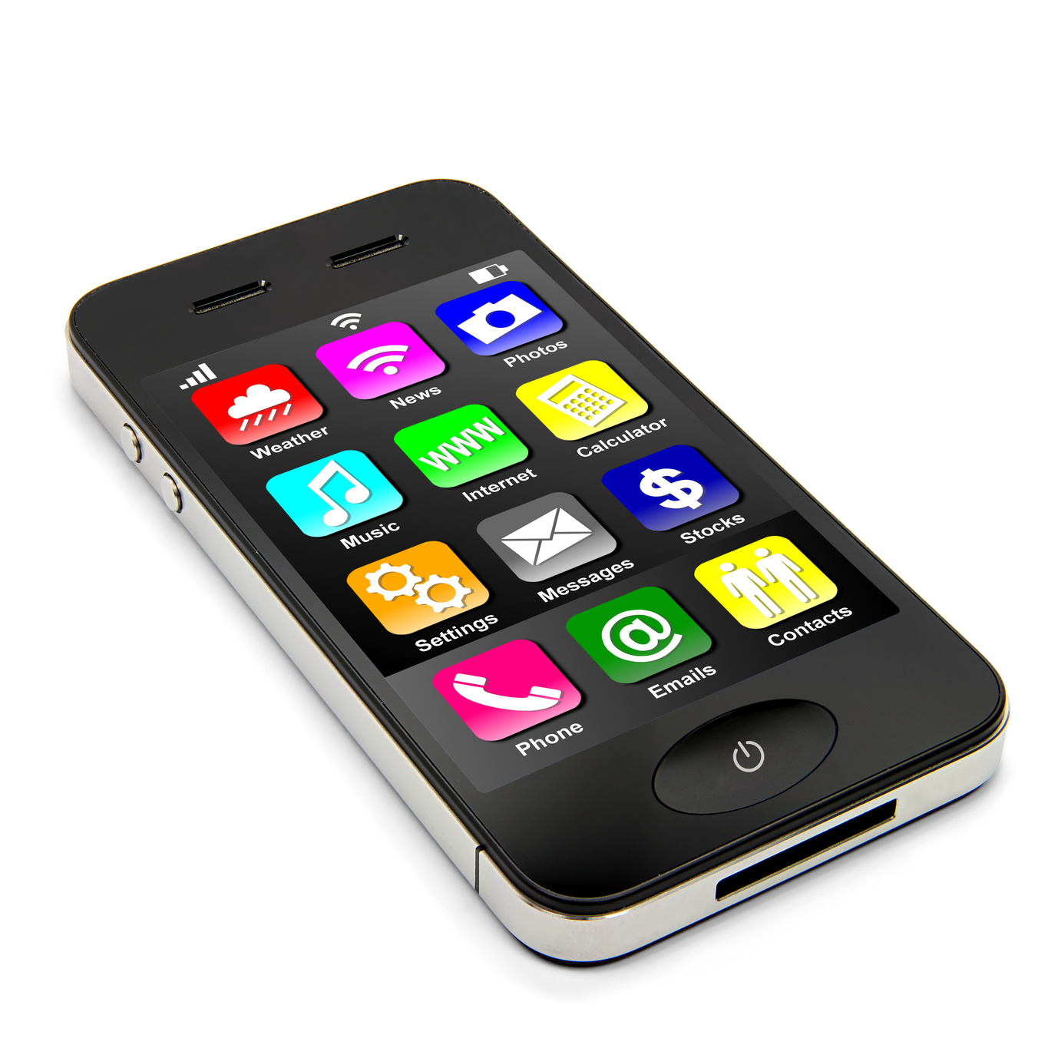
I use my phone to communicate my friends and family and check time, set alarms and organise my daily activities. I also use my phone for homework, school, listen to music and take photos. Overall, my phone is the most practica; device I own as due to its size and I’m able to carry it anywhere and use it at any time.
Ahmad, I. (n.d.)

Screenshot/Photo 2
[Insert Photo/Screenshot below]
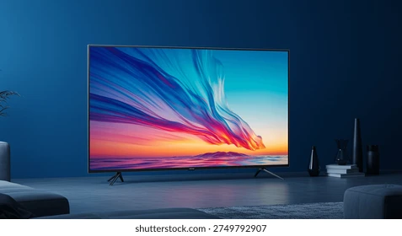
I use TV because it helps me watch my favourite programs in my free time. I often use streaming apps like YouTube or Netflix directly on the smart TV. The television also helps me relax with my family, and we can spend time together. Another good thing is that it helps me stay connected with my friends. In conclusion, even if TVs can be expensive, they are excellent devices for entertainment.
Harvard Health Publishing (2022)

Screenshot/Photo 3
[Insert Photo/Screenshot below]

I use the car to go to many places, such us the supermarket or to take the kids to school. It also helps me travel to other cities and manage my daily needs easily. Another good thing is that a car is very useful when you want to go on holiday with your family. In conclusion, cars are the most popular method of transport today because they make our lives much more comfortable.
Sapwood, C.H. (n.d.)

Screenshot/Photo 4
[Insert Photo/Screenshot below]
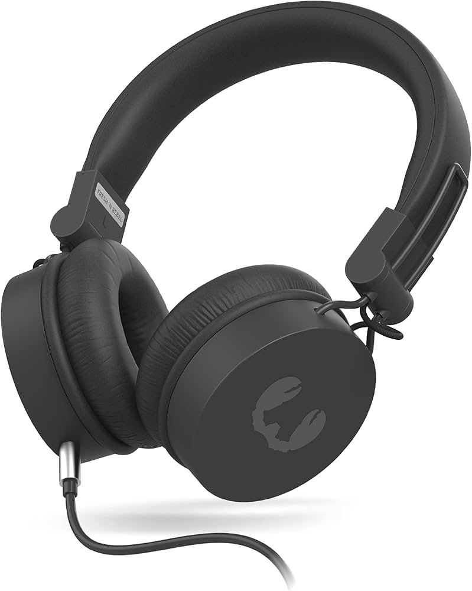
Headphones help me with studying, listening to music, and I can also have private phone calls because other people cannot hear my conversation. In conclusion headphones are very useful in my life, and I am sure many people agree with this.
CNN (2026)

Screenshot/Photo 5
[Insert Photo/Screenshot below]
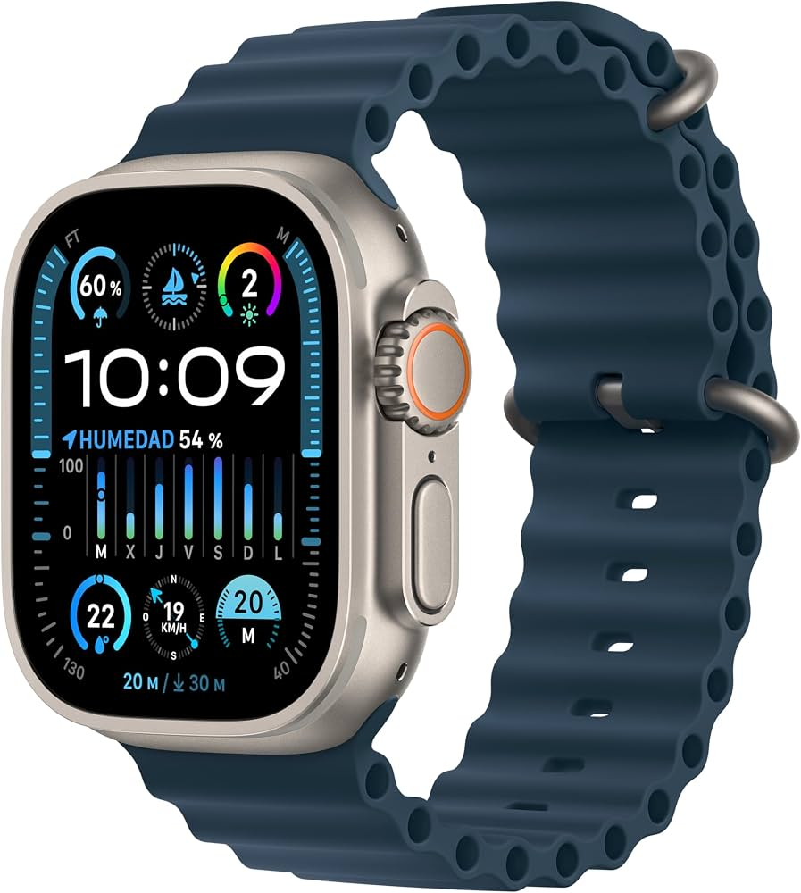
I often use my apple watch to track my heart rate. It is also very helpful for my daily routine because I can always check the time easily. Also, when my phone is out of battery or when I am unable to check it, I can see directly the messages sent to my phone without the inconvenience of having to take out my phone directly. In conclusion, apple watches are useful for time, health and making life easier.
CNET (n.d.)

Screenshot/Photo 6

My Short Reflection
- Write 5–8 simple sentences about your digital life.
- You can use the sentence starters below if helpful.
I use digital skills to make my life easier. For example, for school, communication and my daily activities.
I feel confident when I solve the problem by myself using my computer and my own knowledge.
I want to improve my digital skills because they are very important for my studies and in general with my life.
I often these tools: my smartphone, laptop, smart tv, apple watch, headphones and my car to stay connected with my family and friends every day.
I sometimes feel nervous about the safety of my personal information on the internet.

Sentence starters
- I use digital tools to …
- I feel confident when I …
- I want to improve …
- I often use these tools: …
- I sometimes feel nervous about …
- I hope this module will help me …
- Digital skills are important for me because …
You can write more if you want.

Submission Checklist
Before you submit, please check:
​​​ ☐ I added 4–6 screenshots
☐ I wrote short sentences for each screenshot
☐ I wrote my short reflection
☐ My work is my own
☐ My file opens correctly
​​☐ My file opens correctly
References:
Ahmad, I. (n.d.) Importance of mobile phone in our daily life. Medium. Available at: https://medium.com/@ijazahmadvti/importance-of-mobile-phone-in-our-daily-life-804d95be82b2 (Accessed: 25 October 2026).

Harvard Health Publishing (2022) Too much TV might be bad for your brain. Harvard Medical School. Available at: https://www.health.harvard.edu/mind-and-mood/too-much-tv-might-be-bad-for-your-brain (Accessed: 25 October 2026).

Sapwood, C.H. (n.d.) Benefits of cars: increased mobility and convenience. Medium. Available at: https://medium.com/@chsawood034/benefits-of-cars-increased-mobility-and-convenience-295537abff9a (Accessed: 25 October 2026).

CNN (2026) Headphone overuse dangers: loneliness and wellness. CNN, 19 October. Available at: https://edition.cnn.com/2026/10/19/health/headphone-overuse-dangers-loneliness-wellness (Accessed: 25 October 2026).

CNET (n.d.) Using an Apple Watch for the first time transformed my relationship with self-care. CNET. Available at: https://www.cnet.com/tech/mobile/using-an-apple-watch-for-the-first-time-transformed-my-relationship-with-self-care/ (Accessed: 25 October 2026).

