
Student Name: | Alyson Downes
Student Number: | 2024912
Module No: | BMSK5005
Module Title: | Workplace Culture and its Impact on Organisational Efficiency
Skills for the Workplace
Module Assignment Submission
Statement of Confirmation of Authenticity
By the act of making this submission, the student declares that this is the work of the student named above. The work has not, in whole or in part, been knowingly presented elsewhere for assessment, or where assessment has been built on a previous assessment, this has been identified. Where materials have been used from other sources it has been properly acknowledged. If this statement is untrue, the student acknowledges that an assessment offence has been committed.
Attention is drawn to the plagiarism and unfair practice policies of both the University and of ILM.
Table of Contents
Introduction 4
Critically assess the culture and context of an organisation. 4
Organisational Culture and Context 4
Culture at Disney 5
Hatch’s Cultural Dynamics 6
Organisational Culture – What Does Research Say? 7
The Dark Side of Disney 7
Edgar Schein 7
The Dark Side of Disney – What Does Research Say? 8
Conclusion 8
Evaluate an organisation within its broader environment using appropriate environmental and organisational analysis techniques. 9
Disney Micro Environment Analysis 9
Disney Macro Environment Analysis 10
McKinsey’s 7S Model 11
Conclusion 11
Critically appraise the cultural and ethical behaviour present in one or more organisations. 12
Disney’s Ethics 12
The PLUS Ethical Decision Making Model 14
Are Disney Doing What They Say? 14
Criticisms of Disney 15
Where Disney are Failing 15
Conclusion 15
References 17
Appendices 26
Appendix A 26
Appendix B 27
Appendix C 28
Appendix D 29
Appendix E 30
Appendix F 31
Appendix G 32
Appendix H 33

Introduction

Part one of this assignment will critically assess the culture and context of The Walt Disney Company. It will explore the company values and how they shape the organisational culture.
Part two will analyse both the micro and macro environment in which Disney sits, and how they affect organisational efficiency.
Finally, part three will critically analyse the ethical and cultural behaviour of Disney and explore whether or not their ethics are aligned with their organistaional culture.

Critically assess the culture and context of an organisation.

Sir Edward Tylor defined culture as “that complex whole which includes knowledge, belief, art, morals, law, custom, and any other capabilities and habits acquired by man as a member of society” (Tylor 1871/2012).
Culture largely refers to the patterns of human behaviour and the symbolic frameworks that give those patterns meaning and relevance. Culture can be defined as a way of life. The core elements that make up a culture include values, beliefs, opinions, attitudes, and behavioural norms (LaMorte, 2016).

Organisational Culture and Context
Organisational culture on the other hand, refers to the way things are done in an organisation. The unspoken guidelines that shape individual and group attitudes and behaviour. The structure of the organisation, the methods and procedures used to carry out work, employee conduct and attitudes, the values and traditions of the organisation, and the management and leadership philosophies used are all factors that can affect organisational culture (Chartered Management Institute, 2015).
Schein (1984), identified three layers of culture within an organisation:
- Artefacts. The most visible exhibitions of culture, such as dress code and décor.
- Espoused values. An organisation’s stated ideals and rules of behaviour, such as policies and core values.
- Basic underlying assumptions. The foundation on which culture is based. The unspoken values, assumptions and beliefs. The accepted and unofficial way employees behave within an organisation. Described as ‘the way things are done around here’.
The context of an organisation consists of the environment in which it operates and refers to internal and external issues relevant to the activity of the organisation (Ehsanfar, 2019). Internal matters can include governance structures, leadership methods and organisational culture (Evans et al, 2017), while external context relates to issues such as politics, the environment and the economy (Stojanovic, 2015).

Culture at Disney
Walt Disney dreamed of creating magic beyond his customer’s imaginations, and he realised it would be impossible do this alone. In order to become ‘the happiest place on earth’, they must have the happiest employees. By employing staff that share their core values and ambitions, and rewarding their achievements, they are able to create a ‘magical culture’ that ensures employees provide an enchanting experience for guests (Mapes, 2017).
Disney have six underlying principles their employees are required to uphold. Innovation, quality, community, storytelling, optimism and decency. All of which give an idea of the culture they aim to promote (Zink, 2014).
Strong corporate cultures are characterised by uniformity among employees in relation to values, attitudes and behavioural norms (Pinder, 1998). For this reason, Disney’s commitment to ensuring they achieve their desired culture begins with the recruitment process, which not only focusses on hiring employees with the correct competencies and skill set, but ensuring that their values, attitudes and beliefs, are in alignment. During the interviewing process, the first step is to show potential employees a short film about the Disney corporation, their history, their culture and their values. This leads to an average of 15% of applicants leaving before they are even interviewed. However it helps ensure they are only employing those they consider to be the right fit (Ingelsson et al., 2012).
Disney also aim to promote a culture of opportunity, which is vital for staff retention (Half, 2022). Since it is believed that leaders uphold an organisation’s principles, it makes sense to appoint leaders in accordance with their values (Schein, 2004), which is why Disney like to appoint leaders internally, by offering promotional opportunities to their staff.
Embedded in Disney culture is a commitment to continuous improvement. This is key for successful businesses if they wish to continue being successful (Investors in People, 2019). Disney aim to create a work environment that inspires optimism and drives innovation for all employees. They continually adapt to the changing needs of their people because they realise the importance of maintaining an inclusive, supportive workplace (Disney, 2022). An example of this is the addition of the fifth key, ‘inclusion’, to their customer service framework, previously known as the four keys, in 2021. This was introduced as part of their effort to drive a meaningful change in their culture (D’Amaro, 2021).
Disney is a global organisation and has parks in four countries (Marty, 2017. Appendix A). After initially struggling to make a success of Disneyland Paris and Disneyland Hong Kong, they realised that they cannot simply globalise their existing culture. Although the company’s core values remain consistent worldwide, adaptions are made when placed in a different context (Grassere, 2019). Entertainment options may differ, and although American cuisine is available in every park, there are also native options offered, such as shark-fin soup at Disneyland Hong Kong (Chan, 2011), and alcohol being served with food in Paris. The characters wear different outfits dependant on the location and culture, even management styles and uniforms are changed if deemed inappropriate in a particular context (Douglas, 2019).

Hatch’s Cultural Dynamics
Hatch (1993) expanded on Schein’s three-level model and created her cultural dynamics model. The model explores how cultural elements are related (Appendix B). The four concepts are Values, Artefacts, Symbols and Assumptions (VASA), and the linking processes are realisation, symbolisation, interpretation and manifestation. The process is not linear, it is continuous.
For Disney this would look like:
- Values. Family values, innovation, imagination, storytelling.
- Artefacts. What people see. The castle, the characters, the buildings and cast members.
- Symbols. Anything that represents an association with something wider. For example, Mickey ears are instantly associated with Disney.
- Assumptions. Taken for granted beliefs. For Disney this could mean the knowledge there will always be a happy ending to their stories.
Using the Disney values as a starting block, these were eventually realised into artefacts. Disney became so well known, symbolisation occurred, and the artefacts became figures synonymous with the brand. As time went on, certain assumptions became part of Disney’s culture, which then manifested over time, adding more values, such as inclusion. Subsequently, the cycle continues.

Organisational Culture – What Does Research Say?
Evidence suggests, a strong corporate culture, with shared values, has a positive effect on both individual employees, and organisational success (Groysberg et al., 2018). An early study, surveying American managers on culture in the workplace, found that when individual values are in alignment with an organisation’s, employees work harder and have greater job satisfaction, resulting in greater productivity and better results for the company, as well as a strong, people orientated culture (Posner et al, 1985). Although it should be noted this analysis is not recent, a 2021 study proved it is still relevant, by establishing a clear link between job satisfaction and a strong workplace culture based on shared principles (Jigjiddorj et al., 2021).
Furthermore, Ushakov & Shatila (2021) found that a workplace culture focusing on fun, strong relationships amongst teams, reward and opportunity, all of which form a big part of Disney culture, have a significant positive effect on employee retention.

The Dark Side of Disney
Whilst it is hard to dispute that Disney have a strong organisational culture based on their well-known values, it is difficult to assert whether or not this is the entire story. Disney’s culture is rooted in traditional, nostalgic, American ideals and out-dated family values (Bemis 2017). The typical ‘nuclear’ family tends to be a married heterosexual couple and their children, the man is the breadwinner whilst the woman stays at home raising children. Usually white, middle-class and Christian (May, 2003).
This has resulted in allegations of sexism, homophobia, and criticism surrounding the lack of diversity and inclusivity amongst their popular characters (Best & Lowney, 2009).
Additionally, a 2018 survey of Disney employees found that many struggle to make ends meet, with some having to rely on food banks (Dreier & Flaming, 2020). Ironically, while Disney require their staff to smile at visitors, 43% cannot afford dental care (Dreier, 2020).

Edgar Schein
Revisiting Schein (1984), it could be argued that the majority of people evaluating culture at Disney, are only seeing artefacts and espoused values. Specifically, people are only seeing what Disney want them to see. It is very difficult to identify the true culture of an organisation as an outsider.
According to Schein, it is an organisation’s basic underlying assumptions that give a true reflection of their culture. These are difficult to identify, however Disney’s culture is rooted in conservatism, with traditional American values at their core. Unfortunately this has meant they have faced criticism for the ‘Disneyfication’ of American history, meaning controversies and criticisms are glossed over (Bemis, 2017). It could be argued that a culture that is based on bias and untruth, cannot be as positive and strong as Disney like to portray.

The Dark Side of Disney – What Does Research Say?
Disney’s expectations of their staff can be intense. They are expected to ‘put on a show’ and convey a happy façade regardless of how they are feeling (Zink, 2014). If staff are always expected to perform and play a role, it can be difficult be authentic, which can affect job satisfaction (Van Den Bosch & Taris, 2013).
Additionally, a study on ‘emotional regulation’ at Disney, found they actively encourage staff to conceal their true emotions, and ‘put on an act’ at all times. Although understandable, the study found this can lead to emotional exhaustion (Reyers & Matusitz, 2013).
Interestingly, Disneyland Hong Kong are not required to be ‘the happiest employees on earth’. In Hong Kong, overly friendly people are viewed with suspicion, so smiles are not necessarily viewed positively. Therefore Hong Kong staff are only required to smile at guests for 60 seconds when they enter the park (Matusitz, 2009).

Conclusion
The criticism of how Disney treat their employees is not entirely justified. Their hourly rate is above minimum wage, and they offer benefits such as health insurance and on-site childcare facilities, and funding for qualifications (Disney Careers, 2020). On the other hand, wages have not increased in line with inflation, and the pay gap between CEOs and employees is getting bigger (DePillis, 2019). Therefore there is certainly room for improvement in this area.
Whilst certain criticisms of Disney are valid, it is important to recognise their commitment to continuous improvement, and their willingness to learn and change. There has been well-deserved criticism for the lack of diversity and inclusion in their past, however they have recognised this and made steps to redress the balance. For example, there are now far more characters of different ethnicities, stories presenting a wider range of cultures, as well as openly gay characters (Rude, 2022). Additionally, whilst they have faced allegations of sexism for how female characters have been portrayed in the past, this is not entirely fair. In fact, recent research has shown that children who are most engaged with ‘princess culture’, have more equal ideas towards gender roles, better body esteem, and less adherence to overtly masculine standards (Ellwood, 2021).
They have learned from past mistakes in their locations outside of America, and by acclimatising, learning, and intertwining their core values with local cultures, their parks are thriving worldwide.
Disney’s willingness to adapt and look to the future, whilst retaining the sense of nostalgia that they’re known for, is why they continue to be successful. Timelessness and innovation are ingrained in their culture, and as long as that continues, they will remain as ‘supercalifragilisticexpialidocious’ as ever.

Evaluate an organisation within its broader environment using appropriate environmental and organisational analysis techniques.

All organisations exist within a ‘business environment’, and this is usually divided into two categories. Micro and macro environments. The micro environment refers to the environment that directly impacts a business. The micro environment consists of suppliers, customers, competitors and the general public, and is specific to a business, sector or the location in which they operate. A macro environment on the other hand, refers to broader factors that affect a business. Such as the environment in which all businesses operate. It is made up factors that are political, social, economic and technological (Khartit, 2021).
The Walt Disney Company operates six business segments with two primary divisions. Disney Media and Entertainment Distribution (DMED), and Disney Parks, Experiences and Products (DPEP) (Low, 2020).

Disney Micro Environment Analysis
A SWOT analysis of Disney (Appendix C), found the company’s biggest strength to be their strong brand identity. Their name and logo are instantly recognisable, and they were recently ranked as the 5th ‘world’s most admired’ company (Burdette, 2022). Other strengths are their reliability that comes from a strong relationship with suppliers, a large cash flow that allows investments and acquisitions, a huge portfolio of brands, including Marvel, Fox, Pixar, ABC and Miramax, and a diversified business (Gupta, 2019).
Arguably Disney’s biggest weakness could be their poor financial planning, their investment in Hulu led to them reporting a loss of over $1billion in 2018, and their acquisition of Fox cost them almost $20billion more than their original bid (Tully, 2020).
The biggest threat Disney face is likely to be their ever growing list of competitors. They operate in an extremely competitive industry and have to keep evolving if they are stay ahead of the competition (Brown, 2022).
However, Disney are a company that are excellent at turning threats in to opportunities. In recent years, it was argued their biggest threat was the increase in streaming services, resulting in a big change in how the public consume their media. However Disney were quick to realise the opportunity this created for them and launched Disney plus in 2019. The streaming service has been a huge success for them and has now overtaken Netflix to become the world’s largest streaming company (Freitag, 2022).

Disney Macro Environment Analysis
A PESTLE analysis of Disney (Appendix D) found one of the political factors affecting them to be intellectual property rights (IPR). IPR vary in country to country so a global company like Disney needs to be mindful of this. There is political support for stronger IPR which would benefit Disney by minimising violations (Brown, 2019).
Economically, the media and entertainment sector is seeing steady growth, which is good news for Disney. However the global economy is still turbulent after the pandemic which saw Disney lose an estimated $700 million (Shaw, 2021).
Socially, consumer habits for media consumption have changed significantly in recent times, with a huge increase in the popularity of streaming services. Disney have taken full advantage with the launch of Disney plus. There is also a bigger focus on diversity, and whilst Disney have been criticised in the past for a lack of diversity in their characters, in recent years they have sought to address this, which will work in their favour in the long term by increasing their audience (Shaw, 2021).
Augmented reality (AR) is a growing trend in technology. It is estimated that 1.1 billion people will use AR on their phones in 2022, up from 500 million in 2020 (Ripert, 2022). Disney have already anticipated this, and in September 2022 they debuted their first AR movie on Disney plus (Greener, 2022).
There are no legal factors that are an immediate cause for concern for Disney, although they have to be mindful of increasing environmental protection policies and any changes to consumer law (Brown, 2019).
Environmentally, climate change remains a concern, and all organisations are expected to play their part. In response to this Disney have already begun their investment in renewable energy and are committed to a long term goal of net zero greenhouse gas emissions by 2030. Environmental sustainability featured significantly in their latest Corporate Social Responsibility (CSR) report (The Walt Disney Company, 2021).

McKinsey’s 7S Model

McKinsey’s 7S model (Waterman et al., 1980. Appendix E), is a framework for organisational effectiveness, which asserts that for an organisation to be successful, there are seven variables that must be in alignment (Kenton, 2019). These factors are classified as either hard or soft. The hard elements are easily identified and influenced by management. The hard factors at Disney are:
- Strategy. Disney’s CEO claims their strategy is based on ‘storytelling excellence’, ‘innovation’ and a ‘relentless focus on our audience’ (Maas, 2022).
- Structure. Disney’s use a multidivisional (M-form) structure that focuses on business type, appropriate for diversified organisations (Williams, 2017).
- Systems. Daily procedures, internal processes and policies. Such as their recruitment and training procedures (Morris, 2021).
The soft factors on the other hand, are less tangible and difficult to describe, and are influenced by organisational culture. The soft factors in relation to Disney are:
- Shared values. Disney’s shared values are optimism, innovation, decency, quality, community and storytelling (Williams, 2017).
- Skills. Disney invest enormously in staff training, both initial, and on-going (Jones, 2018).
- Style. Disney have a participative leadership style and encourage interaction and collaboration amongst employees (Smirti, 2019).
- Staff. Disney recruit staff whose values, attitude and beliefs are in alignment with their own (Ingelsson et al., 2012).
Both Disney and the model, have shared values at their core, as they are vital to the development of all other critical elements (Channon & Caldart, 2015), and therefore essential to success.

Conclusion
Business analysis is essential for organisational efficiency. By evaluating both the internal and external environment in which the business operates, organisations are able to identify vulnerabilities and threats, and come up with strategies to overcome them. Additionally, the process ensures awareness of evolving trends, enabling them to consider their implications (Cadle et al., 2010).
An analysis of Disney demonstrates their position as one of the strongest companies in the entertainment industry. Although they have an abundance of competitors, their huge portfolio means they do not pose too much of a threat. Their biggest weaknesses lie in their high expenditure and poor financial planning. However, their awareness of the broader market and commitment to innovation mean that they are ahead of their curve. They are already advanced in latest trends and are adapting to the future. They are also committed to their environmental CSR goals, and are investing enormously in this area (Media, 2022).

Critically appraise the cultural and ethical behaviour present in one or more organisations.

Ethical behaviour refers to the attitude, conduct and moral principles, that both individuals and organisations exhibit in their conduct and dealings. Ethical behaviour is necessary for safety, environmental protection, and adherence to laws and regulations. It ensures openness, honesty and fairness, as well as a sense of social responsibility (Stanley, 2021).
Cultural behaviour on the other hand, refers to the way individuals or organisations act, how they communicate, and how they understand the world. Culture is learned through socialisation and is formed by values, attitudes and beliefs. It is shared between groups (Ahmed, 2019). Individual and group behaviours amongst employees, play a part in forming the true culture of an organisation (Chartered Management Institute, 2015).
Businesses are facing increasing demands to look beyond their own profits, and to consider the societies in which they operate (Crane et al., 2019).

Disney’s Ethics
Disney take their ethical and social responsibilities seriously. Different countries have different ethical standards, and as a multinational organisation, they are required to balance the values of their own country with the necessity to be accepting and tolerant of practices in the countries where they operate (Strand et al., 2015).
They claim they are committed to ‘creating a better world through the power of stories’, as outlined in their 2021 CSR report (The Walt Disney Company, n.d.) A summary of the promises and achievements set out in report are:
- Diversity, equality and inclusion. Disney vow to ensure that voices of the underrepresented are amplified and represented accurately through their stories. They donated $150million to programs aiding under-represented communities in the 2021/22 financial year.
- Environmental sustainability. Disney’s goal is to create a ‘healthier home for people and wildlife’. Their aim for 2030 is to have zero emissions and to use 100% carbon electricity. They have eliminated plastic straws from Disney World and are composting waste. Their toys now have plastic free packaging, and they have 292 acres of solar panels at Disney World alone. Added to this, they support over 600 wildlife conservation charities, donating over $120million since 1995.
- Charitable giving. Disney pledge to bring positive, lasting change to communities globally, through their charity donations and collaborations with non-profit organisations. In 2021 alone, they donated $294million to charity.
- Investing in people. Disney’s human capital management strategy claims to offer opportunities for professional advancement, invest in the well-being, health and safety of employees and focuses on creating a supportive and inclusive culture.
- Operating responsibility. Disney claim to be committed to operating with integrity. All suppliers creating Disney branded goods are expected to operate in line with their supply chain code of conduct (The Walt Disney Company, 2022). They are also committed to ethical sourcing and digital safety (The Walt Disney Company, 2022).
Ethical behaviour is becoming increasingly important to organisations, as consumers have more awareness of the environmental and social impacts of products and content they consume. Disney have to ensure they live up to these expectations in order to remain successful. Additionally, businesses with strong CSR, attract a wider range of investors, and have a more positive public image (StudySmarter, 2019).
Organisations that behave in an ethical manner, have the same expectations for their employees. When employees have business ethics as a guiding principle, they are able to make better decisions, faster. Furthermore, both performance and loyalty increase (Horton, 2022). Disney employees are expected to operate within the guidelines set out in their Standards of Business Conduct (Appendix F), which require all staff to act with honesty and integrity.

The PLUS Ethical Decision Making Model
The PLUS model (Appendix G), is used by organisations to aid with the decision making process, and ensure decisions reached satisfy their ethical standards, not just business needs (Ethics and compliance initiative, 2019). All decisions must go through the PLUS filters to ensure ethical factors are embedded in the decision. Using Disney’s decision to introduce a ‘fifth key’, inclusivity, to their customer service framework in 2021 as an example, the model is used as follows:
- Policies. Does the decision align with the company’s policies and guidelines? Yes, there are no issues with updating this particular policy.
- Legal. Is the decision acceptable legally? Yes, there are no legal issues.
- Universal. Does the decision conform to the organisation’s universal values? Yes. After some criticism Disney wanted to prove their values included everyone. This was an important factor in the decision being proposed, and an important step in driving cultural change.
- Self. Does it satisfy a personal sense of what is right, good and fair? Yes. This was likely the key reason the decision went ahead.
Although the example above is straightforward, all companies are required to make tough decisions. Stopping to ask these questions during the decision making process can help to ensure outcomes are consistently reached with ethics and culture and in mind (Niemann, 2018).

Are Disney Doing What They Say?
Evidence suggests that Disney are living up to their promises. They are consistently named as one of the top 10 organisations for their approach to CSR (Gonçalves, 2019).
Since 1980, they have helped the Make a Wish foundation grant over 145,000 wishes globally (Make a Wish, 2022) as part of their charitable giving pledge.
Additionally, a case study found Disney to be extremely pro-active on environmental issues. Since 1995, their conservation fund has donated over $70million to aid declining wildlife populations. The American Environmental Protection Agency (EPA) have named Disney as an ‘Energy Star Partner’ in recognition of their energy-saving technologies, and they have reduced their emissions by almost 50% since 2012 (Luiten, 2020).
Furthermore, Disney are outperforming their competitors when it comes to CSR and are considered to have CSR practices embedded into their business model, strategies and culture (Holcomb et al., 2010).

Criticisms of Disney
Although part of Disney’s CSR promises are to avoid sweatshops and child labour in their manufacturing processes, this wasn’t always the case. According to human rights activists, in the late 1990s, many of Disney's consumer products were made in sweatshops in Bangladesh, China, and Haiti (NLC, 1996).
More recently, Disney have been accused of failing to live up to their human rights promises in China. Despite pulling their business out of Russia in response to the war with Ukraine due to human rights concerns, they continue to trade in China, despite the country being sanctioned by the U.S for forced labour violations (Rapoza, 2022).

Where Disney are Failing
In 2005, it was found that Disney breached their standards of business conduct policy by failing to disclose conflicts of interest. The organisation settled charges in relation to several breaches. One example being failing to disclose that the company employed the children of three directors, paying them salaries between $60,000 and $150,000 (Jennings, 2005).
Interestingly, a further study found that brand bias plays a part in the public perception of how ethical an organisation behaves. Disney and Walmart have previously scored similarly in their sustainability activities, however public perception rated Disney as the 2nd highest sustainable company in the sample, whilst Walmart were ranked amongst the lowest. This suggests Disney’s wholesome, caring, family orientated image, has more of an impact on public perception than their actions (Peloza et al., 2012).
However it is important to note that neither of these studies are recent, suggesting that lessons have been learned, and improvements made,

Conclusion
In summary, evidence suggests that Disney are one of the leading organisations in relation to ethical behaviour. They set high standards for both their organisation, and their employees.
Although there is certainly room for improvement, particularly where their relationship with China is concerned, Disney are doing more than their competitors, and improving consistently.
They are committed to their environmental and sustainability goals, their charitable giving is impressive, and they take their social responsibility seriously.
It can therefore be asserted that Disney’s ethical behaviour, their organisational culture and their core values, are in alignment.

References

Ahmed, A. (2019). Cultural Behavior in the Workplace. Chron.com. https://smallbusiness.chron.com/cultural-behavior-workplace-10277.html (Accessed 9th November 2022)

Bemis, B. (2017, January 3). How Disney Came to Define What Constitutes the American Experience. Smithsonian; Smithsonian.com. https://www.smithsonianmag.com/history/how-disney-came-define-what-constitutes-american-experience-180961632 (Accessed 4th November 2022)

Best, J., & Lowney, K. S. (2009). The Disadvantage of A Good Reputation: Disney as a Target for Social Problems Claims. The Sociological Quarterly, 50(3), 431–449. https://doi.org/10.1111/j.1533-8525.2009.01147.x (Accessed 4th November 2022)

Brown, L. (2022). Walt Disney Company SWOT Analysis & Recommendations. Panmore Institute. https://panmore.com/walt-disney-company-swot-analysis-recommendations#:~:text=This%20SWOT%20analysis%20identifies%20the (Accessed 5th November 2022)

Brown, L. (2019, February 28). Walt Disney Company PESTEL/PESTLE Analysis & Recommendations. Panmore Institute. https://panmore.com/walt-disney-company-pestel-pestle-analysis-recommendations (Accessed 5th November 2022)

Burdette, K. (2022). World’s Most Admired Companies. Fortune; Fortune. https://fortune.com/worlds-most-admired-companies/ (Accessed 5th November 2022)

Cadle, J., Paul, D., & Turner, P. (2010). BUSINESS ANALYSIS TECHNIQUES 72 Essential Tools for Success. http://ndl.ethernet.edu.et/bitstream/123456789/19870/1/37.pdf (Accessed 8th November 2022)

Chan, A. (2011). 10.5840/jbee20118120. CrossRef Listing of Deleted DOIs, 8(1). https://doi.org/10.5840/jbee20118120 (Accessed 7th November 2022)

Channon, D. F., & Caldart, A. A. (2015). McKinsey 7S model. Wiley Encyclopedia of Management, 12, 1–1. https://doi.org/10.1002/9781118785317.weom120005 (Accessed 8th November 2022)

Chartered Management Institute. (2015). Understanding Organisational Culture. https://www.managers.org.uk/~/media/Files/PDF/Checklists/CHK-232-Understanding-organisational-culture.pdf (Accessed 1st November 2022)

Crane, A., Matten, D., Glozer, S., & Spence, L. J. (2019). Business Ethics: Managing Corporate Citizenship and Sustainability in the Age of Globalization. (5th ed.). Oxford University Press. (Accessed 10th November 2022)

D’Amaro, J. (2021, April 13). A Place Where Everyone is Welcome. Disney Parks Blog. https://disneyparks.disney.go.com/blog/2021/04/a-place-where-everyone-is-welcome/ (Accessed 2nd November 2022)

Dreier, P. (2020, March 15). Disney Is Not the Greatest Place on Earth to Work. The Nation. https://www.thenation.com/article/economy/disney-iger-labor/ (Accessed 4th November 2022)

Dreier, P., & Flaming, D. (2020). Working for the Mouse: Inequality at Disneyland. Contexts, 19(1), 24–29. https://doi.org/10.1177/1536504220902198 (Accessed 4th November 2022)

Disney. (2022). Culture and Values – Life at Disney. Sites.disney.com. https://sites.disney.com/lifeatdisney/culture-and-values/ (Accessed 2nd November 2022)

Disney Careers. (2020). Employee and Cast Member Benefits | Disney Aspire Educational Program. Disneycareers.com. https://jobs.disneycareers.com/benefits (Accessed 7th November 2022)

Douglas, C. (2019). It’s A Small World After All: An International Analysis of The. It’s a Small World after All: An International Analysis of the Walt Disney Company, 16. https://www.lagrange.edu/academics/undergraduate/undergraduate-research/citations/_images/03DouglasC%202019Citations%20Its%20A%20Small%20World%20After%20All%20An%20International%20Analysis%20of%20The%20Walt%20Disney%20Company.pdf (Accessed 7th November 2022)

Ehsanfar, M. (2019). Understanding and Defining the Organizational Context. Www.linkedin.com. https://www.linkedin.com/pulse/understanding-defining-organizational-context-mohsen-ehsanfar#:~:text=the%20context%20of%20the%20organization (Accessed 4th November 2022)

Ellwood, B. (2021, December 23). Longitudinal study suggests Disney princess culture has a positive impact on young children’s gender development. PsyPost. https://www.psypost.org/2021/12/longitudinal-study-suggests-disney-princess-culture-has-a-positive-impact-on-young-childrens-gender-development-62267 (Accessed 7th November 2022)

Ethics and compliance initiative. (2019). The PLUS Ethical Decision Making Model - Ethics & Compliance Initiative. Ethics & Compliance Initiative. https://www.ethics.org/resources/free-toolkit/decision-making-model/ (Accessed 11th November 2022)

Evans, J. M., Grudniewicz, A., Gray, C. S., Wodchis, W. P., Carswell, P., & Baker, G. R. (2017). Organizational Context Matters: A Research Toolkit for Conducting Standardized Case Studies of Integrated Care Initiatives. International Journal of Integrated Care, 17(2). https://doi.org/10.5334/ijic.2502 (Accessed 5th November 2022)

Freitag, L. (2022, August 10). Disney Overtakes Netflix in Worldwide Subscription Numbers. CBR. https://www.cbr.com/disney-passes-netflix-as-worlds-largest-streaming-company/ (Accessed 5th November 2022)

Gonçalves, A. (2019, March 11). What Are The 100 Companies With The Best Reputation On Corporate Responsibility? Youmatter. https://youmatter.world/en/top-100-companies-best-csr-reputation2019-28108/ (Accessed 11th November 2022)

Grassere, J. (2019, October 25). Disney Parks and soft globalization. Diggit Magazine. https://www.diggitmagazine.com/articles/disney-parks-and-soft-globalization (Accessed 6th November 2022)

Greener, R. (2022, September 14). Disney Opens First AR Film amid Immersive Push. XR Today. https://www.xrtoday.com/mixed-reality/disney-opens-first-ar-film-amid-immersive-push/ (Accessed 5th November 2022)

Groysberg, B., Lee, J., Price, J., & Cheng, J. Y.-J. (2018). The Leader’s Guide to Corporate Culture. Harvard Business Review; hbr.org. https://hbr.org/2018/01/the-leaders-guide-to-corporate-culture (Accessed 7th November 2022)

Gupta, S. K. (2019, March 22). Disney SWOT analysis 2019 | SWOT Analysis of Disney | Business Strategy Hub. Business Strategy Hub. https://bstrategyhub.com/swot-analysis-of-disney-2019-disney-swot-analysis/ (Accessed 5th November 2022)

Half, R. (2022). Effective employee retention strategies. Roberthalf.com. https://www.roberthalf.com/blog/management-tips/effective-employee-retention-strategies (Accessed 3rd November 2022)

Hatch, M. J. (1993). The Dynamics of Organizational Culture. Academy of Management Review, 18(4), 657–693. https://doi.org/10.5465/amr.1993.9402210154 (Accessed 3rd November 2022)

Hiatt, J. M. (2006). ADKAR: A model for change in business, government, and our community (1st ed.). Prosci Learning Center Publications. (Accessed 8th November 2022)

Holcomb, J., Okumus, F., & Bilgihan, A. (2010). Corporate social responsibility: what are the top three Orlando theme parks reporting? Worldwide Hospitality and Tourism Themes, 2(3), 316–337. https://doi.org/10.1108/17554211011052230 (Accessed 11th November 2022)

Horton, M. (2022, July 1). Why Is Business Ethics important? Investopedia. https://www.investopedia.com/ask/answers/040815/why-are-business-ethics-important.asp (Accessed 10th November 2022)

Ingelsson, P., Eriksson, M., & Lilja, J. (2012). Can selecting the right values help TQM implementation? A case study about organisational homogeneity at the Walt Disney Company. Total Quality Management & Business Excellence, 23(1), 1–11. https://doi.org/10.1080/14783363.2011.637801 (Accessed 2nd November 2022)

Investors in People. (2019). Continuous improvement models: four great options for you. Investors in People. https://www.investorsinpeople.com/knowledge/continuous-improvement-models-four-great-options-for-you/#:~:text=is%20continuous%20improvement%3F- (Accessed 4th November 2022)

Jennings, M. M. (2005). CONSPICUOUS GOVERNANCE FAILURES: WHY SARBANES-OXLEY IS NOT AN ETHICS WARRANTY. Corporate Finance Review, 9(5), 41-47. https://www-proquest-com.ezproxy.uwtsd.ac.uk/scholarly-journals/conspicuous-governance-failures-why-sarbanes/docview/198832669/se-2 (Accessed 11th November 2022)

Jigjiddorj, S., Zanabazar, A., Jambal, T., & Semjid, B. (2021). Relationship Between Organizational Culture, Employee Satisfaction and Organizational Commitment. SHS Web of Conferences, 90, 02004. https://doi.org/10.1051/shsconf/20219002004 (accessed 6th November 2022)

Jones, B. (2018, March). How Disney Empowers Its Employees to Deliver Exceptional Customer Service - SPONSOR CONTENT FROM DISNEY INSTITUTE. Harvard Business Review. https://hbr.org/sponsored/2018/02/how-disney-empowers-its-employees-to-deliver-exceptional-customer-service (Accessed 8th November 2022)

Kenton, W. (2019, July 2). McKinsey 7S Model. Investopedia. https://www.investopedia.com/terms/m/mckinsey-7s-model.asp (Accessed 8th November 2022)

Khartit, K. (2021). What Is a Macro Environment? Investopedia. https://www.investopedia.com/terms/m/macro-environment.asp#:~:text=Macro%20environment%20analysis%20is%20part (Accessed 5th November 2022)

LaMorte, W. (2016). What is Culture? Boston University School of Public Health. https://sphweb.bumc.bu.edu/otlt/mph-modules/PH/CulturalAwareness/CulturalAwareness2.html (Accessed 1st November 2022)

Low, E. (2020, October 12). Disney Reorganizes Content and Distribution Units to Bolster Streaming Businesses. Variety. https://variety.com/2020/tv/news/walt-disney-structural-reorganization-media-entertainment-business-1234801683/ (Accessed 5th November)

Luiten, S.-C. (2020). Corporate social responsibility and consumerism: case examples from Hyatt, Scandic and Walt Disney. Worldwide Hospitality and Tourism Themes, ahead-of-print(ahead-of-print). https://doi.org/10.1108/whatt-06-2020-0045 (Accessed 11th November 2022)

Maas, J. (2022, January 10). Disney CEO Bob Chapek Reveals 2022 Goals in Staff Memo to “Set the Stage for Our Second Century.” Variety. https://variety.com/2022/biz/news/disney-bob-chapek-2022-goals-1235150476/ (Accessed 8th November 2022)

Make a Wish. (2022). Corporate partner - Disney | Make A Wish. Www.make-a-Wish.org.uk. https://www.make-a-wish.org.uk/get-involved/corporate-partnerships/disney/#:~:text=Since%201980%2C%20Disney%20has%20helped (Accessed 11th November 2022)

Mapes, T. (2017). Walt Disney’s Dream Culture. Www.linkedin.com. https://www.linkedin.com/pulse/walt-disneys-dream-culture-tara-mapes (Accessed 2nd November 2022)

Marty. (2017, September 20). New one-day “Mega Park Hopper” allows entrance into all 14 Disney Parks worldwide. Uncle Walt’s Insider. https://unclewalts.com/world/new-one-day-mega-park-hopper-allows-entrance-into-all-14-disney-parks-worldwide/ (Accessed 6th November 2022)

Matusitz, J. (2009). Disney’s successful adaptation in Hong Kong: A glocalization perspective. Asia Pacific Journal of Management, 28(4), 667–681. https://doi.org/10.1007/s10490-009-9179-7 (Accessed 7th November 2022)

May, E. T. (2003). “Family Values”: The Uses and Abuses of American Family History. Revue Francaise Detudes Americaines, 97(3). https://www.cairn.info/revue-francaise-d-etudes-americaines-2003-3-page-7.htm (Accessed 7th November 2022)

Media, T. D.-D. D. (2022). Disney. Disney. https://impact.disney.com/environment/environmental-sustainability/ (Accessed 8th November 2022)

Morris, A. (2021, November 8). Disney HR Policies – Walt Disney Human Resources Case Study. Employee Experience Magazine. https://www.emexmag.com/disney-hr-policies-walt-disney-human-resources-case-study/#Disney_HR_Policies_An_Overview (Accessed 8th November 2022)

Niemann, J.-A. (2018). Decision Making Frameworks - Tips for Better Business Outcomes. Www.linkedin.com. https://www.linkedin.com/pulse/decision-making-frameworks-tips-better-business-outcomes-niemann (Accessed 11th November 2022)

NLC. (1996). Disney’s Hell in Haiti. Www.hartford-Hwp.com. http://www.hartford-hwp.com/archives/43a/294.html (Accessed 4th November 2022)

Peloza, J., Loock, M., Cerruti, J., & Muyot, M. (2012). Sustainability: How Stakeholder Perceptions Differ from Corporate Reality. California Management Review, 55(1), 74–97. https://doi.org/10.1525/cmr.2012.55.1.74 (Accessed 11th November 2022)

Pinder, C. C. (1998). Work Motivation in Organizational Behavior. https://doi.org/10.4324/9781315734606 (Accessed 2nd November 2022)

Posner, B. Z., Kouzes, J. M., & Schmidt, W. H. (1985). Shared values make a difference: An empirical test of corporate culture. Human Resource Management, 24(3), 293–309. https://doi.org/10.1002/hrm.3930240305 (Accessed 4th November 2022)

Rapoza, K. (2022). Disney Forced To Face Activist Shareholder Inquiring About China. Forbes. https://www.forbes.com/sites/kenrapoza/2022/03/11/disney-forced-to-face-activist-shareholder-inquiring-about-china/?sh=1baa7ec6749b (Accessed 11th November 2022)

Reyers, A., & Matusitz, J. (2012). Emotional Regulation at Walt Disney World: An Impression Management View. Journal of Workplace Behavioral Health, 27(3), 139–159. https://doi.org/10.1080/15555240.2012.701167 (Accessed 4th November 2022)

Ripert, D. (2022, February 6). Top 5 Augmented Reality Trends for 2022. Entrepreneur. https://www.entrepreneur.com/business-news/top-5-augmented-reality-trends-for-2022/412819#:~:text=From%20just%20over%20500%20million (Accessed 5th Novemner 2022)

Rude, Ma. (2022, June 22). A Brief Timeline of Disney’s 16 “First Gay Characters.” Www.out.com. https://www.out.com/film/2022/3/22/disneys-first-out-lgbtq-gay-characters#media-gallery-media-4 (Accessed 7th November 2022)

Schein, E. H. (1984). Coming to a New Awareness of Organizational Culture. MIT Sloan Management Review. https://sloanreview.mit.edu/article/coming-to-a-new-awareness-of-organizational-culture/?use_credit=fecf2c550171d3195c879d115440ae45 (Accessed 1st November 2022)

Schein, E. H. (2004). Organisational Culture and Leadership. Jossey-Bass.(Accessed 3rd November 2022)

Shaw, A. A. (2021, February 11). PESTLE Analysis of Disney. SWOT & PESTLE Analysis. https://swotandpestleanalysis.com/pestle-analysis-of-disney/ (Accessed 5th November 2022)

Smirti. (2019, July 4). Walter Elias Disney: Transformational and Participative Leadership Style. Management Notes. https://www.managementnote.com/walter-elias-disney/#:~:text=His%20leadership%20style%20created%20trust (Accessed 8th November 2022)

Stanley, J. (2021, July 16). Business ethical behaviour and why it matters. Real Business. https://realbusiness.co.uk/business-ethical-behaviour-matters (Accessed 9th November 2022)

Stojanovic, S. (2015). Context of the organization in ISO 9001:2015 explained. Advisera.com. https://advisera.com/9001academy/knowledgebase/how-to-identify-the-context-of-the-organization-in-iso-90012015/#:~:text=To%20determine%20external%20context%2C%20you (Accessed 4th November 2022)

Strand, R., Freeman, R. E., & Hockerts, K. (2015). Corporate Social Responsibility and Sustainability in Scandinavia: An Overview. Journal of Business Ethics, 127(1), 1–15. https://doi.org/10.1007/s10551-014-2224-6 (Accessed 10th November 2022)

StudySmarter. (2019). Walt Disney CSR Programs: Definition, Programs & Goals. StudySmarter UK. https://www.studysmarter.co.uk/explanations/business-studies/business-case-studies/walt-disney-csr-programs/ (Accessed 10th November 2022)

The Walt Disney Company. (n.d.). Inspiring a better world through the power of stories. Disney. https://impact.disney.com/ (Accessed 10th November 2022)

The Walt Disney Company. (2021). 2021 Corporate Social Responsibility Report. https://impact.disney.com/app/uploads/2022/02/2021-CSR-Report.pdf (Accessed 5th November 2022)

The Walt Disney Company. (2022, February 22). Disney Releases 2021 Corporate Social Responsibility Report. The Walt Disney Company. https://thewaltdisneycompany.com/disney-releases-2021-corporate-social-responsibility-report/#:~:text=The%20Company (Accessed 10th Novemebr 2022)

The Walt Disney Company. (2022c, February 22). Disney Releases 2021 Corporate Social Responsibility Report. The Walt Disney Company. https://thewaltdisneycompany.com/disney-releases-2021-corporate-social-responsibility-report/#:~:text=The%20Company (Accessed 10th November 2022)

Tully, S. (2020, May 10). Disney’s biggest financial problem has nothing to do with coronavirus. Fortune. https://fortune.com/2020/05/10/disney-fox-deal-financial-problems-coronavirus/ (Accessed 5th November 2022)

Tylor, E. (2012). Primitive Culture: Researches Into the Development of Mythology, Philosophy, Religion, Art, and Custom. Cambridge University Press. (Original work published 1871) (Accessed 1st November 2022)

Udokang, M. (2020). Organizational Culture within The Walt Disney Company. ProjectManagement.com. https://www.projectmanagement.com/blog-post/66932/Organizational-Culture-within-The-Walt-Disney-Company (Accessed 2nd November 2022)

Ushakov, D., & Shatila, K. (2021). The Impact of Workplace Culture on Employee Retention: An Empirical Study from Lebanon. The Journal of Asian Finance, Economics and Business, 8(12), 541–551. https://doi.org/10.13106/jafeb.2021.vol8.no12.0541 (Accessed 4th November 2022)

Van Den Bosch, R., & Taris, T. W. (2013). Authenticity at Work: Development and Validation of an Individual Authenticity Measure at Work. Journal of Happiness Studies, 15(1), 1–18. https://doi.org/10.1007/s10902-013-9413-3 (Accessed 4th November 2022)

Waterman, R. H., Peters, T. J., & Phillips, J. R. (1980). Structure is not organization. Business Horizons, 23(3), 14–26. https://doi.org/10.1016/0007-6813(80)90027-0 (Accessed 8th November 2022)

Williams, A. (2017a, December 16). Walt Disney Company’s Organizational Structure for Synergistic Diversification. Panmore Institute. https://panmore.com/walt-disney-company-organizational-structure-synergistic-diversification (Accessed 8th November 2022)

Williams, A. (2017b, December 17). Disney’s Organizational Culture for Excellent Entertainment (Analysis). Panmore Institute. https://panmore.com/disney-organizational-culture-excellent-entertainment-analysis#:~:text=A%20disadvantage%20of%20Disney (Accessed 4th November 2022)

Zink, C. (2014). ScholarWorks@UARK One Mans Dream: How a Company’ s Unique Culture can Translate into Long Term Success. https://scholarworks.uark.edu/cgi/viewcontent.cgi?referer=&httpsredir=1&article=1008&context=acctuht (Accessed 4th November 2022)

Appendices

Appendix A

Disney theme park locations.

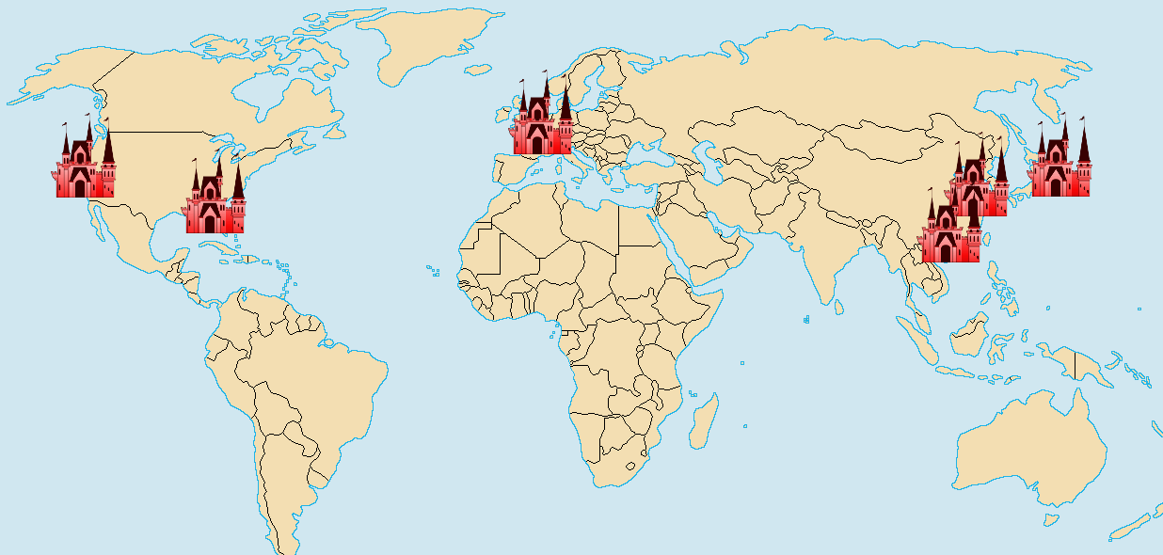
(Marty, 2017)

Appendix B

Hatch’s cultural dynamics model.
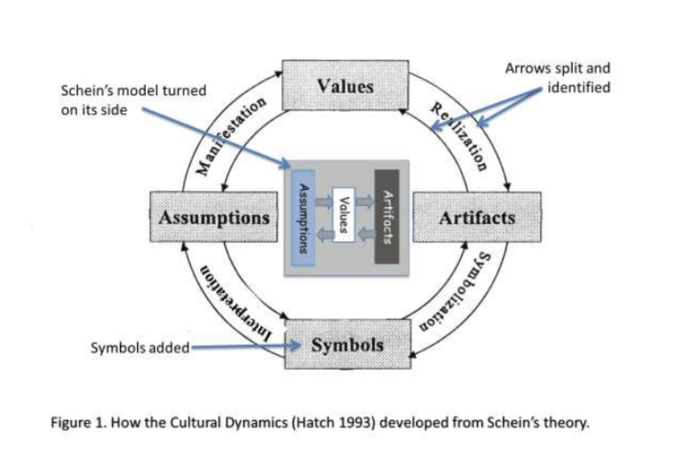
(Hatch, 1993)

Appendix C

A SWOT analysis of The Walt Disney Company.

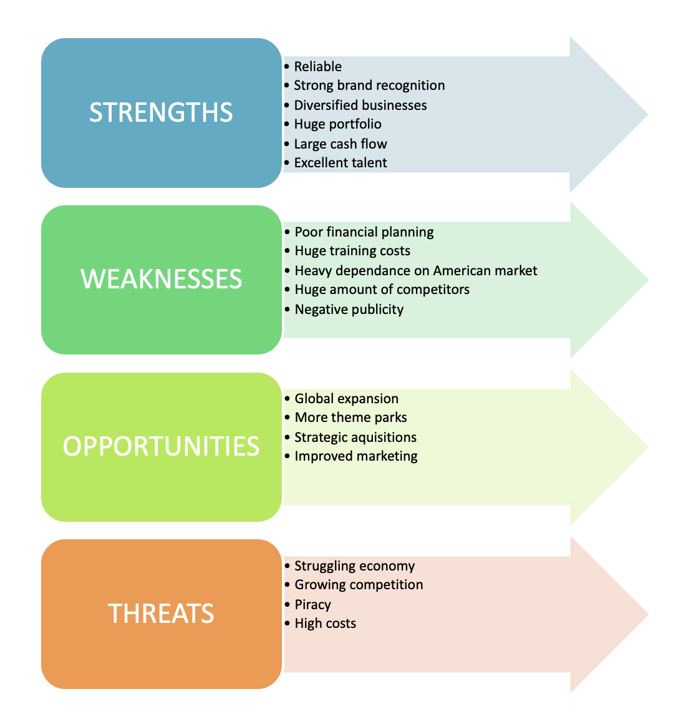

Appendix D

A PESTLE analysis of The Walt Disney Company.
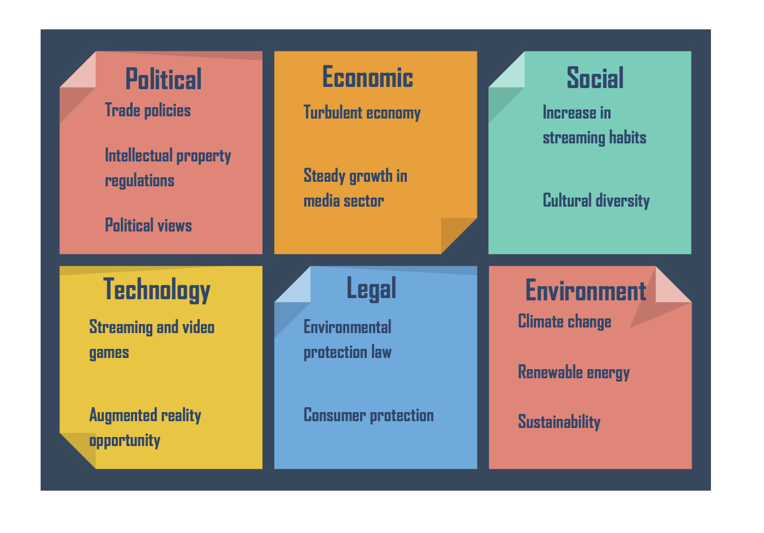

Appendix E

McKinsey’s 7S model.

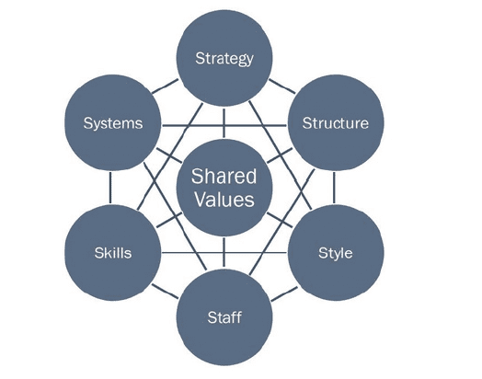
(Waterman et al., 1980)

Appendix F

Disney’s Standards of Business Conduct:

https://impact.disney.com/app/uploads/2022/01/TWDC-Standards-of-Business-Conduct-1.pdf

Appendix G

The PLUS ethical decision making model

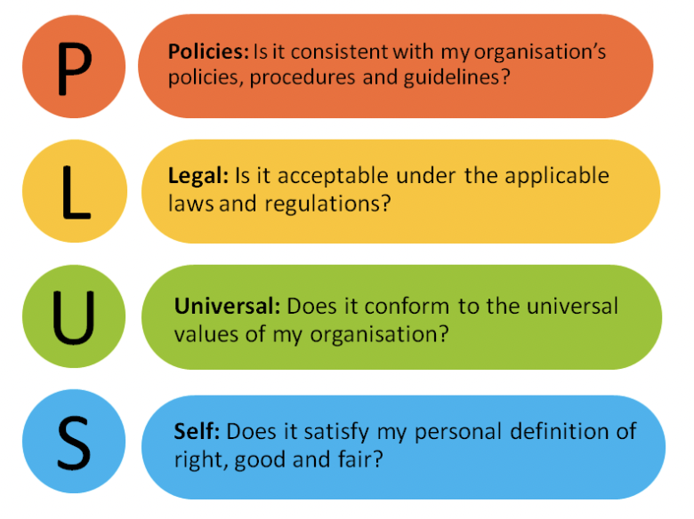
(Ethics and compliance initiative, 2019)

Appendix H

A study comparing the CSR strategies of the top three theme park in Florida.

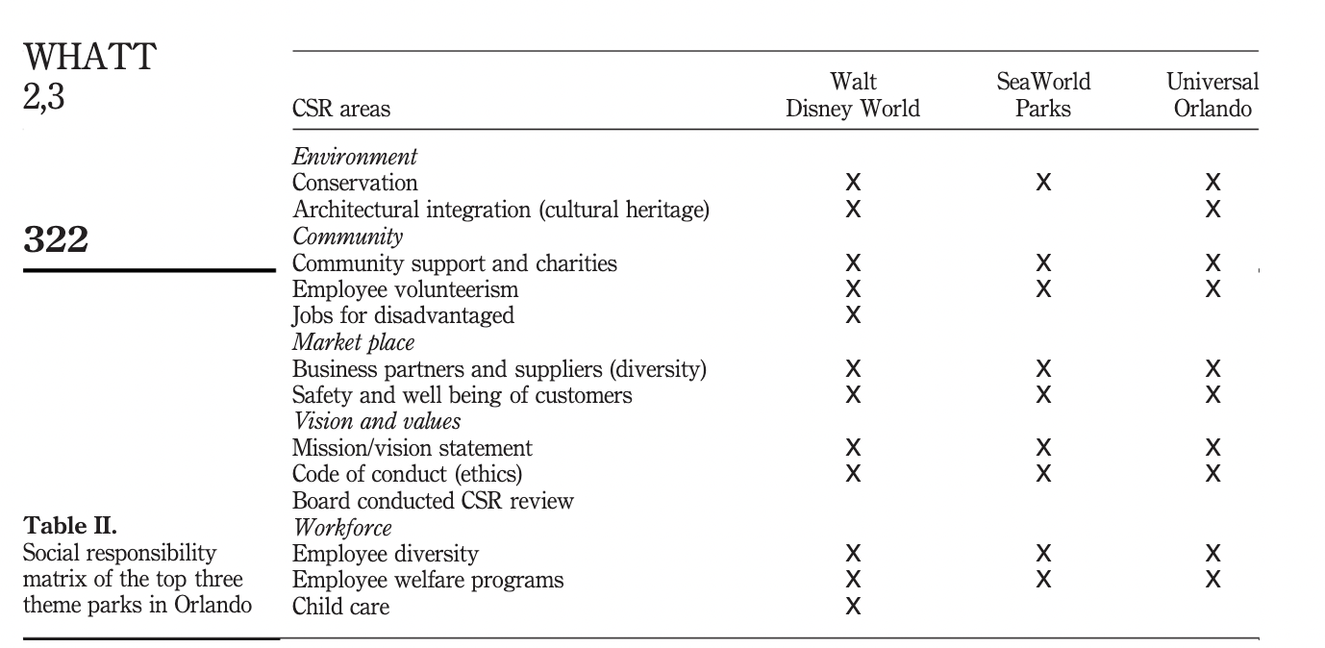

(Holcomb et al., 2010)

